4. SQL Injection

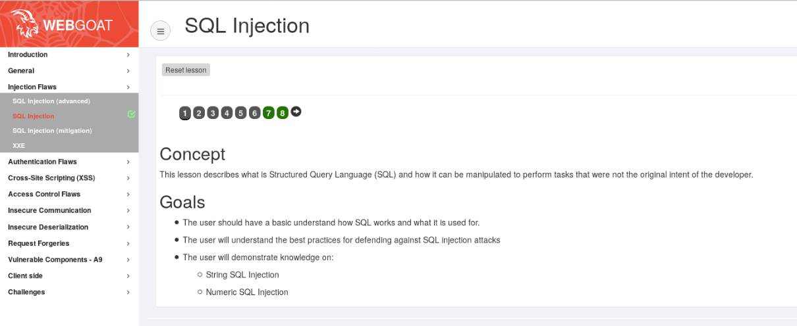

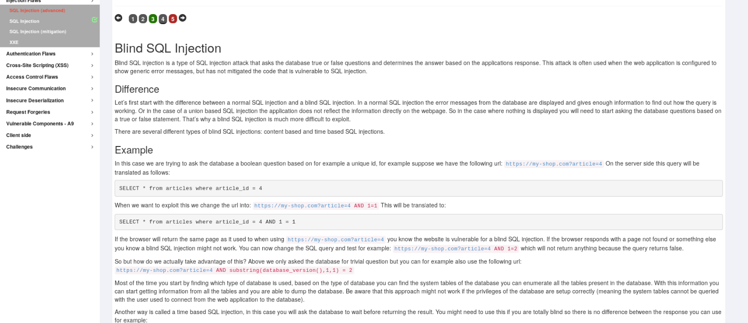

5. Authentication Flaws

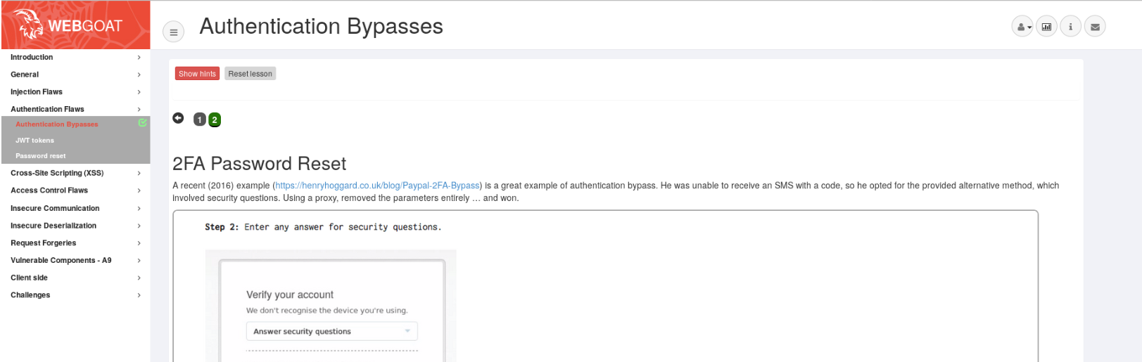

6. Cross-Site Scripting (XSS)

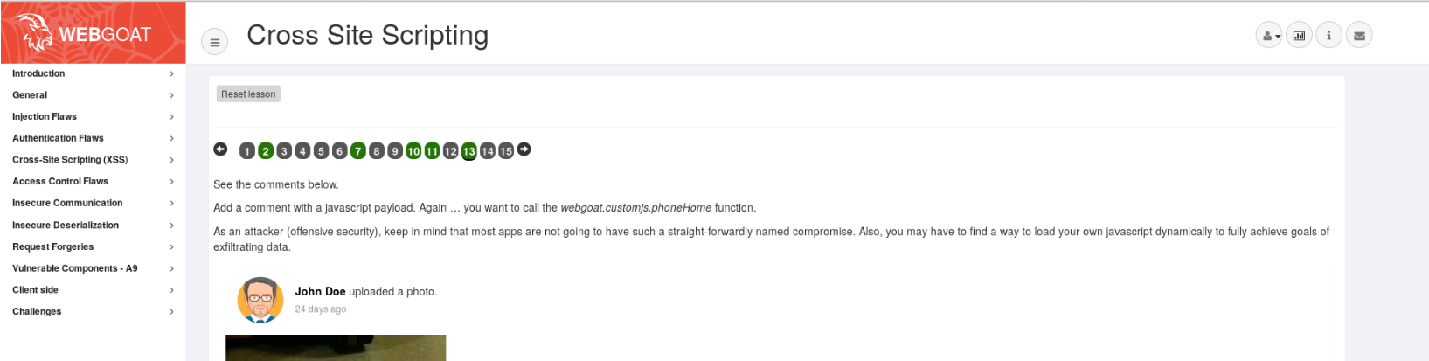

7. Access Control Flaws

*userId, role*

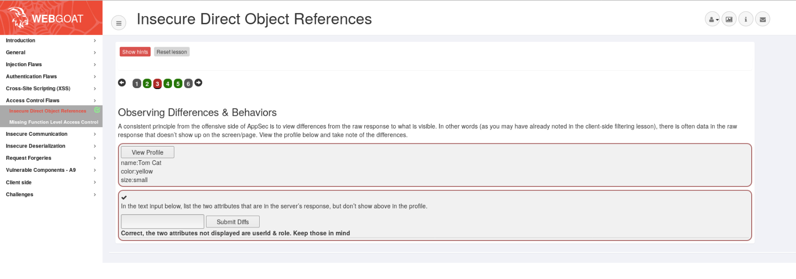

8. Request Forgeries

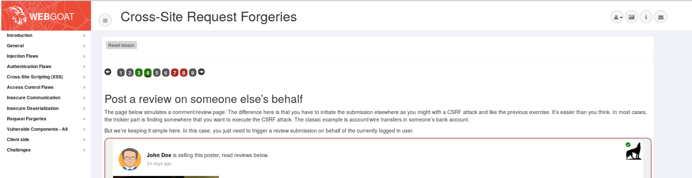

9. Vulnerable Components – A9

