**GREEN ACADEMY VIETNAM**

---

**GRADUATION PROJECT**

WEB DESIGN

**HOTDOG HUT**

**Students: Pham Khac Huy**

**Class: WEB-D007**

**Guide teacher: Huynh Ngoc Duy**

**MỤC LỤC**

**OVERVIEWS 3**

**APPLICATION FEATURES** **4**

**TECHNICAL CONSTRUCTION** **7**

**CONSEQUENCE** **9**

**REFERENCES** **10**

# Overviews

* HotDog Hut is a website specialize in sell and supply hot dog and sandwiches with hot dog and sandwiches famous from reputable companies like ABC company, HotDog King… Always ensure the quality of products.
* The goal of the website is to continue to develop new functions for the website such as online orders, customer feedback, chat with employees, page admin...

Home Page

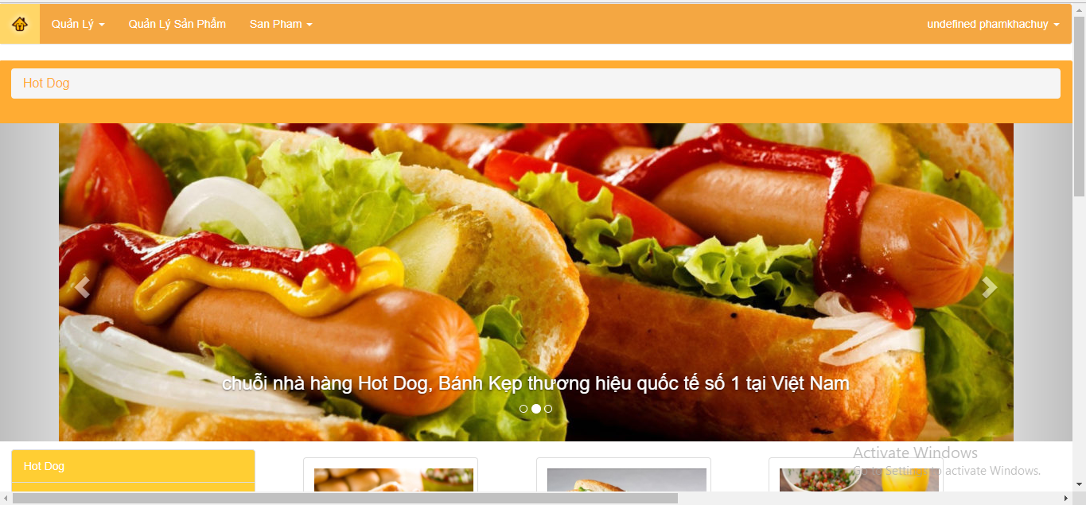

# APPLICATION FEATURES

* Trình bày về tính năng và đặc điểm của ứng dụng.
* Hình ảnh thể hiện nội dung của ứng dụng
* Thể hiện User Case của ứng dụng

**Features of website:**

* Login

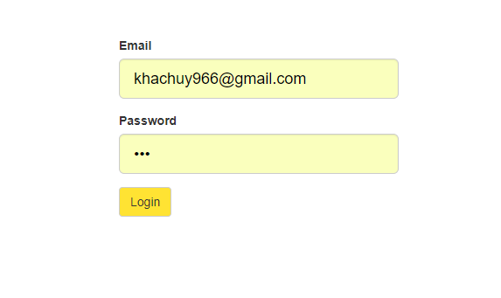

Login form is the user account to interact with the website such as purchase, feedback ...

* Administration



Because we is no time, the admin page is replaced with the admin bar. The admin bar is a place to users manage, brands, products, and product categories.

Create Brand

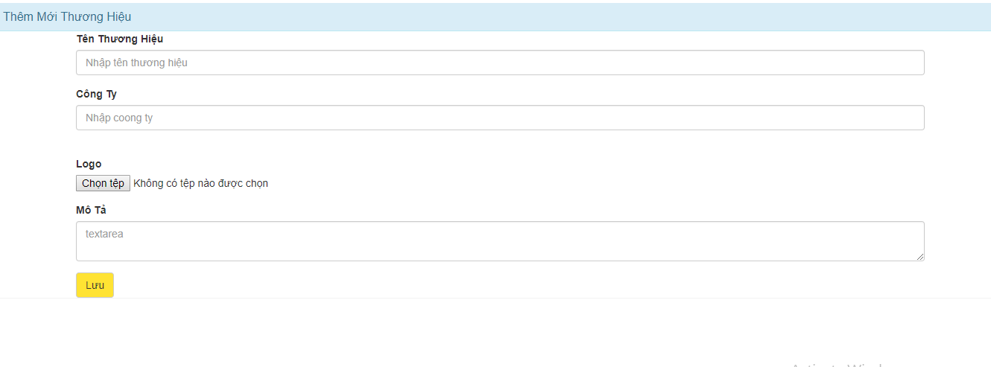

Create Category

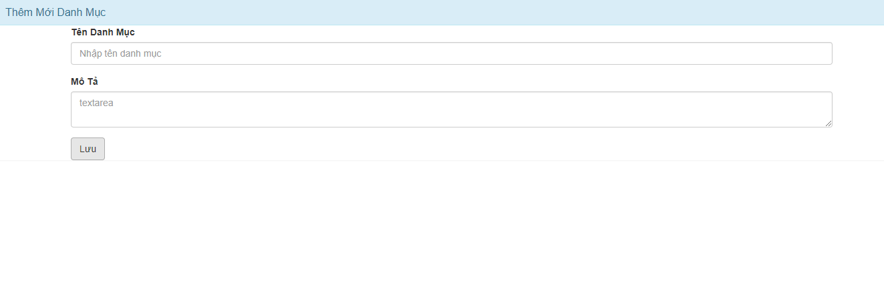

Create,edit,delete Product

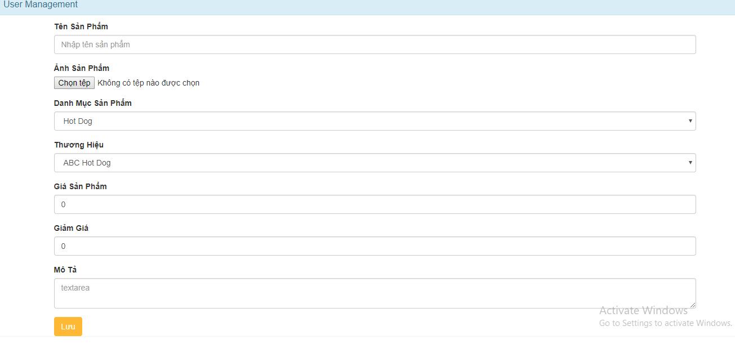

Users management

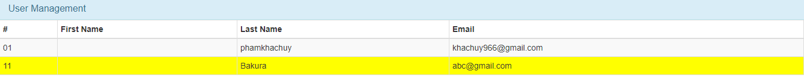

Brand

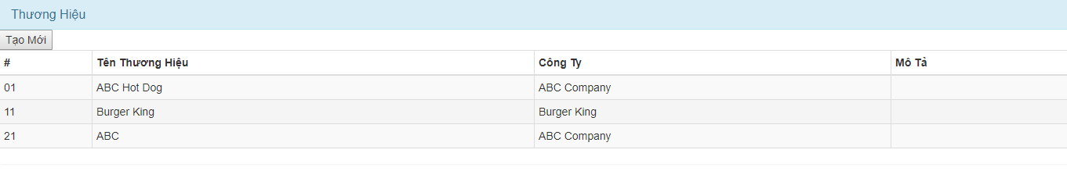

Product categories

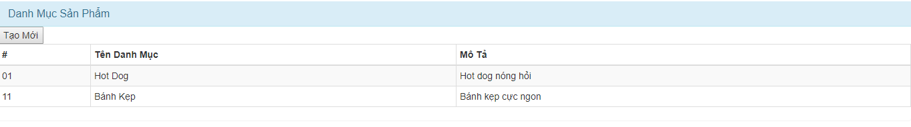

* Page Body:

Catalog: There are only two main types of products: sausages and sandwiches.

when choose the type product, product frames will be show the list of the corresponding products.

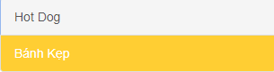

Products: Place show product list

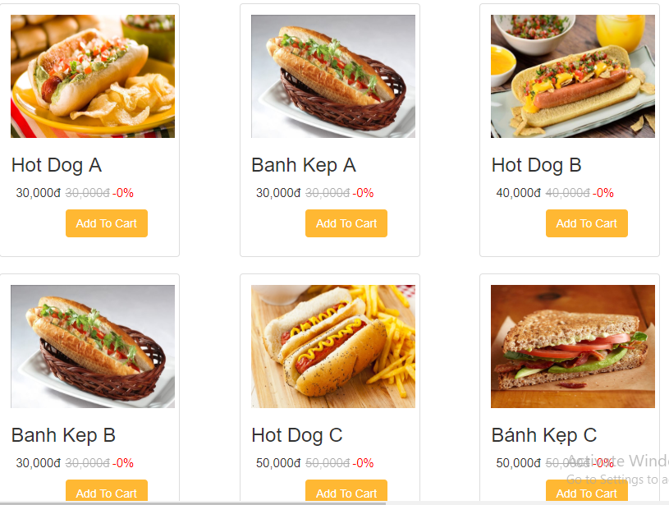**TECHNICAL CONSTRUCTION**

* Nói rõ ứng dụng sử dụng những công nghệ/nền tảng nào (ReactJS, JQuery…)
* Mô hình entity cơ sở dữ liệu.
* Workflow mô tả những công nghệ/nền tảng đã sử dụng.
* The website is written in ReactJS, Jquery, Bootstraps, Css.
* The CHEN (Entity Relationship model - E-R) model introduced in 1976 is a model widely used in conceptual database designs, based on the assumption The real world through a set of objects is called entities and relationships between these objects.

1. React: ReactJS is a Javascript library for building user interfaces front-end), developed by Facebook. ReactJS is often used to develop single-page applications, complex applications or mobile applications that are easy to use.
2. Web Application Structure: In the section on ReactJS, we will build a web application client that is structured The directory structure created by the create-react-app.
3. The main Javascript library used to build the application is ReactJS. There are 2 additional libraries: JQuery The JQuery library supports the ReactJS library that interacts directly with the HTML DOM.

HTML CSS Bootstrap, used to style the client interface of the web page.

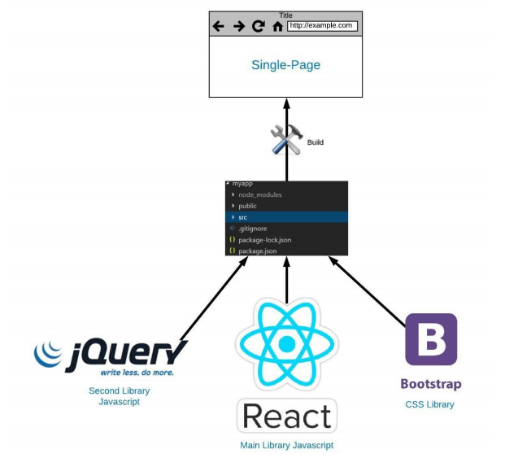

* ES6 Javascript: ES6 (ES2015) stands for ECMAScript 6, which is the latest version of Javascript based ECMAScript standard. ECMAScript is an international standard in Javascript programming, a set of standards and rules In Javascript programming like variable declaration, method definition, class definition…
* Connect to the database using api.

# CONSEQUENCE

Has put the site into normal operation with features like admin and show, add, delete, edit products. In the future will look nice interface and more features such as page admin, feedback, chat with staff, order online ...

# REFERENCES

1. https://vi.wikipedia.org/wiki/Giao_thức_truyền_thông

2. https://www.scnsoft.com/blog/web-application-architecture

3. <https://github.com/Bakura0123/GreenAcademy/tree/master/Document>

4. <https://react-bootstrap.github.io/>

5. https://nodejs.org/en/