 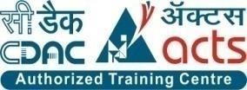

**INSTITUTE FOR**

**ADVANCED COMPUTING**

**AND SOFTWARE**

**DEVELOPMENT AKURDI,**

**PUNE**

Documentation On

**“FARMER’S E-STORE”**

PG-DAC SEP 2021

*Submitted By:*

**Group No: 2**

# Abhilasha Angaitkar (219004)

# Bal Krishan Sah (219040)

**Mr. Prashant Karhale Mr.Chetan Pardeshi**

**Centre Coordinator Project Guide**

# Table of Contents

1. Introduction 1

Documentation Purpose 1

Problem Statement 2

Product Scope 2

Aim & Objectives 3

1. Overall Description 4

Existing system Functions 3

Proposed System………………………………………………………………………4

Benefits of Ecommerce system 5

Users and Characteristics 6

Operating Environment 7

1. Requirements Specification 8

External Interface Requirements 8

Non-Functional Requirements …………………9

1. System Diagram 10

Activity Daigram 10

Data Flow Diagram 11

ER Diagram 13

Use Case Diagram 14

1. Table Structure 15

Table Design 17

Conclusion 18

Future Scope 18

1. References 19

**E commerce Website**

# Introduction:

**Documentation Purpose**

This document is meant to delineate the features of Farmer’s E-store , so as to serve as a guide to the developers on one hand and software validation document for the prospective client on the other. It is a system design especially for establishing direct link between Farmers and Customers. This provides complete functionality of listing and placing order. Farmer’s E-Store provides the features for admin. Seller and customer for buy and sell products online.

Farming is the Prime Occupation in India in spite of this, today the people involved in farming belongs to the middle class and is in deep poverty. The Advanced techniques and the Automated machines which are leading the world to new heights, is been lagging when it is concerned to farming, either the lack of awareness of the advanced facilities or the unavailability leads to the poverty in farming. Even after all the hard work and the production done by the farmers, in today’s market the farmers are cheated by the Agents, leading to the poverty. Agro-marketing would make all the things automatic which make easier serving as a best solution to all the problems.

We are developing project to develop an e-commerce Java web application for the farmers where they can sell their products online.

Seller can add, update, delete and view products of seller. Also can view received orders. Also can view received orders. Customer can view and select category, select product and place orders. Admin can View the list of all Customers , View the list of all Sellers and can verify them.

## 

## Problem Statement

## In the existing system all transactions, dealings of products, purchasing of products were done manually which is time consuming. To buy any product user has to collect information about it either by visiting the shop or by asking people which is better. There is no computer system for handling payments. All calculations are performed manually, which may not always be accurate. Maintaining records is difficult.

## Farmer’s E-Store provides the features for seller, customer and admin. It’s a simple platform which will help to connect farmers and customers However, there is a lot of competition among multiple e-commerce sites for online shopping . But our platform will be dedicated and focus only on Farm products which will increase simplicity in shopping farm products. When users land on an e-commerce site, they expect to find what they are looking for quickly and easily that’s actually we provided.

## Product Scope

This project traverses a lot of areas ranging from business concept to computing field, and required to perform several researches to be able to achieve the project objectives. The area covers include:

* Commerce industry: This includes study on how the daily Commercial work actually is being done, process involved and opportunity that exist for improvement.
* J2EE Technology used for the development of the application.
* General customers as well as the Application Management Staff / Admin will be able to use the system effectively.
* Web-platform means that the system will be available for access 24/7 except when there is a temporary server issue which is expected to be minimal.

## Aims & Objectives

Specific goals are: -

* + To produce a web-based system that allows the admin to add or remove categories, verify sellers, manipulate and manage all the system.
  + To ease sellers by providing different functionalities to them.
  + To ease customers by providing user friendly interface to help them and to have great shopping experience as well as to add and track orders efficiently.

## Overall Description

**Existing system function:**

In the existing system all transactions, dealings of products, purchasing of products were done manually which is time consuming.

To buy any product user has to collect information about it either by visiting the shop or buy asking people which is better.

There is no computer system for handling payments. All calculations are performed manually, which may not always be accurate. Maintaining records is difficult.

**PROPOSED SYSTEM**

**Product functionality:**

Farmer’s E-Store provides the features for seller, customer and admin. It includes several functionalities describes as below:

**Seller Management:**

Seller can add, update, delete and view products of seller. Also can view received orders.

**Customer Management:**

Customer can view and select category, select product and place orders.

**Generating orders:**

When customer select the payment option the dummy transaction takes place and the orders are placed automatically for selected products.

**Admin:**

It provides facility to add, update, delete and view sellers who are selling products. It provides facility to add, update, delete and view customers who are purchasing products. It provides facility to admin to verify seller and maintain the productivity of software effectively.

## 

## Benefits of Ecommerce System-

* It saves a lot of time, money and labour costs.
* It is user-friendly website to use.
* This online system helps in keeping record of business.
* Helps to increase business.
* Beneficial for both sellers as well as customers.
* Fast Services: In order to get business target sellers can work fast and deliver products very fast manner. So automatically customer will get experience of fast service.
* The continuous monitoring of admin and the overall business becomes easy and secure.
* Includes the least of paper work.
* The website acts as a shop that is open 24/7.
* It increases the efficiency of the management at offering quality services to the customers.
* It provides custom features development and support with the application.

**Users and Characteristics:**

**Admin:**

* Admin can Login/Logout to the system.
* View the list of all Customers.
* View the list of all Sellers and can verify them.
* Can remove Customers, Sellers.
* Admin can add/remove category
* Can see all orders and their status.

**Seller:**

* Seller can Login/Logout/Register to the system.
* View/Update personal details.
* View/Update their products.
* Seller can update quantities of their products.
* Seller can view orders and can update orders status.

**Customer:**

* Customer can Login/Logout/Register to the system.
* View/Update personal details.
* View/Select category.
* View/Select products available in specific category.
* Customer can Add/Remove/Update product into cart.
* View products present into cart with total amount.
* Customer can pay and place the order.
* Customer can view orders.

## OPERATING ENVIRONMENT:

**Server Side:**

* Processor: Intel® i3 processor
* RAM: Minimum 4GB
* OS: Windows or any Equivalent OS
* Database: MySQL Workbench
* Development Tool : Spring tool suite

**Client Side (minimum requirement):**

* Processor: Intel Dual Core
* HDD: Minimum 80GB Disk Space
* RAM: Minimum 1GB
* OS: Windows or any Equivalent OS

# Requirement Specification

**External Interface Requirements:**

**Customer Interfaces:**

* All the customer will see the login page when they enter in this website. This page asks the user email and password.
* After being authenticated by email and password, user will be redirect to their corresponding home page where they can do various activities.
* The user interface will be simple and consistence, using terminology commonly understood by intended users of the system.

**Seller Interfaces:**

* All the seller will see the login page when they enter in this website. This page asks the user email and password.
* After being authenticated by email and password, user will be redirect to their corresponding home where they can do various activities.
* The user interface will be simple and consistence, using terminology commonly understood by intended users of the system.

**Hardware Interfaces:**

* No extra hardware interfaces are needed.
* The system will use the standard hardware and data communication resources.
* This includes, but not limited to, general network connection at the server/hosting site, network server and network management tools.

**Application Interfaces:**

OS: Windows 7, Linux

Web Browser:

## 

## The system is a web-based application; clients need a modern web browser such as Mozilla Firebox, Internet Explorer, Opera, and Chrome. The computer must have an Internet connection in order to be able to access the system.

## Non-Functional Requirements:

Following Non-Functional Requirements will be there in the insurance to the internet:

1. 24X7 availability.
2. Better component design to get better performance at peak time.
3. Flexible service based architecture.

Various other Non-Functional Requirements are:

* Security
* Reliability
* Maintainability
* Portability
* Extensibility
* Reusability
* Compatibility
* Resource Utilization

## SYSTEM DIAGRAMS

## Admin Activity Daigram

## 

## Seller Activity Daigram

## 

## Customer Activity Daigram

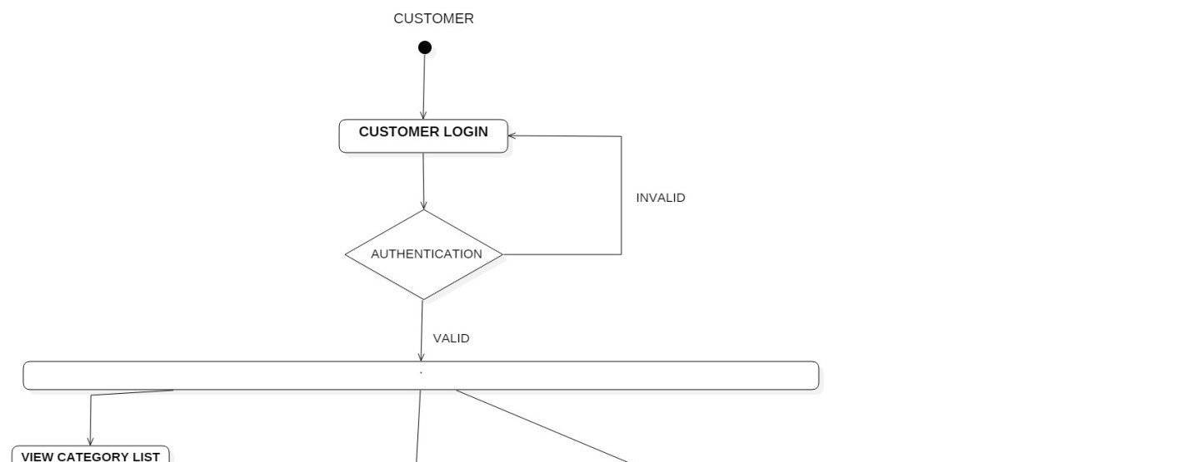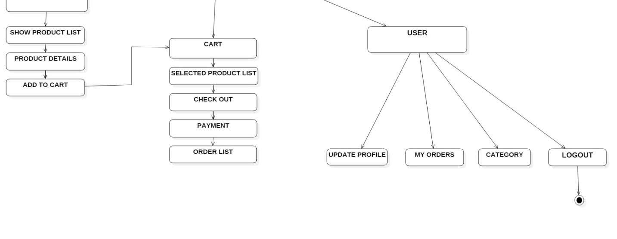

## Data Flow Diagram:

## 

## ER Diagram:

The Entity-Relationship (ER) model was originally proposed by Peter in 1976 [Chen76] as a way to unify the network and relational database views. Simply stated the ER model is a conceptual data model that views the real world as entities and relationships. A basic component of the model is the Entity-Relationship diagram which is used to visually represent data objects.

* It maps well to the relational model. The constructs used in the ER model can easily be transformed into relational tables.
  + It is simple and easy to understand with a minimum of training. Therefore, the model can be used by the database designer to communicate the design to the end user.
  + In addition, the model can be used as a design plan by the database developer to implement a data model in specific database management software.

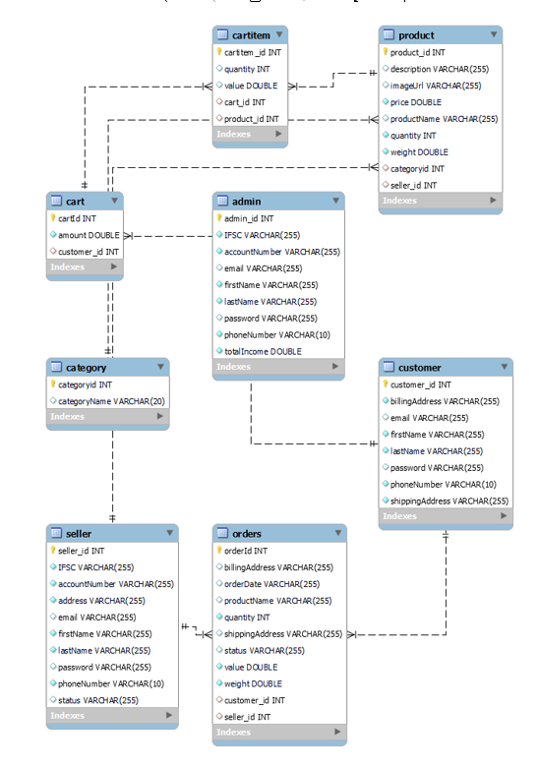

## Use Case Diagram-

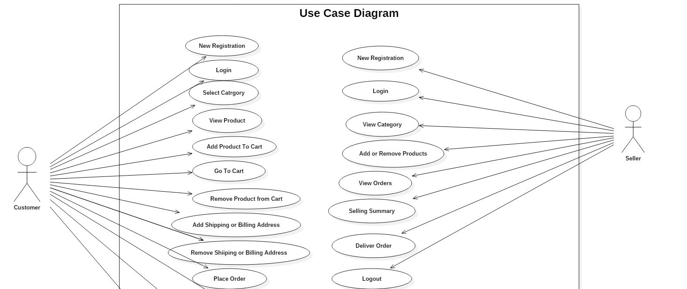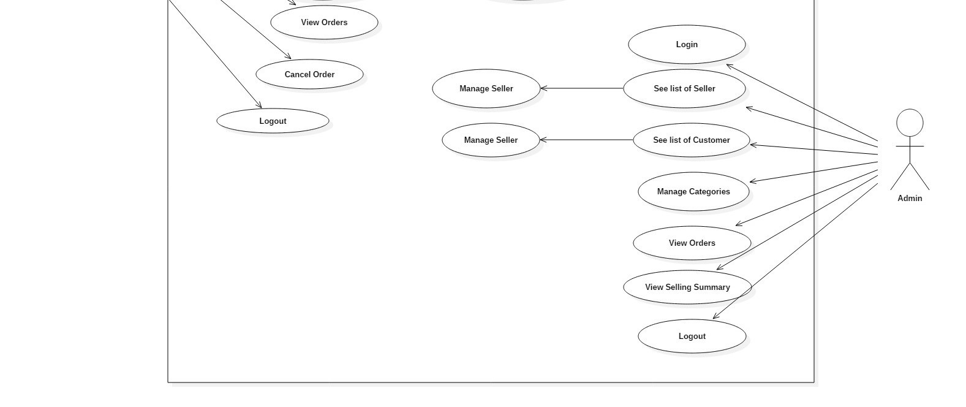

**Table Structure:**

* **Admin**

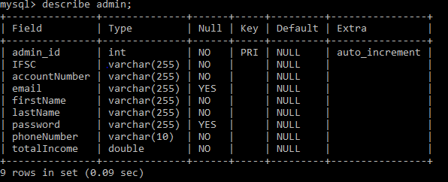

* **Cart**

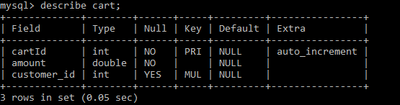

* **Cartitem**

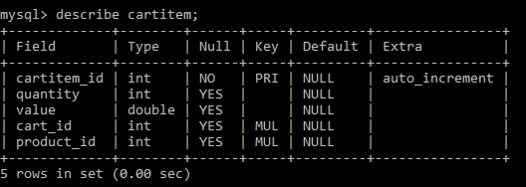

* **Category**

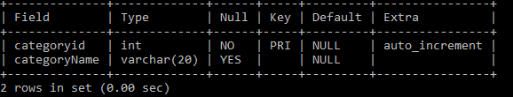

* **Customer**

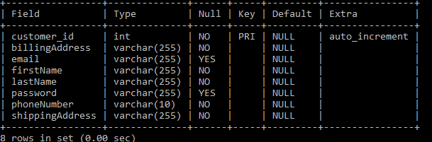

* **Seller**

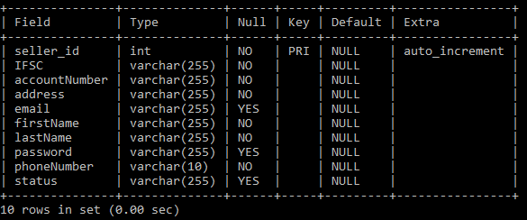

* **Product**

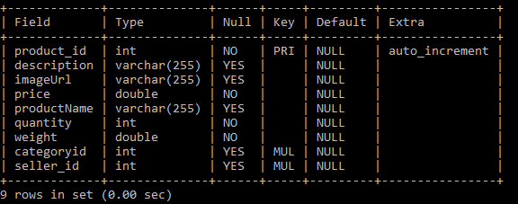

* **Orders**

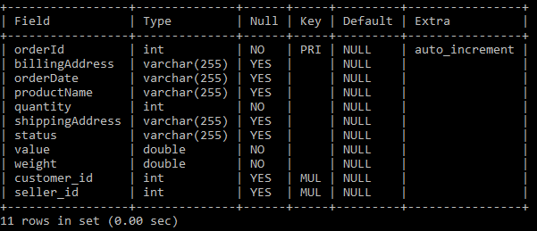

## 

## Conclusion

The project entitled "Farmer’s E-Store" is still under construction. The work on the project is under progress. The part of our system has been developed with much care that it is free of errors and at the same time it is efficient and less time consuming. The important thing is that the system is robust. We have tried our level best to make the site as dynamic as possible. Also provision is provided for future developments in the system. The main motive for the project was to provide dynamic online platform to help farmers in every possible way and provide them a stable platform where they can perform every transaction with ease.

The internet has become major source in modern business, thus electronic shopping has gained significance not only from the entrepreneur’s but also from the customer’s point of view. For the entrepreneur, electronic shopping generate new business opportunities and for the customer, it makes comparative shopping possible.

## Future Scope :

**Partial Payment**: Partial payment will help user as well as farmer to buy and sell the product required by user accordingly.

**Payment Gateway**:In this project we have designed false transaction which will show only that transaction is successful, similar to virtual transaction for better understanding. Since the implementation of payment gateway is not possible right now, it would be implemented in future.

Debit/Credit payment modes would be implemented in future.

* **References:**
* [Bootstrap · The most popular HTML, CSS, and JS library in the world. (getbootstrap.com)](https://getbootstrap.com/)
* [Recharts](https://recharts.org/en-US/)
* [Spring Data JPA - Reference Documentation](https://docs.spring.io/spring-data/jpa/docs/current/reference/html/)