READ INSTRUCTIONS BEFORE USING THE TEMPLATE
Delete this text box after the document is complete
<This Template is to be used for preparing the Test Strategy for all BTC Projects>
Test Strategy

Document Id: <Project_Test Strategy>
Version: <X.YY>
Release date: <DD-MMM-YYYY>

Project Name: <Project Name>
Project Code: <Project Code>

Document Information
Document Name | Test Strategy Document
Original Author(s) | <<Enter Names>>
Current Revision Author(s) | <<Enter Names >>
Current Owner of the document | <<Enter Names >>

Change History
Version | Date | Author(s) | Revision Notes

Reviewers
Program Role | Reviewer’s Name | Date | Signature or Initials

Approvals
Role | Approver’s Name | Date | Signature or Initials

Table of Contents
1 Purpose 4
2 Audience 4
3 References 4
4 Acronyms 5
5 Glossary of Terms and Definitions 5
6 Application Details 6
6.1 Application Overview 6
6.2 Testing Scope & out of scope 6
6.3 Test Strategy Overview 6
6.4 Assumptions and Dependencies 9
7 Test PREPARATION Activities 9
8 TEST DELIVERABLES 10

- Purpose
<Mention the purpose of this Test Strategy document and briefly describe how this document will be used>

Example: This document is the Test Strategy for the project <Project Name>. It documents the planned and implementation approach to ensure that the test objectives set in the Test Methodology and Test Management Plan are managed for this <Test Phase>.>

- Audience
<Mention the intended audiences for the Test Strategy. The stakeholders, affected groups and users of this document should be identified >

- References

Reference  Number | Title
BTC Processes Specific References
BTC-M-01 | BTC Testing Methodology
BTC-T-01 | Test Management Plan
BTC-P-01 | Testing process Document
BTC-G-01 | Testing Guidelines
Project Specific Reference documents
 | BRD
 | BSD

<Mention all the reference documents (Procedures, or processes, or guidelines, or templates) to this list including project related documents>

- Acronyms
<Mention all the acronyms applicable to this project>

Acronym |  | Description
TMP | Test Management Plan
TSR | Test Summary Report
BRD | Business Requirement Document
ITP | Integration Test Plan

- Glossary of Terms and Definitions

<Mention all the terms and definitions applicable to this project>

TERM | DEFINITION
UAT | User Acceptance Test – Performed to demonstrate a system’s readiness for operational use or acceptance. This follows system testing. It focuses on requirements. It ends when the system is approved by the sponsor.
System Test | Performed to develop confidence that a system is ready for UAT. This forms a basis of regression test set and often represents the bulk of the testing effort. It is the most comprehensive of the tests. It is intended to test software design and requirements. Completed when the system is ready for UAT.
Integration Test | To progressively test interfaces between units and modules. Intended to focus on the interfaces between functions, modules, and systems. It ends when the entire system has been integrated and stability has been demonstrated.
Unit Test | Used to determine that a module (unit) meets the requirements. Testing can be black box or white box. It is the primary means for evaluating code coverage. It ends when each unit has met the exit criteria.
Black Box Testing | Testing, either functional or non-functional, without reference to the internal structure of the component or system.
White Box Testing | Testing based on an analysis of the internal structure of the component or system.
Smoke Test | A subset of the planned test cases used to ensure the systems work as expected. This is used to ensure the most critical functions of the programs work, without completing the entire test suite. With daily builds, this will become essential to ensuring that a quick sanity check is done to ensure the system is ready for testing.
Code Coverage | Used to evaluate the testing done on a module or system. Evaluates how much of the program the test plan is stepping through.

- Application Details
  - Application Overview
<Mention the overview of the application to be tested and briefly describe how the test strategy is being defined for this application. Also provide all high level details of application which are relevant like background of the application, architectural diagram, interfaces, functionality and current release plans etc>

  - Testing Scope & out of scope

<Mention the testing scope and out of scope for the application, interfaces>

Ex : Unit Testing, System Testing, System Integration testing, Regression testing, Performance testing, UAT. Also identify manual and automation testing scope and test strategy>

  - Test Strategy Overview

Testing Type | Task | Details
Unit Testing | Test Approach | Describe the overall approach to testing. Specify  Major test activities  Testing techniques used  How the results of tests will be verified  How the errors will be fixed and tests rerun (regression testing if any)  How the effectiveness of testing will be judged  Describe the reviews to be conducted to verify the correctness and completeness of testing activities.>
 | Testing Coverage | Describe the test coverage and number test cycles planned
 | Test Environment & Test Data | Describe the Test environments and test data to be identified
 | Test Items | Describe all the test items planned to be tested which at the minimum include Modules, batch jobs, reports, Interfaces etc
 | Testing Tools | Describe the tools, in-house developed scripts used for Code coverage and automated testing tools, defect management tools
System Testing | Test Approach
 | Testing Coverage | Test cases should ensure  System still performs as per its requirements  Performance requirements of the system are met  No new errors are introduced as a result of the changes
 | Test Environment & Test Data
 | Test Items
 | Testing Tools
Regression Testing | Test Approach
 | Testing Coverage | Test cases should ensure  System still performs as per its requirements  Performance requirements of the system are met  No new errors are introduced as a result of the changes
 | Test Environment & Test Data
 | Test Items
 | Testing Tools
System Integration Testing | Test Approach
 | Testing Coverage | Test cases should ensure  System still performs as per its requirements  Performance requirements of the system are met  No new errors are introduced as a result of the changes  End2End testing with all interfaces
 | Test Environment & Test Data
 | Test Items
 | Testing Tools
Performance Testing | Test Approach
 | Testing Coverage | Performance requirements of the system are met such as :  Load testing  Stress Testing  Volume testing
 | Test Environment & Test Data
 | Test Items
 | Testing Tools
User Acceptance Testing | Test Approach
 | Testing Coverage | Test cases should ensure  System still performs as per its requirements  Performance requirements of the system are met  No new errors are introduced as a result of the changes  End2End testing with all interfaces
 | Test Environment & Test Data
 | Test Items
 | Testing Tools
Other Testing Services | Test Approach
 | Testing Coverage
 | Test Environment & Test Data
 | Test Items
 | Testing Tools
Support Services | User Acceptance Testing Support

  - Assumptions and Dependencies
<Describe the assumptions and dependencies identified for the project>

- Test PREPARATION Activities
<Following is a schematic representation of the test preparation activities to be carried out for the identified applications or systems>

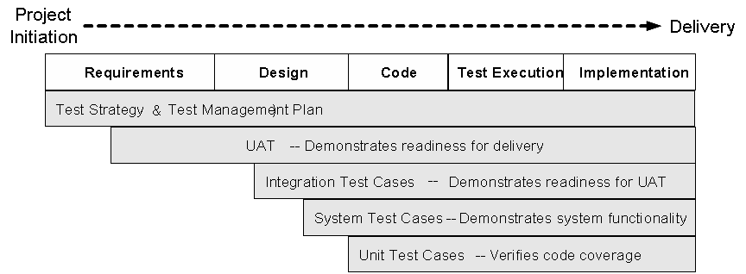

<* As per Brickred Systems’ Computer Controls and SOX requirements – Unit Test Plans must be created and executed before system testing begins for the project.>

<Test Management Plan (TMP) will be addressing the following requirements since the TMP will be maintained as a pure planning document>

- Test Objectives and Scope
- Testing Schedule
- Test Execution models (onsite / Offshore)
- Resource Requirements
- Test Environment Requirements
- Risks and Issues to be addressed
- Test Completion Criteria
- Suspension and Resumption Criteria
- Assumptions and Dependencies
- Test Team Organization>

- TEST DELIVERABLES
<Mention the test deliverables to be created for the testing activities to be carried out for the application or system>

< Test Scenarios
- Brief description of the application features to be tested>

<Test Cases / Automation Scripts

- UAT Test Cases - to be completed during the design stages of the project by the business and BSG.
- System Integration Test Cases - to be completed in parallel with the high level design phase activity.
- System Test Cases - to be completed with a combination of Integration Test development completion and in parallel with the detailed design documents. System Test cases may be updated once the Unit Test cases are completed>

<Test Reports
- Integration, System and UAT test reports recording the results of the Integration, System and UAT testing activities>
- Defect Reports>

