# **eForms – 2nd round of consultation**

## Process

The Commission proposes a major update to the public procurement standard forms aiming at significantly improving data on procurement in the EU. The implementing regulation on eForms is intended to replace the [Implementing Regulation 2015/1986](http://eur-lex.europa.eu/legal-content/EN/TXT/?uri=uriserv:OJ.L_.2015.296.01.0001.01.ENG), currently in force.

This 2nd consultation is based on the results of a [1st consultation](http://ec.europa.eu/growth/tools-databases/newsroom/cf/itemdetail.cfm?item_id=8997) which took place between 22/11/2016 and 30/01/2017. The results of the 1st consultation were discussed with Member States at the Economic and Statistical Working Group (ESWG) of 8 April 2017.

In general, the stakeholders agreed that improvements to the current forms are necessary. However, several shortcomings of the Commission’s proposal were identified. These were the excessive complexity of the presentation, the short duration of the consultation, the insufficient flexibility offered by the implementing act in the past, and the need for better coordination with other standardisation projects. To address these concerns, we have simplified the consultation in several ways, as explained in section 3 of this document.

Furthermore, concerns were raised about the deadlines for implementation. The Commission is well aware of the effort needed by MS to implement the current forms and understands their concerns about a new process of implementation. Thus, the Commission does not plan to rush for any unreasonably rapid implementation deadline. In this context, we recall that during the meeting of the ESWG, an implementation deadline of two years (from the moment when the technical files are made available by the Commission) was mentioned as reasonable by several MS, so that is the one used in the indicative timing below.

This is the indicative timing for eForms:

* New targeted consultation on proposed approach (June 2018 – September 2018)
* Commission services complete the draft implementing regulation (October 2018)
* Public feedback on the draft implementing regulation (November 2018)
* Draft implementing regulation translated into all EU official languages (December 2018)
* Approval by Member States’ in the Advisory Committee on Public Procurement and adoption by the European Commission (January – February 2019)
* Publications of a new standard format for electronic exchange of notices by the Publication Office of the EU. Start of implementation in Member States. (February 2020)
* End of implementation in Member States (February 2022)

## Context

This section recalls the main points given in the explanatory document of the 1st consultation. Please refer to this document for a more in-depth discussion.

### Policy

eForms are one of the actions in the [Single Market Strategy](http://ec.europa.eu/growth/single-market/strategy_en), where the European Commission has committed to "facilitate the collection, consolidation, management and analysis of procurement data, supporting Member States’ efforts towards better governance in public procurement [because] governance of procurement systems needs to be improved to ensure efficiency, transparency and integrity.” [1]

### Purpose

The main purpose of the new eForms is to meet the needs of a diverse set of stakeholders involved in the publication and use of procurement data (while complying with the applicable provisions of the directives). Overall, these needs can be grouped into three goals: competition for public contracts, good governance of public spending, and low costs of publishing (incl. low administrative burden). These reflect the procurement directives' core principles of equal treatment, non‑discrimination, transparency, proportionality, and competition.

Concretely, eForms will bring many improvements large and small, such as:

* Improving the accuracy of information by defining the meaning of each field.
* Simplifying the forms by removing unnecessary differences and confusing concepts.
* Making forms more user-friendly and understandable by giving Member States the freedom to use the field labels that work in their national contexts.
* Lowering administrative burden by improving consistency with other standards and tools such as the ESPD and e‑catalogues.
* Giving more freedom to buyers by allowing them to specify more information (e.g. selection criteria) at the level of lots instead of the level of notices.
* Helping improve governance by making structured buyer and seller identifiers mandatory and including a limited number of policy relevant fields (e.g. on green, social, and innovative procurement).
* Balancing transparency and competition by adding the option to, in justified cases, mark fields in contract award notices as not intended for publication.
* Supporting the (voluntary) publication of below-threshold notices in the TED format by including fields relevant for below-threshold procurement.
* Simplifying the forms by updating the process for publishing corrections of notices.
* Enabling better identification of business opportunities in the EU by introducing an EU wide procurement procedure identifier.

### Legal framework and current status

Public procurement directives require that public contracts are advertised through the publication of notices.

These notices shall include the information set out in those directives, in line with the relevant directive annexes (see overview Annex II of this document). They shall be drawn up and transmitted by electronic means to the Publications Office and be published in the format of standard forms.

Standard forms shall be established by the Commission by means of implementing acts (cf. for instance article 51(1) of directive 2014/24). The transmission of the notices shall be done in accordance with the format and procedures for transmission established by the Commission and made accessible at <http://simap.europa.eu>(Annex VIII of Directive 2014/24).

The current standard forms were established by Commission Implementing Regulation 2015/1986 of 11 November 2015. There are currently 22 different standard forms.

The Publications Office has established an exchange format for electronic exchange of notices. Buyers can send notices for publishing in structured electronic format via online forms provided by the Publications Office "eNotices" application or through qualified intermediaries – "TED eSenders".

## Updated proposal

The main body of the updated proposal is the spreadsheet available at [github.com/eForms/eForms](https://github.com/eForms/eForms/blob/master/README.md). Practical information about participating in the consultation is in section 6 of this document.

To address the concerns raised in the 1st round of the consultation, we have simplified the proposal in two major ways:

* By reducing the scope of the consultation. Instead of providing extensive information relevant for the final implementation of eForms, we now provide only the information strictly necessary for the adoption of the implementing act. Concretely, this means we have removed information about codelists[2], validation rules, user interfaces, TED presentation, etc.[3]
* By simplifying the description of individual data elements. In the 1st consultation, we proposed field labels while stating that any label with the same meaning can be used as well[4]. This goal was to allow Member States to set labels as they see fit, as long as the same meaning is respected. In this updated proposal, we are taking a more straightforward approach with the same effect: we propose to disregard labels and adopt only the meaning (i.e. the description) of the individual data elements.

Specifically, the simplification efforts have led to reducing the number of:

* consultation formats from 2 to 1;
* rows in the consultation spreadsheet from approximately 350 to 250;
* columns in the consultation spreadsheet from 47 to 43;
* pages in introductory document from 32 to 12.

These changes are based on the fact that the directives do not impose that information should be sent to the Publications Office in a specific layout. The adoption of a specific visual template for transfer of information is the heritage of a time when transmission workflows were paper-based and, for the sake of efficiency, data sent for publication and data actually published were strictly the same and respected the same formal layout.

However, in electronic exchanges, what matters is that information is exchanged in a structured format, rather than the form in which this information will ultimately be displayed. Successful electronic exchange of data requires only that (1) data to be exchanged is identified, (2) data to be exchanged is properly structured, and (3) a standard exchange format is defined. The way in which the information will finally be displayed and the way information is transmitted in the first place are independent.

Thus, the Commission proposes that the following aspects are addressed separately:

1. Content of the notices: information to be sent to the Publication Office
2. Layout of the notice: how should information be displayed (e.g. on TED)
3. Transmission of the notice for publication: which are the formats and procedures for transmission of notices to the Publications Office for publication on TED

Concerning point 1, this is specified in the spreadsheet which is the subject of this consultation. This will be the annex to the new implementing regulation establishing the content of the public procurement notices published on TED.

Concerning point 2, the Commission services propose that the layout of notices (how the information should be displayed in user interfaces and on TED) should not be covered by the implementing regulation. However, the Commission will informally provide models (including for example labels for individual fields in all languages) for appropriate display of notices, which can then be (adapted and) reused by Member States.

Concerning point 3, according to the directives, the formats and procedures for transmission of notices are out of the scope of the regulation. A review of the standard exchange format will be done by the Publications Office while implementing the new data standard.

### Content of the notices: which information is to be sent to the Publications Office

The information to be transmitted electronically to the Publications Office for publication[5] should be identified and minimum attributes defined. The unit of information in the implementing regulation Annex is referred to as a business term (BT).

#### Legal Status of the fields

Depending on its legal status, information in a notice falls within one of the three groups mentioned below. This is marked as such in the implementing regulation Annex.

* Mandatory information. A notice must include this information to be published on TED.
* Conditionally mandatory information. Under certain conditions (specified by the Publications Office of the EU) a notice must contain this information to be published on TED. For example, the internet address of an electronic auction must be given *if* the procedure includes an electronic auction.
* Optional information. This information may be included in a notice, in which case it will be published on TED.

#### Harmonization of information between main types of notices

Notices under different legal annexes require different information. Some of the information detailed in the directives is common to notices under all legal annexes (for example about the identity of the buyer), while some information is common to notices with the same general function (e.g. that is notices announcing an intention to procure, notices calling for competition, and notices announcing the result of a procurement procedure). For the sake of simplicity and consistency, the Commission services propose, as far as useful for users and legally possible, to align the type of information required for each type of notice around the three main functions mentioned above.

#### Standard format of the information provided

Proper management of information requires that it respects a common, standard format. The regulation will include a minimum set of requirements for the data sent for publication to facilitate exchange and reuse. For each information, its type is given (text, values, dates, use of predefined classifications, etc.) and whether it is repeatable.

### Layout of the notice: how should the information be displayed

According to the procurement directives, notices should be published in a standard format. It is important for the readers of TED to understand that regardless of the geographical origin of notices, the same information can be displayed in the same way, following the same order and using the same labels.

The Commission does not find it necessary to adopt visual templates for the publication of data. Including only a list of data in the implementing act will allow TED to fulfil its legal obligation as well as to flexibly adapt the information displayed, possibly even allowing for customised display according to user's specific preferences, so that different users' needs are met.

In this context, we note that there are already differences between data published in TED and in national sites (both as regards the types of notices published and the content of the notices). Furthermore, there are differences between the standard forms as adopted by Regulation 2015/1986 and the notices displayed in TED.

### Transmission of the notice for publication: what are the formats and procedures for transmission of notices

Notices shall be drawn up and transmitted by electronic means to the Publications Office, in accordance with the format and procedures for transmission established by the Commission and made accessible at <http://simap.europa.eu>.

Formats and procedures for transmission of notices are not in the scope of the standard forms implementing act. For further information on these topics, please see Annex I.

## Problems to be solved by the text of the implementing regulation

Some issues are not addressed in the spreadsheet sent for consultation. This is because, instead, they will be resolved in the legal text of the implementing regulation. In particular, this concerns the link with the European Single Procurement Document and notice corrections.

### European Single Procurement Document (ESPD)

Concerning the ESPD, we propose that the Publications Office will have the right to create extensions to eForms, which can then be voluntarily used by Member States' buyers. The first such extension would be an implementation of the ESPD data model[6] that could be included as part of contract notices. This would leave Member States the freedom to choose how they want to manage the current overlap between the ESPD and eForms concerning exclusion grounds and selection criteria. In particular, those interested would be able to include the information only in the contract notice, which would also serve as the buyer-side ESPD document. Such an approach has various advantages, such as reducing the number of documents that buyers need to fill in and companies need to read as well as avoiding inconsistency between different sources of documents.

### Notice corrections

Concerning notice corrections, we propose that rather than using a special notice, every notice can be corrected by being republished with the correct information. This will increase the flexibility and speed of corrections as well as simplify technical implementation.

## Advantages of the updated proposal

* As data does not need to be sent to the Publications Office in a specific layout, national authorities and TED eSenders have the flexibility to choose the most appropriate interfaces for input of data, including the choice of the most appropriate labels, how to display optional elements (e.g. making them mandatory at national level; not displaying them at all) and the order for input of data.
* Number of issues raised during the previous consultation are avoided, such as the question of simplification and harmonization of labels, unique field numbering.
* Mandatory information to be sent to the Publications Office will be clearly identified. Member States will be free to adopt stricter requirements for publication both at national and at European level.
* The Publications Office will provide for an interface for input of data. It is planned that this interface can be made available to third parties, who will not need to develop their own interface, but can build on this. Member States will also have access to models (including labels) used in TED applications.
* The use of predefined lists and the adoption of basic standards for input of data will improve the quality of the data provided and facilitate reuse.
* Definition of better rules will increase clarity.

## Participating in the consultation

Comments should be given only through the website [github.com/eForms/eForms](https://github.com/eForms/eForms/blob/master/README.md). We believe GitHub is a useful tool for this complex file, because it allows discussing issues one by one, enables exchanges between all participants, and helps keep track of different topics easily and transparently.

We will also hold regular and ad-hoc webinars. The regular webinars will systematically cover the whole spreadsheet document, while the ad-hoc webinars will concentrate on any issues that are brought up by Member States.

### Using GitHub

1. Go to [github.com/eForms/eForms](https://github.com/eForms/eForms/blob/master/README.md), click "Sign up" and follow the instructions. For easier communication, we suggest using your name and surname as "Username".
2. Again at [github.com/eForms/eForms](https://github.com/eForms/eForms/blob/master/README.md), you can download the [main consultation spreadsheet](https://github.com/eForms/eForms/raw/master/20180604_eForms_consultation.xls) in the bottom left. In the top right corner, you can also choose your email notification settings (to be kept up to date with new issues, choose "watching").
3. If you would like to comment (usually because something should be changed in the spreadsheet), click "Issues". There, you can open new issues by clicking on "New issue". Also, you can comment on issues already opened by others by scrolling or searching.

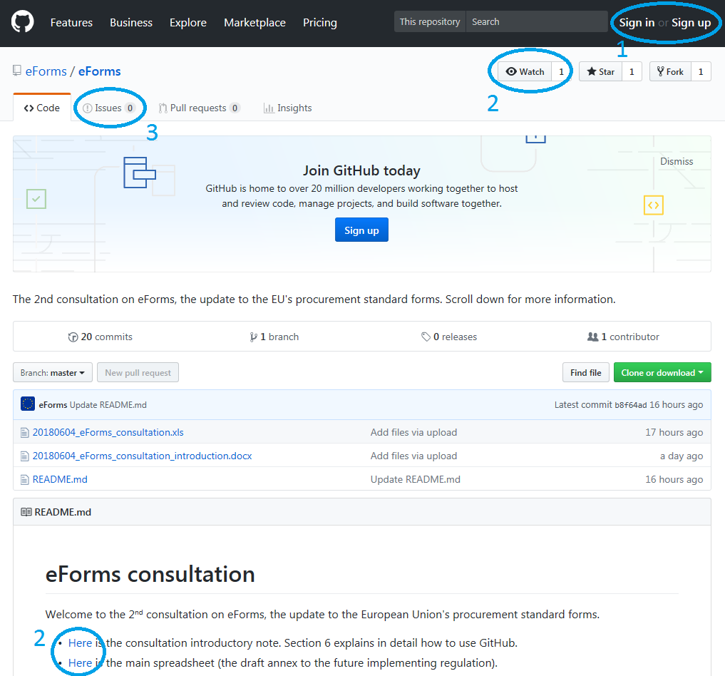

How to name your issue?

To make things readable, every issue should have the following information in the title.

1. ID (the first column of the spreadsheet) and Business Term (the second column of the spreadsheet) to be discussed, e.g. "BT-01 (Legal Basis);"
2. Name of the column (the first row of the spreadsheet) to be discussed;   
   (e.g. "Description," or "PIN only D81;")
3. Short summary of the issue (e.g. "Typo", "Inconsistent with other BTs", "rename")

For example, a title could be "BT-01 (Legal Basis); Description; Typo"

If your issue doesn't fit the instructions above (e.g. because it is more general), just follow them as far as possible.

**Before opening a new issue**, look whether it hasn't already been discussed. You can do this, for example, by writing the ID number in the search bar (if you specify "in:title", your search will be more accurate). For example, if you wanted to search for the issue mentioned in the box above, you would search for "BT-01 in:title".

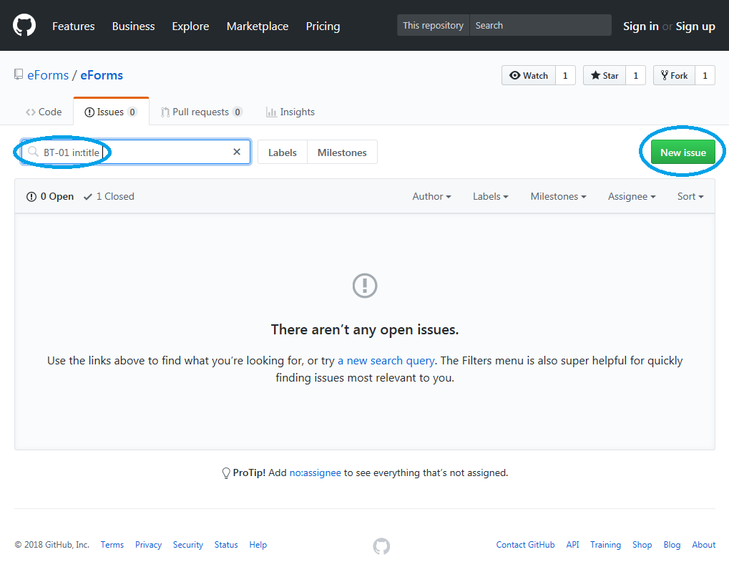

(To ensure the consultation is easy to read, please note we may format the submitted issues.)

### Webinars

Regular webinars will be held every second Thursday at 14:00, beginning with 5th July. To join the webinar, go to <https://ecwacs.webex.com/meet/jhercher> and follow the instructions. During the regular seminars, we will progressively go through the whole consultation spreadsheet. Other topics and issues can be discussed as well during the calls, depending on the preferences of the participants.

* 5th July (rows 3-54 of the spreadsheet)
* 19th July (rows 55-99 of the spreadsheet)
* 2nd August (rows 100-150 of the spreadsheet)
* 16th August (rows 151-182 of the spreadsheet)
* 30th August (rows 183-224 of the spreadsheet)
* 13th September (rows 225-249 of the spreadsheet)

We are also looking forward to having ad-hoc webinars on any topic of interest to Member States. Please get in touch at [GROW-G@ec.europa.eu](mailto:GROW-G@ec.europa.eu).

### Consultation tips

* Don’t wait with opening issues on GitHub until you've read the whole document. Instead, open an issue as soon as you spot something you don't like. The reply can save you time for the rest of your analysis.
* More than 75% of all notices on TED are contract notices and contract award notices under Directive 24 (classical procurement). If you don't have enough time, you can concentrate only on these notices (columns U and AD of the spreadsheet).
* In some countries, some types of notices are not used at all (e.g. PIN profile, PIN QS). If that is the case in your country, you might want to ignore these types of notices.
* If you want to share this consultation with stakeholders, you can simply send them a link to [github.com/eForms/eForms](https://github.com/eForms/eForms/blob/master/README.md). The document you are currently reading is uploaded there as well.

## Annex I

### Further information on the transmission of the notice for publication

#### Format for transmission of notices

The Publications Office has established a standard exchange format for electronic exchange of notices. This is a "de facto" XML standard, widely used both for submission of notices and for reuse of published notices. It presents a number of problems, mainly due to its rigidness.

A review of the standard exchange format is to be done in parallel with the implementation of the new data standard. The purpose of this review is to simplify and lighten up the implementing XML schema, so that the impact of updates and evolutions is not cumbersome for the TED eSenders and it is simpler to reuse the XML.

#### Procedures for transmission of notices

There are two ways to submit public procurement notices for publishing in structured electronic format. Buyers can fill in online forms provided by the Publications Office eNotices application for input of data. This is recommended for those buyers who only need to publish a small number of notices annually and/or who do not wish to spend time and money to develop customized software. A review of the eNotices application is foreseen to allow for a better user experience.

Buyers can also use the services of qualified intermediaries – TED eSenders - to send their notices to the Publications Office. TED eSenders are public or private bodies which underwent a qualification process and provide for an interface for publishing notices.

It is for the TED eSenders and for the Publications Office to develop user interfaces allowing for the input of required procurement data for further publication. These interfaces do not have to reproduce strictly the standard forms, but need to offer all required options so that users can fill in the necessary data.

The Commission shall establish a standard exchange format for electronic exchange of notices and shall provide for the appropriate means of reception of notices.

## Annex II

|  |  |  |  |  |  |
| --- | --- | --- | --- | --- | --- |
| **Notice Type** | **Description** | **Legal annex in 2014/24/EU** | **Legal annex in 2014/25/EU** | **Legal annex in 2014/23/EU** | **Legal annex in 2009/81/EC** |
| **PIN profile** | Notice of the publication of a **p**rior **i**nformation **n**otice or a **p**eriodic **i**ndicative **n**otice on a buyer **profile.** | Annex V Part A | Annex VI Part B | - | Annex IV(I) |
| **PIN only** | **P**rior **i**nformation **n**otice or a **p**eriodic **i**nformation **n**otice (not used as a call for competition, not used to shorten time limits for receipt of tenders). | Annex V Part B (I) | Annex VI Part A (I) | - | Annex IV(II) |
| **PIN time limit** | **P**rior **i**nformation **n**otice or a **p**eriodic **i**nformation **n**otice used to **shorten time limits** for receipt of tenders. | Annex V Part B (II) | Annex VI Part A (II) | - | - |
| **PIN CFC general** | **P**rior **i**nformation **n**otice or a **p**eriodic **i**nformation **n**otice (not about social or other specific services) used as a **c**all **f**or **c**ompetition. | Annex V Part B (II) | Annex VI Part A (II) | - | - |
| **PIN CFC social** | **P**rior **i**nformation **n**otice or a periodic information notice about **social** or other specific services used as a **c**all **f**or **c**ompetition. | Annex V Part I | Annex XVIII(B) | Annex VI | - |
| **PIN QS** | Notice on the existence of a **q**ualification **s**ystem. | - | Annex X,  Annex XVIII(C) | - | - |
| **CN general** | **C**ontract **n**otice (not about social or other specific services). | Annex V Part C, | Annex XI, | Annex V, | Annex IV(III) |
| **CN social** | **C**ontract **n**otice for **social** or other specific services. | Annex V Part H, | Annex XVIII(A) | - | - |
| **CN subco** | **Subco**ntracting **n**otice. | - | - | - | Annex V |
| **CN design** | **Design** contest **n**otice. | Annex V Part E, | Annex XIX | - | - |
| **CAN general** | **C**ontract **a**ward **n**otice (not about social or other specific services). | Annex V Part D, Annex V Part G, | Annex XII,  Annex XVI, | Annex VII, | Annex IV(IV) |
| **CAN social** | **C**ontract **a**ward **n**otice about social or other specific services. | Annex V Part J, Annex V Part G, | Annex XVIII(D), Annex XVI | Annex VIII | - |
| **CAN design** | Notice of the result of a **design** contest. | Annex V Part F, Annex V Part G | Annex XX | - | - |
| **CAN VEAT** | **V**oluntary **e**x-ante **t**ransparency **n**otice. | Special: 89/665/EEC (Art. 3a), 92/13/EEC (Art. 3a) | | | |

1. <http://eur-lex.europa.eu/legal-content/EN/TXT/?uri=COM%3A2015%3A550%3AFIN>, p. 13, p.59 (shortened)
2. Contrary to the other removed items, codelists have been included in the previous implementing regulation. The Commission proposes to exclude them for the eForms regulation.
3. These technical aspects can be discussed with the Publications Office once the work on the standard exchange format begins.
4. See the 1st consultation's Explanatory note, section 7.2.
5. Some information sent to the Publications Office is not intended for publication.
6. <https://github.com/ESPD/ESPD-EDM>