23CSE202 DATABASE MANAGEMENT SYSTEMS
S3 B.Tech CSE
Department of Computer Science and Engineering
Amrita School of Computing, Amritapuri Campus
3. Database Design Document
Group No : A2
Team Members :
Roll No | Student Name
AM.SC.U4CSE25003 | Aadi Dahiya
AM.SC.U4CSE25011 | Adish Koshy Kiron
AM.SC.U4CSE25028 | Bal Govind B
AM.SC.U4CSE25068 | A S Varun

Project Title : Academic Research Metadata Repository: A Relational Database System

3.1 Detailed description of the project

Problem and objective
Scholarly research is scattered across many publishers and journals, which makes it hard for students and researchers to locate relevant papers, trace how papers cite one another, or discover work across disciplines. The objective of this project is to centralise research metadata (not the papers themselves) in a single, queryable relational database implemented in PostgreSQL. The database stores papers, their authors, the journals and publishers that carry them, the subjects they belong to, and the citations between papers. It supports two kinds of use: searching the repository, and analysing it through citation statistics.

Scope and users
The intended users are students and researchers who browse and search the repository. The system is read-oriented: there are no user accounts, no authentication and no storage of paper files. Data is loaded by the database administrators through SQL scripts.

Entities and attributes
The data is organised around five entities. Every entity has an integer surrogate primary key.
Entity | Meaning | Attributes (primary key underlined in 3.3)
PUBLISHER | An organisation that issues journals. | publisher_id, name
JOURNAL | A periodical issued by one publisher. | journal_id, name, issn, publisher_id
PAPER | A research paper published in one journal. | paper_id, title, pub_year, doi, abstract, journal_id
AUTHOR | A person who writes papers. | author_id, name, affiliation
SUBJECT | A research area used to classify papers. | subject_id, name

Relationships and cardinalities
Relationship | Entities | Cardinality | Participation and meaning
issues | PUBLISHER, JOURNAL | 1 : N | A publisher issues zero or more journals. Every journal is issued by exactly one publisher.
contains | JOURNAL, PAPER | 1 : N | A journal contains zero or more papers. Every paper is published in exactly one journal.
writes | AUTHOR, PAPER | M : N | An author writes zero or more papers. Every paper has at least one author. The relationship carries the attribute author_order (the author's position on that paper).
classified_as | PAPER, SUBJECT | M : N | A paper has zero or more subjects; a subject classifies zero or more papers. Optional on both sides.
cites | PAPER, PAPER | M : N (recursive) | A paper cites zero or more papers and is cited by zero or more papers. The graph formed by citations is traversed with recursive queries.

Business rules and how each is enforced
The rules below are the contract between the design and the implementation. The last column names the mechanism used in the PostgreSQL scripts (01_schema.sql), so each rule can be demonstrated.
No. | Rule | Enforced by
BR1 | Every journal is issued by exactly one publisher. | journal.publisher_id is NOT NULL and a foreign key.
BR2 | Every paper is published in exactly one journal. | paper.journal_id is NOT NULL and a foreign key.
BR3 | Every paper has at least one author; each author has a distinct position on a paper. | Deferred constraint triggers trg_paper_needs_author and trg_paper_author_keeps_one (checked at COMMIT, so a paper and its authors can be inserted together); UNIQUE (paper_id, author_order); CHECK (author_order >= 1).
BR4 | A paper may have no subject; a subject may classify no paper. | Bridge table paper_subject with a composite primary key and no mandatory-row rule.
BR5 | A paper never cites itself, and cites only papers from an earlier year. | CHECK (citing_paper_id <> cited_paper_id); triggers trg_citation_years and trg_paper_year_update. Because the year strictly decreases along every citation, the citation graph cannot contain a cycle.
BR6 | A DOI or an ISSN, when present, identifies exactly one paper or journal and has a valid format. | UNIQUE plus a CHECK on the pattern. Both columns are nullable.
BR7 | Publisher names and subject names are unique. | UNIQUE (name) on each table. Author names are deliberately not unique.
BR8 | A publisher cannot be deleted while it has journals, a journal while it has papers, an author while he or she has papers. Deleting a paper (or a subject) removes its dependent link rows. | ON DELETE RESTRICT on publisher to journal, journal to paper, author to paper_author; ON DELETE CASCADE on paper to paper_author, paper_subject, citation, and on subject to paper_subject.
BR9 | Citation counts, rankings and per-subject totals are never stored. | There is no such column. They are computed by aggregation queries over citation (see 03_queries.sql).

Design decisions
- One journal per paper and one publisher per journal. A paper appears in exactly one journal, and we record the publisher of record for each journal. A journal that changes publisher over time would need a history table; this is outside the project scope.
- Surrogate keys. Titles and personal names are not unique, and DOIs and ISSNs can be missing, so none of them can serve as the primary key. DOI and ISSN are still declared UNIQUE.
- Citations are rows, not counts. Each citation is a row in a bridge table on PAPER, because a paper can cite many papers and be cited by many. A stored citation_count column would duplicate information that already exists in citation and could silently become wrong when a citation is added or deleted.
- Search and analytics drive the schema. Search covers title, author, journal and subject, including typo-tolerant title search with the PostgreSQL pg_trgm extension (a GIN trigram index on paper.title). Analytics covers citation counts, citations by subject and citation rankings, computed with aggregation; recursive queries are used to follow citation chains of unknown length.

3.2 ER Diagram
The design is presented at two levels. Figure 3.1 is the conceptual ER diagram: five entities and five relationships, with cardinality and participation. Figure 3.2 is the logical model: the same design after mapping, showing the eight tables with their keys and the crow's-foot notation of each foreign-key link.
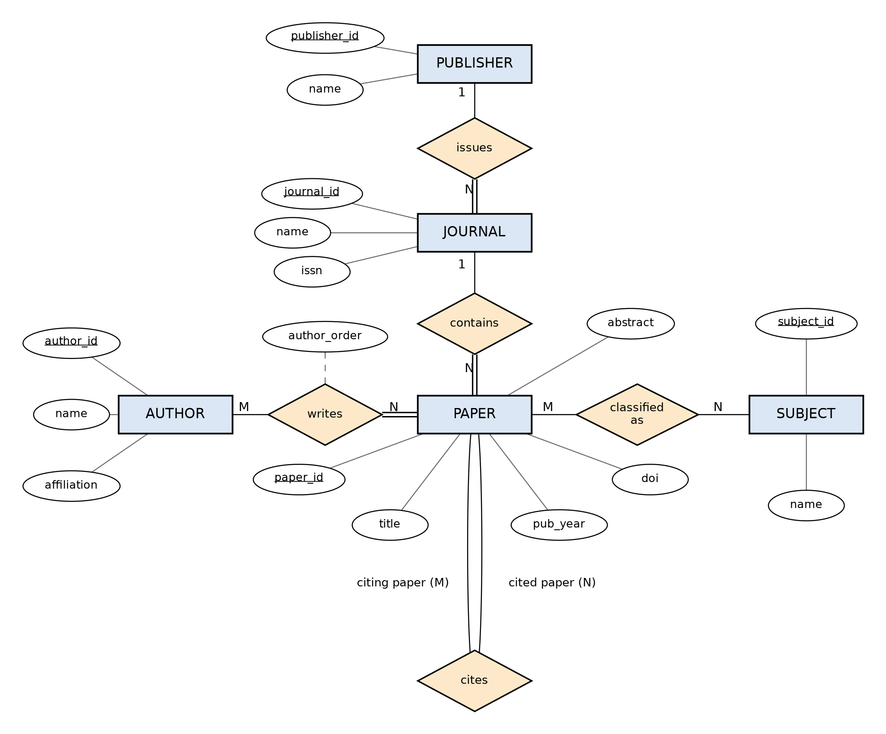
Figure 3.1 Conceptual ER diagram. Rectangle = entity, diamond = relationship, ellipse = attribute (underlined = primary key), dashed link = attribute of a relationship, double line = total (mandatory) participation, 1 / M / N = cardinality.
How to read Figure 3.1: a double line from PAPER to writes means every paper has at least one author; a double line from JOURNAL to issues means every journal has a publisher; a double line from PAPER to contains means every paper has a journal. Single lines mean participation is optional. cites is a recursive relationship: PAPER plays two roles, the citing paper and the cited paper.

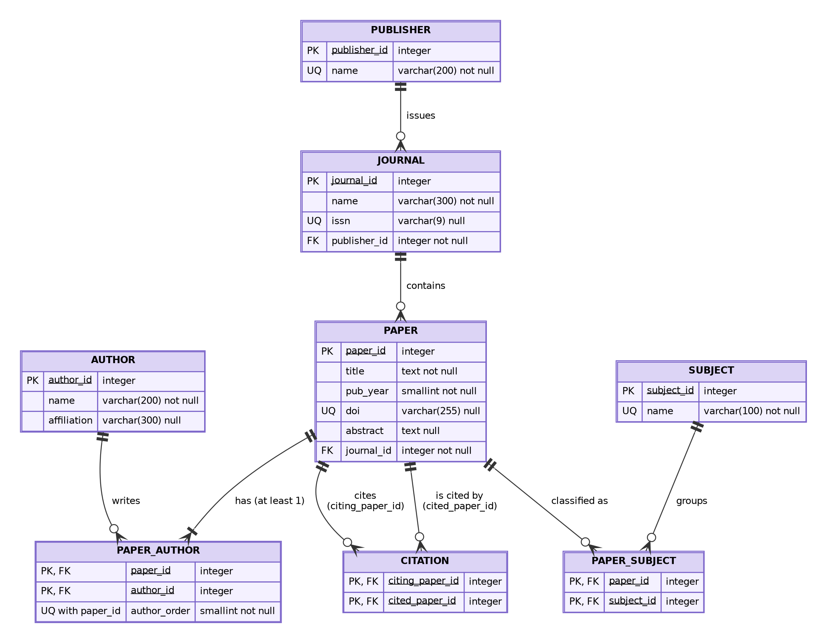
Figure 3.2 Logical model (crow's-foot notation). PK = primary key, FK = foreign key, UQ = unique. A double bar marks the "exactly one" side; a circle with a crow's foot marks "zero or many"; a bar with a crow's foot marks "one or many".
The two figures describe the same design. Each M:N relationship of Figure 3.1 becomes a bridge table in Figure 3.2: writes becomes PAPER_AUTHOR, classified_as becomes PAPER_SUBJECT, and the recursive cites becomes CITATION with two foreign keys to PAPER. Each 1:N relationship becomes a foreign key on the "many" side. The "at least one" mark on the PAPER to PAPER_AUTHOR link is the one rule that no declarative constraint can express; it is enforced by the deferred trigger described in BR3.

3.3 Relational Schema
The conceptual model maps to eight relations by three rules. (1) Each entity becomes a table whose primary key is its identifier. (2) For each 1:N relationship, the key of the "one" side is added to the "many" side as a foreign key declared NOT NULL where participation is total, which is what enforces "exactly one". (3) Each M:N relationship becomes a bridge table whose primary key is the combination of the two foreign keys; a relationship attribute (author_order) is stored in the bridge table. Five entities plus three bridge tables give eight relations. The types below are the PostgreSQL types used in 01_schema.sql; keys are generated with GENERATED BY DEFAULT AS IDENTITY.

PUBLISHER
Attribute | PostgreSQL type | Key | Constraints / references
publisher_id | integer | PK | Identity column.
name | varchar(200) | UQ | NOT NULL, UNIQUE.

JOURNAL
Attribute | PostgreSQL type | Key | Constraints / references
journal_id | integer | PK | Identity column.
name | varchar(300) |  | NOT NULL.
issn | varchar(9) | UQ | Nullable; UNIQUE; CHECK format NNNN-NNNN (last character may be X).
publisher_id | integer | FK | References PUBLISHER(publisher_id); NOT NULL; ON DELETE RESTRICT.

PAPER
Attribute | PostgreSQL type | Key | Constraints / references
paper_id | integer | PK | Identity column.
title | text |  | NOT NULL. Trigram GIN index for fuzzy search.
pub_year | smallint |  | NOT NULL; CHECK between 1900 and 2100.
doi | varchar(255) | UQ | Nullable; UNIQUE; CHECK pattern 10.<digits>/<suffix>.
abstract | text |  | Nullable.
journal_id | integer | FK | References JOURNAL(journal_id); NOT NULL; ON DELETE RESTRICT.

AUTHOR
Attribute | PostgreSQL type | Key | Constraints / references
author_id | integer | PK | Identity column.
name | varchar(200) |  | NOT NULL. Not unique: different people share names.
affiliation | varchar(300) |  | Nullable.

SUBJECT
Attribute | PostgreSQL type | Key | Constraints / references
subject_id | integer | PK | Identity column.
name | varchar(100) | UQ | NOT NULL, UNIQUE.

PAPER_AUTHOR
Attribute | PostgreSQL type | Key | Constraints / references
paper_id | integer | PK, FK | References PAPER(paper_id); ON DELETE CASCADE.
author_id | integer | PK, FK | References AUTHOR(author_id); ON DELETE RESTRICT.
author_order | smallint |  | NOT NULL; CHECK (author_order >= 1); UNIQUE (paper_id, author_order).
{paper_id, author_id} is the primary key. This bridge table exists because writes is many-to-many: neither PAPER nor AUTHOR can hold the mapping on its own. author_order describes the pairing itself (an author's position on one particular paper), so it belongs here. Because no two authors can share a position on the same paper, {paper_id, author_order} is a second candidate key (see 3.4).

PAPER_SUBJECT
Attribute | PostgreSQL type | Key | Constraints / references
paper_id | integer | PK, FK | References PAPER(paper_id); ON DELETE CASCADE.
subject_id | integer | PK, FK | References SUBJECT(subject_id); ON DELETE CASCADE.

CITATION
Attribute | PostgreSQL type | Key | Constraints / references
citing_paper_id | integer | PK, FK | References PAPER(paper_id); ON DELETE CASCADE.
cited_paper_id | integer | PK, FK | References PAPER(paper_id); ON DELETE CASCADE; CHECK (citing_paper_id <> cited_paper_id).
Both columns reference PAPER, which makes CITATION a self-referencing structure. A row (a, b) records that paper a cites paper b. This table is what the recursive queries traverse; the counts and rankings come from ordinary aggregation over it. The year rule (BR5) is enforced by triggers because a CHECK constraint cannot look at another table.

Referential actions
Parent | Child (foreign key) | On delete of parent
PUBLISHER | JOURNAL.publisher_id | RESTRICT
JOURNAL | PAPER.journal_id | RESTRICT
AUTHOR | PAPER_AUTHOR.author_id | RESTRICT
PAPER | PAPER_AUTHOR.paper_id, PAPER_SUBJECT.paper_id, CITATION.citing_paper_id, CITATION.cited_paper_id | CASCADE
SUBJECT | PAPER_SUBJECT.subject_id | CASCADE

3.4 Normalization and Functional Dependency Analysis

3.4.1 Semantic assumptions
Functional dependencies come from what the data means, not from how the tables happen to look. The dependencies in this section rest on the following facts about the domain, all of which are also enforced in the schema.
No. | Assumption
A1 | Paper titles are not unique (two papers can share a title), so title determines nothing.
A2 | Person names are not unique (two authors can share a name), so AUTHOR.name determines nothing. For the same reason name does not determine affiliation.
A3 | A DOI identifies at most one paper. The column is nullable, so this holds for papers that have a DOI (SQL UNIQUE allows several NULLs). paper_id remains the primary key.
A4 | An ISSN identifies at most one journal (nullable in the same way).
A5 | Publisher names are unique; subject names are unique.
A6 | On one paper, no two authors hold the same position, and one author appears at most once.
A7 | A paper is published in one journal; a journal has one publisher (BR1, BR2).

3.4.2 Functional dependencies
Relation | Functional dependencies
PUBLISHER | publisher_id → name; name → publisher_id (A5)
JOURNAL | journal_id → name, issn, publisher_id; issn → journal_id (A4)
PAPER | paper_id → title, pub_year, doi, abstract, journal_id; doi → paper_id (A3)
AUTHOR | author_id → name, affiliation
SUBJECT | subject_id → name; name → subject_id (A5)
PAPER_AUTHOR | {paper_id, author_id} → author_order; {paper_id, author_order} → author_id (A6)
PAPER_SUBJECT | No non-trivial dependency (all-key relation).
CITATION | No non-trivial dependency (all-key relation).

A dependency such as title → pub_year does not hold (A1), and name → affiliation does not hold in AUTHOR (A2). Updating a journal's ISSN or a publisher's name touches exactly one row, because the descriptive attributes of each entity are stored once, in the entity's own table.

3.4.3 Candidate keys by attribute closure
K+ denotes the closure of K under the dependencies of 3.4.2. A set is a candidate key when its closure is the whole relation and no proper subset has this property.
PUBLISHER R = {publisher_id, name}
{publisher_id}+ = {publisher_id, name} = R -> key
{name}+ = {name, publisher_id} = R -> key
Candidate keys: {publisher_id}, {name}. Both attributes are prime.

JOURNAL R = {journal_id, name, issn, publisher_id}
{journal_id}+ = R -> key
{issn}+ = {issn, journal_id, name, publisher_id} = R -> key
{name}+ = {name}; {publisher_id}+ = {publisher_id} -> not keys
(journal names can repeat, and a publisher has many journals)
Candidate keys: {journal_id}, {issn}.
Prime: journal_id, issn. Non-prime: name, publisher_id.

PAPER R = {paper_id, title, pub_year, doi, abstract, journal_id}
{paper_id}+ = R -> key
{doi}+ = R (doi -> paper_id, then paper_id -> all) -> key
{title}+ = {title}; {journal_id}+ = {journal_id} -> not keys (A1, A7)
Candidate keys: {paper_id}, {doi}.
Prime: paper_id, doi. Non-prime: title, pub_year, abstract, journal_id.

AUTHOR R = {author_id, name, affiliation}
{author_id}+ = R -> key
{name}+ = {name}; {affiliation}+ = {affiliation} -> not keys (A2)
Candidate key: {author_id} only. Non-prime: name, affiliation.

SUBJECT R = {subject_id, name}
{subject_id}+ = {subject_id, name} = R -> key
{name}+ = {name, subject_id} = R -> key
Candidate keys: {subject_id}, {name}.

PAPER_AUTHOR R = {paper_id, author_id, author_order}
{paper_id}+ = {paper_id}; {author_id}+ = {author_id}
{author_order}+ = {author_order}; {author_id, author_order}+ = itself
(no dependency can fire without paper_id)
{paper_id, author_id}+ = {paper_id, author_id, author_order} = R -> key
{paper_id, author_order}+ = {paper_id, author_order, author_id} = R -> key
Candidate keys: {paper_id, author_id}, {paper_id, author_order}.
Every attribute is prime.

PAPER_SUBJECT R = {paper_id, subject_id}
{paper_id}+ = {paper_id}; {subject_id}+ = {subject_id}
{paper_id, subject_id}+ = R -> key
Candidate key: {paper_id, subject_id}.

CITATION R = {citing_paper_id, cited_paper_id}
{citing_paper_id}+ = {citing_paper_id}; {cited_paper_id}+ = {cited_paper_id}
Both together = R -> key
Candidate key: {citing_paper_id, cited_paper_id}.

The primary key of each relation is chosen from its candidate keys: the surrogate identifier for the five entities, and the composite foreign-key pair for the bridge tables. The remaining candidate keys (name, issn, doi, {paper_id, author_order}) are enforced by UNIQUE constraints.

3.4.4 Normal forms applied
- 1NF: every attribute is atomic and single-valued, and there are no repeating groups.
- 2NF: the relation is in 1NF and no non-prime attribute depends on a proper subset of a candidate key.
- 3NF: the relation is in 2NF and, for every non-trivial dependency X → A, either X is a superkey or A is prime.
- BCNF: for every non-trivial dependency X → Y, X is a superkey.

3.4.5 Verification for each relation
Relation | 1NF | 2NF | 3NF | BCNF | Reason
PUBLISHER | Yes | Yes | Yes | Yes | Both determinants (publisher_id, name) are candidate keys. All attributes are prime.
JOURNAL | Yes | Yes | Yes | Yes | Determinants journal_id and issn are candidate keys. Both candidate keys are single attributes, so no partial dependency is possible. publisher_id → name does not appear here because the publisher's name is stored only in PUBLISHER.
PAPER | Yes | Yes | Yes | Yes | Determinants paper_id and doi are candidate keys. No dependency exists among title, pub_year, abstract and journal_id (A1). The journal's attributes are stored only in JOURNAL, so there is no transitive dependency paper_id → journal_id → name.
AUTHOR | Yes | Yes | Yes | Yes | The only determinant is author_id, the key. name does not determine affiliation (A2).
SUBJECT | Yes | Yes | Yes | Yes | Determinants subject_id and name are candidate keys.
PAPER_AUTHOR | Yes | Yes | Yes | Yes | Two overlapping candidate keys; every attribute is prime, so 2NF and 3NF hold trivially. Both determinants of 3.4.2 are candidate keys, so BCNF holds as well. author_order depends on the whole of either key, not on paper_id or author_id alone.
PAPER_SUBJECT | Yes | Yes | Yes | Yes | All-key relation; only trivial dependencies.
CITATION | Yes | Yes | Yes | Yes | All-key relation; only trivial dependencies.

Why PAPER_AUTHOR needs the closer look. It is the one relation with two overlapping candidate keys. That is the situation in which a relation can satisfy 3NF and still fail BCNF, because 3NF allows a dependency whose right-hand side is prime. Here it does not fail: the second dependency, {paper_id, author_order} → author_id, has a candidate key on its left-hand side. Without the second key the schema would still be in BCNF; with it, the schema is in BCNF and the position rule (A6) is guaranteed by the database.
Conclusion. All eight relations are in BCNF with respect to the dependencies of 3.4.2. Adding or removing the alternate candidate keys does not change this, since any additional determinant is itself a key.

3.4.6 Derivation from an unnormalized relation
The final schema can be derived step by step from a single flat relation. Starting point (repeating groups in braces):
PAPER_FLAT(paper_id, title, pub_year, doi, abstract,
journal_id, journal_name, issn, publisher_id, publisher_name,
{ author_id, author_name, affiliation, author_order },
{ subject_id, subject_name }, { cited_paper_id })

Anomalies of the flat relation. (i) Update: the publisher name is repeated in every row of every paper of its journals, so renaming a publisher means changing many rows and missing one leaves the data inconsistent. (ii) Insertion: a new journal, publisher, author or subject cannot be recorded until a paper exists for it. (iii) Deletion: deleting the only paper of a journal also deletes the journal and its publisher. (iv) The braces violate 1NF.
Step | Action and result
1NF | Move each repeating group into its own relation keyed by paper_id:  PAPER1(paper_id, title, pub_year, doi, abstract, journal_id, journal_name, issn, publisher_id, publisher_name)  AUTHORSHIP1(paper_id, author_id, author_name, affiliation, author_order)  CLASSIFICATION1(paper_id, subject_id, subject_name)  CITATION(citing_paper_id, cited_paper_id)
2NF | In AUTHORSHIP1 (key {paper_id, author_id}) the dependency author_id → author_name, affiliation is a partial dependency. In CLASSIFICATION1 (key {paper_id, subject_id}), subject_id → subject_name is partial. Extract:  AUTHOR(author_id, name, affiliation); PAPER_AUTHOR(paper_id, author_id, author_order)  SUBJECT(subject_id, name); PAPER_SUBJECT(paper_id, subject_id)
3NF | In PAPER1, paper_id → journal_id → journal_name, issn, publisher_id is a transitive dependency. Extract JOURNAL(journal_id, name, issn, publisher_id) and keep journal_id in PAPER.  In JOURNAL, journal_id → publisher_id → publisher_name is again transitive. Extract PUBLISHER(publisher_id, name) and keep publisher_id in JOURNAL.
BCNF | Check every determinant of 3.4.2 against the candidate keys of 3.4.3 (table in 3.4.5). All are keys, so no further decomposition is needed. The result is exactly the eight relations of 3.3.

3.4.7 Lossless join and dependency preservation
Lossless join. Every step above has the form: for a relation R(A, B, C) with the dependency A → B, replace R by (A, B) and (A, C). The common attribute A is a key of the first relation, so by Heath's theorem the natural join of the two parts returns exactly R, with no spurious tuples. In the final schema the joins run along the foreign keys (for example journal_id and publisher_id), and query Q1 and Q2 of 03_queries.sql rebuild the paper–journal–publisher and paper–authors views of the original flat relation.
Dependency preservation. Every dependency of 3.4.2 has all of its attributes inside a single final relation, so each one is enforced by a key or UNIQUE constraint on that relation and no cross-table check is needed. Dependencies that span the original flat relation, such as paper_id → publisher_name, are consequences of the preserved ones (paper_id → journal_id, journal_id → publisher_id, publisher_id → name) and need no separate enforcement.

3.4.8 Further remarks
- Why PAPER_AUTHOR and PAPER_SUBJECT are separate tables. Authors and subjects of a paper are independent facts. If they were combined in one relation (paper_id, author_id, subject_id), the multivalued dependencies paper_id →→ author_id and paper_id →→ subject_id would force every author to be paired with every subject of the paper, which is a 4NF violation and a source of redundancy. Separate bridge tables avoid it.
- Why citation counts are not stored. A citation_count column in PAPER would not violate BCNF, but it would be derived data that duplicates the rows of CITATION and must be kept in step with them. Computing it by COUNT(*) ... GROUP BY cited_paper_id keeps a single source of truth (BR9).

3.5 Implementation and verification
The schema is implemented in PostgreSQL by five SQL scripts, run in the order shown.
Script | Content
01_schema.sql | Creates the eight tables with all constraints of 3.3, the three business-rule triggers (BR3, BR5), the foreign-key indexes and the pg_trgm GIN index on paper.title.
02_seed.sql | Sample data: 6 publishers, 8 journals, 11 authors, 9 subjects, 24 papers, 50 authorships, 43 classifications and 45 citations. It includes the optional cases of the model: a publisher with no journal, a journal with no paper, an author with no paper, a subject with no paper, and a paper with no subject.
03_queries.sql | 21 queries: joins, GROUP BY and HAVING, subqueries, NOT EXISTS, a window-function ranking, recursive citation chains with a cycle guard, and fuzzy title search with pg_trgm.
04_constraint_tests.sql | 39 tests that try to violate each business rule and each referential action. The expected result is 39 passed, 0 failed. All test changes are rolled back.
05_trigram_demo.sql | Loads 200,000 generated papers and compares the EXPLAIN ANALYZE plan of a fuzzy title search without and with the trigram index (sequential scan versus bitmap index scan).

The web interface described in the UI Design Document is a separate static front end. It does not connect to the database at run time; its sample data follows the structure of this schema.

