23CSE202 DATABASE MANAGEMENT SYSTEMS
S3 B.Tech CSE
Department of Computer Science and Engineering
Amrita School of Computing, Amritapuri Campus
2. UI Design Document
Group No : A2
Team Members :
Roll No | Student Name
AM.SC.U4CSE25003 | Aadi Dahiya
AM.SC.U4CSE25011 | Adish Koshy Kiron
AM.SC.U4CSE25028 | Bal Govind B
AM.SC.U4CSE25068 | A S Varun

Project Title : Academic Research Metadata Repository: A Relational Database System

2.1. Functional requirements
- FR1 Browse. Browse and explore papers, authors, journals, publishers and research areas (subjects). A paper page shows its journal, publisher, year, DOI, authors in order and subjects.
- FR2 Search and filter. Search research records by paper title, author, journal or subject, tolerating small typing mistakes, and filter the paper list by subject.
- FR3 Citations and statistics. View citation information: the most cited papers, what each paper cites and which papers cite it, the chain of papers reached by following citations, citations by subject, and papers per journal.
How each requirement is met. Every interface feature corresponds to a query of the database project (db/03_queries.sql). The table shows which one.
Interface feature | Page | Database query it mirrors
Papers of a subject (filter) | Papers | Q4: papers joined to paper_subject for one subject
Papers of an author / journal | Authors, Journals | Q3 (author search), Q5 (papers per journal)
Journals and papers of a publisher | Publishers | Q7: publisher, journal and paper with LEFT JOINs
Citation count of a paper | Every paper card | Q8: COUNT of citation rows per cited paper (never stored)
Top-ten ranking, ties share a rank | Citations | Q9: window function RANK()
Citations by subject | Statistics | Q10: citations received per subject
Papers per journal | Statistics | Q5: LEFT JOIN with GROUP BY
Cites / cited by | Paper detail | Q15: direct citations in both directions
Citation chain with steps | Paper detail | Q16: recursive query over citation
Typo-tolerant search | Search box | Q18 / Q19: pg_trgm trigram similarity (imitated in the browser)

Scope of this prototype. The interface is a static front end hosted on GitHub Pages. Its data file, src/data/repository.json, is generated from the PostgreSQL database by scripts/export-ui-data.sh, so it contains exactly the rows of the database. The numbers on screen (citation counts, rankings, per-subject totals, citation chains) are computed from those rows with the same logic as the SQL queries above. The interface does not open a connection to PostgreSQL at run time; the database itself is demonstrated through the SQL scripts in the db folder. The typo-tolerant search imitates pg_trgm in the browser with its own similarity threshold, so scores can differ slightly from the SQL; for the example query "reproducable" the interface and PostgreSQL (query Q19b) return the same two papers.

2.2. Non functional requirements
- Usability: a clean, intuitive layout for students and researchers; one navigation bar with a search box on every page; every paper title links to its detail page.
- Responsiveness: the layout adapts to desktop and smaller screens. Cards flow from several columns to one, the search box takes the full width on narrow screens, and the navigation bar scrolls horizontally.
- Maintainability: pages, shared components, the data layer (repository.ts) and the utilities are in separate files. Replacing the JSON file with an API call would only change the data layer.
- Data consistency: the interface never stores a derived value. Citation counts and rankings are recomputed from the citation rows, as the database design requires.
- Compatibility and deployment: runs in modern web browsers and deploys to GitHub Pages with hash-based URLs (for example #/papers/1), so direct links work without server configuration.

2.3. List of AI tools used for building UI
Sl. No | Tool | Use
1 | Claude / Claude Code | Frontend polishing of the original interface and README.
2 | Claude | Audit of the original documents; design and review of the PostgreSQL schema, sample data, 21 queries and 39 constraint tests; revision of the interface (paper detail page, publishers page, several subjects per paper, citation chain, typo-tolerant search, removal of unused files) to use data exported from the database; drafting of the Word documents. All SQL was run and checked by a team member on PostgreSQL 18.6; the results are shown in the Database Design document.

2.4. List of files
Main files in the GitHub repository:
File | Purpose
index.html | Page shell and title.
src/main.tsx | Starts React and the hash router.
src/App.tsx | Page layout (header, search box, navigation, footer) and the route table.
src/pages/Overview.tsx | Home page: six totals and the latest publications.
src/pages/Papers.tsx | Paper list with the subject filter.
src/pages/PaperDetail.tsx | One paper: metadata, authors in order, cites, cited by, citation chain.
src/pages/Directories.tsx | Authors, journals, publishers and subjects directories.
src/pages/SearchPage.tsx | Search results.
src/pages/Citations.tsx | Citation explorer: top ten with ranks.
src/pages/Statistics.tsx | Two charts: citations by subject, papers per journal.
src/components/ui.tsx | Shared title, card, paper card and paper list.
src/data/repository.json | Generated from PostgreSQL: the table rows.
src/data/repository.ts | Typed data layer; derived views (counts, rankings, chain).
src/utils/search.ts, trigram.ts, format.ts | Search, trigram similarity, number and plural formatting.
src/index.css | Tailwind entry point and shared styles.
package.json, package-lock.json | Dependencies and scripts.
vite.config.ts, tailwind.config.js, postcss.config.js | Build and style configuration.
tsconfig.json, tsconfig.app.json, tsconfig.node.json | TypeScript configuration.
scripts/export-ui-data.sh, scripts/format-json.mjs | Regenerate repository.json from the database.
db/01_schema.sql ... db/06_export_ui_data.sql | PostgreSQL schema, sample data, queries, tests, index demo, export.
docs/ | Design document and ER diagrams.
README.md | How to run the database and the interface.
.github/workflows/deploy.yml | Builds and publishes the site to GitHub Pages.

2.5. UI Screenshot
Deployed UI: https://balgovindb.github.io/academic-repo/
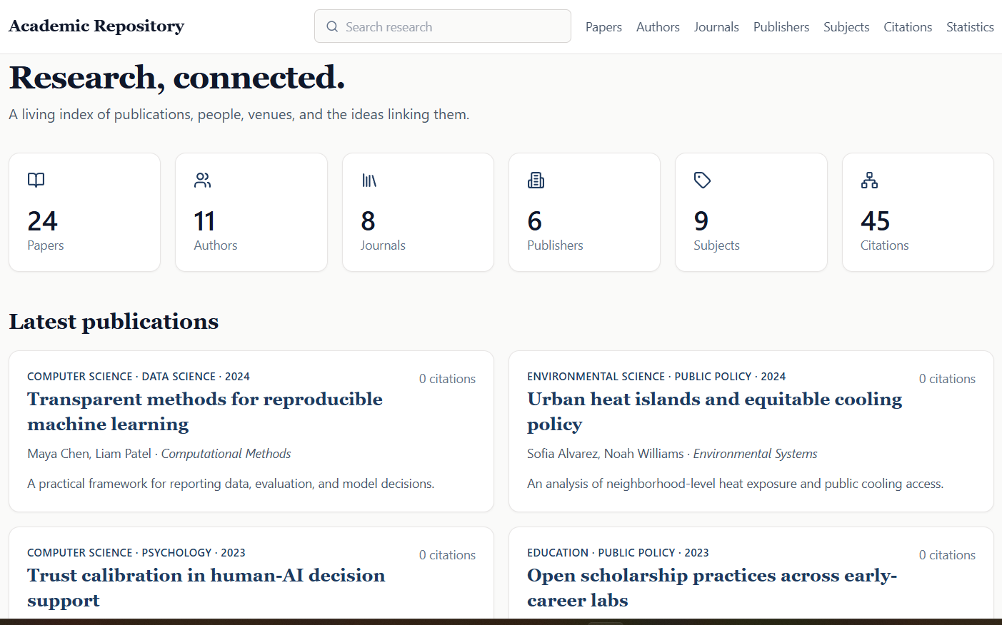
Figure 2.1 Overview page (six totals, latest publications)
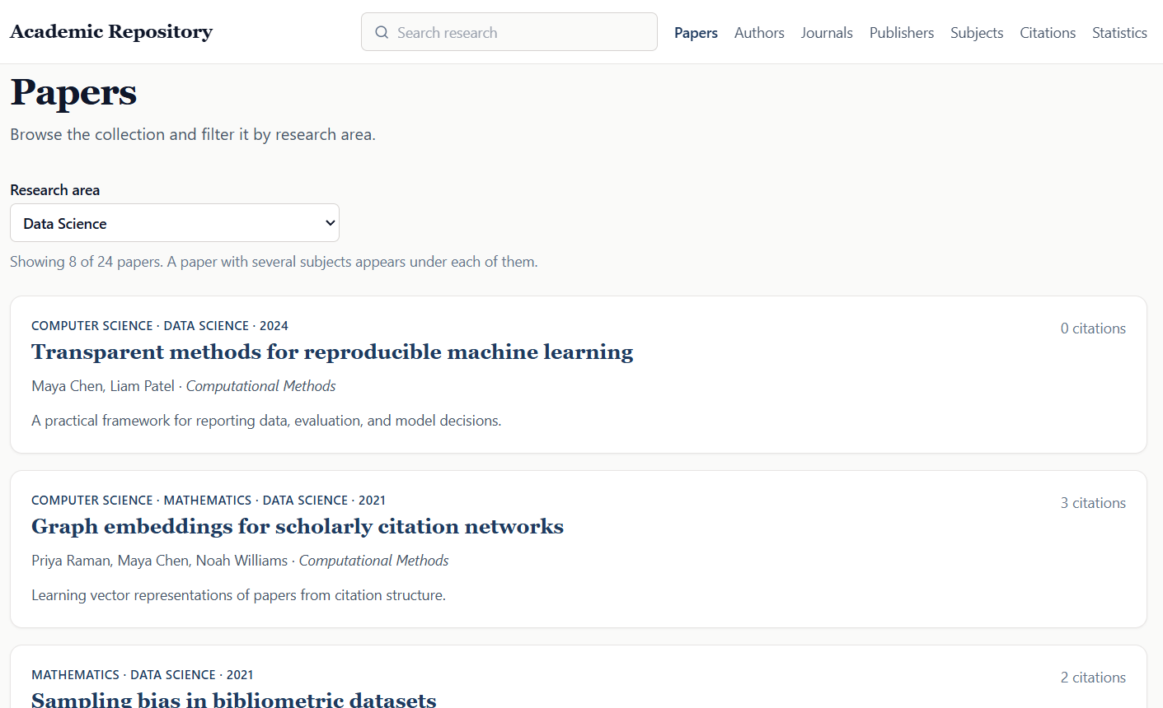
Figure 2.2 Papers page with a subject selected
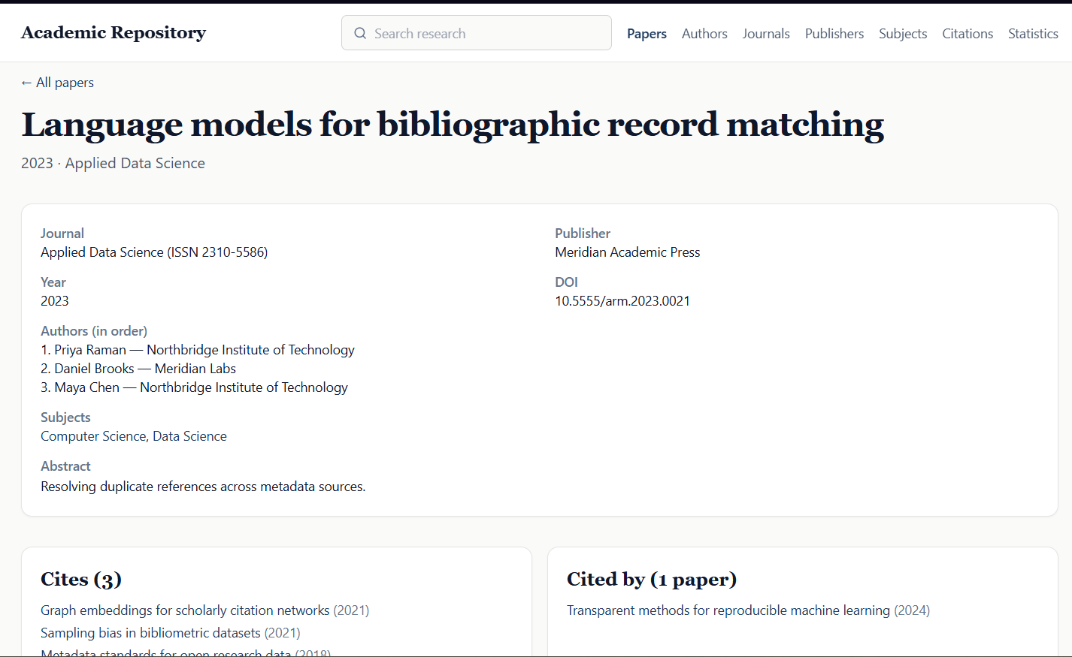
Figure 2.3 Paper detail page showing metadata, authors in order, cites and cited by
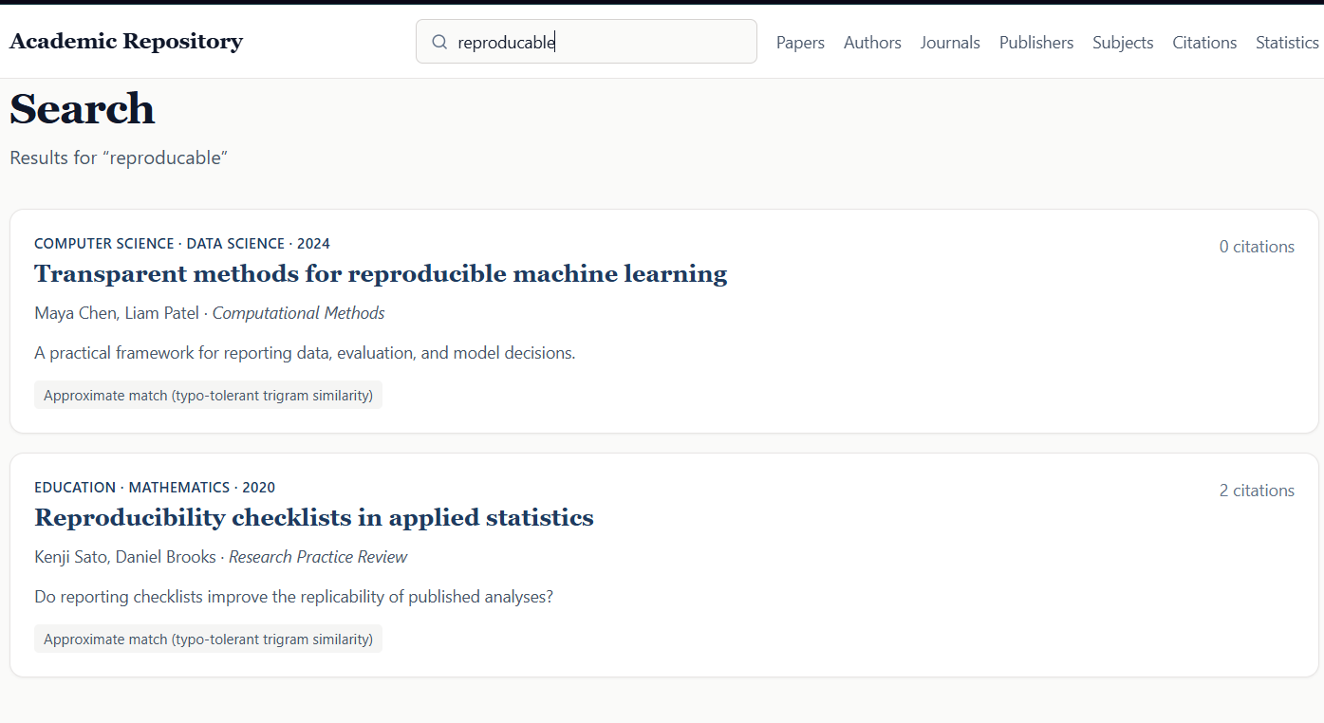
Figure 2.4 Search results for a misspelled query, for example "reproducable", showing the approximate-match note
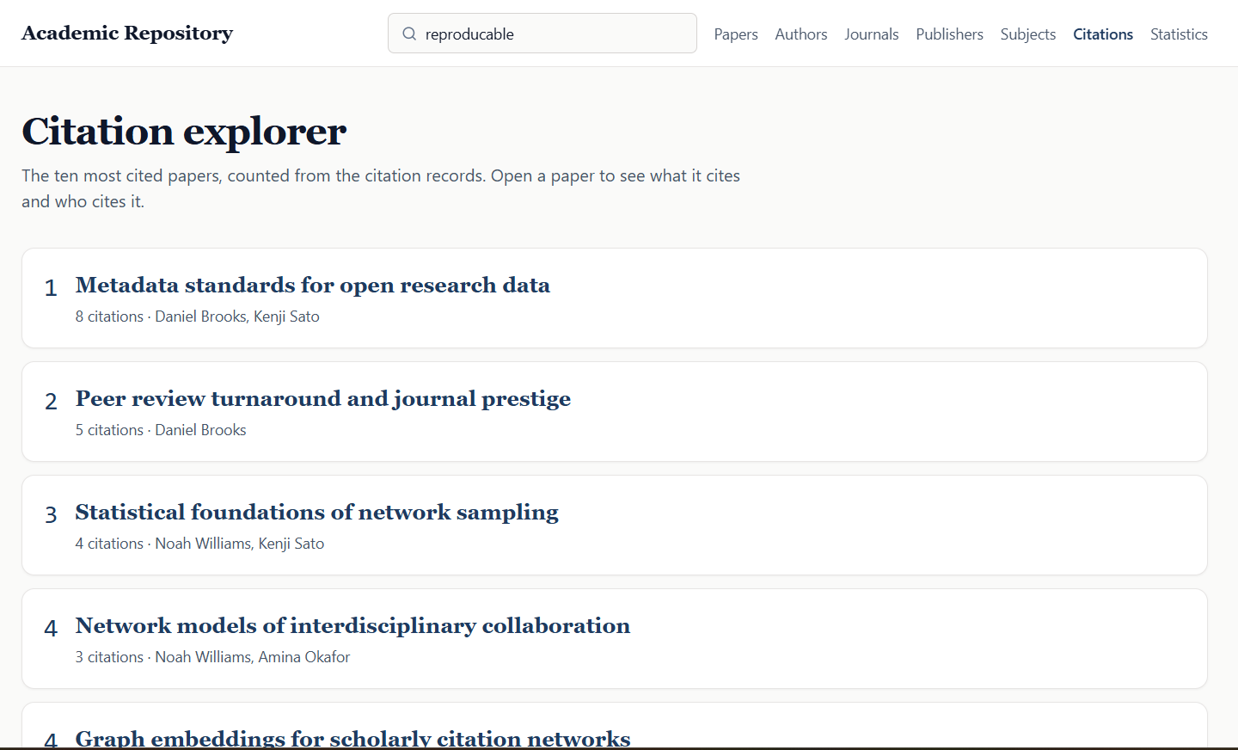
Figure 2.5 Citation explorer (most cited papers with ranks, top of the list)
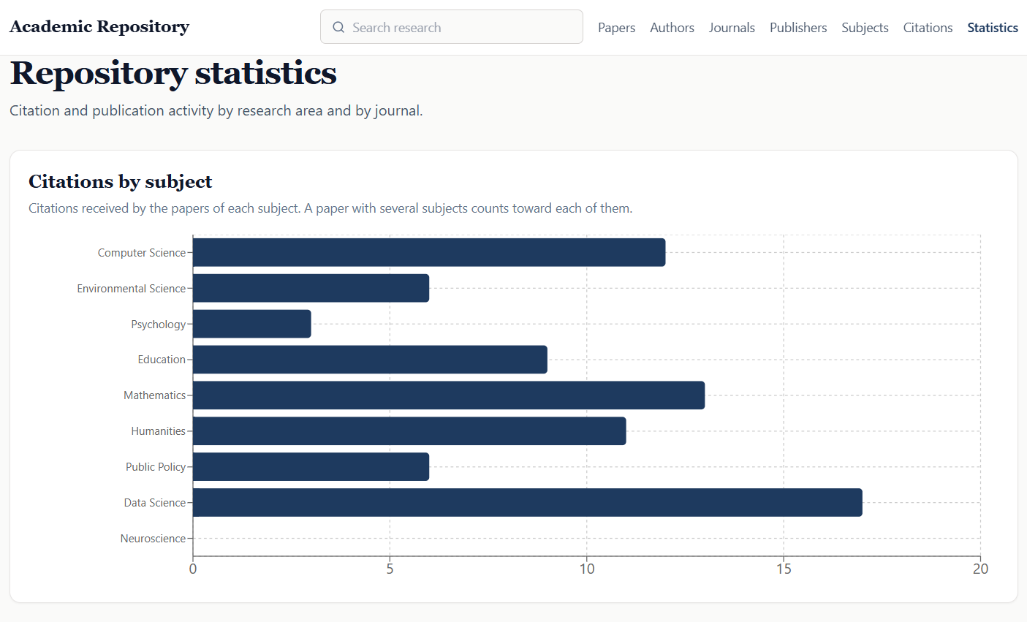
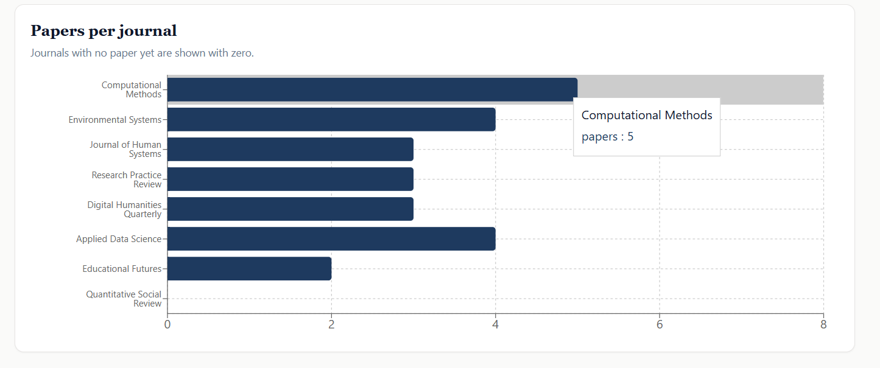
Figure 2.6 Statistics page (both charts)
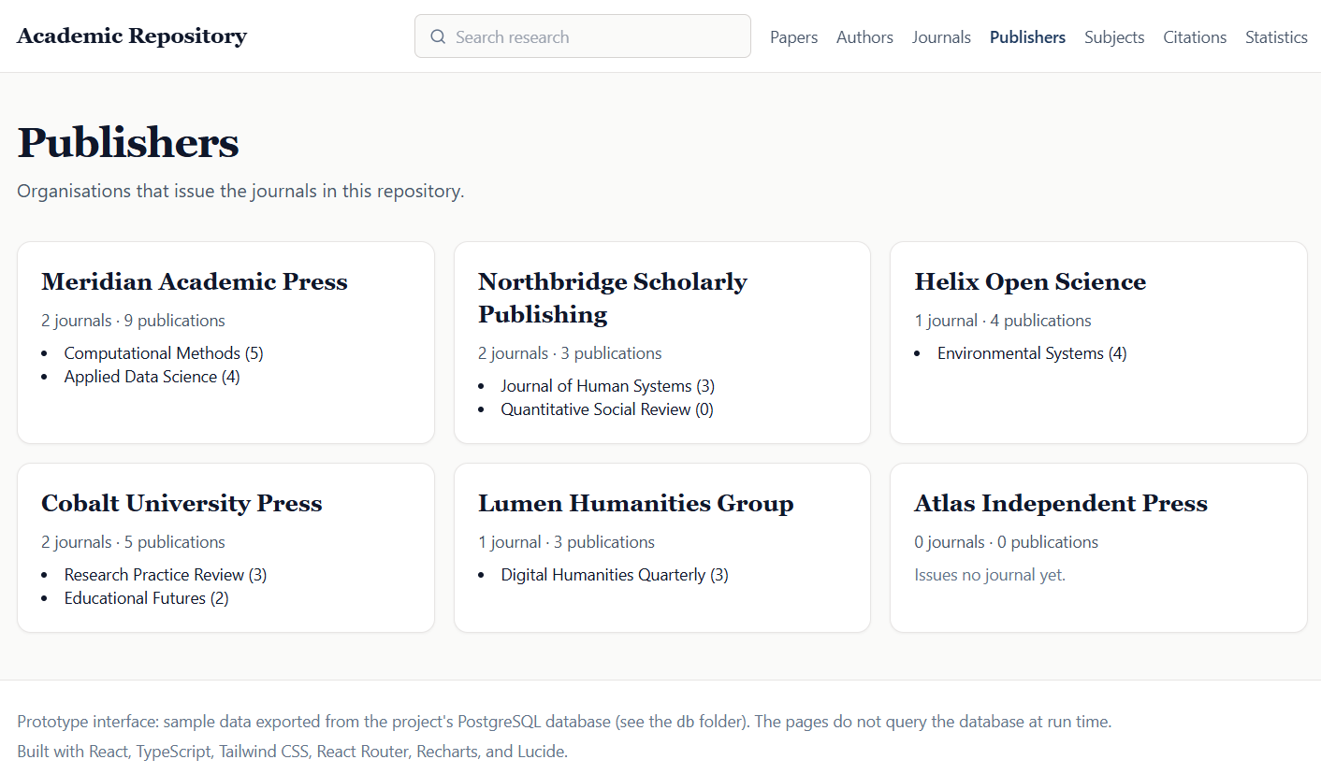
Figure 2.7 Publishers page (including a publisher with no journal)
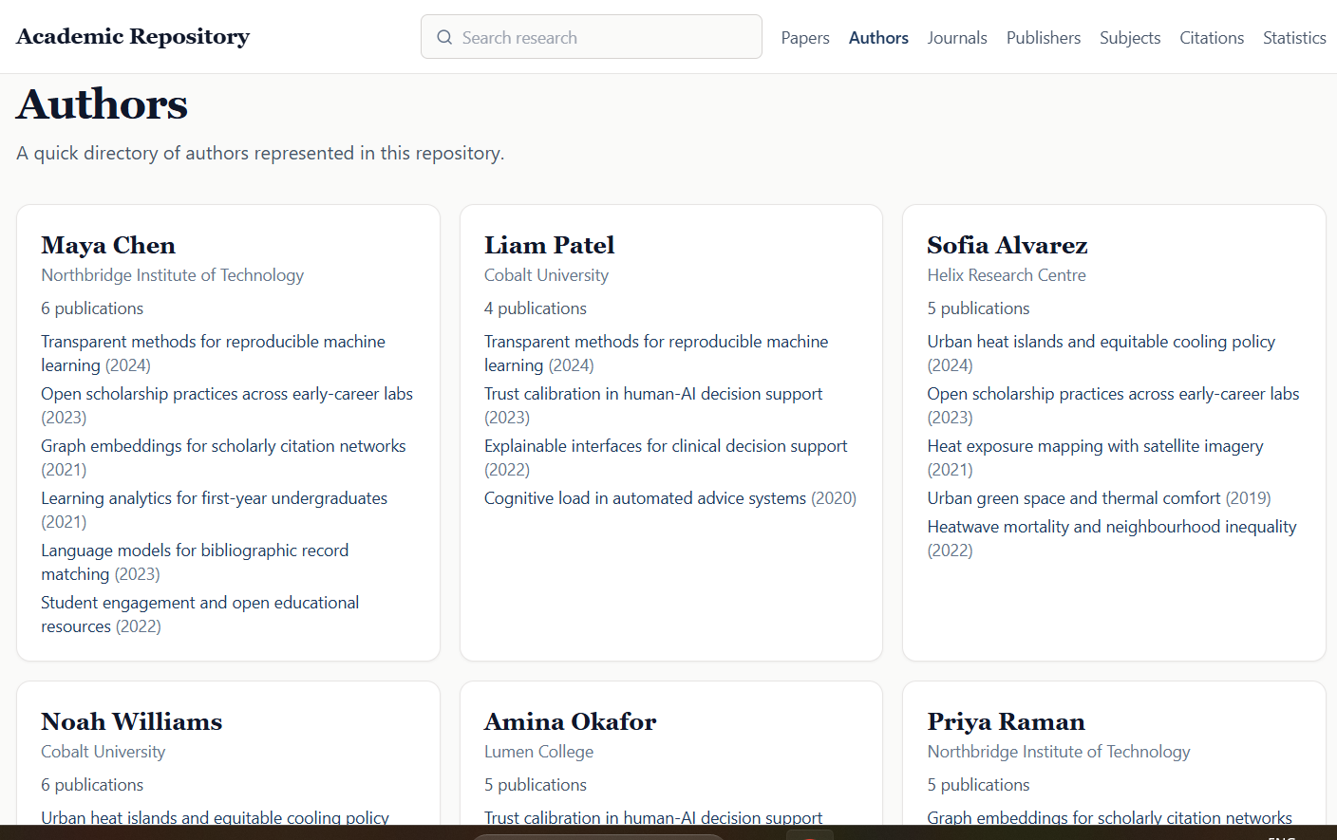
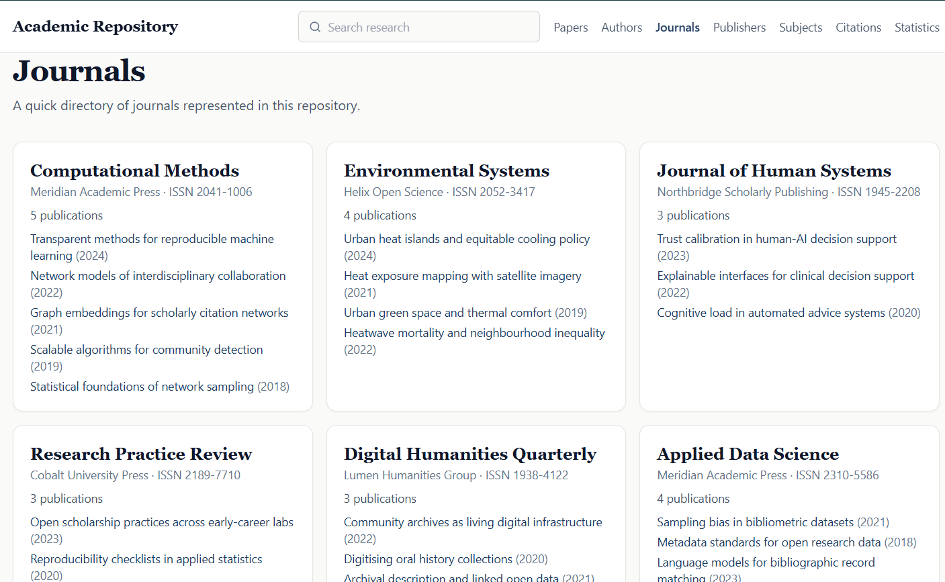
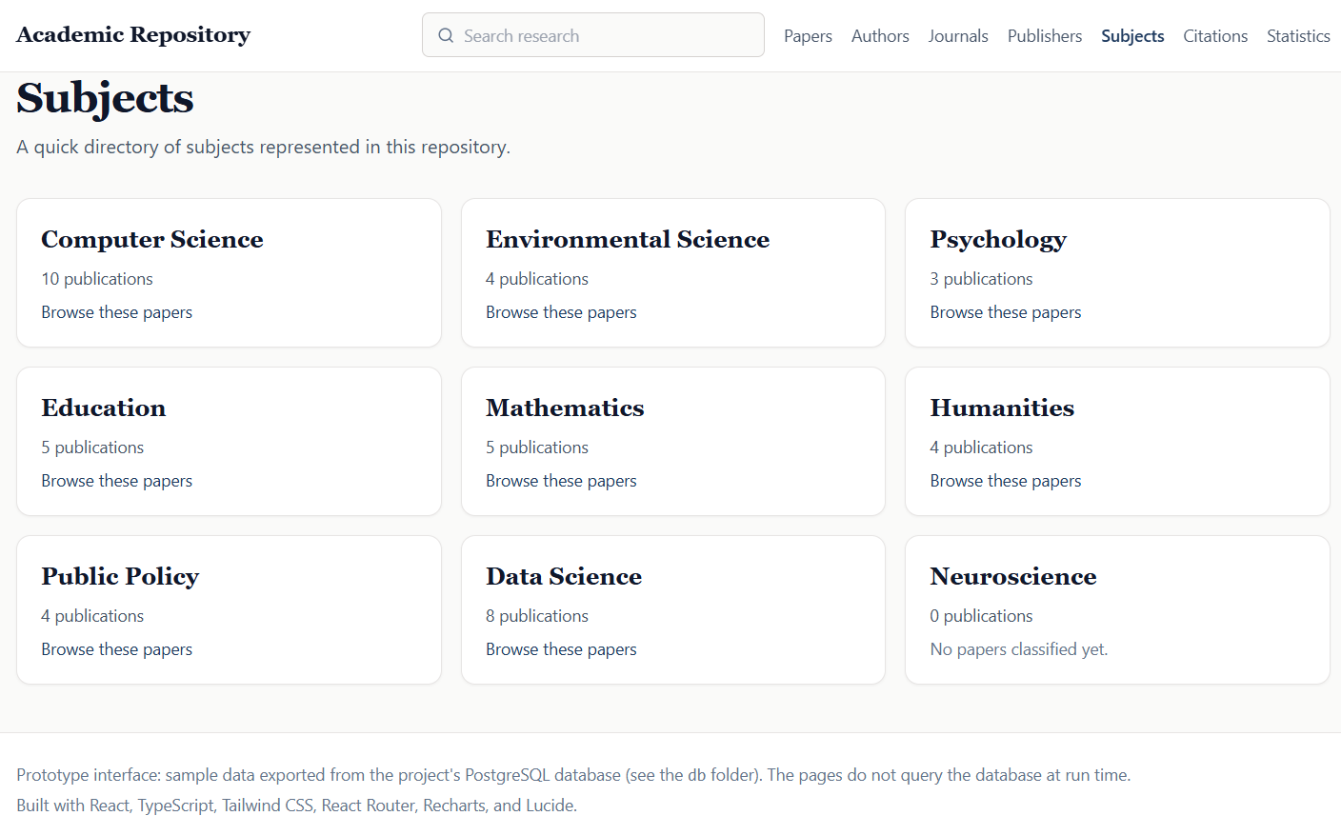
Figure 2.8 Authors, Journals and Subjects pages

2.6. GitHub Link
https://github.com/BalGovindB/academic-repo

