**E-Commerce Application using IBM Cloud Foundry**

**Phase 3**

This e-commerce cloud application is a digital framework accessible via the internet that empowers businesses in the realm of online retail. Its core capabilities encompass the seamless management of product catalogs, secure payment processing, efficient order fulfillment, and customer relationship handling. Capitalizing on cloud technology, these platforms provide an abstract infrastructure that guarantees scalability, reliability, and accessibility. This abstract solution allows businesses to extend their online presence with ease, minimizing the need for traditional on-site infrastructure, thereby offering a convenient and cost-effective approach for businesses venturing into the world of online retail.

**STEP 1 : REGISTRATION IN IBM CLOUD**

**To do any work on the IBM cloud foundry we need to create an account and familiar with the concepts and dashboard in the Foundry.**

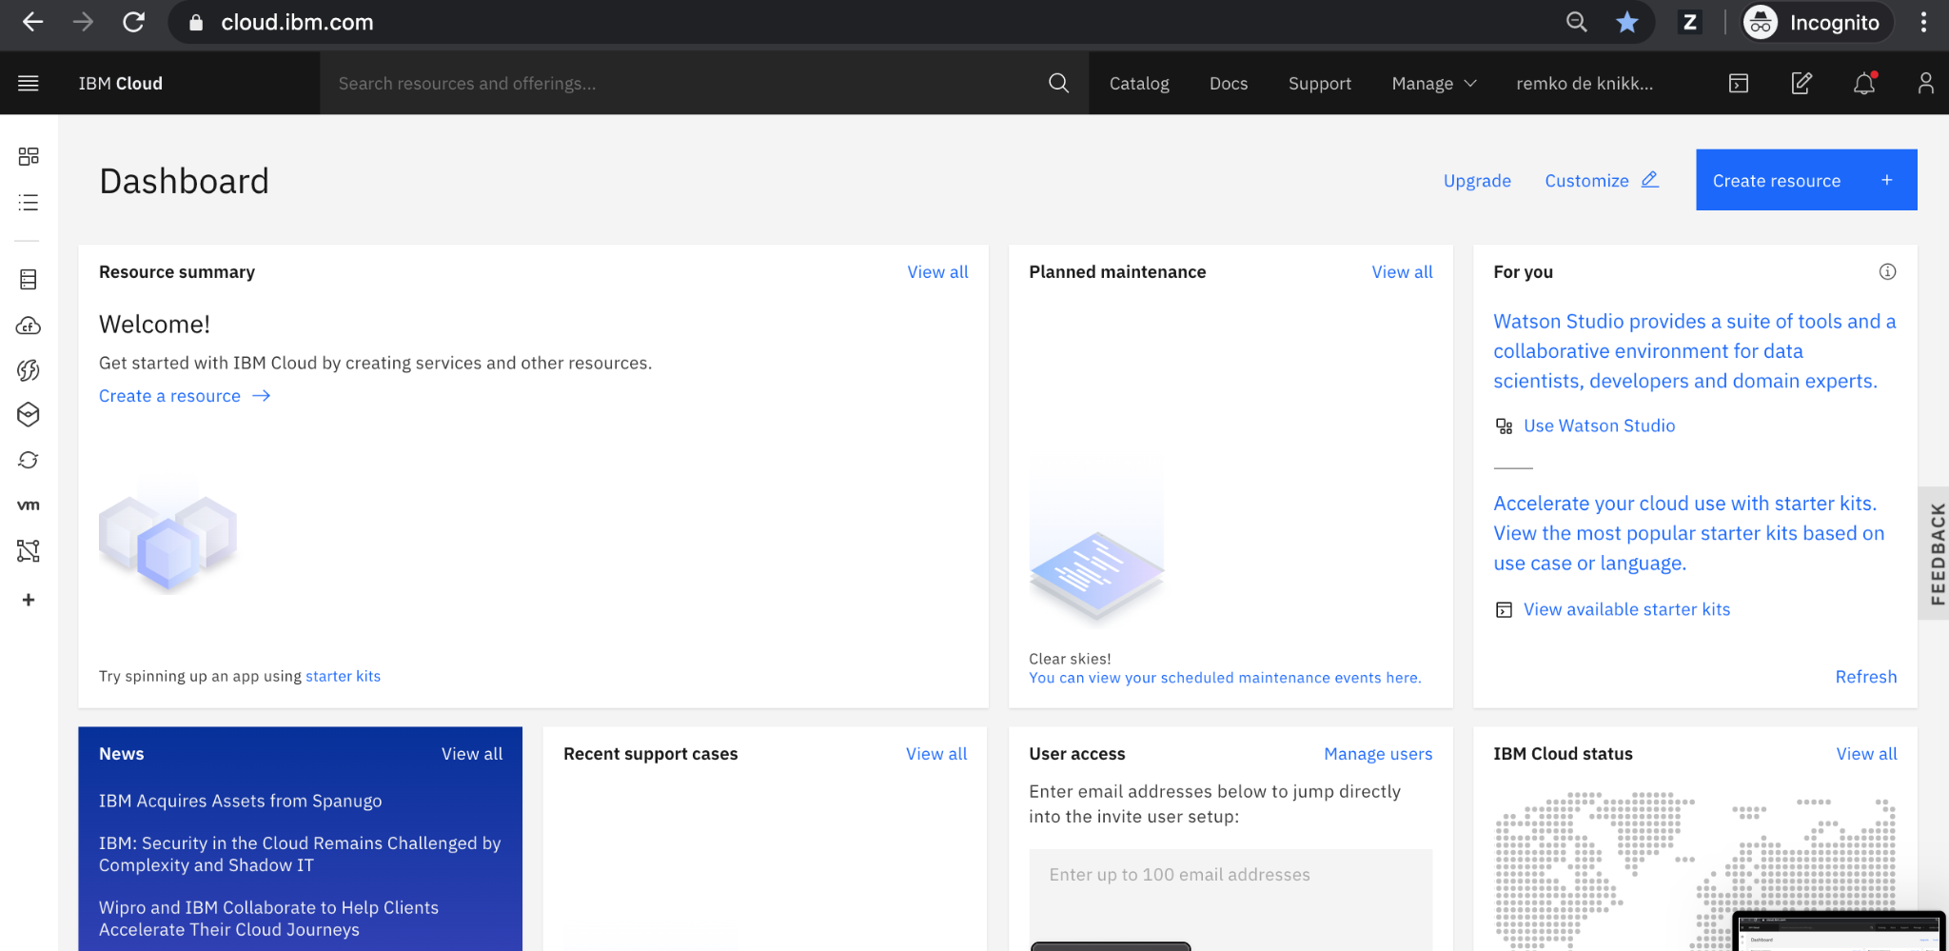

**STEP 2 : USE THE AVAILABLE TOOLS AND CREATE A BUCKET**

There are variety of tools avilable in the IBM vloud foundry like

* IBM Kubernetes Service: If you prefer containerized applications, this managed Kubernetes service can help you orchestrate and manage containers effectively.
* IBM Cloud Databases: For managing your application's data, you can use IBM's managed database services like Db2 on Cloud, which offers reliability and scalability.
* IBM Cloud Object Storage: Store and manage product images, documents, and other media files in a scalable, secure, and cost-effective manner.
* IBM API Connect*: This tool helps you manage and secure the APIs that power your e-commerce application, ensuring they are accessible to authorized users.
* IBM Cloud DevOps Services: Utilize DevOps tools for continuous integration and continuous delivery (CI/CD) pipelines to automate your application deployment and updates.

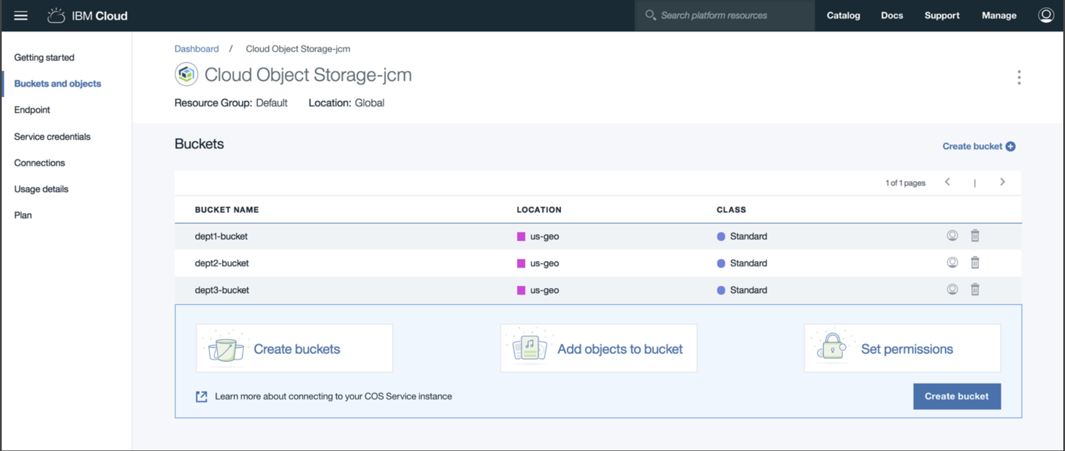

* Create a bucket and start adding objects to it
* **STEP 3 :PLAN THE CONTENT**

Plan to execute the idea of the application you had in mind we provide features like

1 .user profiles

2.personalized recommendations

3.order tracking

4.shopping cart

5.search and filters

**STEP 4 :ADDING CONTENT TO THE BUCKET:**

To add content to a COS bucket, you can use a variety of tools, such as the IBM Cloud CLI, the IBM Cloud Console, or a third-party tool such as Cyberduck.

