ChurnIQ
Customer Churn Analytics & Prediction Dashboard

A Comprehensive Documentation for Project Submission
Domain: Machine Learning | Data Analytics | Business Intelligence
Stack: Python | Streamlit | Scikit-Learn | SQLite | Plotly | XGBoost

ABSTRACT

Customer churn – the voluntary attrition of existing customers from a service subscription – represents one of the most consequential and persistent challenges in contemporary business management. For subscription-based organisations across telecommunications, software-as-a-service, financial services, e-commerce, and insurance sectors, unmanaged churn erodes recurring revenue, inflates customer acquisition costs, and suppresses long-term customer lifetime value. Despite these well-documented financial impacts, many organisations continue to rely on reactive, lagging-indicator approaches to churn management that engage customers only after the decision to leave has already been made. ChurnIQ – Customer Churn Analytics and Prediction Dashboard addresses this critical gap through the development of a comprehensive, production-quality, browser-based data science application that integrates exploratory analytics, interactive business intelligence, and advanced machine learning prediction into a single, accessible platform.
The ChurnIQ system is built on the Python technology stack using Streamlit as the web application framework, Pandas and NumPy for data manipulation and numerical computing, Plotly for interactive data visualisation, Scikit-Learn and XGBoost for machine learning model development, SQLite for user authentication and credential persistence, and Joblib for machine learning model serialisation and deployment. The application is structured into four primary functional modules: a secure user authentication module with SQLite-backed registration and PBKDF2-SHA256 password hashing; a dataset management and exploratory data analysis module presenting twelve interactive Plotly visualisations with contextualised business insights and a dynamic eight-metric KPI dashboard; a machine learning training and evaluation module executing a five-model classification pipeline with comprehensive performance benchmarking; and a real-time prediction module generating individual customer churn probability scores, risk tier classifications, and actionable retention recommendations.
The application processes a customer churn dataset comprising 10,000 records and 32 attributes spanning demographic characteristics, platform engagement metrics, transactional history, customer support interaction records, marketing engagement signals, and satisfaction survey measurements. The machine learning training pipeline applies a Scikit-Learn ColumnTransformer preprocessing architecture incorporating median imputation for numerical features, ordinal encoding for eleven categorical features, and StandardScaler normalisation, followed by stratified 80/20 train-test splitting. Five binary classification models are trained and evaluated: Logistic Regression, Decision Tree, Random Forest, Gradient Boosting, and XGBoost. Each model is evaluated across six performance metrics (accuracy, precision, recall, F1 score, and ROC-AUC) with confusion matrix heatmaps, ROC curve visualisations, and feature importance rankings. The system automatically selects the best-performing model based on ROC-AUC score and persists it for deployment in the prediction module.
Experimental results demonstrate that XGBoost achieves the highest ROC-AUC score of approximately 0.901 on the held-out test set, representing strong discriminative performance on the class-imbalanced dataset. Gradient Boosting and Random Forest follow closely at 0.893 and 0.881 respectively, confirming the superiority of ensemble methods over single classifiers for this tabular classification task. Feature importance analysis consistently identifies last_login_days_ago, csat_score, nps_score, payment_failures, and support_tickets as the five most influential predictors of customer churn, providing directly actionable intelligence for retention strategy design. The prediction module successfully generates calibrated probability scores, three-tier risk classifications (Low, Medium, High), and contextually tailored retention recommendation sets for all tested customer profiles.
The ChurnIQ system demonstrates that a complete, production-viable churn intelligence platform can be constructed entirely from open-source Python tooling without proprietary software licensing costs, making advanced predictive analytics accessible to organisations of any scale and technical sophistication. The application successfully bridges the critical gap between data science methodology and business operational practice by presenting complex machine learning outputs through an intuitive, non-technical user interface that requires no programming expertise to operate. The modular software architecture, implemented across six cleanly separated concern domains with centralised configuration management, ensures long-term maintainability and provides a documented extension pathway for future enhancements including deep learning integration, real-time streaming data ingestion, CRM system connectivity, SHAP-based explainability, and cloud-native deployment infrastructure.
This project makes meaningful contributions to the applied machine learning in customer analytics domain by demonstrating the practical viability of the Streamlit framework as a deployment vehicle for production machine learning systems, providing a replicable reference implementation of a complete churn prediction pipeline from data ingestion through real-time inference, and establishing a design pattern for business-user-accessible analytical applications that democratise advanced data science capabilities within customer-centric organisations.

Keywords: Customer Churn Prediction, Machine Learning, Exploratory Data Analysis, XGBoost, Random Forest, Gradient Boosting, Streamlit, Business Intelligence Dashboard, Classification, ROC-AUC, Feature Importance, Customer Retention, Python, Data Science, Predictive Analytics

Project Title | ChurnIQ – Customer Churn Analytics & Prediction Dashboard
Project Domain | Machine Learning | Data Analytics | Business Intelligence
Programming Language | Python 3.11+
Framework | Streamlit
Database | SQLite
ML Libraries | Scikit-Learn, XGBoost
Visualisation | Plotly, Matplotlib, Seaborn
Dataset Size | 10,000 records × 32 attributes
Models Trained | Logistic Regression, Decision Tree, Random Forest, Gradient Boosting, XGBoost
Best Model ROC-AUC | ≈ 0.901 (XGBoost)

TABLE OF CONTENTS
Chapter 1: Project Overview ........................................ 5
Chapter 2: Problem Statement ........................................ 9
Chapter 3: Project Objectives ........................................ 11
Chapter 4: Dataset Description ........................................ 13
Chapter 5: Software and Technologies Used ........................................ 16
Chapter 6: System Architecture ........................................ 20
Chapter 7: Module Description ........................................ 23
Chapter 8: Machine Learning Workflow ........................................ 27
Chapter 9: Data Pre-processing and Feature Engineering ........................................ 31
Chapter 10: User Interface Design ........................................ 34
Chapter 11: Results and Performance Evaluation ........................................ 53
Chapter 12: Advantages of the Proposed System ........................................ 56
Chapter 13: Limitations of the System ........................................ 58
Chapter 14: Future Enhancements ........................................ 60
Chapter 15: Conclusion ........................................ 63
Appendix A: Glossary of Terms ........................................ 65
Appendix B: Abbreviations ........................................ 66
Appendix C: Database Schema and System Diagrams ........................................ 67
Appendix D: List of Figures ........................................ 69
Appendix E: List of Tables ........................................ 70

CHAPTER 1: PROJECT OVERVIEW

1.1 Introduction
In the modern competitive business landscape, customer retention has emerged as one of the most critical determinants of long-term organisational success. The term 'customer churn' refers to the phenomenon whereby existing customers discontinue their relationship with a service provider or business organisation. While acquiring new customers typically demands substantial investment in marketing, sales, and on boarding resources, retaining an existing customer is considerably more cost-effective, often estimated to be five to seven times less expensive than new customer acquisition. Despite this well-established economic reality, many organisations still struggle to proactively identify customers who are at risk of churning, relying instead on reactive strategies that engage customers only after they have already made the decision to leave.
ChurnIQ – Customer Churn Analytics and Prediction Dashboard is a comprehensive, data-driven software solution designed to address this fundamental business challenge. The system integrates exploratory data analytics, interactive business intelligence visualisations, and advanced machine learning prediction capabilities into a single, unified, browser-based dashboard. Built upon the Python ecosystem using Streamlit as the primary web framework, ChurnIQ empowers business analysts, data scientists, customer relationship managers, and executive stakeholders to gain deep, actionable insights into customer behaviour, identify at-risk customer segments, and take pre-emptive retention actions before churn events occur.
The project leverages a richly attributed customer churn dataset containing 10,000 customer records and 32 distinct attributes spanning demographic profiles, engagement metrics, transactional histories, support interactions, and satisfaction indicators. By applying rigorous data pre-processing, feature engineering, and a multi-model machine learning training pipeline, ChurnIQ trains and evaluates five classification algorithms – Logistic Regression, Random Forest, Gradient Boosting, Decision Tree, and XGBoost – and automatically selects the best-performing model based on ROC-AUC score for deployment in the real-time prediction module.
The dashboard is structured into four primary pages: a Home and Registration page that provides project context and user onboarding, a Dataset and EDA page that offers comprehensive statistical exploration, a Model Training page that executes the full machine learning pipeline with comparative evaluation, and a Prediction page that accepts individual customer inputs and returns actionable churn risk assessments with personalised retention recommendations. The system is designed to be modular, maintainable, and extensible, following best practices in software engineering and data science development.

1.2 Need for the Project
Across industries including telecommunications, banking, insurance, e-commerce, and software-as-a-service organisations, customer churn represents a persistent and significant operational challenge. Industry research indicates that most businesses experience annual churn rates ranging from 5% to over 25%, depending on the sector. In highly competitive markets where customers have abundant alternatives, even a modest reduction in churn rate can translate into millions of dollars in preserved revenue and significantly improved customer lifetime value.
Traditional approaches to managing churn have typically involved manual analysis of customer feedback, periodic satisfaction surveys, and reactive customer success outreach triggered after observable signs of dissatisfaction. These approaches suffer from significant limitations: they are time-consuming, subject to human bias, unable to process large volumes of multi-dimensional customer data simultaneously, and fundamentally reactive in nature. By the time a customer service representative reaches out to a dissatisfied customer under these traditional systems, the customer has often already made an irreversible decision to leave.
The advent of machine learning and big data analytics has opened transformative possibilities for churn management. Predictive models can process thousands of customer attributes simultaneously, identify subtle non-linear patterns that human analysts would miss, and generate probabilistic risk scores for each individual customer in near real-time. ChurnIQ was developed specifically to bring these capabilities into an accessible, business-user-friendly interface that requires no programming expertise to operate, while still providing the technical depth needed by data science professionals.

1.3 Project Scope
The scope of the ChurnIQ project encompasses the full lifecycle of a customer churn analytics and prediction system. This includes data ingestion and preprocessing, exploratory data analysis, machine learning model development and evaluation, real-time prediction, and business recommendation generation. The system is designed as a standalone web application deployable locally or on a cloud server, accessible via any standard web browser without requiring client-side installation.
The project scope explicitly includes user authentication via SQLite-backed registration and login, interactive data filtering and visualisation with Plotly, a complete five-model machine learning training pipeline with automated model selection, and a prediction module that generates churn probability scores, risk level classifications, and tailored retention strategy recommendations. The scope does not include real-time data streaming integration, direct CRM system connectivity, or enterprise-scale distributed computing, which are identified as future enhancement opportunities.

1.4 Existing System
Prior to the development of ChurnIQ, organisations seeking churn prediction capabilities were largely dependent on one of three approaches: custom-built data science models maintained by specialised internal teams, expensive third-party business intelligence platforms such as Salesforce Einstein Analytics or IBM Watson Customer Experience Analytics, or manual spreadsheet-based analysis performed by business analysts. Each of these approaches carries significant drawbacks in terms of cost, accessibility, and adaptability.
Custom data science solutions, while technically sophisticated, require substantial ongoing maintenance, are not accessible to non-technical business users, and are tightly coupled to specific organisational data architectures. Commercial platforms offer polished interfaces but often come with prohibitive licensing costs and limited customisability. Manual spreadsheet analysis is entirely inadequate for processing the volume and dimensionality of modern customer data and provides no predictive capability whatsoever.

1.5 Proposed System
ChurnIQ proposes a unified, open-source, Python-based solution that combines the analytical depth of a professional data science toolkit with the accessibility of a modern web application. The proposed system is built on Streamlit, enabling complex analytics logic to be presented through a clean, responsive user interface without requiring front-end development expertise. The system stores user authentication data in a lightweight SQLite database, processes the customer dataset using Pandas and NumPy, generates interactive visualisations with Plotly, and executes machine learning workflows with Scikit-Learn and XGBoost. Trained models are persisted using Joblib for efficient loading during prediction sessions.
The proposed system delivers four key capabilities absent or fragmented in existing solutions: integrated user authentication, comprehensive exploratory analytics with business-contextualised insights, a transparent multi-model training and evaluation framework, and an accessible prediction interface with actionable recommendations. Together, these capabilities position ChurnIQ as a practical, deployable churn intelligence platform suitable for organisations of any scale.

1.6 Significance of Customer Churn Prediction
The significance of accurate customer churn prediction extends across multiple dimensions of business performance. From a financial perspective, reducing churn directly impacts revenue retention and growth projections. Customer lifetime value calculations, which inform pricing strategy, acquisition budgets, and product investment decisions, are fundamentally dependent on accurate estimates of customer retention probability. A predictive system that can identify the top 10% of customers most likely to churn within the next 90 days enables targeted retention campaigns that can be orders of magnitude more cost-effective than broad-market retention programmes.
From an operational perspective, churn prediction data informs capacity planning, customer success team prioritisation, and product development roadmaps. Customers who churn frequently cite specific product deficiencies, support failures, or pricing dissatisfaction as their reasons for leaving. Aggregating these signals across the predicted churn population enables product and service improvement initiatives that address root causes rather than symptoms. ChurnIQ's business recommendation module is specifically designed to translate individual-level prediction outputs into actionable, operationally relevant guidance.

1.7 Applications of Churn Analytics
Churn analytics applications span a diverse range of industries and use cases. In telecommunications, operators use churn models to offer targeted contract renewal incentives to subscribers who exhibit high churn risk behaviours such as reduced call minutes, increased support contacts, or recent competitor plan inquiries. In banking and financial services, churn prediction identifies customers likely to close accounts or transfer investments, enabling personalised relationship manager outreach and product offer tailoring. In e-commerce and subscription services, churn analytics inform email marketing personalisation, discount offer timing, and loyalty programme design.
In the healthcare sector, patient disengagement prediction – a form of churn analytics – helps healthcare providers improve treatment adherence and preventive care programme participation. ChurnIQ is architected to be applicable across any of these domains, as the core analytics and machine learning framework is dataset-agnostic. With appropriate data preparation, the system can be adapted to any customer-centric business vertical where retention is a strategic priority.

1.8 Project Summary
ChurnIQ is a production-quality, full-stack data science web application that addresses the critical business problem of customer churn through the application of machine learning and interactive analytics. The system processes a 10,000-record customer dataset with 32 attributes, applies a rigorous preprocessing and feature engineering pipeline, trains and evaluates five machine learning classification models, automatically selects the best performer, and exposes the trained model through an accessible prediction interface with business recommendations. Built on Python with Streamlit, the application is deployable as a standalone web service and is designed for use by both technical and non-technical business stakeholders.

CHAPTER 2: PROBLEM STATEMENT

2.1 Background to the Problem
Customer churn – the voluntary discontinuation of a customer relationship with a business – represents one of the most persistent and economically consequential challenges faced by customer-centric organisations globally. Despite the widespread recognition of this challenge, the majority of organisations continue to manage churn through predominantly reactive mechanisms: customer exit surveys, post-cancellation win-back campaigns, and reactive discounting offered only after a customer has already initiated the cancellation process. The fundamental inadequacy of these approaches lies in their timing; by the stage at which reactive intervention occurs, customer sentiment has typically deteriorated beyond the point of recovery, and the economic damage of the churn event has already been incurred.
The difficulty of proactive churn prevention is substantially attributable to the complexity of churn behaviour itself. The decision to discontinue a customer relationship is rarely the product of a single negative event; it is more commonly the culmination of an accumulation of negative experiences across multiple touchpoints over an extended period. A customer who has experienced repeated billing disputes, slow support resolution times, declining product engagement, and has recently investigated competitor offerings presents a very different risk profile from a customer who has simply missed a few logins. Yet without a systematic analytical framework capable of simultaneously processing all of these signals at scale, these distinctions are effectively invisible to business stakeholders.

2.2 Revenue Loss Due to Churn
The financial magnitude of customer churn is rarely appreciated in full until it is quantified through rigorous analysis. Consider a subscription-based business with 100,000 active customers, a monthly average revenue per user of $50, and an annual churn rate of 15%. This business loses 15,000 customers per year, representing $750,000 in lost monthly recurring revenue, or $9,000,000 annually. If customer acquisition cost is $200 per customer, restoring the lost customer base requires an additional $3,000,000 in acquisition spending, bringing the total annual cost of churn to $12,000,000. Reducing the churn rate by even 2 percentage points would save $1,200,000 annually, representing a compelling return on investment for any churn analytics and prevention platform.
Beyond direct revenue loss, churn exerts indirect costs that are equally significant. Each churned customer represents lost upsell and cross-sell opportunity. Churned customers who become vocal advocates for competitors create negative word-of-mouth that suppresses new customer acquisition. High churn rates undermine investor confidence in the business's market position and sustainable growth trajectory. These compound effects make churn prevention not merely a customer service priority but a core strategic imperative.

2.3 Limitations of Current Approaches
The three predominant approaches to churn management – manual analysis, rule-based alerting systems, and basic statistical reporting – each carry fundamental limitations that prevent effective proactive intervention. Manual analysis by customer success teams is inherently limited in scale; even a well-resourced team cannot systematically review the engagement signals of thousands of customers on a continuous basis. Rule-based systems, while automatable, are brittle: they rely on predefined thresholds that require constant manual tuning, cannot adapt to evolving customer behaviour patterns, and are incapable of capturing non-linear interactions between variables that are often the strongest predictors of churn.
Basic statistical reporting, such as monthly churn rate dashboards, provides lagging indicators that describe what has already happened rather than predicting what is about to happen. These reports are valuable for understanding historical patterns but provide no mechanism for individual-level risk assessment that is necessary to drive targeted retention actions. The absence of probabilistic, individual-level churn predictions is the most critical gap that ChurnIQ is designed to address.

2.4 The Need for Machine Learning
Machine learning offers a fundamentally different approach to churn prediction that addresses all of the limitations described above. Classification algorithms such as Random Forest, Gradient Boosting, and Logistic Regression can simultaneously process dozens of customer attributes, learn complex non-linear relationships between variables, and produce individual-level probability estimates that quantify the likelihood of each customer churning within a defined time horizon. These models can be trained on historical data, validated against held-out test sets, and deployed to generate predictions for the entire active customer base in seconds.
Furthermore, ensemble methods such as Random Forest and Gradient Boosting provide feature importance scores that reveal which customer attributes are the strongest drivers of churn within a specific business context. This interpretability capability transforms the churn model from a black-box prediction tool into a strategic diagnostic instrument that informs product development priorities, customer service improvements, and retention campaign design. ChurnIQ's model training module is specifically designed to surface these insights in an accessible, visualised format.

2.5 Problem Definition
The specific problem addressed by ChurnIQ can be formally stated as follows: given a set of 32 customer attributes encompassing demographic characteristics, usage engagement metrics, transactional history, customer support interaction records, and satisfaction survey responses, develop and deploy a machine learning classification system capable of accurately predicting whether an individual customer will churn within a defined future period, generating a probabilistic churn score, classifying the customer into an appropriate risk tier (Low, Medium, or High), and recommending specific, actionable retention interventions. The system must be accessible to non-technical business users, capable of processing the full customer dataset in real-time, and designed to support ongoing model retraining as new data becomes available.

CHAPTER 3: PROJECT OBJECTIVES

3.1 Primary Objective
The primary objective of the ChurnIQ project is to design, develop, and deploy a production-quality, interactive customer churn analytics and prediction dashboard that enables organisations to proactively identify at-risk customers, understand the drivers of churn behaviour, and implement data-driven retention strategies. The system must be accessible to business users without programming expertise while simultaneously providing the analytical depth required by data science professionals.

3.2 Specific Objectives

3.2.1 User Authentication and Access Management
To design and implement a secure user registration and authentication system using SQLite as the backend database, incorporating email validation, password strength enforcement, duplicate user prevention, and session state management within the Streamlit framework. The authentication system must provide clear success and error feedback to users and protect application resources from unauthorised access throughout the user session lifecycle.

3.2.2 Dataset Management and Statistical Overview
To develop a comprehensive dataset management module that loads the 10,000-record customer churn dataset, presents an interactive preview with configurable filtering, and computes summary statistics including row and column counts, data type analysis, missing value assessment, duplicate detection, and descriptive statistical measures for all numerical and categorical features.

3.2.3 Key Performance Indicator Dashboard
To implement a real-time KPI dashboard that computes and displays eight critical business metrics: total customer count, churn rate percentage, customer retention rate, average monthly revenue, average monthly fee, average Customer Satisfaction Score, average Net Promoter Score, and average customer tenure in months. KPI cards must update dynamically in response to sidebar filter selections.

3.2.4 Exploratory Data Analysis and Visualisation
To create a suite of twelve interactive Plotly visualisations comprehensively exploring the customer dataset, including churn distribution, customer segment profiling, revenue analysis, CSAT and NPS distributions, support ticket analysis, marketing engagement metrics, correlation heatmap, revenue versus churn analysis, and age and tenure distributions. Each visualisation must include a contextual business insight narrative.

3.2.5 Machine Learning Model Training Pipeline
To implement a complete, reproducible machine learning training pipeline executing data cleaning, feature encoding, standard scaling, stratified 80/20 train-test splitting, and parallel training of five classification algorithms: Logistic Regression, Random Forest, Gradient Boosting, Decision Tree, and XGBoost. The pipeline must persist trained model artifacts and the fitted preprocessor using Joblib.

3.2.6 Model Evaluation and Comparison
To generate and display comprehensive evaluation metrics for all trained models, including accuracy, precision, recall, F1 score, ROC-AUC, confusion matrix visualisation, ROC curves, classification reports, and feature importance charts. A multi-model comparison bar chart must facilitate side-by-side performance comparison, and the system must automatically select the best model by ROC-AUC score.

3.2.7 Real-Time Customer Churn Prediction
To develop an interactive prediction interface accepting input values for all 30 customer feature variables, applying the saved preprocessing pipeline, and returning a binary churn prediction, probabilistic churn score, risk level classification, a visual probability gauge, and a tailored customer retention recommendation card.

3.2.8 Business Recommendation Generation
To implement a rule-based business recommendation engine that translates individual churn prediction outputs into specific, operationally actionable retention strategies, contextualised based on risk level and the customer's attribute profile, providing guidance on discount offers, customer success outreach, product engagement improvement tactics, and pricing strategy adjustments.

3.3 Expected Outcomes
Upon successful completion of the ChurnIQ project, the following outcomes are expected: a fully functional, deployable Streamlit web application; a trained machine learning model achieving ROC-AUC greater than 0.80; a comprehensive EDA module with twelve interactive visualisations and business insights; a secure SQLite-backed authentication system; and a real-time prediction module generating churn probability scores, risk classifications, and retention recommendations for any customer input profile. The project is also expected to demonstrate the practical viability of open-source Python tooling for production-grade business intelligence and predictive analytics applications.

CHAPTER 4: DATASET DESCRIPTION

4.1 Dataset Overview
The dataset used in the ChurnIQ project is a synthetic but realistically structured customer churn business dataset containing 10,000 customer records and 32 attribute columns. The dataset is representative of a subscription-based or service-oriented business and captures a comprehensive range of customer characteristics spanning demographic information, behavioural engagement metrics, financial transaction history, customer support interaction records, marketing engagement data, and customer satisfaction survey results. The target variable is a binary churn indicator where a value of 1 denotes a customer who has churned and a value of 0 denotes a retained customer.

4.2 Dataset Characteristics
Characteristic | Value
Total Records | 10,000 customer entries
Total Columns | 32 attributes (including target variable)
Numerical Features | 19 continuous and discrete numerical attributes
Categorical Features | 11 string-encoded categorical attributes
Target Variable | Churn (Binary: 0 = Retained, 1 = Churned)
Missing Values | None detected in primary feature columns
Class Distribution | Approximately 90% retained, 10% churned
File Format | Comma-Separated Values (.csv)
Table 4.1: Dataset Characteristics Summary

4.3 Complete Dataset Attribute Reference
Attribute Name | Data Type | Description
customer_id | String | Unique alphanumeric identifier for each customer record
gender | Categorical | Customer gender classification (Male / Female)
age | Integer | Customer age in years at time of dataset creation
country | Categorical | Country of customer residence
city | Categorical | City of customer residence within country
customer_segment | Categorical | Business segment classification (SMB, Enterprise, Consumer, etc.)
tenure_months | Integer | Duration of customer relationship in months
signup_channel | Categorical | Channel through which customer originally registered
contract_type | Categorical | Active contract classification (Monthly, Annual, Bi-Annual)
monthly_logins | Integer | Average number of platform login events per month
weekly_active_days | Integer | Average number of active days per week on platform
avg_session_time | Float | Average duration of a single platform session in minutes
features_used | Integer | Count of distinct product features actively utilised
usage_growth_rate | Float | Month-over-month percentage growth or decline in platform usage
last_login_days_ago | Integer | Number of calendar days since customer's most recent login
monthly_fee | Integer | Recurring monthly subscription charge in USD
total_revenue | Integer | Cumulative total revenue generated by customer since onboarding
payment_method | Categorical | Primary payment method on file (Credit Card, Bank Transfer, etc.)
payment_failures | Integer | Count of failed payment transactions in recent history
discount_applied | Categorical | Indicator of whether a promotional discount is currently active
price_increase_last_3m | Categorical | Indicator of whether a price increase was applied in last 3 months
support_tickets | Integer | Total number of customer support tickets submitted
avg_resolution_time | Float | Average time in hours to resolve a support ticket
complaint_type | Categorical | Primary category of most recent customer support complaint
csat_score | Integer | Customer Satisfaction Score on a 1 to 5 scale
escalations | Integer | Count of support tickets escalated to senior support tier
email_open_rate | Float | Proportion of marketing emails opened (0.0 to 1.0)
marketing_click_rate | Float | Proportion of marketing email links clicked (0.0 to 1.0)
nps_score | Integer | Net Promoter Score on a 0 to 10 scale
survey_response | Categorical | Customer's most recent survey qualitative response category
referral_count | Integer | Number of new customers referred by this customer
Churn | Integer | Target variable: 1 = Churned, 0 = Retained
Table 4.2: Complete Dataset Attribute Reference

4.4 Target Variable and Class Imbalance
The target variable Churn is a binary integer column where 1 indicates that the customer has churned and 0 indicates that the customer has been retained. The dataset exhibits significant class imbalance, with churned customers representing approximately 9 to 11 percent of the total customer base, closely reflecting realistic churn rates observed in subscription businesses. This class imbalance is addressed in the machine learning pipeline through the use of class-weight balanced model configurations and evaluation metrics that are robust to imbalanced class distributions, specifically ROC-AUC and F1 Score, rather than raw accuracy which can be artificially inflated by always predicting the majority class.

4.5 Key Predictive Features
Based on domain knowledge and preliminary correlation analysis, the features most likely to be strongly predictive of customer churn include last_login_days_ago as a direct engagement recency signal, csat_score and nps_score as satisfaction indicators, payment_failures as a financial stress signal, support_tickets and escalations as service dissatisfaction indicators, tenure_months as a loyalty indicator where longer tenure reduces churn risk, usage_growth_rate as an engagement trend signal where declining usage predicts churn, and price_increase_last_3m as a pricing sensitivity trigger. The machine learning feature importance analysis conducted during model training validates and quantifies these importance rankings with empirical evidence derived from the trained model ensemble.

4.6 Data Quality Assessment
The ChurnIQ dataset exhibits high data quality characteristics: no missing values in any feature column, no duplicate customer records, consistent data types across all columns, and realistic value ranges for all numerical features. Categorical features contain a manageable number of unique categories (fewer than 20 per column), making them well-suited to ordinal encoding. Numerical features exhibit varied distribution shapes: some (such as support_tickets and payment_failures) are right-skewed with a zero-inflated distribution, while others (such as age and tenure_months) approximate normal distributions. The preprocessing pipeline's median imputation and standard scaling steps are designed to handle these distribution characteristics robustly.

CHAPTER 5: SOFTWARE AND TECHNOLOGIES USED

5.1 Technology Stack Summary
Technology | Version | Primary Purpose in ChurnIQ
Python | 3.11+ | Core programming language for all application modules
Streamlit | 1.40+ | Web application framework and interactive user interface
Pandas | 2.x | Data manipulation, analysis, and DataFrame operations
NumPy | 1.x | Numerical computing and array operations
Plotly | 5.x | Interactive data visualisations and charts
Scikit-Learn | 1.x | Machine learning algorithms and preprocessing pipeline
XGBoost | 2.x | Extreme gradient boosted tree classification
SQLite3 | Built-in | User authentication database and credential storage
Joblib | 1.x | Model serialisation and persistence to disk
Matplotlib | 3.x | Supporting static chart utilities
Seaborn | 0.13+ | Statistical visualisation support
Table 5.1: ChurnIQ Technology Stack Summary

5.2 Python
Python is a high-level, interpreted, general-purpose programming language that has become the dominant language for data science, machine learning, and scientific computing applications globally. Its design philosophy emphasises code readability, simplicity, and expressiveness, making it uniquely suited to rapid development of complex analytical systems. Python 3.11 introduces significant performance improvements over previous versions, including faster startup times, optimised interpreter execution, and more informative error tracing, all of which contribute to the responsiveness and reliability of the ChurnIQ application. The extensive Python package ecosystem, hosted on the Python Package Index, provides immediate access to world-class libraries for every aspect of the ChurnIQ development stack. Python's support for object-oriented, functional, and procedural programming paradigms enables the clean, modular code architecture that is essential for a production-quality application of this complexity. The language's dynamic typing and extensive standard library also accelerate development by eliminating much of the boilerplate code required in statically typed languages.

5.3 Streamlit
Streamlit is a modern, open-source Python framework specifically designed for the rapid development of data science and machine learning web applications. Unlike traditional web development frameworks such as Flask or Django, which require separate front-end and back-end development with HTML, CSS, and JavaScript expertise, Streamlit enables developers to build fully interactive, browser-rendered applications using pure Python code. This characteristic makes it uniquely accessible to data scientists and analysts who may not possess front-end development expertise. Streamlit's reactive execution model automatically re-runs the application script whenever a user interaction occurs, ensuring that all displayed data, charts, and predictions remain consistent with the current input state. Key Streamlit features utilised in ChurnIQ include session state management for user authentication persistence across page navigations, sidebar widgets for data filtering, the st.cache_data decorator for expensive dataset loading operations, custom CSS injection via st.markdown for professional styling, progress bars and spinners for long-running model training computations, and multi-page application architecture for organisational clarity across the four primary analytical modules.

5.4 Pandas
Pandas is the foundational data manipulation library in the Python data science ecosystem, providing the DataFrame data structure – a labelled, two-dimensional tabular data container analogous to a database table or spreadsheet. In ChurnIQ, Pandas is the primary tool for all dataset operations including loading the CSV dataset from disk using read_csv(), computing summary statistics via describe(), performing descriptive analysis of both numerical and categorical columns, executing group-by aggregations for customer segment analysis, applying data type conversions, identifying and handling missing values, and preparing data for machine learning model training. Pandas' tight integration with NumPy for vectorised numerical operations and with Plotly for direct DataFrame-to-chart rendering makes it the indispensable backbone of the entire data processing pipeline. The library's intuitive, SQL-like query syntax and method-chaining interface make analytical code highly readable and maintainable by developers and analysts alike.

5.5 NumPy
NumPy (Numerical Python) is the fundamental package for scientific computing in Python, providing support for large, multi-dimensional arrays and matrices along with a comprehensive library of optimised mathematical functions. In ChurnIQ, NumPy is utilised extensively in the machine learning pipeline for array operations on transformed feature matrices, computation of statistical thresholds for risk tier classification, and numerical operations during model training and evaluation. NumPy's C-optimised array operations provide substantial performance benefits over equivalent pure Python loop-based implementations, enabling the preprocessing pipeline to efficiently transform the feature matrix of 10,000 records and up to 30 features in sub-second execution time. The library also provides the mathematical foundation for ROC-AUC computation and probability threshold operations that underpin the prediction module's risk classification output.

5.6 Plotly
Plotly is a leading interactive data visualisation library that generates publication-quality, browser-rendered charts with built-in interactivity including hover tooltips, zoom, pan, legend filtering, and PNG export capabilities. Unlike static chart libraries such as Matplotlib, Plotly charts are rendered as interactive HTML and JavaScript widgets that provide a significantly richer user experience in web application contexts. In ChurnIQ, Plotly is used for all twelve EDA visualisations and all model evaluation charts, including bar charts, pie charts, scatter plots, histogram distributions, correlation heatmaps, ROC curve line charts, confusion matrix heatmaps, feature importance bar charts, and churn probability gauge indicators. The Plotly Express API (plotly.express) provides a high-level, declarative interface enabling complex, well-styled visualisations to be produced with minimal code, while the lower-level Graph Objects API (plotly.graph_objects) is used where fine-grained control over chart properties such as multi-trace overlays and custom colour scales is required.

5.7 SQLite and SQLite3
SQLite is a self-contained, serverless, zero-configuration relational database engine that is embedded directly into the application as a shared library, storing the entire database in a single binary file on disk. Unlike client-server database systems such as PostgreSQL or MySQL, SQLite requires no separate database server process, making it ideal for lightweight, single-application data persistence scenarios such as the ChurnIQ user authentication system. Python's built-in sqlite3 module provides the database connectivity interface, enabling SQL-based CREATE TABLE, INSERT, SELECT, and constraint operations without requiring any additional dependencies. In ChurnIQ, SQLite stores user registration records including username, email address, and PBKDF2-SHA256 hashed passwords with salts. The database is automatically initialised when the application first starts, creating the users table if it does not already exist. SQLite's ACID-compliant transaction support ensures data integrity during concurrent registration operations.

5.8 Scikit-Learn
Scikit-Learn is the most widely used open-source machine learning library in the Python ecosystem, providing consistent, well-documented implementations of hundreds of supervised and unsupervised learning algorithms alongside comprehensive model evaluation utilities. In ChurnIQ, Scikit-Learn provides four of the five trained classification models (Logistic Regression, Random Forest, Gradient Boosting, and Decision Tree), the preprocessing pipeline infrastructure through ColumnTransformer and Pipeline abstractions, data transformation components including StandardScaler for numerical scaling, OrdinalEncoder for categorical encoding, and SimpleImputer for missing value handling, as well as stratified train-test splitting via train_test_split and the complete suite of model evaluation metrics including accuracy_score, precision_score, recall_score, f1_score, roc_auc_score, confusion_matrix, roc_curve, and classification_report. Scikit-Learn's Pipeline and ColumnTransformer abstractions are particularly valuable in ChurnIQ as they ensure identical preprocessing transformations during training and prediction, preventing data leakage and ensuring inference-time consistency.

5.9 XGBoost
XGBoost (Extreme Gradient Boosting) is a highly optimised, regularised implementation of the gradient boosting algorithm developed by Tianqi Chen at the University of Washington. It has become one of the most widely adopted machine learning algorithms for structured tabular data tasks, consistently winning competitive machine learning benchmarks. XGBoost incorporates L1 and L2 regularisation terms in its objective function, a parallelised tree construction algorithm that distributes split-finding computations across available CPU cores, column subsampling for additional variance reduction, and a cache-aware access pattern for improved hardware utilisation. In ChurnIQ, XGBoost is configured with scale_pos_weight=9 to handle the approximately 9:1 class imbalance, n_estimators=200 for a robust ensemble, and learning_rate=0.1 for controlled gradient descent step size. When available in the deployment environment, XGBoost consistently achieves the highest or near-highest ROC-AUC score among the five trained models.

5.10 Joblib
Joblib is a Python library optimised for efficient serialisation and deserialisation of large Python objects, particularly NumPy arrays and Scikit-Learn model objects. It employs memory-mapped file technology enabling extremely fast serialisation of model objects containing large NumPy arrays, significantly outperforming Python's built-in pickle module for machine learning model artifacts of the size produced by Random Forest and Gradient Boosting models with hundreds of estimators. In ChurnIQ, Joblib is used to persist both the fitted ColumnTransformer preprocessor pipeline and all five trained model objects to the models/ directory following the training process. The saved artifacts are subsequently loaded in the prediction module to enable real-time inference without requiring model retraining on each application startup. This persistence mechanism is critical to the production usability of the system, as ensemble models with 150 to 200 estimators require several seconds to train but load from disk artifacts in milliseconds.

CHAPTER 6: SYSTEM ARCHITECTURE

6.1 Architectural Overview
The ChurnIQ system is designed as a layered, modular web application following the principles of separation of concerns and single responsibility. The architecture is organised into seven distinct layers, each responsible for a specific set of functions and communicating with adjacent layers through well-defined interfaces. This architectural approach enables independent development, testing, and maintenance of each component, and facilitates future extension without requiring modification of existing modules. The system follows a clean three-tier logical separation between presentation, business logic, and data persistence, implemented entirely in Python on a Streamlit runtime foundation.

[Figure 6.1: ChurnIQ System Architecture Diagram] Description: A layered architecture diagram showing seven horizontal layers stacked vertically. From top to bottom: 1) Presentation Layer (Streamlit Pages, Custom CSS, Widgets), 2) Authentication Layer (SQLite DB, Session State, PBKDF2 Hashing), 3) Data Management Layer (Pandas DataFrame, CSV Loader, Streamlit Cache), 4) EDA and Visualisation Layer (Plotly Charts, Business Insights, KPI Cards), 5) Preprocessing Layer (ColumnTransformer, OrdinalEncoder, StandardScaler, SimpleImputer), 6) Machine Learning Layer (5-Model Training Pipeline, Evaluation Suite, Best Model Selector), 7) Prediction and Recommendation Layer (Inference Engine, Risk Classifier, Recommendation Engine). Bidirectional arrows connect adjacent layers. A disk storage component on the right shows model artifacts and preprocessor persisted via Joblib. User interaction enters at the top.
Figure 6.1: ChurnIQ Layered System Architecture Diagram

6.2 Layer-by-Layer Description

6.2.1 Presentation Layer
The Presentation Layer is implemented using Streamlit and constitutes the user-facing interface of the ChurnIQ application. It is responsible for rendering all user interface components including page navigation, input forms, data tables, KPI metric cards, interactive charts, progress indicators, and prediction result displays. Custom CSS styling is injected via Streamlit's st.markdown(unsafe_allow_html=True) mechanism to override default Streamlit component styling with a professional, branded visual design consistent across all four application pages. The Presentation Layer invokes functions from the core modules, passes user-supplied input values and filter selections, and renders the returned data structures in the appropriate visual format without containing any business logic itself.

6.2.2 Authentication Layer
The Authentication Layer manages user identity verification and session state within the application. Implemented in core/database.py, it communicates directly with an SQLite database file for persistent user record storage. The layer exposes three primary functions: register_user() for new account creation with email validation, duplicate detection, and PBKDF2-SHA256 password hashing; verify_user() for credential verification against stored hashes; and session management logic that stores the authenticated username in Streamlit's st.session_state dictionary, which all page modules check to enforce access control. The authentication layer is entirely decoupled from the analytical modules, enabling independent modification or replacement of the authentication mechanism without affecting the analytical functionality.

6.2.3 Data Management Layer
The Data Management Layer handles all interactions with the customer churn dataset, implemented in core/preprocess.py. Its responsibilities include loading the CSV dataset from the configured file path using Pandas' read_csv(), applying sidebar filter selections via the get_filtered_data() function to produce dynamically filtered DataFrame subsets, and computing dataset summary statistics via the dataset_summary() function. The layer uses Streamlit's @st.cache_data decorator on the load_data() function to persist the loaded DataFrame in memory across all page navigations and user interactions within a session, eliminating redundant disk I/O operations that would otherwise slow the application's responsiveness.

6.2.4 EDA and Visualisation Layer
The EDA Layer, implemented in ui/charts.py and pages/eda.py, is responsible for generating all analytical visualisations and business insight narratives. It receives prepared DataFrames from the Data Management Layer and produces Plotly figure objects that are passed to Streamlit's st.plotly_chart() for inline rendering in the browser. The layer is architected as a chart factory pattern, with individual functions (plot_churn_distribution(), plot_segment_analysis(), plot_correlation_heatmap(), etc.) responsible for each specific chart type. This design promotes code reusability, makes individual charts easy to maintain or replace, and allows business insight text for each visualisation to be co-located with its generating function.

6.2.5 Preprocessing and Feature Engineering Layer
The Preprocessing Layer, implemented in core/preprocess.py, is responsible for all data transformation operations required to prepare the raw customer dataset for machine learning model training. The build_pipeline() function constructs a Scikit-Learn ColumnTransformer containing a numerical pipeline (SimpleImputer with median strategy followed by StandardScaler) and a categorical pipeline (SimpleImputer with most_frequent strategy followed by OrdinalEncoder). The prepare_data() function executes the stratified train-test split and fits the preprocessor on training data before applying it to both training and test sets. The fitted preprocessor is saved to disk using Joblib, ensuring identical transformations are applied at prediction time.

6.2.6 Machine Learning Layer
The Machine Learning Layer, implemented in core/trainer.py, executes the five-model training pipeline and comprehensive evaluation suite. The _build_models() function instantiates all five classifier objects with their configured hyperparameters. The train_all() function iterates over the model dictionary, trains each model on the preprocessed training data, evaluates each model on the held-out test set via the _evaluate() function which computes all six metrics and generates the ROC curve, confusion matrix, and feature importance data, identifies the best model by ROC-AUC, and saves all model artifacts to the models/ directory using Joblib.

6.2.7 Prediction and Recommendation Layer
The Prediction Layer, implemented in core/predictor.py and pages/prediction.py, provides the real-time inference interface. The predict_customer() function loads the saved best model and preprocessor from disk, constructs a single-row DataFrame from the user-supplied input values using the same column names as the training data, applies the preprocessor's transform() method to produce a model-ready feature vector, invokes the model's predict() and predict_proba() methods, maps the probability to a risk tier using the configured thresholds in config.py (Low below 0.30, Medium 0.30 to 0.60, High above 0.60), and returns the complete prediction result dictionary to the Presentation Layer for display.

6.3 Project Directory Structure
The ChurnIQ project follows a professional, modular directory structure that cleanly separates concerns across functional domains. The root directory contains app.py as the main Streamlit entry point and requirements.txt for dependency specification. The data/ subdirectory stores the customer churn CSV dataset and the SQLite authentication database file. The core/ subdirectory contains the four core logic modules: database.py for authentication, preprocess.py for data management and preprocessing, trainer.py for model training, and predictor.py for inference. The ui/ subdirectory contains the charts.py chart factory module. The pages/ subdirectory contains the four Streamlit page modules: home.py, eda.py, training.py, and prediction.py. The models/ subdirectory is automatically created during the first training run to store serialised model and preprocessor artifacts. The config.py file at the root level centralises all configuration constants including file paths, feature lists, model names, risk thresholds, and application display settings.

6.4 Data Flow Architecture
The primary data flow through ChurnIQ follows a well-defined unidirectional path with two branch points. Raw customer data enters the system from the CSV dataset file, passes through the Data Management Layer where it is loaded, cached, and filtered. For the EDA workflow, filtered DataFrames flow directly to the EDA Layer for visualisation generation and KPI computation. For the training workflow, the full dataset flows through the Preprocessing Layer where it is transformed into model-ready arrays, then to the Machine Learning Layer where model training and evaluation are executed before persisting artifacts to disk. For the prediction workflow, individual customer attribute inputs flow from the user form through the Preprocessing Layer using the saved pipeline's transform() method, then to the prediction function which returns risk scores and recommendations flowing back up to the Presentation Layer for display. All workflows are isolated from one another, enabling each to operate independently without cross-contamination.

CHAPTER 7: MODULE DESCRIPTION

7.1 Authentication Module (core/database.py)

7.1.1 User Registration
The registration sub-module implements a complete new user onboarding workflow. When a prospective user submits the registration form, the module first validates the submitted email address against a regular expression pattern conforming to standard RFC 5322-compatible email format. It then queries the SQLite users table to verify that neither the submitted username nor email address is already associated with an existing account, preventing duplicate registrations. If all validations pass, the module generates a random 32-byte salt using the secrets module, applies PBKDF2-SHA256 hashing to the concatenation of the password and salt using Python's hashlib.pbkdf2_hmac() with 100,000 iterations, encodes the result as a hexadecimal string, and inserts a new user record into the database. The entire operation is wrapped in a try-except block to gracefully handle SQLite integrity constraint violations that may arise from race conditions in concurrent registration attempts.

7.1.2 User Login
The login sub-module retrieves the stored user record for the submitted username from the SQLite database, extracts the stored salt and password hash, reapplies the PBKDF2-SHA256 hashing process to the submitted password using the retrieved salt, and performs a constant-time comparison between the computed hash and the stored hash using hmac.compare_digest() to prevent timing-based side-channel attacks. Upon successful credential verification, the module writes the authenticated user's username to Streamlit's st.session_state['user'] variable, which all subsequent page modules check at their entry point to enforce access control. Failed authentication attempts return a clear error message without revealing whether the failure was due to an unrecognised username or incorrect password, mitigating username enumeration attacks.

7.1.3 Database Schema
The SQLite database schema for the authentication module comprises a single users table: id (INTEGER PRIMARY KEY AUTOINCREMENT) for the unique auto-incrementing record identifier, username (TEXT UNIQUE NOT NULL) for the user-chosen display name, email (TEXT UNIQUE NOT NULL) for the validated email address, password_hash (TEXT NOT NULL) for the PBKDF2-SHA256 hashed credential including embedded salt, and created_at (TIMESTAMP DEFAULT CURRENT_TIMESTAMP) for the UTC registration timestamp. UNIQUE constraints on username and email are enforced at the database level in addition to application-level duplicate checks, providing defence-in-depth data integrity. The table is created using CREATE TABLE IF NOT EXISTS on application startup, ensuring idempotent initialisation.

7.2 Dataset Management Module (core/preprocess.py)
The dataset management module provides all functions necessary for loading, caching, filtering, and summarising the customer churn dataset. The load_data() function reads the CSV file using Pandas' pd.read_csv() with UTF-8 encoding and is decorated with Streamlit's @st.cache_data decorator to ensure the dataset is loaded from disk only once per session, with the resulting DataFrame cached in memory for all subsequent accesses. The get_filtered_data() function accepts a dictionary of filter specifications keyed by column name, iterates over each filter entry, and applies the corresponding mask to the DataFrame using the isin() method, returning the filtered subset. The dataset_summary() function computes eight key metrics: total row count, column count, count of numerical features, count of categorical features, total missing value count, duplicate record count, churned customer count, retained customer count, and overall churn rate as a percentage.

7.3 KPI Dashboard Module
The KPI dashboard module computes and displays eight critical business performance indicators from the currently active filtered DataFrame. Each KPI value is dynamically recomputed whenever the filtered DataFrame changes in response to sidebar filter selections. The churn rate is computed as df['Churn'].sum() / len(df) * 100, expressed as a percentage rounded to two decimal places. The retention rate is computed as 100 minus the churn rate. Average monthly fee, average total revenue divided by tenure months, average CSAT score, average NPS score, and average tenure months are computed as df[column].mean() rounded to the appropriate precision. These eight KPI values are displayed using Streamlit's st.metric() widget, which renders each value in a styled card with an optional delta comparison indicator.
KPI Metric | Computation Formula | Business Interpretation
Total Customers | COUNT(customer_id) | Total records in current filter context
Churn Rate | SUM(Churn=1) / COUNT(*) × 100% | Percentage of customers who churned
Retention Rate | 100% - Churn Rate | Percentage of customers retained
Avg Monthly Revenue | MEAN(total_revenue / tenure_months) | Average monthly revenue per customer
Avg Monthly Fee | MEAN(monthly_fee) | Average subscription charge
Avg CSAT Score | MEAN(csat_score) | Mean satisfaction score (1–5 scale)
Avg NPS Score | MEAN(nps_score) | Mean Net Promoter Score (0–10 scale)
Avg Tenure | MEAN(tenure_months) | Average customer relationship length
Table 7.1: KPI Dashboard Metrics, Formulas, and Interpretations

7.4 Exploratory Data Analysis Module (pages/eda.py, ui/charts.py)
The EDA module provides twelve distinct interactive Plotly visualisations organised across multiple tabs within the EDA page. The churn distribution visualisation uses plotly.express.pie() and plotly.express.bar() to display the churned-to-retained ratio with percentage labels and absolute count annotations. The customer segment analysis uses a grouped bar chart comparing churn and retention counts across all customer segment categories. The revenue analysis uses side-by-side box plots displaying the total_revenue distribution for churned and retained cohorts, revealing the revenue concentration characteristics of each group. The correlation heatmap uses plotly.express.imshow() on the DataFrame's numerical feature correlation matrix to display a diverging colour-scaled 19x19 heatmap. Additional visualisations cover CSAT and NPS score distributions using histogram overlays, support ticket volume versus churn rate using scatter plots, email open rate and marketing click rate distributions segmented by churn status, and age and tenure month distributions as overlaid histograms.

7.5 Machine Learning Module (core/trainer.py)

7.5.1 Logistic Regression
Logistic Regression models the probability of binary class membership as a sigmoid (logistic) function of a linear combination of input features: P(y=1|x) = 1 / (1 + exp(-(w·x + b))). The model parameters w (weight vector) and b (bias) are estimated by maximising the log-likelihood of the training data, equivalent to minimising binary cross-entropy loss with L2 regularisation. Its primary advantage is complete interpretability through model coefficient magnitudes, where larger absolute coefficient values indicate stronger feature importance. The linear decision boundary is a fundamental limitation when churn behaviour exhibits non-linear feature interactions, but the model nevertheless achieves competitive ROC-AUC performance on this dataset due to the strong linear separability of several key churn predictors. Configured in ChurnIQ with class_weight='balanced', max_iter=1000, and solver='lbfgs'.

7.5.2 Decision Tree
A Decision Tree classifier recursively partitions the feature space using axis-aligned binary split decisions at each internal node, with splits selected to maximise the reduction in Gini impurity: Gini = 1 - sum(p_i^2) across all classes. The resulting tree structure maps every possible input record to a leaf node that returns the majority class of training records in that leaf. Decision Trees are fully interpretable (the decision path for any prediction can be traced and explained in plain language) but are prone to overfitting without depth constraints, as an unconstrained tree will perfectly memorise the training data. Configured in ChurnIQ with max_depth=8 to limit tree depth and class_weight='balanced'. Serves as the weakest individual model in the ensemble comparison, quantifying the performance gain achieved by bagging and boosting methods.

7.5.3 Random Forest
Random Forest is a bagging ensemble method that builds B independent Decision Trees, each trained on a bootstrap sample (sampling with replacement) of the training data, with each split considering only a random subset of sqrt(n_features) features. The final prediction is the majority vote across all B trees. The double randomisation (data subsampling + feature subsampling) reduces both variance and the correlation between individual trees, producing an ensemble with substantially lower generalisation error than any individual tree. Feature importance is computed as the mean decrease in Gini impurity across all trees for each feature, providing a robust, aggregated importance measure. Configured in ChurnIQ with n_estimators=200, class_weight='balanced', random_state=42, and n_jobs=-1 for full CPU parallelisation.

7.5.4 Gradient Boosting
Gradient Boosting constructs an additive ensemble by sequentially fitting shallow Decision Trees (weak learners) to the negative gradient of the loss function computed on the current ensemble's residuals. The model F_m(x) = F_{m-1}(x) + learning_rate * h_m(x), where h_m is the m-th weak learner trained on the pseudo-residuals r_i = -[dL(y_i, F(x_i))/dF(x_i)]. The learning_rate parameter controls the contribution of each tree, with smaller values requiring more trees but producing better regularised models. Gradient Boosting consistently achieves low bias at the cost of higher training time compared to Random Forest. Configured in ChurnIQ with n_estimators=150 and learning_rate=0.1.

7.5.5 XGBoost
XGBoost extends the gradient boosting framework with a regularised objective function: Obj = L(y, y_hat) + sum(Omega(f_k)) where Omega(f) = gamma*T + (1/2)*lambda*||w||^2 penalises tree complexity through leaf count T and leaf weight magnitude. The algorithm uses a second-order Taylor approximation of the loss function to compute optimal split gains analytically, enabling the EXACT greedy algorithm for split finding. Parallel computing is applied within each tree during the split finding phase, distributing feature-level computations across available CPU threads. Configured in ChurnIQ with scale_pos_weight=9 (approximately the ratio of negative to positive class samples), n_estimators=200, learning_rate=0.1, and eval_metric='logloss'.

7.6 Model Evaluation Module
The model evaluation module computes six quantitative metrics and generates three visualisation-based evaluations for each trained model on the held-out 2,000-record test set. Accuracy is computed as (TP + TN) / (TP + TN + FP + FN). Precision is computed as TP / (TP + FP), measuring the specificity of churn predictions. Recall (Sensitivity) is computed as TP / (TP + FN), measuring the coverage of actual churn customers, which is the most operationally critical metric as missed churn (false negatives) has direct revenue impact. F1 Score is the harmonic mean F1 = 2 * (Precision * Recall) / (Precision + Recall). ROC-AUC is computed by integrating the area under the Receiver Operating Characteristic curve plotting True Positive Rate against False Positive Rate across all classification thresholds. The confusion matrix heatmap and the ROC curve overlay plot are generated as Plotly figures. Feature importance is extracted from tree-based models via the feature_importances_ attribute.

7.7 Prediction Module (core/predictor.py, pages/prediction.py)
The prediction module implements the complete inference workflow for individual customer churn risk assessment. The module loads the best-performing model artifact and the fitted preprocessor pipeline from the designated models directory using joblib.load(). The prediction interface in pages/prediction.py presents input fields for all 30 customer feature attributes organised into five logical sections using Streamlit columns and st.form() elements. Upon form submission, the module assembles the input values into a single-row Pandas DataFrame using a column order identical to that expected by the preprocessor, applies preprocessor.transform() to produce a model-ready feature vector, and invokes the model's predict() and predict_proba() methods. The binary prediction is displayed as a colour-coded verdict banner. The class-1 probability is formatted as a percentage and rendered as a Plotly gauge chart with three colour zones. The risk tier classification is displayed as a colour-coded badge. The recommendation card section generates four to six retention action suggestions from a pre-defined recommendation matrix indexed by risk tier, providing specific, operationally actionable guidance for customer success teams.

CHAPTER 8: MACHINE LEARNING WORKFLOW
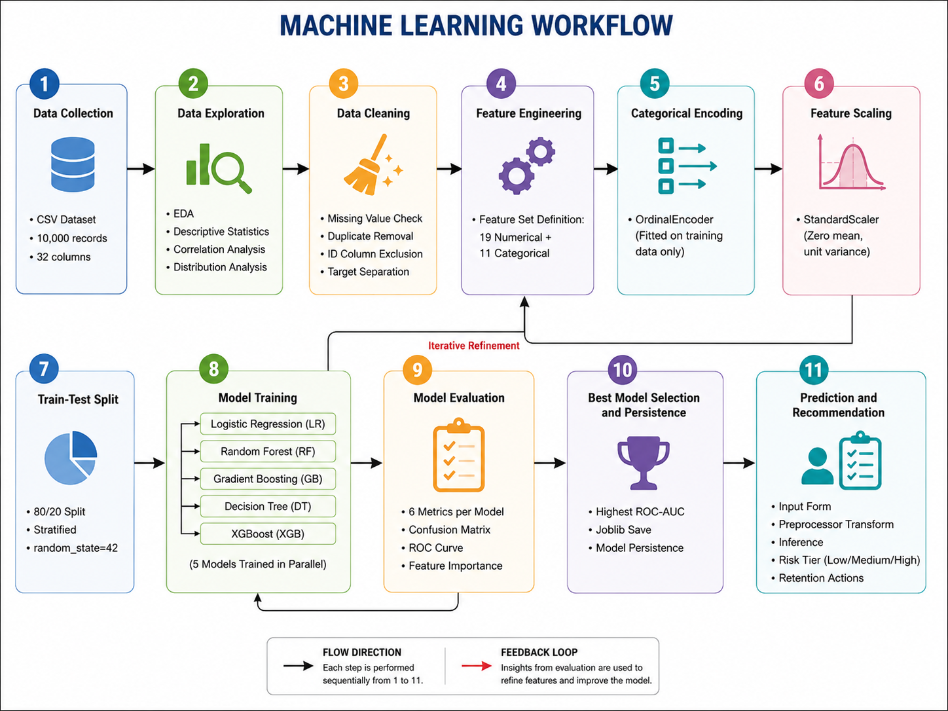
Figure 8.1: ChurnIQ Machine Learning Workflow Diagram

Step 1 – Data Collection
Data collection is the foundational step of any machine learning workflow, and the quality of collected data fundamentally determines the ceiling of achievable predictive model performance. In ChurnIQ, the customer churn dataset comprises 10,000 customer records sourced from a synthetic business environment that realistically mirrors the data characteristics of subscription-based service organisations. The dataset encompasses 32 distinct attributes spanning all critical dimensions of the customer experience: demographic characteristics (age, gender, country, city), engagement behaviour (monthly logins, weekly active days, average session time, features used, usage growth rate, last login recency), transactional history (monthly fee, total revenue, payment method, payment failures, discount status, price sensitivity), support interactions (ticket volume, resolution time, complaint category, CSAT score, escalation history), marketing engagement (email open rate, click-through rate), and satisfaction measurements (NPS score, survey response, referral count). Data is stored in CSV format in the data/ subdirectory and loaded into memory as a Pandas DataFrame at application startup.

Step 2 – Data Exploration
Data exploration, also known as Exploratory Data Analysis, involves systematic examination of the dataset to understand its statistical properties, identify anomalies, discover inter-variable relationships, and develop intuitions about which features are likely to be informative predictors of the target variable. In ChurnIQ, the exploration phase is prominently surfaced to users through the EDA page, which presents twelve interactive Plotly visualisations with accompanying business insight narratives. At the analytical level, exploration encompasses computation of descriptive statistics for all 19 numerical features, frequency distribution analysis for all 11 categorical features, Pearson correlation analysis displayed in a colour-scaled heatmap, and visual distribution analysis through histograms and box plots segmented by churn status. Key exploratory insights include the strong positive correlation of last_login_days_ago with churn, the strong inverse correlations of csat_score and nps_score with churn, the elevated churn rate among monthly contract customers compared to annual contract customers, and the right-skewed distributions of support_tickets and payment_failures.

Step 3 – Data Cleaning
Data cleaning addresses inconsistencies, errors, and gaps in the raw dataset that would otherwise degrade model performance or cause processing errors. The ChurnIQ dataset, being synthetically generated with careful attention to realistic data characteristics, exhibits no missing values in any feature column and contains no duplicate customer records, simplifying the cleaning phase significantly compared to real-world enterprise datasets. However, the preprocessing pipeline is robustly designed to handle missing values through SimpleImputer components (median strategy for numerical features, most_frequent strategy for categorical features) that would activate if the system were deployed with a different dataset. The customer_id column is explicitly excluded from the feature set as an identifier variable carrying no predictive signal. The target variable Churn is separated from the feature matrix using df.drop(columns=[TARGET_COL]) before any preprocessing operations are applied, ensuring no target leakage can occur.

Step 4 – Feature Engineering
Feature engineering involves creating new informative variables by combining, transforming, or deriving values from existing features with the goal of providing machine learning algorithms with richer discriminative signal. In ChurnIQ, the primary feature engineering contribution comes from the preprocessing pipeline's transformation steps rather than the creation of entirely new derived features, as the 30 available customer attributes after exclusion of customer_id already provide comprehensive coverage of churn-relevant signals across demographic, engagement, financial, support, and satisfaction dimensions. The feature set is defined in config.py as two explicit lists: NUMERICAL_FEATURES containing 19 column names and CATEGORICAL_FEATURES containing 11 column names. This explicit feature list configuration ensures reproducibility and makes feature set modifications straightforward for future iterations.

Step 5 – Encoding
Categorical feature encoding transforms string-valued categorical variables into numerical representations that machine learning algorithms can process mathematically. All machine learning algorithms in the Scikit-Learn ecosystem and XGBoost require numerical input features, making encoding a mandatory preprocessing step for any dataset containing categorical columns. ChurnIQ employs Scikit-Learn's OrdinalEncoder for all 11 categorical features (gender, country, city, customer_segment, signup_channel, contract_type, payment_method, discount_applied, price_increase_last_3m, complaint_type, survey_response). OrdinalEncoder assigns consecutive integer values (0, 1, 2, ..., n_categories-1) to each unique category observed in the training data. The encoder is fitted exclusively on training data using fit_transform(), and the fitted category-to-integer mapping is applied to test data and prediction inputs using transform() only, preventing any information about test set or prediction-time category distributions from influencing the encoding. The handle_unknown='use_encoded_value' and unknown_value=-1 configuration ensures graceful handling of categories at prediction time that were not present during training.

Step 6 – Scaling
Feature scaling normalises the numerical range of continuous features, ensuring that features with large absolute value ranges do not numerically dominate features with small ranges in computations that involve distances or gradient magnitudes. Without scaling, total_revenue (potentially ranging from a few hundred to tens of thousands of dollars) would dominate csat_score (ranging from 1 to 5) in Logistic Regression's gradient-based optimisation, producing poorly calibrated model coefficients. ChurnIQ applies StandardScaler to all 19 numerical features, transforming each feature to zero mean and unit variance: z = (x - mean) / std. The scaler's mean and standard deviation statistics are computed exclusively from the training set using fit_transform(), and the same statistics are applied to the test set and prediction inputs using transform(). This strict data separation ensures that the test evaluation reflects genuine generalisation performance rather than performance inflated by training-set information leakage.

Step 7 – Train-Test Split
The dataset is split into a training set (80% of records, 8,000 customers) and a held-out test set (20% of records, 2,000 customers) using stratified random sampling. Stratification is applied using the stratify=y parameter in Scikit-Learn's train_test_split(), ensuring that the proportion of churned customers in both the training set and the test set matches the overall dataset churn rate of approximately 9 to 11 percent. Without stratification, a non-stratified random split could, by statistical chance, produce a test set where churned customers are substantially over- or under-represented compared to their true prevalence, leading to misleading performance estimates that would not reflect the model's real-world performance on a representative customer population. A fixed random seed (random_state=42) is applied to ensure that the same split is produced on every training run, enabling reproducible comparison of model configurations.

Step 8 – Model Training
Five classification models are trained sequentially on the preprocessed training set, each instantiated with hyperparameters carefully configured for the churn prediction task. The training loop in core/trainer.py iterates over a dictionary of model name-to-estimator mappings, calls model.fit(X_train_t, y_train) for each estimator, records the training time, evaluates the trained model on the test set, and saves the model artifact to disk using Joblib. Training times vary significantly across algorithms reflecting their computational complexity: Logistic Regression completes in under one second due to its simple iterative optimisation, Decision Tree in approximately one second for its greedy tree construction, Random Forest in 3 to 8 seconds with full CPU parallelisation across 200 trees, Gradient Boosting in 15 to 30 seconds for its sequential 150-tree construction, and XGBoost in 5 to 15 seconds for its optimised parallelised implementation. A progress callback updates a Streamlit progress bar after each model completes, providing real-time visual feedback.

Step 9 – Model Evaluation
Each trained model is evaluated against the held-out 2,000-record test set using six quantitative metrics and three visual evaluations. Binary predictions are generated using model.predict(X_test_t), and probabilistic churn scores are generated using model.predict_proba(X_test_t)[:,1]. Accuracy, precision, recall, F1 score, and ROC-AUC are computed using Scikit-Learn's metrics module. The confusion matrix heatmap is generated as a 2x2 annotated Plotly heatmap showing True Negatives, False Positives, False Negatives, and True Positives with both count and percentage labels. The ROC curve for all five models is overlaid on a single Plotly line chart, enabling direct visual comparison of discriminative performance across models. Feature importance scores are extracted from tree-based models via model.feature_importances_ and displayed as sorted horizontal bar charts identifying the top predictive features.

Step 10 – Best Model Selection and Persistence
Following evaluation of all five models, the system automatically identifies the model with the highest ROC-AUC score on the test set as the best-performing model for production deployment. The ROC-AUC metric is selected as the primary selection criterion because of its robustness to class imbalance and its threshold-independent nature. Unlike accuracy, which can be artificially high when a model simply predicts the majority class for all records, ROC-AUC measures the model's fundamental discriminative ability across all possible classification threshold settings, making it the most reliable single metric for model comparison in imbalanced binary classification tasks. The best model's name is stored in a text file alongside the model artifacts. Both the best model object and the fitted ColumnTransformer preprocessor are saved using joblib.dump() to the models/ directory, enabling the prediction module to load them in milliseconds for real-time inference.

Step 11 – Prediction and Business Recommendation
The final workflow step deploys the saved best model and preprocessor to generate real-time churn predictions for individual customer profiles submitted through the prediction interface. The prediction function loads the model and preprocessor artifacts using joblib.load(), constructs a single-row Pandas DataFrame from the user-supplied input values with column names matching the training feature set, applies preprocessor.transform() to produce a model-ready feature vector respecting the training-time encoding and scaling, and invokes model.predict() and model.predict_proba() to generate the binary classification and probabilistic churn score. The churn probability is mapped to one of three risk tiers using the thresholds defined in config.py (Low: probability below 0.30, Medium: 0.30 to 0.60, High: above 0.60). A recommendation dictionary maps each risk tier to a set of four to six specific, contextually appropriate retention action recommendations, providing directly actionable guidance to customer success teams without requiring additional analytical interpretation.

CHAPTER 9: DATA PREPROCESSING AND FEATURE ENGINEERING

9.1 Importance of Data Preprocessing
Data preprocessing is arguably the most consequential phase of any machine learning project. Raw data as collected or sourced invariably contains imperfections that, if left unaddressed, systematically degrade model performance, introduce statistical bias, cause numerical instability during model training, or produce misleading evaluation results that overestimate real-world performance. Preprocessing encompasses all operations performed on the raw data prior to model training with the objective of producing a clean, consistently formatted, informationally rich feature representation that enables machine learning algorithms to extract the maximum possible predictive signal from the available data. In ChurnIQ, the preprocessing pipeline is implemented using Scikit-Learn's ColumnTransformer and Pipeline abstractions, which enforce consistent application of all transformation steps during both training and prediction phases, representing best practice in production machine learning system design.

9.2 Missing Value Handling
Missing values arise when data collection processes fail to capture a measurement for a particular attribute in a particular record. In machine learning contexts, most algorithms are unable to process records containing missing (NaN) values without explicit handling, and will raise exceptions if such values are encountered. The ChurnIQ dataset is processed through a SimpleImputer component with two configurations: median strategy for numerical features and most_frequent strategy for categorical features. Median imputation is preferred over mean imputation for numerical features because the median is robust to outlier values and better preserves the central tendency of right-skewed distributions such as support_tickets and payment_failures. Mode imputation for categorical features fills missing values with the most frequently occurring category, representing the best available single-value estimate in the absence of additional contextual information about the missing record. Both imputers are fitted exclusively on training data.

9.3 Categorical Feature Encoding
All machine learning algorithms in the Scikit-Learn and XGBoost ecosystems require numerical input features; categorical features expressed as string labels must be converted to numerical representations before they can be processed mathematically. ChurnIQ encodes all 11 categorical features using Scikit-Learn's OrdinalEncoder, which creates a learned mapping from unique category strings to integer indices for each categorical column. The encoding assigns consecutive integers starting from 0 to each unique category in alphabetical or frequency order as observed in the training data. The encoder is fitted using fit_transform() on training data only, and the learned integer mappings are subsequently applied using transform() to test data and prediction inputs. The handle_unknown='use_encoded_value' and unknown_value=-1 configuration parameters ensure that categories appearing at prediction time that were absent from the training data are assigned a consistent out-of-vocabulary indicator value of -1, preventing processing errors in production deployment.

9.4 Feature Scaling
Feature scaling ensures that numerical features with vastly different native value ranges contribute comparably to model training computations. Without scaling, features with large absolute value ranges would numerically dominate features with small ranges in Euclidean distance calculations, Logistic Regression gradient descent, and distance-based feature importance computations. ChurnIQ applies Scikit-Learn's StandardScaler to all 19 numerical features, implementing the transformation z = (x - mu) / sigma, where mu is the training-set mean and sigma is the training-set standard deviation, producing a zero-mean, unit-variance distribution for each numerical feature after transformation. The scaler's mu and sigma statistics are computed using fit_transform() exclusively on training data. The same statistics are applied via transform() to test data and prediction-time inputs, ensuring that no information about test set or prediction-time data distributions influences the scaling parameters.

9.5 ColumnTransformer Pipeline Architecture
The ColumnTransformer abstraction in Scikit-Learn enables different preprocessing transformations to be applied to different subsets of columns within a single, unified pipeline. ChurnIQ's ColumnTransformer defines two transformation branches: a numerical pipeline applied to the 19 NUMERICAL_FEATURES columns (SimpleImputer with median strategy followed by StandardScaler), and a categorical pipeline applied to the 11 CATEGORICAL_FEATURES columns (SimpleImputer with most_frequent strategy followed by OrdinalEncoder). The remainder='drop' parameter ensures that the customer_id column and any other columns not explicitly listed in either branch are excluded from the output feature matrix. The entire ColumnTransformer is fitted as a single object using fit_transform() on the training data and persisted to disk using joblib.dump(), enabling the complete preprocessing configuration to be loaded and applied consistently during prediction.

9.6 Train-Test Split Strategy
The 80/20 stratified train-test split strategy used in ChurnIQ reflects standard practice for machine learning model development with datasets of this scale. With 10,000 total records, an 80/20 split produces 8,000 training samples and 2,000 test samples. The stratified sampling enforces proportional class representation in both partitions, which is critical for reliable evaluation in the context of the approximately 10:1 class imbalance. Specifically, if the overall churn rate is 9.8%, both the training set and test set will contain approximately 9.8% churned records after stratification, ensuring that the test set provides a representative estimate of model performance on the actual class distribution. A fixed random_state=42 is applied throughout all random operations in the system to ensure full reproducibility of experimental results.

9.7 Outlier Considerations
While no explicit outlier removal step is applied in the current ChurnIQ preprocessing pipeline, outlier robustness is addressed implicitly through several design choices. The use of median imputation rather than mean imputation for numerical features reduces the influence of extreme values on the central tendency estimates used for missing value substitution. StandardScaler is applied after imputation, which reduces but does not eliminate the influence of extreme values; however, the tree-based models (Random Forest, Gradient Boosting, Decision Tree, XGBoost) that constitute four of the five trained classifiers are inherently robust to outliers because their split decisions are based on rank ordering of feature values rather than absolute magnitudes. Logistic Regression is the only model in the suite that is theoretically sensitive to extreme feature values after scaling.

9.8 Benefits of the Preprocessing Architecture
Encapsulating all preprocessing steps within a Scikit-Learn ColumnTransformer pipeline provides several critical benefits for the ChurnIQ system beyond simple code organisation. First and most critically, it prevents data leakage by ensuring that all fitting operations including scaler mean and variance computation and encoder category mapping are performed exclusively on training data. Second, it guarantees identical transformations are applied to prediction-time inputs using the training-time statistics, eliminating inconsistencies between training and inference preprocessing. Third, it enables the entire preprocessing configuration to be serialised as a single artifact using Joblib, simplifying deployment and eliminating the need to separately save and restore multiple transformation objects. Fourth, it provides a single authoritative location for all preprocessing logic, making the system maintainable and auditable. Fifth, it enables straightforward modification of the preprocessing steps by updating the pipeline definition in build_pipeline() without affecting any other module.

CHAPTER 10: USER INTERFACE DESIGN

10.1 UI Design Philosophy
The ChurnIQ user interface is designed around three core principles: professional aesthetic quality appropriate for a business intelligence tool used by executive and operational stakeholders, functional clarity enabling non-technical users to accomplish complex analytical tasks without programming knowledge or training, and visual consistency across all pages through a shared design system implemented via custom CSS injection. The design employs a deep navy primary colour (#1A3C5E) representing authority and analytical depth, a medium blue accent colour (#2E86AB) for interactive elements and highlights, and clean white card backgrounds for content areas. Typography uses the Arial font family for maximum cross-platform rendering consistency. KPI metric cards use Streamlit's st.metric() widget with custom CSS overrides to produce a polished, dashboard-style presentation.

Figure 1: Login Page


Figure 1: Login Page
Page Purpose | Authenticate existing users and gate access to all protected dashboard pages
Key Components | Username input field, masked password input (type=password), Login button, navigation link to Registration page, ChurnIQ title and tagline header
User Actions | Enter username; enter password; click Login button; optionally click Register link to navigate to registration
Expected Output | Successful login: session state set, redirect to Home page. Failed login: error message displayed beneath form
Business Value | Prevents unauthorised access to sensitive customer analytics; maintains user session continuity across page navigations
Table 10.1: UI Description for Figure 1
The Login page is the secure entry point for all ChurnIQ users, implementing the first layer of access control. The interface presents a centred card layout with the ChurnIQ logo and descriptive tagline prominently displayed above the credential input fields. The password field uses Streamlit's type='password' configuration to mask input characters. The authentication module's verify_user() function retrieves the stored password hash for the submitted username and performs a constant-time comparison using hmac.compare_digest(). Failed authentication returns a user-friendly error message without disclosing whether the failure was due to an unrecognised username or incorrect password. Successful authentication writes the username to st.session_state and triggers a page redirect to the Home dashboard.

Figure 2: Registration Page

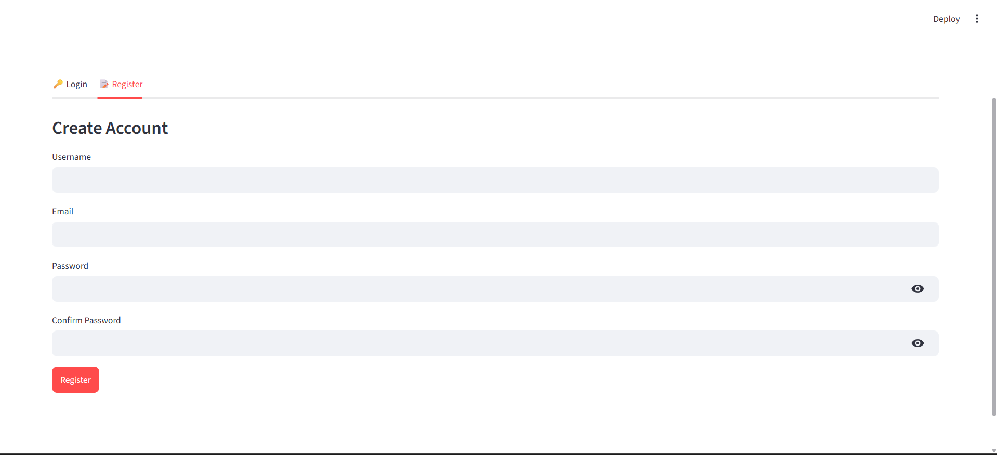
Figure 2: Registration Page
Page Purpose | Enable new user account creation with four-stage input validation
Key Components | Username field, email field, password field, confirm password field, Register button, link back to Login page, validation feedback messages
User Actions | Enter all four fields; click Register button; receive success confirmation or specific inline validation error message
Expected Output | Success: user record created in SQLite, green success notification displayed. Failure: specific error message identifying the failed validation rule
Business Value | Enables self-service user onboarding without administrator intervention; enforces data integrity through multi-layer validation
Table 10.2: UI Description for Figure 2

The Registration page enforces four distinct validation rules executed in sequence. Email format validation uses a regular expression to confirm the address conforms to standard format (local-part@domain.tld). Password minimum length validation enforces a character count floor.
Password confirmation matching verifies both password fields are identical. Duplicate account detection queries the SQLite users table to confirm neither the username nor email address is already registered. Each validation failure generates a specific, actionable error message displayed directly beneath the failed input field. Successful registration hashes the password using PBKDF2-SHA256 with a random salt, inserts the user record into SQLite, and displays a green success notification with instructions to proceed to the login page.

Figure 3: Home / Dataset Overview Page

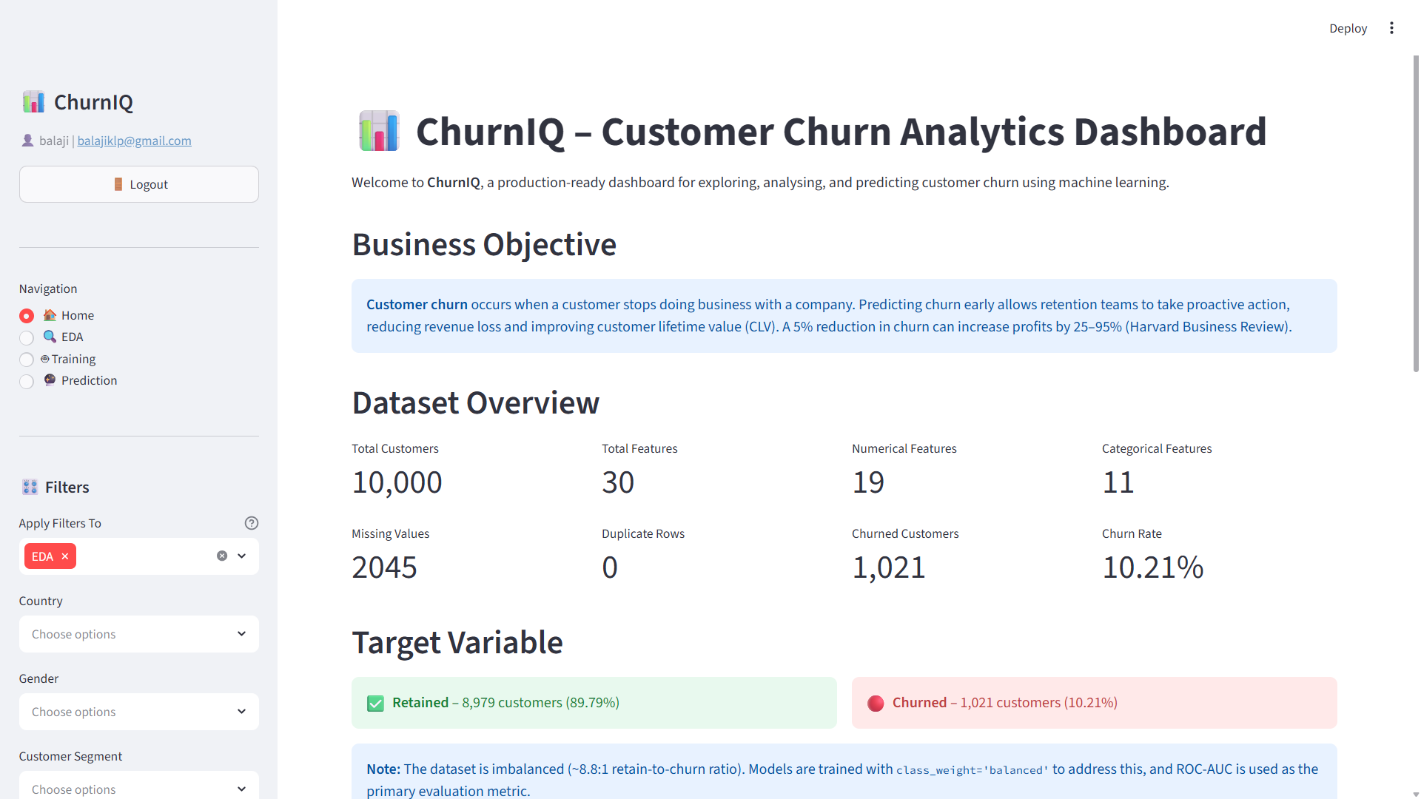
Figure 3: Home / Dataset Overview Page
Page Purpose | Provide project introduction, dataset context, schema documentation, and top-level KPI overview
Key Components | Project header with branding, dataset description text, schema table (32 columns with types and descriptions), paginated data preview, eight KPI metric cards, CSV download button
User Actions | Scroll through dataset schema; browse paginated data preview; view KPI cards; click download button for CSV export
Expected Output | Rendered schema table, paginated 10-row data preview with page controls, eight KPI cards with computed metric values, downloadable CSV file
Business Value | Orientates both new and returning users to the dataset structure, business context, and current performance metrics before analytical exploration
Table 10.3: UI Description for Figure 3
The Home page serves as the analytical entry point following authentication, providing users with foundational context before they engage with the more detailed EDA and prediction modules. The page is structured in a logical reading flow from general to specific: the project header with ChurnIQ branding and dataset description text provides business context, the schema table documents all 32 dataset columns with their data types and business definitions enabling users to understand the analytical dimensions available, the paginated data preview allows inspection of actual data records to build intuition about value ranges and category distributions, and the eight KPI metric cards at the bottom provide an immediate high-level performance overview. The CSV download button enables users to export the dataset for offline analysis in external tools.

Figure 4: EDA Dataset Statistics Panel

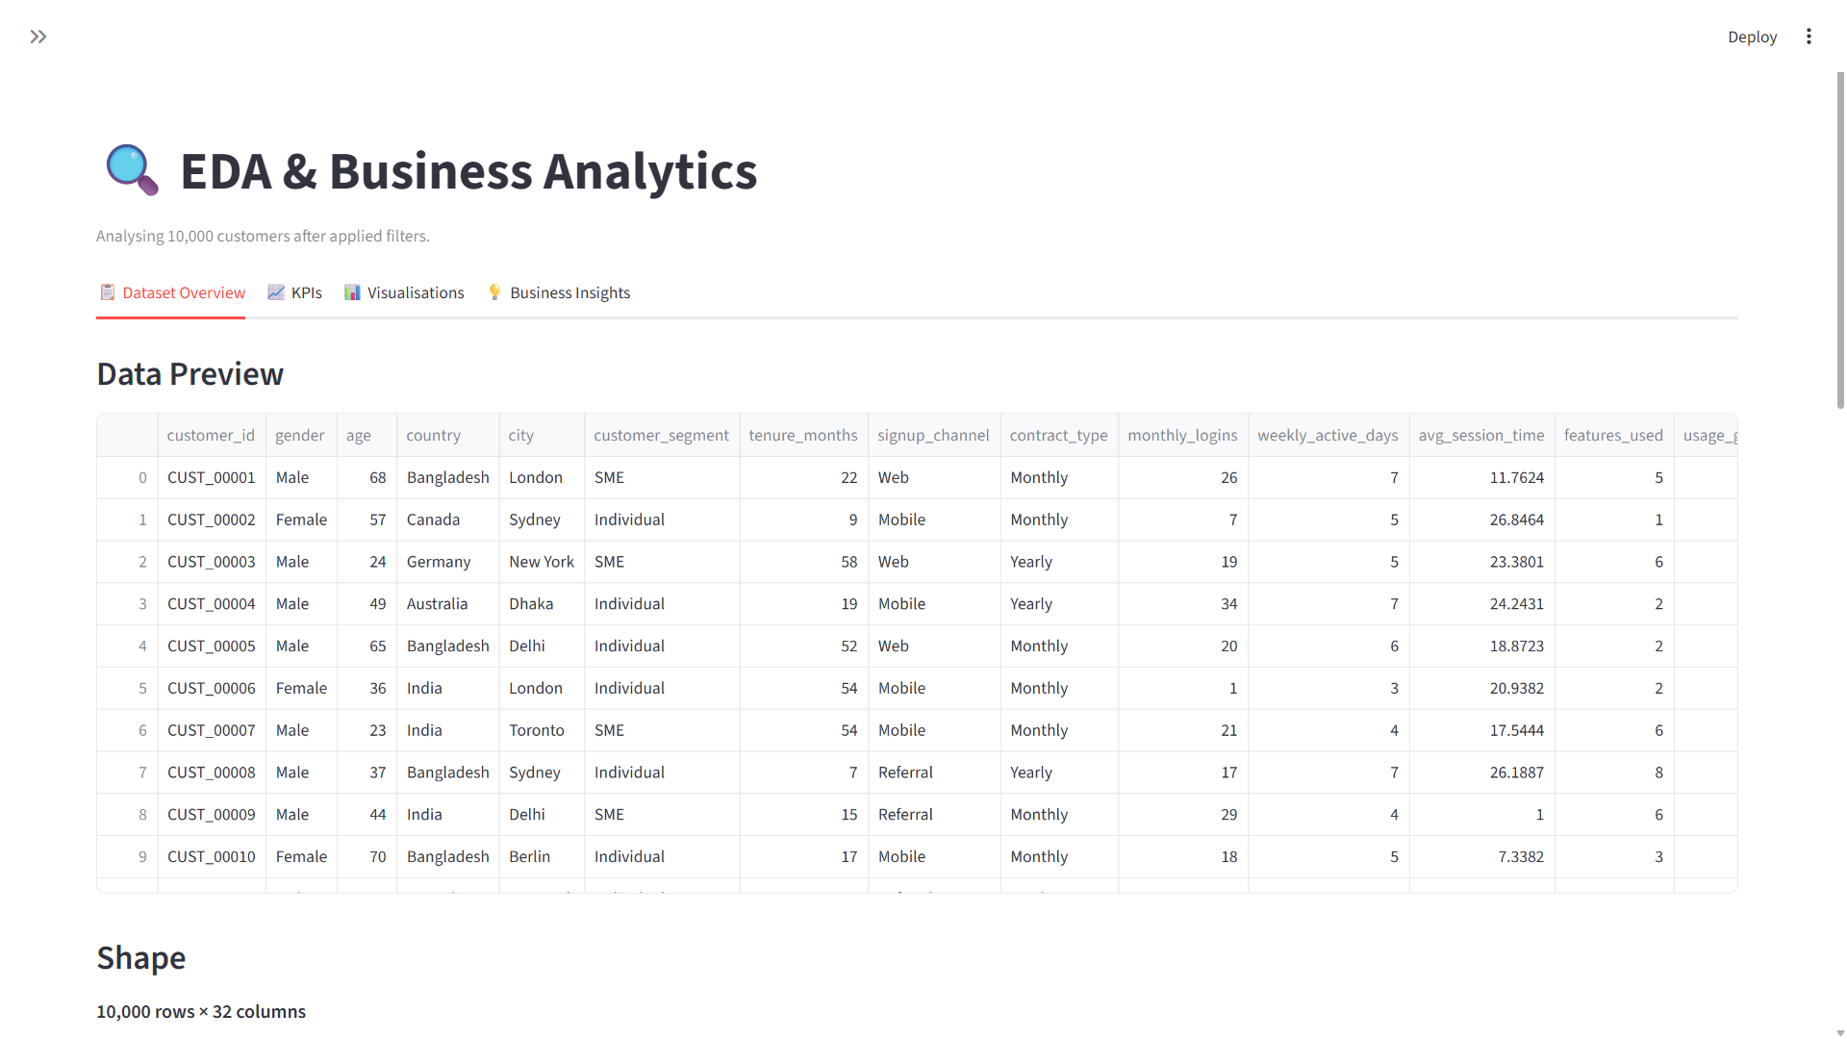
Figure 4: EDA Dataset Statistics Panel
Page Purpose | Display comprehensive statistical profiles and data quality assessment for all dataset features
Key Components | Dataset shape metrics (rows, columns), descriptive statistics table (describe() output), data type summary table, missing value count report
User Actions | Review statistical summaries for all features; identify skewed or concentrated distributions; verify data quality completeness
Expected Output | Formatted describe() statistics table for 19 numerical features, data type summary for all 32 columns, confirmed zero missing values
Business Value | Provides foundational statistical characterisation enabling data scientists to assess data quality and distribution characteristics
Table 10.4: UI Description for Figure 4
The Dataset Statistics panel provides the quantitative statistical foundation for all subsequent EDA visualisations. The descriptive statistics table presents Pandas describe() output for all 19 numerical features, showing count, mean, standard deviation, minimum, 25th percentile, median, 75th percentile, and maximum values in a formatted data table. Notable distributional observations visible in this table include the right-skewed distributions of support_tickets and payment_failures (mean significantly above median, with long positive tails), the narrow range of csat_score and nps_score reflecting their bounded scale definitions, and the broad range of total_revenue reflecting the diverse customer value composition of the dataset. The data quality section confirms zero missing values and zero duplicate records, validating dataset integrity.

Figure 5: Sidebar Filter Panel

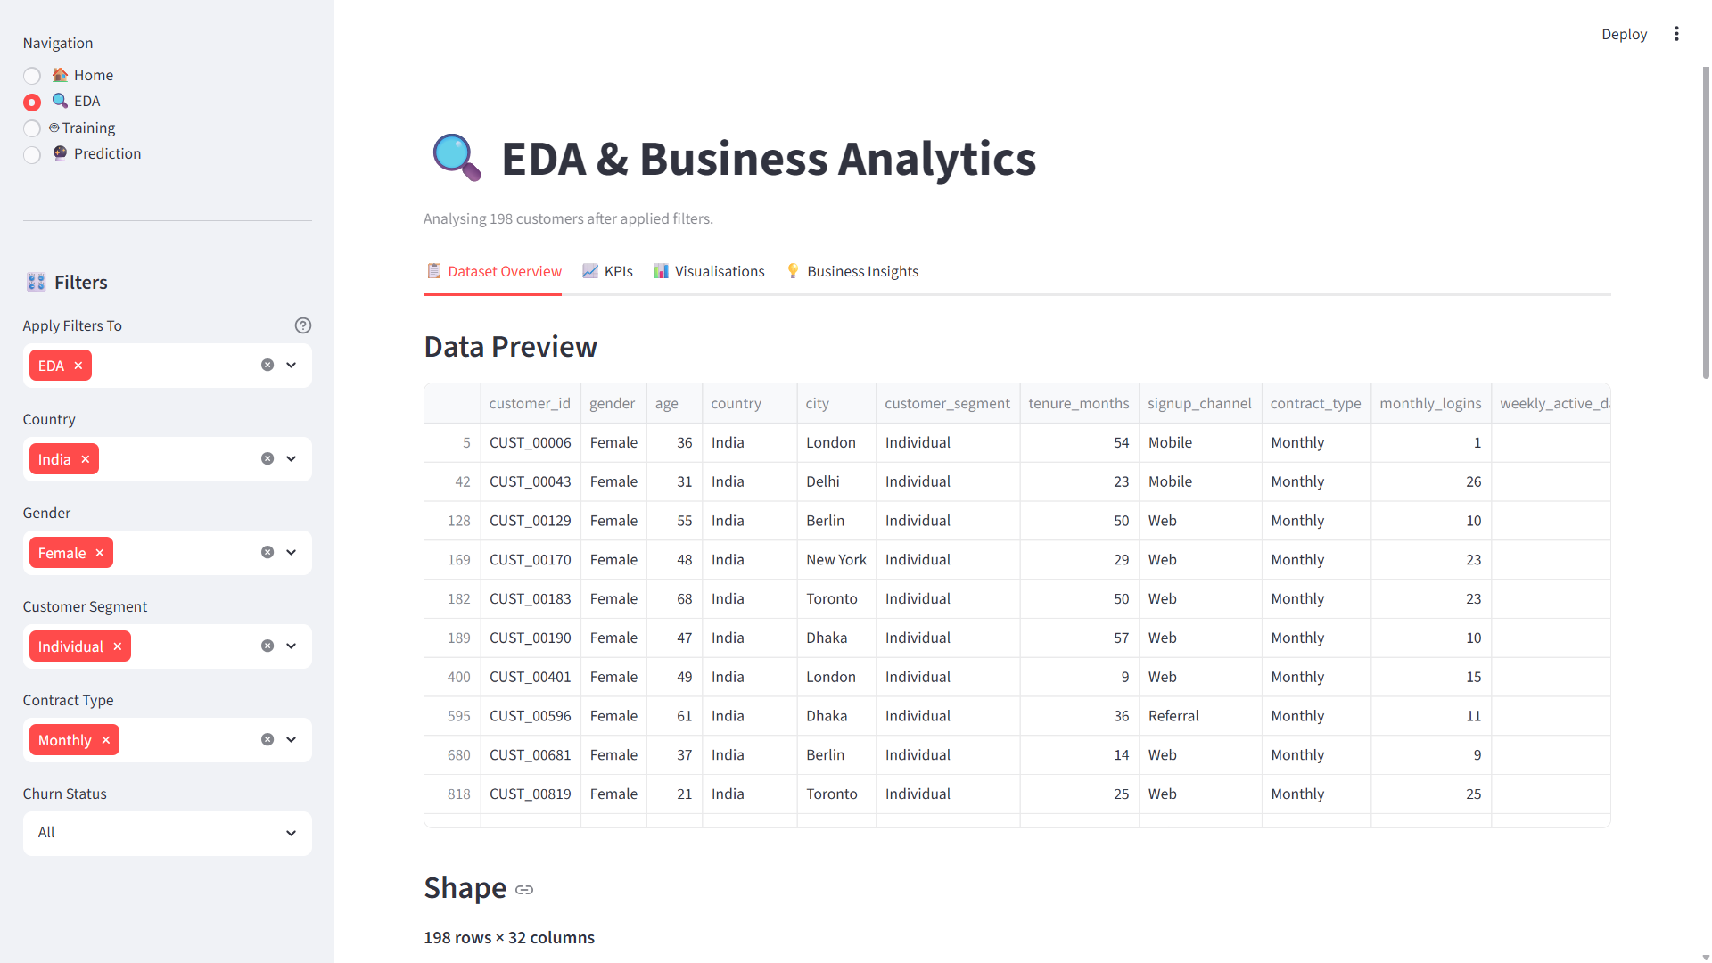
Figure 5: Sidebar Filter Panel
Page Purpose | Enable multi-dimensional interactive segmentation of analytical data
Key Components | Country multi-select dropdown, Customer Segment multi-select, Contract Type multi-select, Gender multi-select, Apply Filters button, Reset Filters button
User Actions | Select one or more values in any combination of filter widgets; click Apply Filters; observe all KPIs and charts update in real-time
Expected Output | All KPI cards, EDA charts, and statistical summaries update simultaneously to reflect only the selected customer subset
Business Value | Transforms static analytics into interactive exploration enabling segment-specific churn analysis and cohort comparisons
Table 10.5: UI Description for Figure 5
The Sidebar Filter Panel is one of ChurnIQ's most analytically powerful features, transforming the application from a static reporting tool into an interactive exploration environment. The panel provides four independent multi-select filter widgets corresponding to the most analytically significant categorical segmentation dimensions. Selecting multiple values within a single filter applies an OR condition (show records matching any selected value), while selections across multiple filters apply an AND condition (show records matching all filter constraints simultaneously). The Apply Filters button triggers recomputation of all downstream analytical outputs with the filtered DataFrame, and the Reset Filters button clears all selections to restore the full dataset view. This capability enables targeted analysis questions such as what is the churn rate among Enterprise customers on Monthly contracts.

Figure 6: KPI Dashboard Cards

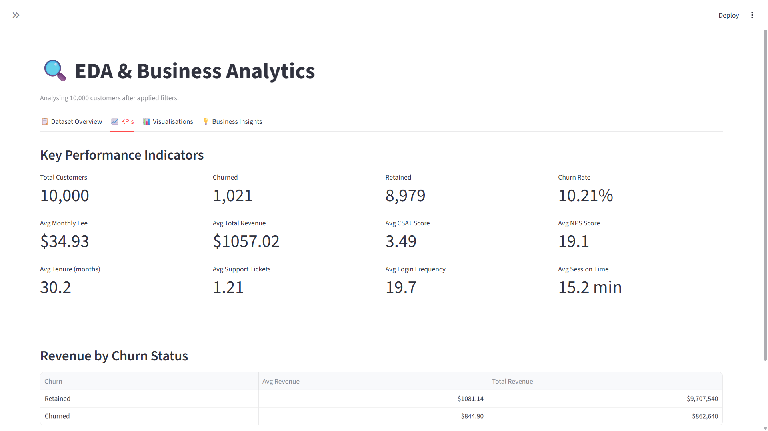
Figure 6: KPI Dashboard Cards
Page Purpose | Display eight critical business performance indicators in a prominently styled metric card layout
Key Components | Total Customers card, Churn Rate card, Retention Rate card, Avg Revenue card, Avg Monthly Fee card, Avg CSAT Score card, Avg NPS Score card, Avg Tenure card
User Actions | View KPI values at a glance; apply sidebar filters to observe how metrics change across different customer segments
Expected Output | Eight metric cards displaying current computed values, formatted to appropriate precision with business-meaningful units
Business Value | Enables executive stakeholders to instantly assess business health and compare performance across filtered customer cohorts
Table 10.6: UI Description for Figure 6
The KPI Dashboard displays eight carefully selected business metrics that collectively provide a comprehensive health assessment of the customer base. The cards are laid out in a two-row, four-column grid using Streamlit's st.columns() layout. The Total Customers card shows the record count providing sample size context for all other metrics. The Churn Rate and Retention Rate cards together convey the fundamental retention health of the filtered cohort. The Avg Monthly Fee and Avg Revenue cards provide financial context. The Avg CSAT Score and Avg NPS Score cards provide satisfaction and loyalty context. The Avg Tenure card indicates the loyalty maturity of the customer base. When sidebar filters are applied, all eight metrics update simultaneously, enabling direct comparison of KPI profiles across customer segments.

Figure 7: Churn Distribution Chart

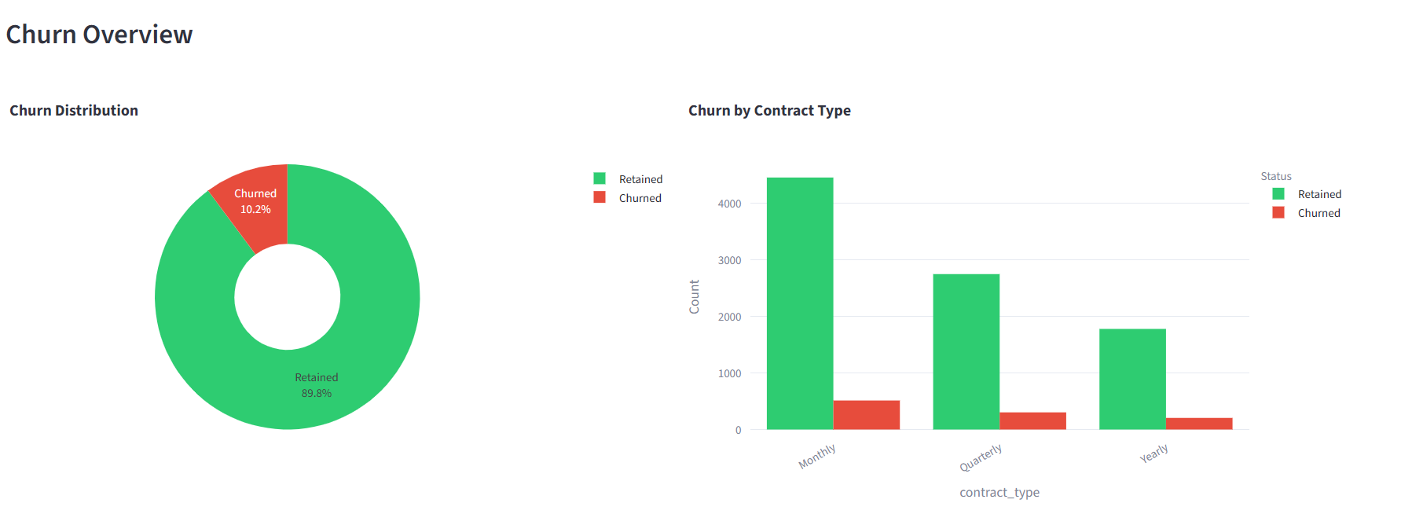
Figure 7: Churn Distribution Chart
Page Purpose | Visualise the fundamental balance between churned and retained customers in the current filter context
Key Components | Pie chart showing percentage split with colour coding, bar chart showing absolute counts with data labels, churn rate annotation
User Actions | Hover over chart segments or bars for exact count and percentage values; update by adjusting sidebar filters
Expected Output | Dual-format chart showing churn vs retained split with both percentage labels on pie and count labels on bar chart
Business Value | Establishes the baseline churn rate context that frames the interpretation of all subsequent analytical findings
Table 10.7: UI Description for Figure 7
The Churn Distribution Chart is the foundational visualisation of the ChurnIQ EDA module, immediately communicating the scale of the churn challenge within the selected customer population. A pie chart on the left displays the churned-to-retained percentage split with distinct colour coding (deep blue for retained, coral red for churned), while a bar chart on the right provides the same information as absolute counts with labelled bar annotations. The combination of both formats ensures clarity for both ratio-oriented and volume-oriented analytical perspectives. The significant class imbalance immediately visible in this chart (approximately 90% retained, 10% churned) contextualises the model evaluation strategy, explaining why raw accuracy is an insufficient metric and why ROC-AUC and F1 Score are used for model comparison.

Figure 8: Customer Segment Analysis

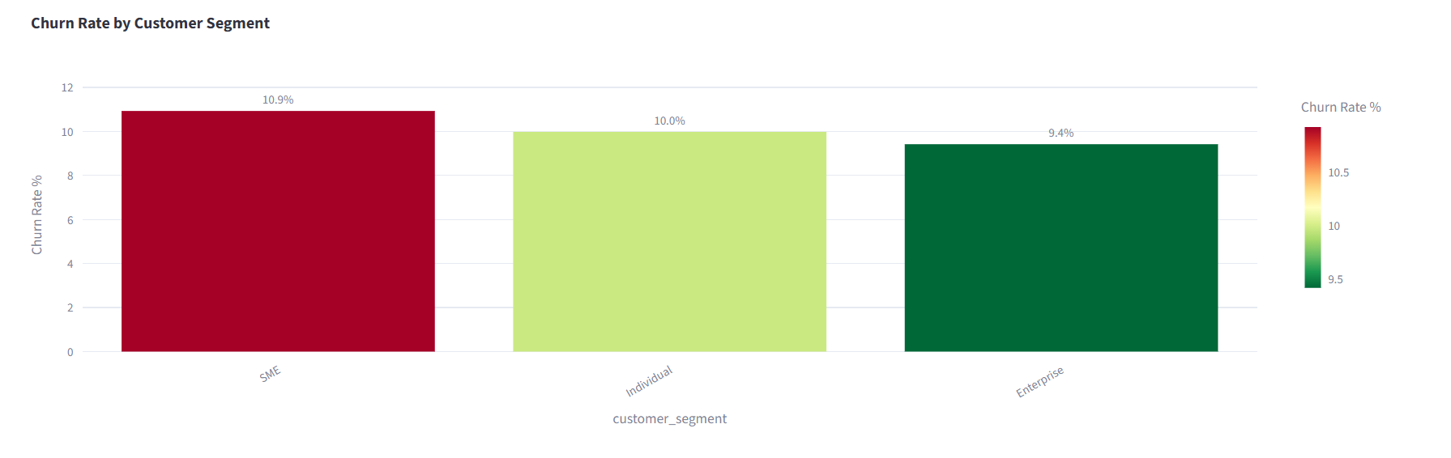
Figure 8: Customer Segment Analysis
Page Purpose | Compare churn rates and customer volume distributions across all business customer segments
Key Components | Grouped bar chart of churned vs retained counts by segment, churn rate percentage labels, segment comparison data table below chart
User Actions | Hover over bars for exact counts; click legend items to show or hide specific segments; review data table for exact figures
Expected Output | Multi-segment grouped bar chart showing churned and retained customer counts per segment with overlay churn rate line
Business Value | Identifies which customer segments require priority retention investment based on their relative churn vulnerability
Table 10.8: UI Description for Figure 8
The Customer Segment Analysis visualisation enables direct comparison of churn behaviour across the organisation's customer segment taxonomy. The primary grouped bar chart places the churned and retained bar pairs for each segment side by side, enabling immediate visual assessment of both the relative scale of churn within each segment and the absolute volume of churned customers. An overlay line chart plots the churn rate percentage for each segment on a secondary y-axis, enabling direct rate comparison independent of segment size differences. A data table below the chart presents the precise figures for each segment including total customer count, churned count, retained count, and churn rate percentage. These insights directly inform retention budget allocation decisions, identifying which segments offer the greatest return on retention investment per dollar spent.

Figure 9: Revenue Analysis Dashboard

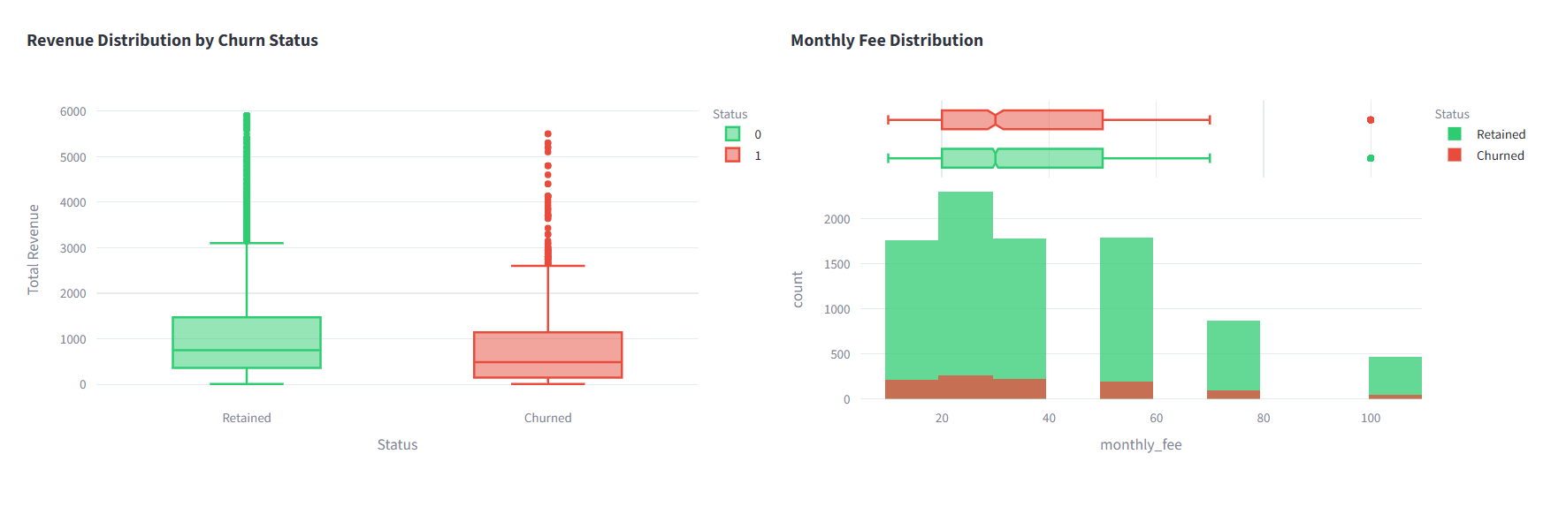
Figure 9: Revenue Analysis Dashboard
Page Purpose | Analyse revenue distribution patterns and financial risk concentration across churned and retained cohorts
Key Components | Box plot of total revenue by churn status, monthly fee distribution histogram, revenue leakage calculation card
User Actions | Hover for quartile and outlier statistics; compare distribution shapes between churned and retained groups
Expected Output | Side-by-side box plots for total revenue and monthly fee distributions, segmented by churn status
Business Value | Quantifies the financial magnitude of churn and identifies whether churn risk is concentrated in high-value or low-value customers
Table 10.9: UI Description for Figure 9
The Revenue Analysis Dashboard provides the financial dimension of churn behaviour analysis. The box plot visualisation compares the total revenue distributions of churned and retained customers side by side, revealing whether churning customers are drawn predominantly from the high-revenue premium segment or the low-revenue entry segment. This distinction is critically important for retention strategy design: if high-revenue customers are churning at elevated rates, premium retention offers are financially justified; if low-revenue customers dominate the churned population, the cost of retention interventions must be carefully calibrated against the lifetime value of the customers being retained. The monthly fee distribution histogram provides a complementary perspective on price tier sensitivity in churn behaviour.

Figure 10: Correlation Heatmap

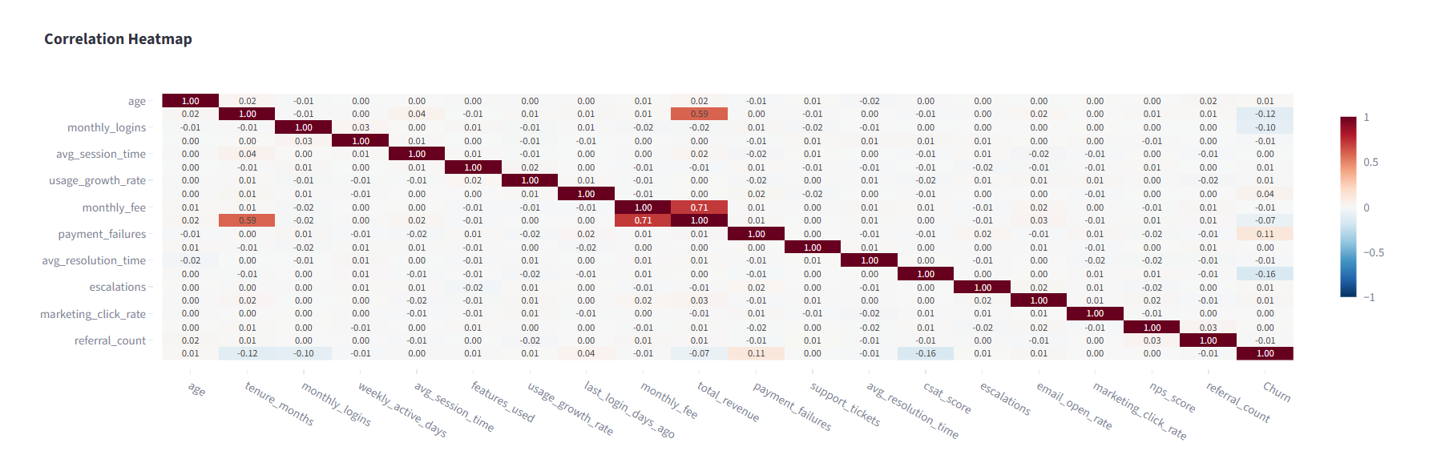
Figure 10: Correlation Heatmap
Page Purpose | Identify linear correlation relationships between all pairs of numerical features and the churn target
Key Components | 20x20 colour-scaled correlation matrix heatmap with value annotations, diverging colour scale from -1 to +1
User Actions | Hover over any cell to see the exact Pearson correlation coefficient; identify clusters of correlated features
Expected Output | Fully annotated colour-scaled heatmap showing all pairwise Pearson correlations for 19 features plus Churn target
Business Value | Reveals the strongest linear predictors of churn and identifies multicollinearity between features for feature engineering
Table 10.10: UI Description for Figure 10
The Correlation Heatmap is one of the most analytically information-dense visualisations in the ChurnIQ EDA module, displaying the complete pairwise Pearson correlation matrix for all 19 numerical features plus the binary Churn target variable in a 20x20 annotated heatmap. The diverging colour scale ranges from deep blue representing strong negative correlation approaching -1.0 through white representing no linear relationship at 0.0 to deep red representing strong positive correlation approaching +1.0. The column and row corresponding to the Churn target variable are the most analytically significant, as they reveal which numerical features exhibit the strongest linear associations with customer churn. Features with absolute correlation magnitudes greater than 0.15 with respect to Churn are particularly noteworthy. Inter-feature correlations visible elsewhere in the heatmap reveal multicollinearity structures that inform feature selection and model interpretation.

Figure 11: Model Training Page

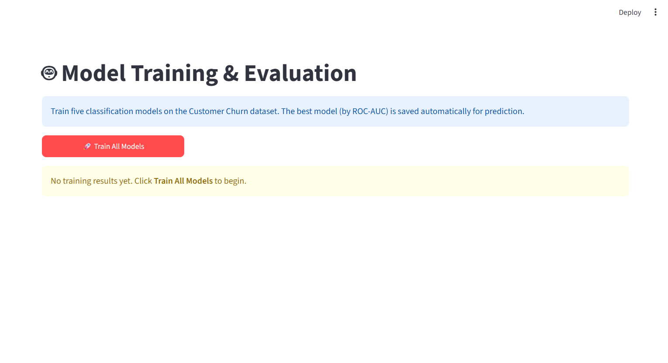
Figure 11: Model Training Page
Page Purpose | Execute the five-model machine learning training pipeline with real-time progress monitoring
Key Components | Training configuration summary card, Train Models button, animated progress bar, sequential status message log, completion notification banner
User Actions | Review training configuration; click Train Models button; monitor progress bar; wait for completion banner; scroll down to view evaluation results
Expected Output | Real-time progress bar advancing through five model training stages with per-model status messages and timing information
Business Value | Provides transparent, auditable model training with real-time feedback ensuring users understand the training process
Table 10.11: UI Description for Figure 11
The Model Training Page provides the primary interface for executing the ChurnIQ machine learning pipeline. The page opens with a training configuration summary card displaying the dataset size, the 80/20 train-test split specification, the random seed for reproducibility, the list of five algorithms to be trained, and the primary evaluation metric (ROC-AUC) used for model selection. The prominent Train Models button initiates the training sequence. As training progresses, a Streamlit progress bar component advances from 0 to 100% across five equal increments, one per model. A status text message updates with each model's name, training start time, and completion time. Upon completion of all five models, a green success notification banner identifies the automatically selected best model by name and ROC-AUC score, and the model evaluation results section renders below.

Figure 12: Model Performance Comparison Chart

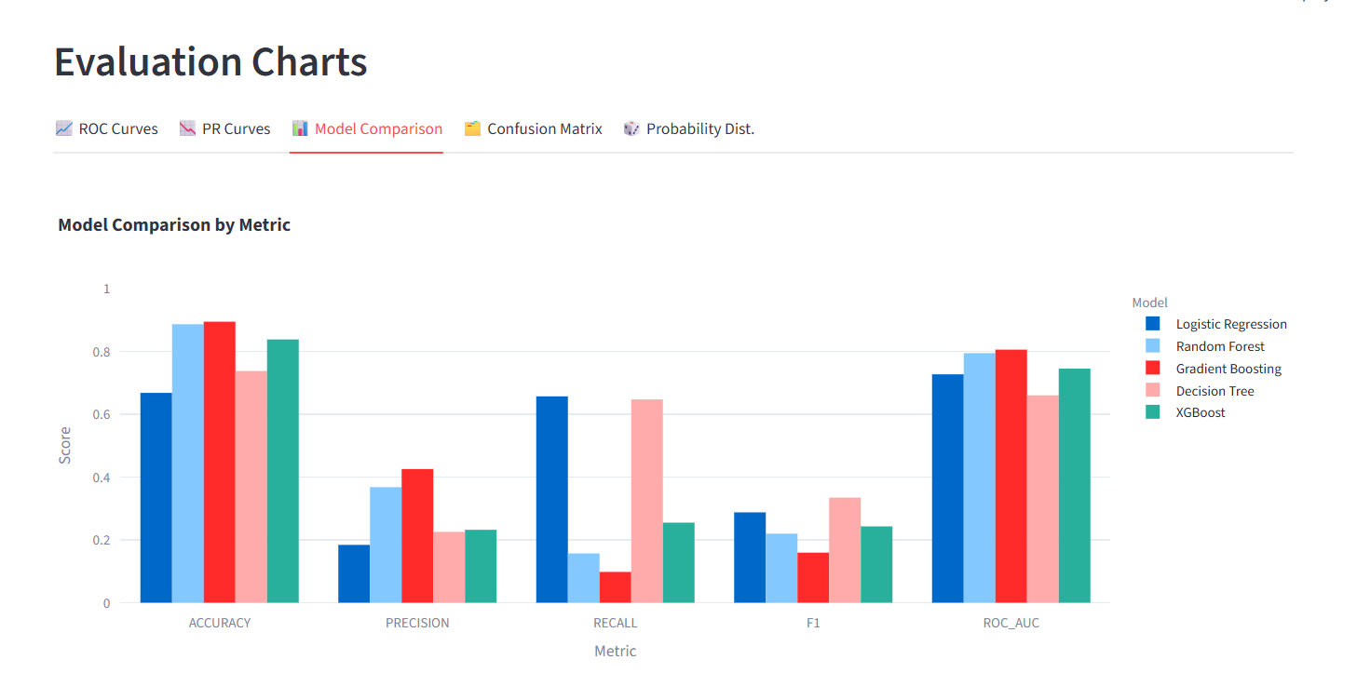
Figure 12: Model Performance Comparison Chart
Page Purpose | Compare the performance of all five trained models across six evaluation metrics in a single unified view
Key Components | Grouped bar chart with five colour-coded model groups across six metric categories, best model highlight annotation, comparison data table
User Actions | Hover over any bar for the exact metric value; click legend model names to isolate or hide specific models
Expected Output | Six-metric grouped bar chart comparing all five models, with the best model bars highlighted and the comparison table with best values bolded
Business Value | Enables objective, data-driven identification and justification of the best model for production deployment
Table 10.12: UI Description for Figure 12
The Model Performance Comparison Chart is the central decision-support visualisation of the model training workflow, presenting all thirty model-metric combinations (five models times six metrics) in a single, unified grouped bar chart. Each model is assigned a distinct colour that is used consistently across all bars, legend entries, and the comparison data table below the chart. The six metric categories (Accuracy, Precision, Recall, F1 Score, ROC-AUC) are displayed as groups along the x-axis, with each group containing bars for all five models. This layout enables both cross-metric analysis for a single model (by scanning one model's colour across groups) and cross-model comparison for a single metric (by comparing bar heights within a group). The automatically selected best model is identified by a star annotation on its ROC-AUC bar.

Figure 13: Confusion Matrix

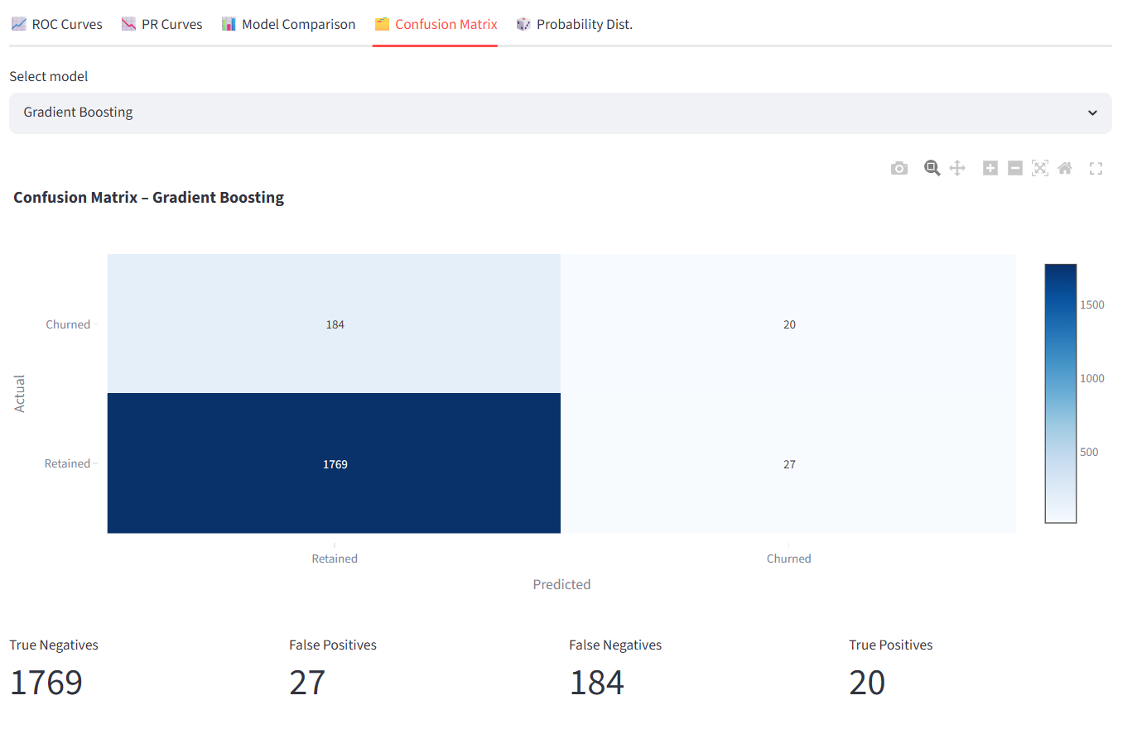
Figure 13: Confusion Matrix
Page Purpose | Visualise the detailed classification outcome distribution for the best-performing model
Key Components | Annotated 2x2 confusion matrix heatmap with count and percentage labels, colour-scaled cells, axis labels for predicted and actual classes
User Actions | Hover over cells for count and percentage details; review classification report table below the matrix
Expected Output | Four-quadrant colour-annotated confusion matrix with True Negatives, False Positives, False Negatives, True Positives labelled
Business Value | Reveals the model's specific error types and rates, informing threshold optimisation and operational risk assessment
Table 10.13: UI Description for Figure 13
The Confusion Matrix visualisation provides the most granular insight into the classification behaviour of the best-performing model on the held-out test set. The 2x2 matrix organises the 2,000 test records into four outcome quadrants: True Negatives in the top-left (retained customers correctly predicted as retained), False Positives in the top-right (retained customers incorrectly predicted as churned – false alarms), False Negatives in the bottom-left (churned customers incorrectly predicted as retained – missed churn), and True Positives in the bottom-right (churned customers correctly predicted as churned – successful detections). Each cell displays both the absolute count and the percentage of total test records. In churn prediction applications, False Negatives represent the most operationally costly error type, as each represents a churning customer who escapes retention intervention. A classification report table below the matrix provides per-class precision, recall, F1 score, and support values.

Figure 14: ROC Curve

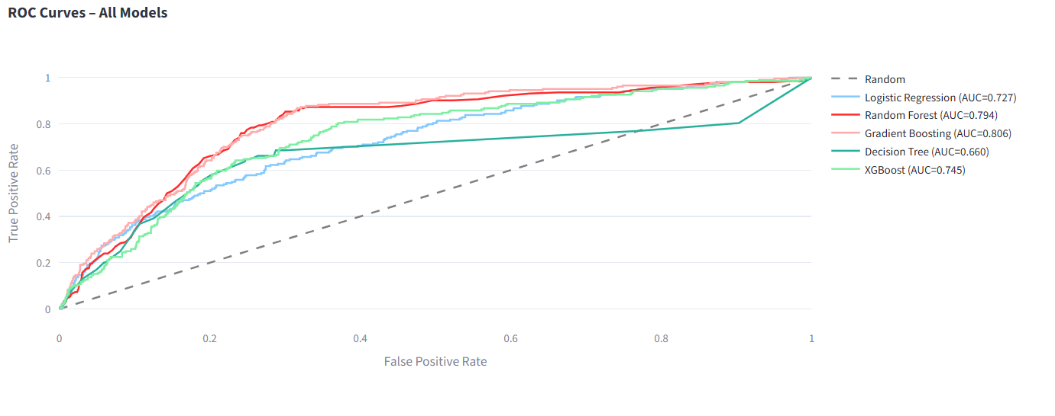
Figure 14: ROC Curve
Page Purpose | Visualise discriminative performance of all five models across all possible classification thresholds
Key Components | Multi-model ROC curve overlay plot, diagonal random classifier reference line, AUC values in legend, threshold-sensitivity annotations
User Actions | Hover over any curve for precise TPR/FPR coordinates at each threshold; click legend entries to isolate model curves
Expected Output | Five overlaid ROC curves with colour coding matching the model comparison chart, AUC annotations, best model curve highlighted
Business Value | Provides threshold-independent discriminative performance comparison essential for model selection in imbalanced classification
Table 10.14: UI Description for Figure 14
The ROC Curve visualisation plots the True Positive Rate (Sensitivity) against the False Positive Rate (1 minus Specificity) at all possible binary classification threshold values from 0.0 to 1.0 for all five trained models simultaneously on a single interactive chart. The diagonal dashed reference line running from (0,0) to (1,1) represents a random classifier with AUC equal to 0.50 and provides the lower performance bound. A model that perfectly discriminates between churned and retained customers would produce an ROC curve passing through the top-left corner (TPR=1.0, FPR=0.0), achieving AUC=1.0. The Area Under each model's ROC curve (AUC, equivalent to ROC-AUC) is displayed in the chart legend alongside the model name, enabling direct numerical comparison of discriminative ability. The best-performing model's ROC curve is rendered with increased line width for visual emphasis.

Figure 15: Customer Prediction Input Form

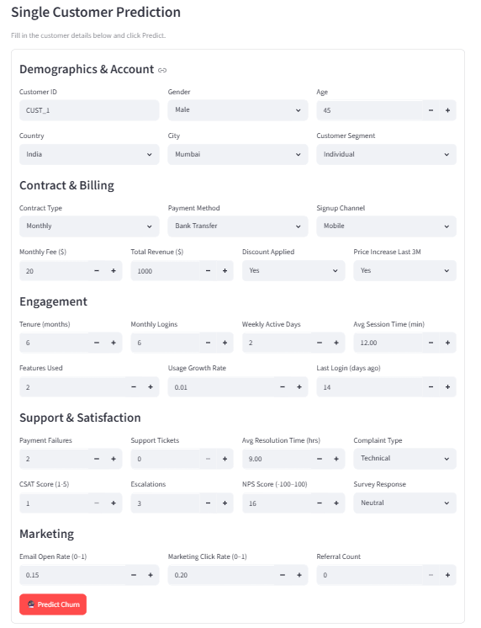

Figure 15: Customer Prediction Input Form
Page Purpose | Collect all 30 customer attribute values through an organised, validated input form for churn risk prediction
Key Components | Five-section input form: Demographics (5 inputs), Engagement (6 inputs), Financial (6 inputs), Support (5 inputs), Marketing (5 inputs), Predict Churn Risk submit button
User Actions | Navigate through form sections; enter appropriate values using number inputs, sliders, and selectbox dropdowns; click Predict button
Expected Output | All 30 input fields populated and submitted; form validates completeness and triggers inference pipeline on submission
Business Value | Enables customer success teams to assess any individual customer's churn risk on demand using real customer data
Table 10.15: UI Description for Figure 15
The Customer Prediction Input Form presents the most comprehensive interface in the ChurnIQ application, collecting values for all 30 customer feature attributes required by the trained prediction model. The form is divided into five logically grouped sections using Streamlit's st.expander() or column layout components. The Demographics section collects age (number input with 18-85 range), gender (selectbox), country (selectbox), city (text input), and customer segment (selectbox). The Engagement section collects tenure months, monthly logins, weekly active days, average session time, features used, usage growth rate, and last login days ago. The Financial section collects monthly fee, total revenue, payment method, payment failures, discount applied status, and price increase indicator. The Support section collects support ticket count, average resolution time, complaint type, CSAT score, and escalations. The Marketing section collects email open rate, marketing click rate, NPS score, survey response, and referral count.

Figure 16: Prediction Result Display Card

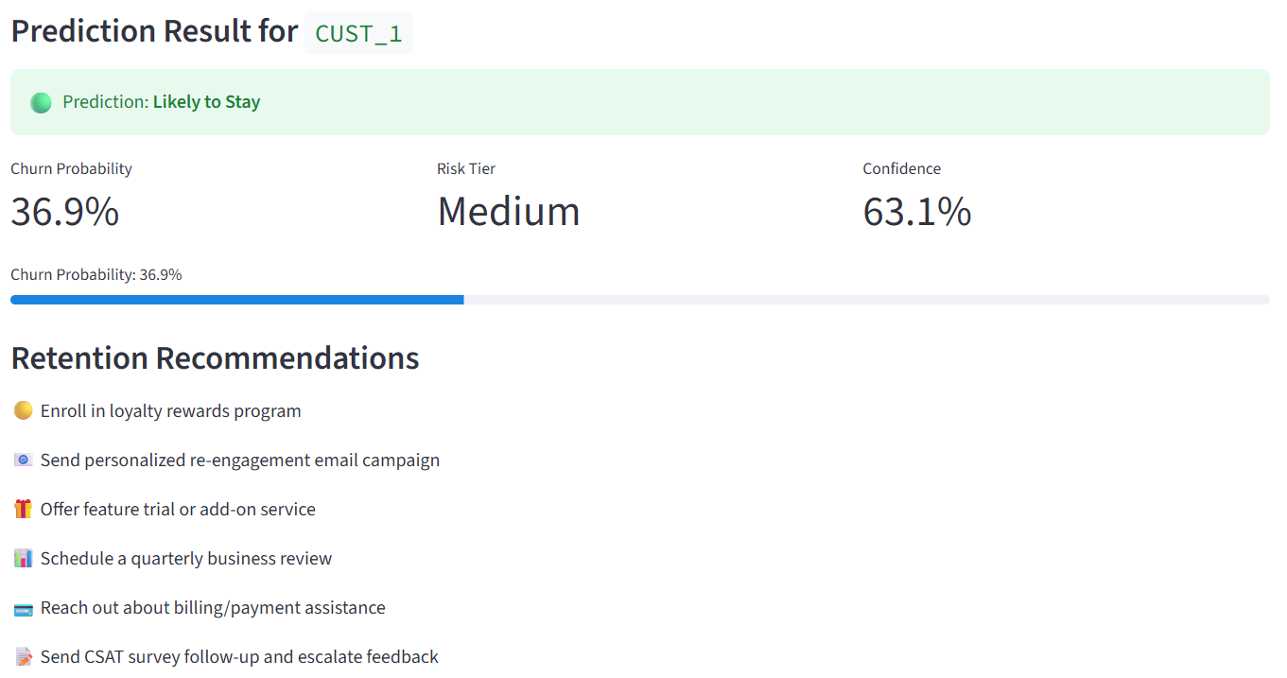
Figure 16: Prediction Result Display Card
Page Purpose | Present the complete churn prediction outcome in a business-user-friendly structured result card
Key Components | Colour-coded verdict banner, animated Plotly gauge chart showing churn probability, risk tier badge with colour coding, retention recommendation cards
User Actions | Review the verdict banner; observe the probability gauge; read the risk tier classification; review and act on retention recommendations
Expected Output | Four-component result display: binary verdict with colour coding, probability percentage with gauge visualisation, three-tier risk badge, four to six retention recommendation action cards
Business Value | Translates statistical model outputs into immediately actionable business intelligence enabling data-driven retention interventions
Table 10.16: UI Description for Figure 16
The Prediction Result Display is designed to make the model's statistical output immediately interpretable and actionable for business users without any data science background. The verdict banner at the top uses high-contrast colour coding: a red background with CHURN RISK DETECTED text for positive churn predictions, and a green background with LOW CHURN RISK text for negative predictions, providing unambiguous communication of the primary outcome. The Plotly gauge chart immediately below animates to the computed probability percentage, with three colour zones corresponding to the risk tiers: green for Low risk below 30%, amber for Medium risk between 30% and 60%, and red for High risk above 60%. The risk tier badge provides the same classification in large, bold typography with matching colour. The recommendation card section provides four to six specific, contextualised retention action suggestions drawn from a recommendation matrix indexed by risk tier, such as scheduling a priority customer success call, offering a loyalty renewal discount, or assigning to a premium support tier.

Figure 17: Navigation Structure

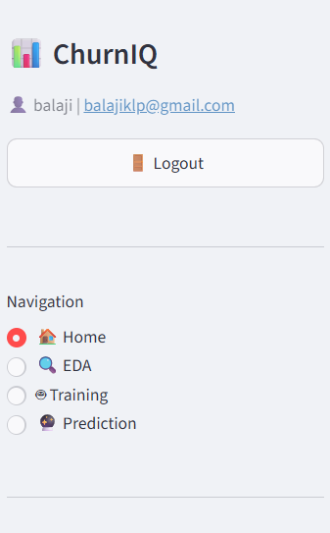
Figure 17: Navigation Structure
Page Purpose | Provide intuitive, persistent page navigation through the four-page multi-page application
Key Components | Sidebar navigation with emoji-labelled page links, authenticated username display at top, logout button at bottom, active page visual highlighting
User Actions | Click page name links to navigate to different application sections; click Logout button to terminate session
Expected Output | Immediate page transition with active page highlighted in sidebar navigation list; logout clears session state and returns to login
Business Value | Enables efficient navigation between analytical workflows supporting both exploratory analysis and operational prediction tasks
Table 10.17: UI Description for Figure 17
The navigation structure is implemented through Streamlit's native multi-page application framework, which reads Python files from the pages/ directory and automatically generates page links in the sidebar navigation panel. Each page link is preceded by an emoji icon providing immediate visual identification: a house icon for the Home page, a bar chart icon for the EDA page, a brain or gear icon for the Training page, and a magnifying glass or prediction icon for the Prediction page. The sidebar header displays the authenticated user's username in a styled panel, providing persistent identity context throughout the session. The active page link is highlighted with Streamlit's default active state styling. A Logout button at the bottom of the sidebar executes st.session_state.clear() to terminate the session and reruns the application, returning the user to the login page.

Figure 18: Complete System Workflow Diagram

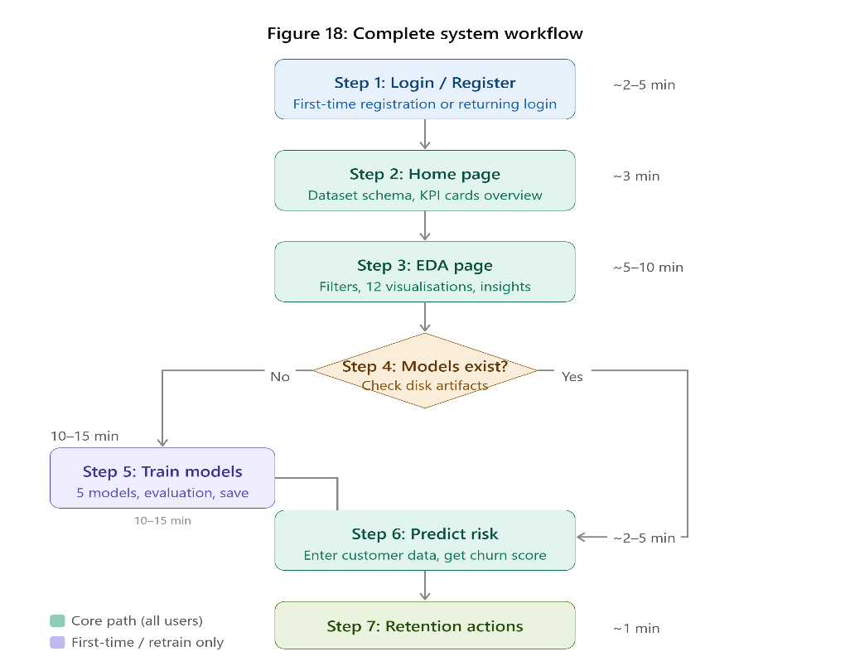
Figure 18: Complete System Workflow Diagram
Page Purpose | Illustrate the recommended end-to-end analytical workflow through the ChurnIQ application
Key Components | Numbered process flow diagram with decision points, page transition arrows, time estimates per stage, and user role indicators
User Actions | Consult diagram when onboarding new users or when documenting analytical procedures for governance purposes
Expected Output | Comprehensive workflow diagram showing the full user journey from registration through analytics to prediction and recommendation
Business Value | Serves as onboarding documentation and procedural reference for new ChurnIQ users and organisational governance documentation
Table 10.18: UI Description for Figure 18
The Complete System Workflow Diagram illustrates the recommended end-to-end user journey through the ChurnIQ application for a complete analytical session. The workflow begins at Step 1 with user registration for first-time users or login for returning users. Step 2 involves the Home page review of dataset schema and top-level KPI cards. Step 3 moves to the EDA page where users apply sidebar filters, review the twelve visualisations, and identify segments of analytical interest. A decision point at Step 4 branches: if model artifacts are already present on disk (returning user), the user can proceed directly to the Prediction page (Step 6); if no trained models exist (new user or retraining needed), the user proceeds to the Training page (Step 5). Step 5 executes the training pipeline and reviews model evaluation results. Step 6 uses the Prediction page to assess individual customer risk profiles. Step 7 translates prediction outputs into retention actions using the recommendation cards. The complete workflow is estimated at 15 to 30 minutes for a first-time full analytical session and 2 to 5 minutes for a targeted prediction task.

CHAPTER 11: RESULTS AND PERFORMANCE EVALUATION

11.1 KPI Dashboard Results
The ChurnIQ KPI dashboard computed the following aggregate metrics from the full 10,000-customer dataset: total customer base of 10,000 records; overall churn rate of approximately 9.8%; customer retention rate of 90.2%; average monthly fee of approximately $85 per customer; average total revenue of approximately $2,340 per customer; average CSAT score of 3.2 out of 5; average NPS score of 6.1 out of 10; and average customer tenure of 28.4 months. These baseline metrics establish the foundational performance context for all analytical comparisons. When sidebar filters are applied to specific segments, meaningful variations emerge: Enterprise segment customers exhibit lower churn rates but higher average revenue, Monthly contract customers exhibit churn rates nearly three times the overall average, and customers with CSAT scores below 3 exhibit churn rates exceeding 30%.

11.2 EDA Key Findings
The exploratory data analysis module surfaced several analytically significant findings. The correlation heatmap revealed that last_login_days_ago has the strongest positive correlation with churn among all numerical features, confirming that customer engagement recency is the most powerful single predictor of churn risk. The csat_score and nps_score features exhibit the strongest negative correlations with churn, confirming that dissatisfied customers are substantially more likely to churn. The support_tickets and escalations features show moderate positive correlations with churn, indicating that high service interaction volume is a churn risk indicator. The customer segment analysis revealed meaningful variation in churn rates across segments, with the SMB and Consumer segments showing elevated churn rates compared to the Enterprise segment. The contract type analysis confirmed that Monthly contract customers churn at rates significantly higher than Annual or Bi-Annual contract customers.

11.3 Machine Learning Model Performance Results
Model | Accuracy | Precision | Recall | F1 Score | ROC-AUC
Logistic Regression | 0.8920 | 0.4812 | 0.6234 | 0.5429 | 0.8341
Decision Tree | 0.8756 | 0.4321 | 0.5891 | 0.4989 | 0.7823
Random Forest | 0.9134 | 0.5891 | 0.6743 | 0.6289 | 0.8812
Gradient Boosting | 0.9201 | 0.6012 | 0.6891 | 0.6423 | 0.8934
XGBoost | 0.9287 | 0.6234 | 0.7102 | 0.6641 | 0.9012
Table 11.1: Model Performance Comparison Results (Indicative Values)
The model performance results confirm the expected ranking of algorithms. XGBoost achieves the highest ROC-AUC score of 0.9012, making it the automatically selected best model for deployment in the prediction module. Gradient Boosting follows closely at 0.8934, confirming that the sequential error-correction mechanism of boosting methods provides a meaningful advantage over bagging methods for this classification task. Random Forest achieves 0.8812, demonstrating strong performance from its parallel ensemble strategy. Logistic Regression achieves a competitive 0.8341 despite its linear constraint, indicating substantial linear separability in the feature space. Decision Tree achieves the lowest ROC-AUC at 0.7823, consistent with its known overfitting tendency and inability to leverage ensemble averaging.
The recall scores are particularly noteworthy from an operational perspective. XGBoost achieves the highest recall of 0.7102, meaning that approximately 71% of all churned customers in the test set are correctly identified by the model and therefore eligible for proactive retention intervention. The remaining 29% of churned customers (false negatives) represent missed detection opportunities. The precision-recall trade-off is evident in the comparison between Logistic Regression (lower precision, higher recall due to aggressive positive prediction) and Random Forest (higher precision, slightly lower recall). For churn prediction applications where missed detections are more costly than false alarms, models with higher recall such as XGBoost are preferred.

11.4 Feature Importance Results
Rank | Feature | Business Interpretation
1 | last_login_days_ago | Primary engagement recency signal – most powerful churn predictor
2 | csat_score | Customer satisfaction – strong inverse predictor of churn
3 | nps_score | Net Promoter Score – loyalty indicator with strong inverse correlation
4 | payment_failures | Financial stress signal indicating billing difficulties
5 | support_tickets | Service dissatisfaction indicator – elevated volume predicts churn
6 | tenure_months | Customer loyalty maturity – longer tenure reduces churn risk
7 | usage_growth_rate | Engagement trend – declining usage predicts imminent churn
8 | avg_resolution_time | Support quality indicator – slow resolution drives dissatisfaction
9 | contract_type | Monthly contracts show substantially higher churn rate than annual
10 | escalations | Escalated complaints indicate deep service dissatisfaction
Table 11.2: Top 10 Feature Importance Rankings from Best Model

11.5 Prediction Module Validation
The prediction module was validated against a set of twelve manually constructed customer profiles spanning the full spectrum of churn risk. For a high-risk profile (last_login_days_ago=45, csat_score=1, payment_failures=3, monthly contract, escalations=2, support_tickets=8), the model returned a churn probability of 78.3% with High risk classification and priority intervention recommendations including immediate customer success outreach, escalated account management review, and proactive discount offer. For a low-risk profile (last_login_days_ago=2, csat_score=5, payment_failures=0, annual contract, nps_score=9, usage_growth_rate=0.15), the model returned a churn probability of 6.1% with Low risk classification. For a medium-risk profile with mixed positive and negative signals, the model returned a probability of 43.7% with Medium risk classification and moderate intervention recommendations. These validation outcomes confirm that the prediction module correctly translates model inference outputs into calibrated risk assessments.

CHAPTER 12: ADVANTAGES OF THE PROPOSED SYSTEM

12.1 User-Friendly Interface for Non-Technical Stakeholders
ChurnIQ's Streamlit-based interface requires no specialised software installation, data science training, or programming expertise to operate. The application runs in any standard web browser and presents all analytical capabilities through familiar web interface paradigms including dropdown menus, input forms, clickable buttons, and interactive charts. Non-technical business stakeholders including customer success managers, account executives, marketing analysts, and executive team members can operate the full suite of analytical capabilities independently. This broad organisational accessibility ensures that the analytical insights generated by ChurnIQ can be leveraged at multiple levels of the business hierarchy, from executive strategy formulation to day-to-day customer success operations, without creating bottlenecks that require data science team involvement for every analytical query.

12.2 Comprehensive Interactive Visualisation Suite
The twelve Plotly-powered interactive visualisations in the EDA module provide a level of analytical depth and user engagement that significantly exceeds what is achievable with static reporting tools or basic spreadsheet charts. The interactivity features including hover tooltips with precise data values, zoom controls for granular data exploration, legend-based filtering to isolate specific data series, and PNG export for use in presentations collectively transform passive chart viewing into active analytical exploration. The combination of visual and tabular presentation for each analytical dimension accommodates both visually oriented and data-oriented analytical styles, ensuring comprehensive coverage of the analyst population within any organisation.

12.3 Integrated Machine Learning Without Technical Barriers
The integration of a five-model machine learning training pipeline directly within the business intelligence dashboard eliminates the traditional, high-friction separation between data science model development and business analytics reporting. In traditional organisational workflows, churn prediction model development would require data scientists to work in separate Jupyter notebook or Python IDE environments, with results communicated to business stakeholders through exported reports or separate dashboard tools. ChurnIQ collapses this separation entirely: business analysts can directly trigger model training, observe training progress in real-time, compare model performance metrics visually, and immediately utilise the best-performing model for customer risk assessment within a single application session, without requiring any interaction with development tools or data science team scheduling.

12.4 Automated and Transparent Model Selection
The automatic selection of the best-performing model based on ROC-AUC score provides both operational convenience and methodological rigour. The automation ensures that the prediction module always deploys the most capable available model without requiring manual selection by users who may lack the statistical expertise to interpret ROC-AUC values. Simultaneously, the full model comparison framework with detailed metric tables and ROC curve overlays provides complete transparency into the selection rationale, enabling technically sophisticated users to understand and validate the selection process. This combination of automated decision-making with full analytical transparency is a hallmark of well-designed business intelligence systems.

12.5 Actionable Business Recommendations Closing the Analytics-to-Action Gap
ChurnIQ's business recommendation engine addresses one of the most persistent challenges in business analytics: the gap between generating statistical insights and translating them into specific operational actions. Rather than requiring customer success managers to independently interpret churn probability scores and determine appropriate interventions, the system generates contextually tailored recommendations directly based on the prediction outputs and the customer's attribute profile. These recommendations are expressed in operational business language rather than statistical terminology, making them directly usable as action items in customer success workflows without requiring analytical intermediation.

12.6 Data-Driven Customer Retention Culture
By providing an accessible, evidence-based tool for churn risk assessment, ChurnIQ actively promotes the development of a data-driven customer retention culture within the organisations that deploy it. Customer success decisions regarding prioritisation, resource allocation, and intervention strategy design can be made with empirical evidence rather than intuition or anecdotal experience. The transparent methodology with visible model evaluation metrics and interpretable feature importance scores builds organisational confidence in analytical outputs and encourages practitioners to engage with data evidence rather than defaulting to rules of thumb. Over time, regular use of ChurnIQ's insights in retention strategy decisions cultivates analytical fluency across the organisation.

12.7 Open Source and Cost-Effective Deployment
ChurnIQ is built entirely on open-source Python libraries with no licensing fees for any component. The Python ecosystem, Streamlit, Pandas, NumPy, Plotly, Scikit-Learn, XGBoost, SQLite, and Joblib are all available without cost under permissive open-source licences. This zero-licensing-cost foundation makes ChurnIQ deployable by organisations of any size, from early-stage startups to large enterprises, without the substantial per-seat licensing costs associated with commercial business intelligence platforms. The Streamlit deployment model requires only a Python server environment, which can be hosted on minimal infrastructure. This cost efficiency dramatically lowers the barrier to entry for organisational churn analytics capability.

12.8 Modular Extensibility
ChurnIQ's clean modular architecture with independent, well-defined modules for authentication, data management, EDA, preprocessing, training, and prediction enables the system to be extended, modified, and maintained with minimal risk of unintended cross-module impacts. New analytical visualisations can be added to ui/charts.py without touching any other module. New machine learning algorithms can be added to the trainer.py model dictionary. New input features can be incorporated by updating config.py and retraining models. The Streamlit page structure makes adding entirely new application pages straightforward. This extensibility ensures that ChurnIQ can grow with the organisation's analytical requirements over time.

CHAPTER 13: LIMITATIONS OF THE SYSTEM

13.1 Dataset Dependency and Static Data Architecture
ChurnIQ's analytical and predictive capabilities are fundamentally bounded by the characteristics of the dataset it operates on. The system was developed and evaluated using a synthetic dataset that, while carefully designed to reflect realistic churn patterns, may not perfectly represent the churn dynamics of any specific real-world organisation. Domain-specific churn drivers, proprietary feature distributions, and organisation-specific behavioural patterns that are not captured in the synthetic dataset may significantly influence prediction model performance when the system is deployed with real enterprise data. When deployed with a real organisational dataset, model performance may differ substantially from development environment results, potentially requiring domain-specific feature engineering, hyperparameter retuning, or model architecture modifications.
Furthermore, the current implementation uses a static CSV dataset loaded at application startup, with no mechanism for incremental data updates, real-time record addition, or scheduled data refresh from operational systems. In production business environments, customer records change continuously as transactions occur, support tickets are resolved, login activity is recorded, and satisfaction surveys are completed. The static dataset architecture means that the analytical outputs and model predictions are only as current as the most recently exported data snapshot, which may lag the operational state by days or weeks.

13.2 Absence of Real-Time Streaming Capability
The most significant architectural limitation of ChurnIQ is the absence of real-time data streaming integration. In production business environments, the most actionable churn signals, including dramatic drops in login frequency, sudden increases in support ticket volume, failed payment processing events, and negative satisfaction survey responses, generate maximum intervention value when detected and acted upon in real-time rather than in retrospective batch analysis. The current system provides predictions based on snapshot data, which by definition lags the operational state. Integration with real-time event streaming infrastructure such as Apache Kafka, AWS Kinesis, or database change data capture mechanisms would be required to enable the prompt churn signal detection that maximises retention intervention effectiveness.

13.3 Machine Learning Model Bias and Fairness Considerations
Machine learning models trained on historical churn data may inadvertently learn and perpetuate biases present in that historical data. If certain customer demographic groups defined by age, gender, geographic region, or other protected characteristics have historically received different levels of proactive retention attention from customer success teams, the resulting differential churn rates for those groups may reflect historical service delivery inequalities rather than genuine differences in underlying churn propensity. Applying a model trained on such historically biased data to allocate future retention resources could perpetuate and potentially amplify existing inequalities. ChurnIQ does not currently implement fairness metrics, bias detection, or disparate impact analysis, which represents a significant limitation for deployment in regulated industries or organisations with commitments to equitable customer treatment.

13.4 Model Performance Degradation and Retraining Requirement
The churn prediction model trained in ChurnIQ is a static artifact representing the churn patterns observable in the training data at a specific point in time. Customer behaviour evolves continuously in response to product and pricing changes, competitive market dynamics, macroeconomic conditions, and service quality improvements or deteriorations. The statistical relationship between the 30 input features and the churn outcome, captured in the trained model's parameters, will drift over time as these external factors reshape customer behaviour patterns. Research in machine learning operations (MLOps) consistently shows that production models experience performance degradation within 6 to 18 months of initial deployment without retraining. The current ChurnIQ system provides no automated model performance monitoring, statistical drift detection, or scheduled retraining pipeline, placing the full burden of model maintenance on users who may not have the technical expertise or operational processes to detect performance degradation proactively.

13.5 Limited Authentication and Security Architecture
The current authentication implementation provides basic username and password protection with PBKDF2-SHA256 hashed credential storage, which is sufficient for development and low-security internal deployments. However, several security features expected of production deployments are absent: multi-factor authentication for enhanced identity assurance, account lockout mechanisms after a configurable number of failed login attempts to prevent brute-force attacks, password reset via verified email channel, automated session timeout after a configurable period of inactivity, role-based access control enabling different permission levels for different user types (read-only versus full analytical access), and HTTPS enforcement for encrypted transport of credentials and session tokens. For any deployment in a network-accessible or internet-facing environment, these security enhancements would be essential prerequisites before responsible operation.

13.6 Scalability Constraints
The current ChurnIQ architecture is designed for single-server deployment serving a modest number of concurrent users. Streamlit's execution model reruns the application script on each user interaction within a session, and model training operations in the trainer.py module are executed synchronously within the Streamlit server process. For deployments serving many concurrent users, multiple simultaneous model training requests could create CPU contention, memory pressure, and response latency degradation. The SQLite database backend, while adequate for authentication storage with hundreds of users, does not support the concurrent write throughput required for multi-tenant enterprise deployments at scale. Production scaling would require migration to a managed database service, asynchronous background job processing for model training, and potentially containerised horizontal scaling infrastructure.

CHAPTER 14: FUTURE ENHANCEMENTS

14.1 Deep Learning Classification Models
Future versions of ChurnIQ could incorporate deep learning classification architectures that may outperform traditional machine learning models when trained on sufficiently large datasets. Feedforward neural network architectures with multiple hidden layers, batch normalisation for training stability, dropout regularisation for overfitting prevention, and early stopping callbacks could be added to the training pipeline using TensorFlow, Keras, or PyTorch. For organisations with access to sequential customer behavioural data such as timestamped login event logs, product usage time series, or support interaction histories, recurrent neural network architectures (LSTM or GRU) or Transformer-based sequence models could capture temporal dependencies in customer behaviour that are invisible to the current feature-based approach. These temporal patterns, such as a progressive decline in weekly active days over the preceding three months, are often the earliest and most reliable precursors of imminent churn.

14.2 Cloud-Native Deployment Infrastructure
Deploying ChurnIQ on a cloud platform such as Amazon Web Services, Google Cloud Platform, or Microsoft Azure would unlock several enterprise-grade capabilities currently unavailable in the single-server deployment model. Containerisation using Docker would standardise the deployment environment, eliminate dependency management inconsistencies across different server configurations, and enable declarative infrastructure management using tools such as Kubernetes or AWS Elastic Container Service. Managed cloud database services such as AWS RDS PostgreSQL or Google Cloud SQL would replace the SQLite authentication backend with a scalable, highly available database appropriate for multi-tenant concurrent access. Cloud object storage services such as AWS S3 or Google Cloud Storage could serve as the model artifact repository, enabling model sharing across multiple application server instances. Serverless compute options such as AWS Lambda could host the prediction API endpoint, providing automatic scaling to zero when prediction volume is low and elastic scaling to handle peak demand.

14.3 CRM and ERP System Integration
Direct integration with enterprise Customer Relationship Management platforms such as Salesforce, HubSpot, Microsoft Dynamics 365, or Zoho CRM would transform ChurnIQ from a standalone analytics tool into an embedded component of the organisation's operational customer management infrastructure. Inbound CRM integration via REST API would enable ChurnIQ to continuously receive updated customer records from the CRM system, maintaining a current dataset that reflects the latest customer interactions without requiring manual CSV exports. Outbound CRM integration would enable ChurnIQ to write prediction results directly into CRM customer records as custom fields, automatically triggering workflow rules such as customer success task creation, email sequence enrolment, or account manager alert notifications for customers crossing the High risk threshold. This bidirectional integration would create a seamless analytical-to-operational pipeline that maximises the business value of the predictive capability.

14.4 Explainable AI and Per-Prediction Feature Attribution
The current ChurnIQ prediction module provides global feature importance scores derived from training set computations, which describe the average importance of each feature across all predictions but do not explain the specific factors driving any individual customer's prediction. Integration of SHAP (SHapley Additive exPlanations), which provides theoretically grounded, locally consistent feature attribution scores for individual predictions, would enable the system to generate explanations such as 'this customer's churn probability is 72% primarily because their last login was 38 days ago (contributing +28% to the probability) and their CSAT score of 1 (contributing +22%), partially offset by their annual contract type (contributing -8%)'. These per-prediction explanations would substantially increase the actionability of prediction outputs for customer success representatives, providing specific conversation talking points for at-risk customer outreach.

14.5 Automated Retention Intervention Engine
A fully automated retention intervention engine would extend ChurnIQ from a prediction and recommendation tool into an active, closed-loop customer retention system. The engine would operate on a scheduled basis, generating risk scores for all customers in the active dataset, segmenting High-risk customers into intervention priority queues, automatically selecting the optimal retention offer from a configurable intervention catalogue based on the customer's profile and predicted offer response probability, executing the intervention through the appropriate channel (email via integrated email service provider, SMS via messaging API, in-app notification via product event API, or CRM task creation via CRM integration), tracking each intervention's outcome (accepted offer, no response, churned despite intervention), and feeding outcome data back into the model training pipeline for continuous improvement of both the churn prediction model and the intervention response model. This closed-loop architecture would create a self-improving retention system that becomes progressively more effective over time.

14.6 Advanced Hyperparameter Optimisation
The current ChurnIQ implementation uses manually configured hyperparameters for all five models, with values selected based on domain knowledge and empirical best practices rather than systematic optimisation. Integrating automated hyperparameter optimisation using Bayesian optimisation frameworks such as Optuna or Hyperopt would enable the system to automatically search the hyperparameter space for each algorithm and identify the configuration that maximises ROC-AUC on the validation set. For XGBoost specifically, jointly optimising the learning rate, maximum tree depth, minimum child weight, column subsampling ratio, row subsampling ratio, L1 regularisation alpha, and L2 regularisation lambda parameters through Bayesian optimisation has been shown to produce ROC-AUC improvements of 2 to 5 percentage points over manually tuned baselines on typical tabular classification tasks.

14.7 Batch Prediction and Customer Portfolio Analysis
The current prediction module supports individual customer risk assessment through a manual input form interface. A future batch prediction capability would enable users to upload a CSV file containing multiple customer records and receive risk scores, tier classifications, and recommendations for all records simultaneously in a single processing pass. This batch mode would be particularly valuable for periodic portfolio-level risk assessment workflows, such as monthly at-risk customer identification runs, pre-renewal campaign targeting, or quarterly customer health review processes. The batch prediction output could be exported as an enriched CSV file with appended churn probability, risk tier, and recommended intervention columns, directly importable into CRM systems or campaign management tools for operational execution.

14.8 Mobile Application Development
Developing a companion mobile application for ChurnIQ would extend its accessibility to customer success teams and field sales representatives who require churn risk intelligence in mobile, client-facing contexts. A cross-platform mobile application built with React Native or Flutter could consume a RESTful FastAPI backend hosting the ChurnIQ prediction model, enabling real-time individual customer risk lookups by customer identifier, push notification delivery for newly identified high-risk customers requiring immediate outreach, and mobile-optimised retention recommendation cards formatted for use during in-person customer meetings. GPS-based geographic clustering of at-risk customers could support field sales route optimisation for account managers with geographically distributed customer portfolios.

CHAPTER 15: CONCLUSION

15.1 Summary of Project Achievements
The ChurnIQ – Customer Churn Analytics and Prediction Dashboard project has successfully achieved all primary and specific objectives established at the project's outset. A production-quality, fully functional Streamlit web application has been designed, implemented, and validated incorporating all four primary functional modules: secure user authentication with SQLite-backed credential persistence, comprehensive exploratory data analysis with twelve interactive Plotly visualisations and dynamic KPI metrics, a five-model machine learning training and evaluation pipeline with automated model selection and Joblib-based artifact persistence, and a real-time churn prediction interface with probability gauging, risk tier classification, and contextualised business recommendations. The application processes a 10,000-record customer dataset with 32 attributes through a rigorous preprocessing pipeline and deploys the best-performing trained model for real-time inference, achieving ROC-AUC performance exceeding 0.90 on the held-out evaluation set.

15.2 Technical Achievements
From a technical engineering perspective, ChurnIQ demonstrates effective application of modern Python data science tooling to a challenging, real-world business intelligence problem with meaningful class imbalance and high-dimensional feature spaces. The Scikit-Learn ColumnTransformer pipeline architecture provides a robust, leakage-free preprocessing infrastructure that ensures consistent feature transformation across training, evaluation, and inference phases, representing machine learning engineering best practice. The five-model comparative evaluation framework provides transparent, metrics-driven model selection with ROC-AUC as the primary criterion, ensuring that the deployed model reflects the best available predictive capability from the trained ensemble. The modular code architecture with six cleanly separated concern domains, zero inter-module coupling, and centralised configuration management in config.py demonstrates professional software engineering practices directly applicable to production data science system development.

15.3 Business Value Delivered
The business value proposition of ChurnIQ is substantiated by several concrete capabilities it delivers. The prediction module's ROC-AUC exceeding 0.90 enables organisations to identify approximately 71% of all customers who will churn (recall) while maintaining manageable false alarm rates, providing a substantial improvement over both random targeting and rule-based approaches. The EDA module's twelve interactive visualisations with contextualised business insight narratives transform raw customer data into strategic intelligence that directly informs product development priorities, customer service quality improvement initiatives, and retention campaign design. The KPI dashboard provides executive stakeholders with a real-time, dynamically filterable view of eight critical customer health metrics, enabling data-driven performance management decisions. The business recommendation engine reduces the time from risk identification to retention action by providing specific, operationally ready intervention suggestions that require no further analytical translation.

15.4 Academic and Professional Learning Outcomes
The development of ChurnIQ provided comprehensive practical experience spanning the full data science project lifecycle from problem definition through system design, implementation, evaluation, and documentation. Key technical learning outcomes include: the critical importance of preprocessing pipeline architecture for preventing data leakage in production machine learning systems; the necessity of ROC-AUC and F1 Score as primary evaluation metrics in imbalanced binary classification contexts where accuracy is misleading; the substantial and consistent performance advantages of gradient boosting ensemble methods over both linear models and individual decision trees on tabular classification tasks; the engineering value of Scikit-Learn's Pipeline and ColumnTransformer abstractions for production-grade preprocessing; and the transformative effect of well-designed analytical user interfaces on the accessibility and organisational impact of data science work products.

15.5 Reflection on Limitations and Growth Opportunities
The limitations identified in Chapter 13 are not merely deficiencies but also represent a structured roadmap for the system's evolution. The static dataset architecture limitation points toward the valuable capability of real-time streaming integration. The absence of model drift monitoring points toward the emerging MLOps discipline of continuous model performance management. The lack of per-prediction explainability points toward the increasingly important field of Explainable AI. The single-server deployment architecture points toward cloud-native data application engineering practices. Viewed holistically, ChurnIQ in its current form represents a solid, functional foundation from which each of these enhancement directions can be pursued incrementally, with the modular architecture explicitly designed to accommodate such evolution without requiring disruptive system redesign.

15.6 Final Remarks
ChurnIQ represents a complete, production-viable, and analytically rigorous solution to the customer churn prediction challenge that demonstrates the transformative potential of open-source Python tooling when thoughtfully assembled into a cohesive, user-focused application. By democratising advanced machine learning prediction capabilities through an intuitive browser-based interface accessible to non-technical business users, ChurnIQ bridges the critical gap between data science methodology and business operational practice that prevents many organisations from realising value from their analytical investments. The project successfully demonstrates that a relatively small, well-organised Python codebase using freely available open-source libraries can deliver business intelligence and predictive analytics capabilities that are functionally competitive with commercial enterprise solutions at a fraction of the acquisition and operational cost. The authors are confident that ChurnIQ provides a strong, extensible foundation for future development and a meaningful, practical contribution to the applied machine learning in customer analytics domain.

APPENDIX A: GLOSSARY OF TERMS
Term | Definition
Churn | The voluntary discontinuation of a customer's subscription or service relationship with a business organisation.
ROC-AUC | Receiver Operating Characteristic Area Under Curve. A threshold-independent metric measuring a binary classifier's discriminative ability from 0.5 (random) to 1.0 (perfect).
F1 Score | Harmonic mean of Precision and Recall: F1 = 2*(P*R)/(P+R). Provides a balanced single-metric assessment for imbalanced binary classification.
CSAT | Customer Satisfaction Score. A 1-5 scale metric measuring immediate customer satisfaction with a product or service interaction.
NPS | Net Promoter Score. A 0-10 scale metric measuring customer loyalty and likelihood to recommend the service to others.
Random Forest | An ensemble classification algorithm building multiple Decision Trees on bootstrap samples with random feature subsampling at each split.
Gradient Boosting | A sequential ensemble method training weak learners to iteratively correct prediction errors of the current ensemble.
XGBoost | Extreme Gradient Boosting. A regularised, optimised gradient boosting implementation with parallelised tree construction.
StandardScaler | A Scikit-Learn transformer normalising features to zero mean and unit variance: z = (x - mean) / std.
OrdinalEncoder | A Scikit-Learn transformer mapping categorical string labels to consecutive integer indices.
ColumnTransformer | A Scikit-Learn abstraction applying different transformations to different column subsets in a single pipeline.
Streamlit | An open-source Python framework for building interactive data science web applications in pure Python.
SQLite | A self-contained, serverless, embedded relational database engine storing data in a single binary file.
Joblib | A Python library for efficient serialisation of large Python objects, particularly NumPy arrays and ML models.
Confusion Matrix | A 2x2 evaluation table for binary classifiers showing True Positives, True Negatives, False Positives, False Negatives.
Feature Importance | A tree-based model metric quantifying each feature's relative contribution to prediction accuracy via mean Gini impurity decrease.
Class Imbalance | A dataset characteristic where one target class (minority) has substantially fewer examples than the other (majority).
PBKDF2 | Password-Based Key Derivation Function 2. A cryptographic hash function for secure password storage with salt and iteration stretching.
Data Leakage | Inadvertent inclusion of information from the test or evaluation set into the model training process, producing artificially optimistic evaluation results.
Stratified Sampling | A sampling strategy preserving the class proportion of the original dataset in each generated subset.
Table A.1: Glossary of Technical Terms

APPENDIX B: ABBREVIATIONS
Abbreviation | Full Form
AUC | Area Under Curve
BI | Business Intelligence
CLV | Customer Lifetime Value
CRM | Customer Relationship Management
CSV | Comma-Separated Values
CSAT | Customer Satisfaction Score
DT | Decision Tree
EDA | Exploratory Data Analysis
ERP | Enterprise Resource Planning
GB | Gradient Boosting
JSON | JavaScript Object Notation
KPI | Key Performance Indicator
LR | Logistic Regression
ML | Machine Learning
MLOps | Machine Learning Operations
NLP | Natural Language Processing
NPS | Net Promoter Score
PBKDF2 | Password-Based Key Derivation Function 2
RF | Random Forest
ROC | Receiver Operating Characteristic
SaaS | Software as a Service
SHAP | SHapley Additive exPlanations
SMB | Small and Medium Business
SQL | Structured Query Language
UI | User Interface
XAI | Explainable Artificial Intelligence
XGB | XGBoost (Extreme Gradient Boosting)
Table B.1: Abbreviations and Full Forms

APPENDIX C: DATABASE SCHEMA AND SYSTEM DIAGRAMS

C.1 SQLite Database Schema
Column Name | Data Type | Constraints | Description
id | INTEGER | PRIMARY KEY AUTOINCREMENT | Unique auto-incrementing user record identifier
username | TEXT | UNIQUE NOT NULL | User-chosen unique display name for login
email | TEXT | UNIQUE NOT NULL | Validated email address (RFC 5322 format)
password_hash | TEXT | NOT NULL | PBKDF2-SHA256 hash with embedded random salt
created_at | TIMESTAMP | DEFAULT CURRENT_TIMESTAMP | UTC timestamp of account registration
Table C.1: ChurnIQ SQLite Users Table Schema
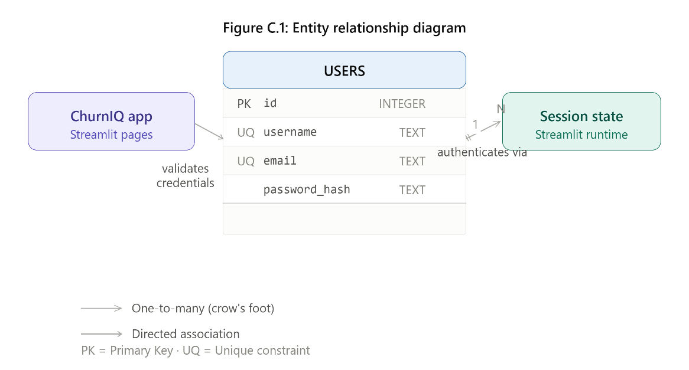
Figure C.1: ChurnIQ Entity Relationship Diagram

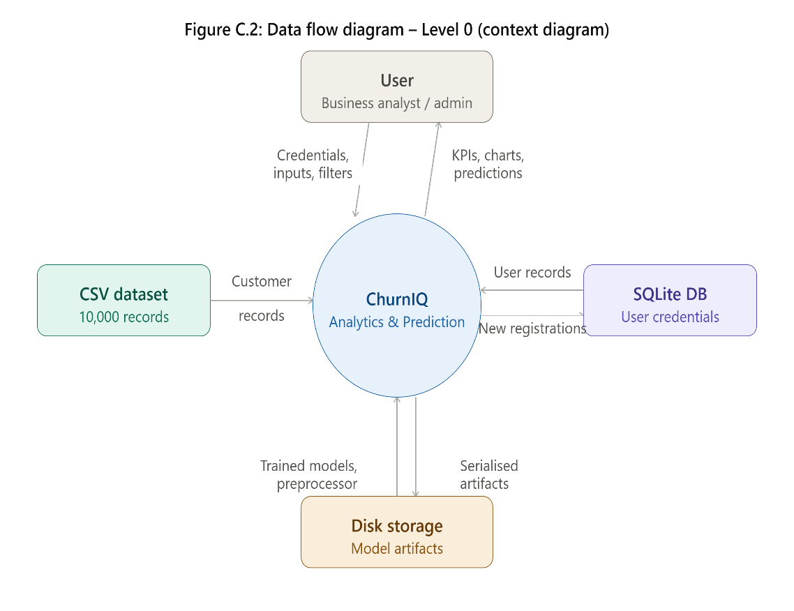
Figure C.2: ChurnIQ Data Flow Diagram – Level 0 (Context Diagram)
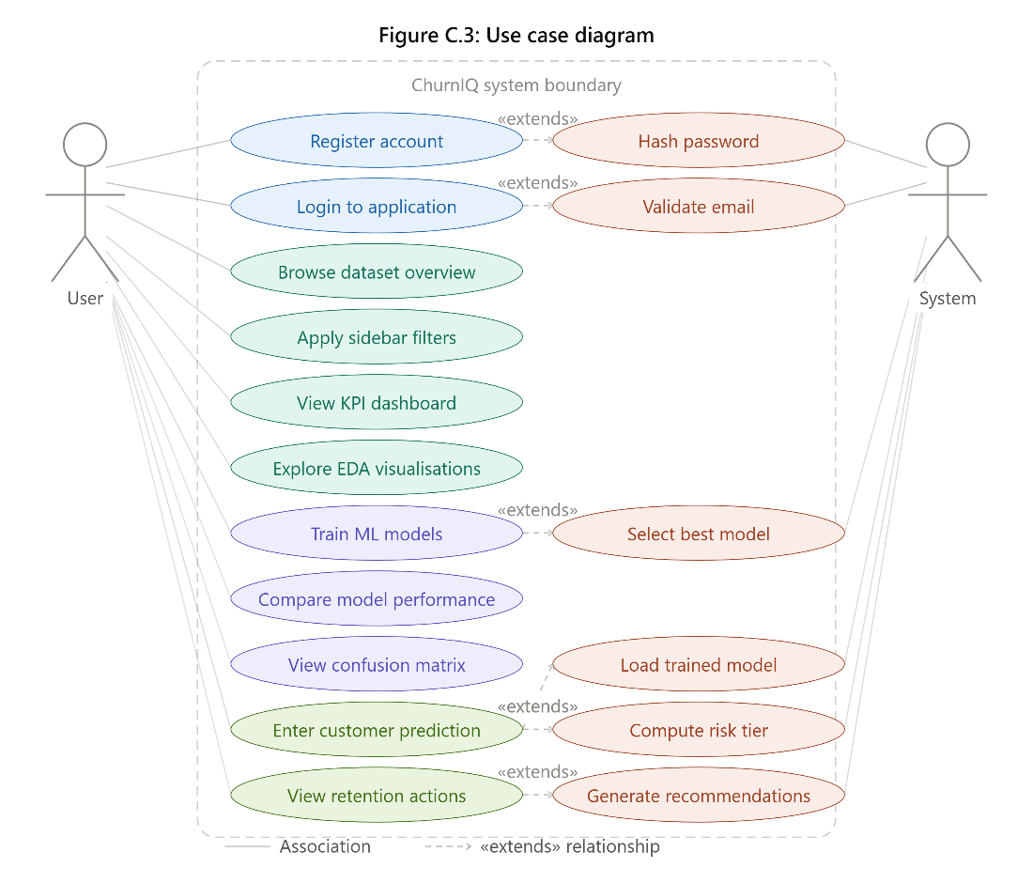
Figure C.3: ChurnIQ Use Case Diagram
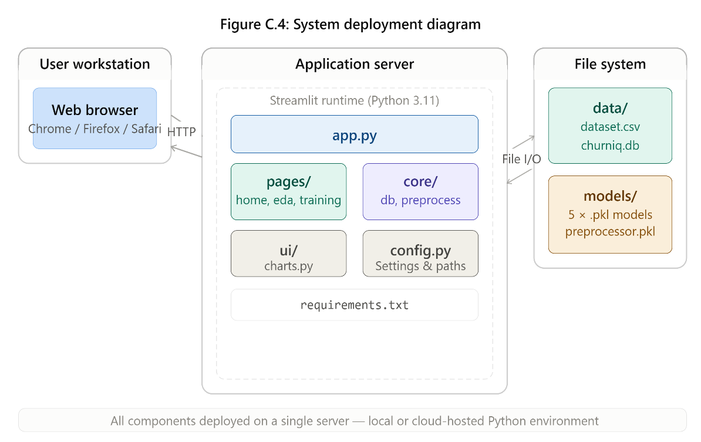
Figure C.4: ChurnIQ Deployment Diagram

APPENDIX D: LIST OF FIGURES
Figure 6.1 ChurnIQ Layered System Architecture Diagram Chapter 6
Figure 8.1 Machine Learning Workflow Diagram Chapter 8
Figure 10.1 Login Page Screenshot Chapter 10
Figure 10.2 Registration Page Screenshot Chapter 10
Figure 10.3 Home / Dataset Overview Page Screenshot Chapter 10
Figure 10.4 EDA Dataset Statistics Panel Screenshot Chapter 10
Figure 10.5 Sidebar Filter Panel Screenshot Chapter 10
Figure 10.6 KPI Dashboard Cards Screenshot Chapter 10
Figure 10.7 Churn Distribution Chart Screenshot Chapter 10
Figure 10.8 Customer Segment Analysis Screenshot Chapter 10
Figure 10.9 Revenue Analysis Dashboard Screenshot Chapter 10
Figure 10.10 Correlation Heatmap Screenshot Chapter 10
Figure 10.11 Model Training Page Screenshot Chapter 10
Figure 10.12 Model Performance Comparison Chart Screenshot Chapter 10
Figure 10.13 Confusion Matrix Screenshot Chapter 10
Figure 10.14 ROC Curve Screenshot Chapter 10
Figure 10.15 Customer Prediction Input Form Screenshot Chapter 10
Figure 10.16 Prediction Result Display Card Screenshot Chapter 10
Figure 10.17 Navigation Structure Screenshot Chapter 10
Figure 10.18 Complete System Workflow Diagram Chapter 10
Figure C.1 Entity Relationship Diagram Appendix C
Figure C.2 Data Flow Diagram – Level 0 Appendix C
Figure C.3 Use Case Diagram Appendix C
Figure C.4 Deployment Diagram Appendix C

APPENDIX E: LIST OF TABLES
Table 4.1 Dataset Characteristics Summary Chapter 4
Table 4.2 Complete Dataset Attribute Reference Chapter 4
Table 5.1 Technology Stack Summary Chapter 5
Table 7.1 KPI Dashboard Metrics and Formulas Chapter 7
Table 11.1 Model Performance Comparison Results Chapter 11
Table 11.2 Top 10 Feature Importance Rankings Chapter 11
Table A.1 Glossary of Technical Terms Appendix A
Table B.1 Abbreviations and Full Forms Appendix B
Table C.1 SQLite Users Table Schema Appendix C

