 

REPORT OF SUMMER INTERNSHIP 2024 (EVEN)

***Submitted by***

|  |  |
| --- | --- |
| **Sathish kanna L** | **111921CS01306** |

***in partial fulfillment for the award of the degree of***

***BACHELOR OF ENGINEERING***

# IN

**COMPUTER SCIENCE AND ENGINEERING**

# S. A. ENGINEERING COLLEGE, CHENNAI 600077

**ANNA UNIVERSITY: CHENNAI 600025**

**JUNE-2024**

# Abstract

This report presents a comprehensive summary of an internship experience in web development at Internpe Academy, emphasizing the creation and integration of essential web functionalities including a Login page, Registration page, and Currency Converter. The internship focused on both front-end and back-end technologies, providing hands-on experience in developing secure, responsive, and user-friendly components essential for a smooth user experience. Agile methodologies were adopted, enhancing project management skills and encouraging efficient collaboration with cross-functional teams, which strengthened communication and problem-solving abilities.

Technical skills acquired included front-end technologies such as HTML, CSS, Tailwind CSS, and React for dynamic, responsive design, as well as back-end technologies like Node.js and Express for handling server-side logic and secure data processing. MongoDB and Firebase were utilized for user data management and currency conversion data storage, ensuring fast and reliable performance. The Login and Registration pages focused on secure authentication, utilizing encryption and validation techniques to safeguard user information. The Currency Converter project, meanwhile, enabled real-time currency conversion, integrating API calls for up-to-date exchange rates and demonstrating effective use of asynchronous JavaScript.

The internship experience provided a well-rounded foundation in web development and reinforced essential soft skills, including teamwork, project coordination, and effective communication. The skills acquired are anticipated to facilitate continued growth and open doors to future opportunities within the rapidly advancing field of web development.

**Keywords**: web development, front-end technologies, back-end technologies, login page, registration page, currency converter, security, user experience, teamwork, communication skills.

# Introduction

This report summarizes the internship experience in Web Development, highlighting the practical skills gained in developing essential web applications, including a Login page, Registration page, and Currency Converter, in a collaborative, professional environment. The internship emphasized both front-end and back-end technologies, providing hands-on experience in creating secure, user-friendly interfaces while adhering to Agile methodologies. Working with cross-functional teams improved communication and problem-solving skills, while exposure to UX design principles and web security best practices reinforced the importance of user-centered design and data protection. Proficiency in version control systems like Git facilitated teamwork by enabling effective collaboration within a shared codebase, and active participation in deployment processes introduced essential DevOps practices. Regular client interactions provided valuable feedback, helping to tailor applications to user needs, while completing diverse projects added to a robust portfolio and strengthened professional connections. Overall, this internship reinforced technical expertise, instilled industry best practices in secure application development, and prepared me for a successful career in web development.

# Company Name:

The internship was undertaken at Internpe, a web development company known for its expertise in full-stack development solutions, encompassing both front-end and back-end services. Internpe collaborates with multiple industries to provide scalable web applications and cloud-based solutions tailored to client needs, ensuring exposure to real-world application development processes.

# Area of Internship:

The internship focused on Application Development, involving direct engagement with both front-end and back-end development aspects. As an Application Development Intern, responsibilities were carried out with a primary emphasis on building responsive and user-friendly applications. This included the integration of UI/UX improvements, addressing compatibility issues, and supporting cross-platform functionality. Regular collaboration with the design team enhanced communication skills, with troubleshooting tasks improving problem-solving abilities. A structured workflow was followed, using agile methodology to complete iterative development tasks, which cultivated a deeper understanding of efficient project management within a professional setting.

# Outcome of Internship:

Several valuable skills were acquired technical and soft skills:

# Technical Skills Acquired:

Proficiency was achieved in front-end technologies, including HTML, CSS, Tailwind CSS, and advanced React concepts, all of which contributed to the creation of responsive and user-friendly interfaces for the Login and Registration pages. Experience was also gained with back-end technologies such as Node.js and Express for server-side programming, which enabled secure data processing essential for user authentication and profile management. MongoDB and Firebase were used for data storage and retrieval, ensuring efficient handling of user information. Additionally, the Currency Converter application utilized API integration and asynchronous JavaScript for real-time currency updates, showcasing a practical understanding of dynamic data processing.

Practical experience in deploying applications on platforms like Render and Vercel enhanced understanding of deployment pipelines and live environment testing, essential for maintaining application functionality and user experience post-deployment.

**3.2 Soft Skills:**

Hands-on experience was acquired with version control systems such as Git and GitHub, developing skills in managing repositories, implementing effective branching strategies, and following best practices for commits. This experience reinforced the importance of maintaining clean and organized code, tracking changes, and collaborating efficiently within a shared codebase. Regular team coordination fostered strong communication skills, while collaborative problem-solving sessions promoted effective teamwork. Knowledge sharing within the team further deepened understanding of diverse technical approaches, enhancing the quality and efficiency of the project work.

**4. Developed Projects:**

During the internship, three major projects were developed:

**4.1 Project: Login Page**

The Login page was developed as a secure, user-friendly interface for user authentication. Built with HTML, CSS, and React, it features form validation, password encryption, and error handling to enhance security. The interface provides a seamless experience with instant feedback, guiding users through the login process. This project also involved implementing authentication tokens and session management on the backend using Node.js and Express, ensuring user data protection and compliance with security best practices.

**4.2 Project: Registration Page**

The Registration page focused on a secure onboarding process for new users. Designed with Tailwind CSS for a clean, responsive layout, the page includes input validation and feedback to guide users through account creation. Backend integration with MongoDB allowed for secure data storage, while Firebase was used to verify and store user information. This project emphasized secure data handling, password encryption, and integration with external APIs for email verification to prevent unauthorized access.

**4.3 Project: Currency Converter**

The Currency Converter was developed as a real-time, interactive tool that allows users to convert currency values based on live exchange rates. Created with React for dynamic interaction, the tool incorporates asynchronous JavaScript and API calls to retrieve the latest exchange rates, ensuring accuracy and user satisfaction. Key features include user-friendly input fields, error handling for unsupported currencies, and instant conversion results, making the application both functional and accessible.

1. 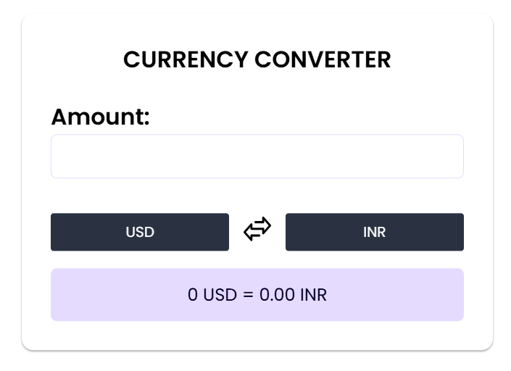**Output:**

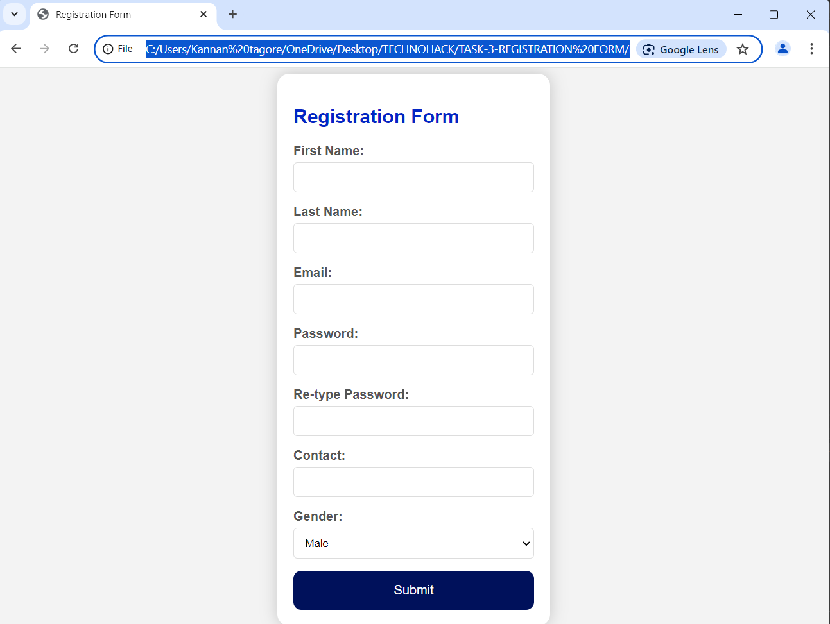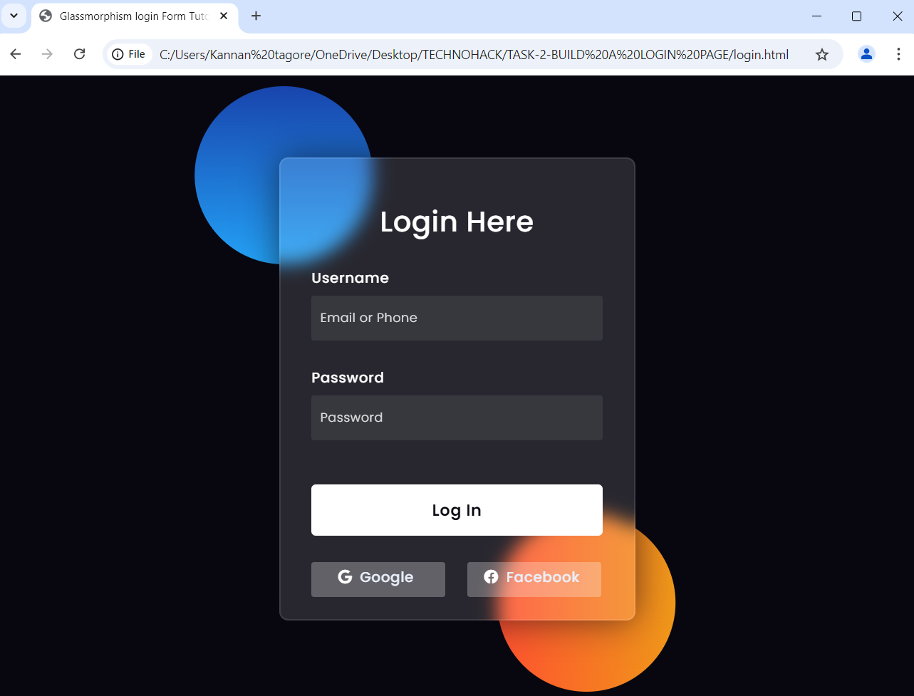

**6. Project Status:**

All three projects—the Login Page, Registration Page, and Currency Converter—were successfully completed and deployed on Vercel, a platform optimized for React and static websites, ensuring smooth and responsive functionality across devices. Each project was rigorously tested in a live environment to verify core functionalities and provide users with a secure, seamless experience. Regular maintenance is conducted to optimize performance and ensure reliability for users. The deployed applications can be accessed via the following links: [Link to Login Page], [Link to Registration Page], and [Link to Currency Converter].

**7. Conclusion:**

The internship provided an excellent platform for developing both technical expertise and professional skills in application development. Hands-on engagement with front-end and back-end technologies, real-world project execution, and collaborative teamwork led to significant learning outcomes. The completion of these projects contributed not only to practical experience with essential frameworks and tools but also reinforced problem-solving and communication skills vital for success in the tech industry. This internship has been a valuable experience, deepening foundational knowledge and preparing for future roles in application development. The skills and insights gained are expected to support continued growth and open opportunities within this dynamic field.

