**Bala Anki Reddy Jinkala**

Email: jb.ankireddy@gmail.com

Mobile: +91-7416675477

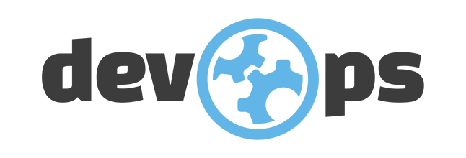

**Professional Summary**

* A competent professional with over 1.7 months of experience in the areas as- Software configuration management, Build and Release, DevOps.
* Having experience in Linux Operating System. Extensively worked on Ubuntu.
* Knowledge on configuration tool: Ansible
* Worked on Docker Including Docker Installation, Creating Images and Containers using docker file.
* Expertise in Python Scripting and have basic knowledge on bash scripting
* Hands on experience with AWS Cloud Services in IAM, EC2, VPC, AMI, ELB, Auto scaling, and more.

**Educational Qualification**

Completed MCA in 2029 from Vignan’s Lara institute of technology & Science, Vadalamudi

**Tools and Technologies**

CI Tools Jenkins

Scripting Python Scripting

Operating Systems Windows, Ubuntu

Cloud Technologies AWS

SCM Tools GIT

Containerization Tool Docker, Docker Swarm

Configuration Tool Ansible

**Work Experience**

Currently working as DevOps Engineer in **Fast script Technologies Pvt Limited, Hyderabad** from August 2022 to till date.

**Professional Experience**

Role: System Engineer Location: Hyderabad August 2022 - Present

**Role & Responsibilities:**

* Created repositories according to the structure required with branches and tags.
* Implemented continuous integration using Jenkins.
* Configured plug-ins for the integration tool to the Version control tool.
* Integrated Maven with Jenkins for the builds as the Continuous Integration Process.
* Integrated Sonar to check the quality of the code by setting Quality Gates.
* Build Java code in different Jenkins servers as per the schedule.
* Automated the deployment of artefacts to various environments DEV, QA, UAT using Ansible Playbooks.
* Deployed the artefacts to Tomcat Servers.
* In charge for maintenance of DEV, QA and UAT environments in AWS VPCs.
* Configured EC2 instances, Load balancer, Auto Scaling, Security Groups, IAM for authentication, Cloud watch for monitoring.
* Automating the infrastructure/ environment provisioning as using Ansible Playbooks for another ancillary application that supports the primary application
* Setting up and maintaining monitoring & alert systems for servers.

**PROJECTS HANDLED:**

Project Name : Hartford insurance company

Client : Hartford (U.S)

Role : System Engineer

Environment : Linux, Git, Jenkins, Maven, Ansible, Tomcat, Shell Scripting

**Description:**

Hartford is a insurance company and this insurance company is having application related to different insurances for that they were maintaining different applications. Initially these were being managed from on prem using blade logic but now they were migrating to aws and we were part of migration project which supp ort daily activities in on prem as well and migrating the things to aws

**Responsibilities:**

* Deploying of applications on different application servers like tomcat, JBoss, and WebSphere using Jenkins.
* Updating and creating Jenkins’s file to support the developers and creating CI-CD setup for new applications.
* Provisioning the ec2 instances lb and others using terraform, ansible and manual sometimes.
* Implemented end-to-end CI/CD using Ansible tower to deploy the pipeline job.