Flower Classification Using Sparse SVM and GoogleNet

line 1: 1st Given Name Surname   
line 2: *dept. name of organization   
(of Affiliation)*  
line 3: *name of organization   
(of Affiliation)*line 4: City, Country  
line 5: email address or ORCID

line 1: 2nd Given Name Surname  
line 2: *dept. name of organization   
(of Affiliation)*  
line 3: *name of organization   
(of Affiliation)*line 4: City, Country  
line 5: email address or ORCID

line 1: 3rd Given Name Surname  
line 2: *dept. name of organization   
(of Affiliation)*  
line 3: *name of organization   
(of Affiliation)*line 4: City, Country  
line 5: email address or ORCID

***Abstract*— The advancement of the recognition of rare plant species will be beneficial in a variety of fields, including the pharmaceutical industry, botany, agriculture, and international trade activities. It was also extremely difficult because there is such a wide variety of flower species, and it is extremely difficult to classify them when they can be extremely similar to one another. This subject has therefore already become critical in this context. For the purposes of learning the dataset, the authors of this paper present a classification system for flower images that is built on Deep CNN based GoogleNet, with sparse SVM serving as a primary classifier to learn the dataset. Deep CNN techniques have recently emerged as the most advanced technology for dealing with such problems. First, we proposed a classification model to improve the performance of flower image classification by using Deep CNN for feature extraction and GoogleNet algorithms for classification. Deep CNN was used for feature extraction and GoogleNet algorithms were used for classification. Second, we demonstrated how image augmentation can be used to improve the performance of a computer simulation. Last but not least, we compared the performances of machine-learning classifiers such as support vector machines. In the study, we evaluated our classification system by comparing it to various datasets. The images of flowers in this dataset total 4242 images. The data was gathered from various sources, including Flickr, Google Images, and Yandex Images. We discovered that the GoogleNet model and SVM Classifier had the highest accuracy at 98.91 percent.**

# Introduction

The most important producers on the planet, flowers can be found in a wide range of climates and habitats, making them the most versatile of all plant life. They also continue to play an important role in the food chain, as they provide food for nearly all of the insect species on the planet. In addition to this, they play an important role in the food chain, and their healing properties can be used to create a wide range of pharmaceutical products. As a result, having a thorough understanding of flowers and their various species is extremely beneficial when it comes to identifying new or rare plant species. Aside from that, many plants may be damaged because they are considered harmful to one's farmland or may be sold at extremely low prices if they are not protected.

All of this occurs as a result of insufficient recognition of the plant species' existence. However, it is a real phenomenon that many of the plants that grow in nature can also be grown in a laboratory setting. Increased recognition capacity of numerous endemic plant species, such as elecampane and verbascum thapsus, whose life is restricted to a specific area and which can only be grown under specific climatic conditions, will also help the pharmaceutical industry to develop further.

There are approximately 250,000 named species of flowers in the world, and there are many different types of flowers. The majority of people see flowers on a daily basis, but they are unable to identify them. They consult with flower experts, peruse flower books, or conduct keyword searches on the Internet in order to determine the names of these flowers. By categorizing flower images, it is possible to identify flower names in a simple and expedient manner. Particularly relevant today, given the widespread use of mobile digital cameras throughout the world. Making a caption for a flower image and sending it to a flower recognition system that classifies flower images will assist people in the identification of flowers.

Some approaches to flower identification have been proposed, and some of them are as follows: Pre-processing, segmentation, hand-design feature extraction, and classification are the four steps that are typically followed in this process. Given that flower images have complex backgrounds, these tasks are time-consuming, and the accuracy of the results is still low, particularly when there are a large number of species to consider. Using deep Convolutional Neural Networks (CNNs), researchers have recently demonstrated a number of successes in a variety of topics in the field of computer vision, including object detection, image segmentation, and image classification, among others.

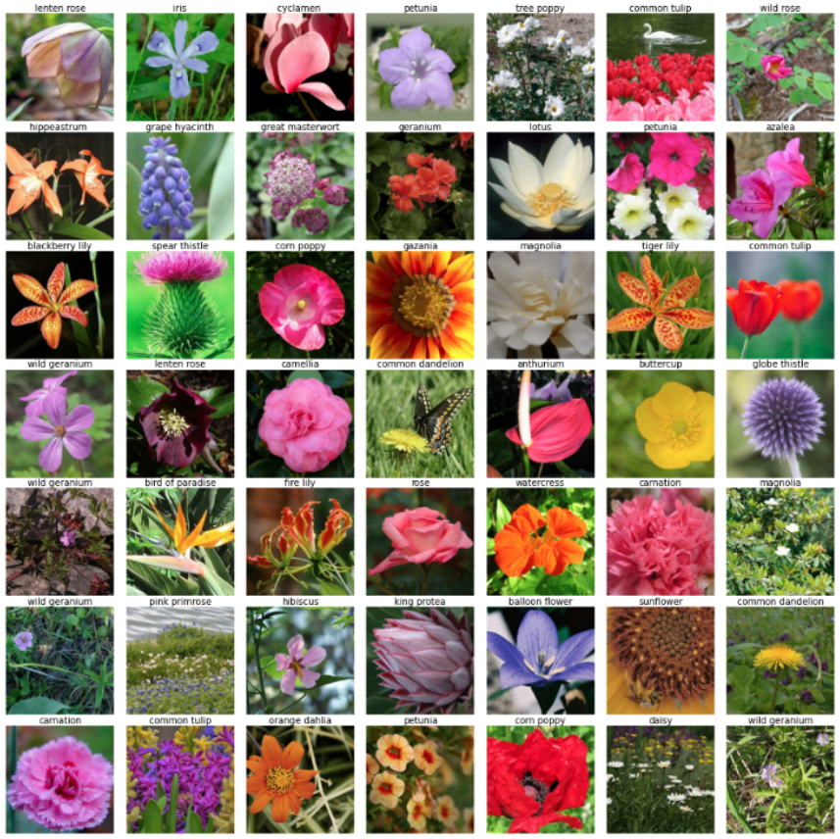

Fig 1. Different flower species

Following the extraction of flower image feature vectors, the proposed approach categorizes the images using GoogleNet model and Support Vector Machine (SVM) classification (SVM). The classification approach is evaluated through the use of five different flower categories. As a result of conducting this evaluation, the results show that the proposed approach is capable of classifying the flower name with a high degree of accuracy. A flower classification system of this type can be applied in a variety of real-world situations. For example, it can be used as an interactive educational tool to improve learning methods for both young and old people, as well as for adults.

All of the remaining pieces of paper have been divided into six sections for your convenience. Introduction: In Section I, we provide a high-level overview of the subject matter. Providing an overview of the research methodology is covered in Section 2. This section also contains a more in-depth discussion of deep learning-based classifiers, their performances, and the datasets that they use. The findings are presented in Section III. Section IV presents a synopsis of our findings and conclusions as a result of our investigation. Additionally, the subject of future work is covered in this section. Section V of the document contains the Acknowledgement section.

# Methodology

## *Datasets*

The images of flowers in this dataset total 4242 images. The data was gathered from various sources, including Flickr, Google Images, and Yandex Images. We can use this dataset to identify plants in a photo using their characteristics.

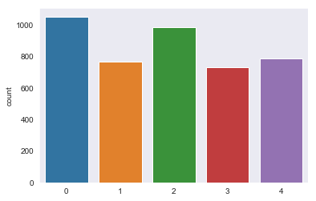

Fig 2. Five different categories of flowers count

The images are categorized into five categories: chamomile, tulip, rose, sunflower, and dandelion, among others.

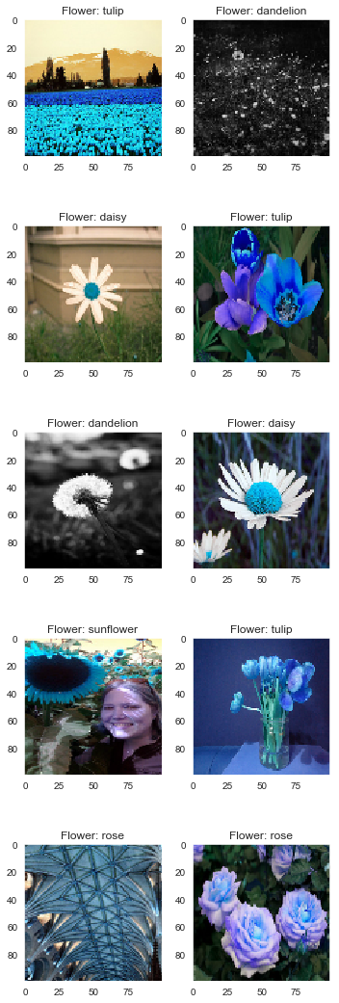



Fig 3. Dataset Sample

There are approximately 800 photos in each class. The photos are not of high quality, with a resolution of approximately 320x240 pixels. There is no single size for photos; instead, they have a variety of sizes and shapes!

## *Data Preparation*

Preprocessing data is one of the most crucial processes in the machine learning process. It is the most crucial stage in improving the accuracy of machine learning models, and it is the most time-consuming. In data preprocessing, the raw data is cleaned up and transformed into clean data, which can then be utilized to train a machine learning model.

The floral areas of a photograph are typically overlaid on a complex background, making it difficult to distinguish them from the background. To select the ROI (Region-Of-Interest) on flower images, we use saliency-segmentation-based approaches, which are described in detail in this paper. Pre-processing techniques are depicted in Fig. 4 in their overall flow. First and foremost, we adapt a saliency extraction method, which is a common segmentation technique, to our needs (e.g., mean-shift algorithm).

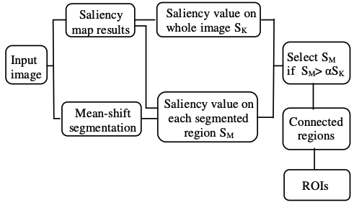

Fig 4. The proposed pre-processing to select the regions of interest (ROI) of flowers.

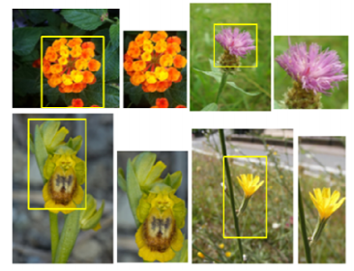

Fig 5. Flower images and detected ROIs.

In this case, the segmented region is chosen on the basis of the condition that the corresponding saliency value is sufficiently large. The connected-region techniques are then used to merge the regions of interest into a single interest-of-regions. Figure 5 shows ROIs (left panel) whose top-left and bottom-right points form a rectangle on the original images, and ROIs (right panel) that do not (right panel).

*C. Modeling*

**I. GoogLeNET**

GoogLeNet is a deep convolutional neural network with 22 layers that is a variant of the Inception Network, a Deep Convolutional Neural Network developed by Google researchers. It is a deep convolutional neural network with 22 layers that was developed by Google researchers. Computer vision tasks such as image classification and object detection were successfully completed using the GoogLeNet architecture, which was presented at the ImageNet Large-Scale Visual Recognition Challenge 2014 (ILSVRC14).

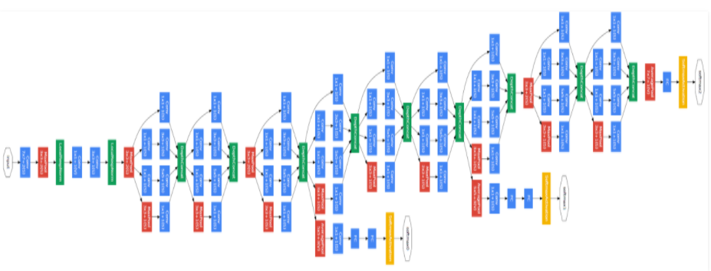

Fig 6. A schematic view of Googlenet network

It is necessary to feed an image of 224 x 224 pixels into the GoogLeNet architecture in order for it to function properly.

*Type:* This refers to the name of the component's current layer in the architecture, which is denoted by the letter T.

*Patch Size:* This refers to the size of the sweeping window that is used across the convolution and pooling layers of the convolution pipeline. Sweeping windows are the same height and width on both sides.

*Stride:* This parameter specifies how much of a shift the filter/sliding window makes relative to the input image. The output dimensions (height, width, and number of feature maps) of the current architecture component after the input has been passed through the layer are referred to as the output size. Within an architecture component, depth refers to the number of levels/layers that are contained within it.

*#1x1 #3x3 #5x5:* This refers to the various convolutions filters that are used within the inception module and are represented by the numbers 1 through 3. This is a reference to the number of 1x1 filters used before the convolutions (3x3) and #5x5 (reduced by three).

*Pool Proj:* The number of 1x1 filters that are used after pooling within an inception module is represented by this value.

*Parameters:* This variable refers to the number of weights that are present in the current architecture component.

*Ops:* This term refers to the number of mathematical operations that are performed within a component's code.

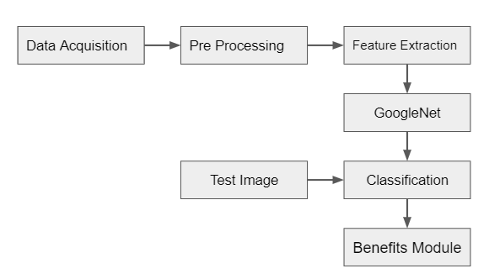

Fig 7. Workflow

Flower images are typically captured against a complicated background that includes a variety of objects in the foreground. Even better, CNN can be applied directly to these images in order to evaluate the effect of background on flower identification; we use some preprocessing techniques on flower images in order to accomplish this. The results are limited to flower regions extracted from a natural image.

CNN is one of the most well-known deep learning approaches, in which multiple layers are trained simultaneously. A CNN typically consists of multiple convolutional and sub-sampling layers, which may or may not be followed by fully-connected layers, similar to a standard multi-layer neural network in structure and function.

**II. Sparse SVM**

Flower images are typically captured against a complicated background that includes a variety of objects in the foreground.

Even sparse SVM can be applied directly to these images in order to evaluate the effect of background on flower identification; however, this is not recommended.

On flower images, we apply a number of different preprocessing techniques.

The results are limited to flower regions extracted from a natural image.

With many applications in various fields, support vector machines (SVMs) have proven to be an effective tool for classification and pattern recognition in a variety of situations.

On the basis of the risk minimization principle, SVM can be defined as a constrained margin maximization problem.

It is formulated as a convex quadratic programming problem, which can be solved quickly and effectively.

Standard SVM, on the other hand, which focuses on minimizing the hinge loss function and the L2 norm, only produces sparsity for the dual variables and not for the primal variables.

The use of support vector machines with other penalties, such as the L1 penalty and the elastic net, for feature selection and prediction has been proposed to deal with the big omics data problem with a large number of features.

These methods, on the other hand, are dealing directly with the primal variables.

They become computationally inefficient when the number of features (genes) is large, as is common in big omics data sets.

## *D. Validation Method*

Precision: Precision is a measure of a classifier's ability to avoid labeling a true negative observation as a positive observation.

Precision=TP/(TP+FP)

Recall (Sensitivity): The ability of a classifier to find positive observations in a dataset is measured by the recall of the classifier. If you wanted to be absolutely certain that you found all of the positive observations, you could increase recall to the maximum.

Recall=TP/(TP+FN)

# Results

The results of this study's analysis were observed with the test dataset, which confirmed the findings of the study.

The SVM classifier was used to classify the new feature set, and the accuracy rate for classification was 26 percent overall.

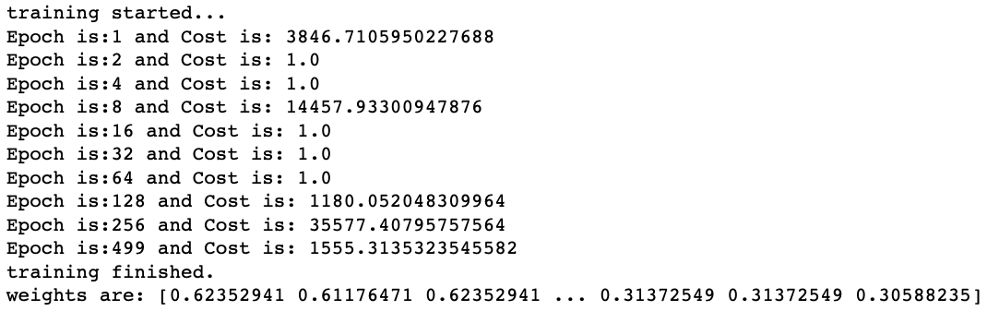

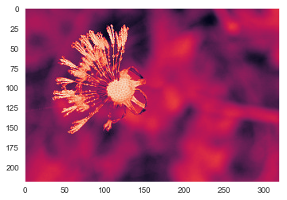



Fig 9. SVM Training Results

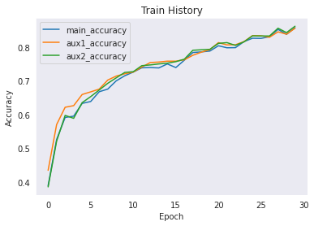

Fig 10. Test Accuracy

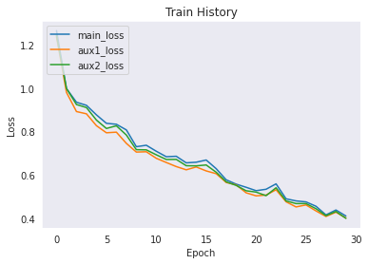

Fig 11. Test loss

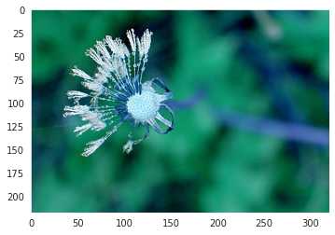

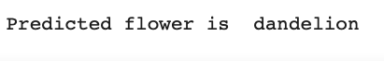

Fig 10. GoogLeNet test result

# Conclusion and future work

The classification of flower species is a time-consuming and difficult endeavor. The presence of herbs, leaves, and other vegetation on and around the flowers makes it more difficult to distinguish between flower species. When it comes to classifying flower species, traditional methods have proven effective.

Deep learning models, on the other hand, have become increasingly popular in recent years as a method of achieving more successful results in such classifications. Deep learning models, in contrast to traditional methods, can directly extract features from input data without the need for a separate feature extraction process to do so.

Main goal of the googleNet model was to extract the features that were discovered when the feature sets obtained through different methods of feature selection intersected with each other. These characteristics are regarded as more stable characteristics, and the findings of the study lend support to this notion.

A total of 98.91 percent of the flowers in the five flower classes were correctly identified as such. In future studies, we will use attention modules to examine different datasets from different perspectives.

Main goal of this model was to extract the features found at the intersection of feature sets obtained using different feature selection methods, which was accomplished through a variety of methods. The results of the experiment revealed that the proposed approach contributes less to the accuracy of classification than the existing approach. We need to improve the accuracy of the model by incorporating neural networks and data augmentation.

# Acknowledgement

##### 

##### 

##### 

# References

1. Thi-Lan Le, Nam-Duong Duong, Hai Vu, Thanh-Nhan Nguyen, “Mica at lifeclef 2015: Multi-organ plant identification”, In Working notes of CLEF 2015 conference, 2015.
2. Nilsback, Maria-Elena, and Andrew Zisserman, “An automatic visual flora-segmentation and classification of flower images”, Oxford University, 2009.
3. Rodrigo, Ranga, Kalani Samarawickrame, and Sheron Mindya. "An Intelligent Flower Analyzing System for Medicinal Plants", Conference on Computer Graphics, Visualization and Computer Vision (WSCG 2013), 2013.
4. Angelova, Anelia, et al, "Development and deployment of a large-scale flower recognition mobile app", NEC Labs America Technical Report, 2012.
5. Hong, An-xiang, et al., "A flower image retrieval method based on ROI feature", Journal of Zhejiang University Science 5.7, 2004, 764-772.
6. Mattos, Andréa Britto, et al, "Flower Classification for a Citizen Science Mobile App", Proceedings of International Conference on Multimedia Retrieval. ACM, 2014.
7. Goëau, Hervé, et al, "LifeCLEF Plant Identification Task 2015", In CEUR-WS, ed.: CLEF: Conference and Labs of the Evaluation forum. Volume 1391 of CLEF2015 Working notes, Toulouse, France, 2015.
8. Szegedy, Christian, et al., "Going deeper with convolutions", Proceedings of the IEEE Conference on Computer Vision and Pattern Recognition, 2015.
9. Yoo, Hyeon-Joong, "Deep Convolution Neural Networks in Computer Vision", IEIE Transactions on Smart Processing & Computing 4.1, 2015, 35-43.
10. Bo, L., Ren,X., Fox, D., “Kernel descriptors for visual recognition”, In Advances in neural information processing systems, 2010, 244-252.
11. M.-E. Nilsback and A. Zisserman, “A visual vocabulary for flower classification,” in 2006 IEEE Computer Society Conference on Computer Vision and Pattern Recognition (CVPR’06), vol. 2. IEEE, 2006, pp.

1447–1454.