1. Home Screen with data and action buttons (New Ticket, Edit, Delete, View)

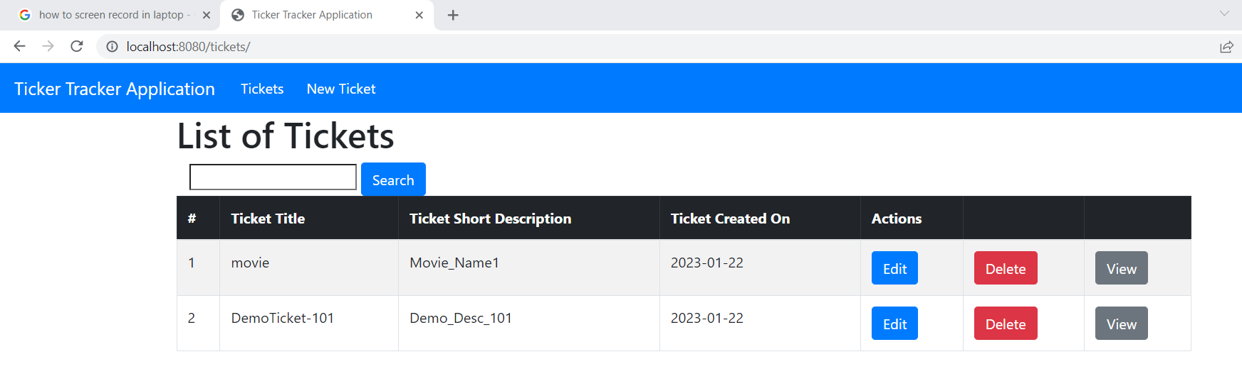

1. Edit page

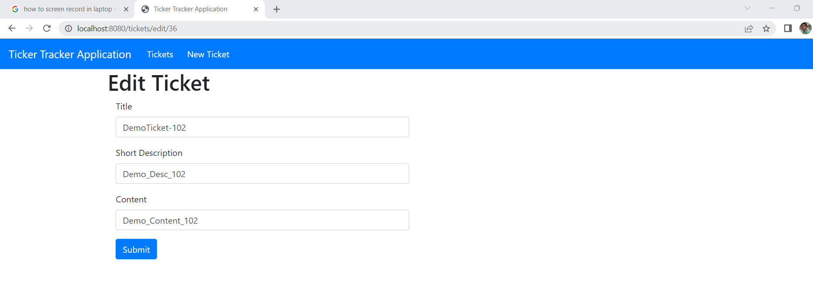

1. Create Ticket page

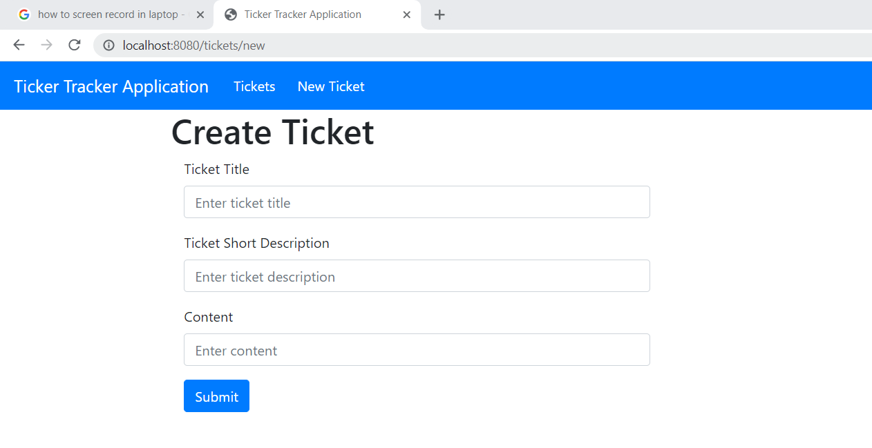

1. View Ticket

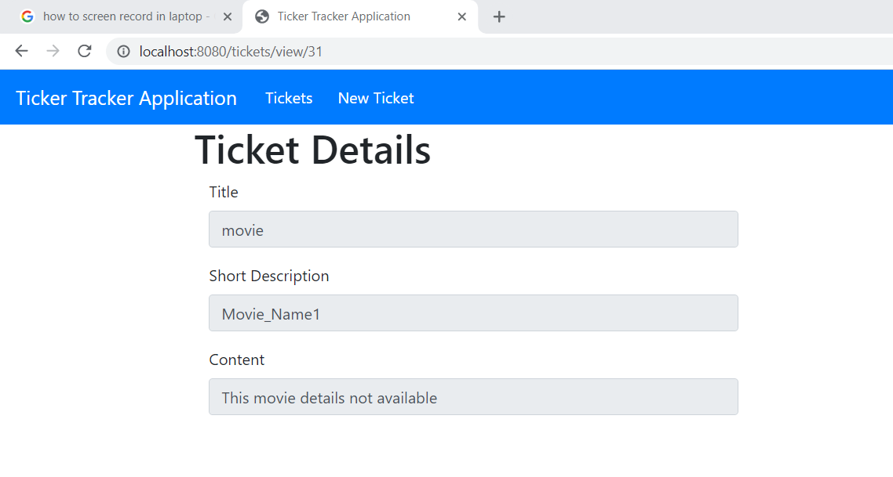

1. Search

