END TO END PROJECT SOP

Contents:

1. Git Repository
2. Virtual Environment
3. Requirement
4. Test app.py file
5. Docker File & .dockerignore
6. .github folder
7. Project Parent Folder
8. Setup file
9. Project Child Folder
10. Architecture
11. Logger
12. Exception
13. Component
14. Entity
15. Config
16. Configuration
17. Utils
18. Constants
19. Configuration of components wrt Entity
20. Artifact Entity
21. Components – Data Ingestion
22. Pipeline – Data Ingestion
23. Components – Data Validation
    1. Data Drift
24. Pipeline – Data validation
25. Components – Data transformation
26. Pipeline – Data Transformation
27. Entity – Model_factory
28. Git Repository:

* Create a new repository in the github as below

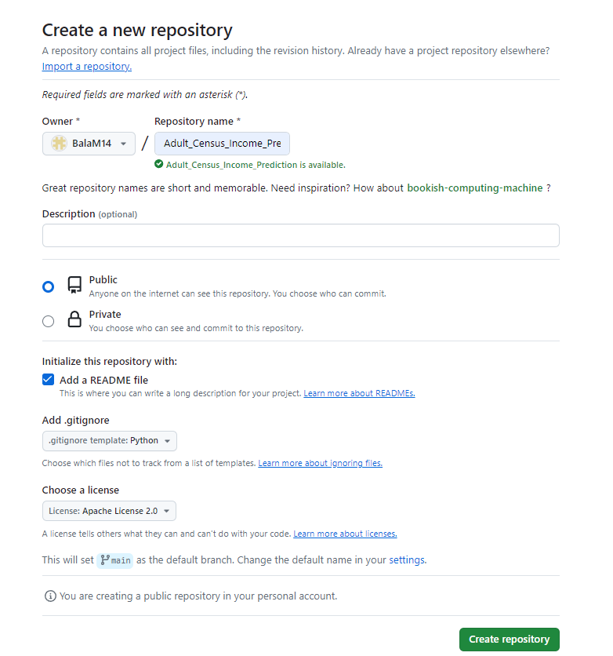

* Get the github clone url from the github repository page.

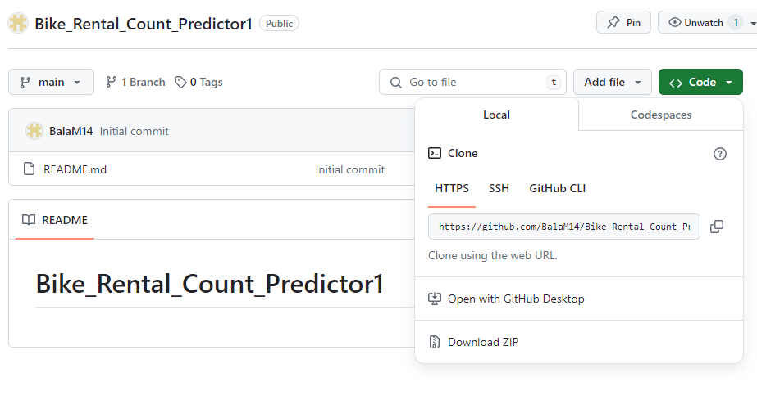

* Open the cmd prompt & go to the path where you want to clone this repository.

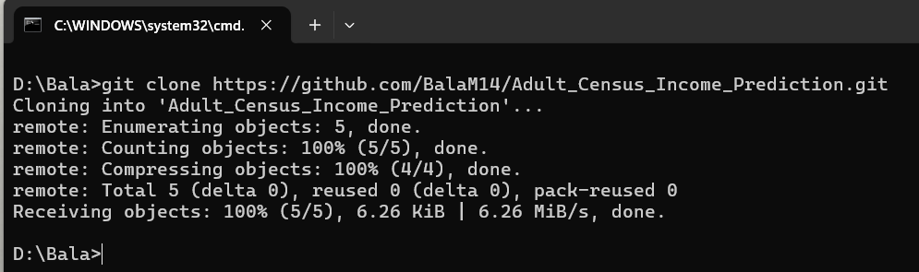

* Repository has been created & cloned to our local systems.

1. Virtual Environment:

* Open the repository in the VS code
* Create the Virtual Environment for the project by using the below command in cmd.

Cmd: conda create –p venv python==3.11 -y

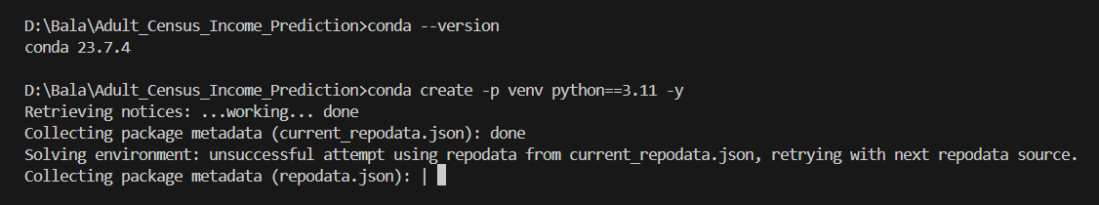

* Activate the newly created environment.

Cmd: conda activate venv

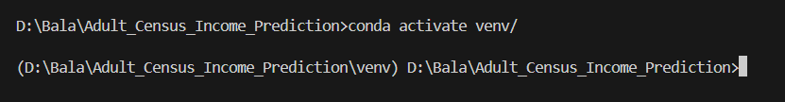

1. Requirement File:

* Create the requirements.txt file to provide the package names to get install by default.

Cmd: pip install -r requirements.txt

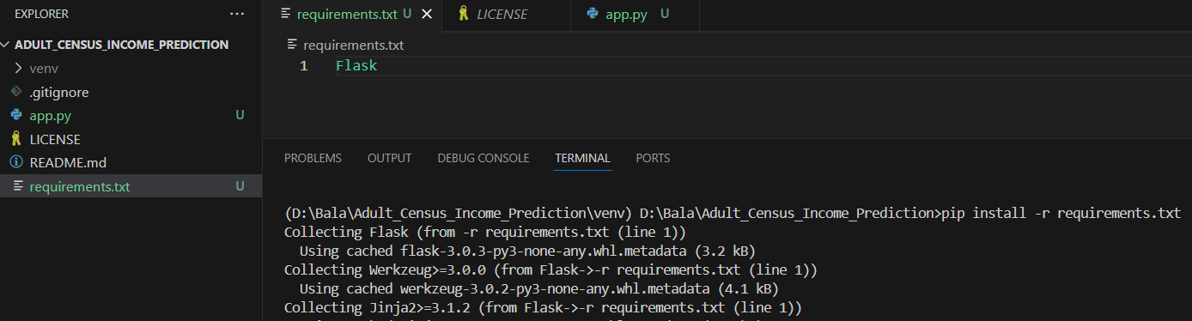

1. Test app.py file:

* Create the app.py file to write the demo code to check the project working.

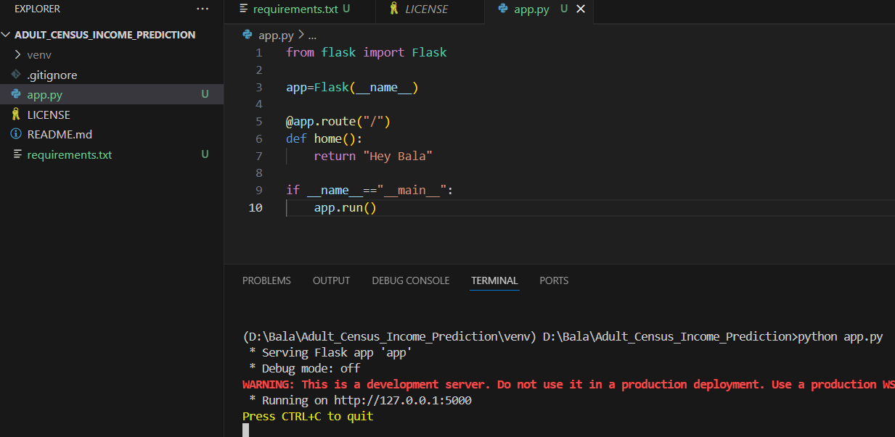

1. Docker File & .dockerignore:

* Create a Dockerfile & .dockerignore file as mentioned below.

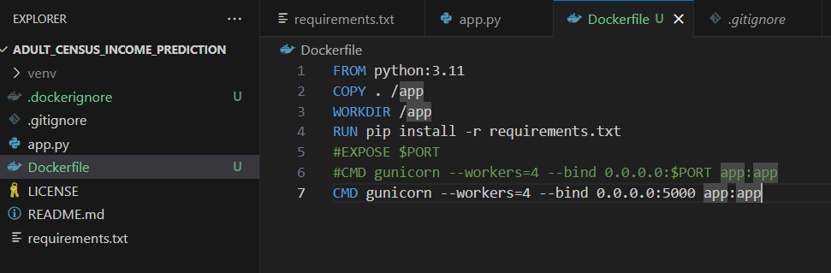

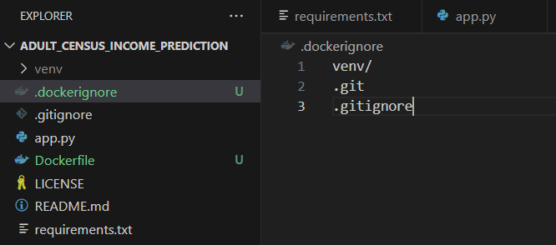

* Create a docker image by using the below command. Please make sure the docker desktop is running before creating the image.

Cmd : docker build -t income_predicton:latest .

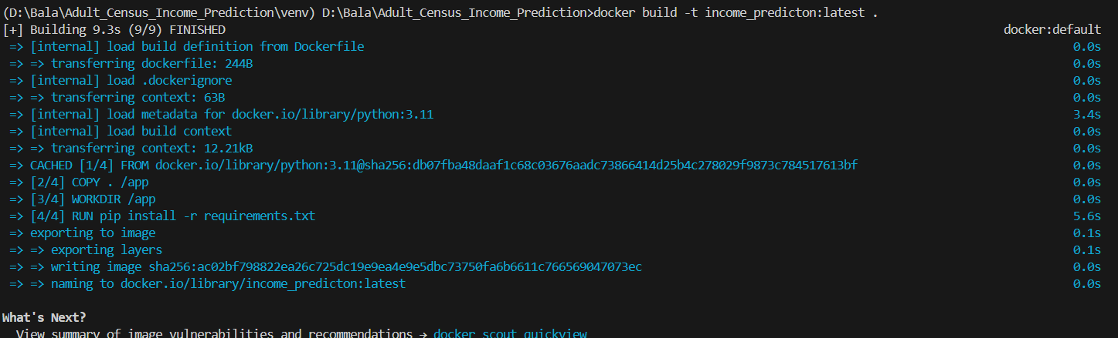

* To list the docker images use the below command.

Cmd : docker images

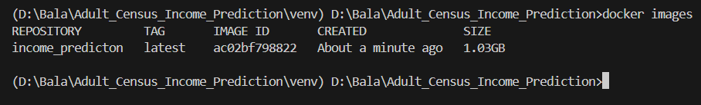

* To run the docker image use the below command.

Cmd: docker run -p 5000:5000 -e PORT=5000 <Image_ID>

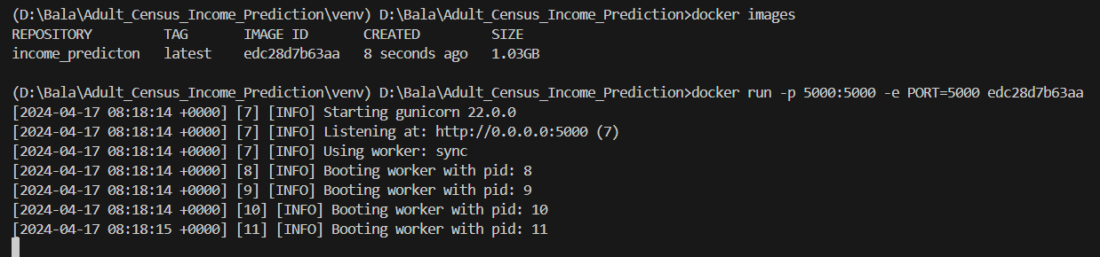

* To check the running image use the below command.

Cmd: docker ps



* To stop the cotainer use the below command.

Cmd: docker stop <container_id_1st_4_char>



1. .github folder:
   * Create a .github folder & a subfolder name as workflows.
   * Inside the worflow folder create a main.yaml file as attached below.



1. Project Parent Folder:
   * Create a parent folder “income” which in future consists of all the components, entities & pipeline features.
   * Inside the housing folder, create the __init__.py file to use this folder as a package in later state.

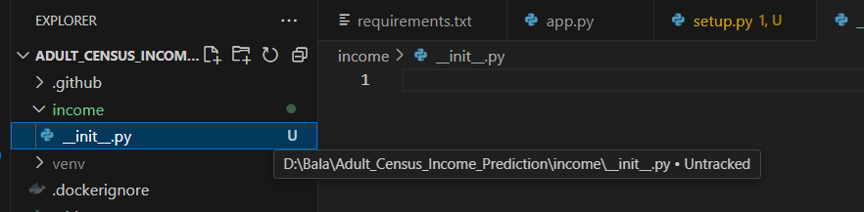

1. Setup.py file:

* Create a setup.py file with the below details.

from setuptools import setup,find_packages

from typing import List

PROJECT_NAME="income_predictor"

VERSION="0.0.3"

AUTHOR="Bala Murugan"

DESCRIPTION="This is a Incomee Predictor ML project"

REQUIREMENT_FILE_NAME="requirements.txt"

HYPHEN_E_DOT = "-e ."

def get_requirements_list() -> List[str]:

    with open(REQUIREMENT_FILE_NAME) as requirement_file:

        requirement_list = requirement_file.readlines()

        requirement_list = [requirement_name.replace("\n", "") for requirement_name in requirement_list]

        if HYPHEN_E_DOT in requirement_list:

            requirement_list.remove(HYPHEN_E_DOT)

        return requirement_list

setup(

    name=PROJECT_NAME,

    version=VERSION,

    author=AUTHOR,

    description=DESCRIPTION,

    packages=find_packages(),                   #Here we are using this find_packages instead of housing is to check all the folders and wherever the __init__.py is there it will create a package

    install_requires=get_requirements_list()

)

* To install the packges via setup.py file use the below command:

Cmd : pip install .

(or)

Cmd : python setup.py install

* Once you execute the above command, you will be able to see the newly genrated folders as mentioned below.

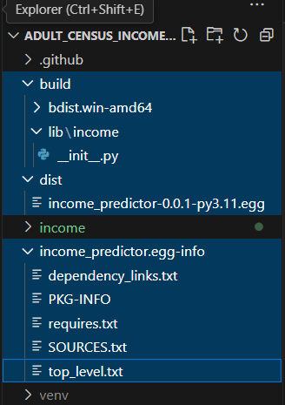

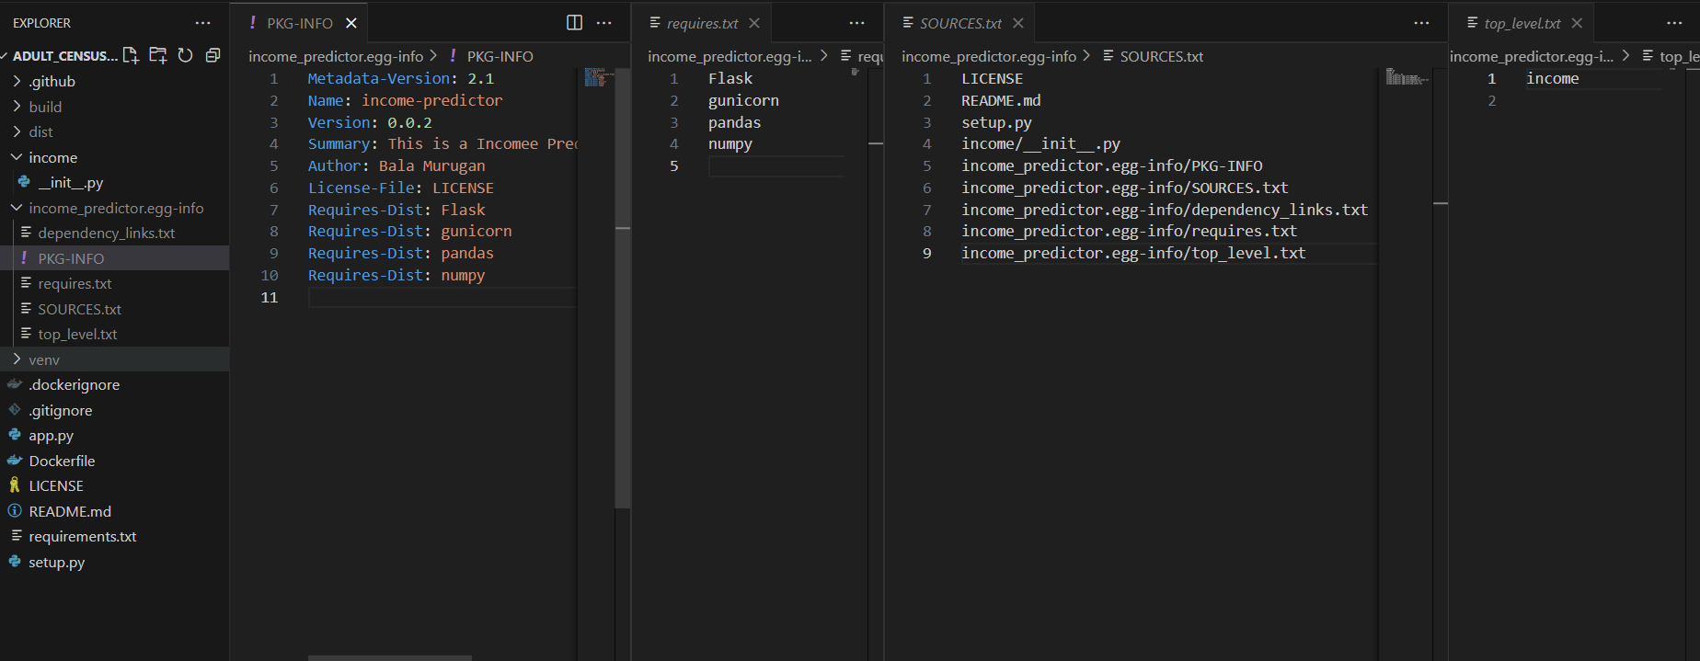

* In requirements.txt file we have specified “-e .” at the EOD file. This is bcoz we need to install all the packages in our project. If we execute the file without “-e .” then it will only install the specified packages in the requirements.txt file alone.

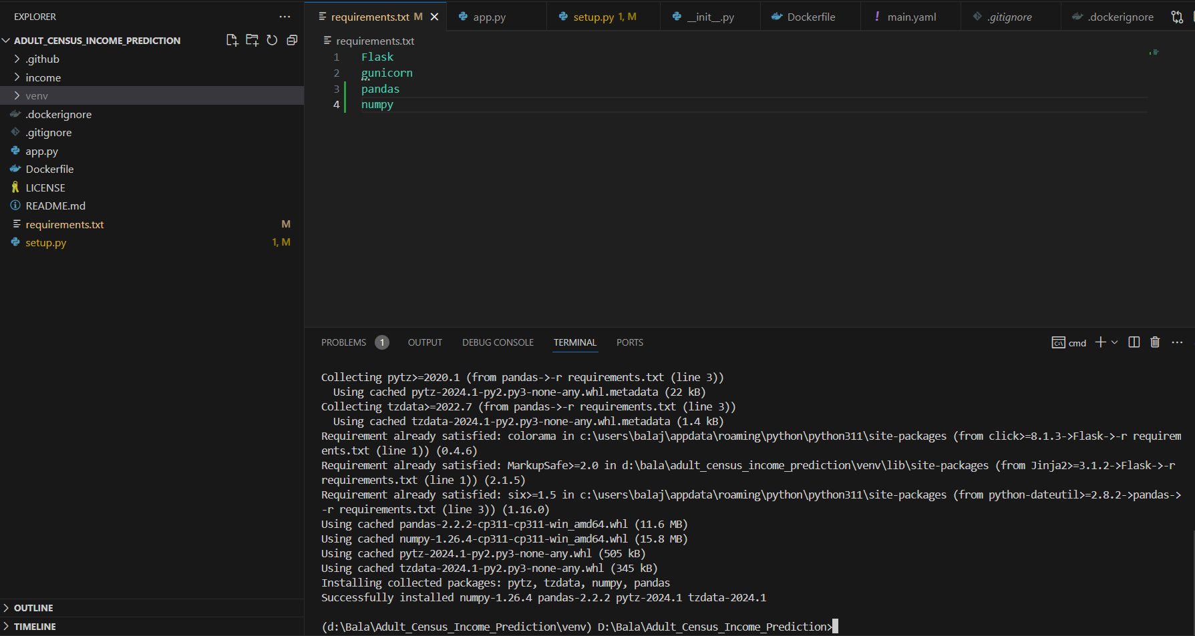

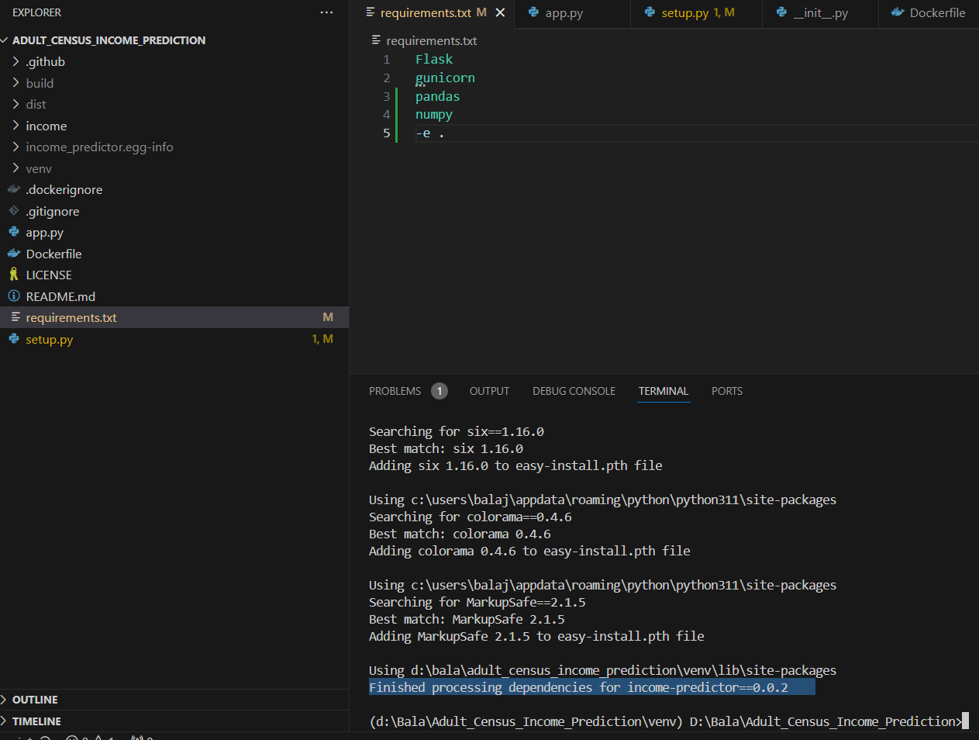

* If we are getting an file permission error then we need to change the value of version in the setup.py file.

1. Project Child Folder:

* Create the Project folder structure as below.

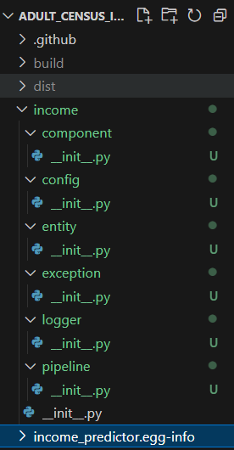

1. Architecture:

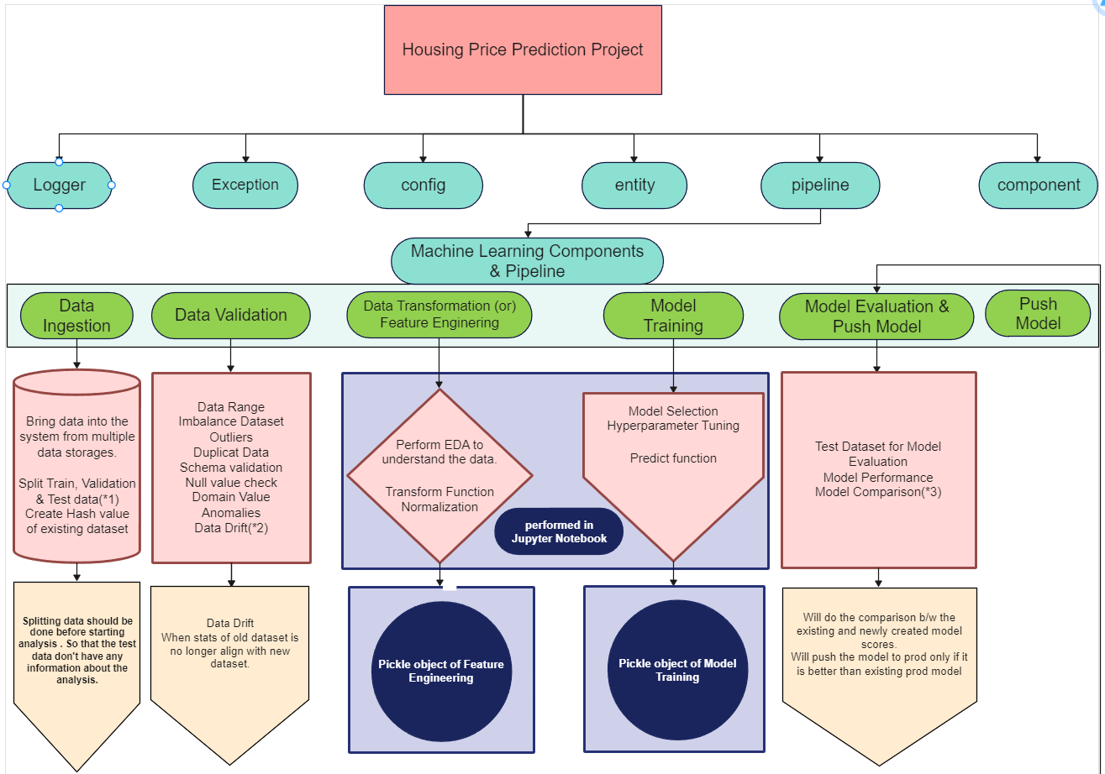

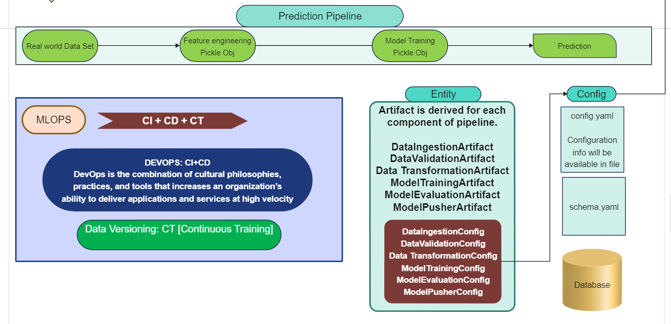

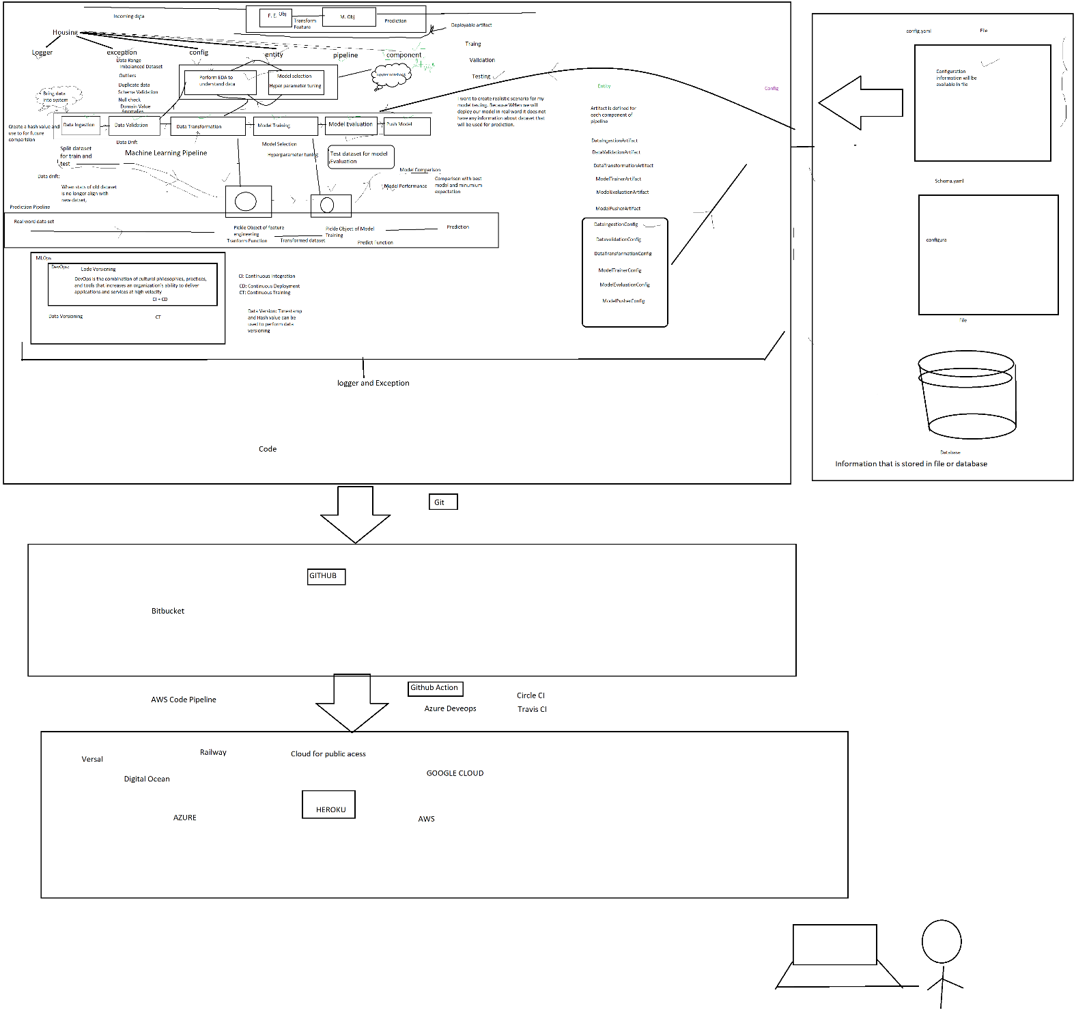

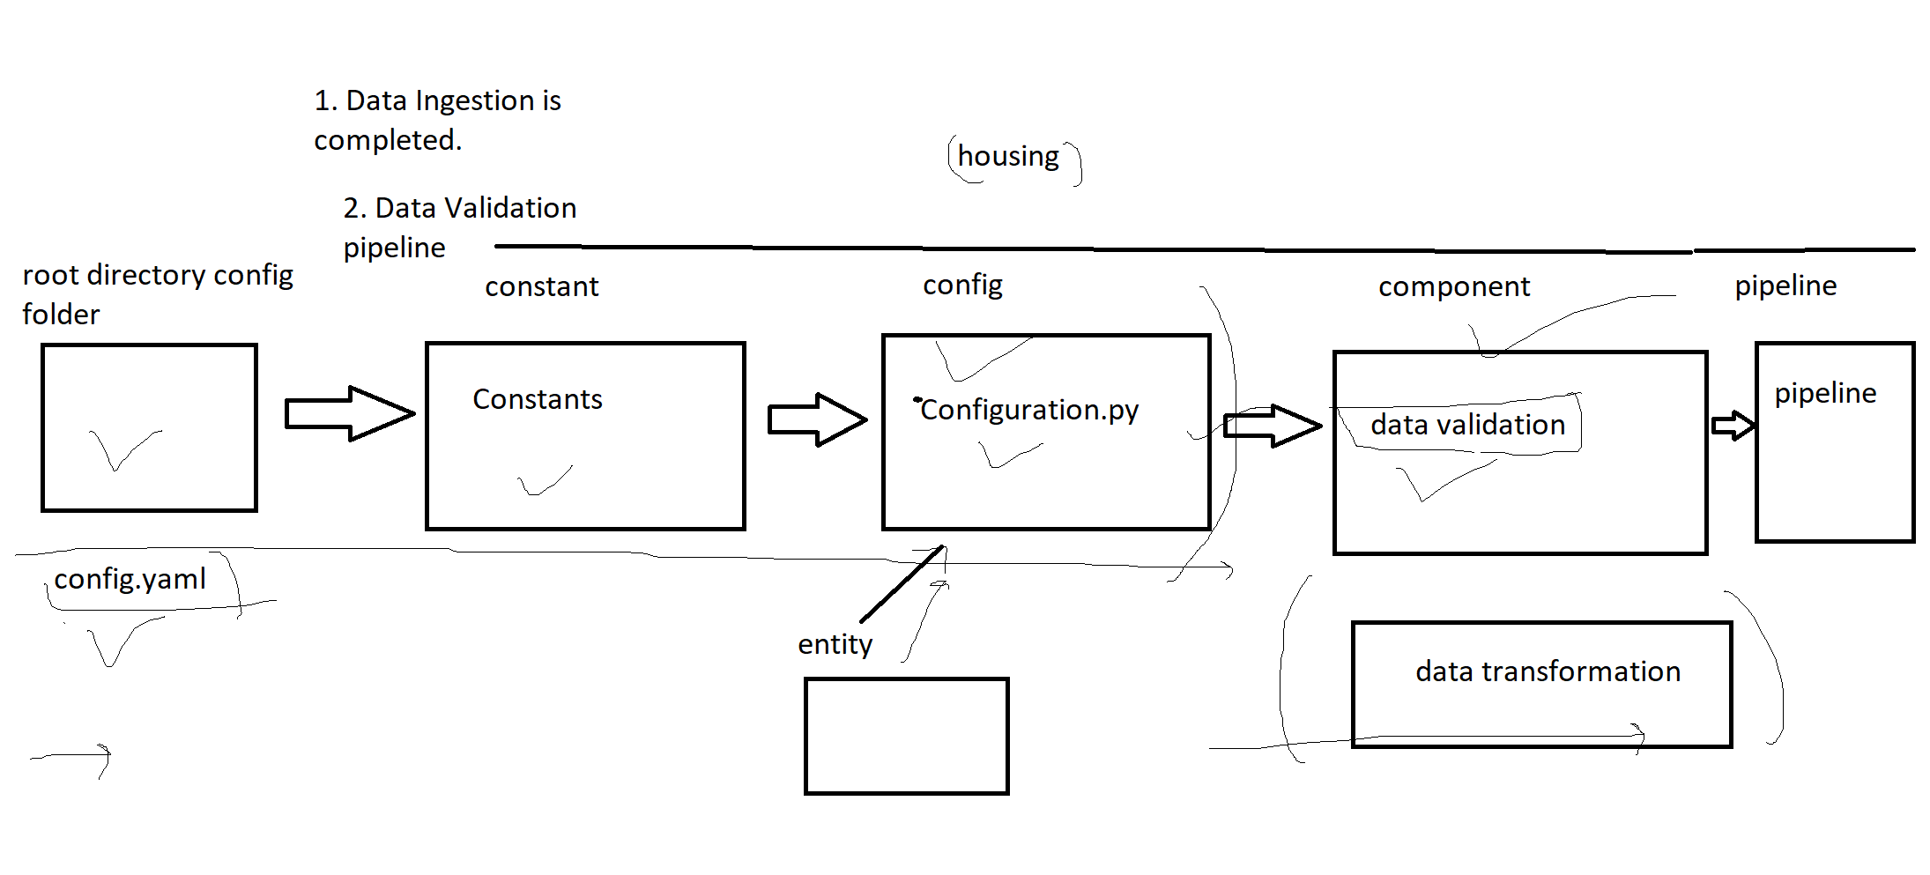

1. Logger:

* Start coding from the logger “__init__.py” file.

import logging

from datetime import datetime

import os

LOG_DIR=f"income_logs/{datetime.now().strftime('%Y_%m_%d')}"

CURRENT_TIME_STAMP = f"{datetime.now().strftime('%H_%M_%S')}"

LOG_FILE_NAME = f"log_{CURRENT_TIME_STAMP}.log"

os.makedirs(LOG_DIR,exist_ok=True)

LOG_FILE_PATH = os.path.join(LOG_DIR,LOG_FILE_NAME)

logging.basicConfig(filename=LOG_FILE_PATH,

                    filemode='w',

                    format='[%(asctime)s] %(name)s %(levelname)s %(message)s',

                    level=logging.INFO)

* Test the logger by importing the logger in app.py, so that it will generate the log file as below.

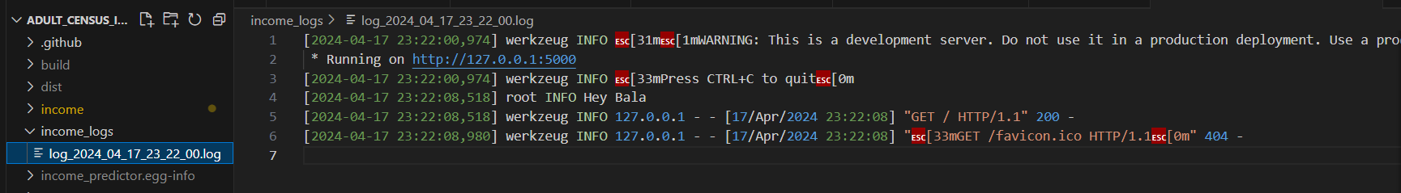

1. Exception:

* Start the coding for the exception.py file

import os

import sys

class IncomeException(Exception):

    def __init__(self,error_message:Exception,error_detail:sys):

        super().__init__(error_message)

        self.error_message = IncomeException.get_detailed_error_message(error_message=error_message,

                                                                        error_detail=error_detail)

    @staticmethod

    def get_detailed_error_message(error_message:Exception,error_detail:sys) -> str:

        """

        error_message : Exception object

        error_detail: object of sys module

        """

        _,_,exec_tb = error_detail.exc_info()               #ignore the 1st 2 values -> type & value and fetching only the traceback

        line_number = exec_tb.tb_frame.f_lineno

        file_name = exec_tb.tb_frame.f_code.co_filename

        error_message = f"Error occured in scrip : [{file_name}] at line number : [{line_number}] error message : [{error_message}]"

        return error_message

    def __str__(self) -> str:

        return self.error_message

    def __repr__(self) -> str:

        return IncomeException.__name__.str()

* Test the exception by importing the IncomeException in app.py, so that it will generate the log file with the error as exception with custom error values as shown below.

**app.py**

from flask import Flask

from income.logger import logging

from income.exception import IncomeException

import sys

app=Flask(__name__)

@app.route("/",methods=['GET','POST'])

def index():

    try:

        raise Exception("we are testing custom exception")

    except Exception as e:

        income = IncomeException(e,sys)

        logging.info(income.error_message)

        logging.info("Testing the logging module")

    return "Hey Bala"

if __name__=="__main__":

    app.run()

Log File:

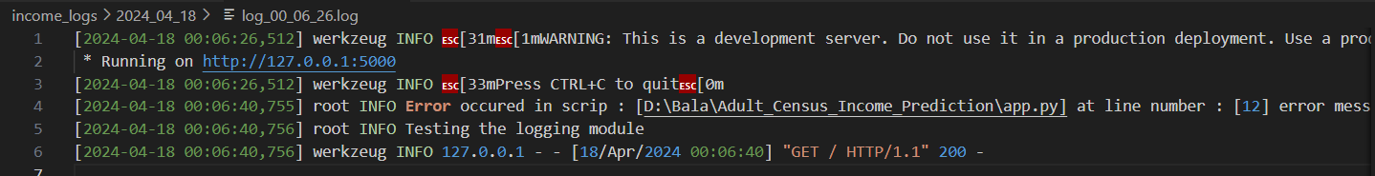

1. Component:

* Create the component python files for each stages as below & same for pipeline folder also.

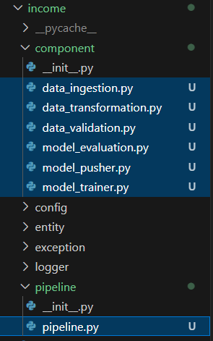

1. Entity

* Create the “config_entity.py” file under the entity folder.

from collections import namedtuple

DataIngestionConfig = namedtuple("DataIngestionConfig",["dataset_download_url","tgz_download_dir",

                                                        "raw_data_dir","ingested_train_dir",

                                                        "ingested_test_dir"])

DataValidationConfig = namedtuple("DataValidationConfig",["schema_file_path","report_file_path","report_page_file_path"])

DataTransformationConfig = namedtuple("DataTransformationConfig",["transformed_train_dir",

                                                                  "tramsformed_test_dir",

                                                                  "preprocessed_object_file_path"])

ModelTrainerConfig = namedtuple("ModelTrainerConfig",["trained_model_file_path","base_accuracy"])

ModelEvaluationConfig = namedtuple("ModelEvaluationConfig",["model_evaluation_file_path","time_stamp"])

ModelPusherConfig = namedtuple("ModelPusherConfig",["export_dir_path"])

TrainingPipelineConfig = namedtuple("TrainingPipelineConfig",["artifact_dir"])

1. Config:

Create a config file in the main path to maintain the generic configurations like schema’s & yaml files.

Inside the config folder create the config.yaml file as show below.



1. Configuration:

Create a configuration.py file under the income/config folder

from income.entity.config_entity import DataIngestionConfig,DataValidationConfig,DataTransformationConfig, \

                                        ModelTrainerConfig,ModelEvaluationConfig,ModelPusherConfig,TrainingPipelineConfig

from income.util.util import read_yaml_file

import os,sys

from income.constant import *

from income.exception import IncomeException

from income.logger import logging

class Configuration:

    def __init__(self) -> None:

        pass

    def get_data_ingestion_config(self) -> DataIngestionConfig:

        pass

    def get_data_validation_config(self) -> DataValidationConfig:

        pass

    def get_data_transformation_config(self) -> DataTransformationConfig:

        pass

    def get_model_trainer_config(self) -> ModelTrainerConfig:

        pass

    def get_model_evaluation_config(self) -> ModelEvaluationConfig:

        pass

    def get_model_pusher_config(self) -> ModelPusherConfig:

        pass

    def get_training_pipeline_config(self) -> TrainingPipelineConfig:

        pass

1. Utils:

Create a util.py file under the util folder as shown below.

import yaml

from income.exception import IncomeException

import os,sys

def read_yaml_file(file_path:str) -> dict:

    """

    Reads a Yaml file and returns the contents as a dictionary.

    file_path:str

    """

    try:

        with open(file_path,"rb") as yaml_file:

            return yaml.safe_load(yaml_file)

    except Exception as e:

        raise IncomeException(e,sys) from e

1. Constants:

Create a constant folder with the python file as constant.py

import os,sys

from datetime import datetime

ROOT_DIR = os.getcwd()   #To get the current working directory

CONFIG_DIR = "config"

CONFIG_FILE_NAME = "config.yaml"

CONFG_FILE_PATH = os.path.join(ROOT_DIR,CONFIG_DIR,CONFIG_FILE_NAME)

CURRENT_TIME_STAMP = f"{datetime.now().strftime('%Y-%m-%d-%H-%M-%S')}"

Update: Configuration.py

from income.entity.config_entity import DataIngestionConfig,DataValidationConfig,DataTransformationConfig, \

                                        ModelTrainerConfig,ModelEvaluationConfig,ModelPusherConfig,TrainingPipelineConfig

from income.util.util import read_yaml_file

import os,sys

from income.constant import *

from income.exception import IncomeException

from income.logger import logging

class Configuration:

    def __init__(self,config_file_path:str=CONFG_FILE_PATH, current_time_stamp:str=CURRENT_TIME_STAMP) -> None:

        try:

            self.config_info = read_yaml_file(file_path=config_file_path)

            self.training_pipeline_config = self.get_training_pipeline_config()

            self.time_stamp = current_time_stamp

        except Exception as e:

            raise IncomeException(e,sys) from e

    def get_data_ingestion_config(self) -> DataIngestionConfig:

        pass

    def get_data_validation_config(self) -> DataValidationConfig:

        pass

    def get_data_transformation_config(self) -> DataTransformationConfig:

        pass

    def get_model_trainer_config(self) -> ModelTrainerConfig:

        pass

    def get_model_evaluation_config(self) -> ModelEvaluationConfig:

        pass

    def get_model_pusher_config(self) -> ModelPusherConfig:

        pass

    def get_training_pipeline_config(self) -> TrainingPipelineConfig:

        pass

Update: constant.py

import os,sys

from datetime import datetime

ROOT_DIR = os.getcwd()   #To get the current working directory

CONFIG_DIR = "config"

CONFIG_FILE_NAME = "config.yaml"

CONFG_FILE_PATH = os.path.join(ROOT_DIR,CONFIG_DIR,CONFIG_FILE_NAME)

CURRENT_TIME_STAMP = f"{datetime.now().strftime('%Y-%m-%d-%H-%M-%S')}"

#Training Pipeline related variablee

TRAINING_PIPELINE_CONFIG_KEY = "training_pipeline_config"

TRAINING_PIPELINE_ARTIFACT_DIR_KEY = "artifact_dir"

TRAINING_PIPELINE_NAME_KEY = "pipeline_name"

Update: configuration.py

from income.entity.config_entity import DataIngestionConfig,DataValidationConfig,DataTransformationConfig, \

                                        ModelTrainerConfig,ModelEvaluationConfig,ModelPusherConfig,TrainingPipelineConfig

from income.util.util import read_yaml_file

import os,sys

from income.constant import *

from income.exception import IncomeException

from income.logger import logging

class Configuration:

    def __init__(self,config_file_path:str=CONFG_FILE_PATH, current_time_stamp:str=CURRENT_TIME_STAMP) -> None:

        try:

            self.config_info = read_yaml_file(file_path=config_file_path)

            self.training_pipeline_config = self.get_training_pipeline_config()

            self.time_stamp = current_time_stamp

        except Exception as e:

            raise IncomeException(e,sys) from e

    def get_data_ingestion_config(self) -> DataIngestionConfig:

        pass

    def get_data_validation_config(self) -> DataValidationConfig:

        pass

    def get_data_transformation_config(self) -> DataTransformationConfig:

        pass

    def get_model_trainer_config(self) -> ModelTrainerConfig:

        pass

    def get_model_evaluation_config(self) -> ModelEvaluationConfig:

        pass

    def get_model_pusher_config(self) -> ModelPusherConfig:

        pass

    def get_training_pipeline_config(self) -> TrainingPipelineConfig:

        try:

            training_pipeline_config = self.config_info[TRAINING_PIPELINE_CONFIG_KEY]

            artifact_dir = os.path.join(ROOT_DIR,training_pipeline_config[TRAINING_PIPELINE_NAME_KEY],

                                        training_pipeline_config[TRAINING_PIPELINE_ARTIFACT_DIR_KEY])

            training_pipeline_config=TrainingPipelineConfig(artifact_dir=artifact_dir)

            logging.info(f"Training Pipeline config: {training_pipeline_config}")

            return training_pipeline_config

        except Exception as e:

            raise IncomeException(e,sys) from e

1. Configuration of Component wrt Entity:

Constant

import os,sys

from datetime import datetime

ROOT_DIR = os.getcwd()   #To get the current working directory

CONFIG_DIR = "config"

CONFIG_FILE_NAME = "config.yaml"

CONFG_FILE_PATH = os.path.join(ROOT_DIR,CONFIG_DIR,CONFIG_FILE_NAME)

CURRENT_TIME_STAMP = f"{datetime.now().strftime('%Y-%m-%d-%H-%M-%S')}"

#Training Pipeline related variablee

TRAINING_PIPELINE_CONFIG_KEY = "training_pipeline_config"

TRAINING_PIPELINE_ARTIFACT_DIR_KEY = "artifact_dir"

TRAINING_PIPELINE_NAME_KEY = "pipeline_name"

#Data Ingestion related variable

DATA_INGESTION_CONFIG_KEY="data_ingestion_config"

DATA_INGESTION_ARTIFACT_DIR="data_ingestion"                #This is not a KEY variable its a direct constant

DATA_INGESTION_DOWNLOAD_URL_KEY="dataset_download_url"

DATA_INGESTION_RAW_DATA_DIR_KEY="raw_data_dir"

DATA_INGESTION_TGZ_DOWNLOAD_DIR_KEY="tgz_download_dir"

DATA_INGESTION_INGESTED_DIR_KEY="ingested_dir"

DATA_INGESTION_INGESTED_TRAIN_DIR_KEY="ingested_train_dir"

DATA_INGESTION_INGESTED_TEST_DIR_KEY="ingested_test_dir"

#Data Validation related variable

DATA_VALIDATION_CONFIG_KEY="data_validation_config"

DATA_VALIDATION_ARTIFACT_DIR="data_validation"

DATA_VALIDATION_SCHEMA_DIR_KEY="schema_dir"

DATA_VALIDATION_SCHEMA_FILE_NAME_KEY="schema_file_name"

DATA_VALIDATION_REPORT_FILE_NAME_KEY="report_file_name"

DATA_VALIDATION_REPORT_PAGE_FILE_NAME_KEY="report_page_file_name"

#Data Transformation related variable

DATA_TRANSFORMATION_CONFIG_KEY="data_transformation_config"

DATA_TRANSFORMATION_ARTIFACT_DIR="data_transformation"

DATA_TRANSFORMATION_TRANSFORMED_DIR_KEY="transformed_dir"

DATA_TRANSFORMATION_TRANSFORMED_TRAIN_DIR_KEY="transformed_train_dir"

DATA_TRANSFORMATION_TRANSFORMED_TEST_DIR_KEY="transformed_test_dir"

DATA_TRANSFORMATION_PREPROCESSING_DIR_KEY="preprocessing_dir"

DATA_TRANSFORMATION_PREPROCESSED_OBJECT_FILE_NAME="preprocessed_object_file_name"

#Model Trainer related variable

MODEL_TRAINER_CONFIG_KEY="model_trainer_config"

MODEL_TRAINER_ARTIFACT_DIR="model_trainer"

MODEL_TRAINER_TRAINED_MODEL_DIR_KEY="trained_model_dir"

MODEL_TRAINER_MODEL_FILE_NAME_KEY="model_file_name"

MODEL_TRAINER_BASE_ACCURACY_KEY="base_accuracy"

MODEL_TRAINER_MODEL_CONFIG_DIR_KEY="model_config_dir"

MODEL_TRAINER_MODEL_CONFIG_FILE_NAME_KEY="model_config_file_name"

#Model Evaluation related variable

MODEL_EVALUATION_CONFIG_KEY="model_evaluation_config"

MODEL_EVALUATION_ARTIFACT_DIR="model_evaluation"

MODEL_EVALUATION_FILE_NAME="model_evaluation_file_name"

#Model Pusher related variable

MODEL_PUSHER_CONFIG_KEY="model_pusher_config"

MODEL_PUSHER_ARTIFACT_DIR="model_pusher"

MODEL_PUSHER_MODEL_EXPORT_DIR="model_export_dir"

Configuration:

* Data Ingestion

    def get_data_ingestion_config(self) -> DataIngestionConfig:

        try:

            artifact_dir = self.training_pipeline_config.artifact_dir

            data_ingestion_artifact_dir = os.path.join(artifact_dir,DATA_INGESTION_ARTIFACT_DIR,self.time_stamp)

            data_ingestion_config = self.config_info[DATA_INGESTION_CONFIG_KEY]

            dataset_download_url = data_ingestion_config[DATA_INGESTION_DOWNLOAD_URL_KEY]

            tgz_download_dir = os.path.join(data_ingestion_artifact_dir,data_ingestion_config[DATA_INGESTION_TGZ_DOWNLOAD_DIR_KEY])

            raw_data_dir = os.path.join(data_ingestion_artifact_dir,data_ingestion_config[DATA_INGESTION_RAW_DATA_DIR_KEY])

            ingested_dir = os.path.join(data_ingestion_artifact_dir,data_ingestion_config[DATA_INGESTION_INGESTED_DIR_KEY])

            ingested_train_dir = os.path.join(ingested_dir,data_ingestion_config[DATA_INGESTION_INGESTED_TRAIN_DIR_KEY])

            ingested_test_dir = os.path.join(ingested_dir,data_ingestion_config[DATA_INGESTION_INGESTED_TEST_DIR_KEY])

            data_ingestion_config = DataIngestionConfig(dataset_download_url=dataset_download_url,

                                                        tgz_download_dir=tgz_download_dir,

                                                        raw_data_dir=raw_data_dir,

                                                        ingested_train_dir=ingested_train_dir,

                                                        ingested_test_dir=ingested_test_dir)

            logging.info(f"Data Ingestion config: {data_ingestion_config}")

            return data_ingestion_config

        except Exception as e:

            raise IncomeException(e,sys) from e

* Data Validation:

    def get_data_validation_config(self) -> DataValidationConfig:

        try:

            artifact_dir = self.training_pipeline_config.artifact_dir

            data_validation_artifact_dir = os.path.join(artifact_dir,DATA_VALIDATION_ARTIFACT_DIR,self.time_stamp)

            data_validation_config = self.config_info[DATA_VALIDATION_CONFIG_KEY]

            schema_dir = os.path.join(ROOT_DIR,data_validation_config[DATA_VALIDATION_SCHEMA_DIR_KEY])

            schema_file_path = os.path.join(schema_dir,data_validation_config[DATA_VALIDATION_SCHEMA_FILE_NAME_KEY])

            report_file_path = os.path.join(data_validation_artifact_dir,data_validation_config[DATA_VALIDATION_REPORT_FILE_NAME_KEY])

            report_page_file_path = os.path.join(data_validation_artifact_dir,data_validation_config[DATA_VALIDATION_REPORT_PAGE_FILE_NAME_KEY])

            data_validation_config = DataValidationConfig(schema_file_path=schema_file_path,

                                                          report_file_path=report_file_path,

                                                          report_page_file_path=report_page_file_path)

            logging.info(f"Data Validation Config: {data_validation_config}")

            return data_validation_config

        except Exception as e:

            raise IncomeException(e,sys) from e

* Data Transformation

    def get_data_transformation_config(self) -> DataTransformationConfig:

        try:

            artifact_dir = self.training_pipeline_config.artifact_dir

            data_transformation_artifact_dir = os.path.join(artifact_dir,DATA_TRANSFORMATION_ARTIFACT_DIR,self.time_stamp)

            data_transformation_config = self.config_info[DATA_TRANSFORMATION_CONFIG_KEY]

            transformed_dir = os.path.join(data_transformation_artifact_dir,data_transformation_config[DATA_TRANSFORMATION_TRANSFORMED_DIR_KEY])

            transformed_train_dir = os.path.join(transformed_dir,data_transformation_config[DATA_TRANSFORMATION_TRANSFORMED_TRAIN_DIR_KEY])

            transformed_test_dir = os.path.join(transformed_dir,data_transformation_config[DATA_TRANSFORMATION_TRANSFORMED_TEST_DIR_KEY])

            preprocessing_dir = os.path.join(data_transformation_artifact_dir,data_transformation_config[DATA_TRANSFORMATION_PREPROCESSING_DIR_KEY])

            preprocessed_object_filed_path = os.path.join(preprocessing_dir,data_transformation_config[DATA_TRANSFORMATION_PREPROCESSED_OBJECT_FILE_NAME])

            data_transformation_config = DataTransformationConfig(transformed_train_dir=transformed_train_dir,

                                                                  tramsformed_test_dir=transformed_test_dir,

                                                                  preprocessed_object_file_path=preprocessed_object_filed_path)

            logging.info(f"Data Transformation Config: {data_transformation_config}")

            return data_transformation_config

        except Exception as e:

            raise IncomeException(e,sys) from e

* Model Trainer:

    def get_model_trainer_config(self) -> ModelTrainerConfig:

        try:

            artifact_dir = self.training_pipeline_config.artifact_dir

            model_trainer_artifact_dir = os.path.join(artifact_dir,MODEL_TRAINER_ARTIFACT_DIR,self.time_stamp)

            model_trainer_config = self.config_info[MODEL_TRAINER_CONFIG_KEY]

            trained_model_dir = os.path.join(model_trainer_artifact_dir,model_trainer_config[MODEL_TRAINER_TRAINED_MODEL_DIR_KEY])

            trained_model_file_path = os.path.join(trained_model_dir,model_trainer_config[MODEL_TRAINER_MODEL_FILE_NAME_KEY])

            base_accuracy = model_trainer_config[MODEL_TRAINER_BASE_ACCURACY_KEY]

            model_config_dir = os.path.join(ROOT_DIR,model_trainer_config[MODEL_TRAINER_MODEL_CONFIG_DIR_KEY])

            model_config_file_name = os.path.join(model_config_dir,model_trainer_config[MODEL_TRAINER_MODEL_CONFIG_FILE_NAME_KEY])

            model_trainer_config = ModelTrainerConfig(trained_model_file_path=trained_model_file_path,

                                                      base_accuracy=base_accuracy)

            logging.info(f"Model Trainer Config: {model_trainer_config}")

            return model_trainer_config

        except Exception as e:

            raise IncomeException(e,sys) from e

* Model Evaluation:

    def get_model_evaluation_config(self) -> ModelEvaluationConfig:

        try:

            artifact_dir = self.training_pipeline_config.artifact_dir

            model_evaluation_artifact_dir = os.path.join(artifact_dir,MODEL_EVALUATION_ARTIFACT_DIR, self.time_stamp)

            model_evaluation_config = self.config_info[MODEL_EVALUATION_CONFIG_KEY]

            model_evauation_file_path = os.path.join(model_evaluation_artifact_dir,model_evaluation_config[MODEL_EVALUATION_FILE_NAME])

            model_evaluation_config = ModelEvaluationConfig(model_evaluation_file_path=model_evauation_file_path,

                                                            time_stamp=self.time_stamp)

            logging.info(f"Model Evaluation Config: {model_evaluation_config}")

            return model_evaluation_config

        except Exception as e:

            raise IncomeException(e,sys) from e

* Model Pusher:

    def get_model_pusher_config(self) -> ModelPusherConfig:

        try:

            artifact_dir = self.training_pipeline_config.artifact_dir

            model_pusher_artifact_dir = os.path.join(artifact_dir,MODEL_PUSHER_ARTIFACT_DIR,self.time_stamp)

            model_pusher_config = self.config_info[MODEL_PUSHER_CONFIG_KEY]

            model_export_dir = os.path.join(artifact_dir,model_pusher_config[MODEL_PUSHER_MODEL_EXPORT_DIR])

            model_pusher_config = ModelPusherConfig(export_dir_path=model_export_dir)

            logging.info(f"Model Pusher Config: {model_pusher_config}")

            return model_pusher_config

        except Exception as e:

            raise IncomeException(e,sys) from e

1. Artifact Entity:

Create a artifact_entity.py file under the entity folder as shown below.

from collections import namedtuple

DataIngestionArtifact = namedtuple("DataIngestionArtifact",["train_file_path", "test_file_path", "is_ingested", "message"])

We need to update the artifact entity for each components as we did for Data Ingestion.

1. Components – Data Ingestion:

Started to write thee code for data_ingestion.py component as shown below.

Here we have to specify all the steps of data ingestion, like in data ingestion 1st we need to download the dataset , extarct the downloaded dataset which is in zip file format, then split the dataset into train and test data.

import os,sys

from income.logger import logging

from income.exception import IncomeException

from income.config.configuration import DataIngestionConfig

from income.entity.artifact_entity import DataIngestionArtifact

class DataIngestion:

    def __init__(self, data_ingestion_config:DataIngestionConfig) :

        try:

            logging.info(f"{'='*20}Data Ingestion log started. {'='*20}")

            self.data_ingestion_config = data_ingestion_config

        except Exception as e:

            raise IncomeException(e,sys) from e

    def download_income_data(self) -> str:

        pass

    def extract_tgz_file(self,tgz_file_path:str):

        pass

    def split_data_as_train_test(self):

        pass

    def initiate_data_ingestion(self) -> DataIngestionArtifact:

        try:

            pass

        except Exception as e:

            raise IncomeException(e,sys) from e

Download_income_data method:

We need to create a folder to save the zip file

Then we need to import “urlib” from “six.moves” to use urlretrieve to download thee data.

    def download_income_data(self) -> str:

        try:

            #Downloading the dataset

            download_url = self.data_ingestion_config.dataset_download_url

            #Folder location to download file

            tgz_download_dir = self.data_ingestion_config.tgz_download_dir

            #To cheeck if the folder exists, but in this case it won't bcoz we using timestamp

            if os.path.exists(tgz_download_dir):

                os.remove(tgz_download_dir)

            #Create the tgz_download directory

            os.makedirs(tgz_download_dir,exist_ok=True)

            #To get the filename from the url

            income_file_name = os.path.basename(download_url)

            #Download data in the below path

            tgz_file_path = os.path.join(tgz_download_dir,income_file_name)

            logging.info(f"Downloading file from [{download_url}] into [{tgz_file_path}]")

            #Downloading the data from the url & saving it to tgz_file_path

            urllib.request.urlretrieve(download_url,tgz_file_path)

            logging.info(f"File : [{tgz_file_path}] has beeen downloaded successfully")

            return tgz_file_path

        except Exception as e:

            raise IncomeException(e,sys) from e

Extract_tgz_file method:

    def extract_tgz_file(self,tgz_file_path:str):

        try:

            raw_data_dir = self.data_ingestion_config.raw_data_dir

            if os.path.exists(raw_data_dir):

                os.remove(raw_data_dir)

            #Create the raw_data_dir directory

            os.makedirs(raw_data_dir,exist_ok=True)

        logging.info(f"Extracting the tgz_file : [{tgz_file_path}] into the dir: [{raw_data_dir}]")

            """with tarfile.open(tgz_file_path) as income_tgz_file_obj:

                income_tgz_file_obj.extractall(path=raw_data_dir)"""

            shutil.copy(tgz_file_path, raw_data_dir)

            logging.info(f"Extraction completed successfully")

Split_data_as_train_test:

    def split_data_as_train_test(self):

        try:

            raw_data_dir = self.data_ingestion_config.raw_data_dir

            #The below cmnd will fetch all filenames in raw_data_dir and return the first file name from the list

            file_name = os.listdir(raw_data_dir)[0]

            income_file_path = os.path.join(raw_data_dir,file_name)

            income_data_frame = pd.read_csv(income_file_path)

            income_data_frame["age_cat"]=pd.cut(income_data_frame['age'],bins=[15,30,45,60,75,np.inf],

                                                labels=[1,2,3,4,5,6])

            strat_train_set = None

            strat_test_set = None

            split = StratifiedShuffleSplit(n_splits=1, test_size=0.2, random_state=42)

            for train_index, test_index in split.split(income_data_frame,income_data_frame['age_cat']):

                strat_train_set = income_data_frame.loc[train_index].drop("age_cat",axis=1)

                strat_test_set = income_data_frame.loc[test_index].drop("age_cat",axis=1)

                train_file_path = os.path.join(self.data_ingestion_config.ingested_train_dir,file_name)

                test_file_path = os.path.join(self.data_ingestion_config.ingested_test_dir,file_name)

                if strat_train_set is not None:

                    os.makedirs(self.data_ingestion_config.ingested_train_dir)

                    logging.info(f"Exporting training dataset to file : [{train_file_path}]")

                    strat_train_set.to_csv(train_file_path,index=False)

                if strat_test_set is not None:

                    os.makedirs(self.data_ingestion_config.ingested_test_dir)

                    logging.info(f"Exporting testing dataset to file : [{test_file_path}]")

                    strat_test_set.to_csv(test_file_path,index=False)

                data_ingestion_artifact = DataIngestionArtifact(train_file_path=train_file_path,

                                                                test_file_path=test_file_path,

                                                                is_ingested=True,

                                                                message=f"Data Ingestion completed successfully")

                logging.info(f"Data Ingestion Artifact : [{data_ingestion_artifact}]")

                return data_ingestion_artifact

        except Exception as e:

            raise IncomeException(e,sys) from e

Destructor:

def __del__(self) -> None:

    logging.info(f"{'='*20}Data Ingestion log Completed. {'='*20}")

1. Pipeline – Data Ingestion:

from income.config.configuration import Configuration

from income.entity.config_entity import DataIngestionConfig

from income.entity.artifact_entity import DataIngestionArtifact

from income.component.data_ingestion import DataIngestion

from income.logger import logging

from income.exception import IncomeException

import os,sys

class Pipeline:

    def __init__(self, config: Configuration = Configuration()) -> None:

        try:

            self.config = config

        except Exception as e:

            raise IncomeException(e,sys) from e

    def start_data_ingestion(self) -> DataIngestionArtifact:

        try:

            data_ingestion = DataIngestion(data_ingestion_config=self.config.get_data_ingestion_config())

            return data_ingestion.initiate_data_ingestion()

        except Exception as e:

            raise IncomeException(e,sys) from e

    def run_pipeline(self):

        try:

            #Dataa Ingestion Piipeline

            data_inegstion_artifact = self.start_data_ingestion()

        except Exception as e:

            raise IncomeException(e,sys) from e

Data Ingestion Testing:

Create a demo.py file to test the entire data ingestion part as show below.

import os,sys

from income.logger import logging

from income.exception import IncomeException

from income.config.configuration import DataIngestionConfig

from income.entity.artifact_entity import DataIngestionArtifact

from income.pipeline.pipeline import Pipeline

def main():

    try:

        pipeline = Pipeline()

        pipeline.run_pipeline()

    except Exception as e:

        logging.error(f"{e}")

        raise IncomeException(e,sys)

if __name__=="__main__":

    main()

Test Output:

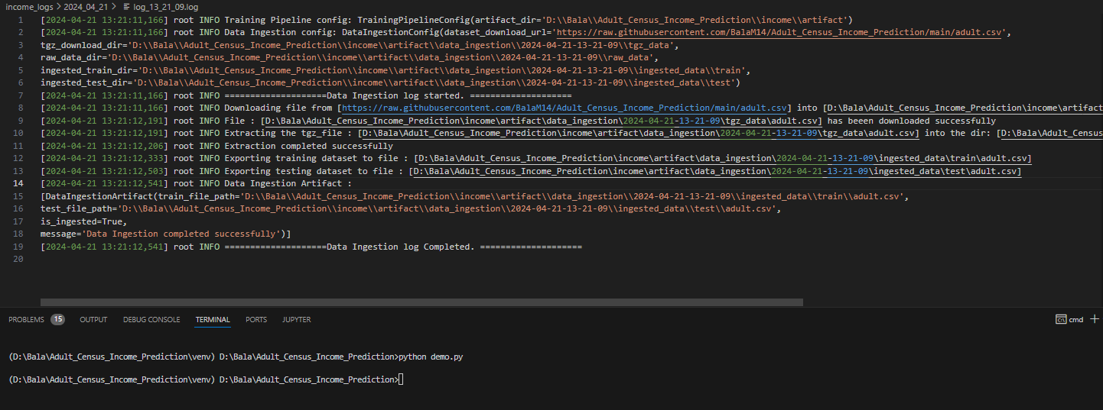

1. Component - Data Validation:

Create a schema.yaml file to declare the column names, column datatypes, numerical/categorical columns & unique values of categorical columns.



The config.py under the entity folder, configuration.py under the config folder & Constant file – all 3 iss already updated. So we need to cross verify whether everything is right.

Component - Data Validation:

import os,sys

from income.logger import logging

from income.exception import IncomeException

from income.entity.config_entity import DataValidationConfig

from income.constant import *

from income.entity.artifact_entity import DataIngestionArtifact

import pandas as pd

class DataVaidation:

    def __init__(self, data_validation_config:DataValidationConfig,data_ingestion_artifact:DataIngestionArtifact):

        try:

            logging.info(f"{'='*20}Data Validation log started. {'='*20}")

            self.data_validation_config = data_validation_config

            self.data_ingestion_artifact = data_ingestion_artifact

        except Exception as e:

            raise IncomeException(e,sys) from e

    def is_train_test_file_exists(self) -> bool:

        try:

            pass

        except Exception as e:

            raise IncomeException(e,sys) from e

    def vaidate_datatset_schema(self) -> bool:

        try:

            pass

        except Exception as e:

            raise IncomeException(e,sys) from e

    def initiate_data_validation(self) -> DataIngestionArtifact:

        try:

            pass

        except Exception as e:

            raise IncomeException(e,sys) from e

    def __del__(self) -> None:

        logging.info(f"{'='*20}Data Validation log Completed. {'='*20}")

Train_Test_file_exists Method:

def is_train_test_file_exists(self) -> bool:

        try:

            logging.info(f"Checking if train & test data is available")

            is_train_file_exist = False

            is_test_file_exist = False

            train_file_path = self.data_ingestion_artifact.train_file_path

            test_file_path = self.data_ingestion_artifact.test_file_path

            is_train_file_exist = os.path.exists(train_file_path)

            is_test_file_exist = os.path.exists(test_file_path)

            is_available = is_train_file_exist and is_test_file_exist

            logging.info(f"Is train & test file exists ? {is_available}")

            if not is_available:

                taining_file_path = self.data_ingestion_artifact.train_file_path

                testing_file_path = self.data_ingestion_artifact.test_file_path

                message = f"Training file : {taining_file_path} or Testing file : {testing_file_path} is not present"

                logging.info(message)

                raise Exception(message)

            return is_available

        except Exception as e:

            raise IncomeException(e,sys) from e

Validate_dataset_schema Method:

def vaidate_datatset_schema(self) -> bool:

        try:

            validation_status = False

            schema = self.data_validation_config.schema_file_path

            train_file_path = self.data_ingestion_artifact.train_file_path

            test_file_path = self.data_ingestion_artifact.test_file_path

            train_df = pd.read_csv(train_file_path)

            test_df = pd.read_csv(test_file_path)

            #check the number of columns

            if len(schema['columns']) != len(train_df.columns) or len(schema['columns']) != len(test_df.columns):

                message = f"The count of dataset columns were mis-matching"

                logging.info(message)

                raise Exception(message)

            #Check the column names are valid

            for i in schema['columns'].keys():

                if i not in train_df.columns or i not in test_df.columns:

                    message = f"The Column name [{i}] is not available in the dataset "

                    logging.info(message)

                    raise Exception(message)

            #Check the data type of the columns

            for i in schema['columns'].keys():

                if schema['columns'][i] != train_df[i].dtype or schema['columns'][i] != test_df[i].dtype:

                    message = f"The Column name [{i}] is having an invalid datatype in the dataset "

                    logging.info(message)

                    raise Exception(message)

            #check the categorical column eligible values

            for i in schema['domain_value'].keys():

                unique_values=[j.strip() for j in train_df[i].unique()]

                for k in unique_values:

                    if k not in schema['domain_value'][i]:

                        message = f"The column name [{i}] is having an invalid value"

                        logging.info(message)

                        raise Exception(message)

            validation_status = True

            message = f"The datasets of [{train_df}] & [{test_df}] are validated successfully"

            logging.info(message)

            return validation_status

        except Exception as e:

            raise IncomeException(e,sys) from e

* DATA DRIFT:

Data drift refers to changes in the distribution of the features an ML model receives in production, potentially causing a decline in model performance.

Imports:

from evidently.model_profile import Profile

from evidently.model_profile.sections import DataDriftProfileSection

from evidently.dashboard import Dashboard

from evidently.dashboard.tabs import DataDriftTab

import json

def get_and_save_data_drift_report(self):

    try:

        profile = Profile(sections=[DataDriftProfileSection()])

        train_df,test_df = self.get_train_test_df()

        profile.calculate(train_df,test_df)

        report = json.loads(profile.json())

        with open(self.data_validation_config.report_file_path,'w') as report_file:

            json.dump(report, report_file, indent=6)

        return report

    except Exception as e:

        raise IncomeException(e,sys) from e

def save_data_drift_report_page(self):

    try:

        dashboard = Dashboard(tabs=[DataDriftTab()])

        train_df,test_df = self.get_train_test_df()

        dashboard.calculate(train_df,test_df)

        dashboard.save(self.data_validation_config.report_page_file_path)

    except Exception as e:

        raise IncomeException(e,sys) from e

def is_data_drift_found(self) -> bool:

    try:

        report = self.get_and_save_data_drift_report()

        self.save_data_drift_report_page()

        return True

    except Exception as e:

        raise IncomeException(e,sys) from e

Complete code of Data Validation Component:

import os,sys

from income.logger import logging

from income.exception import IncomeException

from income.entity.config_entity import DataValidationConfig

from income.constant import *

from income.entity.artifact_entity import DataIngestionArtifact,DataValidationArtifact

from income.util.util import read_yaml_file

import pandas as pd

from evidently.model_profile import Profile

from evidently.model_profile.sections import DataDriftProfileSection

from evidently.dashboard import Dashboard

from evidently.dashboard.tabs import DataDriftTab

import json

class DataValidation:

    def __init__(self, data_validation_config:DataValidationConfig,data_ingestion_artifact:DataIngestionArtifact):

        try:

            logging.info(f"{'='*20}Data Validation log started. {'='*20}")

            self.data_validation_config = data_validation_config

            self.data_ingestion_artifact = data_ingestion_artifact

        except Exception as e:

            raise IncomeException(e,sys) from e

    def is_train_test_file_exists(self) -> bool:

        try:

            logging.info(f"Checking if train & test data is available")

            is_train_file_exist = False

            is_test_file_exist = False

            train_file_path = self.data_ingestion_artifact.train_file_path

            test_file_path = self.data_ingestion_artifact.test_file_path

            is_train_file_exist = os.path.exists(train_file_path)

            is_test_file_exist = os.path.exists(test_file_path)

            is_available = is_train_file_exist and is_test_file_exist

            logging.info(f"Is train & test file exists ? {is_available}")

            if not is_available:

                taining_file_path = self.data_ingestion_artifact.train_file_path

                testing_file_path = self.data_ingestion_artifact.test_file_path

                message = f"Training file : {taining_file_path} or Testing file : {testing_file_path} is not present"

                logging.info(message)

                raise Exception(message)

            return is_available

        except Exception as e:

            raise IncomeException(e,sys) from e

    def get_train_test_df(self):

        try:

            train_file_path = self.data_ingestion_artifact.train_file_path

            test_file_path = self.data_ingestion_artifact.test_file_path

            train_df = pd.read_csv(train_file_path)

            test_df = pd.read_csv(test_file_path)

            return train_df,test_df

        except Exception as e:

            raise IncomeException(e,sys) from e

    def vaidate_datatset_schema(self) -> bool:

        try:

            validation_status = False

            schema_file_path = self.data_validation_config.schema_file_path

            schema = read_yaml_file(file_path=schema_file_path)

            train_df,test_df = self.get_train_test_df()

            #check the number of columns

            if len(schema['columns']) != len(train_df.columns) or len(schema['columns']) != len(test_df.columns):

                message = f"The count of dataset columns were mis-matching"

                logging.info(message)

                raise Exception(message)

            #Check the column names are valid

            for i in schema['columns'].keys():

                if i not in train_df.columns or i not in test_df.columns:

                    message = f"The Column name [{i}] is not available in the dataset "

                    logging.info(message)

                    raise Exception(message)

            #Check the data type of the columns

            for i in schema['columns'].keys():

                if schema['columns'][i] != train_df[i].dtype or schema['columns'][i] != test_df[i].dtype:

                    message = f"The Column name [{i}] is having an invalid datatype in the dataset "

                    logging.info(message)

                    raise Exception(message)

            #check the categorical column eligible values

            """for i in schema['domain_value'].keys():

                unique_values=[j.strip() for j in train_df[i].unique()]

                for k in unique_values:

                    if k not in schema['domain_value'][i]:

                        message = f"The column name [{i}] is having an invalid value"

                        logging.info(message)

                        raise Exception(message)"""

            validation_status = True

            message = f"The datasets of train & test data are validated successfully"

            logging.info(message)

            return validation_status

        except Exception as e:

            raise IncomeException(e,sys) from e

    def get_and_save_data_drift_report(self):

        try:

            profile = Profile(sections=[DataDriftProfileSection()])

            train_df,test_df = self.get_train_test_df()

            profile.calculate(train_df,test_df)

            report = json.loads(profile.json())

            report_file_path = self.data_validation_config.report_file_path

            report_dir = os.path.dirname(report_file_path)

            os.makedirs(report_dir,exist_ok=True)

            with open(report_file_path,'w') as report_file:

                json.dump(report, report_file, indent=6)

            return report

        except Exception as e:

            raise IncomeException(e,sys) from e

    def save_data_drift_report_page(self):

        try:

            dashboard = Dashboard(tabs=[DataDriftTab()])

            train_df,test_df = self.get_train_test_df()

            dashboard.calculate(train_df,test_df)

            report_page_file_path = self.data_validation_config.report_page_file_path

            report_dir = os.path.dirname(report_page_file_path)

            os.makedirs(report_dir,exist_ok=True)

            dashboard.save(report_page_file_path)

        except Exception as e:

            raise IncomeException(e,sys) from e

    def is_data_drift_found(self) -> bool:

        try:

            report = self.get_and_save_data_drift_report()

            self.save_data_drift_report_page()

            return True

        except Exception as e:

            raise IncomeException(e,sys) from e

    def initiate_data_validation(self) -> DataIngestionArtifact:

        try:

            self.is_train_test_file_exists()

            self.vaidate_datatset_schema()

            self.is_data_drift_found()

            data_validation_artifact = DataValidationArtifact(schema_file_path=self.data_validation_config.schema_file_path,

                                                              report_file_path=self.data_validation_config.report_file_path,

                                                              report_page_file_path=self.data_validation_config.report_page_file_path,

                                                              is_validated=True,

                                                              message=f"Data Validation Performed successfully")

            logging.info(f"Data Validation artifact: {data_validation_artifact}")

            return data_validation_artifact

        except Exception as e:

            raise IncomeException(e,sys) from e

    def __del__(self) -> None:

        logging.info(f"{'='*20}Data Validation log Completed. {'='*20}")

1. Pipeline – Data validation:

from income.config.configuration import Configuration

from income.entity.config_entity import DataIngestionConfig

from income.entity.artifact_entity import DataIngestionArtifact

from income.component.data_ingestion import DataIngestion

from income.component.data_validation import DataValidation

from income.entity.artifact_entity import DataValidationArtifact

from income.logger import logging

from income.exception import IncomeException

import os,sys

class Pipeline:

    def __init__(self, config: Configuration = Configuration()) -> None:

        try:

            self.config = config

        except Exception as e:

            raise IncomeException(e,sys) from e

    def start_data_ingestion(self) -> DataIngestionArtifact:

        try:

            data_ingestion = DataIngestion(data_ingestion_config=self.config.get_data_ingestion_config())

            return data_ingestion.initiate_data_ingestion()

        except Exception as e:

            raise IncomeException(e,sys) from e

    def start_data_validation(self,data_ingestion_artifact: DataIngestionArtifact) -> DataValidationArtifact:

        try:

            data_validation = DataValidation(data_validation_config=self.config.get_data_validation_config(),

                                             data_ingestion_artifact=data_ingestion_artifact)

            return data_validation.initiate_data_validation()

        except Exception as e:

            raise IncomeException(e,sys) from e

    def start_data_transformation(self):

        try:

            pass

        except Exception as e:

            raise IncomeException(e,sys) from e

    def start_model_training(self):

        try:

            pass

        except Exception as e:

            raise IncomeException(e,sys) from e

    def start_model_evaluation(self):

        try:

            pass

        except Exception as e:

            raise IncomeException(e,sys) from e

    def start_model_pusher(self):

        try:

            pass

        except Exception as e:

            raise IncomeException(e,sys) from e

    def run_pipeline(self):

        try:

            #Data Ingestion Piipeline

            data_inegstion_artifact = self.start_data_ingestion()

            data_validation_artifact = self.start_data_validation(data_ingestion_artifact=data_inegstion_artifact)

        except Exception as e:

            raise IncomeException(e,sys) from e

Test Code:

import os,sys

from income.logger import logging

from income.exception import IncomeException

from income.config.configuration import DataIngestionConfig

from income.entity.artifact_entity import DataIngestionArtifact

from income.pipeline.pipeline import Pipeline

from income.config.configuration import Configuration

def main():

    try:

        pipeline = Pipeline()

        pipeline.run_pipeline()

        #data_validation_config = Configuration().get_data_validation_config()

        #print(data_validation_config)

    except Exception as e:

        logging.error(f"{e}")

        raise IncomeException(e,sys)

if __name__=="__main__":

    main()

Terminal:

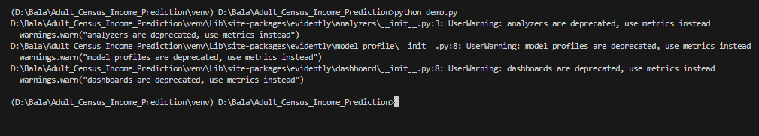

Data Drift Report:

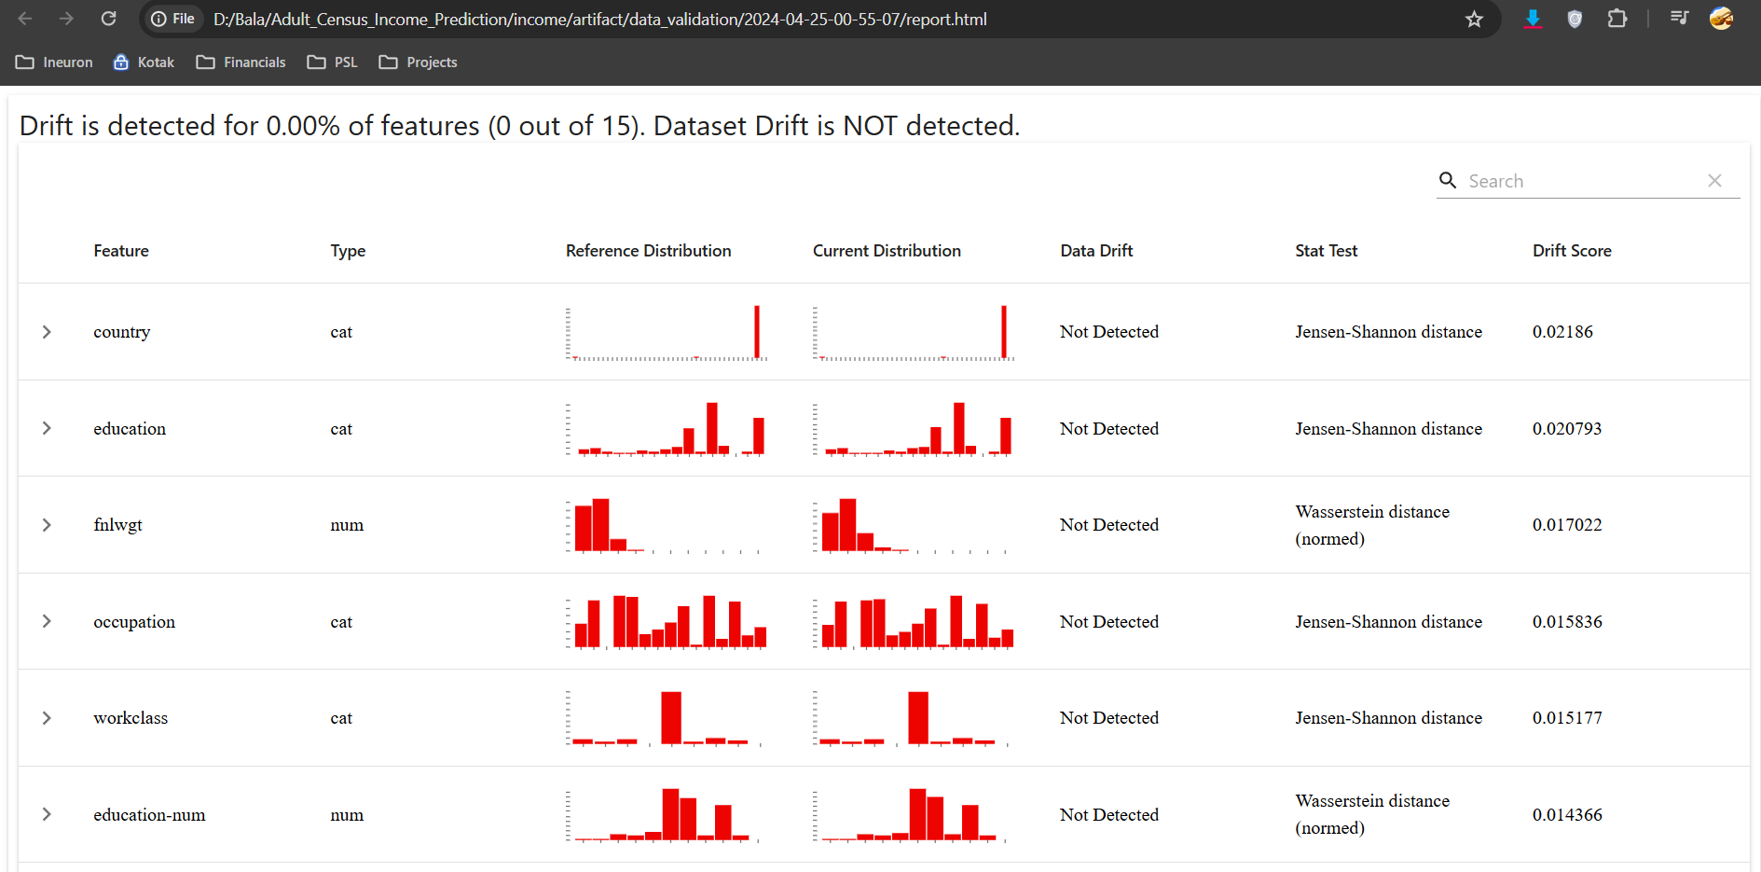

1. Component – Data Transformation:

from income.entity.config_entity import DataTransformationConfig

from income.entity.artifact_entity import DataIngestionArtifact,DataValidationArtifact

from income.logger import logging

from income.exception import IncomeException

import os,sys

import numpy as np

import pandas as pd

from income.util.util import read_yaml_file, save_numpy_array_data, save_object

from income.constant import *

#from sklearn.base import BaseEstimator,TransformerMixin

from sklearn.preprocessing import StandardScaler, OneHotEncoder

from sklearn.pipeline import Pipeline

from sklearn.compose import ColumnTransformer

from sklearn.impute import SimpleImputer

class DataTransformation:

    def __init__(self,data_transformation_config: DataTransformationConfig,

                 data_ingeestion_artifact: DataIngestionArtifact,

                 data_validation_artifact: DataValidationArtifact):

        try:

            self.data_transformation_config = data_transformation_config

            self.data_ingestion_artifact = data_ingeestion_artifact

            self.data_validation_artifact = data_validation_artifact

except Exception as e:

            raise IncomeException(e,sys) from e

    @staticmethod

    def load_data(file_path :str, schema_file_path) -> pd.DataFrame:

        '''

        This function converts the data types as per the schema file values.

        If it is not ablee to convert then it will rasie an exception'''

        try:

            datset_schema = read_yaml_file(schema_file_path)

            schema = datset_schema[DATASET_SCHEMA_COLUMNS_KEY]

            dataframe = pd.read_csv(file_path)

            error_messgae = ""

            for column in dataframe.columns:

                if column in list(schema.keys()):

                    dataframe[column].astype(schema[column])

                else:

                    error_messgae = f"{error_messgae} \nColumn: [{column}] is not in the schema."

            if len(error_messgae) > 0:

                raise Exception(error_messgae)

            return dataframe

        except Exception as e:

            raise IncomeException(e,sys) from e

    def get_data__transformer_object(self) -> ColumnTransformer:

        try:

            schema_file_path = self.data_validation_artifact.schema_file_path

            dataset_schema = read_yaml_file(schema_file_path)

            numerical_columns = dataset_schema[NUMERICAL_COLUMN_KEY]

            categorical_columns = dataset_schema[CATEGORICAL_COLUMN_KEY]

            numerical_pipeline = Pipeline(steps=[

                ('impute', SimpleImputer(strategy='median')),

                ('scaler',StandardScaler())

            ])

            categorical_pipeline = Pipeline(steps=[

                ('impute',SimpleImputer(strategy='most_frequent')),

                ('one_hot_encoder',OneHotEncoder())

            ])

            logging.info(f"Numerical_Columns : [{numerical_columns}]")

            logging.info(f"Categorical_Columns : [{categorical_columns}]")

            preprocessing = ColumnTransformer([

                ('numerical_pipeline',numerical_pipeline,numerical_columns),

                ('categorical_pipeline',categorical_pipeline,categorical_columns)

            ])

            return preprocessing

        except Exception as e:

            raise IncomeException(e,sys) from e

Update Utils:

import yaml

from income.exception import IncomeException

import os,sys

import numpy as np

import dill

def read_yaml_file(file_path:str) -> dict:

    """

    Reads a Yaml file and returns the contents as a dictionary.

    file_path:str

    """

    try:

        with open(file_path,"rb") as yaml_file:

            return yaml.safe_load(yaml_file)

    except Exception as e:

        raise IncomeException(e,sys) from e

def save_numpy_array_data(file_path: str, array: np.array):

    '''

    save numpy array data to file

    file_path: str location of file to save

    array: np.array data to save

    '''

    try:

        dir_path = os.path.dirname(file_path)

        os.makedirs(dir_path,exist_ok=True)

        with open(file_path,"wb") as file_obj:

            np.save(file_obj,array)

    except Exception as e:

        raise IncomeException(e,sys) from e

def load_numpy_array_data(file_path: str) -> np.array:

    '''

    load numpy array data from file

    file_path: str location of file to load

    return : np.array data loaded

    '''

    try:

       with open(file_path,"rb") as file_obj:

           return np.load(file_obj,allow_pickle=True)

    except Exception as e:

        raise IncomeException(e,sys) from e

#To save the object in the pickle format

def save_object(file_path: str, obj):

    '''

    file_path: str location of file

    obj: Any sort of obj

    '''

    try:

        dir_path = os.path.dirname(file_path)

        os.makedirs(dir_path,exist_ok=True)

        with open(file_path,"wb") as file_obj:

            dill.dump(obj, file_obj)

    except Exception as e:

        raise IncomeException(e,sys) from e

#To load the pickle object

def load_object(file_path: str):

    '''

    file_path: str location of file

    '''

    try:

       with open(file_path,"rb") as file_obj:

           return dill.load(file_obj)

    except Exception as e:

        raise IncomeException(e,sys) from e

Complete Code of DataTransformation Component:

from income.entity.config_entity import DataTransformationConfig

from income.entity.artifact_entity import DataIngestionArtifact,DataValidationArtifact,DataTransformationArtifact

from income.logger import logging

from income.exception import IncomeException

import os,sys

import numpy as np

import pandas as pd

from income.util.util import read_yaml_file, save_numpy_array_data, save_object

from income.constant import *

#from sklearn.base import BaseEstimator,TransformerMixin

from sklearn.preprocessing import StandardScaler, OneHotEncoder

from sklearn.pipeline import Pipeline

from sklearn.compose import ColumnTransformer

from sklearn.impute import SimpleImputer

class DataTransformation:

    def __init__(self,data_transformation_config: DataTransformationConfig,

                 data_ingeestion_artifact: DataIngestionArtifact,

                 data_validation_artifact: DataValidationArtifact):

        try:

            self.data_transformation_config = data_transformation_config

            self.data_ingestion_artifact = data_ingeestion_artifact

            self.data_validation_artifact = data_validation_artifact

        except Exception as e:

            raise IncomeException(e,sys) from e

    @staticmethod

    def load_data(file_path :str, schema_file_path) -> pd.DataFrame:

        '''

        This function converts the data types as per the schema file values.

        If it is not ablee to convert then it will rasie an exception'''

        try:

            datset_schema = read_yaml_file(schema_file_path)

            schema = datset_schema[DATASET_SCHEMA_COLUMNS_KEY]

            dataframe = pd.read_csv(file_path)

            error_messgae = ""

            for column in dataframe.columns:

                if column in list(schema.keys()):

                    dataframe[column].astype(schema[column])

                else:

                    error_messgae = f"{error_messgae} \nColumn: [{column}] is not in the schema."

            if len(error_messgae) > 0:

                raise Exception(error_messgae)

            return dataframe

        except Exception as e:

            raise IncomeException(e,sys) from e

    def get_data__transformer_object(self) -> ColumnTransformer:

        try:

            schema_file_path = self.data_validation_artifact.schema_file_path

            dataset_schema = read_yaml_file(schema_file_path)

            numerical_columns = dataset_schema[NUMERICAL_COLUMN_KEY]

            categorical_columns = dataset_schema[CATEGORICAL_COLUMN_KEY]

            numerical_pipeline = Pipeline(steps=[

                ('impute', SimpleImputer(strategy='median')),

                ('scaler',StandardScaler())

            ])

            categorical_pipeline = Pipeline(steps=[

                ('impute',SimpleImputer(strategy='most_frequent')),

            ('one_hot_encoder', OneHotEncoder(sparse_output=False,handle_unknown='ignore')),

                ('scaler', StandardScaler(with_mean=False))

            ])

            logging.info(f"Numerical_Columns : [{numerical_columns}]")

            logging.info(f"Categorical_Columns : [{categorical_columns}]")

            preprocessing = ColumnTransformer([

                ('numerical_pipeline',numerical_pipeline,numerical_columns),

                ('categorical_pipeline',categorical_pipeline,categorical_columns)

            ])

            return preprocessing

        except Exception as e:

            raise IncomeException(e,sys) from e

    def initiate_data_transformation(self) -> DataTransformationArtifact:

        try:

            logging.info(f"Obtaining preprocessing object.")

            preprocessing_obj = self.get_data__transformer_object()

            logging.info(f"Obtaining training and test file path.")

            train_file_path = self.data_ingestion_artifact.train_file_path

            test_file_path = self.data_ingestion_artifact.test_file_path

            schema_file_path = self.data_validation_artifact.schema_file_path

            logging.info(f"Loading training and test data as pandas dataframe.")

            train_df = self.load_data(train_file_path,schema_file_path=schema_file_path)

            test_df = self.load_data(test_file_path,schema_file_path=schema_file_path)

            schema = read_yaml_file(schema_file_path)

            target_column_name = schema[TARGET_COLUMN_KEY]

            logging.info(f"Splitting input and target feature from training and testing dataframe.")

            input_feature_train_df = train_df.drop(columns=[target_column_name],axis=1)

            target_fetaure_train_df = train_df[target_column_name].map({‘ <=50’:0 , ‘ >=50K’:1})

            input_feature_test_df = test_df.drop(columns=[target_column_name],axis=1)

            target_fetaure_test_df = test_df[target_column_name].map({‘ <=50’:0 , ‘ >=50K’:1})

            #For training we need to use fit_tramsform & for testing we use only the transform

            logging.info(f"Applying preprocessing object on training dataframe and testing dataframe")

            input_feature_train_array = preprocessing_obj.fit_transform(input_feature_train_df)

            input_feature_test_array = preprocessing_obj.transform(input_feature_test_df)

            train_arr = np.c_[ input_feature_train_array, np.array(target_fetaure_train_df)]

            test_arr = np.c_[input_feature_test_array,np.array(target_fetaure_test_df)]

            transformed_train_dir = self.data_transformation_config.transformed_train_dir

            transformed_test_dir = self.data_transformation_config.transformed_test_dir

            train_file_name = os.path.basename(train_file_path).replace(".csv",".npz")

            test_file_name = os.path.basename(test_file_path).replace(".csv",".npz")

            transformed_train_file_path = os.path.join(transformed_train_dir,train_file_name)

            transformed_test_file_path = os.path.join(transformed_test_dir,test_file_name)

            logging.info(f"Saving transformed training and testing array.")

            save_numpy_array_data(file_path=transformed_train_file_path,array=train_arr)

            save_numpy_array_data(file_path=transformed_test_file_path,array=test_arr)

            #Save the Preprocessing object in the pickle format to use it in test data

            preprocessing_obj_file_path = self.data_transformation_config.preprocessed_object_file_path

            logging.info(f"Saving preprocessing object.")

            save_object(file_path=preprocessing_obj_file_path,obj=preprocessing_obj)

            data_transformation_artifact = DataTransformationArtifact(

                tranformed_train_file_path=transformed_train_file_path,

                transformed_test_file_path=transformed_test_file_path,

                preprocessed_object_file_path=preprocessing_obj_file_path,

                is_transfomred=True,

                message=f"Data transformation completed successfully")

            logging.info(f"Data tranformation Artifact : [{data_transformation_artifact}]")

            return data_transformation_artifact

        except Exception as e:

            raise IncomeException(e,sys) from e

    def __del__(self):

        logging.info(f"{'='*20}Data Transformation log completed.{'='*20} \n\n")

1. Pipeline – Data Transformation:

from income.config.configuration import Configuration

from income.component.data_ingestion import DataIngestion

from income.component.data_validation import DataValidation

from income.component.data_transformation import DataTransformation

from income.entity.artifact_entity import DataIngestionArtifact

from income.entity.artifact_entity import DataValidationArtifact

from income.entity.artifact_entity import DataTransformationArtifact

from income.logger import logging

from income.exception import IncomeException

import os,sys

class Pipeline:

    def __init__(self, config: Configuration = Configuration()) -> None:

        try:

            self.config = config

        except Exception as e:

            raise IncomeException(e,sys) from e

    def start_data_ingestion(self) -> DataIngestionArtifact:

        try:

            data_ingestion = DataIngestion(

                data_ingestion_config=self.config.get_data_ingestion_config()

                )

            return data_ingestion.initiate_data_ingestion()

        except Exception as e:

            raise IncomeException(e,sys) from e

    def start_data_validation(self,data_ingestion_artifact: DataIngestionArtifact) -> DataValidationArtifact:

        try:

            data_validation = DataValidation(

                data_validation_config=self.config.get_data_validation_config(),

                data_ingestion_artifact=data_ingestion_artifact

                )

            return data_validation.initiate_data_validation()

        except Exception as e:

            raise IncomeException(e,sys) from e

    def start_data_transformation(self,data_ingestion_artifact: DataIngestionArtifact,

                                   data_validation_artifact: DataValidationArtifact) -> DataTransformationArtifact:

        try:

            data_transformation = DataTransformation(

                data_transformation_config=self.config.get_data_transformation_config(),

                data_ingestion_artifact=data_ingestion_artifact,

                data_validation_artifact=data_validation_artifact

                )

            return data_transformation.initiate_data_transformation()

        except Exception as e:

            raise IncomeException(e,sys) from e

    def start_model_training(self):

        try:

            pass

        except Exception as e:

            raise IncomeException(e,sys) from e

    def start_model_evaluation(self):

        try:

            pass

        except Exception as e:

            raise IncomeException(e,sys) from e

    def start_model_pusher(self):

        try:

            pass

        except Exception as e:

            raise IncomeException(e,sys) from e

    def run_pipeline(self):

        try:

            #Data Ingestion Piipeline

            data_inegstion_artifact = self.start_data_ingestion()

            data_validation_artifact = self.start_data_validation(data_ingestion_artifact=data_inegstion_artifact)

            data_transformation_artifact = self.start_data_transformation(

                                                data_ingestion_artifact=data_inegstion_artifact,

                                                data_validation_artifact=data_validation_artifact

                                                )

        except Exception as e:

            raise IncomeException(e,sys) from e

1. Entity-Model_factory:

Create a model.yaml file under the income/config folder with all the model details



In entity folder create the “Model_factory.py” file as shown below.

