The assigned party is Liberal party and the assigned party leader is Trudeau.

1.1) **What is the total number of votes earned by your assigned party in each of the provinces?**  
  
> Table1_BP <- aggregate(StudyFile_BP$LPV_BP, by=list(StudyFile_BP$Prov_BP), FUN=sum, na.rm=TRUE)

> Table1_BP

Group.1 x

1 AB 473416

2 BC 829816

3 MB 268280

4 NB 227764

5 NL 165418

6 NS 324816

7 NT 9172

8 NU 5619

9 ON 2929393

10 PE 51002

11 QC 1515673

12 SK 131681

13 YT 10887

Each row represents a province along with total number of votes earned by liberal party in each province.

**1.2)What is the average score for the answer to the question "How do you feel about the party leaders?" for your party’s leader in Manitoba weighted by the number of electors in each district?**

> ProvFeelTru_BP <- StudyFile_BP %>%

+ select(EDN_BP,Electors_BP,Prov_BP,Trude_BP) %>%

+ group_by(Prov_BP) %>%

+ summarise(wFeelTru_BP = weighted.mean(Trude_BP,w=Electors_BP))

> wMeanTruMB_BP <- ProvFeelTru_BP[ProvFeelTru_BP$Prov_BP == "MB", c("wFeelTru_BP")]

> wMeanTruMB_BP

# A tibble: 1 x 1

wFeelTru_BP

*<dbl>*

1 49.6

The answer is 49.6

1.3) **What is the standard deviation of the answer to the question "And what about the performance of the economy during the past four years? Has it improved, stayed the same, or got worse?" for electoral  
districts that were won by your assigned political party.**

> #Electoral districts won by liberal party

> EdnLibWon_BP <- StudyFile_BP[StudyFile_BP$WinParty_BP == "LIB", c("EDN_BP", "WinParty_BP", "ecc_sat")]

> names(EdnLibWon_BP)[3]<- "EcnmyPerf_BP"

> # head(EdnLibWon_BP)

> # tail(EdnLibWon_BP)

> #calculate standard deviation ignoring NA's.

> EdnLibWonEcoPerfSd_BP = sd(EdnLibWon_BP$EcnmyPerf_BP, na.rm = TRUE)

> EdnLibWonEcoPerfSd_BP

[1] 0.1280154

The answer is 0.1280154

1.4) **The study file has total number of females and total males answering the LPP2015 in each electoral district. What is the 68th percentile (quantile) of number of females across your study file?**

> FemQuntl_68_pc_BP <- quantile(StudyFile_BP$Female_BP,c(.68), na.rm = TRUE)

> FemQuntl_68_pc_BP

68%

58

The answer is 58.

1.5) **What is the mean absolute deviation of turnout for electoral districts in your assigned province?**

#Collect TurnOut data that belongs to Alberta

TurnOutStudyAlberta_BP <- StudyFile_BP[StudyFile_BP$Prov_BP == "AB",c("EDN_BP","Prov_BP","TO")]

colnames(TurnOutStudyAlberta_BP)[3]<- "TurnOut_BP"

#Calculate mean absolute deviation ignoring NA's

MadTOAlb_BP <- mad(TurnOutStudyAlberta_BP$TurnOut_BP, na.rm = TRUE)

MadTOAlb_BP

[1] 4.37367

The answer is 4.37367

**Question 2.1**

1. **Summary table**  
a. **Create a table that shows Number of Electoral Districts (Ridings) won by each party (columns) in each province (rows). Each cell in the table should be the percentage of each row.**

> PropTable_BP<-prop.table(Table_EDN_Party_BP,1)

> Table_EDN_Party_BP <- table(StudyFile_BP$Prov_BP, StudyFile_BP$WinParty_BP)

> Table_EDN_Party_BP

BQP CPC GRN LIB NDP

AB 0 29 0 4 1

BC 0 10 1 17 14

MB 0 5 0 7 2

NB 0 0 0 10 0

NL 0 0 0 7 0

NS 0 0 0 11 0

NT 0 0 0 1 0

NU 0 0 0 1 0

ON 0 33 0 80 8

PE 0 0 0 4 0

QC 10 12 0 40 16

SK 0 10 0 1 3

YT 0 0 0 1 0

> PropTable_BP<-prop.table(Table_EDN_Party_BP,1)

> PropTable_BP

BQP CPC GRN LIB NDP

AB 0.00000000 0.85294118 0.00000000 0.11764706 0.02941176

BC 0.00000000 0.23809524 0.02380952 0.40476190 0.33333333

MB 0.00000000 0.35714286 0.00000000 0.50000000 0.14285714

NB 0.00000000 0.00000000 0.00000000 1.00000000 0.00000000

NL 0.00000000 0.00000000 0.00000000 1.00000000 0.00000000

NS 0.00000000 0.00000000 0.00000000 1.00000000 0.00000000

NT 0.00000000 0.00000000 0.00000000 1.00000000 0.00000000

NU 0.00000000 0.00000000 0.00000000 1.00000000 0.00000000

ON 0.00000000 0.27272727 0.00000000 0.66115702 0.06611570

PE 0.00000000 0.00000000 0.00000000 1.00000000 0.00000000

QC 0.12820513 0.15384615 0.00000000 0.51282051 0.20512821

SK 0.00000000 0.71428571 0.00000000 0.07142857 0.21428571

YT 0.00000000 0.00000000 0.00000000 1.00000000 0.00000000

b. **In what province did your party win the highest percentage of ridings?**

colnames(PropTable_BP)[4] <- "LIB_BP"

> PropTable_BP[,"LIB_BP"]

AB BC MB NB NL NS NT NU

0.11764706 0.40476190 0.50000000 1.00000000 1.00000000 1.00000000 1.00000000 1.00000000

ON PE QC SK YT

0.66115702 1.00000000 0.51282051 0.07142857 1.00000000

Liberal party won the highest percent of ridings in the following provinces:

New Brunswick, Newfoundland and Labrador, Nova Scotia, Northwest Territories,

Nunavut, Prince Edward Island and Yukon. They all got row percentage equal to 1.

**Question 2.2**

2. **Bar Chart**  
a**. Create a bar chart showing the number of Males and Females by which party won the electoral district. NOTE - Exclude the three territories from this analysis (Nunavut, Northwest Territories and Yukon). (Yours will be for winning party, not province)**

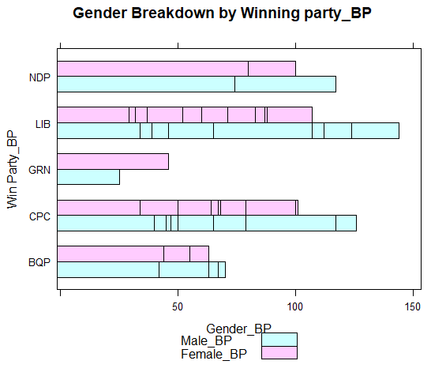

b. **Which party got a higher number of female voters according to this file?**

From the bar chart, I can see that Green party has higher number of female voters than male voters. If we look at whole bar chart, I see the Liberal party has got highest number of female voters.

**Question 2.3**

**Histogram**  
a. **Create a histogram showing the distribution of the answer to the question "How do you feel about the party leaders?" according to the LPP2015. Give your answer for the leader of your assigned party.**

> histogram( ~ Trude_BP, dat=StudyFile_BP, breaks=10, type = "count",

+ main="Trudeau Count of Support_BP")

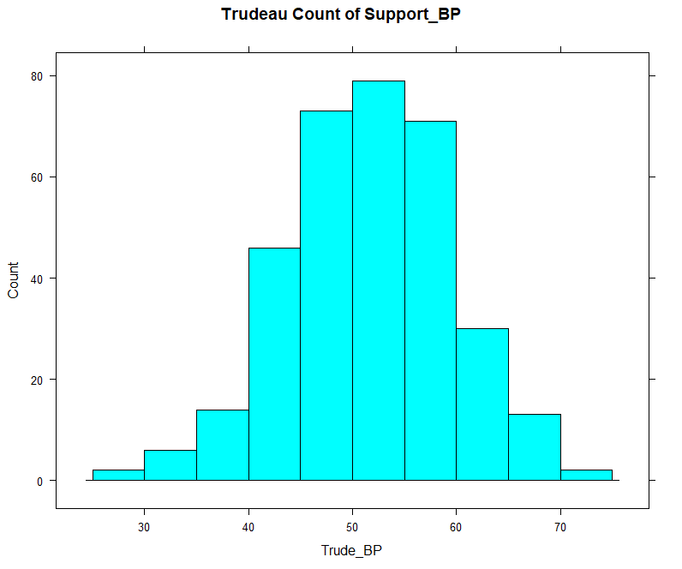

As three groups seems to higher count from 45 to 60, I’m going to reduce the bin size for little more precision.

> histogram( ~ Trude_BP, dat=StudyFile_BP, breaks=20, type = "count",

+ main="Trudeau Count of Support_BP")

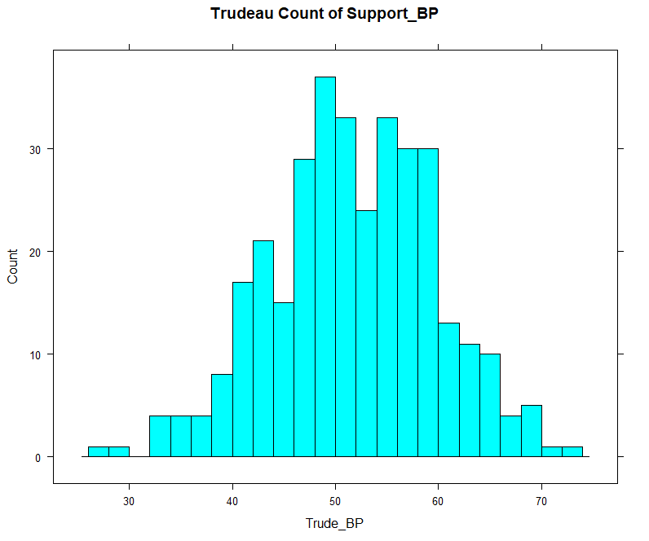

b. **Which range of values has the highest frequency?**

From the above histogram, I can see the range “48 to 50” has the highest frequency.

**Question 2.4**

**Box Plots**  
a. **Create a sequence of box plots showing the distribution of the answer to the question "How do you feel about the political parties?" for your assigned party divided by Electoral Districts won by each party. NOTE - Exclude the three territories from this analysis (Nunavut, Northwest Territories and Yukon)**

> bwplot(NewStudyFile_BP$LiB_BP ~ NewStudyFile_BP$WinParty_BP, data=StudyFile_BP,

+ main="Distribution of Liberal Party Support by WinningParty_BP",

+ xlab="Winning Party_BP", pch = '|')

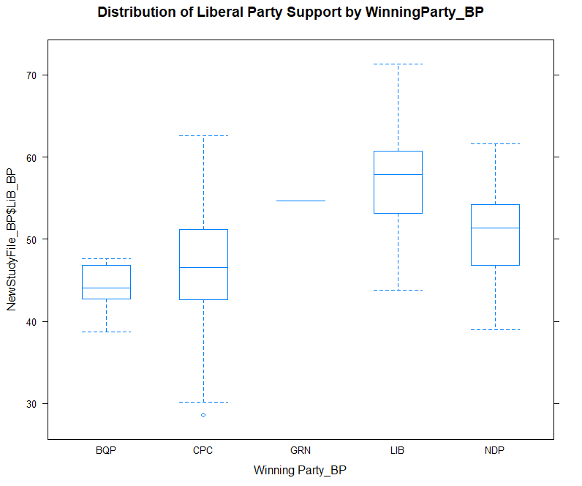  
b. **Which of these charts shows your party has the most support?**

The electoral districts won by Liberal party has more support for Liberal party

c. **Which shows your party has the least?**

The electoral districts won by BQP party has least support for Liberal party  
d. **Which has the greatest variability in support?**

The electoral districts won by Conservative party has greatest variability in support for Liberal party.

Though the IQR of CPC box chart and LIB box plot seemed to be similar but range of CPC box plot (62-30=32)

seems to be slightly greater than that of LIB box(71-44=27).

**Question 2.5**

1. **Create a histogram for the answer to the question: "How do you feel about the political parties?" for your assigned party**

> histogram( ~ LiB_BP, dat=StudyFile_BP, breaks=20, type = "count",

+ main="Support for Liberal Party_BP")

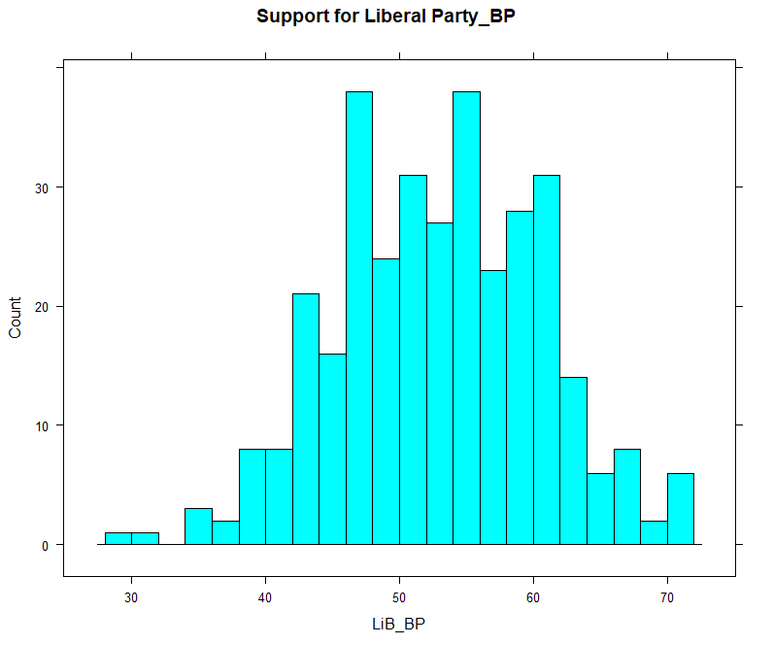

1. **Create a histogram for the answer to the question: "How do you feel about the party leaders?" for your assigned leader.**

> histogram( ~ Trude_BP, dat=StudyFile_BP, breaks=20, type = "count",

+ main="Count of Trudeau Support_BP")

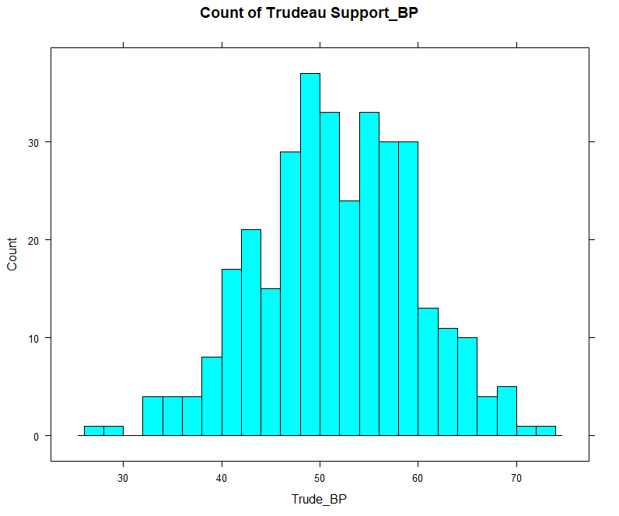

c. **Create a scatter plot showing the relationship between the answer to the question: "How do you feel about the political parties?" for your assigned party and "How do you feel about the party leaders?" for your assigned leader.**

> xyplot(LiB_BP ~ Trude_BP, data=StudyFile_BP, color="violet", pch=20,

+ main="Liberal Party by Trudeau Support_BP")

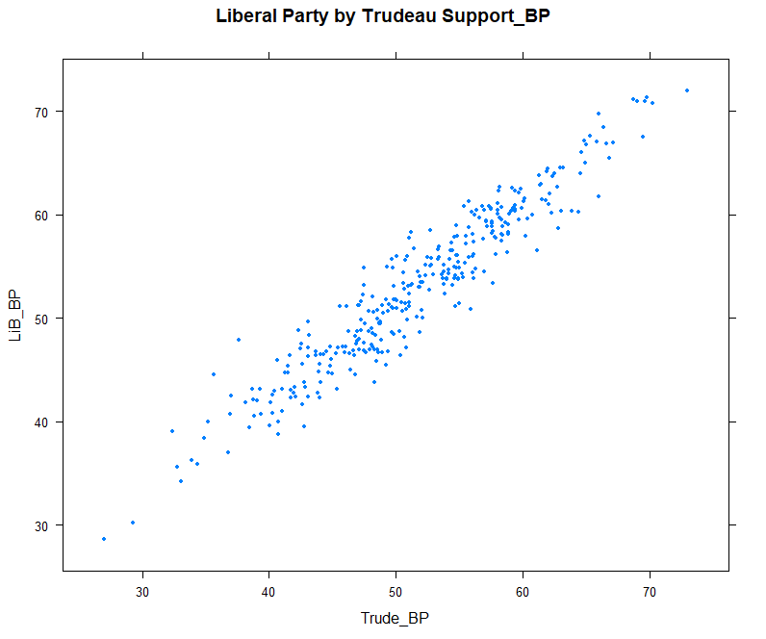  
d. **What conclusions, if any, can you draw from the chart?**

There is a positive correlation between the support for Liberal Party and the support for Trudeau. Trudeau seems to be a better candidate for the liberal party as his supports seems to be proportional to that of liberal party. I can conclude that Trudeau has support in align with that of liberal party.