**Tool Anomaly Detection Readme**

**Perquisites:** Python, Anaconda

Install Python and Anaconda from Chrome.

**Step – 1** Create Virtual Environment

Open Anaconda Prompt and type following commands.

conda update conda

conda create -n envname python=3.11 anaconda

conda activate envname

**Step -2** Install Required Packages

Open Anaconda prompt in the folder of the python file is located and run the following commands.

pip install -r requirements.txt

**Step -3** Run the application.

Open Anaconda prompt in the folder of the python file is located and run the following commands.

streamlit run app.py

**Procedure:**

Download the zip file shared with you unzip it and keep in current directory.

Run

streamlit run app.py

Screenshots for references

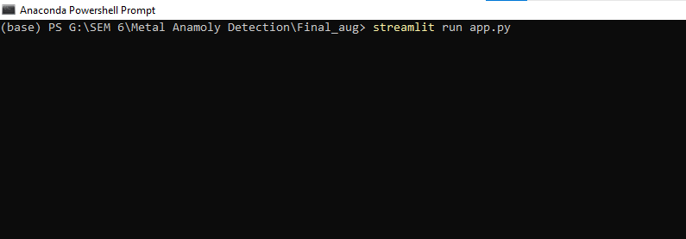

Below screen opens:

Capturing and loading the image:

