page2image568

Customer Analysis using Tableau

**Step 1:** Create a table with the region on the rows shelf, and customer (Count), sales, quantity, sales per customer, profit, and profit ratio on the columns shelf. Rename the worksheet as “Customer Statistics.”

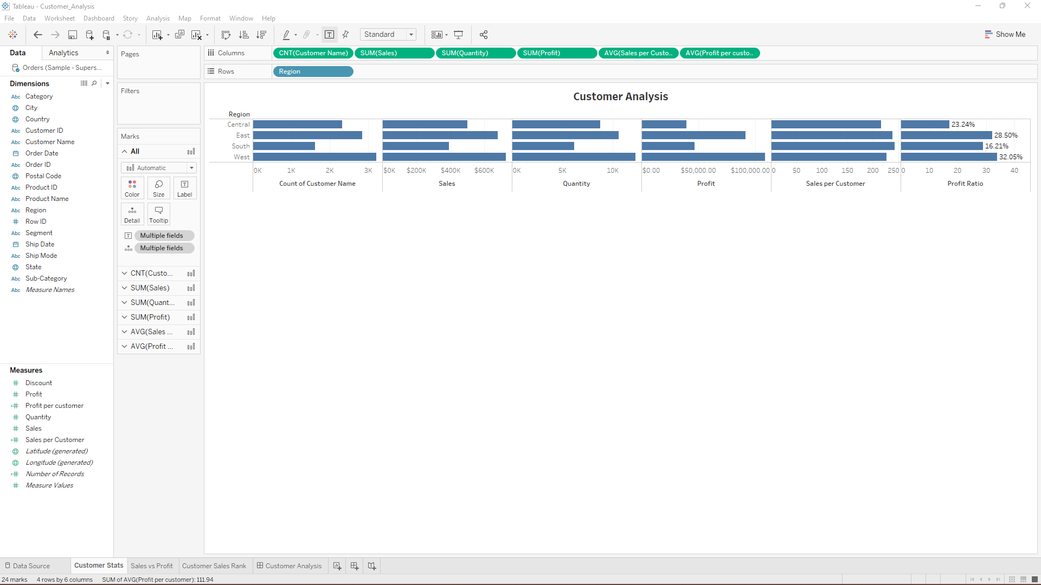

**Step 2:** Create a scatter plot with sales on the X axis, profit on the Y axis, customer name on the detail shelf, and profit ratio on the color shelf. Change the color settings to show “Red–Green Diverging” with green as positive profit ratio, and red as negative profit ratio. Rename the sheet and provide the title as “Sales and Profit by Customer Scatter.”

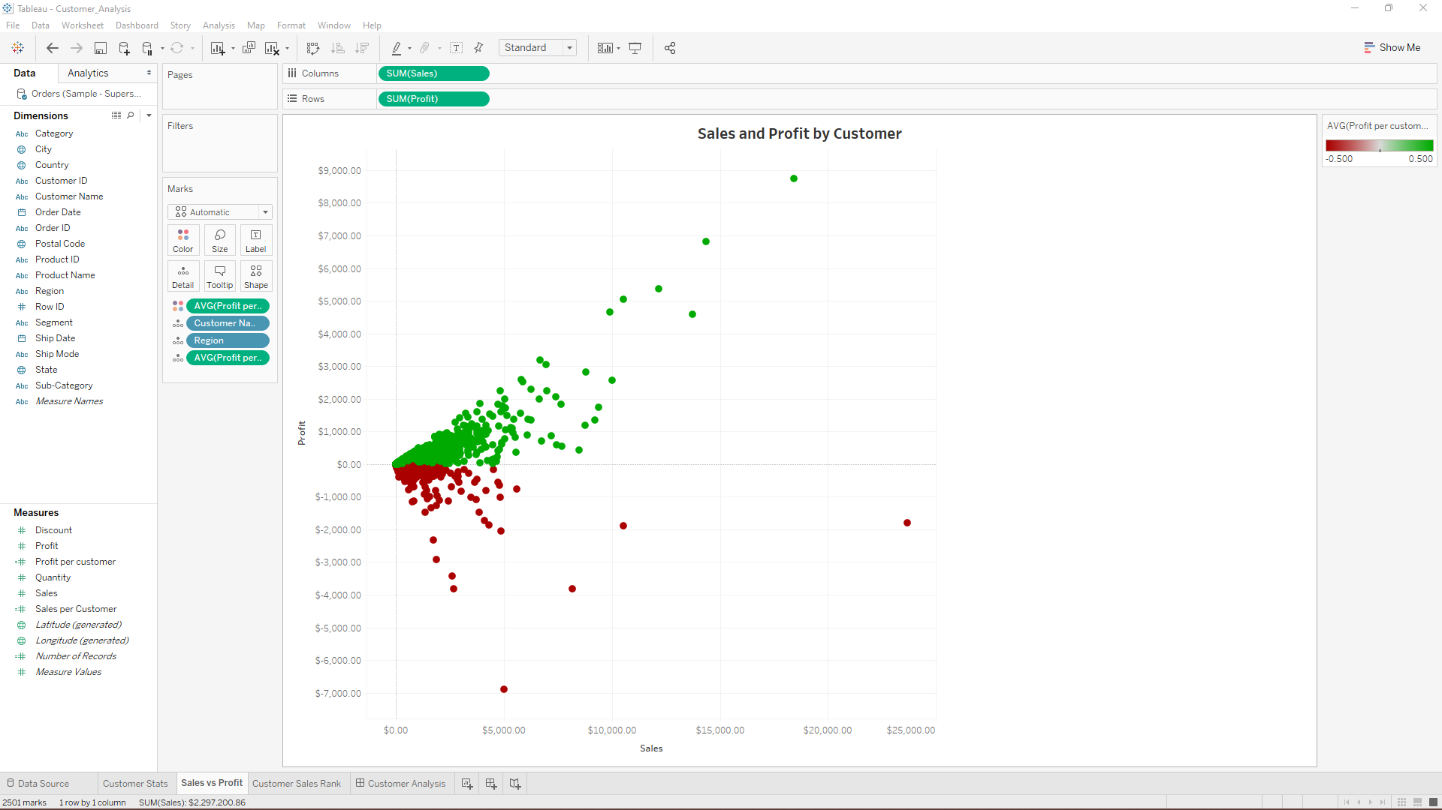

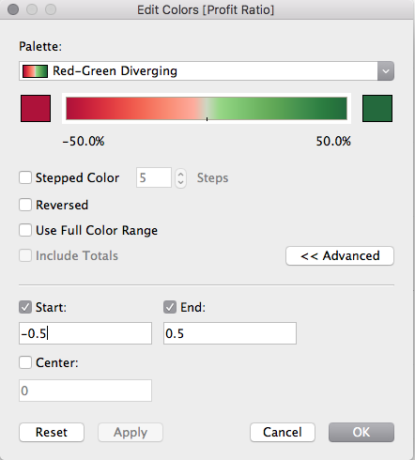

**Step 3:** Create a view with customer name on the rows shelf and sales on the columns shelf. Rename the worksheet as “Customer Sales Rank.”

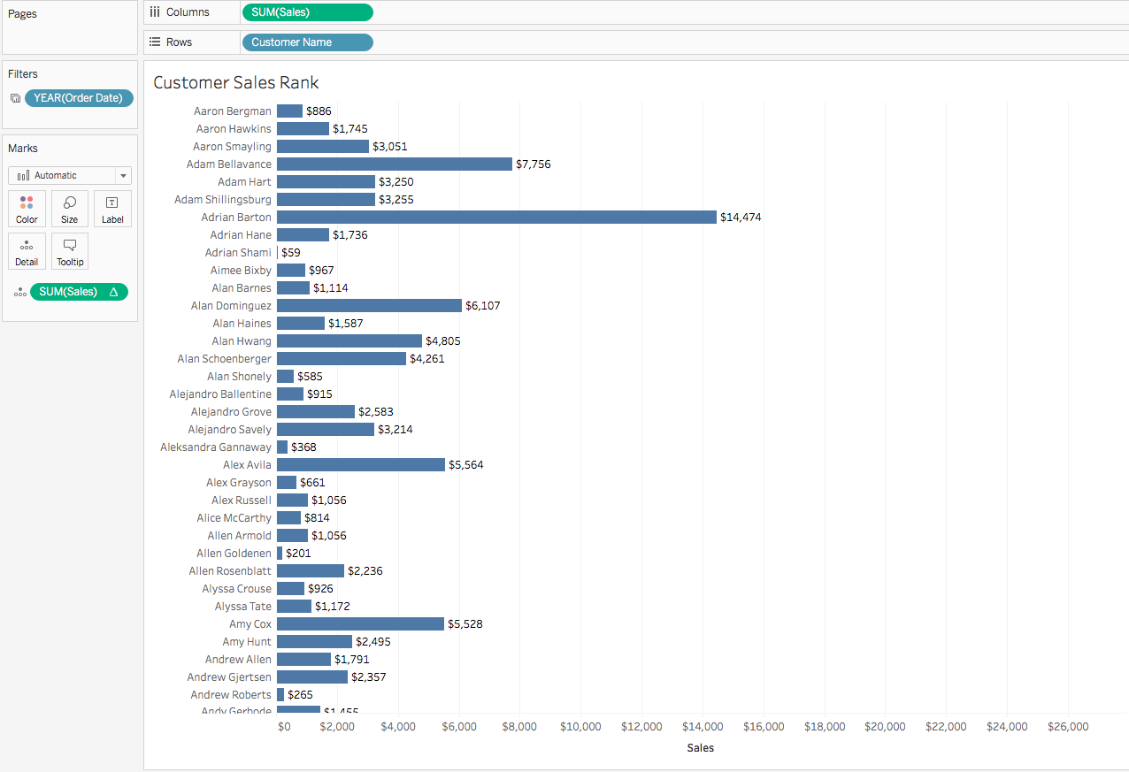

**Step 4:** Drag profit ratio to color shelf and set the color to “Red–Green Diverging” 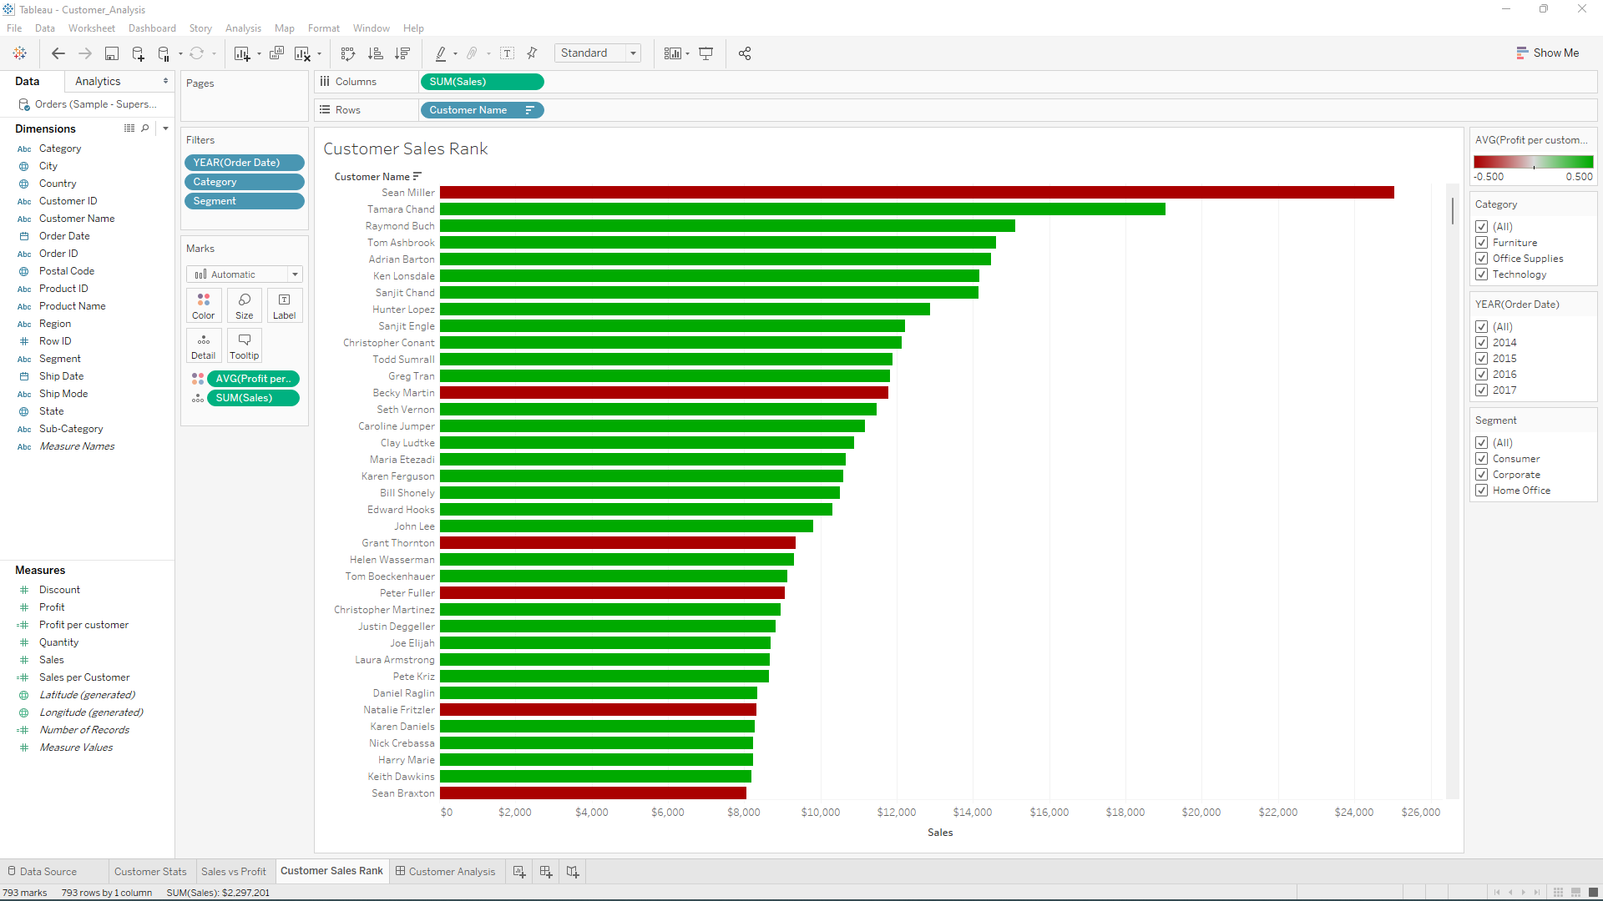

**Step 5:** Sort the customer name field by sales in descending order

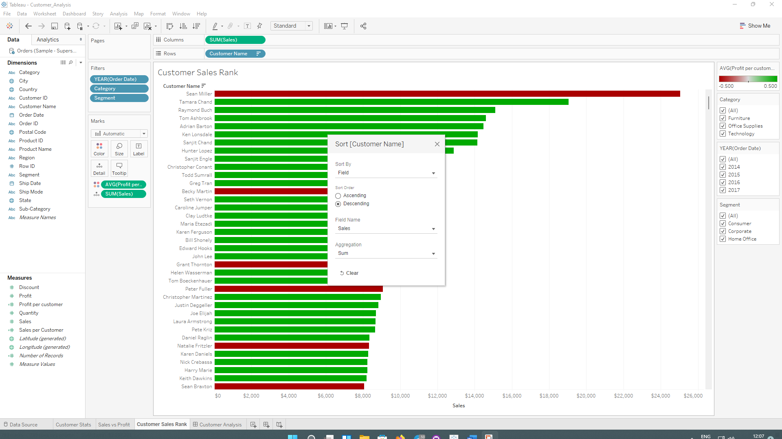

**Step 6:** Add category and segment fields to the filters shelf

