|  |  |  |
| --- | --- | --- |
| ***E:\Projet\Anna University.jpg*** | **INTERNSHIP TRAINING ON**  **AK INFOPARK, NAGERCOIL**  **REPORT** | Ponjesly College of Engineering - Wikipedia |

***Submitted by***

**BALA SURIYA. R**   **961821114021**

ANTONY SHIBU. J 961821114017

MOHAMED MUDHASIR.H. I 961821114037

SIMSON.M 961821114051

***In partial fulfillment for the award of the degree***

***Of***

**BACHELOR OF ENGINEERING**

***In***

**MECHANICAL ENGINEERING**

**PONJESLY COLLEGE OF ENGINEERING**

**NAGERCOIL -629003**

**ANNA UNIVERSITY: CHENNAI 600 025**

**AUGUST 2024**

**ANNA UNIVERSITY: CHENNAI 600 025**

**BONAFIDE CERTIFICATE**

Certified that this internship report **“A STUDY ON MOBILE APPLICATION DEVELOPMENT, NAGERCOIL”** is the bonafide work of **“BALA SURIYA. R (961821114021),** ANTONY SHIBU.J (961821114017)**,** SIMSON.M(961821114051), MOHAMMEDMUDHAS H.I(961821114037)**”**

who carried out the internship report work under my supervision.

|  |  |
| --- | --- |
| **SIGNATURE**  **Dr. A. SARAVANAN, M.E., Ph.D.,**  **HEAD OF THE DEPARTMENT** Department of Mechanical Engineering, Ponjesly College of Engineering,  Nagercoil - 629 003 | **SIGNATURE**  **Mr. R. VINU, M.E.,**  **COORDINATOR**  Department of Mechanical Engineering Ponjesly College of Engineering  Nagercoil – 629 003. |

Submitted for the viva-voce held at Ponjesly college of Engineering on ………………

**INTERNAL EXAMINER EXTERNAL EXAMINER**

# **ACKNOWLEDGEMENT**

First and foremost, we would like to thank the almighty God who has vested in us the mental and physical power to complete this internship report work.

We express our heartfelt thanks to our Chairman **Shri. PON ROBERT SINGH, M.A,** for providing full facilities and technical environment to start this internship report work.

We also express our wholehearted thanks to our Principal Dr**. G. NATARAJAN, M.E., Ph.D.**, for his constant encouragement for finishing the internship report work successfully.

We are thankful to **Dr. G.M. JOSEPH DUNSTON,** Dean, for his unlisted encouragement and moreover for their timely support and guidance till the completion of our internship report work.

We would like to express our profound thanks to our Head of the Department **Dr. A. SARAVANAN, M.E., Ph.D.,** for his excellent support throughout this internship report work.

We also express our wholehearted thanks to our internship coordinator **Mr. R. VINU, M.E.,** for his constant encouragement for finishing the internship report work successfully.

I am also thankful to Mechanical Engineer, Depot Engineer (DE), Assistant Depot Engineer (ADE) and respective Charge men (CM) of TNSTC, Nagercoil for helping us during the internship.

We thank all the teaching and non-teaching staff members of Department of Mechanical Engineering, and our friends for their sole help and cooperation in successful completion of this internship report work. We thank our parents for their understanding and perseverance during our internship report work.

**INTRODUCTION**

This internship report provides a comprehensive overview of my internship experience at the AK INFOPARK on Mobile Application Development in Nagercoil, Tamil Nadu. The internship provided me with an invaluable opportunity to gain practical knowledge and hands-on experience in the world of code, design and user experience operations, contributing to my professional understanding and growth.

**OBJECTIVE:**

The primary objective of this internship report is to present a detailed account of my internship at the AK INFOPARK in Nagercoil. The report aims to shed light on the tasks, responsibilities, and learning outcomes achieved during the internship period. It seeks to provide practical experience in mobile app development, enhance my technical skills, and understand the end-to-end process of creating functional and user-friendly applications.

**COMPANY OVERVIEW:**

The AK INFOPARK in Nagercoil, Tamil Nadu, plays a crucial role in designing logos, website development, mobile applications, web applications, desktop applications, GST registration & filing. Located in a strategic location, The internship program is staffed by skilled technicians and equipped with state-of-the-art facilities to carry out the program.

**DAY 1**

**Orientation and Project Introduction**

**INTRODUCTION:**

This report presents day 1 overview of my internship experience at the AK INFOPARK internship in Nagercoil, specifically focusing on the topic of Orientation and Project Introduction. During this day, we had the opportunity to met the team and got acquainted with the company culture and discussed project goals, expectations. Explored the existing codebase and documentation, gaining valuable insights into the importance of workspace environment and the strategies employed to maintain organized workspace.

**OBJECTIVES OF ORIENTATION ACTIVITIES:**

The primary objectives of this internship report are as follows:

* To provide an overview of the mobile application

development and its work.

* To discuss the significance of app development in a workspace setting.
* To analyse the step-by-step processes and techniques utilized by the workshop staff.

**Importance of Orientation activities:**

The orientation and project introduction are essential for several reasons. Firstly, it promotes a smooth transition, reducing the turnover, consistent information, cost savings, increased confidence and improved performance.

**Importance of Project Introduction:**

Project introduction play crucial roles in the onboarding process for new employees like the Context, Team collaboration, Roles and responsibilities, Expectations and motivation

**CONCLUSION:**

This internship report on orientation and project introduction at the AK INFOPARK has shed light on the significance of team collaboration in a workspace environment and the efforts undertaken on the organized workspace.

**DAY 2**

**Setting Up the Development Environment**

**INTRODUCTION:**

This report provides an overview of my internship experience on setting up the development environment. The objective of this internship was to gain practical knowledge and hands-on experience in the IDE installation and emulator setup.

**OVERVIEW OF DEVELOPMENT ENVIRONMENT SETUP:**

Installation of Android Studio, the official IDE for Android app development. It’s based on IntelliJ IDEA and provides powerful tools for designing, coding, and debugging Android apps. For developing Android, Android Studio comes with the built-in Android Emulator.

**Importance of Emulator SETUP:**

An emulator simulates a mobile device (phone or tablet) on your computer. It allows you to test your app without needing a physical device. The emulator performance can vary based on your computer’s resources and debugging issues specific to emulators like slow startup and network connectivity are some of the challenges faced in setting up the environment.

**OBJECTIVES:**

* Efficiency and Productivity.
* Version Control Integration.
* Error prevention and Debugging.
* Dependency management.

**EXPERIENCES GAINED:**

During internship, I gained valuable experience and learned several key aspects to setup the development environment.

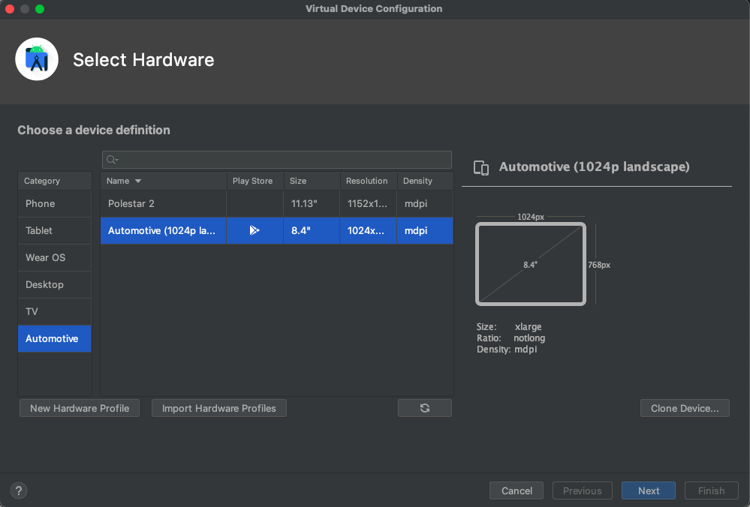

**CONCLUSION:**

The installation of Android Studio was akin to consecrating my digital workspace. I chose a virtual Nexus 6P Android device that blinks to life on my screen. It lacks sentience, but its pixelated existence holds promise.

**DAY 3**

**Exploring the Code Canvas**

**INTRODUCTION:**

This report presents an overview of my Day 3 internship experience working with project structures like directories, packages and modules in the Android studio. The objective of this internship was to gain practical knowledge and hands-on experience in the project structures like the packages and modules.

**OVERVIEW OF XML SYNTAX:**

  Balancing angle brackets and attributes—like composing a sonnet in a foreign language and understanding how ViewModel bridges the gap between data and UI.

**ROLE OF XML:**

As an intern, my primary responsibility was to understand the XML files in Android to define the structure and layout of UI elements within an app.

**IMPORTANCE OF XML IN ANDROID STUDIO:**

* **Layout:** XML describes how UI elements (widgets, views) are organized on the screen. It defines the hierarchy of View and ViewGroup objects.
* **Separation of Concerns:** By using XML, developers separate UI design from code logic. Designers can work on layouts independently, and developers can focus on functionality.

**EXPERIENCE AND LEARNING:**

During internship, I gained valuable experience and learned several key aspects of working with the XML pages for the layout of an activity.

* Different XML files can provide localized content for different languages or regions.
* Centralizing resources ensures consistent styling and branding across the app.

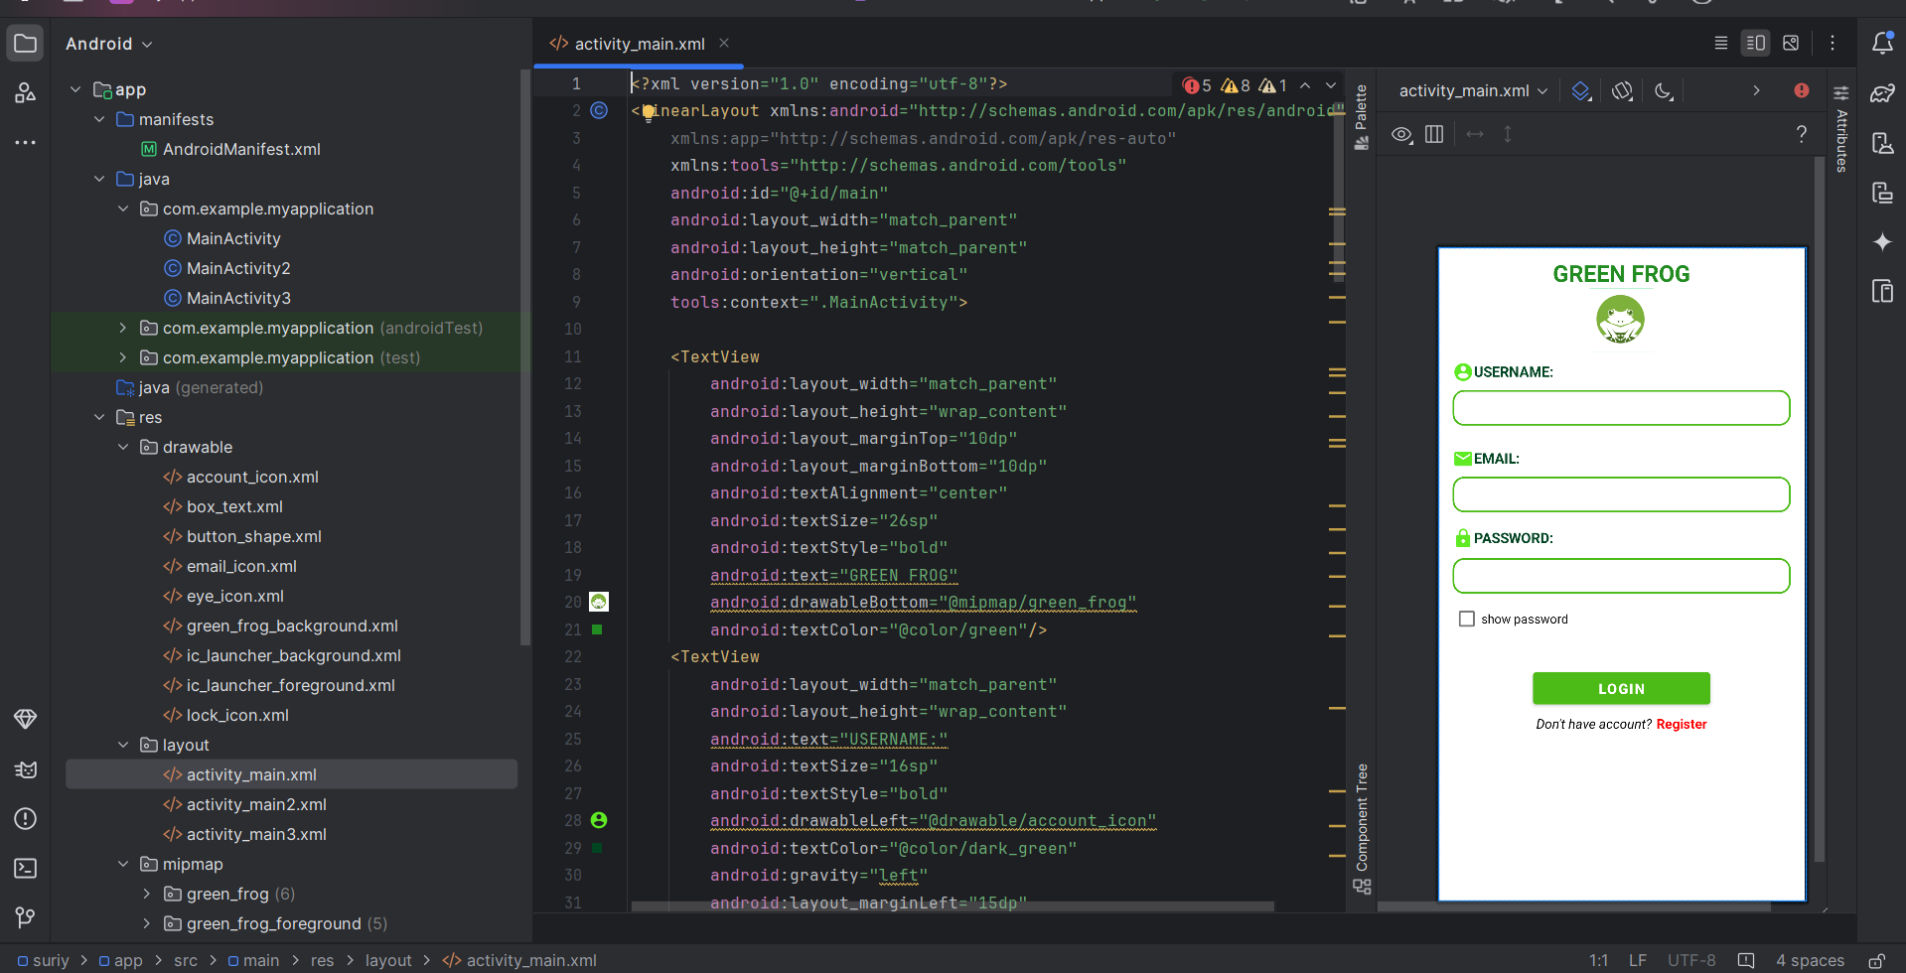

**CONCLUSION:**

My internship experience working with the XML for the layout of the activities in Android studio provided me with valuable practical knowledge and skills in maintaining and organizing the activity. I gained technical expertise, diagnostic skills, and an understanding of layouts and maintenance techniques specific to activity screen.

**DAY 4 - 5**

**Crafting the User Experience**

**INTRODUCTION:**

This report presents an overview of my Day 4 and Day 5 internship experience working with project intersection of aesthetics and functionality in the Android studio. The objective of this internship was to gain practical knowledge and hands-on experience in the XML refinement and responsive design.

**OVERVIEW:**

Dive deeper into XML layouts—buttons, text views, image views, and their attributes. Master the art of constraints—anchoring views, creating responsive designs in the Linear layout. Learnt to make my app inclusive—screen readers, font scaling, and touch targets.

**INTERNSHIP ACTIVITES:**

During internship, I was involved in various activities related to the UI components and layouts:

* **UI Components:** the UI components that are involved in the activity are buttons, Text fields, drop down lists and icons.
* **Linear Layouts:** It is like the backbone of UI layout managers in Android. It’s a versatile view group that arranges its children whether buttons, text fields, or icons—in a single direction: either vertically (like a stack) or horizontally (like a row).

**KEY LEARNINGS:**

My internship provided valuable insights into the UI components, layouts and its significance in the developing the application. The key learnings from the internship include:

**ORIENTATION:**

* Either a vertical or horizontal layout can be created.
* For a vertical layout, children stack on top of each other.
* For a horizontal layout, children align side by side.

**CHILDREN ARRANGEMENT:**

* All children within a Linear Layout are displayed sequentially based on the order they appear in the layout.
* Imagine stacking cards we place one on top of the other.

**LAYOUT WEIGHT:**

* Linear Layout supports the concept of “weight.”
* Each child view can be assigned a weight using the

**android: layout_weight** attribute.

* The weight determines how much space a child occupies relative to others.
* A larger weight value allows a view to expand and fill remaining space.

**CONCLUSION:**

The internship at AK INFOPARK allowed me to gain practical knowledge and hands-on experience with the UI components used in the mobile application development. It was an enriching experience that enhanced my understanding of UI and the layouts.

**DAY 6**

**Basics on Programming Languages**

**INTRODUCTION:**

This is an internship report on programming languages used in mobile application development. Programming languages like Java and Kotlin are the widely used programming languages for mobile application development. These languages are mainly used for the backend purposes.

**OVERVIEW :**

During internship at AK INFOPARK, I learned the basics of java that is used for the backend purposes to make the app work for an activity. I also gained hands-on experience in troubleshooting common errors, such as syntax error, and misalignment. I was assigned to work under the supervision of Mrs. Anushya, who is a senior technician and an expert in Mobile application development. She taught me the theoretical and practical aspects of java and guided me through the steps involved in each activity.

**INTERNSHIP ACTIVITIES:**

Some of the tasks that I performed During internship are:

* Program certain code to perform operations.
* Get the data from the edit text and saving it accordingly.
* Adjusting the layout, such as text view, edit view, and margins, using padding and setting up the borders.
* Testing the activity performance using the emulator that runs the app in the mobile phone connected.

**CONCLUSION:**

I enjoyed working on the main activity as it was challenging and rewarding. I learned a lot from the technicians at AK INFOPARK. I also developed my skills in JAVA, which will be useful for my future career as a mobile application developer.

**DAY 7**

**Building simple UI components**

**INTRODUCTION:**

This internship report provides an overview of my Day 7 internship experience working with project intersection of aesthetics and functionality in the Android studio. The objective of this internship was to gain practical knowledge and hands-on experience in the XML refinement and responsive design with the UI components.

**OVERVIEW:**

**Definition and Function:**

The UI components that are involved in the activity are buttons, Text fields, drop down lists and icons. It consists of a series of attributes with different uses and configurations that allow the developer to select various attributes to match the User experience in a better way.

**ADVANTAGES OF UI COMPONENTS:**

**Consistency and Cohesion:**

UI components are like building blocks. When we use consistent components throughout the app, it creates a cohesive look and feel. Users appreciate familiarity they don’t want to learn a new interface on every screen.

**Responsive Design:**

* UI components are designed to adapt gracefully to different screen sizes and orientations. Whether your user is on a tiny smartphone or a large tablet, the components adjust seamlessly.
* This responsiveness ensures a consistent experience across devices, which is essential for user satisfaction.

**User Expectations:**

* Users have become accustomed to certain UI patterns. They expect a hamburger menu to reveal navigation options, a heart icon to signify liking something, and so on.
* By using standard UI components, you meet these expectations, making your app more intuitive.

**Time and Cost Efficiency:**

* UI components are often pre-built and customizable. Imagine having a library of ready-to-use buttons, sliders, and input fields. Developers can assemble these components like LEGO bricks, saving time and effort.
* Plus, consistent UI components reduce the need for custom design work, which can be costly.

**CONCLUSION:**

The internship at AK INFOPARK allowed me to gain practical knowledge and hands-on experience with the UI components used in the mobile application development. It was an enriching experience that enhanced my understanding of UI and the layouts.

**DAY 8 - 9**

**Data Handling**

**INTRODUCTION:**

The purpose of this internship report is to provide a comprehensive overview of the data handling used in Mobile application development. During internship at the AK INFOPARK, I had the opportunity to study and gain hands-on experience with the data handling employed in the mobile application development.

**OVERVIEW OF DATA HANDLING:**

**Definition and Function**

Mobile applications have seamlessly woven themselves into our daily lives, becoming indispensable tools for communication, productivity, and entertainment. However, with this increased reliance on apps to store and process personal information, ensuring robust data security and privacy has become paramount. As app developers, we play a crucial role in safeguarding user data and maintaining their trust.

**Advantages of Data Handling:**

**Real-Time Data Handling with Streams**

Java allow developers to work with asynchronous data and respond to events as they occur. They’re commonly used for real-time data updates, such as user input, network requests, or database changes.

**Efficient Data handling**

Streams enable developers to respond to events without blocking the main UI thread. This efficiency ensures smooth app performance.

**Improved User Experience**

Real-time data updates keep users informed and engaged. Whether it’s live chat messages or stock prices, timely information enhances the user experience.

**Application Programming Interfaces (API’s)**

Application Programming Interfaces (APIs) expose data and functionality. They empower developers to create new services, products, and business models.

**Modularity**

Modularity: APIs enable modular app construction. [Developers can integrate third-party services seamlessly, accelerating development](https://www.nylas.com/api-guide/benefits-of-apis/).

**Personalization**

Personalization of apps can deliver personalized content based on user preferences and context. [Location-based services, for example, allow targeted recommendations](https://www.builder.ai/glossary/app-development).

**CHALLENGES AND LIMITATIONS:**

**Data Integrity and Synchronization:**

Ensuring consistent data integrity across different app states can be tricky. When an app transitions between foreground, background, and closed states, data synchronization becomes a challenge. [Resource limitations on mobile devices (memory, CPU, battery) shouldn’t hinder data caching or background synchronization](https://www.spaceo.ca/blog/mobile-app-development-challenges/).

**Security and Data privacy:**

Security breaches and data privacy violations are major concerns. Developers must protect user data adequately and ensure the app resists hacking attempts.

**CONCLUSION:**

The internship at AK INFOPARK allowed me to gain practical knowledge and hands-on experience in data handling used in the mobile application development.

**DAY 10**

**Debugging and Trouble shooting**

**INTRODUCTION:**

This internship report provides an overview of the debugging and Trouble Shooting used in mobile application development during internship at the AK INFOPARK, I had the opportunity to study and gain practical experience with android studio. This report aims to highlight the advantages, challenges, and limitations aspects associated with the trouble shooting and debugging.

**OVERVIEW OF DEBUGGING & TROUBLESHOOTING:**

**Definition and Function**

Debugging primarily deals with code issues—unexpected behavior, crashes, or incorrect results. Troubleshooting encompasses identifying and resolving any problem, not just code-related ones. It mainly focuses on network issues, configuration problems, user errors, etc.

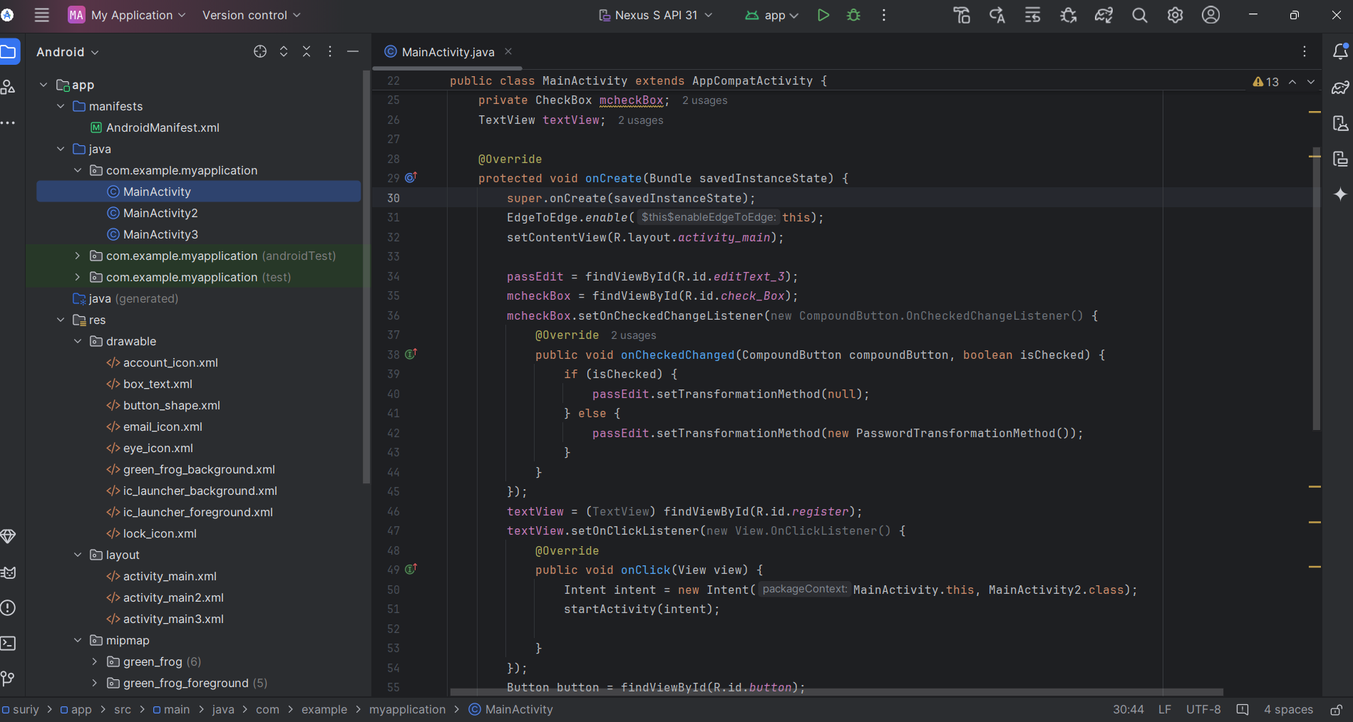

**ADVANTAGES OF DEBUGGING & TROUBLESHOOTING:**

**Enhanced Efficiency:**

Effective debugging techniques save valuable time by quickly identifying and fixing bugs. An organized workflow ensures timely issue resolution.

**Improved Reliability:**

Debugging ensures that your app performs as intended, minimizing unexpected crashes or malfunctions. Reliable apps lead to satisfied users.

**Enhanced User Experience:**

A bug-free app provides a smoother, more enjoyable experience for users. Positive user experiences lead to better app adoption and retention.

**Accelerated Development Cycle:**

Early bug detection allows developers to address issues before they escalate. This speeds up the development process and ensures timely releases.

**CHALLENGES AND LIMITATION:**

**Limited Resources on Mobile Devices:**

Mobile devices have less processing power, memory, and storage than desktop computers. Complex debugging tools may strain device resources.

**Complexity of Mobile Software:**

Mobile apps interact with various components (hardware, OS, network). Debugging across these layers can be challenging.

**Emulator Limitations:**

Emulators may not perfectly replicate real devices. Bugs that occur only on specific devices may be missed during testing.

**Time Constraints:**

Debugging can be time-consuming. Balancing thorough testing with project deadlines is a constant challenge.

**CONCLUSION:**

The internship at AK INFOPARK allowed me to gain practical knowledge and hands-on experience with the debugging and troubleshooting used in the mobile application development. It was an enriching experience that enhanced my understanding of troubleshooting and debugging techniques.

**DAY 11 -12**

**USER EXPERIENCE DESIGN**

**INTRODUCTION:**

This internship report provides an overview of the User experience design used in mobile application development during internship at the AK INFOPARK, I had the opportunity to study and gain practical experience with android studio. This report aims to highlight the advantages, challenges, and limitations aspects associated with the user experience designing.

**OVERVIEW:**

UX design involves continuous refinement. Designers create, test, learn, and refine. Each iteration brings the product closer to an optimal user experience and the usability ensures that users can efficiently achieve their goals. It’s about clear navigation, intuitive interfaces, and minimizing friction.

**ADVANTAGES OF UX DESIGN:**

During internship, I engaged in various activities related to the UX design:

**Increased User Satisfaction:**

UX design prioritizes intuitive interfaces, clear menus, and logical information hierarchy. When users find your product easy to navigate and understand, their satisfaction soars.

**Improved Usability and Accessibility:**

Seamless interactions and responsive interfaces enhance usability. Plus, accessibility features ensure inclusivity for individuals with disabilities.

**Enhanced Brand Reputation:**

A well-designed product leaves a lasting impression. Positive experiences lead to better brand perception and customer loyalty.

**User Engagement and Expanded Reach:**

Intuitive designs encourage users to engage more deeply. Responsive interfaces across devices expand your user base.

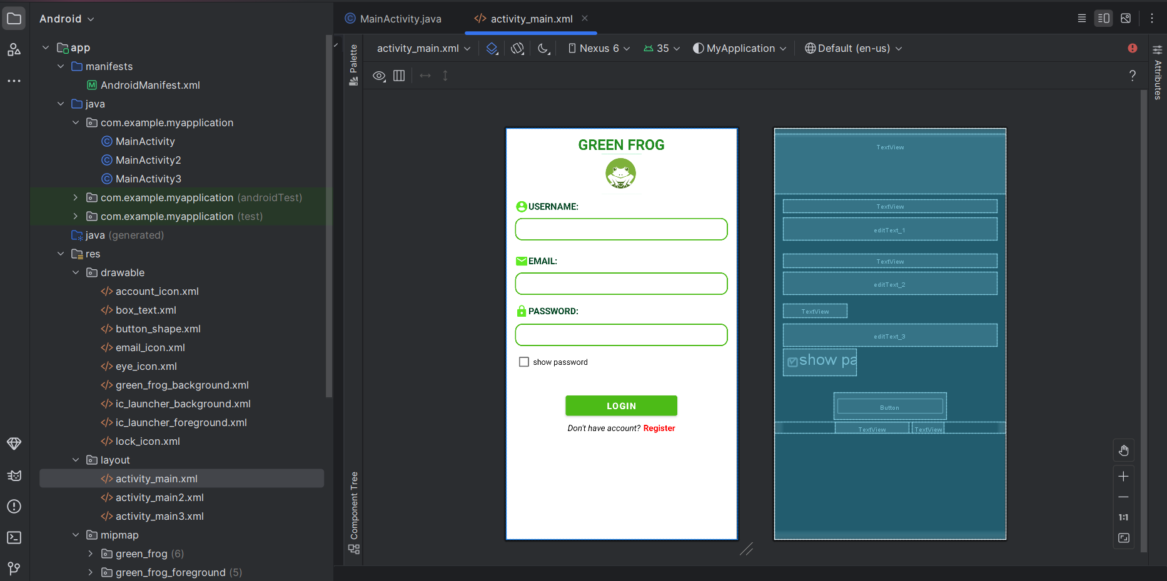

**Key Learnings:**

The internship provided me with valuable insights into the UX design used in android studio for mobile app development.

Key learnings from the internship include:

* Comprehensive knowledge of engine Accessibility, activity procedures, and maintenance requirements.
* Understanding of diagnostic techniques and troubleshooting methods for java in main activities.
* Practical experience in performance evaluation and data analysis.
* Awareness of the importance of regular maintenance in optimizing performance.

**CHALLENGES & LIMITATIONS:**

**Time Constraints:**

Crafting high-quality UX designs involves research, prototyping, and testing. Balancing these processes within project timelines can be challenging.

**Balancing User Needs and Business Goals:**

UX designers must align user needs with business objectives. Striking the right balance ensures a successful product.

**Recruiting Participants for User Research:**

Finding the right participants for interviews or usability tests can be time-consuming. Qualifying criteria matter.

**CONCLUSION:**

The internship at AK INFOPARK allowed me to gain practical knowledge and hands-on experience with the user experience designing used in the mobile application development. It was an enriching experience that enhanced my understanding of user experience designing techniques.

**DAY 13**

**TESTING AND QUALITY ASSURANCE**

**INTRODUCTION:**

This internship report provides an overview of the testing and quality assurance used in mobile application development during internship at the AK INFOPARK, I had the opportunity to study and gain practical experience with android studio. This report aims to highlight the advantages, challenges, and limitations aspects associated with the testing and quality assurance.

**OVERVIEW OF TESTING &QUALLITY ASSURANCE:**

**Definition and Function**

 Testing and QA processes prioritize user experience. They ensure intuitive navigation, aesthetically pleasing design, and seamless functionality. A well tested app is more responsive, fast-loading, and capable of handling large data volumes without lags or crashes. Performance optimization enhances user satisfaction and retention rates.

**ADVANTAGES OF TESTING & QUALITY ASSURANCE:**

**Enhanced User Experience:**

Rigorous testing and QA processes prioritize user experience. They ensure intuitive navigation, aesthetically pleasing design, and seamless functionality. By anticipating user needs and minimizing friction points, high-quality mobile apps lead to greater satisfaction and loyalty.

**Optimized App Performance:**

Quality assurance engineers focus on engineering optimal performance across various devices, operating systems, and network conditions. A well-tested app is more responsive, fast-loading, and capable of handling large data volumes without lags or crashes. Performance optimization enhances user satisfaction and retention rates.

**Reduced Maintenance Costs:**

Investment in a high-quality mobile app helps to reduce maintenance costs in the long run. Thorough testing during development identifies and fixes bugs, glitches, and performance issues early on, minimizing the need for costly post-launch updates and fixes. This proactive approach saves time, resources, and headaches.

**Competitive Advantage:**

In today’s crowded marketplace, quality becomes a differentiator. A superior mobile app stands out, offering a better user experience, performance, and reliability. By delivering excellence, your app gains a competitive edge, attracting more users and driving business growth.

**Higher Revenue Potential:**

High-quality mobile apps have the potential to generate higher revenue. Increased user engagement, better retention rates, and effective monetization opportunities contribute to a healthier bottom line.

**CHALLENGES AND MAINTENANCE CONSIDERATION:**

**Device Fragmentation:**

The mobile ecosystem is diverse, with countless device models, screen sizes, and operating system versions. Ensuring consistent performance across this fragmentation is challenging.

**Specific Device Bugs:**

Some bugs may be specific to certain devices or OS versions. Identifying and addressing these device-specific issues requires thorough testing.

**Emulator Constraints:**

Emulators don’t perfectly replicate real devices. Bugs that occur only on actual devices may be missed during emulator testing.

**Security Issues:**

Ensuring app security is critical. QA must identify vulnerabilities, prevent data leaks, and protect against cyber threats.

**CONCLUSION**

The internship at AK INFOPARK allowed me to gain practical knowledge and hands-on experience with the testing and quality assurance used in the mobile application development. It was an enriching experience that enhanced my understanding of testing methods.

**DAY 14**

**FINALIZING AND PRESENTING**

**INTRODUCTION:**

This internship report provides an overview of the finalizing and presenting the project in mobile application development. During the internship at the AK INFOPARK, I had the opportunity to study and gain practical experience with android studio. This report aims to highlight the challenges and key aspects associated with the finalizing and presenting the project.

**OVERVIEW OF FINALIZING & PRESENTING PROJECT:**

Create wireframes and mockups to visualize the app’s layout and user flow. UX design ensures a seamless and intuitive experience. Developing the interactive prototypes to test functionality and gather feedback.

**CHALLENGES ON FINALIZING:**

**Scope creep:**

Clearly defining the project scope from the outset. Document requirements and prioritizing them. When new requests arise, evaluate their impact on the overall project and adjust accordingly to it.

**Testing Fatigue:**

Break down testing into manageable phases. Use automation tools for repetitive tasks. Involve fresh eyes (other team members or external testers) to catch issues you might miss.

**Last-Minute Bugs:**

Maintain a bug tracker throughout the project. Regularly review and address reported issues. Prioritize critical bugs and fix them promptly.

**CONCLUSION:**

My internship at AK INFOPARK in Mobile Application Development was a valuable learning experience. It provided me with practical skills and insights into the entire development process, which will be beneficial for my future career. I am grateful for the opportunity and the support provided by the AK INFOPARK team.

