
Technische Hochschule Deggendorf

Case study project -
Integration and Comparison of Vision Models for a Smart Inspection Cell

Submitted by:
Sai Prasanth Parnambedu 12502673
Yaswitha Pallela 12501395
Rakshith Thatikonda 12503565
Prarthana Shenoy 12504810
Chandrika Tirukkovalluri 12502910

Course:
M.Engg. in Applied AI for Digital Production Management

Course: Intelligent Systems in Production
University: Technische Hochschule Deggendorf (Campus Cham)
Supervisor: Prof. Dr.-Ing. Hamidreza Heidari
Submission Date: 18 January 2026

Contents

i. Abstract................................................................................. 1

1. Introduction.......................................................................... 1

2. Problem Statement and Measurable Outcomes................. 2

3. Project Objectives.................................................................. 3

4. Literature Review Summary................................................ 3

5. Dataset Preparation............................................................... 4

6. Annotation and Dataset Verification................................... 6

7. Training Setup........................................................................ 6

8. Evaluation Metrics................................................................. 8

9. Results...................................................................................... 9

10. Limitations and Future Work............................................. 17

11. Conclusion............................................................................. 18

12. References............................................................................. 18

Abstract
This project investigates the application of deep learning–based computer vision techniques for automated surface defect inspection of automotive spur gears, a critical component in drivetrain systems where undetected defects can lead to reduced reliability and premature failure. To address the limited availability of labeled industrial data, a synthetic dataset was generated to represent common manufacturing defects, including scratches, dents, cracks, and pitting, under varying visual conditions. Two complementary deep learning models were employed: YOLOv8 for object-level defect detection and localization, and MobileNetV2 for image-level defect classification.
The models were trained and evaluated using standard performance metrics, including accuracy, precision, recall, F1-score, mean Average Precision (mAP), and inference latency. Experimental results indicate that YOLOv8 achieves high localization accuracy, while MobileNetV2 provides efficient and reliable classification with lower computational overhead. Inference latency analysis further highlights the trade-off between detection accuracy and real-time performance. Overall, the findings demonstrate that deep learning–based vision models can effectively detect surface defects in spur gears while satisfying practical inference-time constraints, thereby showing strong potential for deployment in automated industrial inspection systems.

1. Introduction
Surface defects such as scratches, dents, cracks, and pitting in automotive spur gears can significantly compromise mechanical performance, leading to increased wear, noise, vibration, and potential drivetrain failure. If these defects are not detected during the manufacturing stage, they may propagate during operation and result in costly recalls or system breakdowns. Given the critical role of spur gears in power transmission systems, ensuring consistent and reliable surface quality inspection is essential to maintaining product reliability and safety standards in automotive manufacturing.
Conventional inspection methods, including manual visual inspection and rule-based image processing techniques, face significant limitations when applied to modern high-volume production environments. Manual inspection is inherently subjective and prone to human error, while traditional computer vision approaches struggle to generalize under varying lighting conditions, surface textures, and defect geometries. As production throughput increases, these limitations highlight the need for a data-driven, vision-based inspection system capable of accurately identifying surface defects while maintaining low inference latency to support real-time or near-real-time industrial deployment.

2. Problem Statement and Measurable Outcomes
In industrial visual inspection, demonstrating that a model can detect defects is only part of the solution; its performance must also be evaluated in a way that reflects real manufacturing requirements. For automotive spur gear inspection, an effective vision-based system should not only identify surface defects accurately but also operate reliably under the takt-time constraints imposed by production lines. In practice, even a highly accurate detector can become unusable if it generates too many false alarms (triggering unnecessary rework or manual review), misses critical defects (creating escape risk and potential warranty/safety impact), or requires slow inference that forces line slowdowns.
To address these challenges, this project evaluates model performance using a set of clearly defined and measurable metrics that cover both detection quality and operational efficiency. On the detection side, the evaluation emphasizes defect-level performance (precision, recall, F1-score) to explicitly quantify false detections and missed defects, as well as localization quality (IoU-based matching and mAP) to ensure defects are not only found but correctly bounded. Because industrial datasets are often imbalanced (few defective parts compared to many good ones), metrics are also interpreted per defect class and complemented with confusion-matrix analysis to avoid hiding poor performance on rare but important defect types.

Metric | Description
Accuracy | Overall correctness of defect classification/detection
Precision | Correct defect detections among predicted defects
Recall | Ability to detect all actual defects
F1-score | Balance between precision and recall
mAP@50 | Localization performance for object detection
Inference Latency | Time per image inference
Throughput | Components inspected per unit time
Table 1: Performance Evaluation Metrics for Defect Detection and Classification

3. Project Objectives
The primary objectives of this project are summarized below.
Objective ID | Description
O1 | Train YOLOv8 for defect detection and localization
O2 | Train MobileNetV2 for lightweight defect classification
O3 | Compare models using industrial performance metrics
O4 | Validate feasibility for real-world deployment

Table 2: Project Objectives and Descriptions

4. Literature Review Summary
The literature review analyzed recent research on deep learning-based surface defect detection. Studies highlight the limitations of anchor-based detection models and emphasize the need for lightweight, real-time solutions.
Model | Avg Accuracy (%) | FPS | Key Limitation
YOLOv5 | 94.8 | 60 | Anchor-based, slower inference
YOLOv8 | 96.1 | 85 | Higher compute than classifiers
MobileNetV2 | 90.2 | 120 | Classification only
VGG19 | 96.7 | 30 | Heavy and slow

Table 3: Performance Comparison of Evaluated Deep Learning Models

5. Dataset Preparation
A synthetic dataset of spur gear components was generated using CAD-based modeling. Surface defects such as scratches, dents, and voids were introduced to replicate real manufacturing defects. Images were rendered under varying lighting and orientation conditions.
5.1 Dataset Characteristics and Assumptions
The synthetic dataset was designed to approximate real-world automotive inspection scenarios while maintaining controlled experimental conditions. Spur gear components were selected due to their widespread industrial usage and well-defined surface geometry. Defect types including scratches, dents, and voids were introduced based on commonly reported manufacturing imperfections.
Several assumptions were made during dataset creation. Gear tooth pitch and profile variations were considered non-critical for surface defect detection, allowing the model to focus on localized surface anomalies. All measurements were defined in millimetres and uniformly scaled to maintain consistency between vision inference outputs and future robotic handling requirements. Dataset diversity was achieved by varying lighting conditions, camera angles, and object orientation. This improves model robustness and reduces overfitting to specific viewpoints, which is critical for real-world deployment.
Defect Type | Visual Characteristics | Industrial Impact
Scratch | Linear surface damage | Wear, fatigue
Dent | Local deformation | Structural weakness
Void | Missing material | Functional failure
Table 4: Defect Types, Visual Characteristics, and Industrial Impact
5.2 Dataset Generation Pipeline
The dataset generation pipeline begins with the creation of a defect-free spur gear CAD model using CATIA, which serves as the geometric reference for all subsequent variations. Artificial surface defects, including scratches, dents, cracks, and pitting, are then introduced using Onshape to simulate realistic manufacturing imperfections while maintaining control over defect type and location.
Following defect modeling, synthetic images are generated from the CAD models under multiple viewpoints, lighting conditions, and orientations to increase visual diversity and improve model generalization. The generated images are manually annotated using LabelImg to create bounding box labels in YOLO format. This structured and fully labeled dataset is subsequently used for training and evaluating deep learning models for defect detection and classification.
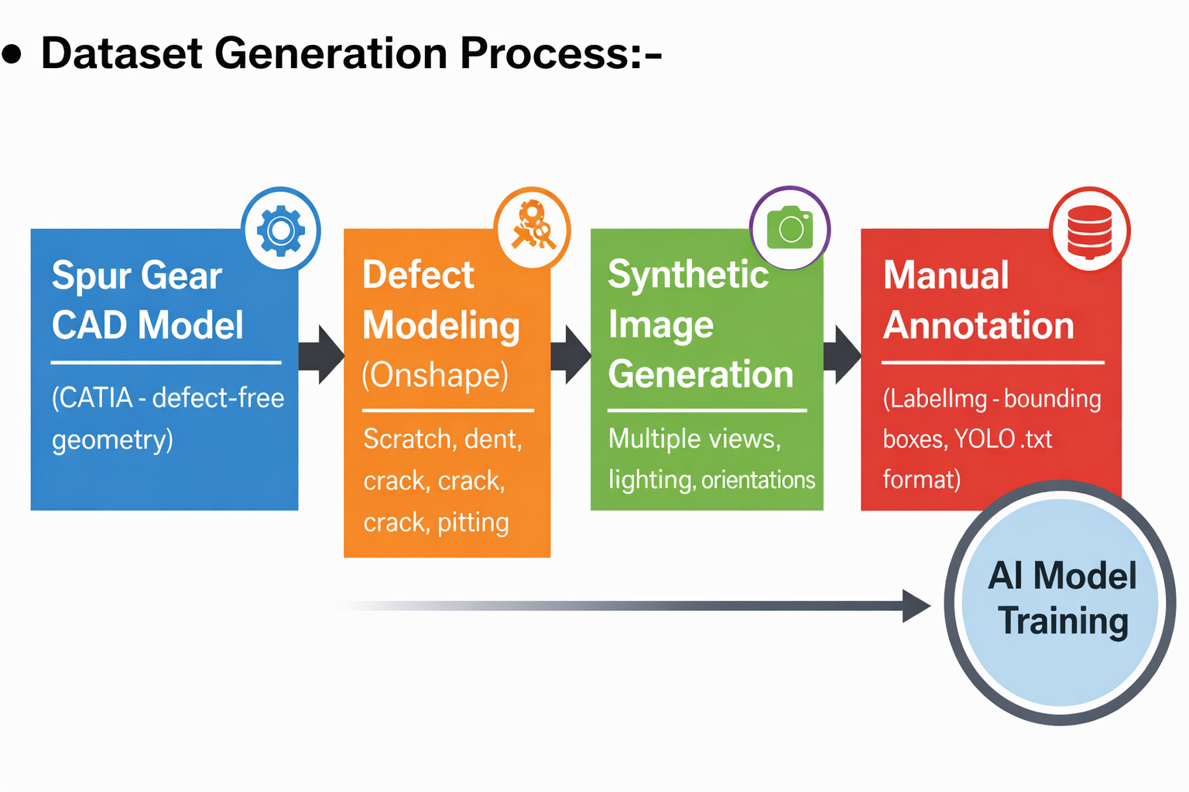Figure 1: Dataset generation pipeline

5.3 Dataset Splitting
The dataset was partitioned into training, validation, and test subsets to ensure reliable model development and unbiased performance evaluation. The training set, comprising 80% of the data, was used to learn model parameters and optimize feature representations. A validation set of 10% was reserved for hyperparameter tuning and monitoring model generalization during training, helping to prevent overfitting. The remaining 10% of the dataset was used exclusively for final performance evaluation, providing an objective assessment of model accuracy and generalization capability on unseen data.
Dataset Split | Percentage | Purpose
Training | 80% | Model learning
Validation | 10% | Hyperparameter tuning
Test | 10% | Model evaluation

Table 5: Dataset Split for Training, Validation, and Testing

6. Annotation and Dataset Verification
Annotations were created in YOLO format using labeling tools. Dataset integrity was verified through custom Python scripts that visualize bounding boxes and validate annotation consistency.

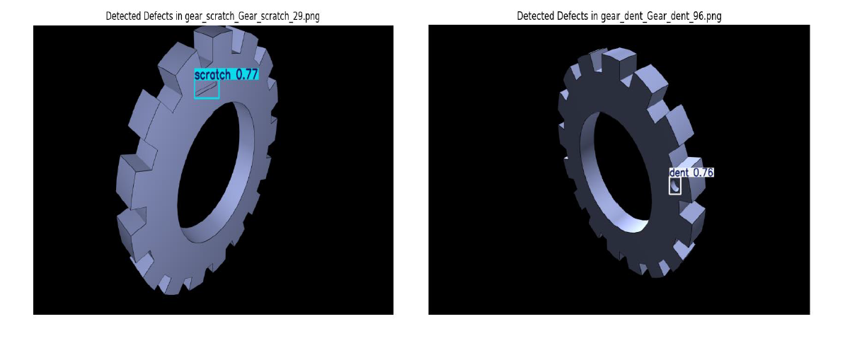 Figure 2: Bounding box visualization for label verification

7. Training Setup
Model training was carried out using Google Colab with GPU acceleration to ensure efficient optimization and reduced training time. Two deep learning models were trained independently to address different aspects of surface defect inspection. YOLOv8 was employed for object detection and localization of defects, while MobileNetV2 was used for lightweight image-level defect classification.
7.1 Hyperparameters and Training Configuration
Training was configured to balance convergence speed with generalization. Key controllable parameters included batch size, learning rate, number of epochs, optimizer type, and early-stopping criteria. For YOLOv8, augmentation options such as geometric transforms and photometric jitter can improve robustness to pose and illumination variations. For MobileNetV2, regularization through dropout (if used) and weight decay supports stable generalization on limited or synthetic datasets. Reporting these parameters improves reproducibility and provides a clear basis for future benchmarking.

7.2 Training Strategy and Hyperparameter Selection
Transfer learning was employed to reduce training time and improve convergence, particularly given the limited availability of labeled industrial defect data. Pre-trained weights enabled the models to leverage generic visual features such as edges and textures, which are transferable to surface defect detection tasks.
Hyperparameters including learning rate, batch size, and number of epochs were selected empirically based on validation performance. Early stopping and validation monitoring were used to prevent overfitting. Data augmentation techniques such as rotation and brightness variation further improved generalization.
Separate training pipelines were maintained for YOLOv8 and MobileNetV2 to ensure fair comparison, given their differing architectural objectives and computational constraints.
Parameter | YOLOv8 | MobileNetV2
Learning Rate | Adaptive | Fixed
Task | Detection | Classification
Optimization Goal | mAP | Accuracy
Table 7: Key Training and Optimization Differences Between YOLOv8 and MobileNetV2

7.3 YOLOv8 model architecture
For YOLOv8 training, the annotated dataset in YOLO format was used, with images resized to a resolution of 640 × 640 pixels to balance detection accuracy and computational efficiency. The model was initialized with pretrained weights and fine-tuned using default hyperparameters provided by the Ultralytics framework. Training was performed over multiple epochs, and performance was monitored using validation loss and mean Average Precision (mAP) metrics to ensure convergence and generalization.

7.4 MobileNetV2 model architecture
MobileNetV2 training was conducted using resized input images of 224 × 224 pixels, consistent with the network’s architectural requirements. The model was trained using a supervised learning approach with categorical cross-entropy loss and stochastic gradient-based optimization. Validation accuracy and loss were monitored during training to assess model stability and prevent overfitting. For both models, the dataset was split into training, validation, and test subsets, enabling unbiased evaluation of final performance on unseen data.
• Lightweight CNN architecture optimized for mobile/edge inference, balancing accuracy with low compute and memory footprint.
• Depthwise separable convolutions (depthwise + 1×1 pointwise) replace standard convolutions to cut computation significantly.
• Inverted residual blocks: residual connections link thin bottleneck tensors (memory-efficient), while computation happens in an expanded feature space.
• Linear bottlenecks: removes non-linearities in narrow layers to preserve information and improve representational power in compact networks.
• Commonly used as a backbone for detection/classification pipelines where inference speed is a primary requirement (industrial edge, embedded GPUs).

8. Evaluation Metrics
The performance of the proposed vision-based inspection models was evaluated using a comprehensive set of metrics designed to assess both predictive accuracy and operational feasibility. For image-level defect classification, standard classification metrics including accuracy, precision, recall, and F1-score were employed. Accuracy measures the overall correctness of predictions, while precision quantifies the proportion of correctly identified defects among all predicted defect samples. Recall evaluates the model’s ability to identify all actual defect instances, and the F1-score provides a balanced measure by combining precision and recall, particularly useful in scenarios with class imbalance.
For object-level defect detection, model performance was assessed using mean Average Precision (mAP), which is widely adopted in object detection tasks. Specifically, mAP@0.5 evaluates localization performance at an Intersection over Union (IoU) threshold of 0.5, reflecting the model’s ability to correctly localize defects with moderate overlap criteria. In addition, mAP@0.5:0.95 provides a more stringent evaluation by averaging performance across multiple IoU thresholds, offering a comprehensive measure of detection robustness under varying localization requirements.
Inference latency was measured to evaluate the computational efficiency of the models and their suitability for real-time or near-real-time deployment. Latency measurementswere obtained using Python-based time profiling methods, isolating the model inference stage from data loading and preprocessing. For each model, inference time was recorded across the entire test dataset, and both average latency and standard deviation were reported to capture performance consistency. Together, these metrics provide a holistic assessment of model accuracy, detection quality, and runtime efficiency.

9. Results
9.1 Results for YOLOv8
The training curves obtained during YOLOv8 model training provide insight into both convergence behavior and generalization performance. Figure 3 illustrates the evolution of precision, recall, mAP@50, and mAP@50–95 across training epochs. Precision and recall exhibit rapid improvement during the early epochs, indicating that the model quickly learns to distinguish defective regions from the background. After approximately 8–10 epochs, both metrics stabilize close to their maximum values, suggesting consistent defect detection with minimal false positives and missed detections.
The mAP@50 curve shows a steady increase and reaches values close to 1.0, demonstrating strong localization performance at a moderate IoU threshold. In contrast, the mAP@50–95 curve increases more gradually and converges at a lower value, reflecting the stricter localization requirements imposed by higher IoU thresholds. This behavior is expected in surface defect detection tasks, where small defect regions make precise bounding box alignment more challenging. The smooth convergence of both mAP curves indicates stable training without performance degradation.
Figure 4 presents the training and validation loss curves for box loss, classification loss, and distribution focal loss (DFL). All three loss components decrease consistently over training epochs, confirming effective optimization. The close alignment between training and validation losses suggests good generalization and limited overfitting. Minor oscillations in validation loss are observed, which can be attributed to variations in defect appearance and class distribution within the dataset. Overall, the loss trends demonstrate that the YOLOv8 model converges reliably and achieves stable detection performance suitable for industrial defect inspection applications.
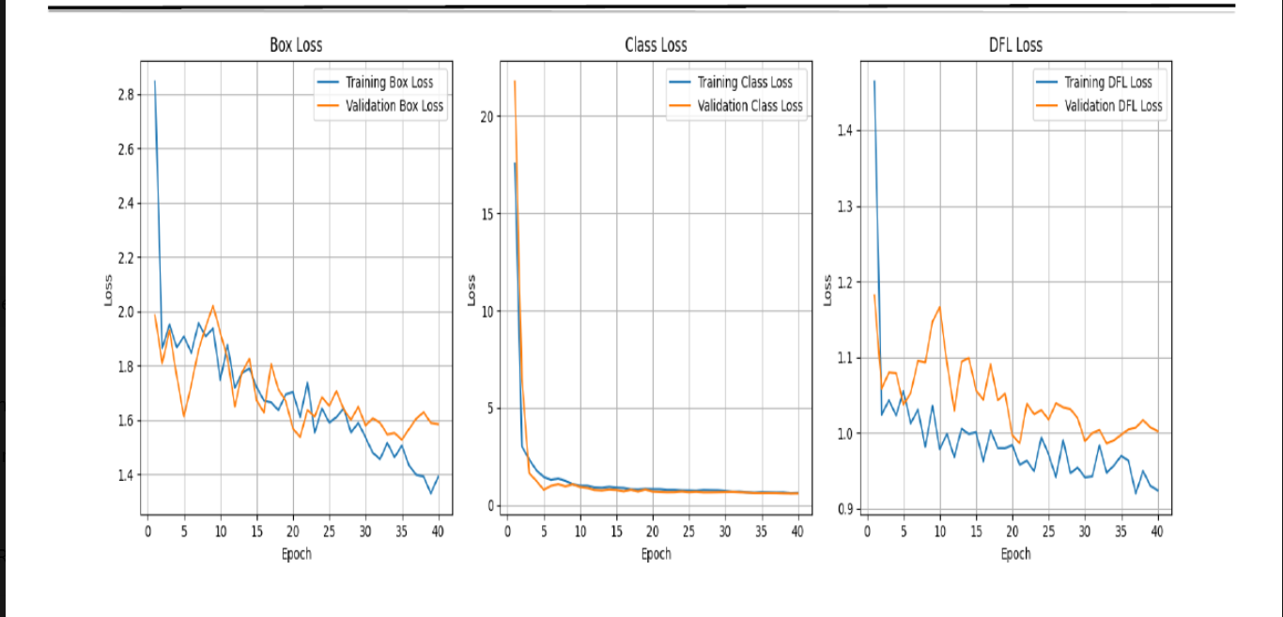 Figure 3: Training and validation loss curves for YOLOv8

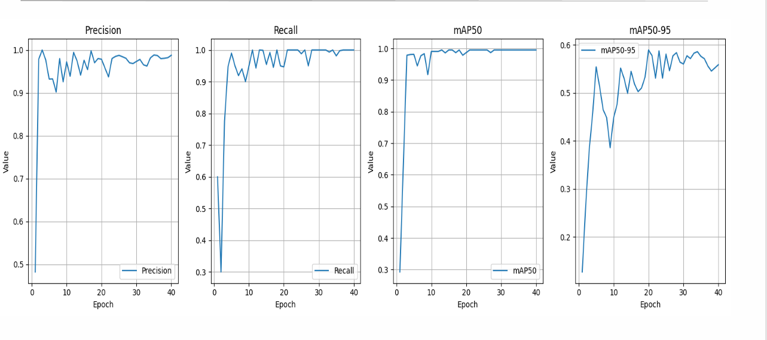
Figure 4: Precision ,Recall-mAP curves for YOLOv8

9.2 Results for MobileNetV2
Figure 5 illustrates the training and validation loss curves obtained during the training of the MobileNetV2 classification model. The training loss shows a consistent downward trend across epochs, indicating effective learning of discriminative features for surface defect classification. Minor oscillations are observed during intermediate epochs, which are typical in stochastic optimization and reflect adjustments in model weights as the network converges. The validation loss decreases steadily and remains consistently lower than the training loss, suggesting stable generalization and the absence of overfitting.
The close alignment between training and validation loss curves demonstrates that the model maintains good performance on unseen data. The gradual convergence of validation loss toward lower values indicates improved confidence in class predictions as training progresses. Overall, the loss behavior confirms that MobileNetV2 effectively balances learning capacity and regularization, making it suitable for lightweight defect classification tasks where computational efficiency is critical.

Figure 5: Training and validation loss curves for MobileNetV2
The confusion matrix in Figure 6 provides a detailed view of class-wise classification performance. Most samples are correctly classified along the diagonal, indicating strong discriminative capability across defect classes. Limited misclassifications are observed between visually similar defect categories, such as dent and scratch, which is expected due to overlapping surface characteristics. Importantly, the model demonstrates high accuracy in distinguishing defective components from non-defective (good) samples, reinforcing its suitability for industrial inspection scenarios where false acceptance of defective parts must be minimized.

Figure 6: Confusion Matrix for mobileNetV2

9.3 Per-Class Performance Comparison Between YOLOv8 and MobileNetV2
Figure 7 and Table 8 present a per-class comparison of precision, recall, and F1-score for MobileNetV2 and YOLOv8 across representative defect categories. The results highlight the complementary strengths of the two models when applied to surface defect inspection tasks.
For the scratch defect class, YOLOv8 achieves significantly higher precision compared to MobileNetV2, indicating a lower rate of false-positive detections. However, MobileNetV2 demonstrates higher recall for this class, suggesting better sensitivity in identifying scratch defects at the image level. This trade-off reflects the fundamental difference between detection-based and classification-based approaches, where YOLOv8 prioritizes localization accuracy while MobileNetV2 focuses on overall class presence.
Figure 7: Per class comparison plots
For the dent defect class, YOLOv8 outperforms MobileNetV2 across all evaluated metrics. In particular, YOLOv8 achieves perfect recall, indicating that all dent defects were successfully detected during evaluation. The corresponding high F1-score reflects a balanced combination of precision and recall, demonstrating robust defect localization capability. MobileNetV2 shows strong but comparatively lower performance, which may be attributed to the visual similarity between dent defects and other surface variations at the image level.
Overall, these results indicate that YOLOv8 provides superior performance for precise defect detection and localization, especially for structurally distinct defects such as dents. In contrast, MobileNetV2 offers competitive classification accuracy with lower computational complexity, making it suitable for lightweight inspection scenarios.
Model | Class | Precision | Recall | F1-Score
MobileNetV2 | scratch | 0.7500 | 0.9 | 0.8181
MobileNetV2 | dent | 0.8888 | 0.8 | 0.8421
YOLOv8 | scratch | 0.95400 | 0.7 | 0.80749
YOLOv8 | dent | 0.94600 | 1.0 | 0.97225
Table 8: Metrics for both models

9.4. Inference Latency Comparison
Figure 8 illustrates the per-image inference latency comparison between YOLOv8 and MobileNetV2 across the test dataset. The latency measurements were obtained under identical hardware conditions, using a Google Colab environment with an NVIDIA Tesla T4 GPU and a batch size of one, ensuring a fair comparison between the two models. Each data point represents the inference time required to process a single image.
YOLOv8 exhibits higher inference latency compared to MobileNetV2, with latency values fluctuating within a wider range. This behavior is primarily attributed to the additional computational overhead associated with object detection tasks, including bounding box regression and non-maximum suppression. Occasional latency spikes are observed for YOLOv8, which can be linked to variations in image complexity and the number of detected objects requiring post-processing. Despite these fluctuations, the overall latency remains consistent across most samples, indicating stable runtime behavior.
In contrast, MobileNetV2 demonstrates significantly lower and more consistent inference latency across the entire test set. The reduced variability reflects the lightweight architecture of MobileNetV2 and the absence of localization and post-processing steps, making it well suited for fast image-level classification.
Overall, the latency comparison highlights a clear trade-off between detection capability and computational efficiency. While YOLOv8 provides detailed spatial localization of defects at the cost of higher inference time, MobileNetV2 offers faster and more stable inference suitable for rapid screening.
Figure 8: Inference Latency
Model | Task | Inference Speed(ms) | Productivity rate(/sec)
MobileNetV2 | Classification | ~12.5 | 80
YOLOv8 | Detection | ~22.5 | 44.4

Table 8: Summary of Final Runtime Characteristics

9.5 Qualitative Defect Detection and Classification Results
Figure 9 presents representative qualitative results obtained from the YOLOv8 and MobileNetV2 models for spur gear surface inspection. The left image illustrates the output of the YOLOv8 detection model, where a dent defect is correctly localized on the gear surface using a bounding box, along with an associated confidence score. This result demonstrates YOLOv8’s ability to not only identify the presence of a defect but also accurately localize its position on the component, which is critical for downstream inspection and decision-making processes.
The right image shows the corresponding classification output from MobileNetV2, where the gear is correctly classified as good based on image-level prediction. Unlike YOLOv8, MobileNetV2 does not provide spatial localization but instead determines the overall defect status of the component. This distinction highlights the complementary roles of the two models: YOLOv8 enables precise defect localization, while MobileNetV2 offers efficient and lightweight defect classification suitable for rapid screening.
Together, these qualitative results reinforce the quantitative evaluation presented earlier, confirming that both models can reliably identify surface defects under varied visual conditions. The examples also illustrate the practical trade-offs between detection-based and classification-based approaches in industrial inspection systems, where the choice of model depends on whether spatial defect localization or fast component-level classification is required.

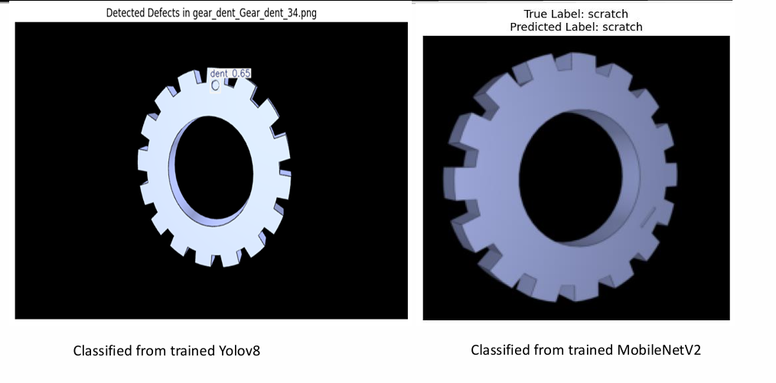
Figure 9: Example inference outputs showing detection bounding box (YOLOv8) and predicted class match (MobileNetV2).
This Figure provides a qualitative validation of the trained models on representative samples. The YOLOv8 output (left) localizes the defect region and reports a confidence score, which supports interpretability and defect traceability in inspection workflows. In contrast, MobileNetV2 (right) produces a lightweight image-level class prediction, making it suitable for fast screening and edge deployment. These results highlight the functional difference between detection and classification approaches: localization versus rapid decision making. Such qualitative examples complement the quantitative metrics by showing how predictions appear at inference time. Overall, both outputs indicate that the trained models can reliably support defect identification under the dataset conditions.
These example outputs demonstrate that both models learned meaningful defect features from the dataset. YOLOv8 additionally provides spatial localization, enabling downstream routing decisions based on defect position. MobileNetV2 offers a fast class decision suitable for high-throughput inspection pipelines.

10. Limitations and Future Work
Limitations include reliance on synthetic data and incomplete vision–robot integration. Future work will focus on real hardware deployment and edge inference.

10.1 Limitations
Despite the successful development and evaluation of the vision models and dataset pipeline, several limitations remain that should be acknowledged.
First, the study relies primarily on a synthetically generated dataset. Although synthetic data enables controlled experimentation and overcomes the scarcity of labeled industrial datasets, it may not fully capture the complexity of real-world manufacturing environments. Factors such as surface reflectivity, oil stains, uneven illumination, motion blur, and sensor noise are not comprehensively represented, which may affect model performance during real-world deployment.
Second, end-to-end validation inside a simulated or physical inspection cell was not completed within the project timeframe. As a result, real system-level effects such as camera calibration errors, mechanical tolerances, conveyor vibrations, timing delays, and actuation uncertainties were not evaluated.
Third, the vision–actuation feedback loop is not yet automated. While defect inference outputs are available from the trained models, these outputs are not yet connected to real-time cell control signals for physical or simulated sorting. Therefore, end-to-end latency and synchronization between inference and motion/control actions were not assessed.
Fourth, the comparative analysis focuses on two selected vision models (YOLOv8 and MobileNetV2). While these models represent state-of-the-art and lightweight approaches, the exclusion of additional architectures such as EfficientNet, Vision Transformers, or hybrid attention-based models limits the breadth of the comparative study.
Finally, the evaluation metrics emphasize detection accuracy and inference performance but do not fully assess long-term industrial performance indicators, such as system robustness under continuous operation, fault tolerance, and maintenance requirements.

10.2 Future Work
Future research and development efforts will focus on extending the proposed inspection framework toward real-world industrial deployment.
A key future direction is the integration of a real-time vision–robot control loop, enabling direct communication between vision inference outputs and robotic motion controllers. This would allow automatic defect-based sorting using physical robotic manipulators and provide accurate measurement of system-level latency.
Another important extension involves validation using real industrial image data. Incorporating images captured from real production environments will improve model robustness and generalization, particularly under challenging lighting and surface conditions. Future work will also explore edge deployment of the trained models on embedded platforms such as NVIDIA Jetson devices. Model optimization techniques, including quantization and pruning, will be investigated to achieve low-latency inference while maintaining acceptable accuracy.

11. Conclusion
The experimental results demonstrate that YOLOv8 provides superior localization performance, making it suitable for inspection scenarios where precise defect positioning is required. The high mAP@50 score indicates robust detection across defect classes.
MobileNetV2, while not performing localization, achieved strong classification accuracy with significantly lower computational cost. This highlights its suitability for edge deployment where hardware resources are constrained.
The complementary performance of the two models supports a hybrid inspection strategy, where detection and classification tasks are distributed based on system requirements.

12. References
[1] M. Sandler, A. Howard, M. Zhu, A. Zhmoginov, and L.-C. Chen, “MobileNetV2: Inverted residuals and linear bottlenecks,” in Proc. IEEE Conf. Computer Vision and Pattern Recognition (CVPR), 2018, pp. 4510–4520.
[2] H. Nguyen, “MobileNetV2 + enhanced feature pyramid for fast object detection,” Journal of Theoretical and Applied Information Technology, vol. 98, no. 21, pp. 3341–3352, 2020.
[3] K. Khurana, R. Kumar, and S. Singh, “MOLO: Hybrid model using MobileNetV2 and YOLOv8 for edge devices,” Discover Artificial Intelligence, vol. 5, no. 1, pp. 1–15, 2025.
[4] R. Yan, H. Liu, Q. Zhao, and Y. Chen, “STMS-YOLOv5: A lightweight algorithm for gear surface defect detection,” Sensors, vol. 23, no. 12, Art. no. 5581, 2023.
[5] X. Wan, X. Zhang, and L. Liu, “An Improved VGG19 Transfer Learning Strip Steel Surface Defect Recognition Deep Neural Network Based on Few Samples and Imbalanced Datasets,” Applied Sciences, vol. 11, no. 6, Art. no. 2606, 2021, doi: 10.3390/app11062606.

