Chapter 1

INTRODUCTION

INTRODUCTION

Education is a fundamental right and an effective tool for breaking the cycle of poverty. However, in many rural communities across India, getting basic education is still a problem due to various economic barriers. Despite government efforts to provide free and compulsory education, many children in rural areas cannot attend school regularly or finish their education.

In rural households, low income, unstable jobs, and poverty often lead families to focus on short-term survival instead of long-term educational goals. Even in government schools where tuition is free, families still find it hard to pay for other costs like stationery and transportation. In many cases, children are taken out of school to help support the family’s income through work or to manage household duties.

Other economic barriers include poor infrastructure, seasonal migration for work, and limited access to financial help or knowledge of welfare programs. These challenges are often worse for girls, children from marginalized communities, and those in isolated villages.

This project aims to examine the economic factors that prevent regular school attendance in rural communities, especially in villages of the Vendayampatti Panchayat in Thanjavur District. By identifying the main challenges and opportunities, the study hopes to help create practical and inclusive solutions that enable rural children to access their right to education.

CONFLICTS:

In conflict-affected countries, schools are often damaged, destroyed, occupied by military forces, or even attacked on purpose. Children and teachers can be targeted.

In 2020, over 2,400 reports of attacks on education and military use of schools and universities were recorded, a 33% increase from 2019 (Global Coalition to Protect Education from Attack). About 128 million children of primary and secondary school age are out of school in crisis-affected countries, including 67 million girls (Plan International, Left Out, Left Behind: Adolescent girls' secondary education in crisis, 2019). It is worth noting that girls are 2.5 times more likely to be out of school if they live in conflict-affected countries.

Economic barriers are the financial challenges that keep children in rural communities from accessing and continuing their education. While government schools in India offer free tuition, many families still find it hard to pay for indirect costs. For daily wage laborers or agricultural workers, even a small educational expense can be daunting. Moreover, when children are seen as potential earners or caretakers, the cost of sending them to school becomes a significant barrier. These economic pressures often lead to irregular attendance, frequent dropouts, and low enrollment rates, especially among girls and marginalized communities. If we do not address these economic constraints, reaching universal education in rural areas will remain a challenge..

Common Types of Economic Barriers:

Financial Barriers:
These include poverty, lack of access to credit or capital, high costs of goods and services, and debt.

Infrastructure Barriers:
Lack of access to essential infrastructure like transportation, communication networks (including internet), and energy can hinder economic participation and growth.

Market Barriers:
These include limited access to markets, lack of information about market opportunities, and dominance of large institutions.

Social and Institutional Barriers:
Social norms, cultural stereotypes, and weak governance structures can also create barriers to economic opportunity.

Education and Skills Barriers:
Inadequate education, lack of training, and skills gaps can limit individuals' ability to participate in the modern economy and compete for better jobs.

VENDAYAMPATTI PANCHAYAT [THANJAVUR]

Education is recognized as a basic human right and a powerful tool for social and economic change. It improves individual skills and job opportunities while also helping communities and nations develop. In India, various government programs, including the Right to Education (RTE) Act, the midday meal scheme, and free textbook distribution, aim to provide universal access to education. However, despite these initiatives, school attendance and retention face significant challenges, especially in rural areas where economic barriers still limit children's access to consistent and quality education.

The Thanjavur district, situated in the Cauvery delta region of Tamil Nadu, is mostly rural and focused on agriculture. Although the district has improved literacy rates and educational facilities, gaps remain, particularly in poorer rural communities. Many families in these areas rely on seasonal agricultural work or daily wages, leading to unstable incomes and limited resources for children's education. As a result, education often takes a back seat to immediate financial needs. Children may drop out of school to help support household incomes or to take on family responsibilities.

Economic obstacles to school attendance appear in different ways. These include the direct costs of education, like uniforms, school supplies, and transportation, as well as the opportunity cost of sending children to school instead of work. Additionally, many parents are not fully aware of the long-term benefits of education. These issues are often worsened by other social and economic factors, such as gender inequality, early marriage, seasonal migration, and insufficient government support.

This project aims to explore the economic factors that hinder school attendance in Thanjavur’s rural areas. By looking at household income levels, access to educational support programs, family attitudes towards schooling, and the actual costs of education, the study hopes to identify key barriers and suggest ways to improve school participation. The findings should help deepen the understanding of the challenges in rural education and aid in creating more effective and focused policy solutions.

STATEMENT OF THE PROBLEM
Economic hurdles significantly affect student appearance, which has increased absence and potentially hinders educational success. Financial barriers can prevent students from meeting the basic requirements such as the supply, transport, or even food and clothing, which they participate or struggle in the school.

OBJECTIVES

- Creating awareness about scholarship and student welfare schemes.
- To ensure affordability, encouraging the people to access the subsidized education.
- Collect and analyse data on school attendance to identify areas of concern and tract progress.
- Encouraging and stimulating the importance of education.
- Raise awareness about the value of education and learning opportunities.

METHODOLGY

The present study is primarily empirical in nature, often survey method is majorly used for the present study. To understand their status and issues, both qualitative and quantitative study methods have been used to analyse the problems and barriers in school attendance. The targeted population are the school students in Vendayampatti panchayat in Thanjavur district
In the present research, data has been collected from the 50 respondents including male and female. Random sampling method has been adopted in selecting the respondents. In this study, both primary and secondary data have been used. Primary data was collected through questionnaires while secondary data was collected from books, reports etc.

SCOPE OF THE STUDY
This project focuses on the rural villages in Vendayampatti Panchayat of Thanjavur District, Tamil Nadu. It aims to explore the specific economic challenges that families face in sending their children to school and how these barriers impact overall attendance, retention, and educational achievement. The study also highlights potential solutions and community-level efforts to overcome these economic hurdles.

LIMITATIONS OF THE STUDY
- This study is majorly dependent on primary data.

- The study is limited only to school attendance of students in Vendayampatti panchayat. Therefore, they may be subject to biases.
- There are some difficulties in order to approach the students directly.

CHAPTER ARRANGEMENTS

CHAPTER 1 INTRODUCTION

The first chapter presents the introduction, statement of the problem, objectives, hypotheses, methodology, and limitation of the study.

CHAPTER 2 CONCEPT AND REVIEW OF LITEREATURE
The second chapter deals with the concepts and review of related literature.

CHAPTER 3 PROFILE OF THE STUDY AREA
The third chapter deals with the theoretical background of the study.

CHAPTER 4 ANALYSIS AND INTERPRETATION OF DATA

The fourth chapter deals with the analysis and interpretation of the data. It also includes testing of the hypotheses.

CHAPTER 5 FINDINGS, SUGGESTION AND CONCLUSION
The fifth chapter deals with the findings, suggestion and the conclusion.

CHAPTER 2

CONCEPTS AND REVIEW OF LITERATURE

CONCEPTS AND REVIEW OF LITERATURE

The second chapter deals with the concepts and review of related literature

A. CONCEPTS:

Poverty and Household Income:

  - Low-income families often prioritize daily survival over education.
  - Children may be pulled out of school to support family income through labour

Direct and Indirect Educational Costs:

Even in government schools, parents face indirect costs like:

  - Uniforms
  - Notebooks and stationery
  - Transport
  - Meals beyond mid-day schemes
  - Exam fees or school events These costs discourage continued attendance.

Opportunity Cost of Education:

  - For many rural families, sending a child to school means loss of potential income from child labour or housework.

Lack of Infrastructure and Accessibility:

  - Poor road conditions, faraway schools, and lack of transport are major economic and physical barriers.
  - Families might need to spend money on travel or keep children home due to safety concerns.

Gender-Based Economic Barriers:

  - Families with limited resources may prioritize boys' education over girls’, especially in rural areas.
  - Girls are often expected to take care of siblings or household chores.

Government Support & Welfare Schemes:

  - Midday meals, free uniforms, scholarships, and textbooks aim to reduce economic barriers.
  - Effectiveness depends on consistent implementation and awareness among rural families.

School Dropout and Attendance Rates:

  - Economic hardship is a leading cause of dropouts or irregular attendance.
  - Children may attend only during seasons when work is unavailable (e.g., postharvest).

Intergenerational Cycle of Poverty:

  - Lack of access to education perpetuates poverty across generations.
  - Economic barriers block long-term development and social mobility.

Migration and Seasonal Employment:

  - Rural families often migrate temporarily for work (e.g., agriculture, construction), disrupting children’s education.
  - Migrant children either miss school or drop out entirely due to lack of continuity and access.

Lack of Awareness and Perceived Value of Education:

  - Some rural families may not see immediate economic benefits in educating their children. This perception leads to low investment in education, especially when basic survival needs take priority.

REVIEW OF LITERATURE:

• Amy Susman-Stillman, Michelle M. Englund, Karen J. Storm, and Ann E. Bailey
Their research highlights that many different factors cause children to miss school, and these reasons vary across communities. They found that challenges in attending preschool can affect how ready children are for school later. Parents often face problems such as illness, lack of transportation, the need for childcare, or family responsibilities. Attendance rates also differ by race and ethnicity — with African American and Hispanic families facing more difficulties compared to White and Asian families.
• Christopher A. Kearney, Joshua Childs, and Shadie Burke
These researchers emphasize that students from marginalized groups — such as those of color, from low-income backgrounds, or with disabilities — face extra barriers to regular school attendance. These challenges are linked to unequal school funding, housing instability, discrimination, and childhood trauma. They recommend policy reforms, early intervention systems, and culturally responsive approaches to help students succeed.
• Sharon Wolf, Dana C. McCoy, and Erin B. Godfrey
In Ghana, governments have made strong efforts to enroll more children in school, but regular attendance remains a challenge, especially for girls. The study found that girls often missed school to care for sick family members, while boys stayed home to work. Some parents, unable to afford school fees, prioritized boys’ education over girls’. This shows how gender and financial issues affect attendance.
• Matodzi G. Sikhwari and Thizwilondi J. Mudau
In South Africa, absenteeism is common in rural and low-income areas due to cultural practices, poverty, and traditional gender roles. Girls are particularly affected. The study, inspired by Paulo Freire’s Critical Pedagogy, suggests that education which respects local culture and actively involves communities can help overcome these barriers and make schooling more inclusive.
• Emily Hannum and Jennifer Adams
After China’s reforms in the 1990s, education became a key path for upward mobility. Although enrollment improved and gender gaps narrowed, students in poor regions still face issues such as inadequate school facilities, shortage of quality teachers, and low parental support. These challenges continue to put children from rural areas at risk of dropping out.
• Afia Arafat, Noor Azizah Ahmad, and Sharifah Fazliyaton Shaik Ismail
In rural Bangladesh, girls’ education is often limited by traditional beliefs and poor economic conditions. Families tend to marry off girls early or keep them home due to social expectations and the idea that boys should receive education instead. However, the study also found positive cases where parents supported their daughters’ schooling, showing that cultural change is possible with awareness and effort.
• Jennifer McCleary-Sills, Lucia Hanmer, Jennifer Parsons, and Jeni Klugman
Education empowers women and benefits society — leading to better health, higher income, and improved child care. Yet, many girls around the world still miss out. Global statistics show that only 60% of countries have gender equality in primary education and just 38% at the secondary level. The researchers stress the need for stronger action in developing countries to close this gap.
• Christopher A. Kearney
Kearney describes absenteeism as a serious issue that affects children’s learning and overall well-being. Missing school is linked to risky behaviors, poor mental health, and academic struggles. Causes include poverty, homelessness, teenage pregnancy, school violence, and lack of parental involvement. The study suggests collaboration between teachers, health professionals, and communities to address the problem effectively.
• Pierre André and Jean-Luc Demonsant
In Senegal, two types of schooling systems exist — public schools and Koranic schools — and this dual structure creates challenges for achieving universal education. The research shows that students who spend too long in Koranic schools struggle to transition to formal education, limiting their progress. Balancing both systems is essential for improving school participation and educational outcomes.
• Garry Hornby and Rayleen Lafaele
Parental involvement in education greatly benefits students, but the way parents engage differs widely. Factors such as family background, beliefs, and communication between parents and teachers influence this involvement. The study identifies barriers in four areas — family, child, teacher relationships, and institutional support — and calls for better strategies to strengthen collaboration between schools and families.
• Amber Humm Patnode, Kim Gibbons, and Rebecca Edmunds
Regular attendance is vital for student achievement, yet chronic absenteeism — missing 15 or more days per year — affects about eight million U.S. students. Research links this to lower grades, emotional struggles, grade repetition, and higher dropout rates. Addressing absenteeism early is key to improving academic and social outcomes.
• Jayne Onslow and Hannah Cartmell
Studies on parental experiences show that when children refuse or struggle to attend school, families often face stress and confusion. Parents may feel blamed or unsupported due to poor coordination between home and school. The authors highlight the need for empathetic, well-organized support systems that consider both student and family needs to improve attendance and well-being.
• Geraldine Horigan, Mark Davies, Florence Findlay-White, David Chaney, and Vivien Coates
Even though structured education programs for managing diabetes have clear benefits, participation rates remain low. The research identifies reasons such as lack of awareness, time constraints, and underestimating the importance of education. Understanding these barriers can help create programs that encourage participation and improve quality of life — lessons that also apply to school attendance initiatives.
• Christopher A. Kearney, Laelia Benoit, Carolina González, and Gil Keppens
The study notes that absenteeism research must now consider modern challenges such as globalization, inequality, and climate change. The authors promote a “theory of change” approach, viewing school attendance as part of preparing students for adult life. Collaboration between schools, families, and governments is crucial for creating fairer and more sustainable education systems.
• Hannah Want and Anthea Gulliford
Their research explores the personal and emotional barriers that stop students from attending school. Transitions between schools, family stress, and mental health issues often make attendance harder. The study emphasizes the importance of listening to students’ experiences and designing school environments that are supportive and inclusive.
• Sharon Wolf, Dana C. McCoy, and Erin B. Godfrey (Follow-up Study)
Further research in Sub-Saharan Africa confirms that although governments have improved access to education, attendance remains low, especially among girls. Illness in families, work obligations, and gender bias continue to keep girls at home. The study suggests focusing on financial support and community engagement to ensure equal opportunities for all children.
• Kerrie Lissack (2021)
Regular school attendance is crucial for children’s learning, emotional development, and mental health. Missing school leads to long-term problems like poor grades and social isolation. The COVID-19 pandemic, which disrupted education for over 1.6 billion students worldwide, highlighted the importance of consistent school attendance and supportive learning systems.
• Susan W. Parker, Luis Rubalcava, and Graciela Teruel
In rural Mexico, language barriers are a major obstacle for indigenous students. Parents who don’t speak Spanish struggle to support their children’s learning, often due to lower education levels rather than income. The researchers found that bilingual education programs significantly improve learning outcomes and help reduce inequality.
• Joe G. Baker
This study shows that education is a powerful tool for upward social mobility. Even students from poor families can achieve success if they perform well in school. Data from the National Educational Longitudinal Study (1988) revealed that academically strong students from low-income backgrounds were more than twice as likely to earn college degrees compared to wealthier but less capable peers. Quality schooling helps bridge the economic gap.
• Sarah LeVine
An ethnographic study conducted in Nepal (1997–98) explored why many women from older generations did not attend school. Social norms, caste discrimination, poverty, and early marriage all played roles in limiting education for girls. The few who continued schooling often faced family pressure to leave. This research deepens our understanding of how gender and social structures affect education in South Asia.

CHAPTER 3

PROFILE OF THE AREA

PROFILE OF THE STUDY AREA
The third chapter deals with the theoretical background of the study.

Thanjavur district

Geographical location of the district

Thanjavur district is one of the 38 districts of the state of Tamil Nadu in South Eastern India. Its headquarters is Tanjavur (Tanjor). The district is located in the delta of the Kaveri River and is mostly agriculture. The district is located at 10.08 ° N 79.16 ° E in Central Tamil Nadu, which is surrounded by Mayladuthurai district in north -east, by Thiruvarur district in the east, in the south with Pudukotai district in the Bay of Bengal, in the north -east, with Kodalore, Chhoti Border, Tirucharapalli, and Ariyallur district.

Administrative profile (taluks/villages)
The Thanjavur district comprises of 3 revenue divisions, 9 revenue taluks, 50 firka and 906 revenue villages.

Meteorological information
Thanjavur district experiences a tropical climate that is generally hot and humid throughout the year. Summers, from March to May, are typically dry and very hot, with temperatures often rising between 35°C and 40°C. The monsoon season begins in June and lasts until September, bringing moderate rainfall and slightly cooler temperatures ranging from 28°C to 35°C. The main rainy season, however, is during the northeast monsoon from October to December, which contributes most of the district’s annual rainfall of about 950 to 1,100 mm. Winters, from November to February, are mild and pleasant, with temperatures ranging from 20°C to 25°C. Humidity remains high for most of the year, especially during the monsoon and summer months. The district’s agriculture, particularly paddy cultivation, is largely dependent on this seasonal rainfall and the water supply from the Cauvery River system.

Economy

Agriculture
Thanjavur district lies in the Kaveri delta, the most fertile region in the state. The district is the main rice producing region in the state and hence known as the Rice Bowl of Tamil Nadu. The Kaveri River and its tributaries irrigate the district. Apart from paddy, farmers here grow coconut and sugarcane and it is the largest producer of coconut in Tamil Nadu. Being an agrarian economy, industrial growth in the district is mainly confined to agrobased industries. Many rice mills and oil mills are spread over the district.

Tourism

Great Living Chola Temples of Thanjavur
Airavateswara Temple, in Darasuram, near Kumbakonam, Thanjavur district, was built by Rajaraja Chola II in the 12th century CE, and is a UNESCO World Heritage Site. Thanjavur's Brihadisvara Temple (known also as Rajarajesvaram or Peruvudaiyar Kōvil), built by the Cholas and now a UNESCO World Heritage Site, is one of the largest of its kind and also one of the finest examples of classical Dravidian architecture in the world. Airavateswara Temple, in Darasuram, near Kumbakonam, has also been designated part of the same UNESCO World Heritage site and forms another major tourist attraction of the district. The green paddy fields of the Kaveri River valley provide a picturesque setting for these and other important ancient monuments of the district.
Prathyangira Devi Temple is also located in the district.

Manora Fort
The Manora Fort is situated 20 km (12 m) away from Pattukkottai and 60 km (37 m) from Thanjavur in the village of Mallipattinam. The fort was built by Maratha ruler Serfoji II in 1814–1815 to commemorate the successful advance of the British over Napoléon Bonaparte. Overlooking the Bay of Bengal, the fort is hexagonal structure and has eight storeys, raising to a height of 75 ft (23 m), tapering to its top. The tower is surrounded by a wall and a moat, resembling a fort. The monument looks like a pagoda, with arched windows, circular staircase and eaves separating one storey from the other.

Flora
The flora of Thanjavur was studied and documented in some detail by S. A. Ganapathy for a doctoral thesis in 1992.

Cultural significance
Thanjavur is famous for the Saraswati veena (the national instrument), Thanjavur art plates, Thanjavur oil paintings and Thalaiyatti Bommai.

Vendayampatti Grama Panchayat (Thanjavur district)

Overview
Vendayampatti Gram Panchayat comprises three main habitations commonly listed together in government/village directories: Vendayampatti, Surakudipatti and Rayamundanpatti.

Geographical area (village-wise)
Vendayampatti village: 978.44 hectares (9.78 km). Surakudipatti village: 589.22 hectares (5.89 km). Rayamundanpatti village: 928.08 hectares (9.28 km). Estimated total area for the panchayat (combined) Sum of the three village areas = 2,495.74 hectares 24.96 km (rounded 25.0 km).

Population / households (Census 2011 highlights)

Vendayampatti: population 1,449; about 374 households. Surakudipatti: population 805 (source shows 805 people / 190 houses — village directories vary slightly). Rayamundanpatti: population 1,418; 335 households (2011 census figures shown in village directories).

Land use and agriculture
These villages lie in the Cauvery delta region and are predominantly agricultural (paddy is the chief crop). Local land-use summaries show substantial irrigated area (canals + wells) and a mix of sown, fallow and non-agricultural land; e.g., Vendayampatti’s total sown/agricultural area and irrigation breakdown are documented in land-use summaries.

Schools in Vendayampatti panchayat
Combined population (2011): villages individually — Vendayampatti 1,449; Surakudipatti 805; Rayamundanpatti 1,418. Village literacy (2011): Vendayampatti 68.3%
(male 76.6%, female 59.7%); Surakudipatti 69.7%; Rayamundanpatti 69–61% (varies by source / method). All are below Tamil Nadu’s state average (80%) in 2011.
Local schools: Panchayat Union Primary Schools exist in Vendayampatti, Surakudipatti and Rayamundanpatti; there is also a Government Higher/High School listed for Rayamundanpatti (upper primary / secondary). UDISE/ district school lists confirm these village-level government schools.

How education currently impacts the panchayat — detailed analysis

- Access to basic schooling (positive):

Primary education is available inside each village (Panchayat Union Primary Schools), so most children can attend school without long travel in early years. This increases basic enrolment and helps deliver universal entitlements (mid-day meals, free textbooks). Presence of a local government middle/high school (nearby Rayamundanpatti listing) means some students can continue beyond grade 5 within the panchayat cluster.

Learning outcomes & literacy gaps (concern):

Literacy rates for the villages (60–70% range in 2011) show a lag compared with the district/state averages, with a pronounced female literacy gap (female rates roughly 53–60% vs male 70–78% in different villages). Lower adult literacy and gender gap limit women’s participation in skilled work, local governance, and health/nutrition decision-making.

Dropout & transition to higher grades (likely constraint):

With only primary schools inside the villages and limited higher-secondary options in immediate vicinity, many students must travel to larger towns for higher-secondary education. That travel cost and distance typically increase dropout risk — especially for girls after puberty. Local listings show a high-school in the cluster but limited higher-secondary/plus-two options locally.

Positive safety-net role of schools:

Government schemes delivered through schools (mid-day meal, school health checks, immunization linkages, scholarships) provide nutritional and financial support to children and poor families — these social benefits are especially important in rural panchayats like Vendayampatti.

CHAPTER 4

ANALYSIS AND INTERPRETATION OF DATA

ANALYSIS AND INTERPRETATION OF DATA

Chapter 4 is comprised of an analysis of the collected data, testing of the hypotheses and the results of the inferential analysis.
TABLE NO:4.1

VILLAGE OF THE RESPONDENT
VILLAGE | NO OF RESPONDENTS | PERCENTAGE
VENDAYAMPATTI | 2 | 4
SORAKUDIPATTI | 6 | 12
RAYAMUNDANPATTI | 37 | 74
NAVALUR | 3 | 6
VADUGANPUDHUPATTI | 2 | 4
Source: Computed from primary data

The above table 4.1 represents the village of the respondents. Overall, the majority of respondents belong to Rayamundanpatti, while the other villages contribute only a small share. Rayamundanpatti has the highest number of respondents (37, i.e., 74%), showing it is the most represented village.
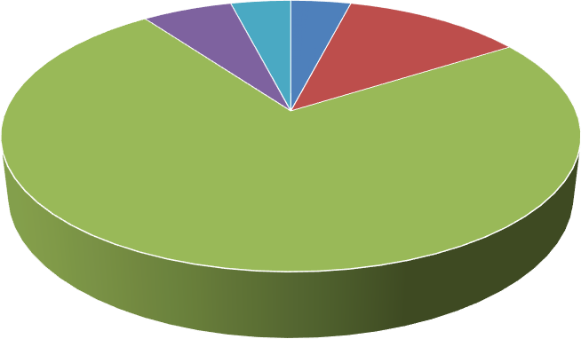
VILLAGE
VENDAYAMPATTI
NAVALUR
SORAKUDIPATTI
VADUGANPURPATTI
RAYAMUNDANPATTI

DIAGRAM 4.1

STANDARD OF THE RESPONDENT
STANDARD | NO OF RESPONDENTS | PERCENTAGE
9th | 23 | 46
10th | 27 | 54
Source: Computed from primary data

The above table 4.2 represent the standard of the respondents. The majority of respondents are from 10th standard (27 respondents, 54%).9th standard has 23 respondents (46%). Overall, respondents are almost evenly distributed, but 10th standard slightly dominates.
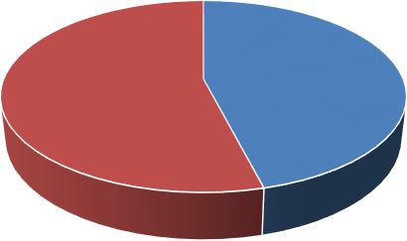
STANDARD

9th 10th

DIAGRAM 4.2

GENDER OF THE RESPONDENTS
GENDER | NO OF RESPONDENTS | PERCENTAGE
BOY | 23 | 46
GIRL | 27 | 54
Source: Computed from primary data

The above table 4.3 represents the Gender of the respondent. Most respondents (70%) have 1 sibling going to school with them.14% have no siblings in school.10% have 2 siblings, and 6% have more than 2 siblings. Overall, the majority go to school with one sibling.

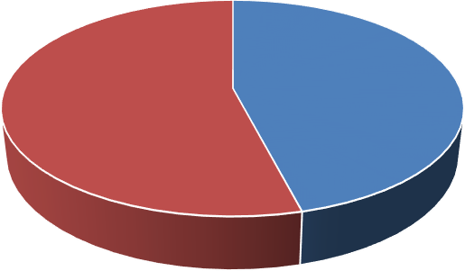
GENDER

BOY GIRL

DIAGRAM 4.3

SIBLINGS GOING TO THE SCHOOL

NO OF SIBLINGS | NO OF RESPONDENTS | PERCENTAGE
NONE | 7 | 14
1 | 35 | 70
2 | 5 | 10
MORE THAN 2 | 3 | 6
Source: Computed from primary data

Table no 4.4 shows the brothers and sisters going to school with the respondents. Most respondents (70%) have 1 sibling going to school with them.14% have no siblings in school.10% have 2 siblings, and 6% have more than 2 siblings. Overall, the majority go to school with one sibling.
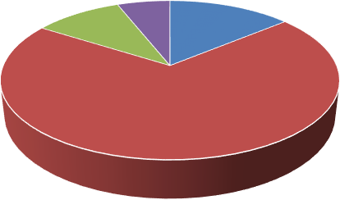
SIBLINGS

NONE 1 2 MORE THAN 2

DIAGRAM 4.4

RESPONDENTS PARENTS WORK

PARENTS WORK | NO OF RESPONDENTS | PERCENTAGE
YES | 21 | 42
NONE | 2 | 4
ONLY ONE WORKS | 27 | 54
Source: Computed from primary data

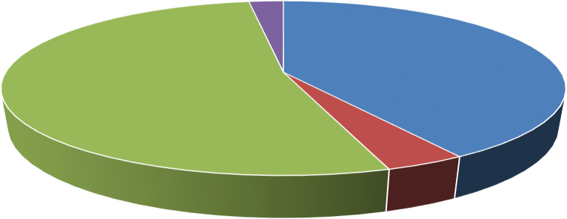
The above table 4.5 shows the respondents parents work. Only one parent working is the most common situation (27 respondents, 54%). Both parents working accounts for 21 respondents (42%). Neither parent working is very rare (2 respondents, 4%). Overall, the majority of families depend on a single working parent.
PARENTS WORK
YES
NONE
ONLY ONE WORKS
DON’T KNOW

DIAGRAM 4.5

DO YOU HAVE TROUBLE GETTING SCHOOL UNIFORMS EVERY YEAR?
UNIFORM | NO OF  RESPONDENTS | PERCENTAGE
YES | 13 | 26
NO | 32 | 64
WE BORROW OR SHARE UNIFORMS | 2 | 4
WE MANAGE WITH OLD ONES | 3 | 6
Source: Computed from primary data
The above table 4.6 shows trouble getting school uniforms. Most respondents (64%) reported no trouble in getting school uniforms.26% face difficulties in getting uniforms every year. A few manage by borrowing/sharing (4%) or using old ones (6%). Overall, the majority do not face uniform issues, but about one-third experience some difficulty.
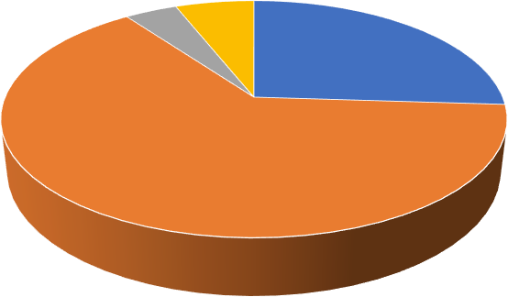
TROUBLE GETTING UNIFORMS
YES
NO
WE BORROW OR SHARE UNIFORMS
WE MANAGE WITH OLD ONES

DIAGRAM 4.6

IS IT DIFFICULT TO GET NOTEBOOKS AND TEXTBOOKS AT HOME?
NOTEBOOKS AND TEXTBOOKS | NO OF RESPONDENTS | PERCENTAGE
YES | 17 | 34
NO | 27 | 54
SECOND-HAND BOOKS | 3 | 6
SHARE WITH FRIENDS | 3 | 6
Source: Computed from primary data
The above table 4.7 shows difficulty in getting notebooks and textbooks. More than half (54%) of respondents said it is not difficult to get notebooks and textbooks.34% reported facing difficulty. A small share manage with second-hand books (6%) or by sharing with friends (6%). Overall, while most students get books without difficulty, about one-third struggle to access them.

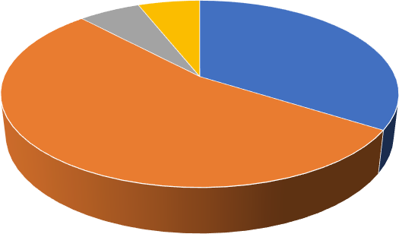
DIFFICULTY IN GETTING TEXTBOOKS AND NOTEBOOKS

YES NO SECOND-HAND BOOKS SHARE WITH FRIENDS

DIAGRAM 4.7

PRIVATE TUITION CLASSES AFTER SCHOOL
PRIVATE TUITION | NO OF RESPONDENTS | PERCENTAGE
YES | 10 | 20
NO | 34 | 68
ATTEND SOMETIMES | 0 | 0
WANT TO BUT CAN’T AFFORD | 6 | 12
Source: Computed from primary data
The above table 4.8 shows respondents’ private tuition classes they go after school. Most respondents (68%) do not attend private tuition after school.20% go for tuition classes.12% want to attend but cannot afford them. None reported attending sometimes. Overall, private tuition is not common, and affordability is a barrier for some students.
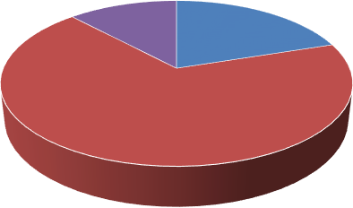
PRIVATE TUITION CLASS
YES NO ATTEND SOMETIMES
WANT TO BUT CANT AFFORD

DIAGRAM 4.8

TRANSPORT | NO OF RESPONDENTS | PERCENTAGE
YES | 2 | 4
NO | 29 | 58
WALK TO SCHOOL | 16 | 32
USE OF BICYCLE | 3 | 6
Source: Computed from primary data
The above table 4.9 shows the transport mode of the respondents to school. Most respondents (58%) do not pay for van or bus transport.32% walk to school, while 6% use a bicycle. Only 4% pay for van or bus transport. Overall, the majority either don’t pay for transport or walk to school, showing limited dependence on paid school transport.
￼
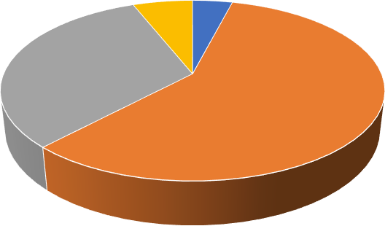
TRANSPORT MODE

YES NO WALK TO SCHOOL USE OF BICYCLE

DIAGRAM 4.9

AFFORDABLITY | NO OF RESPONDENTS | PERCENTAGE
YES | 0 | 0
NO | 42 | 84
SOMETIMES | 8 | 16
OFTEN IN THE PAST | 0 | 0
Source: Computed from primary data
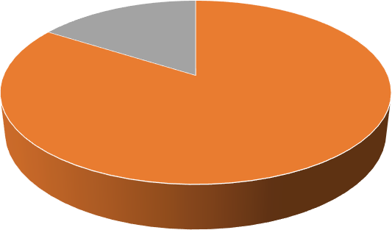
The above table 4.10 shows affordability of the parents for school. Most respondents (84%) have never missed school due to financial reasons.16% reported missing school sometimes because parents couldn’t afford school needs. None reported missing school regularly or often in the past. Overall, financial difficulties cause school absence only for a small minority of students.
AFFORDABLITY OF PARENTS

YES NO SOMETIMES OFTEN IN THE PAST

DIAGRAM 4.10

SCHOOL COST | NO OF  RESPONDENTS | PERCENTAGE
YES | 4 | 8
NO | 28 | 56
SOMETIMES | 15 | 30
THEY DON’T TALK ABOUT IT | 3 | 6
Source: Computed from primary data
The above table 4.11 shows respondents’ views on whether their parents consider school costs too high. A majority, 56% (28 respondents), reported that their parents do not think school costs are too high. 30% (15 respondents) said their parents sometimes feel the costs are high, while 8% (4 respondents) indicated their parents do think school costs are too high.
A small portion, 6% (3 respondents), stated that their parents do not talk about school costs.

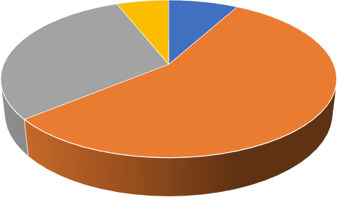
SCHOOL COST ARE TOO HIGH

YES NO SOMETIMES THEY DON’T TALK ABOUT IT

DIAGRAM 4.11

MISSING SCHOOL | NO OF RESPONDENTS | PERCENTAGE
YES | 1 | 2
NO | 20 | 40
ONLY DURING EMERGENCIES | 3 | 6
I TRY NOT TO | 26 | 52
Source: Computed from primary data
The above table 4.12 shows how students respond to missing school due to family money problems. A small portion, 2% (1 respondent), said they miss school, while 40% (20 respondents) said they do not miss school. 6% (3 respondents) miss school only during emergencies, and the largest group, 52% (26 respondents), stated they try not to miss school despite financial difficulties.
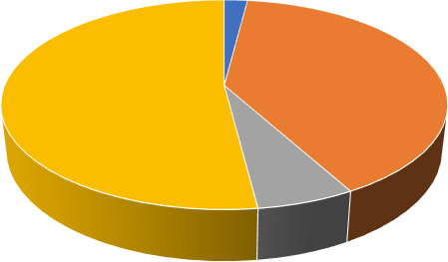
MISSING SCHOOL

YES NO ONLY DURING EMERGENCIES I TRY NOT TO

DIAGRAM 4.12

PHONE OR INTERNET
ONLINE CLASS STRUGGLE | NO OF RESPONDENTS | PERCENTAGE
YES | 11 | 22
NO | 16 | 32
I USED A NEIGHBOR'S PHONE | 4 | 8
I SHARED WITH SIBLINGS | 19 | 38
Source: Computed from primary data
The above table 4.13 shows students’ struggles with attending online classes due to lack of phone or internet. 22% (11 respondents) reported they struggled, while 32% (16 respondents) had no issues. Some students adapted by using alternative resources: 8% (4 respondents) used a neighbour’s phone, and the largest group, 38% (19 respondents), shared a device with siblings to attend classes.
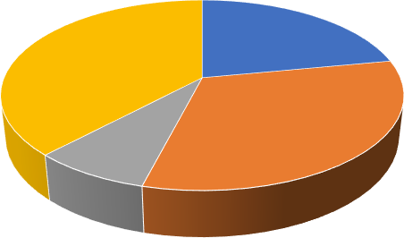
ONLINE CLASS STRUGGLE
YES
NO
I USED A NEIGHBOR'S PHONE
I SHARED WITH SIBLINGS

DIAGRAM 4.13

FREE ITEMS | NO OF RESPONDENTS | PERCENTAGE
YES | 47 | 94
NO | 0 | 0
SOME ITEMS ONLY | 3 | 6
I DON’T KNOW WHAT'S PROVIDED | 0 | 0
Source: Computed from primary data
The above table 4.14 shows students’ access to free items provided by the government, such as books and uniforms. A vast majority, 94% (47 respondents), reported they receive all the free items, while 6% (3 respondents) said they receive some items only. No respondents reported not receiving any items or being unaware of what is provided.
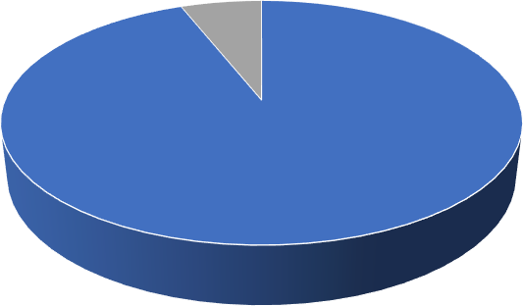
FREE ITEMS PROVIDED BY GOVERNMENT
YES
NO SOME ITEMS ONLY
I DON’T KNOW WHAT'S PROVIDED

DIAGRAM 4.14

IS YOUR SCHOOL BUILDING IN GOOD CONDITION
BUILDING CONDITIONS | NO OF RESPONDENTS | PERCENTAGE
YES | 2 | 4
NO | 4 | 8
SOME PARTS ARE OKAY | 6 | 12
NEEDS IMPROVEMENT | 38 | 76
Source: Computed from primary data

The above table 4.15 shows respondents’ opinions on the condition of their school building, including toilets, drinking water, and classrooms. Only 4% (2 respondents) said the building is in good condition, while 8% (4 respondents) said it is not in good condition. 12% (6 respondents) felt some parts are okay, but the majority, 76% (38 respondents), stated that the school needs improvement.
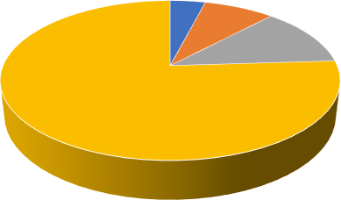
SCHOOL CONDITIONS
YES
NO SOME PARTS ARE OKAY
NEEDS IMPROVEMENT
DIAGRAM 4.15

HELP YOUR PARENTS IN THE FIELD OR OTHER WORK INSTEAD OF GOING
TO SCHOOL SOMETIMES

HELPING PARENTS | NO OF RESPONDENTS | PERCENTAGE
YES | 6 | 12
NO | 22 | 44
ONLY DURING BUSY  SEASONS | 2 | 4
I HELP AFTER SCHOOL | 20 | 40
Source: Computed from primary data

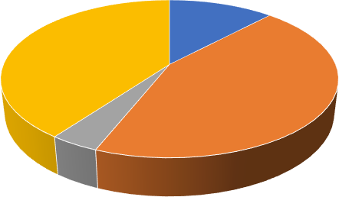
The above table 4.16 shows students’ involvement in helping their parents with work instead of attending school. 12% (6 respondents) said they sometimes skip school to help, while 44% (22 respondents) do not help during school hours. 4% (2 respondents) help only during busy seasons, and 40% (20 respondents) assist their parents after school.
HELPING PARENTS
YES
NO ONLY DURING BUSY SEASONS
I HELP AFTER SCHOOL

DIAGRAM 4.16

DO YOU MISS SCHOOL DURING HARVEST OR FESTIVAL SEASONS

ABSENCE DURING  HARVEST | NO OF RESPONDENTS | PERCENTAGE
YES | 4 | 8
NO | 20 | 40
SOMETIMES FOR A DAY OR TWO | 7 | 14
ONLY DURING MAJOR FESTIVALS | 19 | 38
Source: Computed from primary data

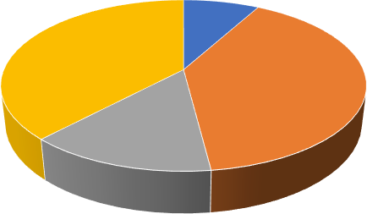
The above table 4.17 shows the absentees on harvest or festival season. It says that school attendance during harvest or festival seasons. 8% (4 respondents) said they miss school, while 40% (20 respondents) do not miss school. 14% (7 respondents) miss school for a day or two sometimes, and 38% (19 respondents) are absent only during major festivals.
ABSENTEES DURING HARVEST/FESTIVAL
YES
NO
SOMETIMES FOR A DAY OR TWO
ONLY DURING MAJOR FESTIVALS

DIAGRAM 4.7

HAVE YOU EVER GONE TO WORK FOR MONEY DURING SCHOOL DAYS

WORKING DURING  SCHOOL DAYS | NO OF RESPONDENTS | PERCENTAGE
YES | 0 | 0
NO | 38 | 76
ONLY DURING  HOLIDAYS | 5 | 10
ONCE OR TWICE IN EMERGENCIES | 7 | 14
Source: Computed from primary data

The above table 4.18 shows students’ engagement in work for money during school days. None of the respondents (0%) reported working regularly during school days. The majority, 76% (38 respondents), said they do not work during school. 10% (5 respondents) work only during holidays, and 14% (7 respondents) have worked once or twice in emergencies.
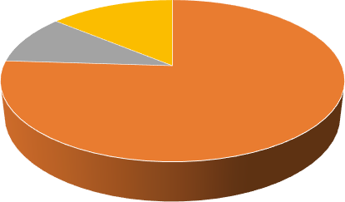
WORKING
YES
NO
ONLY DURING HOLIDAYS
ONCE OR TWICE IN EMERGENCIES

DIAGRAM 4.18

WORK INSTEAD OF STUDY WHEN THERE IS NO MONEY AT HOME

WORK INSTEAD OF  STUDY | NO OF RESPONDENTS | PERCENTAGE
YES | 0 | 0
NO | 41 | 82
THEY SUGGEST IT, BUT  DON’T FORCE | 6 | 12
ONLY WHEN IT’S URGENT | 3 | 6
Source: Computed from primary data

The above table 4.19 shows whether parents ask students to work instead of studying when money is tight at home. 82% (41 respondents) said their parents do not ask them to work, while 12% (6 respondents) reported that their parents suggest it but don’t force them. 6% (3 respondents) said their parents ask them to work only in urgent situations, and 0% indicated they are forced to work instead of studying.
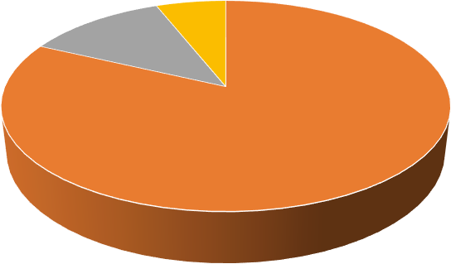
WORK INSTEAD OF STUDY
YES
NO
THEY SUGGEST IT, BUT DON’T FORCE
ONLY WHEN IT’S URGENT

DIAGRAM 4.19

DROPPED OUT OF SCHOOL DUE TO MONEY PROBLEMS

DROPOUTS | NO OF RESPONDENTS | PERCENTAGE
YES | 3 | 6
NO | 41 | 82
A FEW HAVE | 4 | 8
MANY HAVE | 2 | 4
Source: Computed from primary data

The above table 4.20 shows respondents’ observations of friends dropping out of school due to money problems. 6% (3 respondents) reported that a friend has dropped out, while 82% (41 respondents) said no friends have dropped out. 8% (4 respondents) observed that a few friends have dropped out, and 4% (2 respondents) noted that many friends have left school for financial reasons.
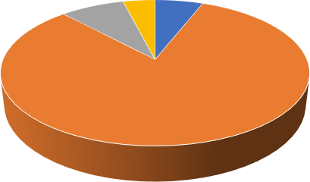
DROPPOUTS
YES
NO A FEW HAVE
MANY HAVE

DIAGRAM 4.20

COMFORTABLE STUDY PLACE AT HOME

COMFORTABLE PLACE  TO STUDY | NO OF RESPONDENTS | PERCENTAGE
YES | 31 | 62
NO | 6 | 12
I STUDY OUTSIDE/AT  SCHOOL | 4 | 8
ONLY WHEN OTHERS ARE QUIET | 9 | 18
Source: Computed from primary data

The above table 4.21 shows students’ access to a quiet and comfortable place to study at home. 62% (31 respondents) reported that they have a suitable study space, while 12% (6 respondents) said they do not. 8% (4 respondents) study outside or at school, and 18% (9 respondents) can study only when others at home are quiet.
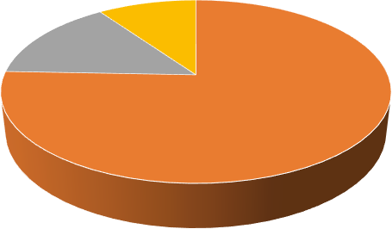
COMFORTABLE PLACE TO STUDY
COMFORTABLE PLACE TO STUDY
YES
NO
I STUDY OUTSIDE/AT SCHOOL

DIAGRAM 4.21

ATTEND TUITION OR COACHING CLASSES OUTSIDE SCHOOL

TUITION OR  COACHING CLASSES | NO OF RESPONDENTS | PERCENTAGE
YES | 4 | 8
NO | 37 | 74
I GO WHEN EXAMS  COME | 2 | 4
I STOPPED DUE TO COST | 7 | 14
Source: Computed from primary data

The above table 4.22 shows students’ participation in tuition or coaching classes outside school. 8% (4 respondents) regularly attend such classes, while the majority, 74% (37 respondents), do not attend. 4% (2 respondents) go to classes only during exams, and 14% (7 respondents) have stopped attending due to the cost.
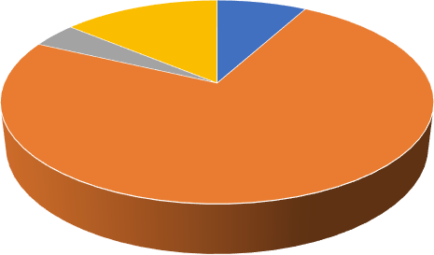
TUITION OR COACHING CLASS
YES
NO I GO WHEN EXAMS COME I STOPPED DUE TO COST

DIAGRAM 4.22

ACCESS TO A SMARTPHONE, COMPUTER, OR INTERNET FOR SCHOOLWORK
ACCESS TO A SMARTPHONE/  INTERNET | NO OF RESPONDENTS | PERCENTAGE
YES | 32 | 64
NO | 9 | 18
I SHARE WITH OTHERS | 4 | 8
ONLY DURING ONLINE CLASSES | 5 | 10
Source: Computed from primary data

The above table 4.23 shows students’ access to a smartphone, computer, or internet for schoolwork. 64% (32 respondents) reported that they have access, while 18% (9 respondents) do not have access. 8% (4 respondents) share devices with others, and 10% (5 respondents) have access only during online classes.
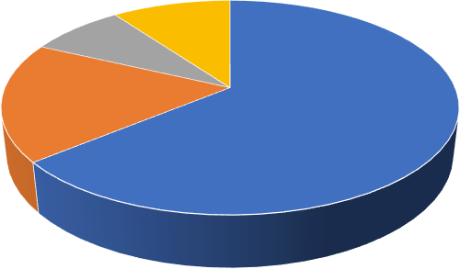
INTERNET ACCESS
YES
NO
I SHARE WITH OTHERS
ONLY DURING ONLINE CLASSES

DIAGRAM 4.23

LACK OF ELECTRICITY AT HOME EVER STOPPED YOU FROM STUDYING

LACK OF  ELECTRICITY | NO OF RESPONDENTS | PERCENTAGE
YES | 2 | 4
NO | 12 | 24
ONLY DURING POWER CUTS | 23 | 46
I USE CANDLES OR LAMPS | 13 | 26
Source: Computed from primary data

The above table 4.24 shows the impact of electricity availability on students’ ability to study at home. 4% (2 respondents) said a lack of electricity has stopped them from studying, while 24% (12 respondents) reported no impact. 46% (23 respondents) are affected only during power cuts, and 26% (13 respondents) use candles or lamps to continue studying.
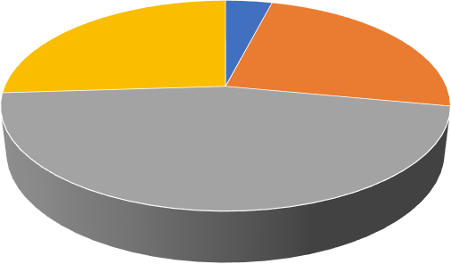
LACK OF ELECTRICITY
YES
NO
ONLY DURING POWER CUTS
I USE CANDLES OR LAMPS

DIAGRAM 4.24

GET HELP WITH STUDIES AT HOME (FROM PARENTS, SIBLINGS, OR OTHERS)
GET HELP WITH  STUDIES | NO OF RESPONDENTS | PERCENTAGE
YES | 5 | 10
NO | 6 | 12
MY SIBLINGS HELP ME | 19 | 38
I HELP OTHERS INSTEAD | 20 | 40
Source: Computed from primary data

The above table 4.25 The table shows students’ access to help with studies at home. 10% (5 respondents) reported receiving help from parents or others, while 12% (6 respondents) do not receive any help. 38% (19 respondents) get help specifically from siblings, and 40% (20 respondents) spend their time helping others instead of receiving help respondents)
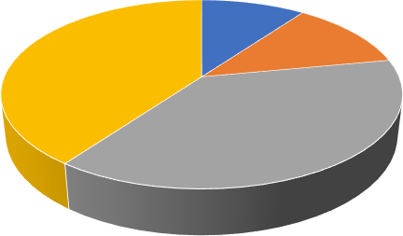
HELP WITH STUDIES
YES
NO MY SIBLINGS HELP ME
I HELP OTHERS INSTEAD

DIAGRAM 4.25

FREE SCHOLARSHIPS OR MONEY HELP FOR STUDENTS

FREE SCHOLARSHIPS  KNOWLEDGE | NO OF  RESPONDENTS | PERCENTAGE
YES | 42 | 84
NO | 2 | 4
I’VE HEARD OF SOME | 5 | 10
I DON’T UNDERSTAND THEM | 1 | 2
Source: Computed from primary data

The above table 4.26 shows student's The table shows students’ awareness of free scholarships or financial help for students. A majority, 84% (42 respondents), said they know about such support, while 4% (2 respondents) are unaware. 10% (5 respondents) have heard of some scholarships, and 2% (1 respondent) does not understand them.
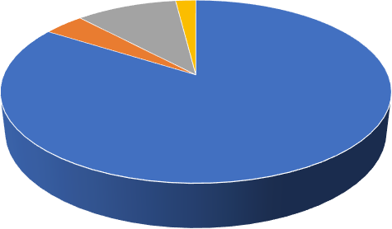
FREE SCHOLORSHIPS
YES
NO I’VE HEARD OF SOME
I DON’T UNDERSTAND THEM

DIAGRAM 4.26

GOVERNMENT SCHEME

GOVERNMENT  SCHEME HELP | NO OF RESPONDENTS | PERCENTAGE
YES | 46 | 52
NO | 1 | 2
I APPLIED BUT DIDN’T  GET | 2 | 4
I’M NOT SURE | 1 | 2
Source: Computed from primary data

The above table 4.27 shows students’ participation in government schemes. 52% (46 respondents) reported that they are receiving help, while 2% (1 respondent) said they are not receiving any help. 4% (2 respondents) applied but did not get assistance, and 2% (1 respondent) is unsure about their status.
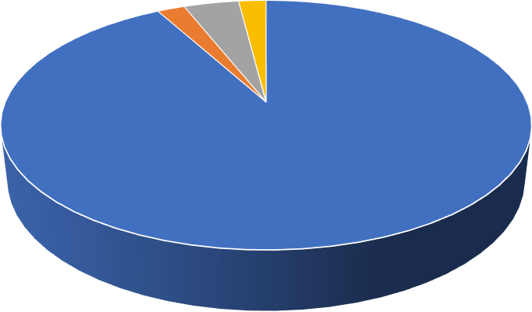
GOVERNMENT SCHEMES
YES
NO I APPLIED BUT DIDN’T GET
I’M NOT SURE

DIAGRAM 4.27

MIDDAY MEAL GIVEN AT SCHOOL

MIDDAY MEAL | NO OF RESPONDENTS | PERCENTAGE
YES | 11 | 22
NO | 6 | 12
IT’S OKAY | 23 | 46
I DON’T EAT IT OFTEN | 11 | 22
Source: Computed from primary data

The above table 4.28 shows students’ opinions about the midday meal at school. 22% (11 respondents) said they like it, while 12% (6 respondents) said they do not like it. 46% (23 respondents) felt it is okay, and 22% (11 respondents) reported that they do not eat it often.
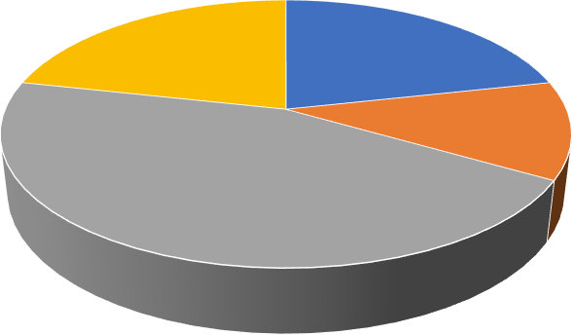
MIDDAY MEAL
YES
NO IT’S OKAY
I DON’T EAT IT OFTEN

DIAGRAM 4.28

FINANCIAL HELP STATUS

REGULAR IF  FINANCIAL HELP | NO OF RESPONDENTS | PERCENTAGE
YES | 4 | 8
NO | 11 | 22
IT MAY HELP A LITTLE | 6 | 12
I ALREADY ATTEND REGULARLY | 29 | 58
Source: Computed from primary data

The above table 4.29 shows whether financial help would affect students’ school attendance. 8% (4 respondents) said they would attend more regularly with financial help, while 22% (11 respondents) said it would not make a difference. 12% (6 respondents) felt it may help a little, and the majority, 58% (29 respondents), already attend school regularly.
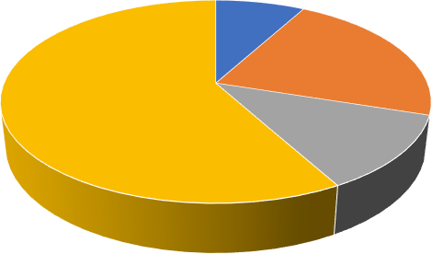
FINANCIAL HELP
YES
NO
IT MAY HELP A LITTLE
I ALREADY ATTEND REGULARLY

DIAGRAM 4.29

POOR FAMILIES FIND IT HARD TO SEND CHILDREN TO SCHOOL

HARD TO SEND  CHILDREN TO SCHOOL | NO OF RESPONDENTS | PERCENTAGE
YES | 2 | 4
NO | 11 | 22
IN SOME AREAS, YES | 13 | 26
DEPENDS ON THE FAMILY | 34 | 68
Source: Computed from primary data

The above table 4.30 shows students’ perceptions of whether poor families find it difficult to send children to school. 4% (2 respondents) said yes, 22% (11 respondents) said no, 26% (13 respondents) felt it is yes in some areas, and the majority, 68% (34 respondents), believed it depends on the family.
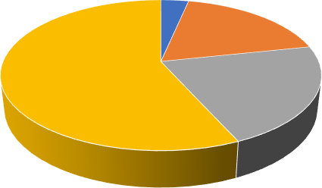
HARD TO SEND CHILDRENS TO SCHOOL
YES
NO IN SOME AREAS, YES
DEPENDS ON THE FAMILY

DIAGRAM 4.30

CHAPTER 5

FINDINGS, SUGGESTIONS AND CONCLUSION

FINDINGS, SUGGESTIONS AND SOLUTIONS

Findings

- The survey found that most participants were from Rayamundanpatti village, making it the main focus area of the study and the community with the highest number of school-going children.
- A majority of the students were in 9th and 10th grades, with slightly more in 10th. This shows that the study mainly focused on teenagers who are at an important stage in their education and most vulnerable to dropping out.
- Girls made up 54% of the respondents, while boys accounted for 46%. This suggests that both genders are almost equally represented in schools, though girls still face a few unique challenges in continuing their education.
- Many students said that their siblings also attended school, which shows that families are making a genuine effort to educate all their children despite limited financial resources.
- More than half of the families had only one earning member, reflecting the financial hardship faced by most households in the community.
- Around one in four students said they had difficulty getting a new uniform every year. This shows that even when schools provide free uniforms, other costs still put pressure on family budgets.
- Nearly one-third of students found it hard to buy notebooks and textbooks, highlighting that financial struggles continue even when tuition fees are waived.
- Some students mentioned using second-hand books or borrowing from friends. This reveals that access to study materials remains a challenge in rural areas.
- Only about 20% of students attended private tuition classes, and another 12% wanted to join but couldn’t afford them. This shows how economic constraints limit extra academic support.
- Most students walked to school, with very few using bicycles or public transport. This indicates that distance and the lack of affordable transport continue to be challenges for rural students.
- While most students said they rarely missed school due to money, about 16% admitted they sometimes stayed home because their parents couldn’t cover school-related expenses.
- Nearly 30% of parents believed that school costs were still too high, even with government support. This could affect their ability to prioritize education in the long term.
- Over half of the students said they made every effort not to miss school, even when their families were struggling financially. This shows a strong commitment to education among rural children.
- During the COVID-19 pandemic, almost one-fourth of students had difficulty attending online classes because they didn’t have a mobile phone or internet access.
- Most students had to share phones or computers with siblings to attend online classes. While this helped them stay connected to learning, it often caused time conflicts and reduced the effectiveness of their studies.
- An impressive 94% of students said they received all the free items provided by the government — such as books, uniforms, and mid-day meals — showing that welfare programs are working effectively in the area.
- However, a few students mentioned receiving only some of these items, suggesting that distribution systems may still need minor improvements.
- School infrastructure was a major concern. Nearly three-fourths of students said their schools needed better classrooms, proper toilets, and clean drinking water.
- Around 12% of students said they occasionally missed school to help their parents in farming, while nearly 40% helped out after school hours. This shows that family responsibilities often interfere with their studies.
- Attendance dropped during harvest seasons and festivals, with almost half of the students missing school during these busy times.
- None of the students worked full-time during school days, but some took up small jobs during holidays or emergencies, which can still affect their academic focus.
- A few parents admitted that they had considered asking their children to work when money was tight, though most were determined not to make them leave school.
- Most students themselves had not dropped out, but many knew friends who had left school due to financial difficulties, showing how closely linked poverty is to education.
- Over 60% of students had a proper place to study at home, but the rest had to study outdoors or wait until the house was quiet, showing that not all students enjoy the same learning environment.
- Most students were aware of government scholarship programs, though some had only partial knowledge of how to apply. This suggests a need for better guidance and awareness about educational benefits.

Suggestions

  - Immediate steps should be taken to improve school facilities, especially classrooms, sanitation, and drinking water, to provide a safe and supportive environment.
  - Local authorities and teachers should conduct awareness drives to inform parents and students about scholarships, welfare schemes, and the long-term value of education.
  - Providing additional subsidies for uniforms, stationery, and transportation could ease the burden on low-income families. Special focus should be given to households with only one earning member.
  - Village-level committees can organize after-school learning spaces or peer tutoring for students who lack resources at home.
  - Ensuring affordable internet and distribution of digital devices would reduce the digital divide, especially in case of online or blended learning.
  - Flexible academic calendars, awareness for parents, and compensatory classes during harvest/festival seasons could help minimize dropouts.
  - Schools should provide career counseling and skill-based learning so that families see tangible value in education, reducing the tendency to push children into work early.

Conclusion

This study clearly shows that while government initiatives like free uniforms, textbooks, and midday meals have reduced some financial pressures, many families in rural areas still struggle to meet the indirect costs of education. Challenges such as poor infrastructure, lack of digital access, seasonal absenteeism, and dependence on singleparent incomes continue to affect the regularity and quality of school attendance. Although most students expressed strong motivation to pursue education, the persistence of economic barriers risks pushing vulnerable children toward irregular attendance or even dropouts.

At the same time, the findings highlight positive aspects such as high awareness of the value of schooling, effective delivery of free items, and active participation of both boys and girls. These strengths provide a strong foundation for further improvement. By strengthening infrastructure, increasing financial and digital support, and involving parents and communities more closely, education in Vendayampatti Panchayat can be made more inclusive and sustainable.

APPENDIX

QUESTIONNAIRE

Section A: Demographic Information
- Which village do you live in?
  - Vendayampatti ☐ Sorakudipatti ☐ Rayamundanpatti ☐ Navalur

  - Vaduganpudhupatti

- What class are you studying in?
  - 9th ☐ 10th

- ☐ Boy ☐ Girl
- How many brothers and sisters go to school with you?
  - None ☐ 1 ☐ 2 ☐ More than 2
- Do both your parents work?
  - Yes ☐ No ☐ Only one works ☐ I don’t know

Section B: School Expenses

- Do you have trouble getting school uniforms every year?
  - Yes ☐ No ☐ We borrow or share uniforms ☐ We manage with old ones
- Is it difficult to get notebooks and textbooks at home?
  - Yes ☐ No ☐ I use second-hand books ☐ I share with friends
- Do you go for private tuition classes after school?
  - Yes ☐ No ☐ I attend sometimes ☐ I want to but can’t afford
- Do you need to pay for the van or bus to go to school?
  - Yes ☐ No ☐ I walk to school ☐ I use a bicycle
- Have you ever missed school because your parents couldn’t afford something for school?
  - Yes ☐ No ☐ Sometimes ☐ Often in the past

Section C: Money Problems at Home
- Do your parents say school costs are too high?
  - Yes ☐ No ☐ Sometimes ☐ They don’t talk about it

- Do you get help with studies at home (from parents, siblings, or others)?
  - Yes ☐ No ☐ My siblings help me ☐ I help others instead

Section F: Support from School or Government

- Do you know about any free scholarships or money help for students?
  - Yes ☐ No ☐ I’ve heard of some ☐ I don’t understand them
- Are you getting help from any government scheme?
  - Yes ☐ No ☐ I applied but didn’t get ☐ I’m not sure
- Do you like the midday meal given at school?
  - Yes ☐ No ☐ It’s okay ☐ I don’t eat it often
- Will you come to school more regularly if your family gets financial help?
  - Yes ☐ No ☐ It may help a little ☐ I already attend regularly
- Do you think poor families find it hard to send children to school?
  - Yes ☐ No ☐ In some areas, yes ☐ Depends on the family

- Do you miss school when your family has money problems?
  - Yes ☐ No ☐ Only during emergencies ☐ I try not to
- Did you struggle to attend online classes because you didn’t have a phone or internet?
  - Yes ☐ No ☐ I used a neighbor's phone ☐ I shared with siblings
- Do you get all the free items the government gives (books, uniforms, etc.)?
  - Yes ☐ No ☐ Some items only ☐ I don’t know what's provided
- Is your school building in good condition (toilets, drinking water, classrooms)?
  - Yes ☐ No ☐ Some parts are okay ☐ Needs improvement

Section D: Work and Responsibilities

- Do you help your parents in the field or other work instead of going to school sometimes?
  - Yes ☐ No ☐ Only during busy seasons ☐ I help after school
- Do you miss school during harvest or festival seasons?
  - Yes ☐ No ☐ Sometimes for a day or two ☐ Only during major festivals
- Have you ever gone to work for money during school days?
  - Yes ☐ No ☐ Only during holidays ☐ Once or twice in emergencies
- Do your parents ask you to work instead of study when there is no money at home?
  - Yes ☐ No ☐ They suggest it, but don’t force ☐ Only when it’s urgent
- Have any of your friends dropped out of school due to money problems?
  - Yes ☐ No ☐ A few have ☐ Many have

Section E: Access to Learning Resources and Support
- Do you have a quiet and comfortable place to study at home?
  - Yes ☐ No ☐ I study outside/at school ☐ Only when others are quiet
- Do you attend tuition or coaching classes outside school?
  - Yes ☐ No ☐ I go when exams come ☐ I stopped due to cost
- Do you have access to a smartphone, computer, or internet for schoolwork?
  - Yes ☐ No ☐ I share with others ☐ Only during online classes
- Has a lack of electricity at home ever stopped you from studying?
  - Yes ☐ No ☐ Only during power cuts ☐ I use candles or lamps

