**HOME – MAIN SCREEN**

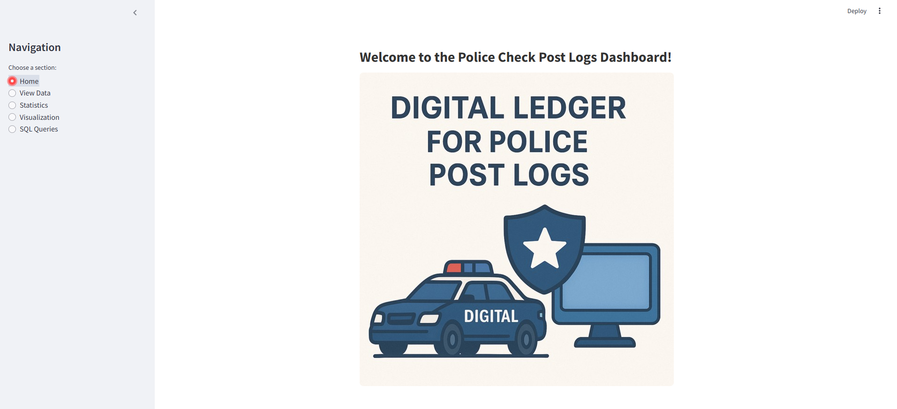

**VIEW DATA – DESCRIPTION OF ALL THE DATA**

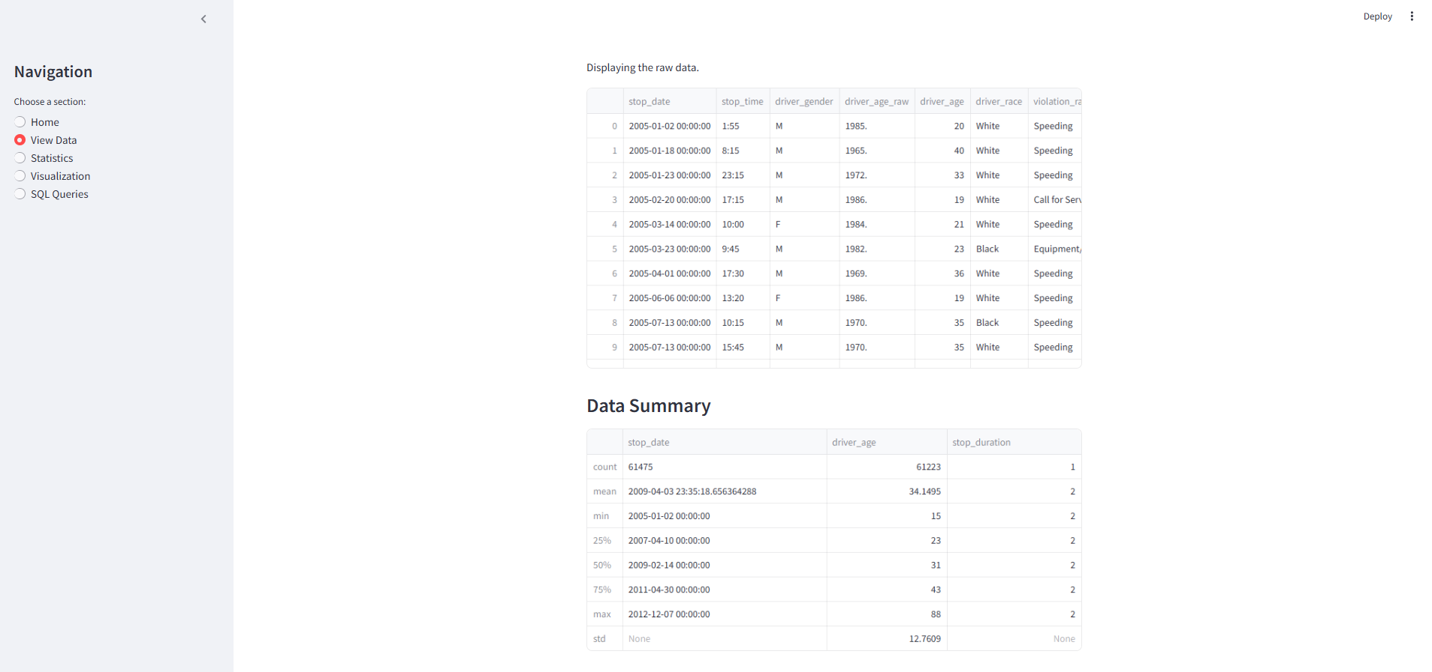

**STATISTICS – OVER VIEW OF THE STATISTICAL VIEW OF THE SUBMITTED DATA**

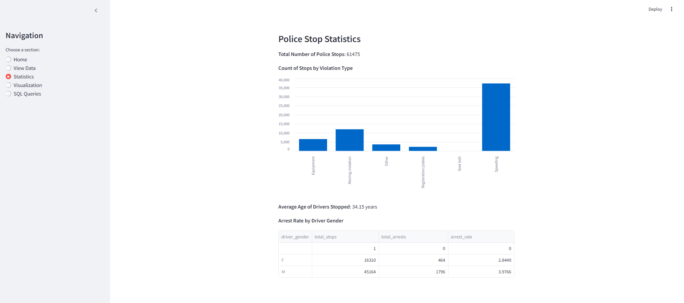

**VISUALIZATION – VISUALIZATION OF THE SUBMITTED DATA**

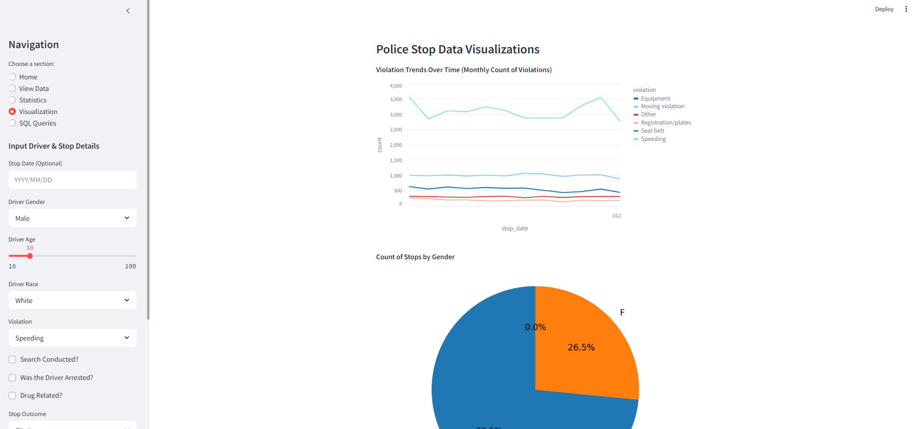

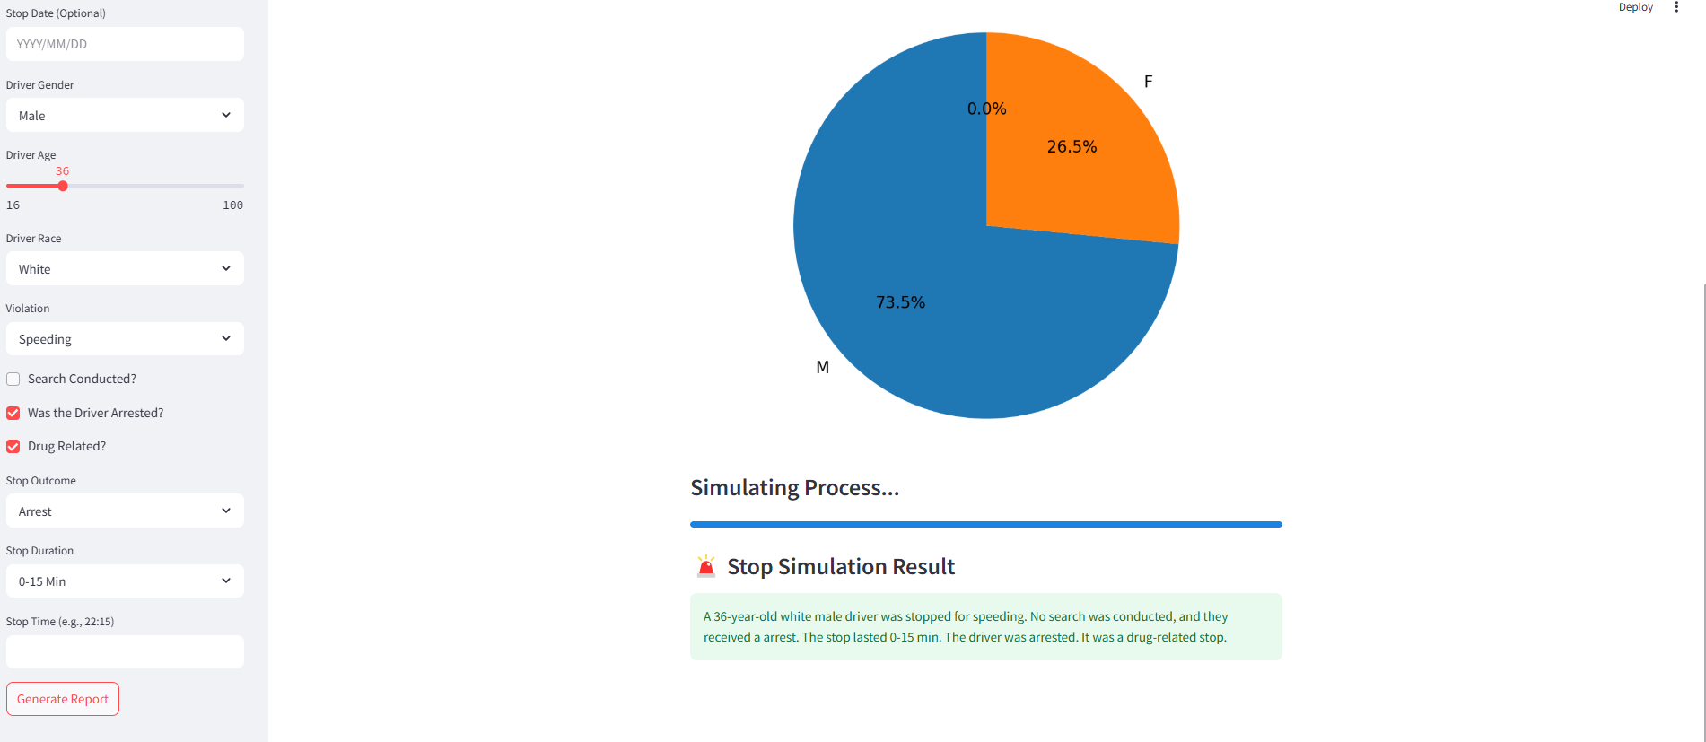

**SQL QUERIES – DROPDOWN WITH ALL THE 22 QUERIES**

