Summary Report of Co-Curricular and Extra-Curricular Activities  (Workshop / FDP / Seminar / Training programs/ Cultural Events) | SUH | 9.06 | VERSION 1

1. Title of the Event: One-Day Workshop on Coding Platforms

2. Type of Event: Workshop

3. Dates and Duration:
From: 20-02-2026 To: 20-02-2026
Total Duration: 1 Day

4. Organised By:
Skill Development Centr(SDC), Sreenidhi University

5. Co - Ordinators:
Mr. Rajinikanth, Deputy Director, SDC.
Mr. Shiva Maram, SDC.
Mr. Sai Krishna, SDC

6. Venue:
Sreenidhi University Campus, Hyderabad

7. Objective of the Event:

The One-Day Workshop on Coding Platforms was conducted to introduce first-year R25 students to essential coding platforms such as LeetCode, CodeChef, HackerRank, GitHub, and VS Code, and to guide them on how to effectively utilize these platforms for skill development, career planning, and placement preparation.

8. Participants:

- Target Audience: Students
- Total Number of Participants: 37
- Departments/Institutions Represented: R25

10. Summary of Sessions:

The One-Day Workshop on Coding Platforms was organized by the Skill Development Centre (SDC) & CDC, Sreenidhi University on 21st February 2026 for R25 first-year students. The workshop aimed to introduce students to important coding platforms such as LeetCode, CodeChef, HackerRank, GitHub, and VS Code, and guide them on how to effectively use these platforms for skill development, career preparation, and placements.

The session focused on helping students understand how to start coding practice, choose the right platforms, structure their preparation, and build a strong coding profile from the first year. A total of 97 students registered, out of which 37 attended, resulting in an attendance rate of 38.14%.

Five speakers delivered sessions on different platforms and career skills, sharing practical insights, platform navigation guidance, and preparation strategies. Feedback collected from 34 participants showed positive responses, with an average rating of 4.0/5, and 76.47% of students rating the workshop as very good or excellent.

Overall, the workshop was informative and beneficial, helping students gain clarity on coding preparation and career development. E-certificates will be provided to all participants, volunteers, and speakers in recognition of their involvement.

11. Outcomes of the Event/Key Take aways:

Students gained awareness of major coding platforms like LeetCode, CodeChef, HackerRank, and GitHub.

Participants learned how to begin coding practice and follow structured preparation.

Students understood the importance of building a strong coding profile for placements.

The workshop motivated students to actively practice coding and improve their technical skills.

12. Supporting Photos:
https://drive.google.com/drive/folders/1h6udQIAufm7x5y8lNyOwrI8aV50mIihP?usp=drive_link
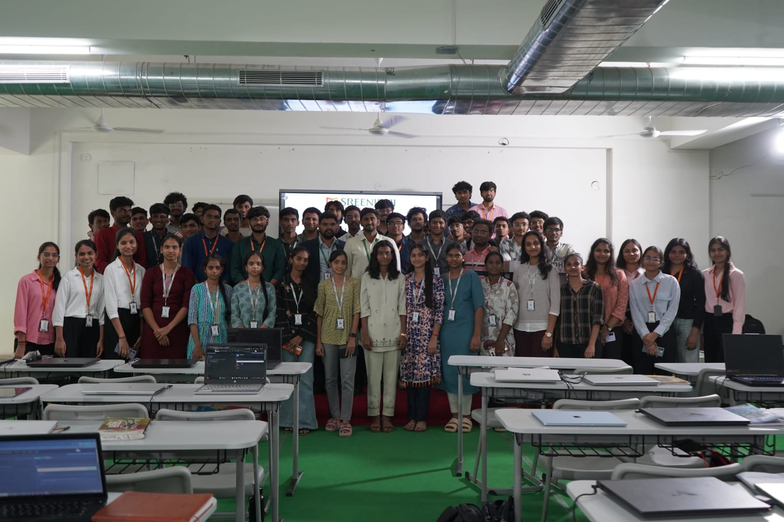

13. Challenges Faced:
None – all sessions proceeded smoothly without any issues.

14. Suggestions/Feedback:
- Overall, the workshop was well-organised and informative for students.
- However, the internet connectivity was slightly slow, which affected a few demonstrations.
- The venue felt a bit congested, and a larger room could improve comfort in future sessions.
- Apart from these minor issues, the session was very useful and well appreciated by participants.

Event Coordinator Year Coordinator/ HoD Dean

