EMR Cluster Health Monitor
Design and Testing Document

Item | Detail
System | Apache Airflow DAG running on Amazon MWAA
DAG ID | emr_cluster_health_monitor
Purpose | Validate EMR cluster availability and node capacity before downstream business processing.
Document Date | 26 Jun 2026
Prepared For | Operations / Support / Platform review
DAG File | emr_cluster_health_monitor_final.py

Executive summary
The DAG performs read-only EMR health validation and sends operational notifications. Healthy clusters generate email only. Unhealthy or missing clusters generate email and SNS SMS alerts. The DAG does not start, stop, resize, terminate, create, or update EMR resources.

1. Overview
This document describes the design, operational flow, notification behavior, and testing evidence plan for the EMR Cluster Health Monitor DAG deployed in MWAA.
Item | Detail
AWS Region | ap-southeast-2
Active EMR states checked | STARTING, BOOTSTRAPPING, RUNNING, WAITING
Primary check | Primary/Master instance group must have one running node.
Core check | Core running node count must be greater than or equal to configured minimum capacity.
Task check | Task running node count must be greater than or equal to configured minimum capacity. If no Task group exists, this check is treated as pass.
Notification channels | Email for all outcomes; SNS SMS only for UNHEALTHY and CLUSTER_NOT_FOUND.

2. Scope and Non-Goals
- The DAG validates whether the expected EMR cluster exists in an active state.
- The DAG reads EMR instance group capacity and evaluates Primary, Core, and Task capacity rules.
- The DAG sends notifications based on the health result.
- The DAG does not perform remediation or alter EMR infrastructure.
- The DAG does not change Jenkins, MWAA configuration, SNS topic configuration, or subscriptions.

3. Design Details

3.1 Components
Component | Role | Side Effect
MWAA / Airflow | Schedules and executes the DAG tasks. | Writes task logs and XCom metadata.
Boto3 EMR client | Lists clusters, describes cluster, and lists instance groups. | Read-only AWS API calls.
Airflow email utility | Sends the HTML email notification. | Sends email through MWAA email configuration.
Boto3 SNS client | Publishes SMS alert to the configured SNS topic. | Publishes SNS message only for unhealthy or cluster-not-found outcomes.
Airflow XCom | Passes the health result from the health-check task to the notification task. | Internal Airflow metadata write/read.

3.2 Health Rules
- Search active EMR clusters and match the configured cluster name.
- If no matching cluster exists, classify the result as CLUSTER_NOT_FOUND.
- If the cluster exists, describe the cluster and retrieve its instance groups.
- Validate Primary, Core, and Task instance group capacity.
- Classify the cluster as HEALTHY only when all required checks pass; otherwise classify it as UNHEALTHY.

3.3 AWS Service Impact
AWS/API Action | Purpose | Read/Write | Resource Change
emr:list_clusters | Find active clusters in configured states. | Read | No
emr:describe_cluster | Read state and metadata for the matched cluster. | Read | No
emr:list_instance_groups | Read running and configured instance group capacity. | Read | No
sns:publish | Send SMS alert for unhealthy or missing cluster. | Write notification | No infrastructure change
Airflow send_email | Send HTML email report. | Notification | No AWS infrastructure change

4. Process Flow
The DAG uses two Airflow tasks: the first task checks EMR health and pushes a structured result to XCom; the second task reads that result and sends notifications.
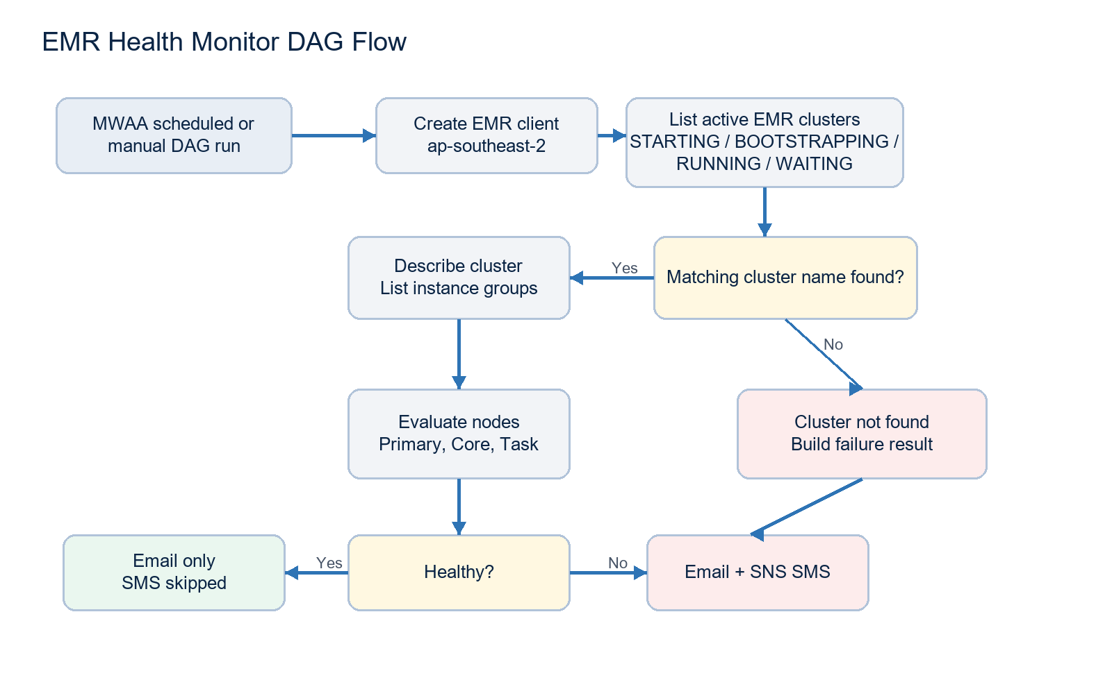
Notification decision
HEALTHY sends email only and logs SMS as skipped. UNHEALTHY and CLUSTER_NOT_FOUND send email and SNS SMS.

5. Notification Design
Scenario | Email | SNS SMS | Subject / Heading Pattern
HEALTHY | Sent | Skipped | EMR <cluster-name> Health Report - Healthy
UNHEALTHY | Sent | Sent | EMR <cluster-name> Health Report - Unhealthy
CLUSTER_NOT_FOUND | Sent | Sent | EMR <cluster-name> Health Report - Cluster Not Found
The email template is table-based with inline styles and solid colors to support both classic Outlook and new Outlook. It includes Cluster Information, Node Capacity where applicable, Health Check Results, quiet Notes for failures, and the standard automated MWAA footer comment.

6. Testing Approach
Testing validates both the health classification logic and the notification behavior visible to support teams. Evidence emails or screenshots should be attached under each scenario after execution.
Test ID | Scenario | Precondition | Expected Result | Evidence Placeholder
TC-01 | Healthy EMR | Matching active cluster exists; Primary is running; Core and Task running counts meet minimum capacity. | DAG succeeds. Email is sent. SNS SMS is skipped and notification summary shows SMS Sent = False. | Attach healthy email evidence here.
TC-02 | Unhealthy EMR | Matching active cluster exists, but Core or Task running count is below configured minimum capacity. | DAG succeeds if at least one notification channel succeeds. Email is sent. SNS SMS is sent. | Attach unhealthy email and/or SMS evidence here.
TC-03 | Cluster Not Found | No active EMR cluster exists with the configured cluster name. | DAG succeeds if at least one notification channel succeeds. Email is sent. SNS SMS is sent. | Attach cluster-not-found email and/or SMS evidence here.

6.1 Evidence Sections

TC-01 Healthy EMR Evidence
Execution Date / Run ID | To be completed
Observed Result | To be completed
Evidence | Attach email screenshot or paste notification evidence here.

TC-02 Unhealthy EMR Evidence
Execution Date / Run ID | To be completed
Observed Result | To be completed
Evidence | Attach email screenshot or paste notification evidence here.

TC-03 Cluster Not Found Evidence
Execution Date / Run ID | To be completed
Observed Result | To be completed
Evidence | Attach email screenshot or paste notification evidence here.

7. Operational Readiness

7.1 Required Configuration
- Set CLUSTER_NAME to the target EMR cluster name.
- Set EMAIL_RECIPIENTS to the operational support distribution list.
- Set SNS_TOPIC_ARN to the SNS topic used for SMS alerting.
- Confirm MWAA email/SMTP configuration is working.
- Confirm the MWAA execution role can call EMR read APIs and SNS publish.

7.2 IAM Permissions
Permission | Purpose
elasticmapreduce:ListClusters | Find active EMR clusters.
elasticmapreduce:DescribeCluster | Read cluster state and identifiers.
elasticmapreduce:ListInstanceGroups | Read node counts and capacity settings.
sns:Publish | Send SMS alert to the configured topic for failure conditions.

7.3 Monitoring and Troubleshooting
- Review the Airflow task logs for the health result and notification summary.
- For healthy runs, confirm SMS Sent is False and the log states SMS notification skipped.
- For failure scenarios, confirm email and SNS publish outcomes are logged.
- If both notification channels fail during an alert scenario, the notification task raises an exception.

8. Sign-Off
Role | Name | Approval | Date
Developer
Platform Owner
Operations / Support
Business Owner

