# CREATE A RESUME

# INTRODUCTION :

# overview

## Our Design a resume using in this canva .

## That was easy to learn a professional designing.

# Purpose

## Our project is creating a resume .

## We Create a resume using in this canva

# 2. Problems Definition&Design Thinking

## 2.1 Empathy map

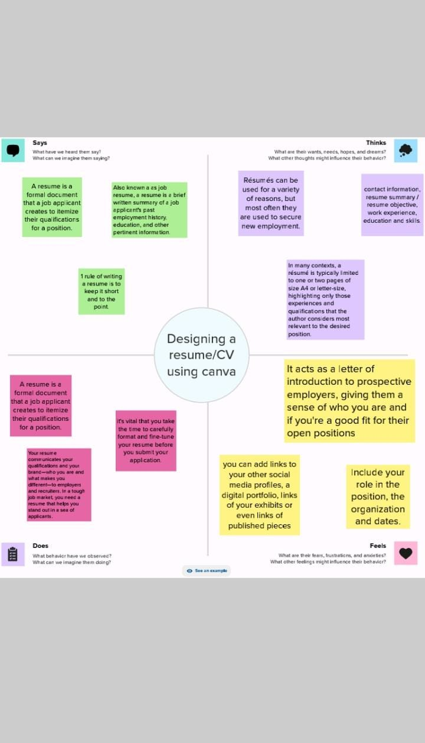

# 2.2 Brain strom and idea prioritization WhatsApp Image 2023-10-13 at 1.24.25 PM.jpeg

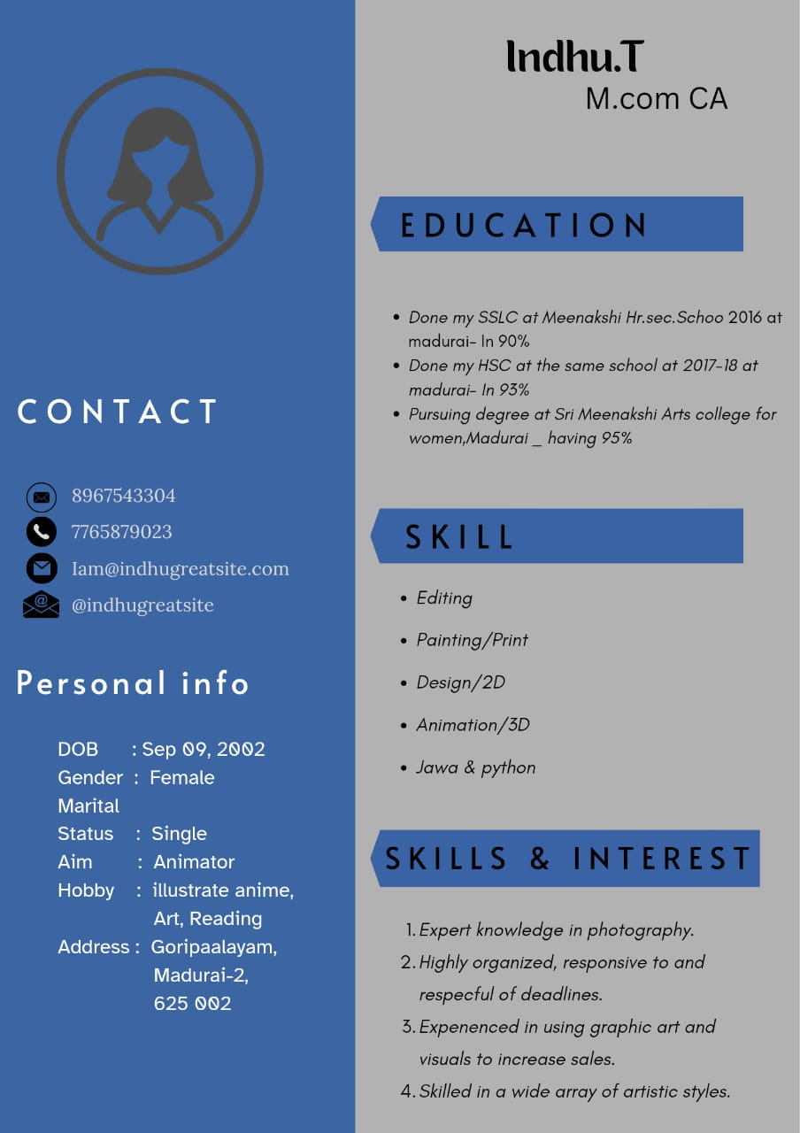

## 4 ADVANDAGES AND DISADVANDAGES

## Easy to using this canva

## Freshers can easy to design anything inthis canva

## In this canva has many templates

## Canva was very useful to everyone

# 5. CONCLUSION

## I easily finish my project resume . canva is the most useful and best app for the freshers . Beacause , that has has many templates that was easy to use .