Claude | ChatGPT | Gemini
Training method | Constitutional AI | Human feedback (RLHF) | Google supervised
Default tone | Analytical, balanced | Conversational, direct | Formal, structured
Response style | Literal, precise | Infers and expands | Over-explains
Fills gaps? | Never | Often | Partially
Best for | Analysis, strategy, writing | General tasks, Q&A | Research, fact-finding

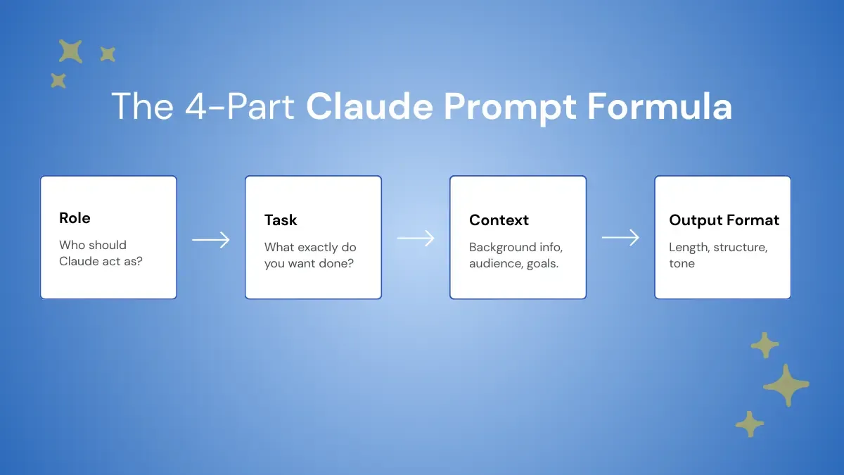

- Role — Who should Claude act as? ("Act as a senior content strategist")
- Task — One specific action per prompt. Not three tasks, not two. One.
- Context — Audience, goal, constraints, and any background information Claude needs
- Output Format — Length, tone, structure, headers or no headers

Model | Tier | Context | Best For | Recommended Setting
Claude Opus 4.8 | Opus | 1M tokens | Complex reasoning, agentic coding, architecture, deep research | High or xhigh effort with adaptive thinking
Claude Sonnet 4.6 | Sonnet | 1M tokens | Writing, analysis, coding, and everyday professional work | Medium effort for a speed and quality balance
Claude Haiku 4.5 | Haiku | 200K tokens | Classification, routing, chat, and short summaries | No effort parameter support
Claude Fable 5 | Frontier | 1M tokens | Long-horizon reasoning and multi-step agentic work | High or max effort with adaptiv
