"2021ல் Won by 70,384
2026ல் அதே தொகுதியில் தோல்வி.
swing: 79,179 votes.
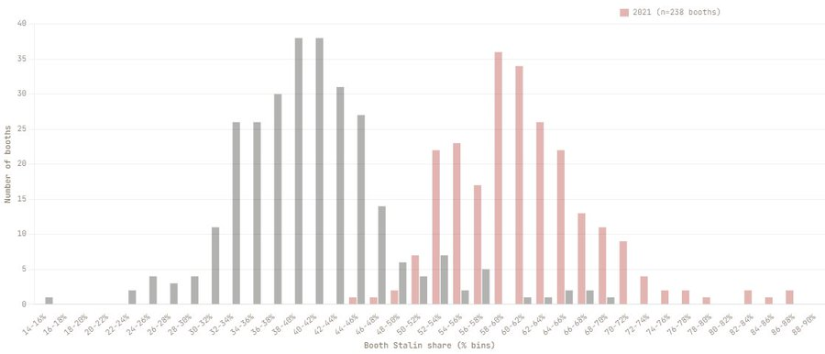

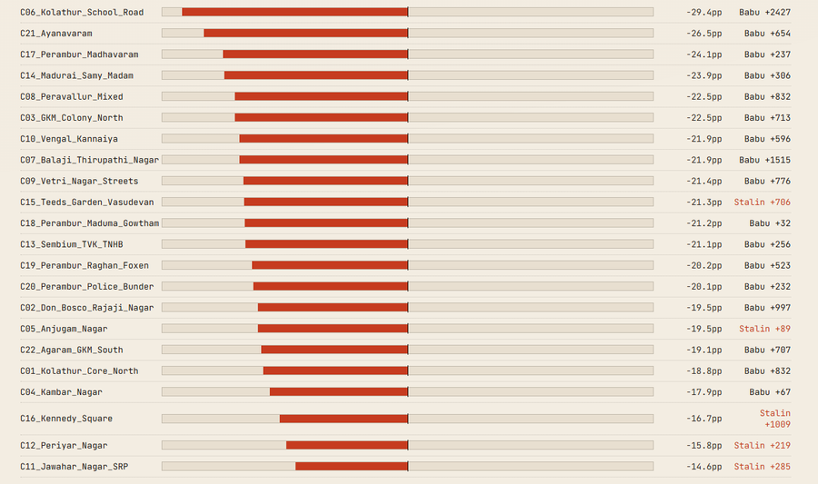
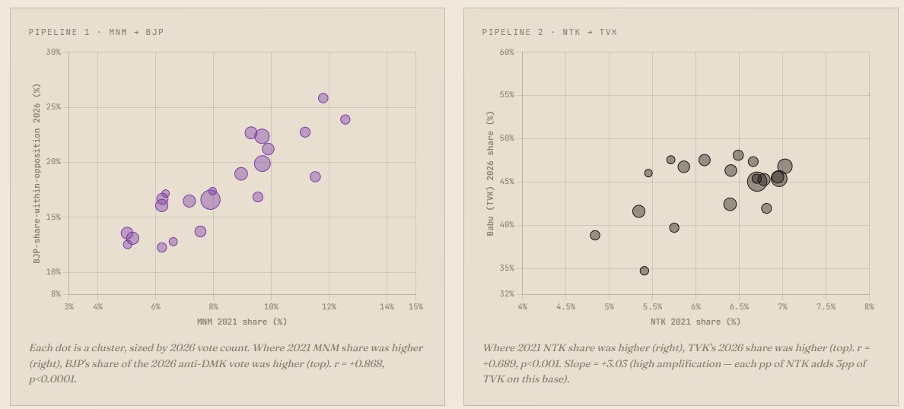

Statistical correlation: r = +0.868
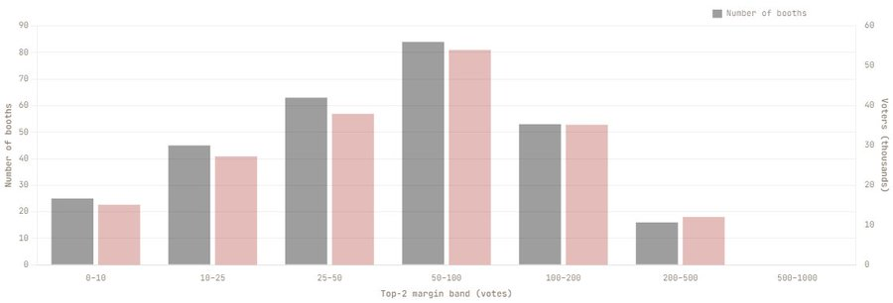
133 booths < 50 vote margin.

Postal ballots: Stalin ~60% EVM votes:
Stalin ~40%
Gap: ~19 percentage points.
Institution-linked voters stayed. Mass electorate shifted.

