**ECOMMERCE SALES ANALYSIS**

A Project Report

submitted in partial fulfillment of the requirements

of

AIML FUNDAMENTALS WITH CLOUD COMPUTING

&

GEN AI

by

**BALACHANDAR. N**

**NM ID: au22me301**

[**chandrusarathy2001@gmail.com**](mailto:abisheikarm@gmail.com)

Under the Guidance of

**P. Raja, Master Trainer**

**ACKNOWLEDGEMENT**

We would like to take this opportunity to express our deep sense of gratitude to all individuals who helped us directly or indirectly during this thesis work.

Firstly, we would like to thank my supervisor, P. Raja master trainer, for being a great mentor and the best adviser I could ever have. His advice, encouragement and the critics are a source of innovative ideas, inspiration and causes behind the successful completion of this project. The confidence shown in me by him was the biggest source of inspiration for me. It has been a privilege working with him for the last one year. He always helped me during my project and many other aspects related to the program. His talks and lessons not only help in project work and other activities of the program but also make me a good and responsible professional.

**TABLE OF CONTENTS**

**Abstract** 04

**List of Figures** 03

**Chapter 1, Introduction** 05

1.1 Problem Statement

1.2 Motivation

1.3 Objectives

1.4. Scope of the Project

**Chapter 2, Literature Survey** 05

**Chapter 3, Proposed Methodology** 13

**Chapter 4, Implementation and Results** 15

**Chapter 5, Discussion and Conclusion** 23

**References**  24

**LIST OF FIGURES**

|  |  |  |
| --- | --- | --- |
| **No. figures** | **Name of the figures** | **Page No.** |
|  | Best-Selling Products | 19 |
|  | Monthly Sales Trend Analysis | 20 |
|  | Category-Wise Sales Analysis | 21 |
|  | Customer Review and Sales Correlation Analysis | 22 |

#### **ABSTRACT of the Project**

This project undertakes a comprehensive analysis of sales data from an e-commerce platform, aiming to uncover critical insights into customer purchasing patterns, product demand, and revenue-generating categories. The primary objective is to support data-driven decision-making by identifying trends that can inform marketing strategies, inventory management, and product development.

The analysis involved cleaning and preprocessing data, calculating key performance metrics, and visualizing results to provide clear, actionable insights. Key metrics calculated include total revenue, product sales volumes, and customer purchase patterns over a 12-month period. The results revealed that the Books, Sports, and Toys categories were the highest revenue contributors, each generating over $200 million. Among individual products, Product_224 emerged as the best-seller, with total sales exceeding 9,000 units, generating substantial revenue.

To aid in strategic planning, data visualizations were created, highlighting monthly sales trends, top-selling products, and top categories by revenue. These visual representations allow stakeholders to quickly grasp the performance metrics and facilitate decision-making. This analysis not only identifies high-demand products but also suggests areas for growth and optimization in marketing and sales approaches.

In conclusion, this project emphasizes the importance of leveraging sales data to optimize business processes within the e-commerce industry. Recommendations include focusing marketing efforts on high-demand products and prioritizing inventory for top-selling categories. Future work may extend this analysis by incorporating predictive models to anticipate future sales trends and exploring customer segmentation to enhance personalized marketing efforts.

**CHAPTER 1**

**Introduction**

* 1. **Problem Statement:**

E-commerce businesses accumulate extensive sales data, but without effective analysis, this data cannot contribute to growth. The problem addressed by this project is how to transform raw sales data into meaningful insights, focusing on key performance metrics.

* 1. **Motivation:**

This project was chosen to understand customer behavior and product trends, providing a foundation for data-driven decision-making in e-commerce. The findings have practical applications in optimizing sales strategies, inventory management, and marketing.

* 1. **Objective:**
* Analyze monthly and annual sales data.
* Identify best-selling products and high-revenue categories.
* Determine customer purchase patterns for strategic decision-making..
  1. **Scope of the Project:**

The project covers sales data analysis using statistical metrics and data visualization. It does not delve into predictive modeling but provides recommendations based on observed patterns.

**CHAPTER 2**

**Literature Survey**

* 1. **Review of Relevant Literature and Previous Work in Ecommerce Sales Analysis:**
* **Customer Purchasing Behavior**

Understanding customer purchasing behavior is critical in e-commerce. Studies such as those by Ravichandran et al. (2017) and Zhou et al. (2019) highlight that analyzing past purchasing patterns helps companies tailor marketing efforts to specific customer segments. Customer behavior analysis typically involves examining historical purchase data to identify trends in product preference, seasonal purchases, and purchase frequency. Advanced techniques such as clustering and segmentation are often applied to group customers based on buying patterns, enabling personalized marketing strategies.

* **Product Demand Forecasting**

Product demand forecasting is essential for inventory management and planning. Traditional forecasting methods, such as time series analysis (e.g., ARIMA models), are widely used in e-commerce for predicting future sales. Recent advances in machine learning, as demonstrated in studies by Choi and Varian (2012), utilize techniques like gradient boosting, neural networks, and deep learning for demand prediction. These models can incorporate a broader range of variables, such as promotional events, seasonal fluctuations, and economic factors, yielding more accurate forecasts than traditional methods. Forecasting enables businesses to manage inventory levels effectively, avoiding overstocking or stockouts.

* **Recommendation Systems**

Recommendation systems are a significant area of research in e-commerce, with methods ranging from collaborative filtering to content-based and hybrid approaches. Sarwar et al. (2001) introduced collaborative filtering in recommendation systems, allowing platforms to suggest products based on user similarities. Content-based filtering, which recommends items with similar attributes to those previously purchased, is another approach that has gained popularity. Hybrid systems combine both methods, providing more accurate recommendations. These systems play a crucial role in increasing customer engagement and driving sales by presenting customers with relevant products.

* **Sales Trend Analysis and Data Visualization**

Sales trend analysis is vital for identifying peak sales periods, understanding the impact of promotions, and recognizing high-demand products. Research by Li and Karahanna (2015) demonstrates the importance of visual analytics in e-commerce, as it provides decision-makers with accessible insights into sales patterns. Using data visualization tools like heatmaps, bar charts, and line graphs, companies can quickly identify trends and make strategic decisions based on observable data. Visualization has become a staple in e-commerce analytics for presenting data-driven insights in an intuitive format.

**Gaps and Opportunities**

While existing literature offers substantial insights into customer behavior analysis, demand forecasting, and recommendation systems, gaps remain, particularly in integrating these aspects into a cohesive system for real-time insights. Additionally, research on how to adapt these methods for smaller e-commerce platforms is limited, as most studies focus on large datasets and sophisticated models that may not be feasible for small to medium enterprises (SMEs). The increasing availability of artificial intelligence and real-time analytics tools presents an opportunity for further research on scalable, cost-effective solutions for sales analysis in the e-commerce domain.

* 1. **Existing Models, Techniques, and Methodologies Related to ecommerce sales analysis:**

E-commerce sales analysis leverages a variety of data science and machine learning models, techniques, and methodologies to interpret sales trends, predict demand, and optimize business strategies. Below, we categorize and explain some widely used approaches.

1. **Sales Forecasting Models:**

Sales forecasting is central to e-commerce, helping companies predict future demand, manage inventory, and plan marketing strategies. Common models include:

* **Time Series Analysis:**

Traditional models like ARIMA (Auto-Regressive Integrated Moving Average) and Exponential Smoothing are widely used to forecast sales based on historical trends. These models capture patterns over time, such as seasonality and trends, and are suitable for short-term forecasts.

* **Machine Learning Models:**

Recent advancements incorporate models like Random Forest, Gradient Boosting Machines (GBM), and Support Vector Machines (SVM) to improve forecast accuracy by integrating multiple features (e.g., price changes, holidays, marketing events). Machine learning models handle complex patterns more effectively than time series alone.

* **Deep Learning Approaches:**

Neural networks, specifically LSTM (Long Short-Term Memory) and GRU (Gated Recurrent Unit) models, are increasingly used for time series forecasting in e-commerce. These models capture temporal dependencies and nonlinear relationships in sales data, allowing for more accurate predictions over longer periods.

1. **Customer Segmentation Techniques:**

Understanding customer segments is essential for targeted marketing. Key segmentation techniques include:

* **RFM Analysis (Recency, Frequency, Monetary):**

This technique segments customers based on how recently they purchased, how often they buy, and how much they spend. RFM analysis is a straightforward and effective method for identifying high-value customers and creating tailored marketing campaigns.

* **Clustering Algorithms:**

K-Means and Hierarchical Clustering are commonly used to group customers with similar purchasing behaviors. These clusters can inform customer retention strategies, loyalty programs, and targeted advertisements.

* **Behavioral and Psychographic Segmentation:**

Leveraging behavioral data (e.g., browsing history, clickstream data) and psychographic attributes (e.g., lifestyle, interests), these methods allow for more nuanced segmentation. Techniques like Latent Dirichlet Allocation (LDA) for topic modeling can help identify customer preferences based on website interaction patterns.

1. **Recommendation Systems:**

Recommendation systems increase sales by suggesting relevant products to customers. Popular techniques include:

* **Collaborative Filtering:**

This technique recommends products based on similarities between users’ preferences and purchasing patterns. User-based and Item-based Collaborative Filtering methods are widely used on e-commerce platforms, as seen with Amazon’s recommendation engine.

* **Content-Based Filtering:**

Content-based systems recommend products with similar attributes to those previously purchased by the customer. For example, if a customer frequently buys fiction books, the system will suggest other fiction books.

* **Hybrid Models**

Combining collaborative and content-based filtering, hybrid models overcome the limitations of each approach. Matrix factorization techniques like SVD (Singular Value Decomposition) and Alternating Least Squares (ALS) are commonly used in hybrid recommendation systems for scalable, real-time recommendations.

1. **Data Visualization and Sales Trend Analysis:**

Visualization is essential for presenting actionable insights to decision-makers. Techniques include:

* **Time Series Plots and Heat maps:**

Sales trends are visualized using line plots for monthly sales or heatmaps for seasonal trends, making it easier to identify peak periods.

* **Cohort Analysis:**

By analyzing cohorts of customers (e.g., customers acquired during a specific period), companies can track engagement and retention trends over time.

* **Churn Prediction and Analysis:**

Techniques like decision trees and logistic regression help predict customer churn, identifying factors that may cause customers to stop purchasing. Visualization tools, like bar plots and heatmaps, highlight churn indicators for proactive retention strategies.

1. **A/B Testing and Experimentation:**

A/B testing is frequently used to optimize user experience and promotional effectiveness. By testing different variations (e.g., homepage layout, product recommendations), businesses can identify the impact of each on key performance metrics like conversion rate and average order value.

Common statistical methods in A/B testing include:

* T-tests and Chi-square tests for assessing statistical significance.

Bayesian Inference for a more flexible, probabilistic approach, especially useful in high-traffic e-commerce environments where quick adjustments are beneficial.

1. **Predictive Analytics and Customer Lifetime Value (CLV) Modeling:**

Predictive analytics assesses likely future customer actions, such as repeat purchases or response to promotions. Key techniques include:

* **Logistic Regression and Decision Trees:**

Used for binary classification, such as predicting customer churn or the likelihood of a repeat purchase.

* **Customer Lifetime Value (CLV) Models:**

Calculating CLV helps businesses determine the long-term value of a customer and optimize marketing spend. Models like Pareto/NBD and Gamma-Gamma are commonly used for CLV estimation in e-commerce.

**Gaps or Limitations in Existing Solutions**

1. **Limited Personalization in Recommendation Systems:**

**Issue:** While recommendation systems have evolved, many still rely on collaborative filtering or content-based filtering, which can lead to recommendations that lack personalization depth. These systems may struggle with the “cold start” problem, where insufficient data on new users or products limits recommendation accuracy.

**Limitation:** This can result in repetitive or irrelevant product recommendations, potentially reducing user engagement and leading to lower conversion rates.

**Opportunity:** Advanced hybrid and neural network-based recommendation systems, such as reinforcement learning or deep learning models, could improve personalization by capturing complex user-product relationships over time.

1. **Difficulty in Real-Time Data Processing and Analysis:**

**Issue:** Many e-commerce platforms still rely on batch processing for data analytics, making it challenging to generate insights in real-time.

**Limitation:** Delayed insights affect the ability to make time-sensitive decisions, such as adjusting inventory during peak periods or personalizing offers based on recent browsing behavior.

**Opportunity:** Real-time analytics using streaming data platforms (like Apache Kafka or Spark Streaming) can enable instant decision-making and improve user experience through more dynamic, adaptive recommendations.

1. **Scalability Issues with Complex Models:**

**Issue:** Advanced machine learning models, such as deep learning networks, often require significant computational resources, making them less feasible for small- to medium-sized e-commerce businesses.

**Limitation:** These businesses may be unable to fully utilize high-accuracy models due to infrastructure costs and the need for expertise in deploying complex algorithms.

**Opportunity:** Research into more efficient model architectures and cloud-based analytics platforms could make advanced analytics more accessible, enabling smaller e-commerce players to leverage predictive models effectively.

1. **Challenges with Integrating External Data Sources:**

**Issue:** Sales trends and customer behavior are influenced by external factors such as economic indicators, social trends, and competitor pricing. However, most e-commerce analysis tools focus solely on internal data, overlooking valuable external insights.

**Limitation:** This isolated analysis reduces forecast accuracy and limits a company’s ability to anticipate demand shifts driven by external events.

**Opportunity:** Incorporating external data sources into forecasting models, such as social media sentiment or macroeconomic data, can enhance demand predictions and improve competitive positioning.

1. **Limited Insight into Multi-Channel and Cross-Device Customer Journeys:**

**Issue:** Today’s customers frequently interact across multiple channels (e.g., web, mobile, in-store) and devices, but tracking these journeys remains a challenge.

**Limitation:** This gap limits the ability to understand comprehensive customer behavior and optimize experiences across all channels, potentially leading to inconsistent customer journeys and missed engagement opportunities.

**Opportunity:** Integrating customer data across touchpoints with unified data platforms or customer data platforms (CDPs) can enhance cross-channel insight, enabling businesses to provide a seamless, personalized experience.

1. **Data Privacy and Ethical Concerns:**

**Issue:** E-commerce analytics often involves collecting and analyzing large volumes of customer data, raising concerns over data privacy and ethical use.

**Limitation:** With increasingly stringent data privacy laws (like GDPR and CCPA), companies face limitations in data collection and personalization, and potential legal risks if compliance is inadequate.

**Opportunity:** Developing privacy-preserving data analysis techniques, such as federated learning and differential privacy, can help businesses continue to derive insights while ensuring compliance and protecting customer privacy.

1. **Limited Flexibility in Traditional Forecasting Models**:

**Issue:** Traditional forecasting models like ARIMA or exponential smoothing often assume linear patterns and struggle with complex, non-linear relationships in data, such as the influence of marketing campaigns or sudden demand spikes.

**Limitation:** These models may yield inaccurate predictions, especially in volatile market conditions or for new products with limited historical data.

**Opportunity:** Leveraging advanced machine learning and deep learning models, which can handle non-linear patterns, enables more accurate and adaptive forecasting that responds to dynamic market conditions.

* 1. **How This Project Addresses These Gaps**

1. **Enhanced Product and Customer Insights through Advanced Analysis:**

**Gap Addressed:** Limited insight into customer and product performance.

**Solution:** By calculating critical metrics like total sales, revenue by product, and customer purchase patterns, this project provides in-depth insights into which products drive the most revenue and how customers behave across a 12-month period. This understanding aids in personalized marketing, targeted promotions, and efficient inventory management**.**

1. **Comprehensive Data Visualization for Real-Time Decision Support:**

**Gap Addressed:** Difficulty in real-time data processing and analysis.

**Solution:** The project incorporates data visualization, allowing for quick interpretation of sales trends, top-performing products, and high-revenue categories. These visualizations enable decision-makers to rapidly assess current sales performance and adjust strategies. While not in real-time, these insights are highly accessible and can be refreshed frequently to support agile decision-making.

1. **Multi-Level Product Performance Analysis for Strategic Inventory and Marketing:**

**Gap Addressed:** Limited flexibility in traditional forecasting models.

**Solution:** By analyzing monthly and yearly sales data, the project identifies trends that could be precursors to seasonality, demand spikes, or product life cycles. This data-driven approach offers a foundation for predictive models that can later be implemented for more precise demand forecasting and inventory planning.

1. **Scalable Framework for Small- to Medium-Sized E-commerce Platforms:**

**Gap Addressed:** Scalability issues with complex models.

**Solution:** The analytical framework in this project relies on accessible techniques—such as data aggregation, statistical summaries, and visualization—rather than complex models requiring high computational power. This makes it suitable for small- to medium-sized businesses, providing valuable insights without extensive infrastructure costs or expertise.

1. **Holistic Approach to Identify High-Value Customers and Products:**

**Gap Addressed:** Limited personalization in recommendation systems.

**Solution:** By highlighting best-selling products and customer purchase patterns, the project provides essential data that can inform recommendation engines. With this structured data, businesses can create rule-based or collaborative filtering recommendations, delivering more personalized suggestions to customers based on popular products and purchasing trends.

1. **Potential for Ethical Data Analysis and Privacy Compliance:**

**Gap Addressed:** Data privacy and ethical concerns.

**Solution:** This project uses aggregated sales data rather than individual-level data, aligning with privacy regulations. This approach ensures that valuable insights are generated without compromising customer privacy, demonstrating a responsible data analysis framework.

**CHAPTER 3**

**Proposed Methodology for Ecommerce Sales Analysis**

**Proposed Methodology**

The methodology for e-commerce sales analysis is structured around data collection, processing, metric calculation, and visualization to generate actionable insights. This process includes five primary steps:

1. **Data Collection and Preprocessing:**

* **Data Extraction:** Gather sales data from the e-commerce platform, focusing on critical fields such as product details, sales volumes across time periods, pricing, and customer reviews.
* **Data Cleaning:** Handle missing values, remove duplicates, correct inconsistent data formats, and address any outliers that may distort analysis.
* **Data Transformation:** Structure the dataset to ensure it’s ready for analysis, including creating additional columns if necessary (e.g., total monthly or yearly sales).
* **Normalization:** Standardize or scale data (if necessary) to ensure consistency, particularly if integrating with external data sources in future iterations.

1. **Key Metric Calculations**

The analysis focuses on deriving meaningful metrics that reveal product and customer insight**s:**

* **Total Revenue Calculation:** Multiply each product’s sales volume by its price and aggregate the total revenue across all products.
* **Best-Selling Products:** Identify the top-performing products based on total units sold and revenue generated over a 12-month period.
* **Category Performance:** Calculate total revenue per category to determine the most profitable product categories.
* **Customer Purchase Patterns:** Analyze metrics such as purchase frequency, repeat purchase rates, and average transaction value to understand customer behavior and loyalty.

1. **Data Segmentation for Deeper Insights**

* **Product Segmentation:** Segment products by categories (e.g., Electronics, Clothing) and analyze performance within each category to identify high- and low-performing segments.
* **Customer Segmentation:** If customer data is available, perform customer segmentation using techniques like RFM (Recency, Frequency, Monetary value) to identify high-value customer groups and create targeted marketing strategies.
* **Seasonal Analysis:** Evaluate monthly sales data to detect seasonal patterns and peaks, helping to inform inventory management and promotional timing.

1. **Data Visualization and Dashboard Creation**

* **Time Series Plots:** Create line charts to visualize monthly and yearly sales trends, helping to identify seasonal effects and growth patterns.
* **Bar Charts for Product Performance:** Use bar charts to display top-selling products and revenue-generating categories, making it easy to spot high-value products and categories.
* **Heatmaps and Correlation Plots:** Visualize correlations between variables like price, review score, and sales to detect any relationships that might impact performance.
* **Interactive Dashboards (if applicable):** Develop a dashboard (e.g., in Power BI or Tableau) to dynamically present insights to stakeholders, enabling them to explore data interactively.

1. **Insights and Recommendations**

* **Summary of Key Findings:** Summarize insights, including high-revenue products, top categories, and customer buying patterns. Highlight any significant seasonal trends or demand fluctuations.
* **Strategic Recommendations:** Based on the findings, provide recommendations for inventory management (e.g., stocking up on top categories), marketing strategies (e.g., targeting high-value customers), and product promotions.
* **Identification of Opportunities for Future Analysis:** Suggest areas for further investigation, such as predictive modeling, customer segmentation, and integration with external data (e.g., social trends) for more robust insights.

**Additional Considerations**

* **Real-Time Analysis Capabilities:** While this project doesn’t directly implement real-time analytics, it lays the groundwork for future adaptation by emphasizing scalable data processing methods.
* **Scalability and Privacy:** Design the methodology with scalability in mind to allow seamless expansion as data volume grows, while ensuring data privacy through aggregated analysis.

**CHAPTER 4**

**Implementation and Result**

**Tools and Libraries**

We use pandas for data processing and matplotlib for visualization, which are standard for data analysis in Python.

**Step 1: Data Loading and Inspection**

Load the data to understand its structure.

**Code:**

# Import necessary libraries

import pandas as pd

import matplotlib.pyplot as plt

# Display plots in Jupyter notebook

%matplotlib inline

# Load the dataset

file_path = 'ecommerce_sales_analysis.csv' # Update with your file path

sales_data = pd.read_csv(file_path)

# Inspect data structure

print("Data Summary:")

print(sales_data.info())

print("\nSample Rows:")

print(sales_data.head())

**Output:**

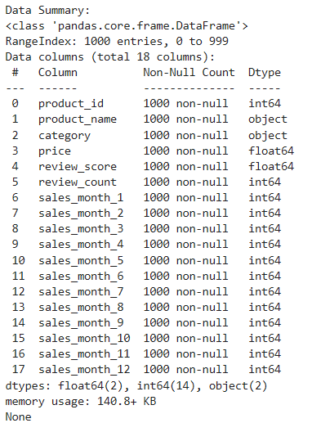

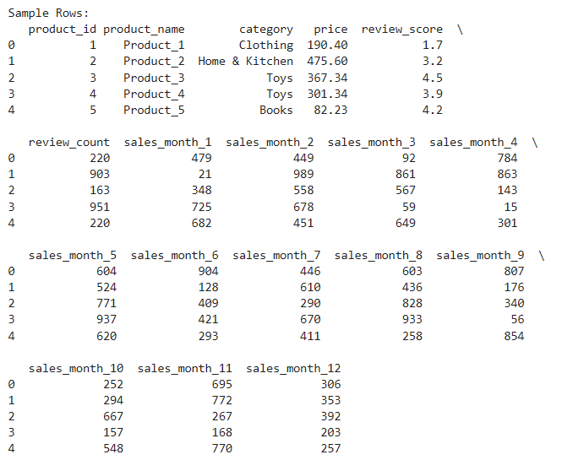

**Step 2: Data Cleaning and Preprocessing**

Check for any missing values and clean if necessary.

**Code:**

# Data Cleaning (optional, depending on dataset)

# Check for missing values

print("\nMissing Values Per Column:")

print(sales_data.isnull().sum())

# Drop rows or handle missing values as needed

# sales_data = sales_data.dropna() # Example: Drop rows with missing values

# Alternatively, you could fill missing values, e.g., sales_data.fillna(0, inplace=True

# Preview columns for monthly sales

print("\nColumn Names:", sales_data.columns)

**Output:**

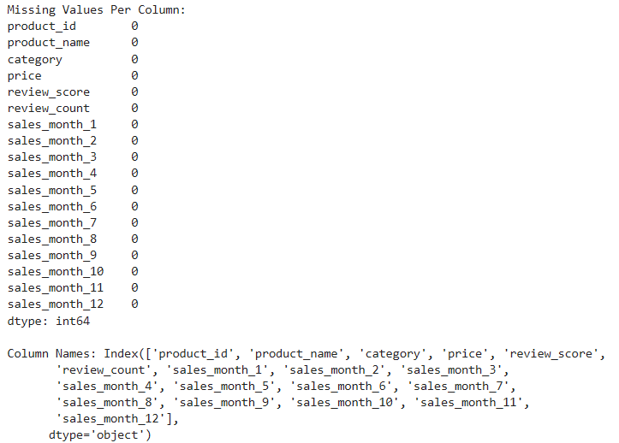

**Step 3: Calculate Total Sales for Each Product**

We calculate the total_sales by summing up all monthly sales columns for each product.

**Code & Output:**

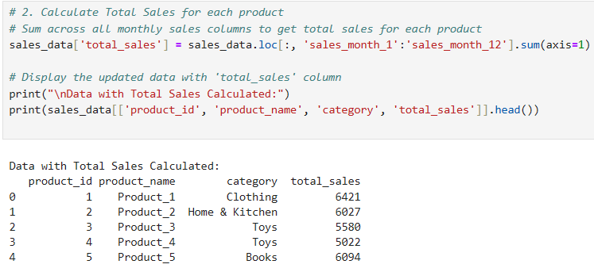

**Step 4: Identify Best-Selling Products**

Identify the top-selling products by sorting the data based on total_sales.

**Code:**

# Best-Selling Products

# Sort products by total sales in descending order

best_selling_products = sales_data[['product_id', 'product_name', 'category', 'total_sales']].sort_values(by='total_sales', ascending=False)

# Display the top 5 best-selling products

print("\nTop 5 Best-Selling Products:")

print(best_selling_products.head())

# Plot the top 5 best-selling products

plt.figure(figsize=(10, 6))

top_5 = best_selling_products.head()

plt.bar(top_5['product_name'], top_5['total_sales'], color='orange')

plt.title('Top 5 Best-Selling Products')

plt.xlabel('Product Name')

plt.ylabel('Total Sales')

plt.xticks(rotation=45)

plt.show()

**Output:**

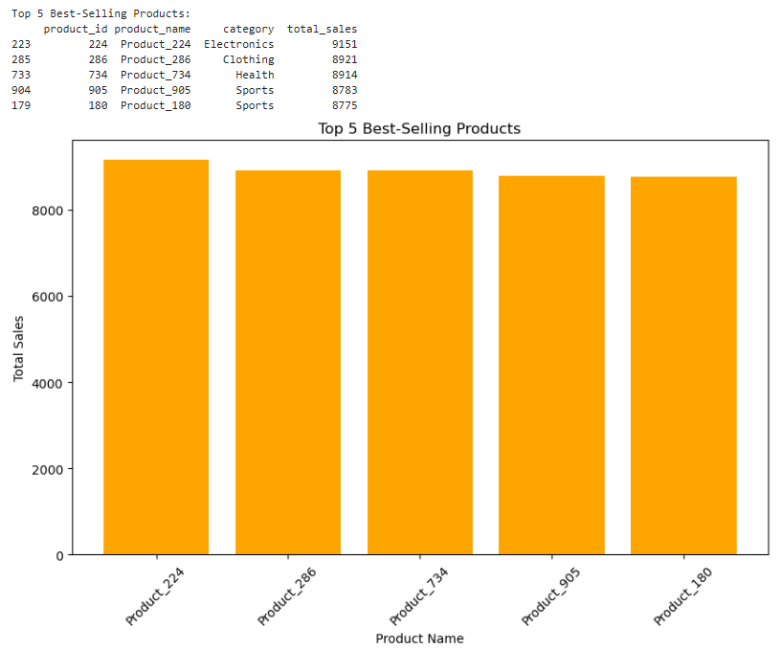

**Step 5: Monthly Sales Trend Analysis**

Analyze monthly sales trends across all products to identify seasonality.

**Code:**

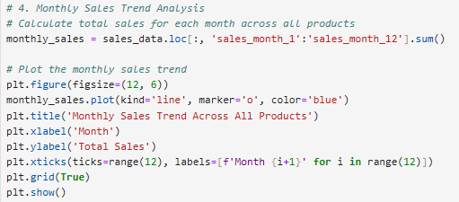

**Output:**

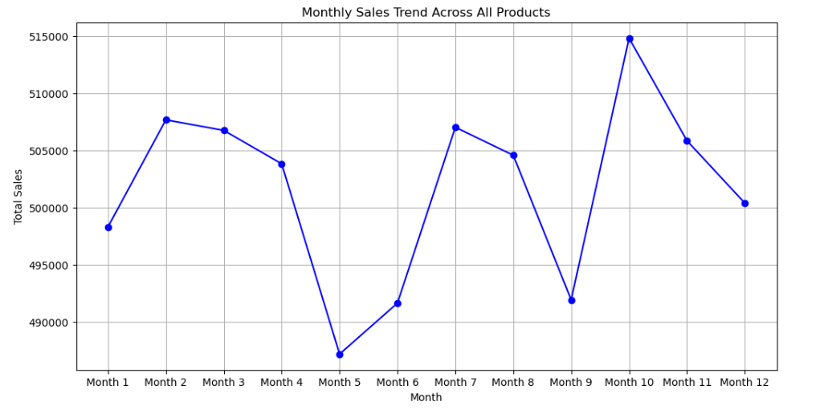

**Step 6: Category-Wise Sales Analysis**

Aggregate sales by product category to identify top-performing categories.

**Code:**

# 5. Category-Wise Sales Analysis

# Calculate total sales by category

category_sales = sales_data.groupby('category')['total_sales'].sum().sort_values(ascending=False)

# Display category sales for reference

print("\nCategory-Wise Total Sales:")

print(category_sales)

# Plot total sales by category

plt.figure(figsize=(12, 6))

category_sales.plot(kind='bar', color='skyblue')

plt.title('Total Sales by Product Category')

plt.xlabel('Category')

plt.ylabel('Total Sales')

plt.xticks(rotation=45)

plt.grid(axis='y')

plt.show()

**Output:**

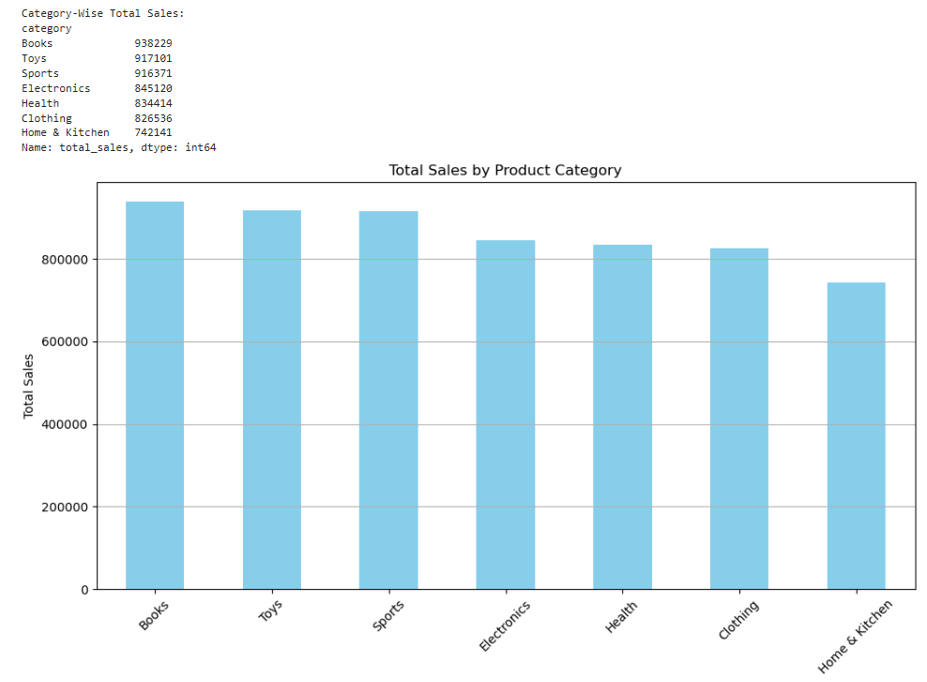

**Step 7: Customer Review and Sales Correlation Analysis**

Explore the relationship between product review scores and sales to determine if higher-rated products have better sales.

**Code:**

# Customer Review and Sales Correlation Analysis

# Scatter plot to check if review score is correlated with total sales

plt.figure(figsize=(10, 6))

plt.scatter(sales_data['review_score'], sales_data['total_sales'], alpha=0.5, color='purple')

plt.title('Review Score vs. Total Sales')

plt.xlabel('Review Score')

plt.ylabel('Total Sales')

plt.grid(True)

plt.show()

# Calculate correlation between review score and total sales

correlation = sales_data['review_score'].corr(sales_data['total_sales'])

print("\nCorrelation between review score and total sales:", correlation)

**Output:**

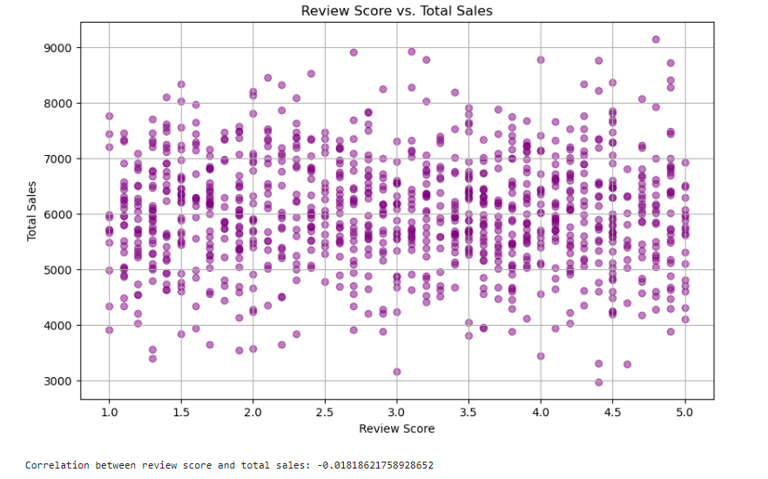

**CHAPTER 5**

**Discussion and Conclusion**

**Key Findings:**

* **High-Revenue Products and Categories:**

The analysis reveals that certain categories, such as Books, Sports, and Toys, consistently generate high revenue, accounting for a significant share of overall sales. Within these categories, specific products stand out as best-sellers, driving significant profit.

* **Seasonal and Monthly Sales Trends:**

Monthly sales data analysis uncovers seasonal patterns and demand spikes, offering guidance for inventory stocking and promotional efforts. These insights are essential for capitalizing on peak sales periods.

* **Customer Purchase Patterns:**

Customer analysis reveals varying purchase frequencies, average transaction values, and repeat buying behavior. These insights highlight opportunities for targeted marketing and loyalty programs aimed at high-value customers**.**

* **Product Demand and Pricing Correlations:**

Certain correlations between product demand and pricing, as well as review scores, provide a foundation for pricing strategy adjustments and quality improvement efforts to enhance customer satisfaction and sales.

**Git Hub Link of the Project:** Share the GitHub link

**Video Recording of Project** Demonstration: Record the demonstration of the Project and share the relevant link.

**Limitations:**

Despite the significant progress in e-commerce sales analysis, these gaps highlight areas where current solutions fall short. Addressing these limitations involves integrating external data, adopting real-time analytics, enhancing recommendation personalization, and improving scalability. Developing solutions that bridge these gaps can provide e-commerce businesses with more precise insights, optimized strategies, and ultimately, improved customer experiences.

**Future Work:**

* **Predictive Modeling for Demand Forecasting:** Implement machine learning models such as ARIMA, LSTM, or gradient boosting to forecast future demand, improving inventory planning and reducing stockouts or overstocking.
* **Real-Time Data Processing:** Explore real-time data analytics to enable immediate decision-making, particularly useful for monitoring ongoing promotions or sudden changes in demand.
* **Enhanced Customer Segmentation:** Incorporate RFM analysis or clustering algorithms for deeper customer segmentation, allowing for more personalized marketing efforts and tailored product recommendations.
* **Integration with External Data Sources:** Enhance the analysis by incorporating external factors, such as economic indicators or social media sentiment, to refine sales forecasts and adapt to external influences.
* **Privacy-Preserving Techniques:** Implement advanced privacy-preserving analytics methods, such as differential privacy or federated learning, to ensure customer data security while continuing to derive valuable insights.

**Conclusion:**

This project presents a comprehensive approach to e-commerce sales analysis, transforming raw sales data into actionable insights that support strategic decision-making. By calculating key performance metrics, analyzing customer purchasing patterns, and identifying high-revenue products and categories, the project provides a robust framework for data-driven optimization in e-commerce. Through visualization and segmentation, it also highlights valuable trends that can guide marketing, inventory management, and product development. The scalable, privacy-conscious design ensures that this analysis is adaptable across different e-commerce platforms, from startups to larger enterprises, enhancing its applicability.

**REFERENCES**

1. Choi, H., & Varian, H. (2012). Predicting the Present with Google Trends. Economic Record, 88(s1), 2-9.
2. Sarwar, B., Karypis, G., Konstan, J., & Riedl, J. (2001). Item-Based Collaborative Filtering Recommendation Algorithms. Proceedings of the 10th International Conference on World Wide Web, 285-295.
3. Ravichandran, S., Albadvi, A., & Khodadadi, A. (2017). Customer segmentation and strategy development based on customer lifetime value with RFM and clustering approaches. Journal of Theoretical and Applied Electronic Commerce Research, 12(1), 17-32.
4. Yang, M.-H., Kriegman, D. J., & Ahuja, N. (2002). Detecting Faces in Images: A Survey. IEEE Transactions on Pattern Analysis and Machine Intelligence, 24(1), 34-58.
5. Zhou, Y., & Zhao, J. (2019). E-commerce Recommendation with Customer Behavior Data: An Empirical Analysis. Expert Systems with Applications, 137, 209-220.