The explanation below describes the step-by-step procedure of the project.

Step 1: Before a user takes a turn 'Button1' is pressed to get the reference image of the snooker table. This happens before a foul has taken place. The reference image we obtained for the test case is given below.

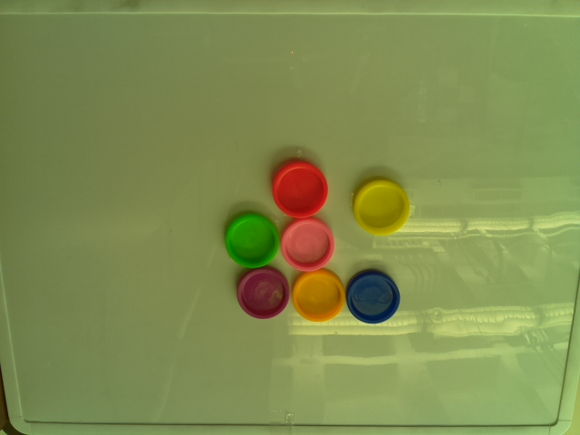

Step 2: Once a foul occurs, we take the reference image and try to put the balls back to their respective places. Once that is done, we press the ‘Button2’ to compare if the balls were put back exactly to where they were previously present.

Outcome:

1. If the balls are not exactly present in their respective places as shown by the picture below the ’Red’ LED lights up indicating that the balls need to be moved and play can’t continue.

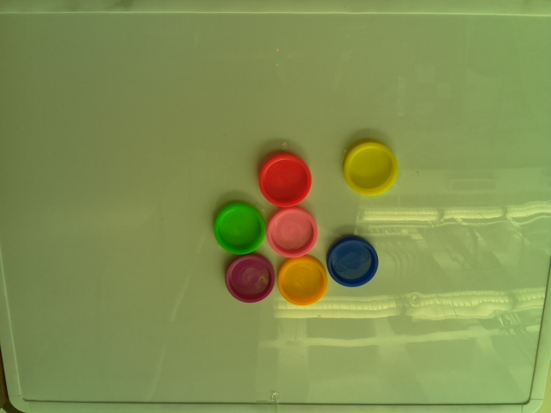

As we can see, the blue and the yellow balls are not exactly in their spots, hence we get the below output:

“Comparing...

The number of different pixels is 7902

The balls are not in the right place”

1. If the balls are exactly present in their respective places as shown by the picture below the ’Green’ LED lights up indicating that play can continue.

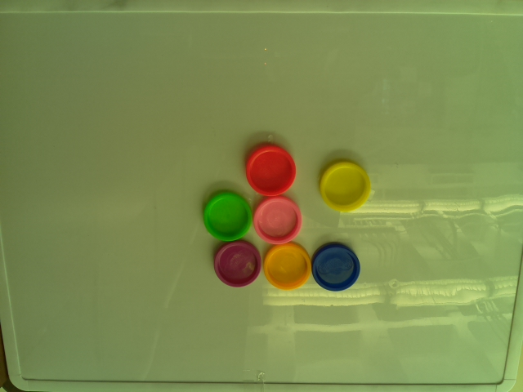

As we can see, the blue and the yellow balls are placed very close to where they were before the foul, hence we get the below output:

“Comparing...

The number of different pixels is 1214

The balls are back in the right place”