**INNOVATION FOR WEBSITE TRAFFIC ANALYSIS**

TEAM MEMBER

**B.BALADHINESH**

Phase 2 Submission Document

**Project Title:** Website Traffic Analysis



**Introduction:**

In the digital age, where websites have become the primary source of information and business transactions, understanding and analyzing website traffic have become crucial. Website traffic analysis is the process of evaluating the behavior of visitors to a website, the pages they interact with, and the actions they take.

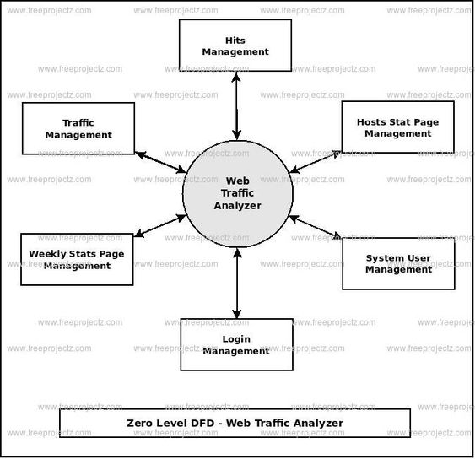

**HITS MANAGEMENT:**

Managing hits in website traffic analysis refers to the process of monitoring, tracking, and analyzing the interactions and requests made to a website. Hits can encompass a wide range of data, such as page views, images, scripts, style sheets, and more. Managing hits is crucial for understanding website performance, user behavior, and making informed decisions for optimizing your website. Here's how you can manage hits in a website traffic analyze.

1. Data Collection : To manage hits, you need a robust web analytics tool. There are various analytics platforms available, such as Google Analytics, Adobe Analytics, and many others. These tools collect data on every interaction or request made to your website.
2. Differentiate Hits : Understand the various types of hits. Some common hit types include:

Page Views : When a user loads a web page.

Events : User interactions like clicks, form submissions, and video views.

Downloads : Tracking files downloaded from your website.

Outbound Links : Monitoring when users click on links leading away from your site.

Images and Assets : Tracking requests for images, stylesheets, and scripts.

1. Real-time Monitoring : Some analytics tools provide real-time tracking, allowing you to see hits as they happen. This can be useful for monitoring sudden spikes in traffic or identifying issues in real-time.

**HOSTS STATE PAGE MANAGEMENT :**

It seems like you're interested in managing the state of hostnames, IP addresses, or domain name mappings in a "hosts" file on a computer. The "hosts" file is a simple text file used to map hostnames to IP addresses and is commonly used to override DNS (Domain Name System) resolutions for specific domains. Below, I'll explain how to manage the hosts file state on various operating systems.

MacOS and Linux:

Editing the Hosts File : On macOS and Linux, the hosts file is usually located at `/etc/hosts`. You'll need root or superuser privileges to edit it.

Add/Modify Entries : Open the hosts file with a text editor, such as nano or vim, and add entries in the same format as shown above for Windows.

Save Changes : After editing, save the file.

**SYSTEM USER MANAGEMENT :**

User management refers to the process of controlling, tracking, and maintaining user accounts and their permissions within a computer system or an organization. This is an essential aspect of information security, access control, and ensuring that individuals have the right level of access to resources and data. User management typically includes tasks such as creating, modifying, and deleting user accounts, assigning or revoking privileges, and monitoring user activities for security and compliance purposes.

Here are some key aspects of user management:

1. User Account Creation
2. User Authentication
3. User Authorization
4. User Profile Management
5. User Access Control
6. User Deactivation/Deletion
7. Password Management

**LOGIN MANAGEMENT :**

Implementing login management for a website traffic analyzer is an important aspect of ensuring that only authorized users can access and utilize the tool. Here's a general outline of how you can set up login management for your website traffic analyzer:

1.User Authentication

2.User Registration

3.User Database

4.Session Management ….etc

**WEEKLY STATUS PAGE MANAGEMENT :**

Managing a weekly status page for a website traffic analysis tool is crucial for keeping stakeholders informed about the performance and trends of the website. Here's how you can effectively manage a weekly status page.

**TRAFFIC MANAGEMENT :**

Traffic management in website traffic analysis refers to the strategies and techniques used to monitor, control, and optimize the flow of traffic to a website. Effective traffic management is essential for ensuring the performance, availability, and security of your website. Here are key aspects to consider.