CUSTOMER SHOPPING BEHAVIOR
ANALYSIS REPORT

End-to-End Analytics Pipeline: Python → MySQL (SQLAlchemy) → SQL → Power BI

1. Executive Summary
This report summarizes an end-to-end customer shopping behavior analysis project built on a retail transaction dataset of 3,900 customers across 19 attributes (demographics, purchase details, discounts, subscriptions, shipping, and reviews). The project followed a three-stage pipeline: data cleaning and feature engineering in Python (pandas), relational analysis using SQL on a MySQL database (loaded via SQLAlchemy), and interactive dashboard development in Power BI.

Across the dataset, customers generated a total revenue of $233,081, with male customers contributing roughly twice the revenue of female customers. Only 27% of customers are active subscribers, discount usage is concentrated in a handful of product categories, and “Loyal” customers (more than 10 previous purchases) make up the vast majority (80%) of the customer base. These findings are detailed question-by-question in Section 4, and visualized in the accompanying Power BI dashboard.

2. Project Methodology
The analysis was carried out in three connected stages, moving raw transactional data through cleaning, structured querying, and finally visual reporting:

2.1 Data Preparation (Python / pandas)
- Loaded the raw CSV (customer_shopping_behavior.csv) into a pandas DataFrame and profiled it with .info() and .describe() to check data types and distributions.
- Identified missing values in the Review Rating column and imputed them using the median rating within each product Category, preserving category-level rating patterns.
- Standardized column names to snake_case (e.g. “Purchase Amount (USD)” → purchase_amount) for consistency and easier SQL/BI referencing.
- Engineered an age_group feature by splitting Age into four equal-sized quantile bins: Young Adult, Adult, Middle-aged, and Senior.
- Engineered a purchase_frequency_days feature by mapping the categorical Frequency of Purchases field (Weekly, Fortnightly, Monthly, etc.) to a numeric day count.
- Verified that Discount Applied and Promo Code Used were identical across all rows, and dropped the redundant promo_code_used column.

2.2 Structured Analysis (MySQL via SQLAlchemy)
- Connected Python to a local MySQL instance using SQLAlchemy's create_engine with the pymysql driver.
- Wrote the cleaned DataFrame to a customer table inside the customer_behaviour database using df.to_sql().
- Authored 10 analytical SQL queries directly against the customer table — covering revenue splits, discount behavior, product rankings, shipping comparisons, subscription impact, customer segmentation, and age-group contribution — using GROUP BY, subqueries, CASE expressions, and window functions (ROW_NUMBER).

2.3 Dashboard Development (Power BI)
- Connected Power BI (customer_shoppping.pbix) to the cleaned dataset to build an interactive dashboard for stakeholder consumption.
- The dashboard translates the SQL findings below into visual, filterable views — enabling drill-down by gender, category, age group, and subscription status.

3. Dataset Overview
The cleaned dataset contains 3,900 customer transaction records with the following key attributes:
Attribute | Detail
Total records | 3,900 customers
Total revenue | $233,081
Average purchase amount | $59.76
Product categories | Clothing, Footwear, Outerwear, Accessories
Locations | 50 U.S. states
Payment methods | Credit Card, Debit Card, PayPal, Venmo, Cash, Bank Transfer
Subscribed customers | 1,053 (27.0%)

4. Key Findings by Business Question
Each question below was answered using SQL against the MySQL customer table (see customer_shopping_behavior.sql for full query text). Results are presented with the underlying figures and a plain-language insight.

Q1. Total revenue generated by male vs. female customers
Gender | Revenue
Male | $157,890
Female | $75,191
Insight: Male customers generated roughly 2.1x the revenue of female customers ($157,890 vs. $75,191), despite the dataset skewing toward male shoppers overall — this is a strong candidate for gender-targeted marketing analysis.

Q2. Customers who used a discount but still spent above the average
Metric | Value
Customers matching criteria | 839
Overall average purchase amount | $59.76
Insight: 839 customers (about 21% of the base) used a discount yet still spent above the $59.76 average — indicating discounts are not purely driving down-market behavior; a meaningful segment discounts opportunistically while still spending generously.

Q3. Top 5 products by average review rating
Rank | Product | Avg. Rating
1 | Gloves | 3.86
2 | Sandals | 3.84
3 | Boots | 3.82
4 | Hat | 3.80
5 | Handbag | 3.78
Insight: Accessories and footwear items dominate the top-rated products, with Gloves rated highest (3.86/5). Ratings across the top 5 are tightly clustered, suggesting consistently high satisfaction rather than one standout product.

Q4. Average purchase amount: Standard vs. Express shipping
Shipping Type | Avg. Purchase Amount
Express | $60.48
Standard | $58.46
Insight: Express shipping customers spend slightly more on average ($60.48 vs. $58.46), a modest but consistent signal that customers willing to pay for faster delivery also purchase higher-value items.

Q5. Do subscribed customers spend more than non-subscribers?
Subscription | Customers | Avg. Spend | Total Revenue
No | 2,847 | $59.87 | $170,436
Yes | 1,053 | $59.49 | $62,645
Insight: Subscribers do not spend more per transaction — average spend is nearly identical ($59.49 vs. $59.87). Subscription revenue share (27%) roughly matches subscriber headcount share, meaning the subscription program is not currently a driver of higher basket size and may need a value-add redesign.

Q6. Top 5 products by discount usage rate
Rank | Product | Discount Rate
1 | Hat | 50.0%
2 | Sneakers | 49.7%
3 | Coat | 49.1%
4 | Sweater | 48.2%
5 | Pants | 47.4%
Insight: Roughly half of all Hat and Sneakers purchases involve a discount— these products may be used as promotional traffic-drivers, or may be more price-sensitive categories worth monitoring for margin impact.

Q7. Customer segmentation by purchase history (New / Returning / Loyal)
Segment | Definition | Customers
New | 1 previous purchase | 83 (2.1%)
Returning | 2–10 previous purchases | 701 (18.0%)
Loyal | 11+ previous purchases | 3,116 (79.9%)
Insight: The customer base is overwhelmingly Loyal (nearly 80%), indicating strong repeat-purchase behaviour and low reliance on brand-new acquisition — but it also signals the New-customer funnel may be underperforming and worth investing in.

Q8. Top 3 most purchased products within each category
Category | #1 | #2 | #3
Accessories | Jewelry (171) | Belt (161) | Sunglasses (161)
Clothing | Blouse (171) | Pants (171) | Shirt (169)
Footwear | Sandals (160) | Shoes (150) | Sneakers (145)
Outerwear | Jacket (163) | Coat (161) | —
Insight: Order volumes are remarkably even within each category (differences of just a few units between rank 1 and rank 3), meaning no single item dominates — category-level, not item-level, merchandising strategy is likely to have more impact.

Q9. Are repeat buyers (5+ previous purchases) more likely to subscribe?
Subscription | Repeat Buyers
No | 2,518
Yes | 958
Insight: Even among loyal repeat buyers, non-subscribers outnumber subscribers by roughly 2.6 to 1. Purchase loyalty is not translating into subscription sign-ups, reinforcing the Q5 finding that the subscription program needs stronger incentives.

Q10. Revenue contribution by age group
Age Group | Revenue
Young Adult | $62,143
Middle-aged | $59,197
Adult | $55,978
Senior | $55,763
Insight: Revenue is fairly evenly distributed across age quartiles ($55.8K–$62.1K each), with Young Adults contributing marginally the most. This suggests the customer base is not concentrated in a single life-stage segment, supporting broad rather than age-niche marketing.

5. Power BI Dashboard
The SQL findings above were operationalized into an interactive Power BI dashboard (customer_shoppping.pbix), allowing stakeholders to explore the data without writing queries. The dashboard includes:
- Revenue KPIs by gender, category, and age group, with slicers for dynamic filtering.
- Discount and promotion analysis, highlighting the highest discount-rate products identified in Q6.
- A customer segmentation view (New / Returning / Loyal) matching the SQL logic in Q7.
- Subscription vs. non-subscription comparison panels reflecting the Q5 and Q9 findings.As a .pbix file, the dashboard is best explored directly in Power BI Desktop for full interactivity (cross-filtering, drill-through, and tooltips are not visible in a static report format).

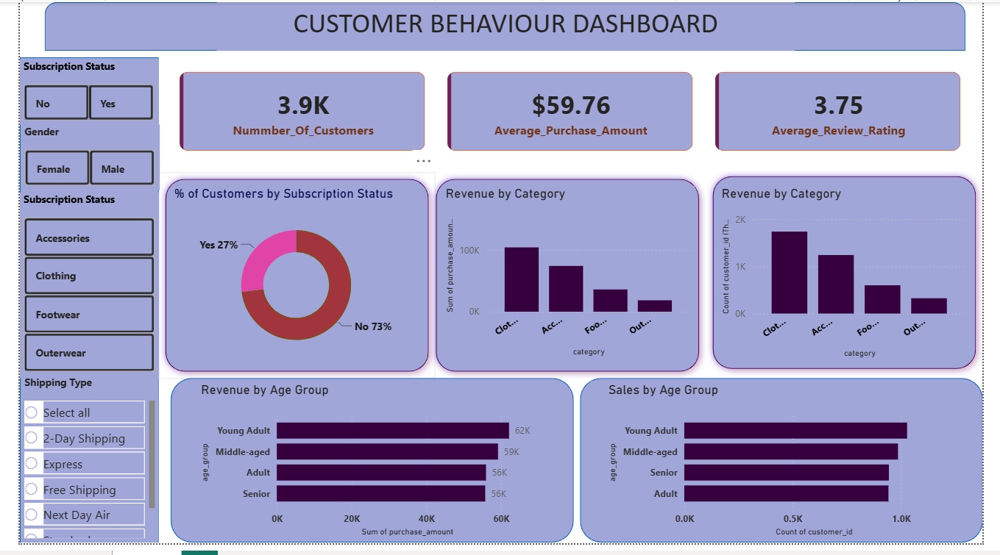

6. Conclusions & Recommendations
- Gender-focused revenue gap: Male customers drive ~68% of revenue — worth investigating whether this reflects product mix, marketing skew, or genuine demand differences before optimizing further toward this segment.
- Subscription program is underperforming: Subscribers spend the same as non-subscribers and repeat buyers rarely subscribe — consider redesigning subscription perks (e.g., free express shipping, early access) to convert the large Loyal segment.
- Discount strategy is concentrated: Hats, Sneakers, Coats, Sweaters, and Pants see discount rates near 50% — review whether these are intentional loss-leaders or margin-eroding habits.
- Retention is a strength, acquisition may be a gap: With ~80% of customers classified Loyal and only 2% New, the funnel may benefit from renewed top-of-funnel investment even as retention remains healthy.
- Category-level, not item-level, focus: Purchase volumes are evenly spread within categories, so merchandising and inventory decisions are likely better made at the category level.

