**5.One2Many_Many2Many**

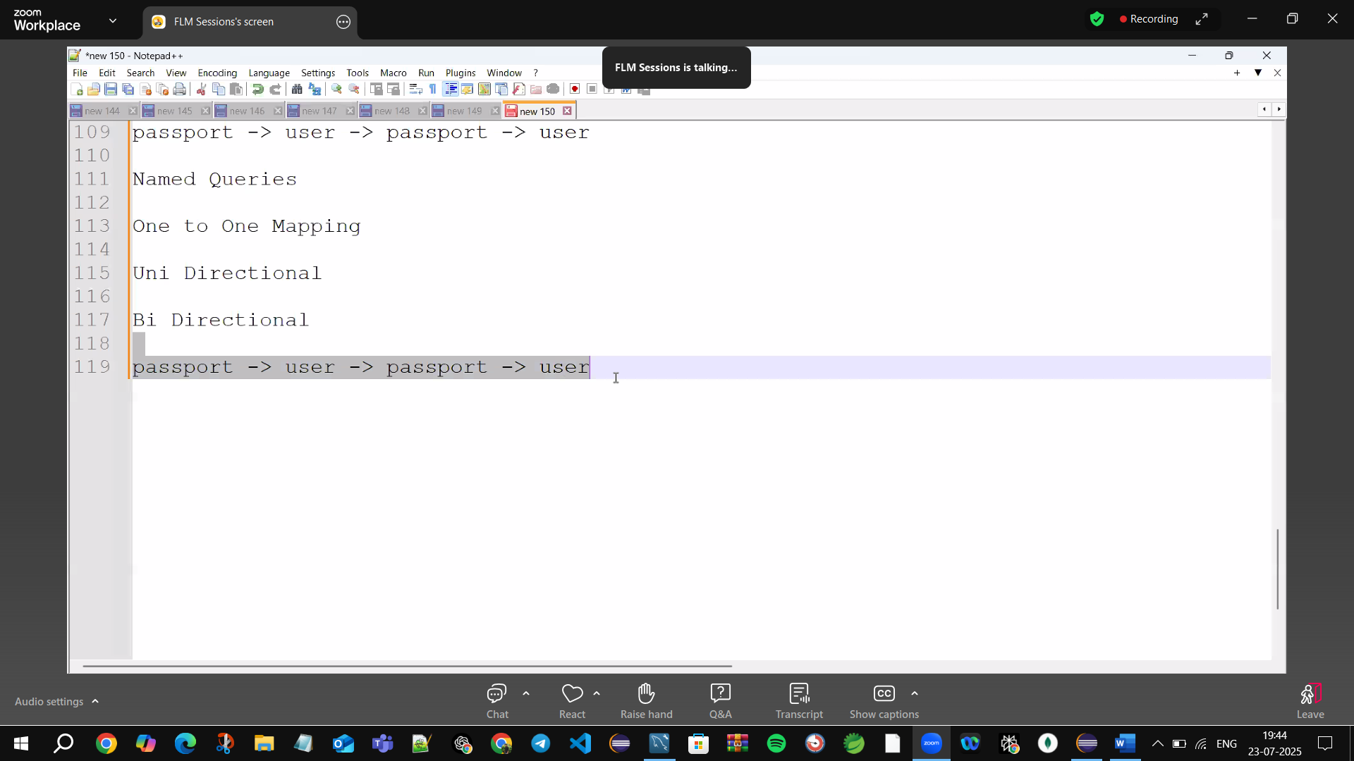

Passport->user->passport->user🡪going into infinite loop(Stack overflow)

joinColumn(name=”pass_num”)🡪User(users table need passport number)

To tell relation b/w passport& User 🡪we put🡪mappedBy=”passport”,cascadeType.All in Passport table

mappedBy=”passport”,🡪give User class Passport object name”passport”(assign to mappedBy)

@GeneratedValue(strategy=GenerationType.IDENTITY)🡪Autogenerated Id (Binds autoincrement values by SQL to Java)

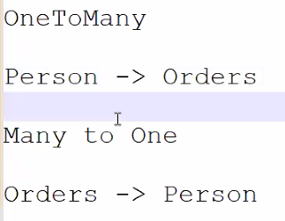

1.OneTo Many🡪Person🡪Orders

2.Many to One🡪Orders🡪Person

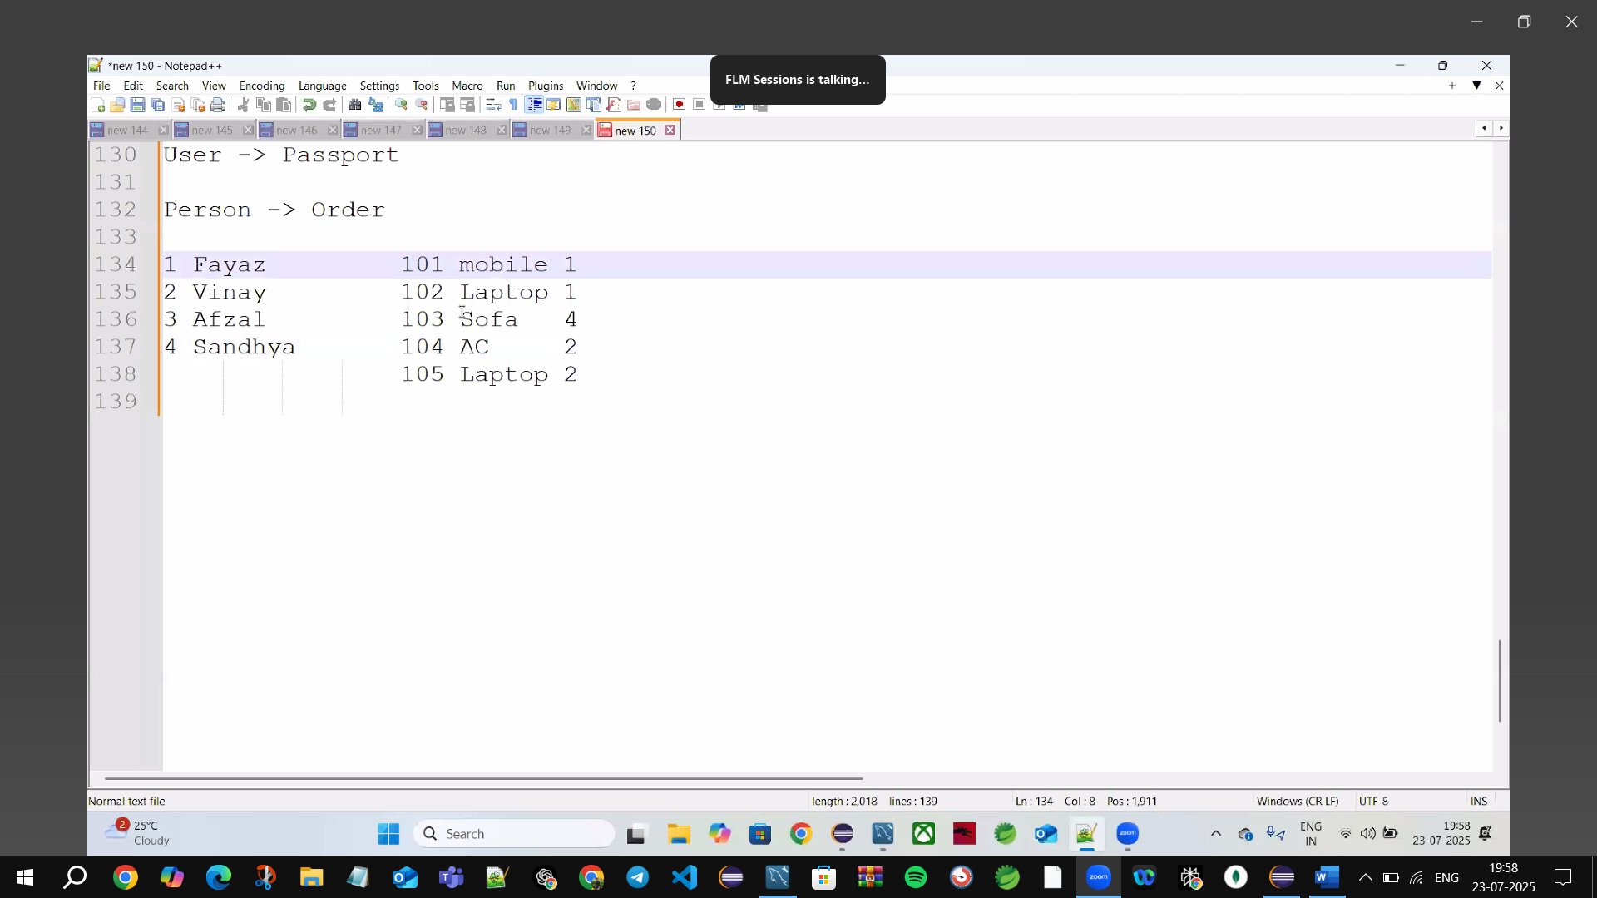

🡪put Foreign key in Orders assign it to persons-1

JoinColumn().class🡪Opposite side. class give(mappedBy=”Object of JoinColumn)”)

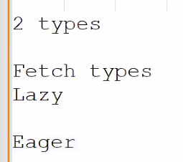

Lazy🡪only fetch Person table data

Eager🡪get both Persons & Orders table data (Un necessary call on Orders)

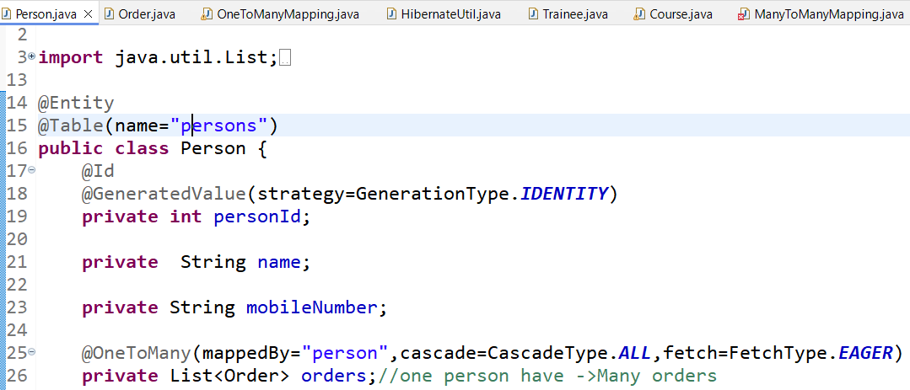



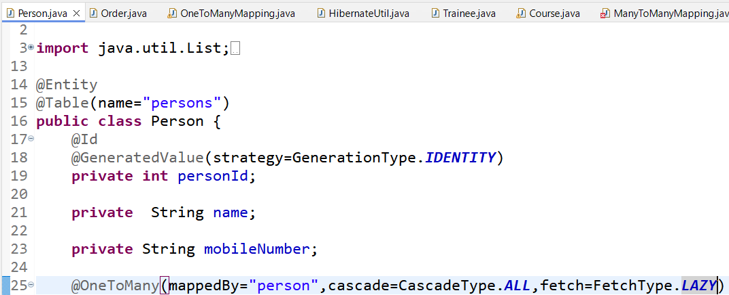

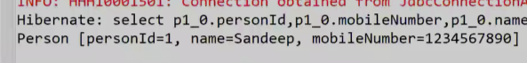

🡪Before Update the data 🡪always find the data first

🡪if you can’t find the old data will remove & new data will become null

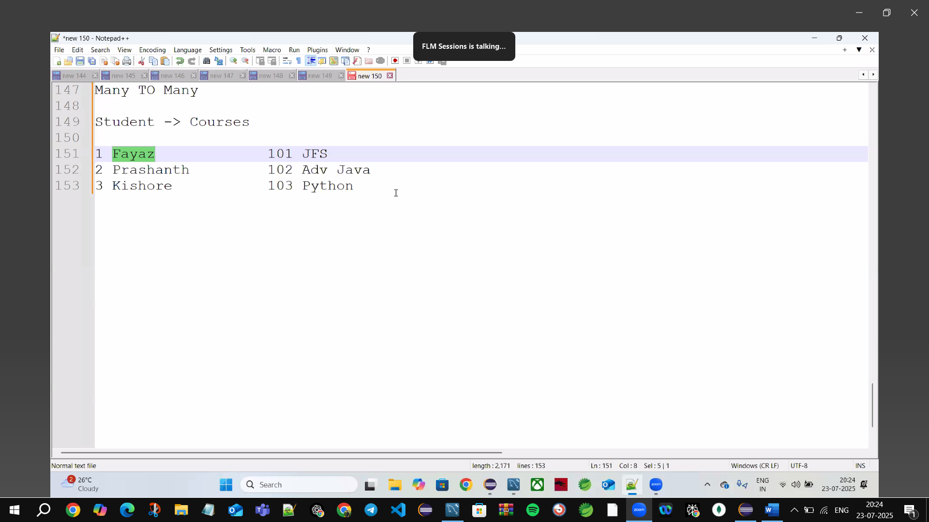

Create new TABLE 🡪TraineeId, & CourseId

🡪Composite primary key

