**1.JDBC: Java Database Connectivity**

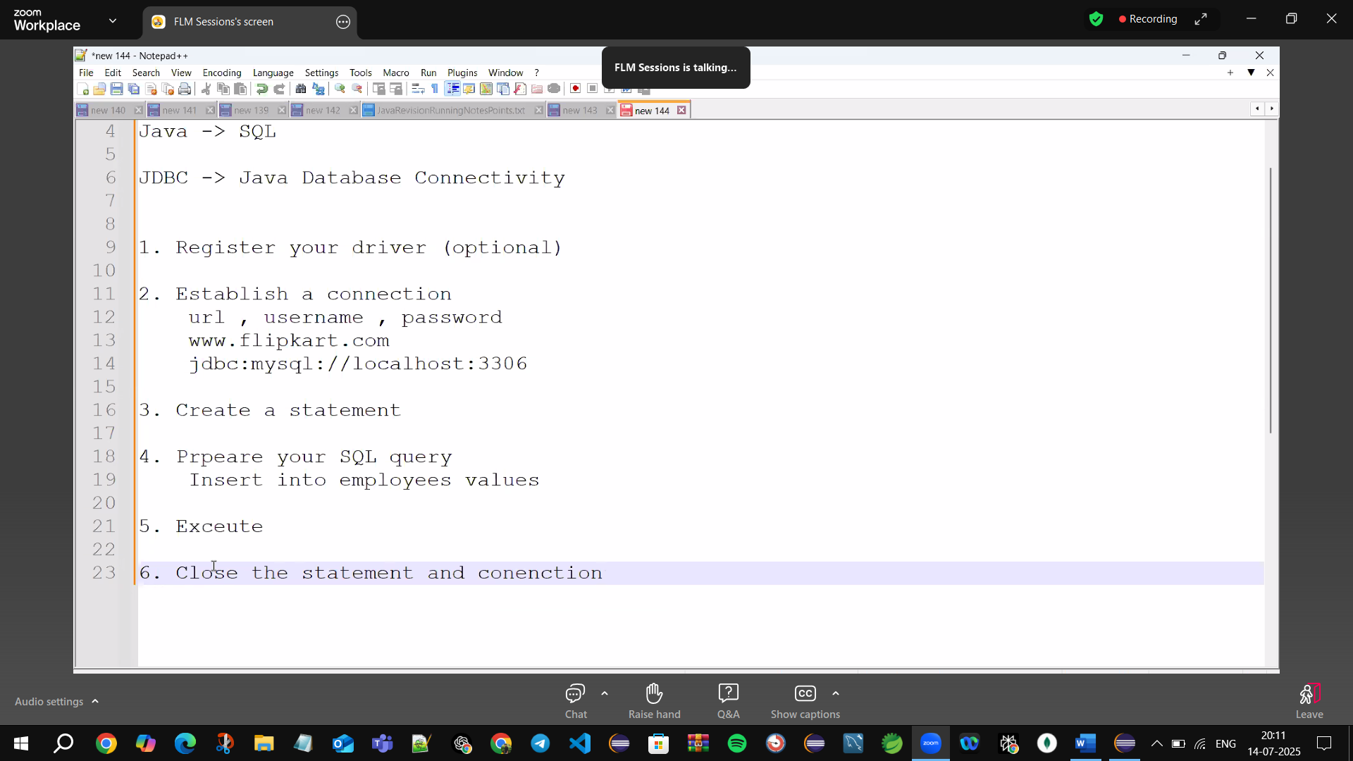

6.close statements for not resources leakage

Trywithresources🡪Autoclose resources

Auto close 🡪Implements Closable Interface

1.Driver🡪Translator 🡪B/w Java & SQL

Connectors🡪ODBC, JDBC

🡪Every data base has individual connectors

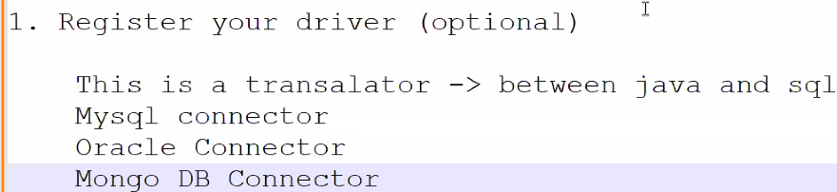

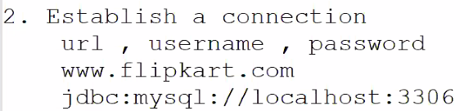

🡪getting internet through connection

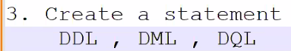

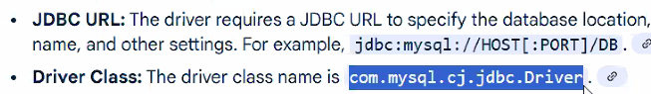

com.mysql.cj.jdbc🡪package name & .Driver 🡪className

cj🡪Connector Java

jar🡪java archive file (contains🡪executable file(.exe)

zip🡪extract & use

**Q) How to load External files in Eclipse?**

**Ans🡪 go to Maven Repository 🡪Configure Build path 🡪set libraries 🡪modulepath🡪add external Jars🡪add jar files🡪Apply & close**

🡪Maven Repository (Central repository)

Right click🡪on Project🡪Build path 🡪Configure Build Path🡪Libraries🡪Modulepath🡪Add External JAR’s🡪Browse where jar files located🡪add Jar file🡪 Apply & close

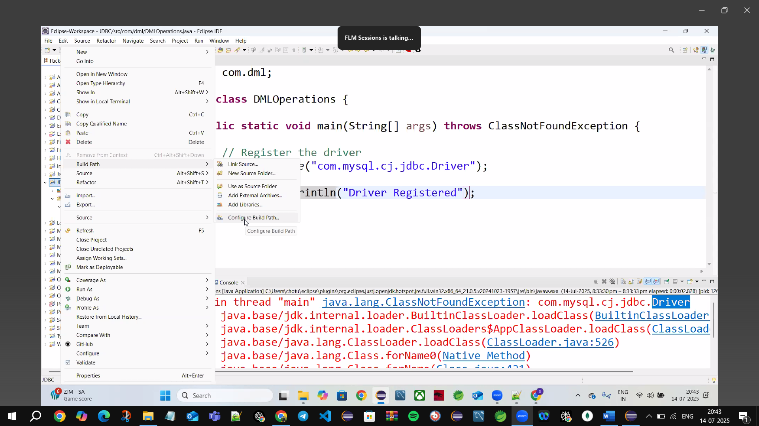

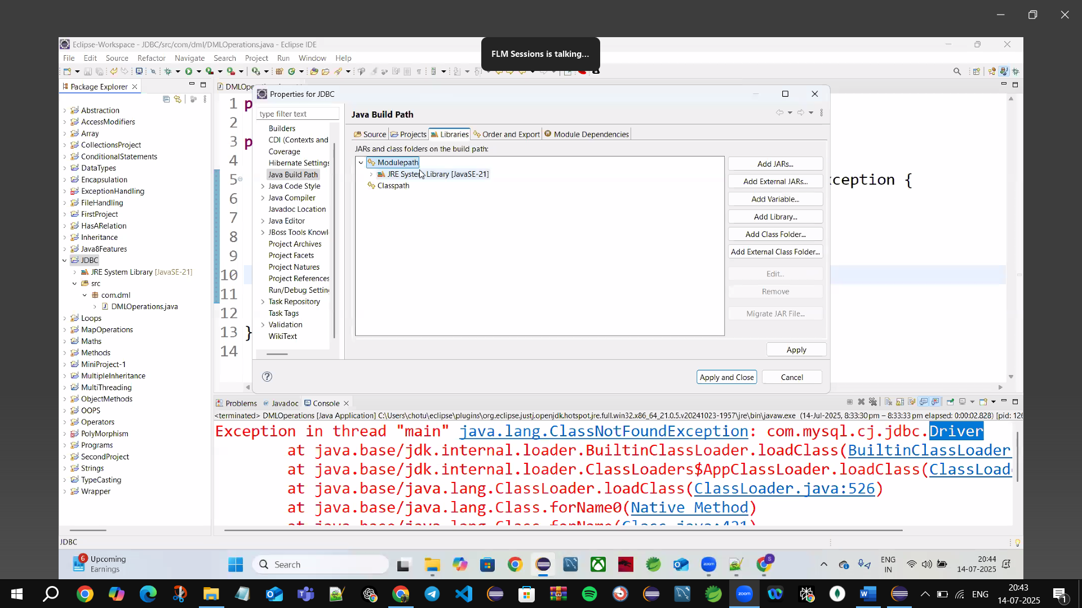

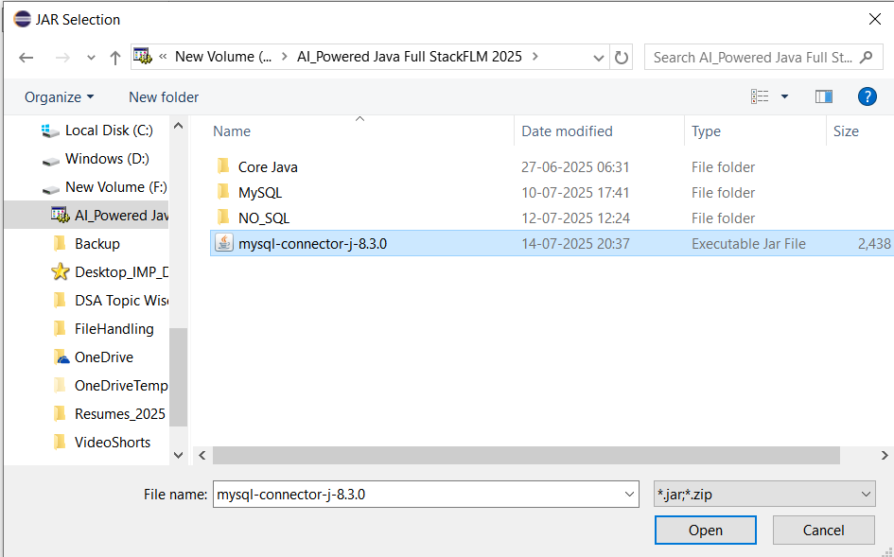

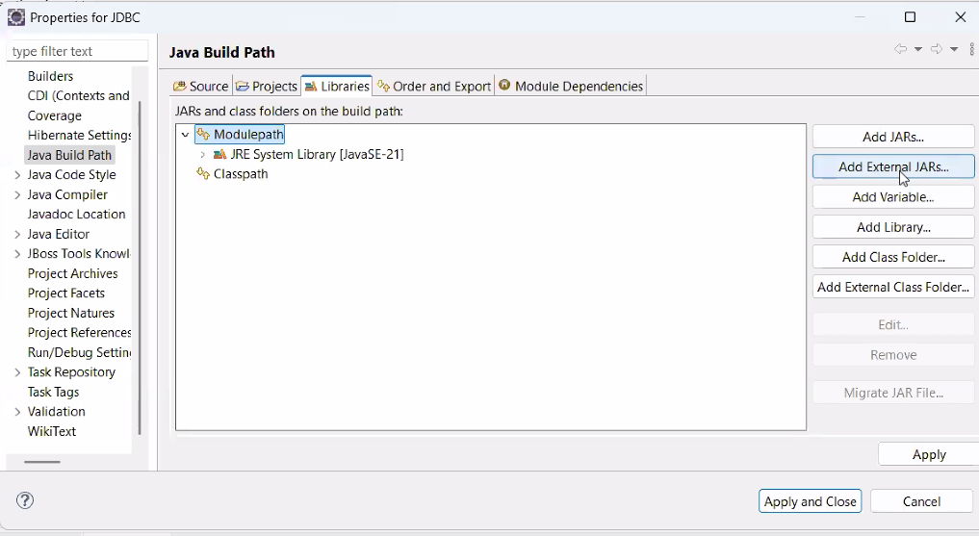

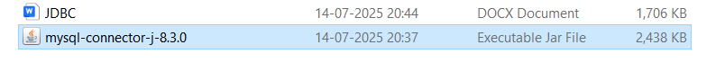

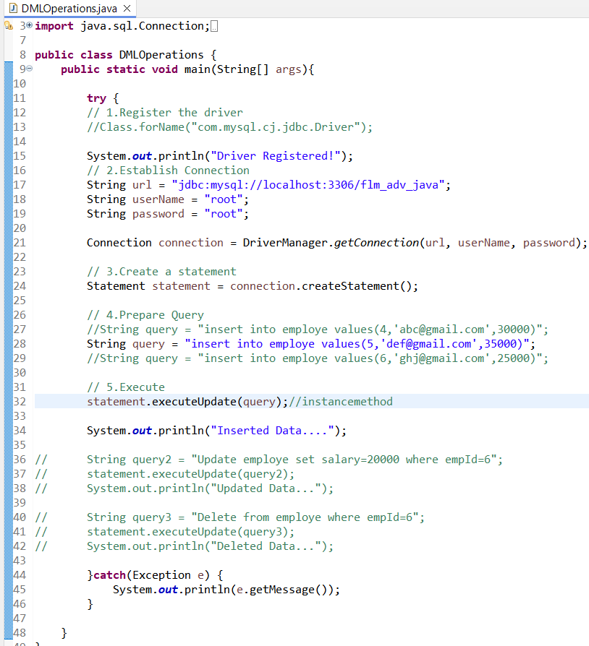

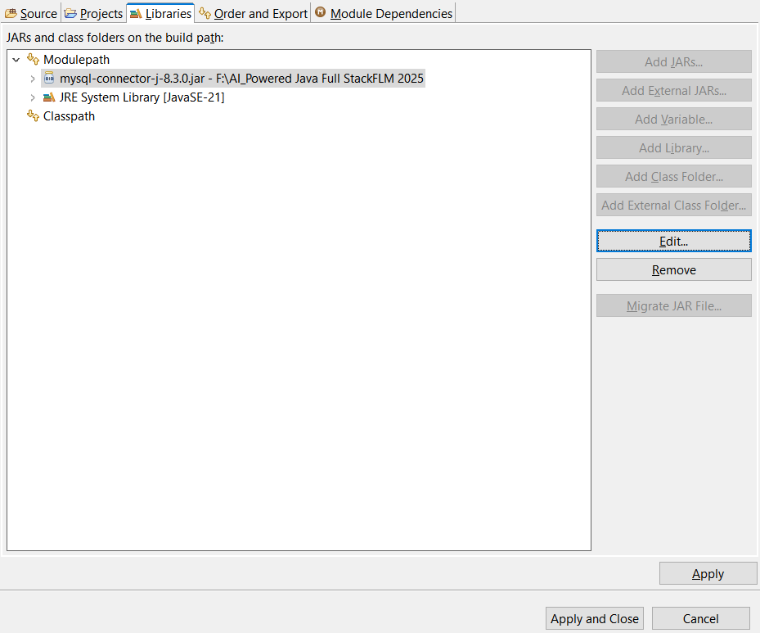

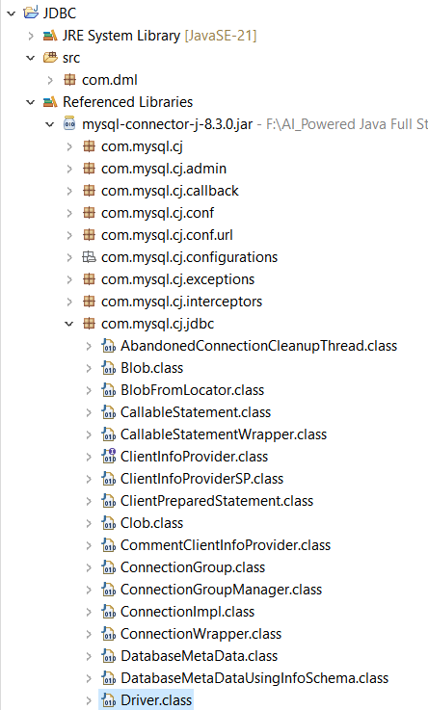

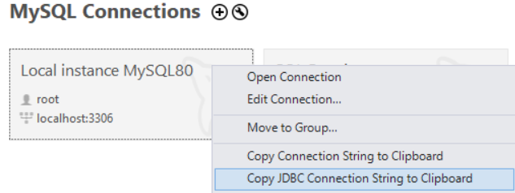jdbc:mysql://localhost:3306/?user=root



Same Driver format

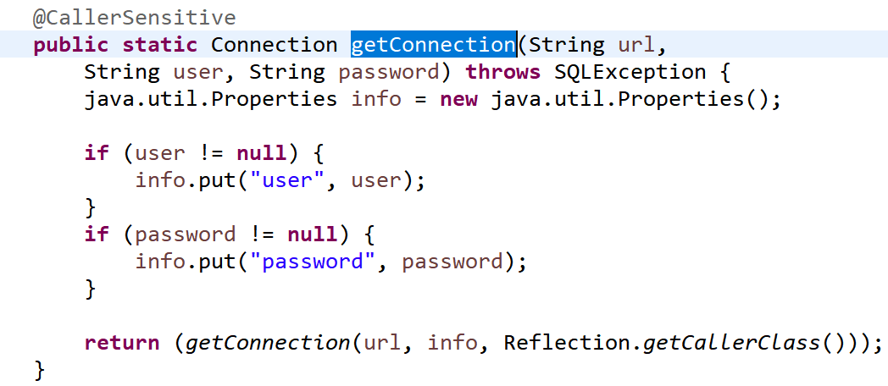

Connection 🡪class



Parent reference holds child object



createStatement()🡪is an interface

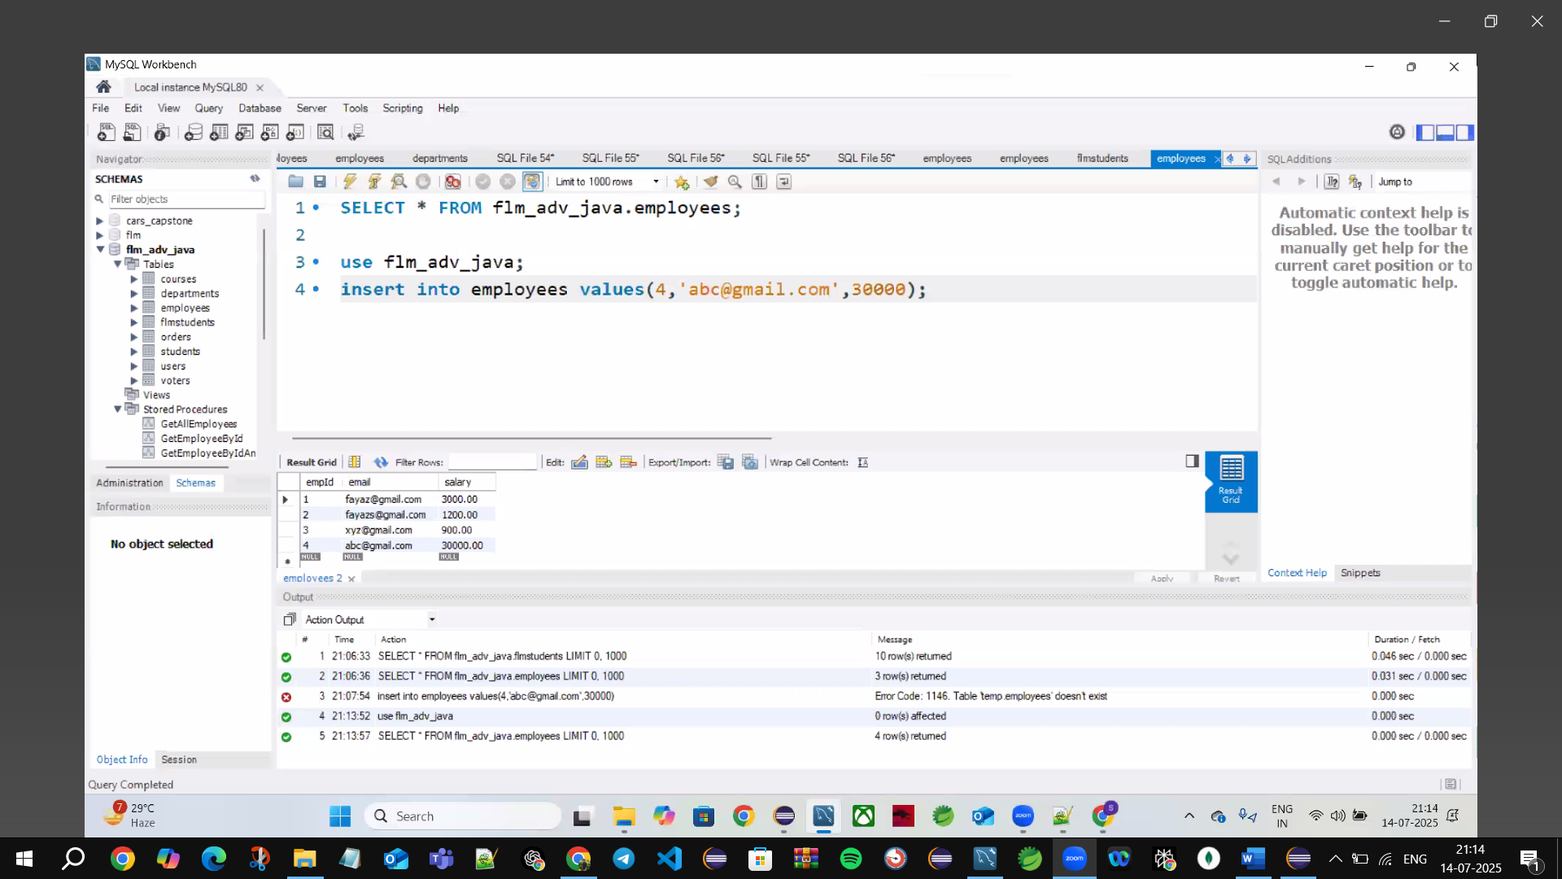

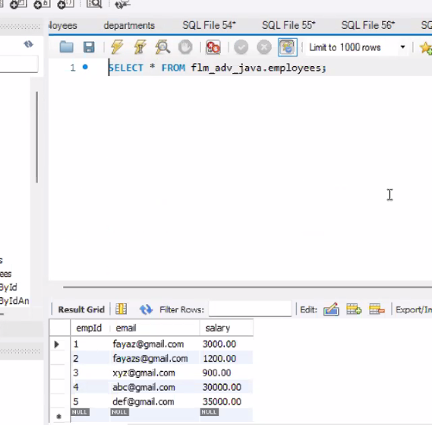

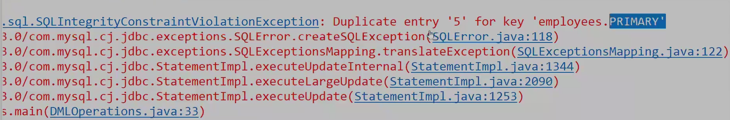

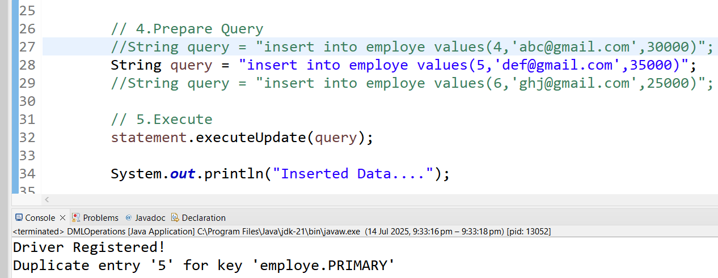

**By Insert Primary key again 🡪we will🡪get Exception🡪 that can be🡪Handled by 🡪Try & catch blocks**

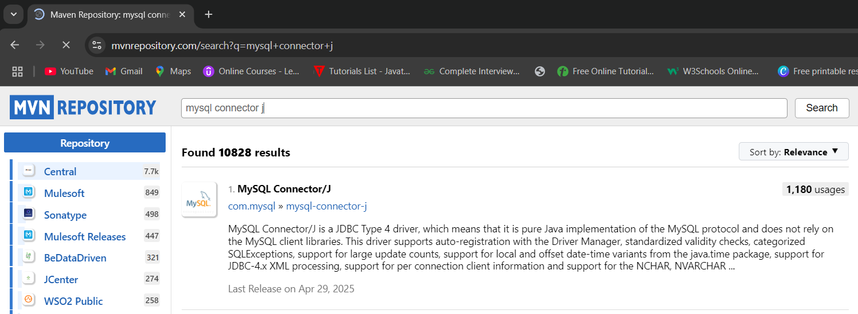

Select Versions🡪8.3.0

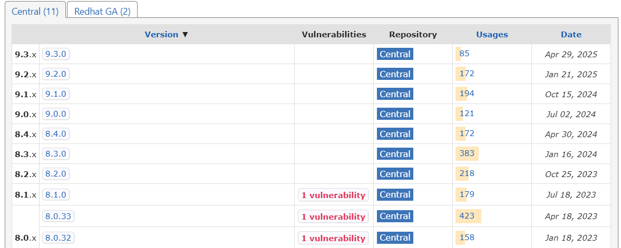

**🡪Download Jar🡪java archive file🡪it’s an executable file**

**🡪We add one Jar files @once for one Project**

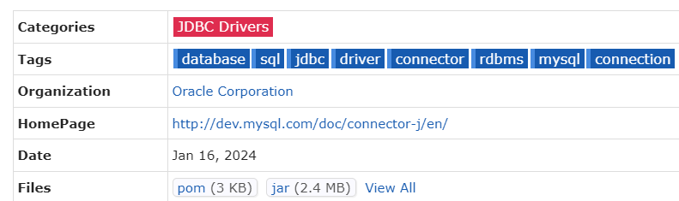



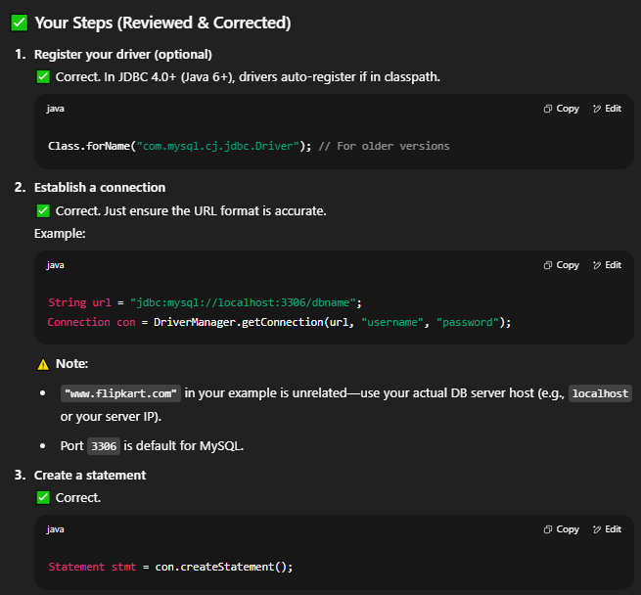

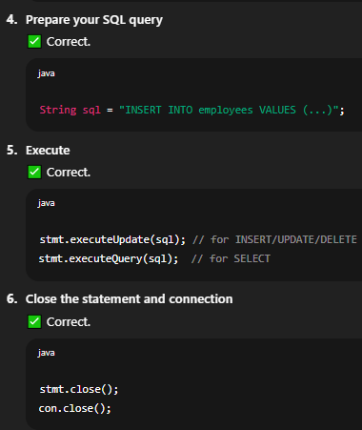

**✅ Enhanced JDBC Steps (Based on Your 6 Steps)**

