I. INTRODUCTION

The problem statement is to find a path in the given maze where the obstacles are moving.
I used rrt algorithm to find the path. I had ideas of using dynamic window approach but dropped it because I found out it was slower than rrt.
Since the path planning had to be done on a video with moving obstacles rrt couldn’t directly be used on a single frame. Considering a frame and generating single a node on it using rrt and then using rrt on the next frame to genrate a new node

Pseudocode:
RRT
Input: Initial configuration init number of frames = F
number of vertices = V
incremental distance = r
Output: RRT graph G

G.init(init)
for frames = 1 to F
for vertices = 1 to F
random_point = RAND_CONF()
nearest_vertex = NEAREST_VERTEX(random_point)
new_node = NEW_NODE(nearest_vertex, random_point,r)
G.add_vertex(new_node)
G.add_edge(random_point,newnode)
G.check_if_destinaion(new_node)
return G
II. PROBLEM STATEMENT

The problem statement asks to do dynamic pathplanning on a path with some stationary obstacles which are shown in black and some dynamic obstacles shown in blue. We have to implement an algorithm that can dynamically avoid the environment. We have to find a path from the start to the end point. The start point is given in red and the end point is given in green.

III. RELATED WORK

Initially I took an approach using the dynamic window algorithm. But left it as it was slower than rrt algorithm.

IV. INITIAL ATTEMPTS
In my first approach i used rrt which I didnt realize i had to call the video infinitely for the path planning to be complete

V. FINAL APPROACH
In the final approach I used rrt for the path planning. I creatd a class for rrt which contained all the functions neccessary for the path planning. In the code the video had to be played infinitely for the path planning to be completed. For that I used a function to recursively call the video as soon as the frames of the video were over.
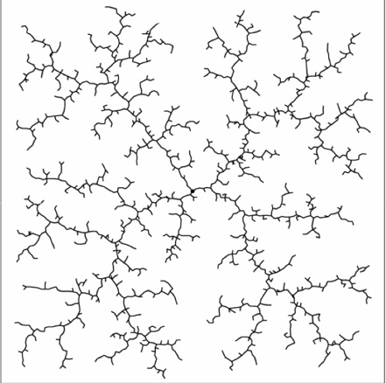

VI. RESULTS AND OBSERVATION
The algorithm can be improvised. Instead of generating random points in the image space and then finding the corrsponding angle, random angles can be generated directly which would serve the same pupose but with greater effeciency(in this case when the random point to be generated is bounded).

VII. FUTURE WORK
The algorithm can be improvised a by generating random angles instead of random points.We can increase the incremental distance for better result.

VIII. CONCLUSION
The algorithm can be used in bots where it can dodge moving obstacles. Which would pop up in various problem statements.
Like to dodge incoming drones and still reach the goal.

IX. REFERENCES

https://github.com/AtsushiSakai/PythonRobotics
Opencv documentation
https://en.wikipedia.org/wiki/Rapidly-exploring_random_tree

