**Phase – 4 Report**

**Feature engineering is the process of creating new features from existing data in order to improve the performance of a machine learning model. In the context of electricity price prediction, some common feature engineering techniques include:**

1. **Creating lagged features**: This involves creating new features that represent the values of other features at previous time steps. For example, you could create a lagged feature that represents the electricity price on the previous day.

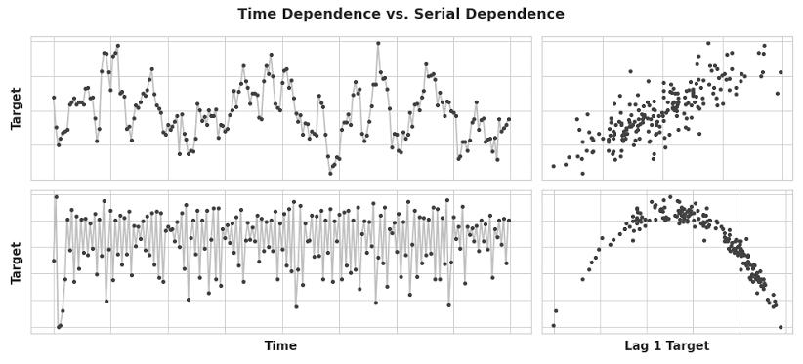

1. **Creating rolling averages:** This involves creating new features that represent the average values of other features over a period of time. For example, you could create a rolling average feature that represents the average electricity price over the past week.

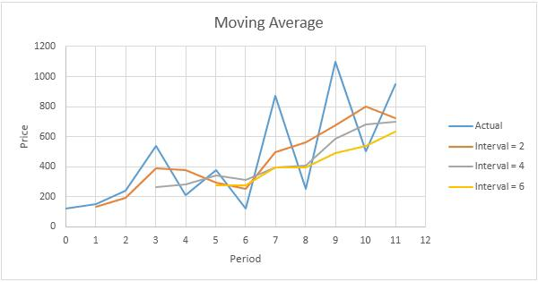

1. 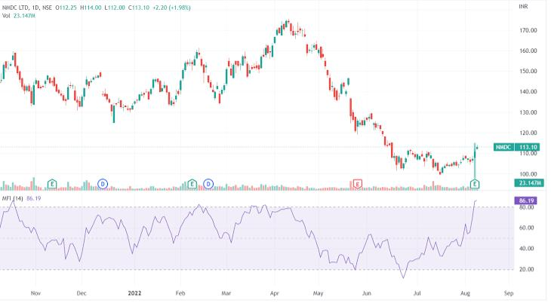**Creating technical indicators:** Technical indicators are mathematical formulas that are used to analyze financial data. Some common technical indicators that are used for electricity price prediction include the moving average, the Bollinger Bands, and the Relative Strength Index.

**Model training**

Once you have engineered your features, you can begin training your machine learning model. To do this, you will need to split your data into two sets: a training set and a test set. The training set will be used to train the model, and the test set will be used to evaluate the performance of the model.

There are a variety of machine learning algorithms that can be used for electricity price prediction. Some popular choices include:

1. **Random forest regression:** Random forest regression is an ensemble learning algorithm that combines the predictions of multiple decision trees.

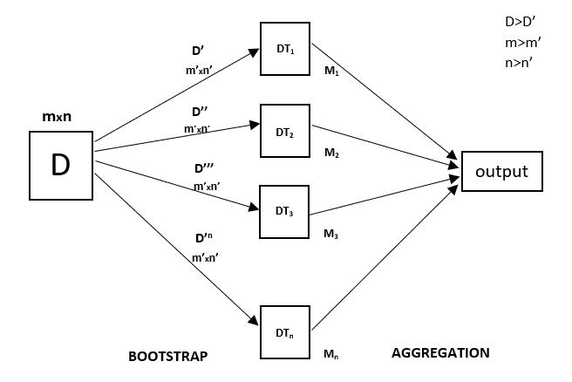

1. **Support vector regression:** Support vector regression is a machine learning algorithm that finds a hyperplane in the data that separates the different classes.

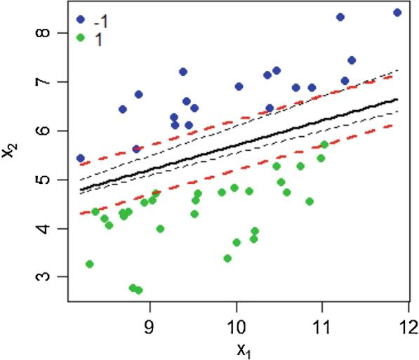

1. **Gradient boosting regression:** Gradient boosting regression is an ensemble learning algorithm that combines the predictions of multiple weak learners.

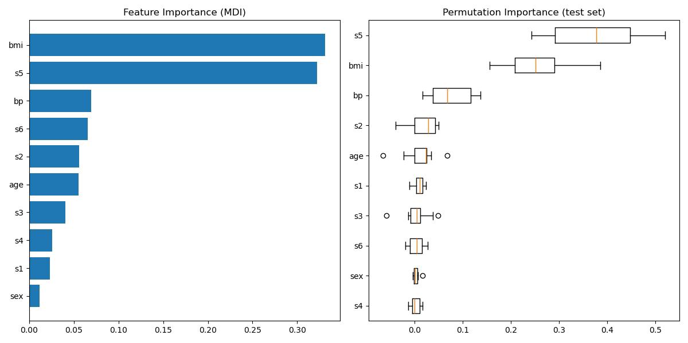

1. 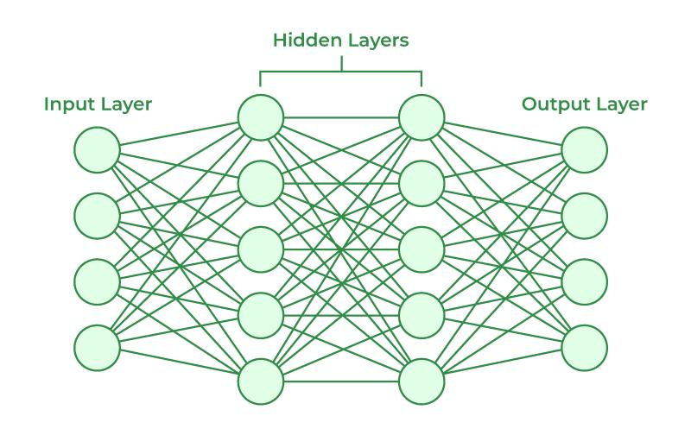**Artificial neural networks:** Artificial neural networks are machine learning algorithms that are inspired by the structure of the human brain.

Once you have chosen a machine learning algorithm, you can begin training your model on the training set. This process can be computationally expensive, but it is important to train your model on a large and representative dataset in order to achieve accurate predictions.

**Evaluation**

Once your model is trained, you need to evaluate its performance on the test set. This will give you a realistic estimate of how well your model will perform on new data.

There are a variety of metrics that can be used to evaluate the performance of an electricity price prediction model. Some common metrics include:

1. **Mean absolute error (MAE):** The MAE is the average of the absolute differences between the predicted prices and the actual prices.

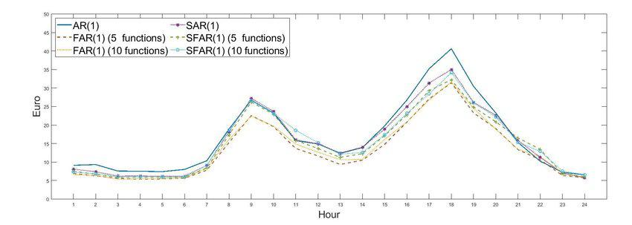

1. **Mean squared error (MSE):** The MSE is the average of the squared differences between the predicted prices and the actual prices.

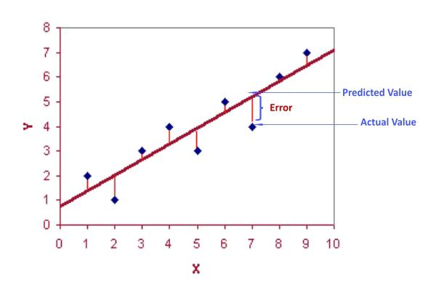

1. **Root mean squared error (RMSE):** The RMSE is the square root of the MSE.

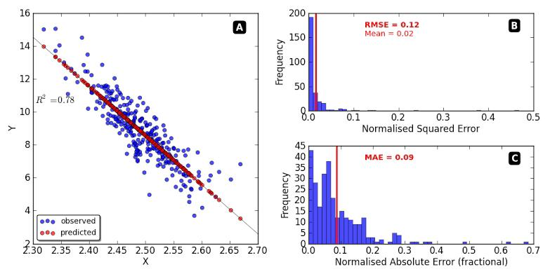

The lower the MAE, MSE, and RMSE, the better the model is performing.

If you are not satisfied with the performance of your model, you can try different feature engineering techniques, different machine learning algorithms, or different hyperparameter settings. You can also try collecting more data, especially if your current dataset is small or not representative.

Once you are satisfied with the performance of your model, you can deploy it to production and use it to predict future electricity prices.