**Problem Statement:**

The problem is to develop a model for electricity price prediction. Electricity prices are influenced by various factors, such as demand, supply, weather conditions, and market dynamics. Predicting these prices accurately is crucial for consumers, energy companies, and policymakers to make informed decisions and manage their energy costs effectively.

**Design Thinking Process:**

1. **Empathize** : Understand the needs and pain points of stakeholders, such as consumers, energy providers, and regulators. Gather data on historical electricity prices and factors affecting them.
2. **Define** : Clearly define the problem and its scope. Determine the specific goals and objectives of the electricity price prediction project, including the time horizon and geographical region of interest.
3. **Ideate** : Brainstorm potential solutions and approaches for electricity price prediction. Explore various algorithms and data sources that could be used for accurate predictions.
4. **Prototype** : Create a preliminary model or system for electricity price prediction. This could involve selecting a machine learning algorithm, collecting relevant data, and developing a basic prediction model.
5. **Test** : Evaluate the prototype’s performance using historical data. Measure the model’s
6. **Implement** : Develop a production-ready electricity price prediction system. This includes scaling up the model, integrating it into existing infrastructure, and ensuring it meets performance requirements.
7. **Iterate** : Continuously monitor and improve the model. Collect real-time data and retrain the model to adapt to changing market conditions.

**Phases of Development:**

1. **Data Collection :** Gather historical data on electricity prices, weather conditions, demand, supply, market trends, and other relevant factors. Clean and preprocess the data to make it suitable for analysis.
2. **Feature Engineering :** Identify key features that impact electricity prices, such as time of day, day of the week, holidays, and weather variables. Create meaningful features and engineer them for the predictive model.
3. **Model Selection :** Choose appropriate machine learning or statistical models for electricity price prediction. Common models include regression, time series forecasting, and machine learning algorithms like Random Forest, Gradient Boosting, or LSTM (Long Short-Term Memory).
4. **Training and Validation :** Split the data into training and validation sets. Train the model on historical data and validate its performance. Fine-tune hyperparameters to improve accuracy.
5. **Testing and Evaluation :** Test the model on a separate test dataset to assess its generalization capabilities. Evaluate its performance using metrics like Mean Absolute Error (MAE), Root Mean Squared Error (RMSE), and Mean Absolute Percentage Error (MAPE).
6. **Deployment :** Integrate the trained model into a production environment where it can make real-time predictions. Implement mechanisms for data ingestion, model updates, and result delivery.
7. **Monitoring and Maintenance :** Continuously monitor the model’s performance in a production environment. Implement alerting systems to detect anomalies or drift in data patterns. Regularly retrain the model to keep it up-to-date.
8. **Feedback Loop :** Gather feedback from end-users and stakeholders to identify areas for improvement. Use this feedback to refine the model and the prediction system.
9. **Scalability and Optimization :** As the project evolves, ensure that the system can handle increased data volume and complexity. Optimize the model and infrastructure for efficiency and cost-effectiveness.
10. **Documentation :** Maintain comprehensive documentation for the project, including data sources, model architecture, and system configuration. This helps in knowledge transfer and troubleshooting.

some common libraries for time series forecasting.

**Python Code:**

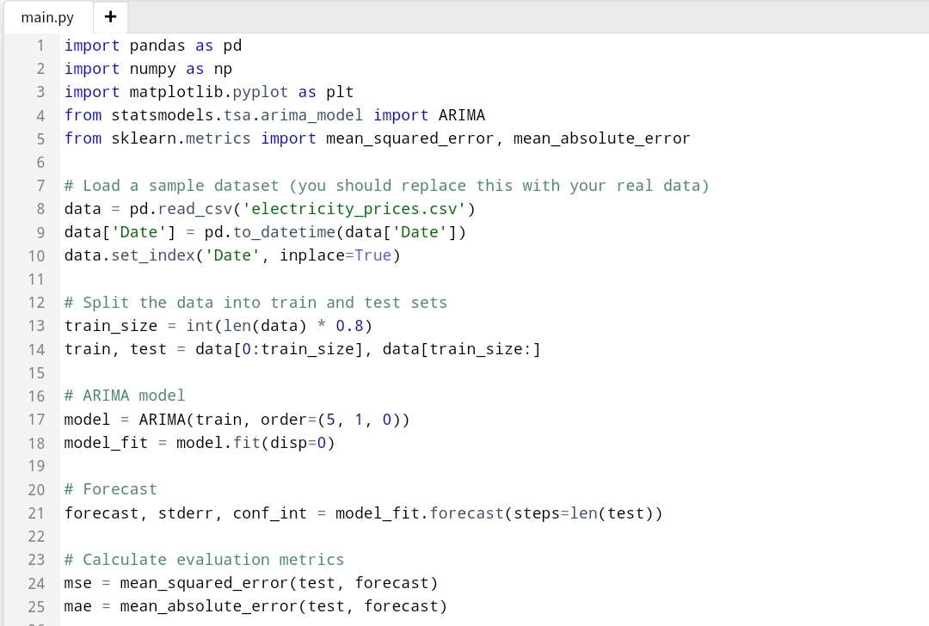

In this code:

1. We load a sample dataset of electricity prices from a CSV file.

2. The data is split into a training set (80%) and a test set (20%).

3. We use an ARIMA model to fit the training data and forecast the test data.

4. Evaluation metrics (MSE and MAE) are calculated to assess the model’s performance.

5. We plot the actual and predicted electricity prices for visualization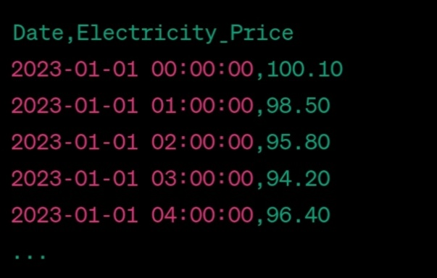

**Choice of Time Series Forecasting Algorithm:**

The choice of a time series forecasting algorithm depends on the specific characteristics of the data and the goals of the electricity price prediction project. Here are some common time series forecasting algorithms and considerations for their selection:

1. **ARIMA (AutoRegressive Integrated Moving Average)** : ARIMA models are suitable for stationary time series data, where the statistical properties like mean and variance remain constant over time. It’s a good choice when you have a relatively simple and unchanging historical price data.
2. **SARIMA (Seasonal ARIMA) :** SARIMA models extend ARIMA to handle seasonal patterns. If electricity prices exhibit strong seasonal or periodic behavior, SARIMA can be a suitable choice.
3. **Exponential Smoothing (ETS) :** ETS models are versatile and can adapt to various types of time series data. They are useful when you want a simple, interpretable model that captures trend and seasonality.
4. **Prophet :**  Prophet is a forecasting tool developed by Facebook that works well for datasets with daily observations, missing data, and seasonal effects. It is user-friendly and can handle outliers and holidays.
5. **Machine Learning Models (e.g., LSTM, GRU) :**  If the electricity price data is highly complex with non-linear patterns, machine learning models like Long Short-Term Memory (LSTM) or Gated Recurrent Unit (GRU) may be effective. They are capable of capturing long-range dependencies and are often used for more advanced time series forecasting tasks.

The choice of algorithm should be based on the analysis of the data and experimentation to determine which model performs best in terms of predictive accuracy and suitability for the specific characteristics of electricity price data.

**Dataset Used:**

The dataset used for the electricity price prediction project typically includes historical data on electricity prices and various factors influencing those prices. The dataset may consist of the following features:

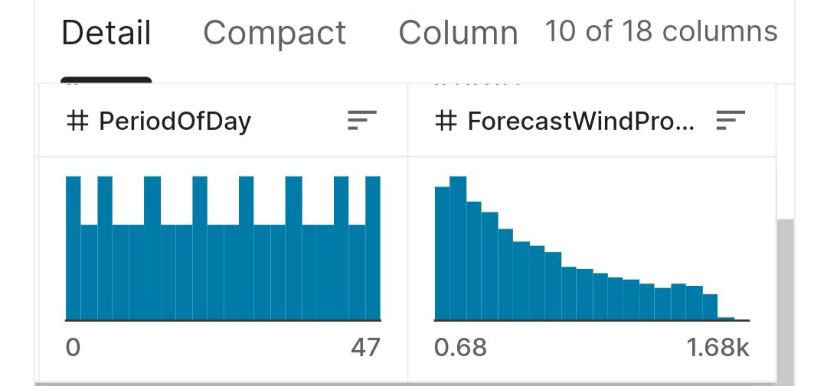

**Evaluation Metrics for Time Series Forecasting:**

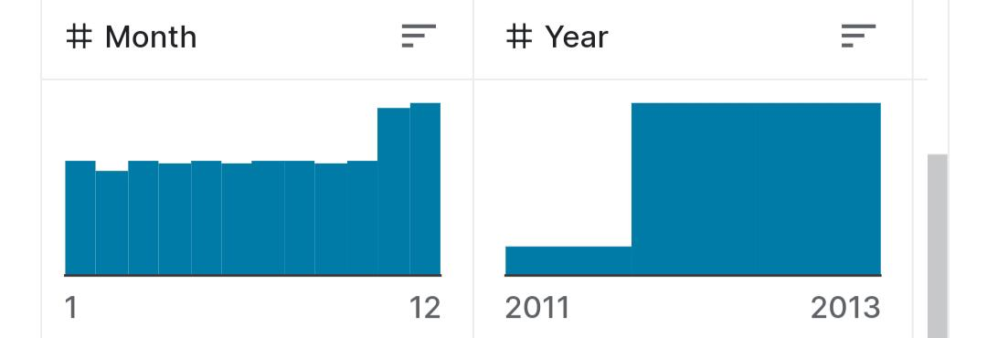

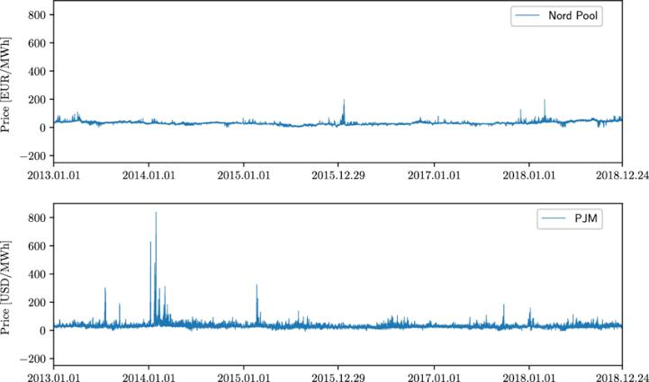

Selecting appropriate evaluation metrics is crucial for assessing the performance of a time series forecasting model. The choice of metrics depends on the project’s objectives and the desired balance between accuracy and interpretability. Here are common evaluation metrics:

1. **Mean Absolute Error (MAE) :** MAE measures the average absolute difference between predicted and actual values. It is easy to interpret, as it represents the average magnitude of forecasting errors.
2. **Root Mean Squared Error (RMSE) :** RMSE is similar to MAE but penalizes larger errors more heavily because it takes the square of the differences. It provides a good balance between bias and variance in forecasting errors.
3. **Mean Absolute Percentage Error (MAPE) :** MAPE is useful for understanding the percentage error in predictions. It is helpful when you want to assess forecast accuracy in terms of a percentage of the actual values.
4. **SMAPE (Symmetric Mean Absolute Percentage Error) :** SMAPE is another percentage-based metric, which symmetrically measures the percentage difference between predicted and actual values. It has advantages in handling zero values and extreme outliers.
5. **Forecast Error (Bias) :** Calculating the mean forecast error provides insight into whether the model tends to systematically over- or under-predict electricity prices.
6. **AIC (Akaike Information Criterion) and BIC (Bayesian Information Criterion):** These metrics help in model selection by considering the trade-off between model complexity and goodness of fit. Lower values indicate better models.
7. **Coverage Probability :** For probabilistic forecasts, it’s essential to evaluate whether the model’s prediction intervals cover the observed values at a desired level (e.g., 95% coverage).
8. **Quantile Loss :**  In probabilistic forecasting, quantile loss assesses the accuracy of predicted quantiles, which can provide insights into uncertainty levels.

The choice of evaluation metrics depends on the project’s objectives. For example, if you need to assess the economic impact of forecast errors, MAPE or SMAPE may be more relevant. It’s also common to use a combination of metrics to provide a comprehensive view of the model’s performance, especially when dealing with electricity price prediction, where accuracy is critical.