**Abstract**

IOT based street light monitoring and controlling system to ensure, low power consumption, consumption monitoring, instant faulty light detection and light dimming as per external lighting conditions. Our proposed system consists of smart street lights that have external light sensing that automatically turns on at desired intensity based on amount of lighting needed.

The system also allows the controller/monitoring person to check estimate power consumptions as per current intensity of light as well as predict monthly power consumption. IEEE 802.11wireless technology is utilized in limited regions or confined premises where all appliances are connected to a cloud.

The second variant, which is similar to the street lamp pole, Wired setup is used to eliminate range issues when the number of appliances develops solely in one direction .Also each of the unit has load sensing functionality that allows it to detect if the light has a fault. It then automatically flags that light is faulty and this data is sent over to the IOT monitoring system so that action can be taken to fix it.

**Table of Contents**

**Abstract…………………………………………………………………………………**

**1.Introduction…………………………………………………………………………**

1.1 Introduction……………………………………………………………………………………

1.2 Statement of the problem……………………………………………………………..

1.3 Objectives Scope…………………………………………………………………………..

1.4 Applications……………………………………………………………………………………

1.5 Limitations……………………………………………………………………………………..

**2. Literature Survey………………………………………………………………….**

**3.** **Analysis………………………………………………………………………………**

**4. Design…………………………………………………………………………………**

**5.** **Implementation……………………………………………………………………**

**6.** **Execution Procedure and Testing……………………………………………**

**7.** **Results & performance Evaluation…………………………………………**

**8.** **Conclusion and future work…………………………………………………..**

**9.** **Appendix……………………………………………………………………………..**

9.1 Program listing/code

9.2 List of Abbreviations/Nomenclature

9.3 List of figures

**10. References**

Chapter-1

**Introduction**

* 1. **Introduction:**

The daily lighting system has limited to only two ON and OFF options, and is not effective, this type of operation results in power loss due to continued peak voltage. The diversion of electricity from street lights is therefore one of the obvious power losses, but with the use of automation, this results in many new energy and money savings methods.

LDR is used as a sensor in this module. The aim is to provide an efficient & energy-saving lighting system by determining the present lighting condition and changing the lights accordingly.(light dependent resistor) The thought of outlining a new framework for the street lights that don't devour immense measure of power and light up vast zone with high intensity.

Smart street lights framework is an essential piece of the smart city which represents LO-40% of aggregate power utilizations which is a discriminating attentiveness toward general society powers. So a vital and productive vitality advancements are to be executed for monetary and social security.

A simple and effective solution to this would be dimming the lights during off peak hours . Whenever presence is detected, the lights around it will glow at the normal (bright) mode. This would save a lot of energy and also reduce cost of operation of the streetlights. We can check the status of street light on internet using IOT (Internet of things) from anywhere in real time and solve the issues if happen during the processing.

**Background of Study** : The present framework is similar to, the road lights will be exchanged on in the night prior to the sun sets and they are exchanged off the following day morning after there are adequate lights on the streets.

The hindrance of the framework is that we require manual operation of the road light which needs labor' In sunny and rainy days, ON and OFF time differ discernibly which is one of the significant hindrances of the present street lights systems' Conventional street lighting systems are online most of the day without purpose'.

The consequence is that a large amount of power is wasted meaninglessly' With the wide accessibility of adaptable lighting innovation like light transmitting diode (LED) lights and all over accessible remote web association, quick responding, dependable working, and power moderating street lighting frameworks get to be reality. The reason for this work is to portray the Smart street Lighting framework, a first way to deal with perform the interest for adaptable smart lighting frameworks.

The goal of this undertaking is to plan an automated lighting framework which focuses on the saving of power; to construct a vitally energy efficient smart lighting framework with integrated sensors and controllers; to outline a smart lighting framework with particular methodology plan, which makes the framework adaptability and expandability and configuration a smart lighting framework which similarity and versatility with other commercial products and mechanized automated system, which may incorporate more then lighting frameworks'

1.2 **Statement of the problem:**

In most of the cities, the street lights are ON when it is not need and It is OFF when is not needed. Because of these situation the huge energy expenses for a city gets wasted. Usually the lights are ON in the evening after the sunset, it continuous to be ON till the sun rises in the next day morning. This paper focuses on reducing the energy by automatically switching ON and OFF street lights. When vehicles come to the street/road the sensor will capture the movements of the vehicles then lights automatically ON. Otherwise automatically OFF the lights.

1.3 **Objectives** :

The objective for this project is to design a smart lighting system which targets the energy saving and autonomous operation on economical affordable for the streets. Build an energy saving smart lighting system with integrated sensors and controllers. Design a smart lighting system with modular approach design, which makes the system scalability and expandability.

Design a smart lighting system which compatibility and scalability with other commercial product and automation system, which might include more than lighting systems.

1.4 **Scope:**

The street lighting is one of the largest energy expenses for a city. An intelligent street lighting system can cut municipal street lighting costs as much as 50% - 70%. An intelligent street lighting system is a system that adjusts light output based on usage and occupancy, i.e., automating classification of pedestrian versus cyclist, versus automotive.

1.5 **Applications:**

* Street lights of main roads of Town, city or town ship.
* Industrial Lighting.
* Plant Lighting.
* Premises of large complexes.
* Society/colony internal lightings.
* With The Help Of IOT, Street Lights Can Switch ON And OFF Automatically.
* Maintenance Of Street Lights Using IoT Is Quite Less Which Leads To Cost Reduction.
* No Large Manpower Is Required To Maintain These Street Lights Using IOT.
* Power Consumption Is Quite Low In These Street Lights Using IOT Which Also Leads To Energy Conservation.

1.6 **Limitations:**

* Implementation cost is high.
* In case of defect or repair, troubleshooting of the system is complex.
* System is prone to damage by environmental conditions.
* Risk of theft of the automatic street light system is relatively higher since they are non-wired & are much expensive.
* Snow, dust or moisture can accumulate of PV panels which can hinder energy production.

Chapter-2

**Literature Survey**

2.1 **Literature Survey :**

Automatic Street Lights, This project is all about to control the power consumptions at the streets and eliminating manpower. This includes controlling a circuit of street lights with specific Sensors, LDR and Microcontrollers during day and night. This requires three basic components i.e. LDR, Sensors and microcontroller. During daytime there is no requirement of street lights so the LDR keeps the street light off until the light level is low or the frequency of light is low the resistance of the LDR is high.

Automatic Street Light Control System Using Microcontroller, This paper aims at designing and executing the advanced development in embedded systems for energy saving of street lights. Nowadays, human has become too busy, and is unable to find time even to switch the lights wherever not necessary. This paper gives the best solution for electrical power wastage. Also the manual operation of the lighting system is completely eliminated.

In this paper the two sensors are used which are Light Dependent Resistor LDR sensor to indicate a day/night time and the photoelectric sensors to detect the movement on the street. the microcontroller PIC16F877A is used as brain to control the street light system, where the programming language used for developing the software to the microcontroller is C-language.

Automated street lighting using PLC, Street light controlling using PLC is a novel concept using XD26 PLC controller.

Chapter-3

**Analysis**

3.1 **Analysis:**

To study about the smart street light system, we have to take an analysis on different aspects anticipated by other researchers .This is a description which is related to the work done on Smart Street Light with various components and by using different algorithms.

This was developed and implemented by different aspects in several platforms. On developing the rural area, electricity is the major need. This proposes that smart system which can make decision for the bright control. On developing the rural area, electricity is the major need. This proposes that smart system which can make decision for the bright control.

Many researches and techniques are made by engineering students, faculty of universities, colleges and research organizations to make the outdoor lighting system less power consuming. The latest technology, which is used globally in these days is light emitting diode based system, it is treated as energy efficient and reliable lighting technology, which reduced the public lighting cost as well as energy consumption up to 80% and also responsible for the reduction of carbon dioxide emissions. Life span of LED lamps is about 50 times longer than other conventional lamps.

Busy areas should be lighten all the time; however, this is not the case with rural areas. Sometimes, when people leave their shops, restaurants, cinemas, they keep walking around midnight, latter, there are very few people on the road at night. So, there is a temporary need for lighting streets or road, in relation to a continuous illumination of streets or road in urban areas. For energy saving on street lights we can install an automatic system which can turn on or off lighting system or the brightness of lamps increase or decrease according to detection.

A new innovative street light system with optimized street light management and efficiency is presented. It uses many sensors to control and guarantee a better efficient system. Presence of a person or an obstacle is detected by using the presence detector sensors. Street lights will be switched ON only when a person or an obstacle comes in the detection range else it will be switched OFF.

The Energy crises occur in the cities may be reduced because 50 to 60 percent of electricity is saved and these energies were used in other important purposes. This system is entirely adaptable to the requirements of users and creates safe environment. This approach requires minimum hardware with simple software. To control streetlight decisions were taken by the system.

This is one of the major causes of shifting to the automatic system, since there is less wastage of power and thus saving a lot of monetary expenses .If we uses this idea and implement to it in our society it will be helpful in saving enough amount of electricity and off-course money.

Smart street lights are no more a myth. When we are capable of designing circuits at home and interfacing them with software to control their functions, on a larger scale there are developments happening.

Chapter-4

**Design**

4.1 **Design**:

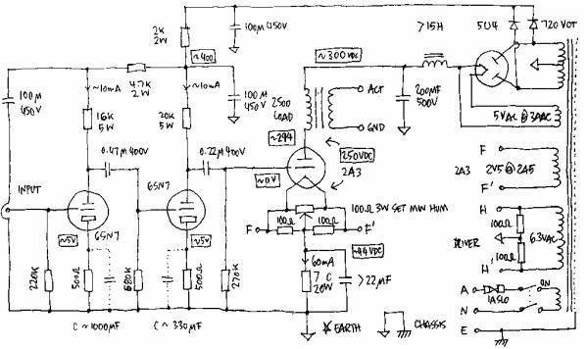

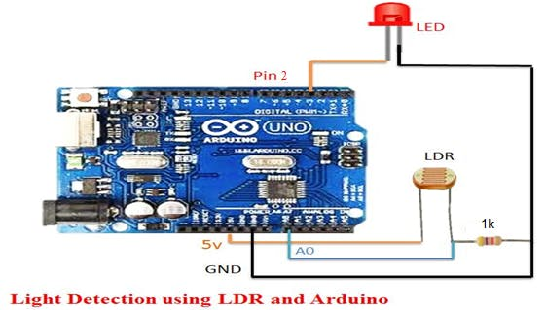

4.2 **Design**:

The output from the LDR is connected to the AO and initially LDR flag and LDR value is set to zero. The value of LDR reference value is initialized and set to 500(baud rate). If the Arduino UNO reads any value from LDR whose value is less than the LDR reference value than it will turn on the street lights.

The output from IRI and IR2, IR3, and object IR4 are connected to the pin 1,2,3,4 and reference value of all sensor is set to 500(baud rate).Another four proxy value for each object sensor are set to zero and if any object sensor detects any presence of objects then Arduino UNO compares the value with the object reference value. If the sensed value is less than the reference value it will glow with 100% of its intensity otherwise LEDs will be off. The first and the last LED glows continuously to detect the start and end of the road.

All the constraints must be taken into account, e.g., the operating conditions, limitations on electrical and optical components, cost, LED driver current, and expected system lifetime, when an LED lighting system is designed so as to meet the user’s specific needs, e.g., temperature ratings, expected brightness.

There is no way that an LED lamp can be made 100% efficient due to the inevitable power loss in the driver of the lamp. For this sake, the power loss must be taken into account in the design phase of an LED lighting system. Typically, an LED driver is measured to have an efficiency ranging from 80% to 90%, while an LED driver with a high efficiency over 90% is a high price one. As illustrated in Figure 2, the driver’s efficiency is found as a function of load. It is noted that a load above 50% is recommended for optimized efficiency, namely minimized cost.LED lamp is indeed a DC operated device, meaning that AC 220 V must be rectified into DC in advance.

All the constraints must be taken into account, e.g., the operating conditions, limitations on electrical and optical components, cost, LED driver current, and expected system lifetime, when an LED lighting system is designed so as to meet the user’s specific needs, e.g., temperature ratings, expected brightness. There is no way that an LED lamp can be made 100% efficient due to the inevitable power loss in the driver of the lamp.

For this sake, the power loss must be taken into account in the design phase of an LED lighting system. Typically, an LED driver is measured to have an efficiency ranging from 80% to 90%, while an LED driver with a high efficiency over 90% is a high price one. As illustrated in Figure 3, the driver’s efficiency is found as a function of load. It is noted that a load above 50% is recommended for optimized efficiency, namely minimized cost. For indoor use, anefficiency of 87% is highly recommended, while a lower one is recommended for outdoor use or for an extended lifetime.

The lighting comes from LED bulbs, which are trigger by multi sensors. A person, object/vehicle appears nearby the sensors, It capture the signals and turn ON the particular street lights. When object moves lights automatically works. SSLS used to save the energy, mainly helps to save the power. IR LED lights dependent devices whose resistance decreases when light falls on them and increases in the dark. When a light dependent resistor is kept in dark, its resistance is very high. The vehicle which passes by the street light is detected by IR sensor. Relay are used as a switch to switch on/off the street light bulb.

Chapter-5

**Implementation**

**5.1 Implementation:**

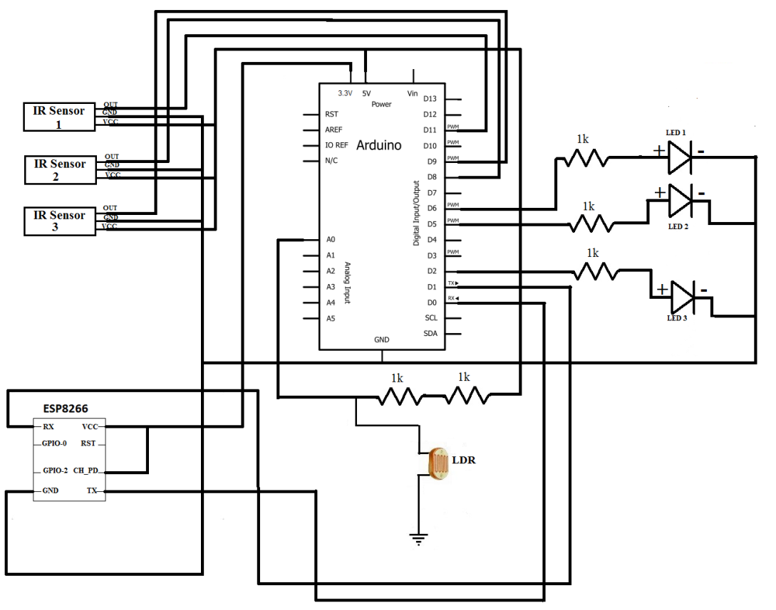

* We have used one LDR circuit to distinguish between the day and night. LDR with a small register in series is connected across the 5V and GND of the Arduino Uno.
* From the midpoint of the LDR potential divider circuit the output of the circuit is feed to A0 of the Arduino.
* which turn on all the street lights which are represented by Led connected to the output pin.
* LDR is a special type of resistor whose value depends on the brightness of the light which is falling on it.
* It has resistance of about 1M-ohm when in total darkness but a resistance of only 5 k-ohm when brightness is illuminated.
* The voltage is directly proportional to the conductance so more voltage we will get when there is sunlight and vice-versa.
* we have to set a reference value for the switching actions of the Led. The reference value is set to 500(baud rate).
* Four infrared receiver and sender circuits are made to detect the movements and output from the receiver is fed to the input terminal. All the object sensors are connected between 5V and GND of the Arduino UNO.

The concept of IR Sensor used to detect the obstacles to transmit an infrared signal. This IR signal reflect from the object and the signal is get at the infrared receiver. The smart street light controller must be installed on the light pole which consist of microcontroller along with various sensor and wireless module.

The smart street light controller installed on the street light poll will control LED street lighting depending on movements of the object in the street. The captured data cane transferred to base station where the energy gets stored using wireless technology to monitor the smart system. The smart system can be operated either manually or automatically. The control system will switch ON and OFF the street lights at needed timings and can also vary the intensity of the street light according to the necessity.

Chapter-6

**Execution Procedure and Testing**

6.1 **Execution Procedure and Testing :**

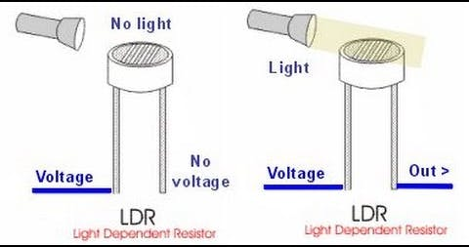

* The output from the LDR is connected to the A0 and initially LDR flag and LDR value is set to zero.
* The value of LDR reference value is initialized and set to 500(baud rate).
* If the Arduino UNO reads any value from LDR whose value is less than the LDR reference value than it will turn on the street lights.
* The output from lR1 and lR2, lR3, and object lR4 are connected to the pin L,2,3,4 and reference value of all sensor is set to 500(baud rate).
* Another four proxy value for each object sensor are set to zero and if any object sensor detects any presence of objects then Arduino UNO compares the value with the object reference value. lf the sensed value is less than the reference value it will glow with 100% of its intensity otherwise LEDs will be off.

6.2 **Testing:**

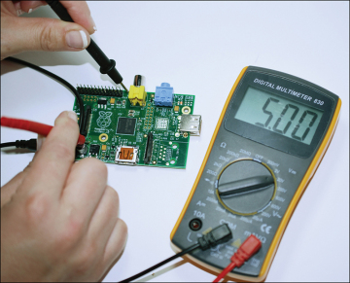

**Testing Tools:**

* Multi meter

A multi meter or a multi tester, also known as a volt/ohm meter or VOM, is an electronic measuring instrument that combines several measurement functions in one unit. A typical multi meter may include features such as the ability to measure voltage, current and resistance.

* Power Supply
* Oscilloscope

An oscilloscope is a laboratory instrument commonly used to display and analyze the waveform of electronic signals. In effect, the device draws a graph of the instantaneous signal voltage as a function of time.

Chapter-7

**Results & performance Evaluation**

7.1 **Results :**

The result of the system, as we have discussed in the earlier pages of the report, the LDR detects the light that has been falling on it, so does the IR sensor and as soon as they detect or obsorb light they will send an signal to the microcontroller which there by turns ON the street light, and also the IR sensor detects the vehicle motion which also sends an signal to the microcontroller when it detects an vehicle and again the microcontroller turns ON the street light. This will be the result of the proposed, Smart Street Light Control System.

* This project is to design a smart lighting system which targets the energy saving and autonomous operation on economical affordable for the streets.
* Build an energy saving smart lighting system with integrated sensors and controllers. Design a smart lighting system with modular approach design, which makes the system scalability and expandability.
* Design a smart lighting system which compatibility and scalability with other commercial product and automation system, which might include more than lighting systems.

7.2 **Performance Evaluation:**

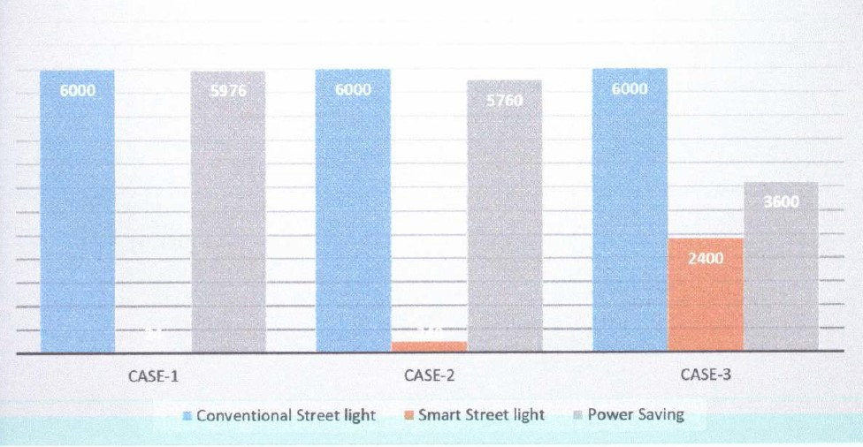

Performance of solar streetlight interventions in two humanitarian settings. Displaced settlements often lack street lighting and electricity. Given that off-grid solar streetlights produce surplus energy, we hypothesized that this energy could be made available for daily usage, to improve system performance and provide further energy access to displaced populations. We recognize, however, that solar streetlight performance and longevity have typically been poor in remote and refugee settings.

Eleven solar streetlights were fitted with ground-level sockets and their performance monitored, in two displaced settlements: a refugee camp in Rwanda and an internally displaced population settlement in Nepal. Considerable performance gaps were found across all eleven systems. Inefficient lights and mismatching system components were major issues at both sites, reducing targeted designed performance ratios by 33% and 53% on average in Rwanda and Nepal, respectively. The challenges of deploying these types of systems in temporary settlements are outlined and a number of suggestions are made to guide future developments in the design and implementation of sustainable solar streetlight interventions.

Chapter-8

**Conclusion and future work**

8.1 **Conclusion and future work:**

This paper elaborates the design and construction of automatic light control system circuit. Circuit works properly to turn lamp ON/OFF. LDR sensor is the main conditions in working the circuit. If the conditions have been satisfied the circuit will do the desired work according to specific program. Each sensor controls the turning ON or OFF the lighting column. The lights has been successfully controlled by microcontroller. With commands from the controller the lights will be ON in the places of the movement when it's dark. Finally this control circuit can be used in various purposes.

In this paper Smart street lighting system is described that integrates new technologies offering ease of maintenance and energy saving. It tackles the problem of energy wastage which in turn reduces power consumption, increases road safety and gives efficient way to handle switching on/off streetlight by using automatic and time scheduling approach.

Additional functionalities were added to enhance the performance of the system by lowering overall power usage, which was accomplished by employing a motion sensor, or by employing a light sensor. These sensors were controlled by Arduino UNO microcontroller. This system is remote control monitoring. The environmental parameters for this system are light and motion.

Wi-Fi and with IOT platforms-Thing speak. After the environmental parameter data gathered from the sensors are handled and sent to the cloud platforms and IOT by Wi-Fi utilizing the HTTP protocol. Data was represented in time-series on platform of IOT, and users could acquire access to it and get real-time information on the internal environment. The proposed system indicates that a smart lighting model supports save less power consumption in cities. Since energy saving plays an important role. This strategy provides an effective alternative for lowering energy use. In the future, we will utilize the camera to increase the security for the road.

In this survey, we analyze that IOT has groomed rabidly with our day to day life. Smart Street light System is one of the major parts which use IoT concepts. Smart Street Lighting System clearly tackles the major problems like Energy wastage, Crime detection, disposal of incandescent lamps, maintenance cost etc., This system ensures traffic safety and the security to the people which can stop from women annoyance, burglaries and further intimidations.

The Energy crises occur in the cities may be reduced because 50 to 60 percent of electricity is saved and these energies were used in other important purposes. This system is entirely adaptable to the requirements of users and creates safe environment. This approach requires minimum hardware with simple software. To control streetlight decisions were taken by the system; it is possible to avoid negligence factors by human operatives. It will also helpful in making our city as the Smart City.

The above project we can develop solar street light system with Automatic street light controller. The system can be powered from a battery, which can be charged during day time.

**Appendix**

**Program listing/code:**

int smooth;

int LDR;

int threshold=40;//sun's intensity

int brightness=0;

int ledState=0;

int sensor1=11;

int sensor2=8;

int sensor3=9;

int led1=5;

int led=6;

int led2=2;

int carPresent=0;

int carPresent1=0;

float beta=0.65;

void setup(){

// put your setup code here, to run once:

Serial.begin(115200);

pinMode(sensor1, INPUT);

pinMode(sensor2, INPUT);

pinMode(sensor3, INPUT);

pinMode(led,OUTPUT);

pinMode(led1,OUTPUT);

pinMode(led2,OUTPUT);

}

void loop(){

smooth= smooth - (beta * (smooth - analogRead(A0)));

delay(1);

LDR= round(((float)smooth / 1023) * 100);

if(LDR <=40)

brightness=0;

else

{

brightness= map(LDR, 40, 100, 0, 255);

}

checkSensors();

if(carPresent==1)

{

ledState=1;

digitalWrite(led,HIGH);

digitalWrite(led1,HIGH);

analogWrite(led,brightness);

analogWrite(led1,brightness);

}

elseif(carPresent==0)

{

ledState=0;

digitalWrite(led,HIGH);

//digitalWrite(led1,HIGH);

analogWrite(led,ledState);

//analogWrite(led1,ledState);

if(carPresent1==1)

{

ledState=1;

if(ledState==1)

{

analogWrite(led1,brightness);

analogWrite(led2,brightness);

}

}

elseif(carPresent1==0)

{

ledState=0;

digitalWrite(led1,HIGH);

digitalWrite(led2,HIGH);

analogWrite(led1,ledState);

analogWrite(led2,ledState);

}

}

String data=(String)ledState+","+(String)brightness+";";

Serial.print(data);

// Serial.print(digitalRead(sensor1));

// Serial.print("\t");

// Serial.print(digitalRead(sensor2));

// Serial.print("\t");

// Serial.print(ledState);

// Serial.print("\t");

// Serial.println(brightness);

delay(100);

}

void checkSensors()

{

if(digitalRead(sensor1)==0)//Car captured in 1st sensor

{

if(digitalRead(sensor2)==1)//Car still didnt reach the 2nd sensor

carPresent=1;

}

elseif(digitalRead(sensor2)==0)//Car reached the 2nd sensor

{ //No cars detected behind the first car

if(digitalRead(sensor1)==1)

{

carPresent=0;

carPresent1=1;

}

elseif(digitalRead(sensor1)==0)

{

analogWrite(led,brightness);

analogWrite(led1,brightness);

analogWrite(led2,brightness);

digitalWrite(led,HIGH);

digitalWrite(led1,HIGH);

digitalWrite(led2,HIGH);

}

}

elseif(digitalRead(sensor3)==0)//car reached the 3rd sensor

{

//No cars detected behind the first car

if(digitalRead(sensor2)==1)

{

carPresent=0;

carPresent1=0;

}

elseif(digitalRead(sensor2)==0)

{

carPresent=0;

carPresent1=1;

}

}

}

**List of Abbreviations/Nomenclature:**

**LED**: Light-Emitting Diode

**LDR**: Light Dependent Resistor

**IOT**: Internet Of Things

**PCB**: Printed Circuit Board

**List of figures:**

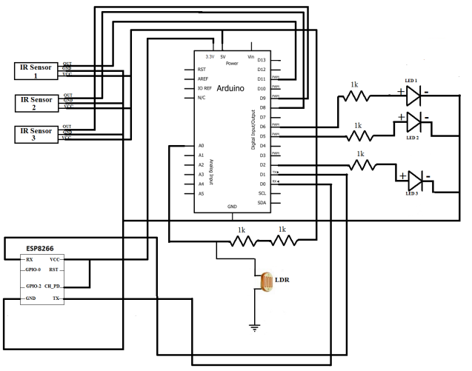

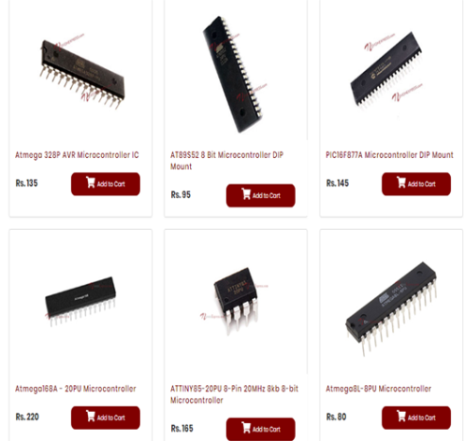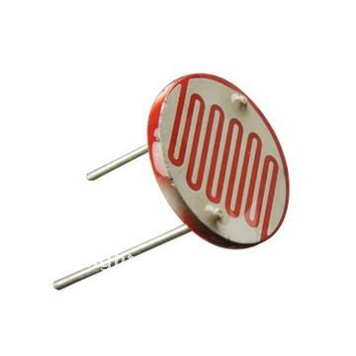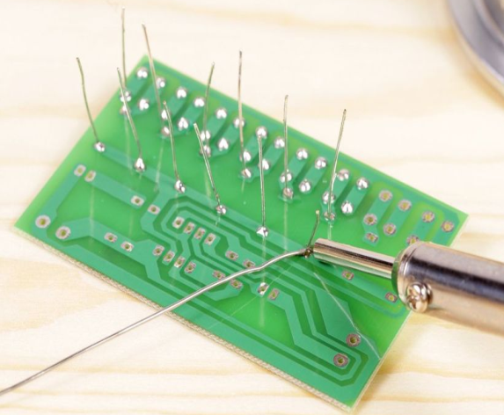

**References: -**

This is a list of external material referred to in the Text. The entries should be numbered in the order in which the references occur. These references are indicated in the text by the use of the number either in superscript3 or bracketed [3] form. This will indicate the complete citation in the reference section. The format of this citation depends on whether it refers to a book or technical paper.

(a) Books: The convention here is: Hengyu Wu, Minli Tang and Guo Huang, "Design of multi-functional street light control system based on AT89S52 single-chip microcomputer," The 2nd International Conference on Industrial Mechatronics and Automation, Wuhan, 2010, pp. 134-137. DOI: 10.1109/ICINDMA.2010.5538068.

(b) Technical Paper:[2019 International Conference on Computational Intelligence and Knowledge Economy (ICCIKE)](https://ieeexplore.ieee.org/xpl/conhome/8976368/proceeding) **Publisher:**IEEE