**ReadMe:**

**The application was developed in Visual Studio 2015 – version 14.0.25.**

**To Run the Application:**

1. Extract the Zip file submitted.

2. Right click on the Microsoft Visual Studio Solution file and open it up with visual studio.

3. Build the project imported into visual studio and then after building run the application.

**Notes:**

* The application requires no user input.
* The number of retailer threads is set to 5 and chicken Farm thread to 1.
* The program was developed using the pseudocode from the book and the one given in the pdf.
* The Price values were calculated using an algorithm defined by the author.
* The Total Amount was calculated in the same format that was given in the requirement.
* The threads are terminated safely once 5 price cuts are made.
* Locks and synchronized statements are used to handle synchronous access to shared buffer
* The Time is calculated using the initial and final time stamp value of the thread which is stored.
* Encoding and Decoding classes have been implemented locally.

**Test Cases:-**

**No INPUT given by the user**

**OUTPUT:-**

**INITIAL PAGE:** 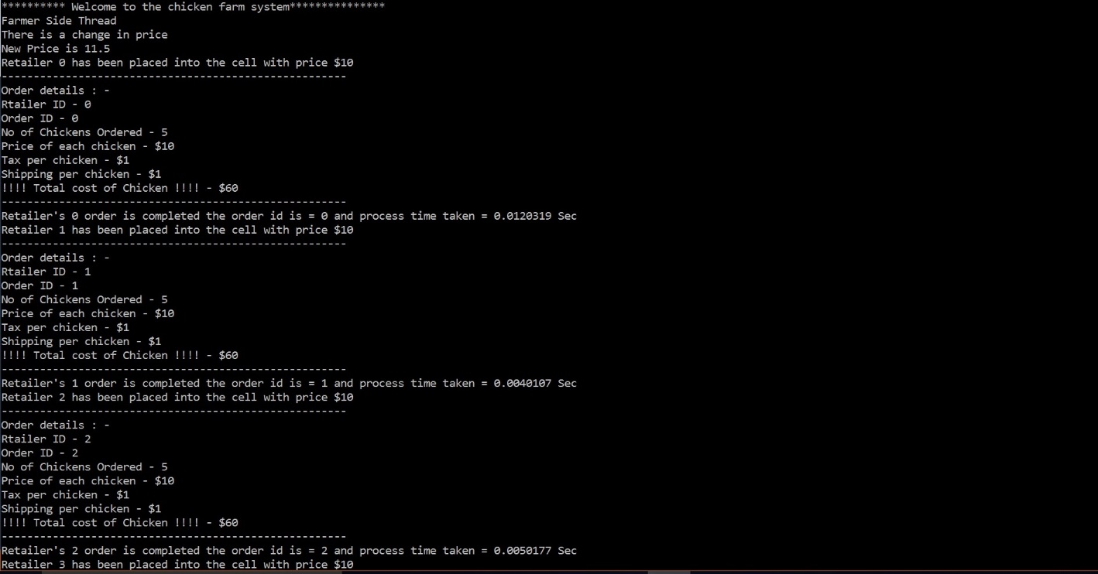

**FINAL PAGE:**

