**ASSIGNMENT – 4**

**Balaji Chandrasekaran**

**1208948451**

**SERVICES IMPLEMENTED:**

The two services that I choose and implemented is

1. VERIFICATION Service.
2. TRANSFORMATION Service.

**GUI of the application:**

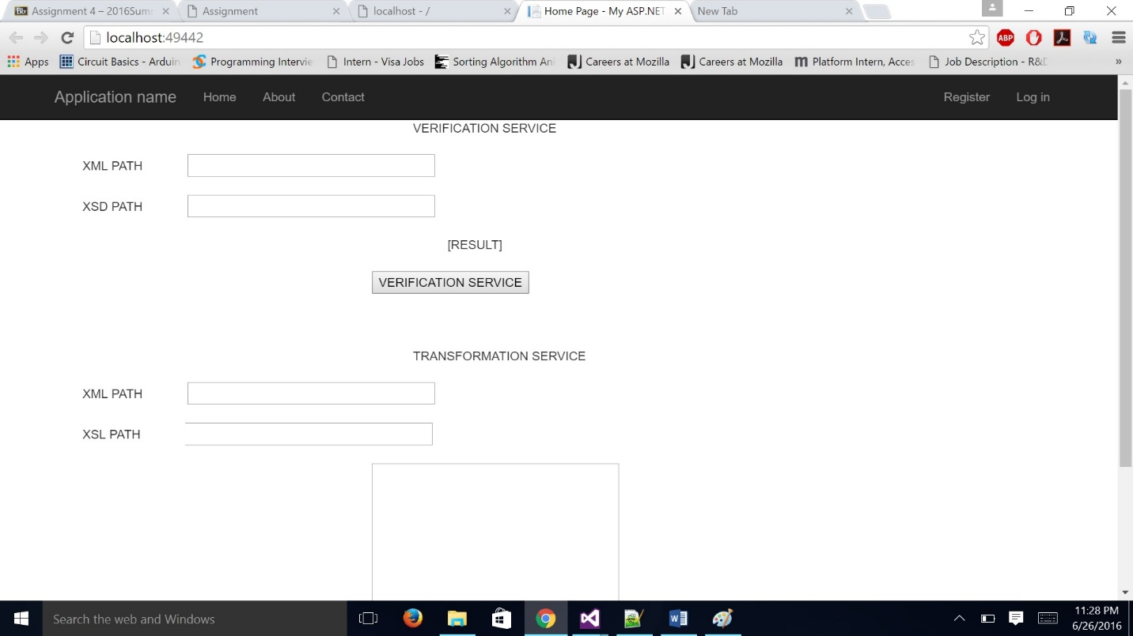

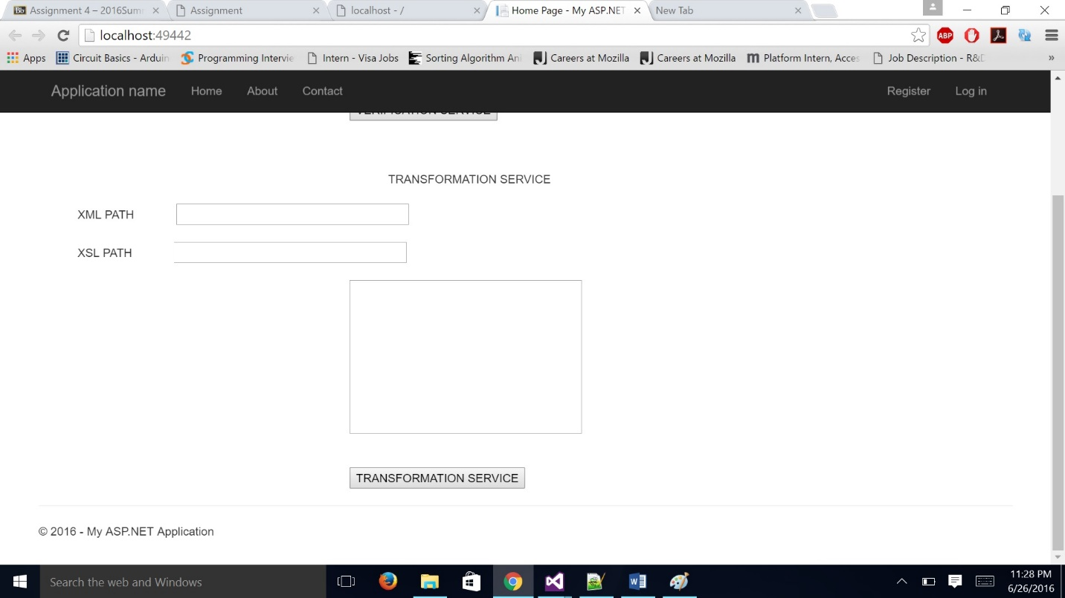

**VERIFICATION SERVICE.**

* In case of Verification service, we pass in the XML file and its XSD schema file and verify whether they both match and that the xml file abides to.

INPUT: XML file location & XSD file location.

XML file location: http://webstrar13.fulton.asu.edu/Persons.xml

XSL file location: <http://webstrar13.fulton.asu.edu/Persons.xsd>

OUTPUT: Whether the verification is a success of failure.

SUCCESS:

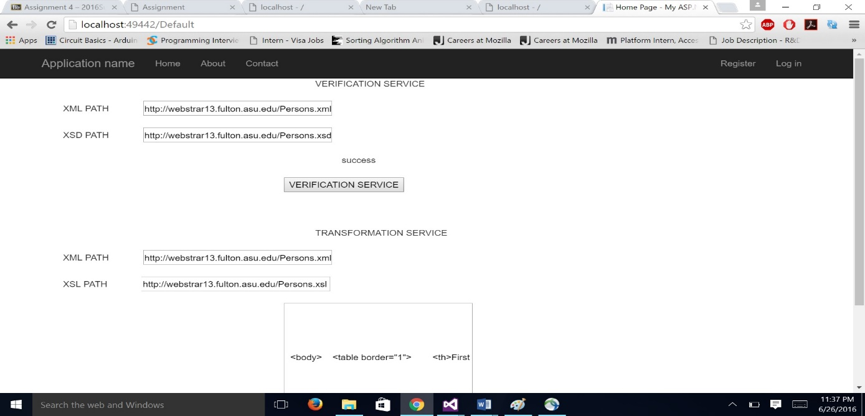

FAILURE:

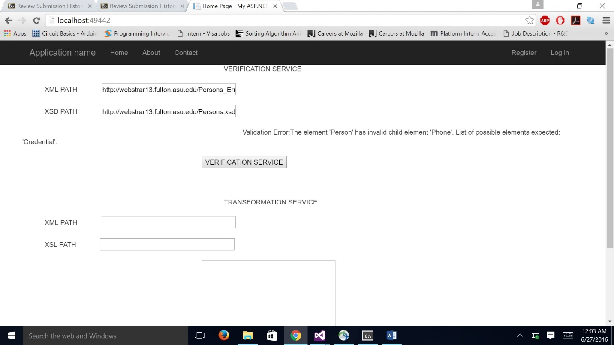

**TRANSFORMATION SERVICE**

In case of transformation service, we convert the given xml using a XSL file and obtain a html file which is used for representing the xml file in a feel good table format.

INPUT: XML file location & XSL file location.

XML file location: http://webstrar13.fulton.asu.edu/Persons.xml

XSL file location: http://webstrar13.fulton.asu.edu/Persons.xsl

OUTPUT: A string which is a html page content.

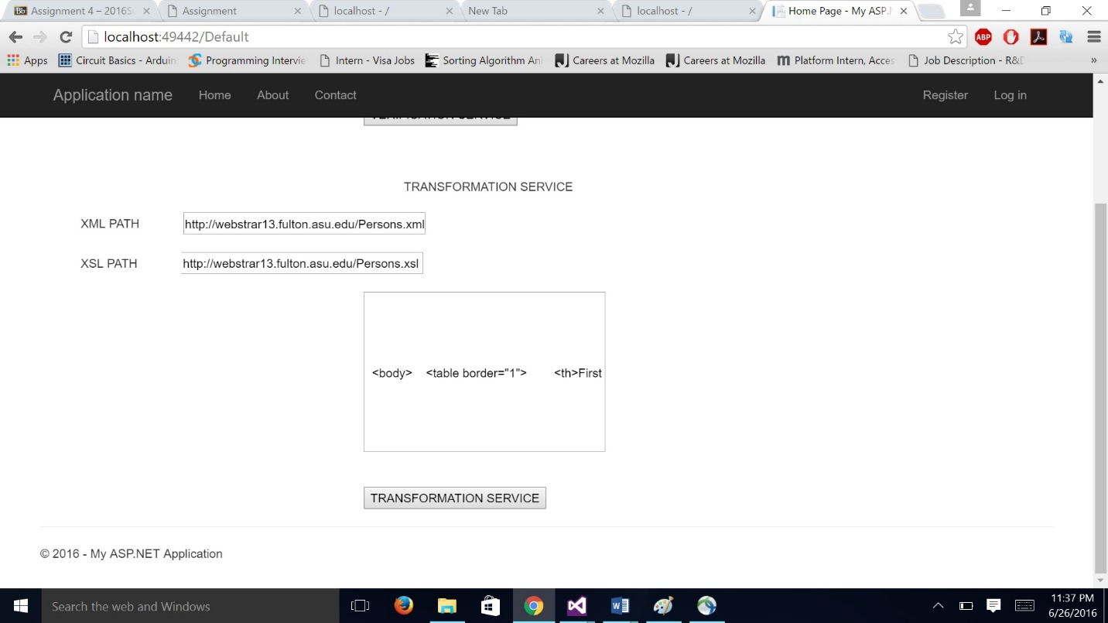

**OUPUT html file executed output:**

