# ENVIRONMENT USED

OS - windows-10

IDE - Netbeans

GlassFISH Server 4.1.1

# INSTRUCTIONS FOR EXECUTING

1. Extract the zip files and just open them both in Netbean.
2. After importing the files Just Right Click the project named

CSE564_HATEAOS_bchandr6_AppealSystemServer and click run. This will start the server.

1. Select the server as GlassFish 4.1.1.
2. After the server starts run the client.
3. A webpage will be displayed like below after the server starts.

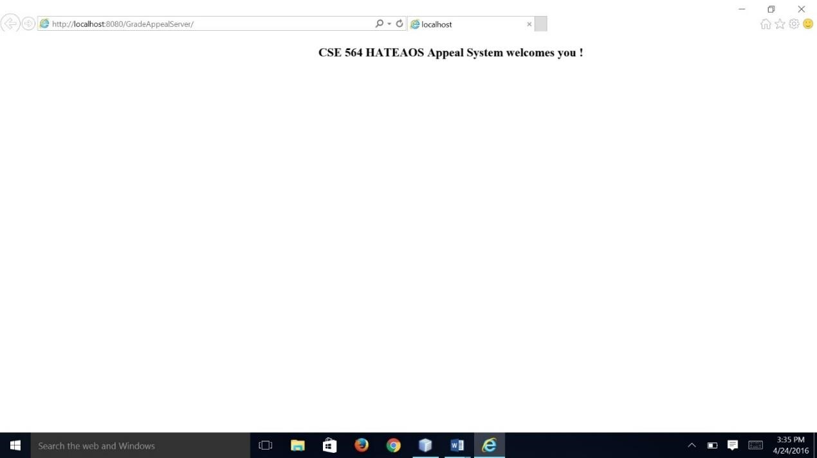

1. After the page is displayed right click and run the client.

(CSE564_HATEAOS_bchandr6_AppealSystemClient)

1. If asks for a main class choose the main class in the following package “com.mycompany.gradeappealclient.client”.
2. The client will do the necessary task and display in the console the output.

REFERENCES: - HATEAOS PROJECT GIVEN BY PROFESSOR.

