ENVIRONMENT USED

OS - windows-10

IDE - Eclipse Mars.1 Release (4.5.1)

APACHE - TOMCAT v8.0

TOMCAT Working Directory Folder – “JSON/FoodItemData.json”

INSTRUCTIONS FOR EXECUTING

1. Import the POX-FoodMenu-1208948451-Eclipse.zip file into the Eclipse IDE by extracting and importing by FILE->IMPORT->EXSISTING PROJECT INTO WORKSPACE.
2. Just Right Click the project and click run on server.
3. The Client side will open in the browser in eclipse (Note:- copy the link from the browser to any external browser to execute there)
4. Enter the Input in the “POST Request” BOX and HIT “SEND”.

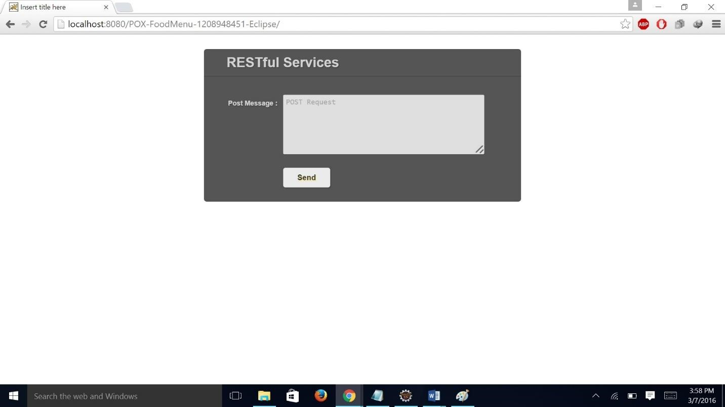

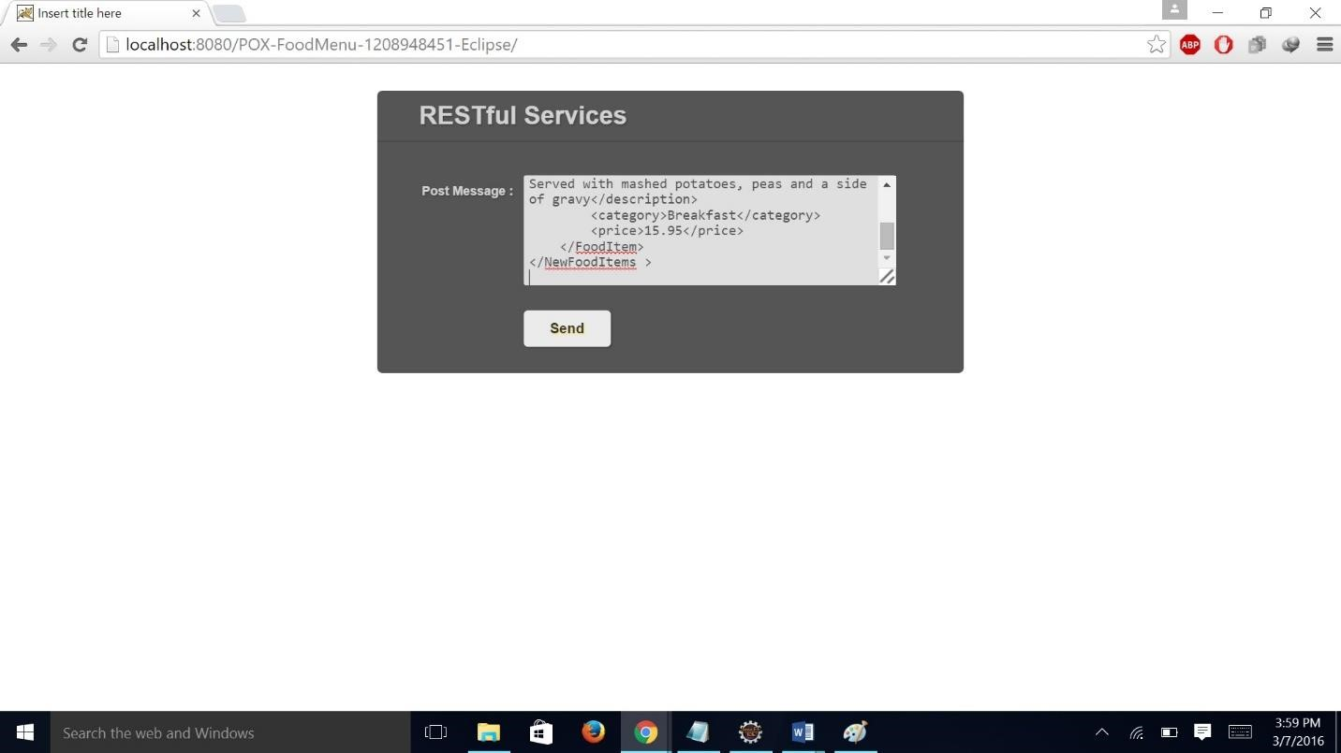

1. Has you hit the BUTTON the client will send the info and the server will process it and return the output as desired.

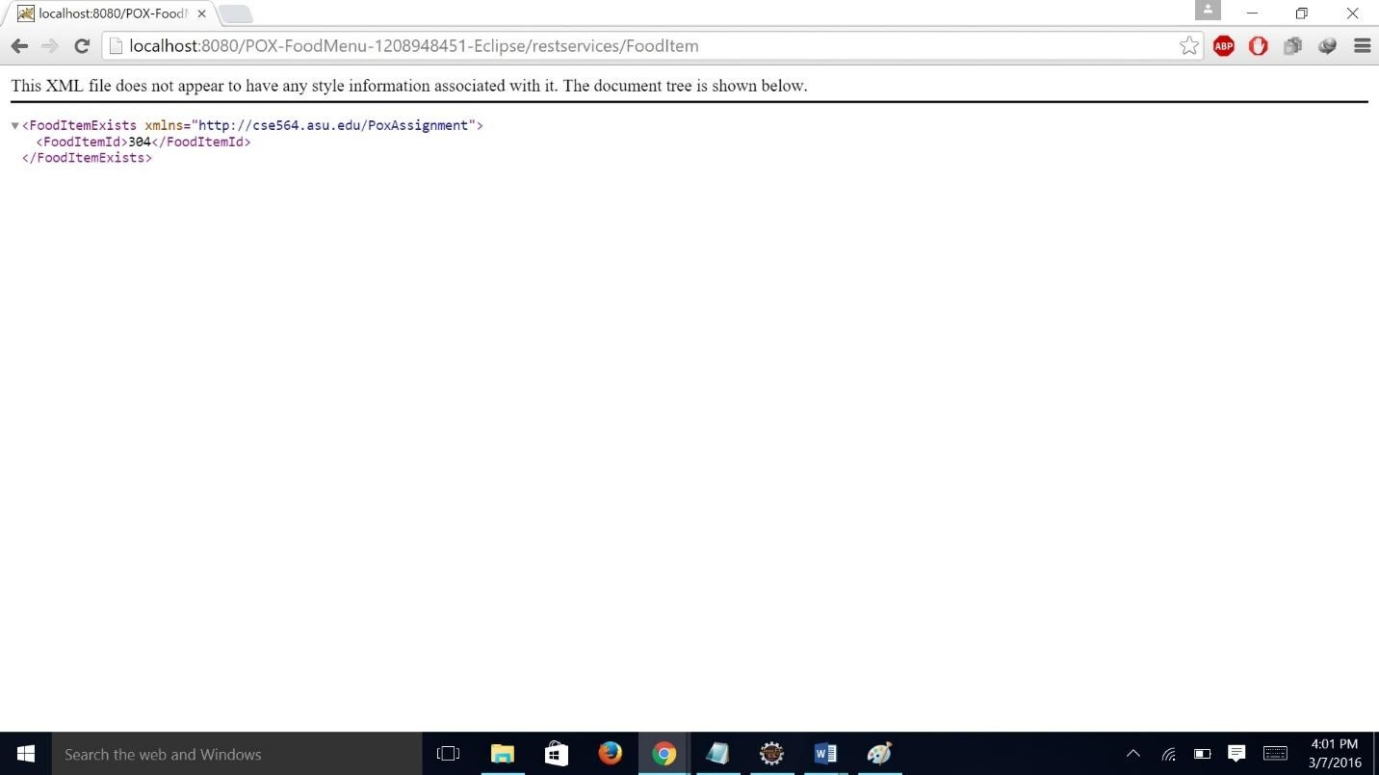

1. If you want to test for more input hit the back button and repeat the steps 4 & 5.
2. **Please Place the .json file in the current working directory of TOMCAT by creating a folder inside the directory as “JSON” and placing the .json file inside it, for the application to work else it will throw “File Not Found Exception”.**
3. You Can Even see the output in console of eclipse about the input and the function being executed.
4. Please make sure while giving input give it in proper format or else it won’t be processed.

Eg:-

“- give proper quotes as it was wrong in the given example file “POX over

HTTP.doc”

Space- check for space before xmlns.

Example:- (proper ones)

**To Retrieve Items:-**

<SelectedFoodItems xmlns="http://cse564.asu.edu/PoxAssignment">

<FoodItemId>100</FoodItemId>

<FoodItemId>304</FoodItemId>

</SelectedFoodItems>

**Invalid Retrieve:-**

<SelectedFoodItems xmlns="http://cse564.asu.edu/PoxAssignment">

<FoodItemId>600</FoodItemId>

</SelectedFoodItems>

**To Add Items:-**

**Unsuccessful add:-**

<NewFoodItems xmlns="http://cse564.asu.edu/PoxAssignment">

<FoodItem country="GB">

<name>Cornish Pastry</name>

<description>Tender cubes of steak, potatoes and swede wrapped in flakey short crust pastry. Seasoned with lots of pepper. Served with mashed potatoes, peas and a side of gravy</description>

<category>Breakfast</category>

<price>15.95</price>

</FoodItem>

</NewFoodItems >

**Successful add:-**

<NewFoodItems xmlns="http://cse564.asu.edu/PoxAssignment">

<FoodItem country="IN">

<name>CDosa</name>

<description>Tender cubes of steak, potatoes and swede wrapped in flakey short crust pastry.

Seasoned with lots of pepper. Served with mashed potatoes, peas and a side of gravy</description> <category>Breakfast</category>

<price>15.95</price>

</FoodItem>

</NewFoodItems >