Task 1 Report
- Add Task Description
- Attach Screenshot Of Output.
- Describe Widget/Algorithm Used In Task

- Task Description
Develop a role-based authorization system to control access to routes or components based on user roles(e.g., admin, user, guest). Implement checks to ensure users can only access authorized areas. Redirect unauthorized users or display an error message.

- Task Output Screenshot
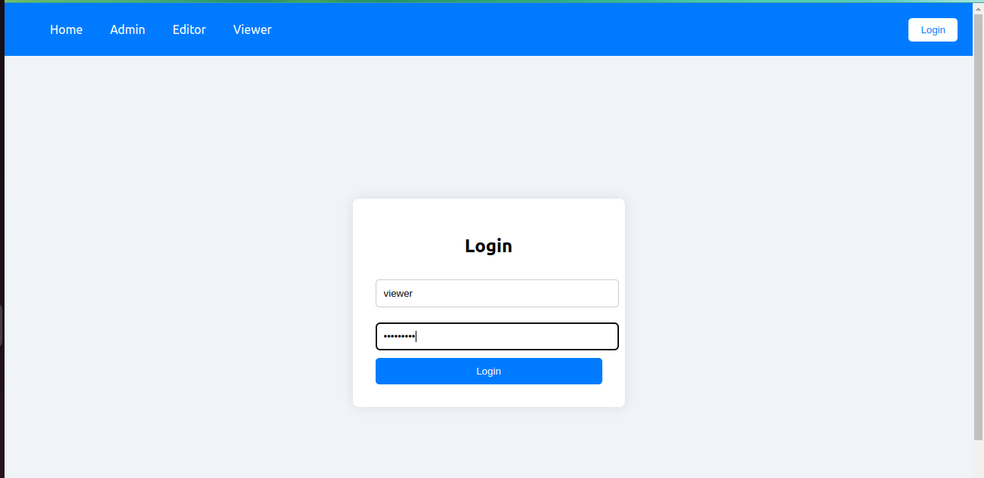

3. Widget/Algorithms Used in Task
- Middleware/Route Guards: Implemented using the ProtectedRoute component, which intercepts route requests and checks the user’s role before granting access to pages like Admin, Editor, and Viewer.
- Role-Permission Mapping: Managed through the users.js file, where each user has a predefined role (admin, editor, viewer) that determines access to specific pages.
- Authentication Algorithm: The login system matches the username and password with stored credentials using React's state management.
- Access Control Logic: Conditional checks in ProtectedRoute allow or deny access based on the user's role, ensuring only authorized users can view protected content.

