Task 2 Report
- Add Task Description
- Attach Screenshot Of Output.
- Describe Widget/Algorithm Used In Task

- Task Description
Build a dynamic form that allows users to add or remove input fields based on their interaction (e.g., clicking "Add" or "Remove"). Implement logic to handle varying numbers of fields and validate user inputs dynamically. Ensure the form is responsive and user-friendly.

- Task Output Screenshot
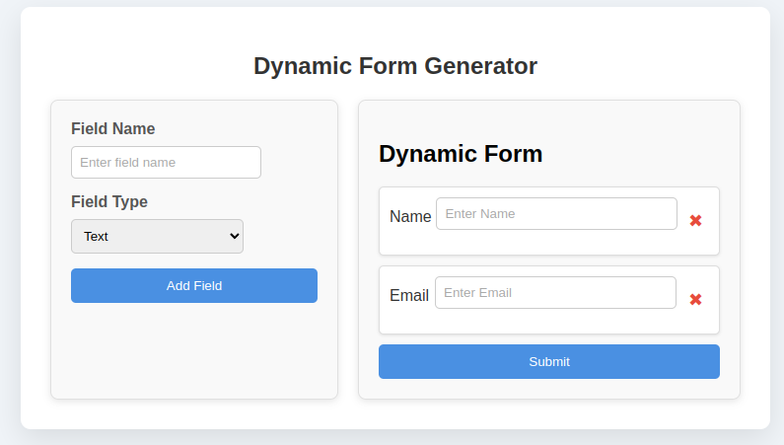

3. Widget/Algorithms Used
- State Management: Used React’s useState hook to manage dynamic input fields, storing and updating field values as needed.
- Event Handling: Implemented onChange events to capture and update input values in real-time.
- Dynamic Rendering Algorithm: Conditional rendering of input fields based on user actions (like adding or removing fields).
- Array Mapping: Utilized JavaScript's map() function to iterate over input fields stored in state and render them dynamically.
- Validation Logic: Added field-level checks to ensure correct input types or required values before submission.

