Task4 Report
- Add Task Description
- Attach Screenshot Of Output.
- Describe Widget/Algorithm Used In Task

- Task Description
Build a multi-step form that guides users through different sections, each requiring input before progressing. Implement validation at each step to ensure all required fields are filled out correctly before moving to the next section. Provide navigation buttons (Next, Previous) for smooth transitions between steps. Ensure form data is stored persistently across steps until final submission.

- Task Output Screenshot
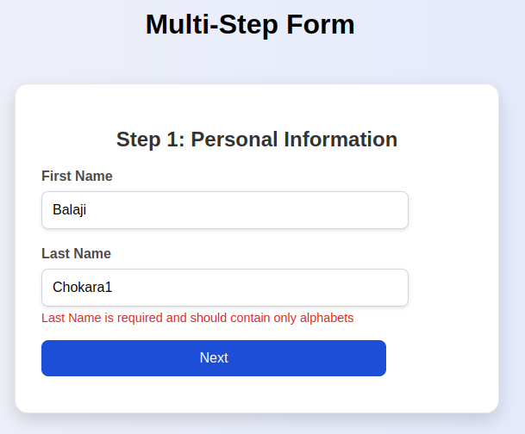

3. Widget/Algorithms Used
- State Management: Utilized React's useState hook to manage form data and track the current step of the multistep form.
- Step Navigation Logic: Implemented functions to navigate between form steps, updating the current step based on user actions (e.g., "Next" and "Previous" buttons).
- Conditional Rendering: Used conditional rendering to display only the active step's form fields, ensuring a clean user interface.
- Validation Schema: Applied a validation library (like Yup) or custom validation functions to validate inputs for each step before proceeding to the next.
- Submission Handling: Implemented a final submission handler that compiles data from all steps and performs a complete validation check before sending to the server.
- Feedback Mechanism: Provided visual feedback (e.g., error messages, success indicators) for validation errors at each step to enhance user experience.

