Task5 Report
- Add Task Description
- Attach Screenshot Of Output.
- Describe Widget/Algorithm Used In Task

- Task Description
Develop a Password Validator that evaluates password strength in real time, classifying them as Good, Very Good, Strong, or Excellent based on criteria such as length and character variety. It checks for uppercase and lowercase letters, numbers, and special characters while providing immediate visual feedback to help users enhance their password security.

- Task Output Screenshot
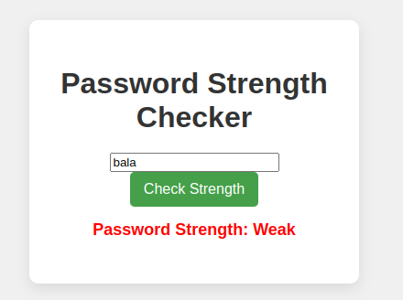

3. Widget/Algorithms Used in Task for Password Validator (JavaScript)
- State Management: Utilized variables to track the password input and its validation status within the form.
- Regular Expressions: Implemented regex patterns to validate password criteria such as minimum length, uppercase letters, numbers, and special characters.
- Validation Logic: Created functions that validate the password input on key events (e.g., oninput or onchange) to provide real-time feedback.
- Feedback Mechanism: Used DOM manipulation to display visual indicators (like green checkmarks or red crosses) next to each password requirement based on validation status.
- Strength Calculation: Developed a scoring algorithm to evaluate the password strength based on criteria met, enhancing user awareness of security.
- Error Messaging: Displayed clear error messages for each validation rule that is not satisfied, guiding users to create a stronger password.

