Task3 Report
- Add Task Description
- Attach Screenshot Of Output.
- Describe Widget/Algorithm Used In Task

- Task Description
Develop a todo list app using Redux for state management, allowing users to add, remove, and mark tasks as complete. Implement actions and reducers to handle task operations and store the todo state centrally. Ensure the app has a clear UI to display active and completed tasks. Use Redux to ensure efficient updates and state persistence across the app.

- Task Output Screenshot
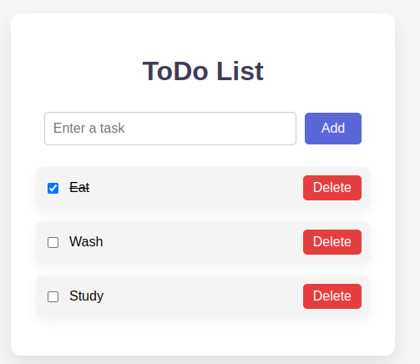

- Widget/algorithms Used In Task
- Input Field & Buttons: To add tasks and trigger actions (e.g., Add, Remove, Mark Complete.
- Redux Store: Centralized state management for storing tasks and their statuses.
- Actions & Reducers: Algorithms to handle task addition, removal, and status updates in Redux.
- Conditional Rendering: To display tasks as active or completed based on their status.

