K.BALAJI
192324180
SIMATS ENGINEERING
ASSESSMENT TOOL 3 – Assignment 2

COURSE NAME: STATISTICS WITH R PROGRAMMING COURSE CODE: ITA04

COURSE OUTCOME COVERED

CO3: Construct and manipulate data frames using reshaping, merging, and file I/O operations in R to prepare structured datasets for analysis.. (BL3, BL5)

Assessment Tool Weightage: 20%

QUESTIONS: 5 Total Marks: 100

Annexure
Assignment 2
Code of Conduct:
I K.BALAJI/192324180(Name / Reg No) certify that this submission is my original work and that I have adhered to the guidelines specified for this assessment.
I understand that any violation of academic integrity rules will result in disciplinary action.

Signature of the student:
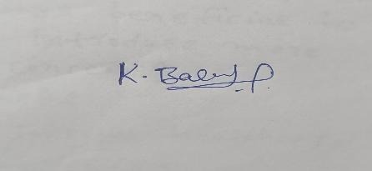

1)How does daily Air Quality Index (AQI) change over time in different cities, and does it show an overall increasing or decreasing trend?
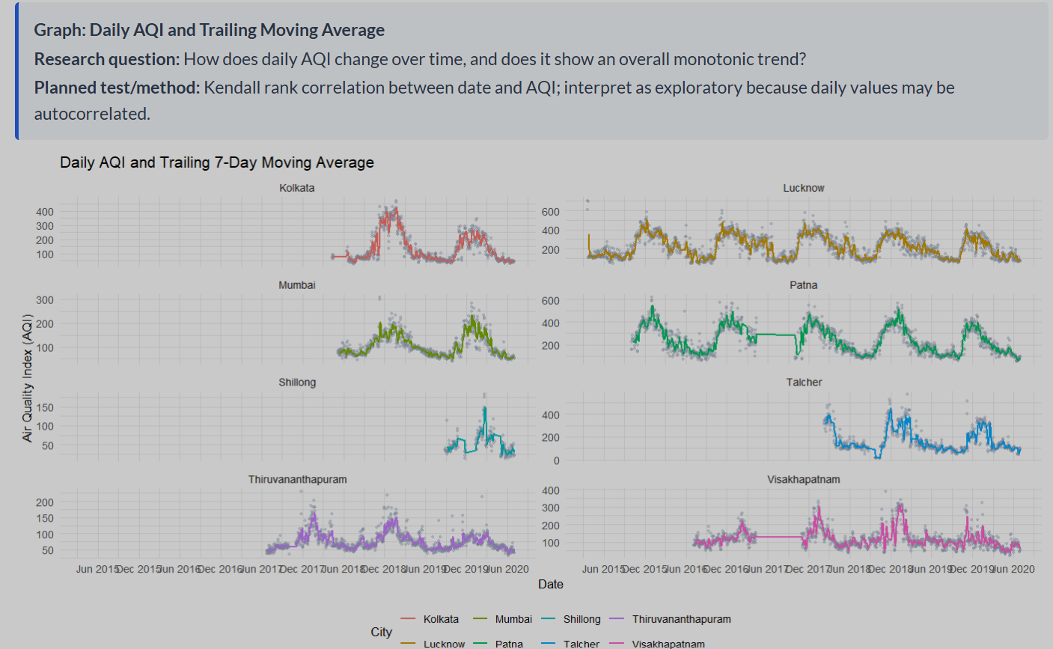
1. Graph type
Graph name: Daily AQI and Trailing 7-Day Moving Average
Graph type: Time-series line chart with scatter points, using faceted plots for different cities.
- X-axis: Date
- Y-axis: Air Quality Index (AQI)
- Grey dots: Daily AQI observations
- Colored line: Trailing 7-day moving average
- Multiple panels: Each panel represents a different city.
2. Formula used
The main formula is the 7-day moving average.
$$MA_{t}=\frac{1}{7}\sum_{i=0}^{6}{A}QI_{t-i}$$Where:
- \(MA_t\) = moving average on the current day.
- \(AQI_t\) = AQI on the current day.
Kendall Rank Correlation Formula
$$τ=\frac{C-D}{\left({n \atop 2}\right)}=\frac{2\left(C-D\right)}{n\left(n-1\right)}$$
Where:
- \(\tau\) = Kendall rank correlation coefficient.
- \(C\) = Number of concordant pairs.
- \(D\) = Number of discordant pairs.
- \(n\) = Number of observations, assuming no tied pairs for this simplified formula.

CODE:

library(ggplot2)
library(dplyr)
library(zoo)
aqi_data$Date <- as.Date(aqi_data$Date)
aqi_data <- aqi_data %>%
arrange(City, Date) %>%
group_by(City) %>%
mutate(
Moving_Average = rollmean(
AQI, k = 7, fill = NA, align = "right"
)
) %>%
ungroup()
ggplot(aqi_data, aes(x = Date, y = AQI)) +
geom_point(color = "grey50", alpha = 0.5) +
geom_line(
aes(y = Moving_Average, color = City),
linewidth = 0.8
) +
facet_wrap(~City, scales = "free_y") +
labs(
title = "Daily AQI and Trailing 7-Day Moving Average",
x = "Date",
y = "Air Quality Index (AQI)",
color = "City"
) +
theme_minimal()
2) How do monthly mean AQI levels evolve through time across different cities?
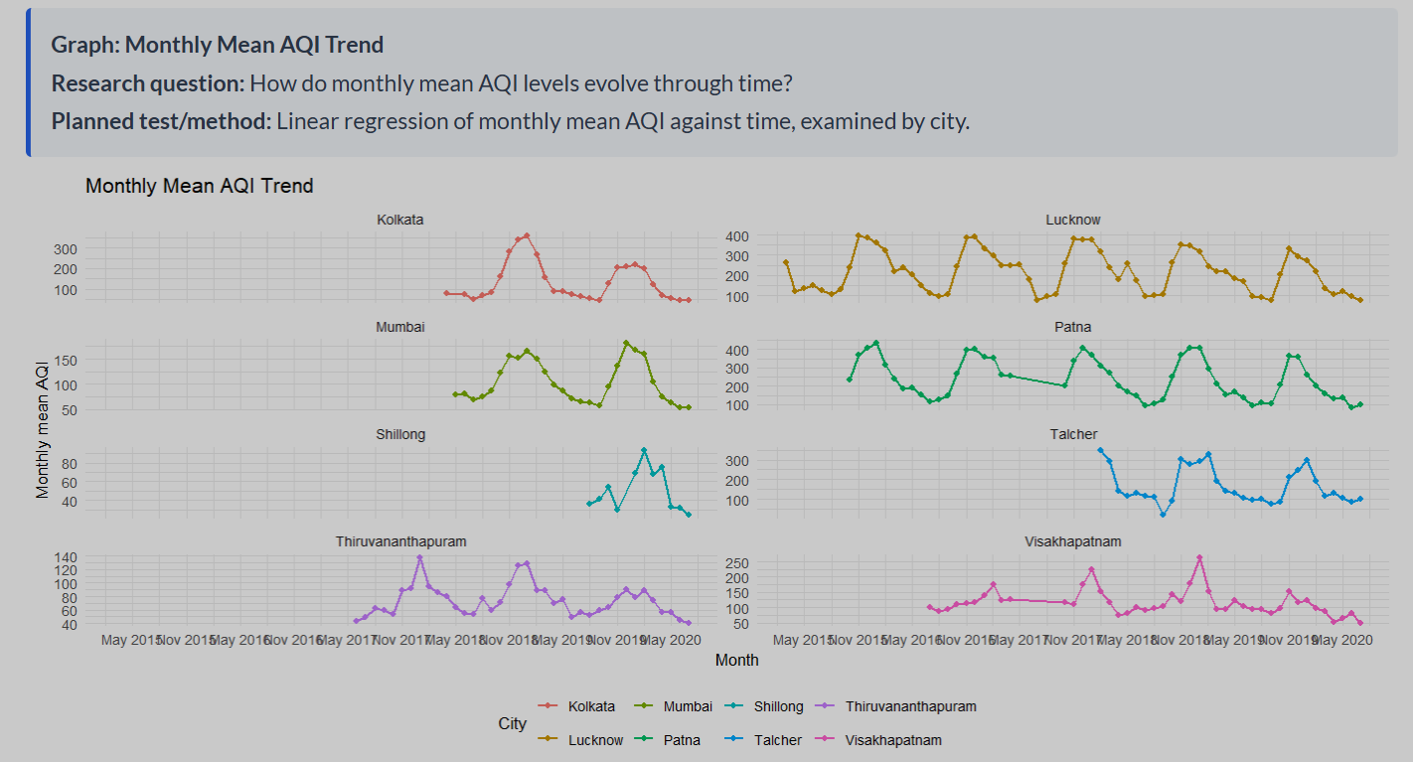
3. Formula used
The main formula is the Monthly Mean AQI.
$${\overline{AQI}}_{m}=\frac{1}{n_{m}}\sum_{i=1}^{n_{m}}{A}QI_{i}$$
Where:
- \(\overline{AQI}_m\) = Mean AQI for a particular month.
- \(AQI_i\) = Daily AQI value for each valid observation in that month.
- \(n_m\) = Number of valid daily AQI observations in that month.

4. Statistical method: Linear regression
- Your graph description also mentions linear regression to examine the trend over time.
$${\overline{AQI}}_{t}=β_{0}+β_{1}t+ε_{t}$$
Where:
- \(\overline{AQI}_t\) = Monthly mean AQI at time \(t\).
- \(\beta_0\) = Intercept.
- \(\beta_1\) = Estimated change in monthly mean AQI per month.
- \(t\) = Time index, such as 1, 2, 3, and so on.
- \(\varepsilon_t\) = Random error.
CODE:
library(dplyr)
library(ggplot2)
library(lubridate)
aqi_data$Date <- as.Date(aqi_data$Date)
monthly_data <- aqi_data %>%
filter(!is.na(Date), !is.na(AQI)) %>%
mutate(Month = floor_date(Date, "month")) %>%
group_by(City, Month) %>%
summarise(
Mean_AQI = mean(AQI),
.groups = "drop"
)
ggplot(monthly_data,
aes(x = Month, y = Mean_AQI,
color = City, group = City)) +
geom_line() +
geom_point() +
facet_wrap(~City, scales = "free_y") +
labs(
title = "Monthly Mean AQI Trend",
x = "Month",
y = "Monthly Mean AQI"
) +
theme_minimal()
3) Does the Air Quality Index (AQI) distribution vary significantly between the years 2015 and 2020?
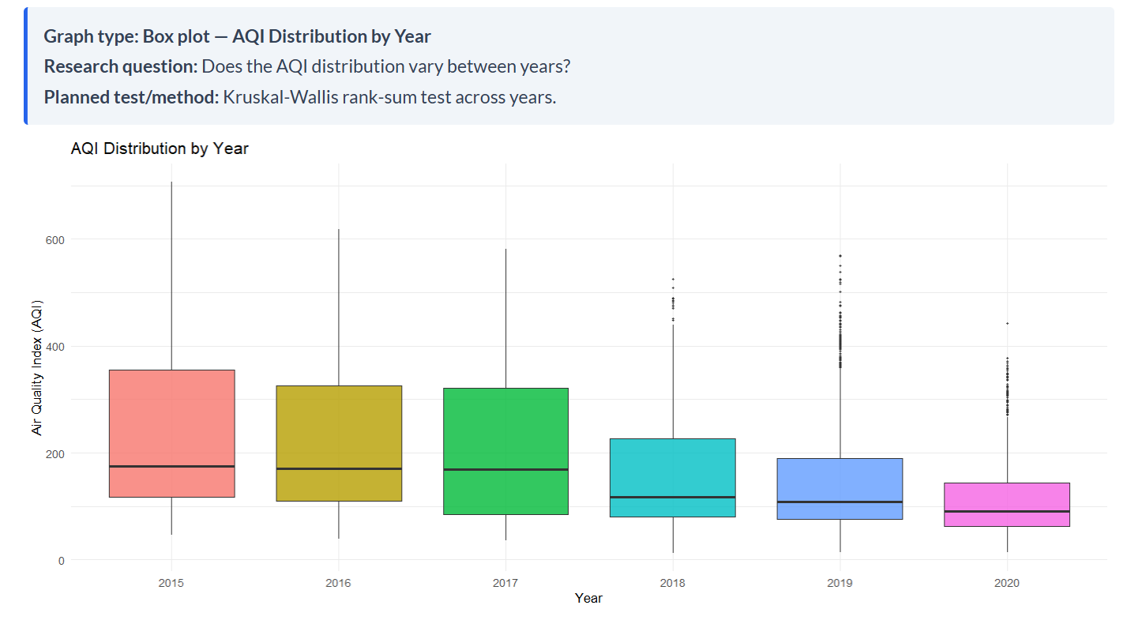
2. Formula Used
A. Box plot formulas
A box plot uses quartiles to summarize the AQI distribution.
Measure | Formula / Meaning
First quartile (\(Q_1\)) | 25th percentile
Median (\(Q_2\)) | 50th percentile
Third quartile (\(Q_3\)) | 75th percentile
Interquartile range (IQR) | \(IQR=Q_3-Q_1\)
Lower outlier boundary | \(Q_1-1.5(IQR)\)
Upper outlier boundary | \(Q_3+1.5(IQR)\)
Values outside the outlier boundaries are generally displayed as individual points.
B. Kruskal–Wallis test formula
$$H=\frac{12}{N\left(N+1\right)}\sum_{i=1}^{k}{\frac{R_{i}^{2}}{n_{i}}}-3\left(N+1\right)$$
Where:
- \(H\) = Kruskal–Wallis test statistic
- \(N\) = Total number of observations across all years
- \(k\) = Number of groups (here, 6 years)
- \(n_i\) = Number of AQI observations in year \(i\)
- \(R_i\) = Sum of the ranks for year \(i\)

CODE:
import pandas as pd
import matplotlib.pyplot as plt
import seaborn as sns
from scipy.stats import kruskal
df=pd.read_csv("your_aqi_dataset.csv")
df=df[['Year','AQI']].dropna()
df['Year']=df['Year'].astype(int)
df=df[df['Year'].between(2015,2020)]
plt.figure(figsize=(12,6))
sns.boxplot(data=df,x='Year',y='AQI')
plt.title('AQI Distribution by Year')
plt.xlabel('Year')
plt.ylabel('Air Quality Index (AQI)')
plt.grid(axis='y',alpha=0.3)
plt.tight_layout()
plt.show()
groups=[g['AQI'].values for _,g in df.groupby('Year') if len(g)>0]
statistic,p_value=kruskal(*groups)
print("Kruskal-Wallis Statistic:",statistic)
print("P-value:",p_value)
if p_value<0.05:
print("AQI distributions differ significantly.")
else:
print("No significant difference in AQI distributions.")
4) Is the annual mean AQI increasing or decreasing over the study period?
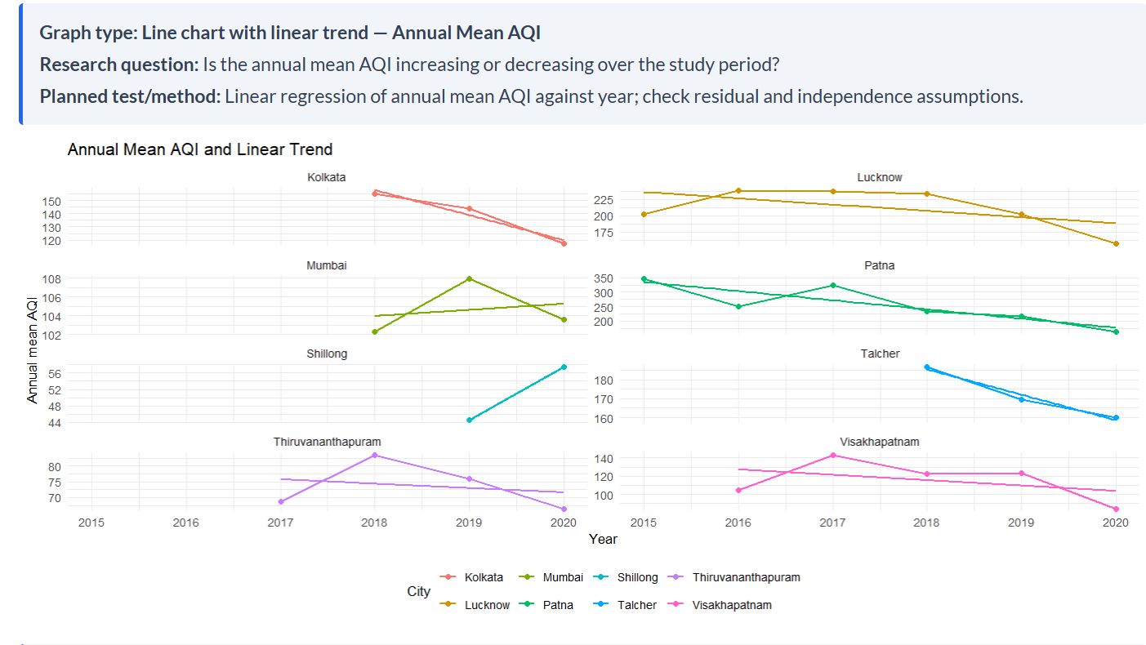
Formula Used
Linear Regression:
$$y=a+bx$$
• \(y\) = Annual mean AQI
• \(x\) = Year
• \(a\) = Intercept
• \(b\) = Slope (increasing or decreasing trend)
Slope formula:
$$b=\frac{\sum{\left(x_{i}-\overline{x}\right)}\left(y_{i}-\overline{y}\right)}{\sum{{\left(x_{i}-\overline{x}\right)}^{2}}}$$
CODE:
import pandas as pd
import matplotlib.pyplot as plt
import seaborn as sns
from scipy.stats import linregress

df=pd.read_csv("your_aqi_dataset.csv")
df=df[['City','Year','AQI']].dropna()
df=df[df['Year'].between(2015,2020)]
data=df.groupby(['City','Year'])['AQI'].mean().reset_index()
cities=data['City'].unique()
fig,axes=plt.subplots(4,2,figsize=(14,10))
axes=axes.flatten()
for i,city in enumerate(cities):
d=data[data['City']==city]
x=d['Year']
y=d['AQI']
axes[i].plot(x,y,marker='o',label='Annual Mean AQI')
if len(d)>1:
r=linregress(x,y)
axes[i].plot(x,r.intercept+r.slope*x,label='Linear Trend')
print(city,"Slope:",round(r.slope,2),"P-value:",round(r.pvalue,4))
axes[i].set_title(city)
axes[i].set_xlabel('Year')
axes[i].set_ylabel('Annual Mean AQI')
axes[i].legend()
axes[i].grid(True,alpha=0.3)
for j in range(len(cities),len(axes)):
fig.delaxes(axes[j])
plt.suptitle('Annual Mean AQI and Linear Trend')
plt.tight_layout()
plt.show()
5) Has the proportion of days in each AQI health category changed over time?
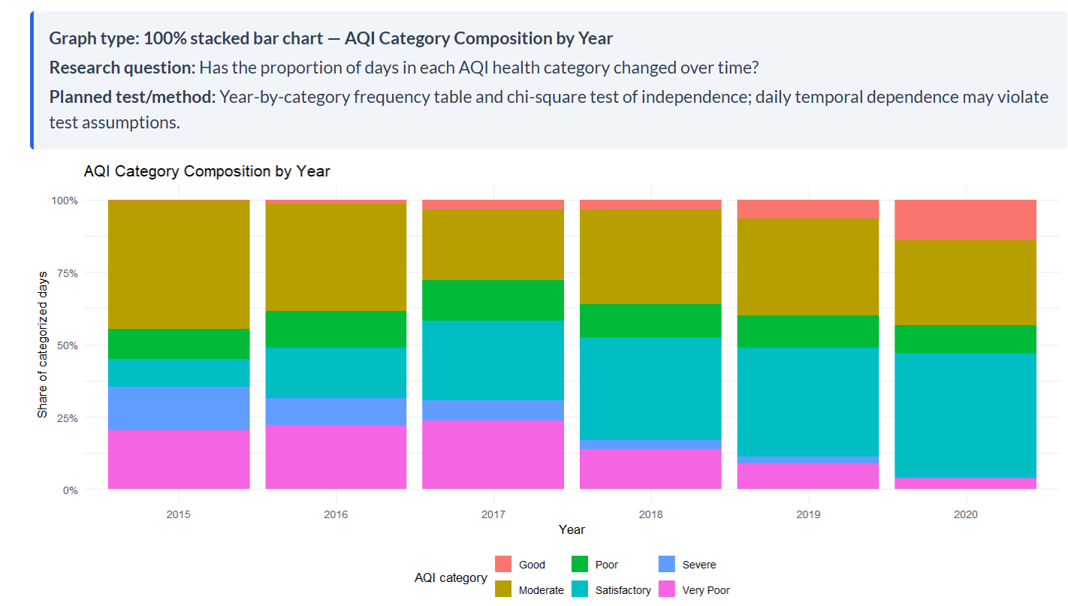
Formula Used
Percentage of each AQI category:
$$\text{Percentage}=\frac{\text{Days in category}}{\text{Total days in year}}×100$$
Chi-square test of independence:
$$χ^{2}=\sum{\frac{{\left(O-E\right)}^{2}}{E}}$$
Where \(O\) = observed frequency and \(E\) = expected frequency.
CODE:
import pandas as pd
import matplotlib.pyplot as plt
from scipy.stats import chi2_contingency

df=pd.read_csv("your_aqi_dataset.csv")
df=df[['Year','AQI']].dropna()
df=df[df['Year'].between(2015,2020)]
bins=[-float('inf'),50,100,200,300,400,float('inf')]
labels=['Good','Satisfactory','Moderate','Poor','Very Poor','Severe']
df['Category']=pd.cut(df['AQI'],bins=bins,labels=labels)
table=pd.crosstab(df['Year'],df['Category'])
percentage=table.div(table.sum(axis=1),axis=0)*100
percentage.plot(kind='bar',stacked=True,figsize=(12,6),colormap='hsv')
plt.title('AQI Category Composition by Year')
plt.xlabel('Year')
plt.ylabel('Share of Categorized Days (%)')
plt.legend(title='AQI Category',bbox_to_anchor=(1.02,1))
plt.tight_layout()
plt.show()
chi2,p,dof,expected=chi2_contingency(table)
print("Chi-square Statistic:",chi2)
print("P-value:",p)
print("Degrees of Freedom:",dof)
if p<0.05:
print("AQI category proportions changed significantly over time.")
else:
print("No significant association between year and AQI category.")

