1. Set the global configuration file with your user name, email and editor as Notepad++. List all the properties which you just set.

* git config –global user.name “username”
* git config –global user.email “emailid”
* git config –global core.editor “notepad++”

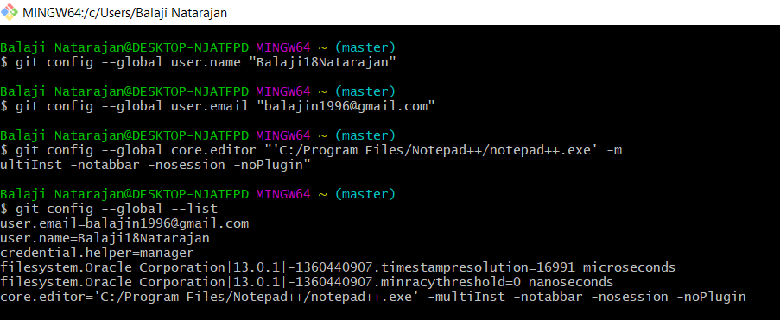

1. Make a fresh Git project

* git init

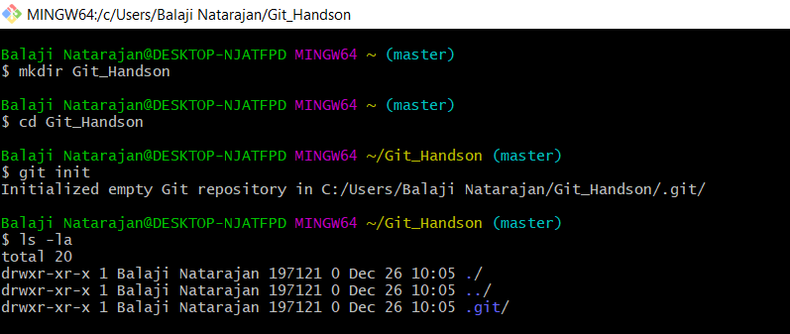

1. Create a Github account (Or use the account if already registered). Clone a project from the remote repository to your local repository

* git clone <git url>

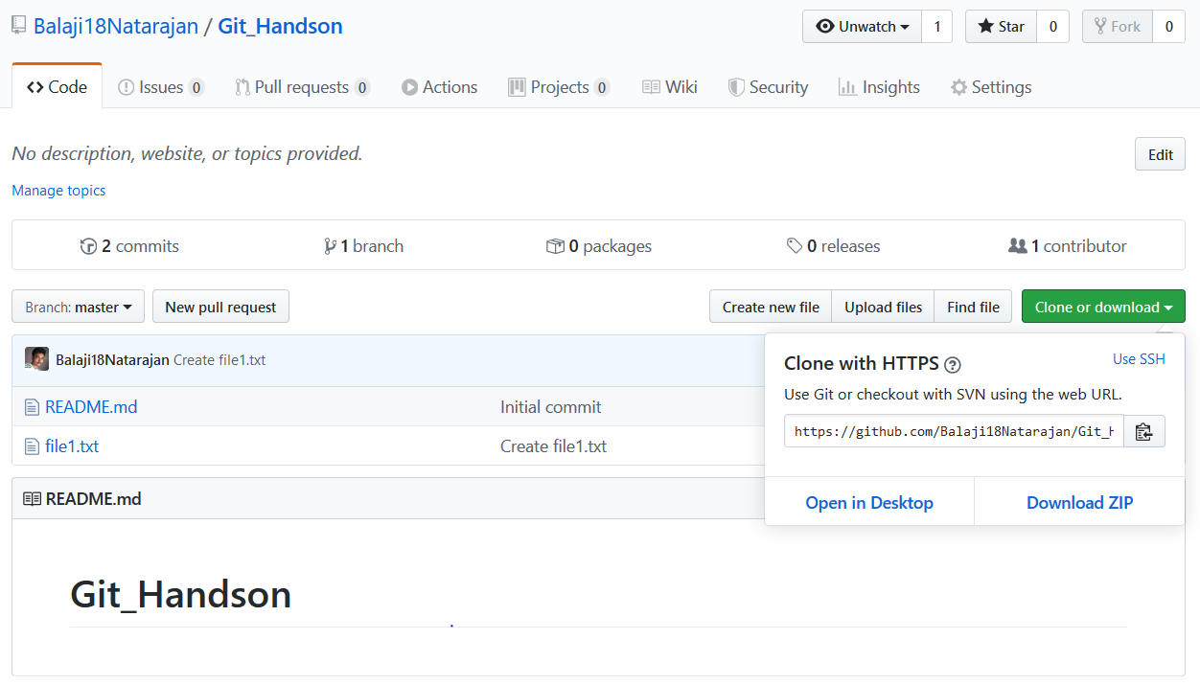

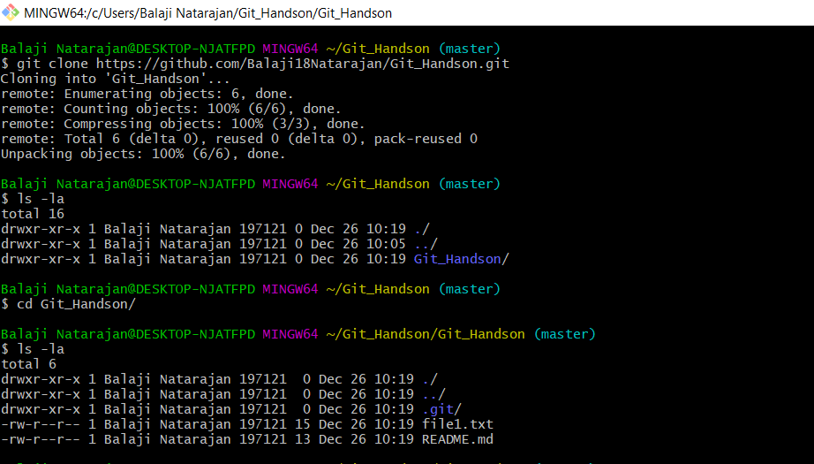

1. Push the project created in assignment 2 to the remote repository.

* git add .
* git commit -m “commit message”
* git push <remote> <branch>

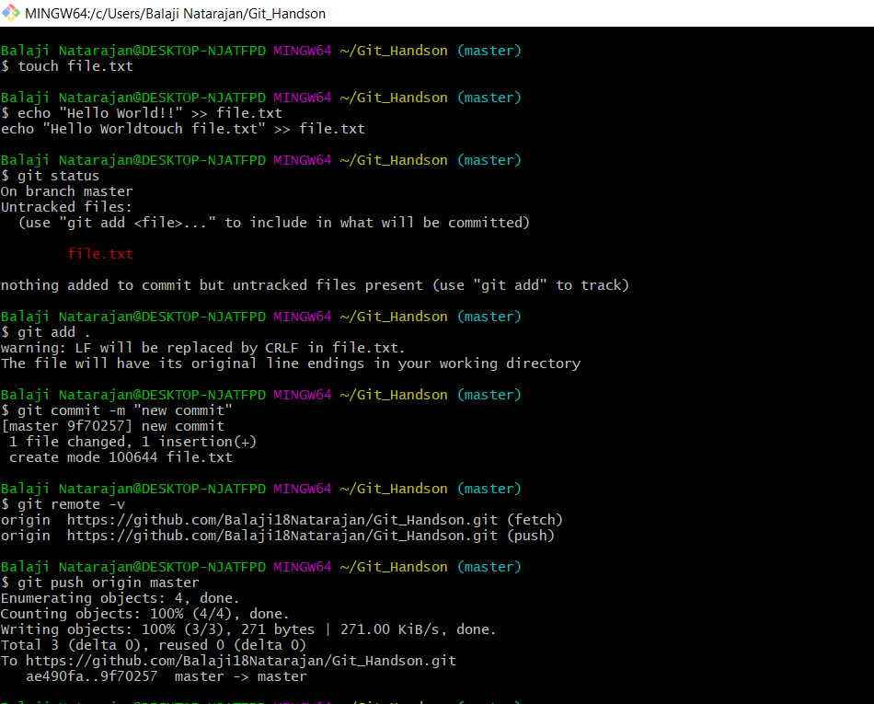

1. Use the different ways of renaming and moving files

* git mv [-v] [-k] source destination  
    
  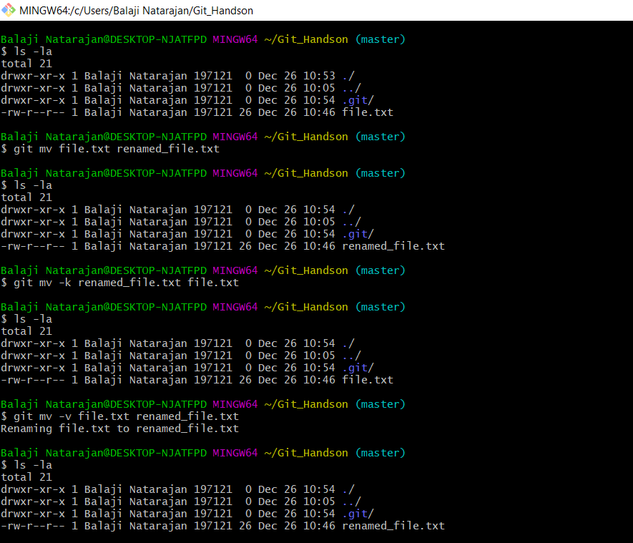

1. You just created a new file, but then you decided that the file is to be removed. How do you delete this untracked file?

* rm new_file

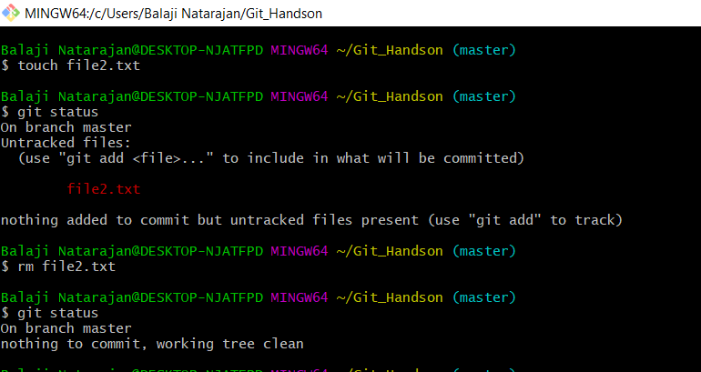

1. Demonstrate the following:
2. delete of a tracked file

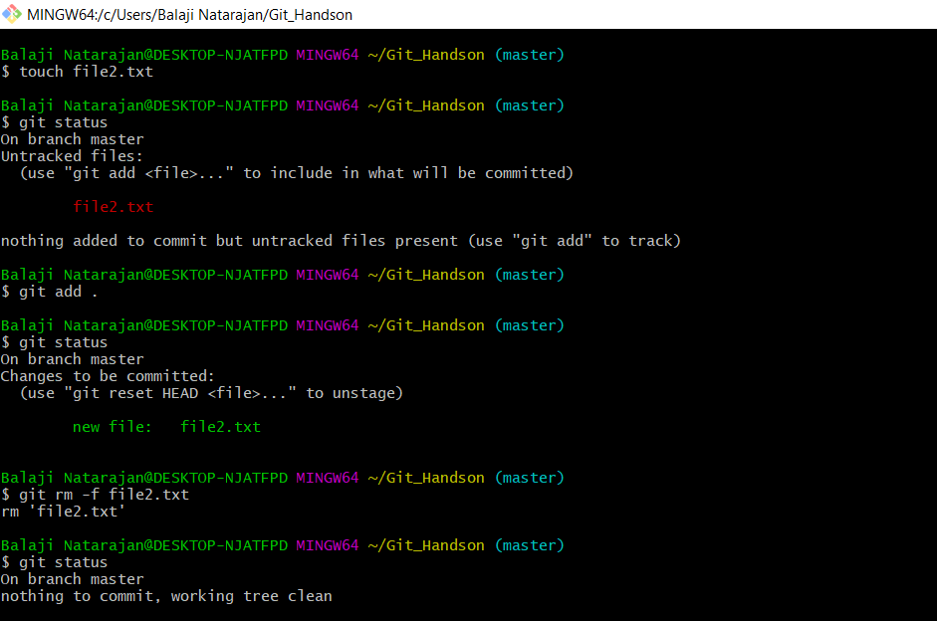

1. backing out staged deletion  
     
   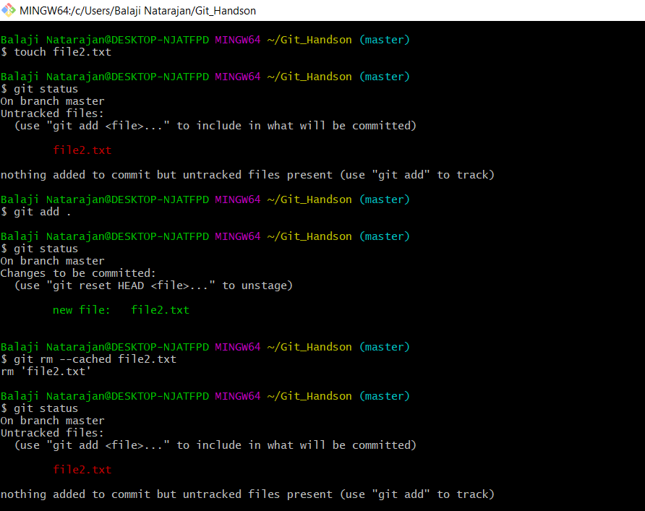
2. recursive deletion

