**Part-A (15-20 Minutes):**

1. How many total combinations are possible?

* 36 combinations are possible when throwing two dice.

2. Calculate and display the distribution of all possible combinations that can be

obtained when rolling both Die A and Die B together.

3. Calculate the Probability of all Possible Sums occurring among the number of

combinations from (2).

**Code :**

**die_A = [1, 2, 3, 4, 5, 6]**

**die_B = [1, 2, 3, 4, 5, 6]**

**print("All possible combinations : ")**

**combination_sum_array = []**

**for i in range(len(die_A)):**

**for j in range(len(die_B)):**

**sum_of_pairs = die_A[i] + die_B[j]**

**if(sum_of_pairs not in combination_sum_array):**

**combination_sum_array.append(sum_of_pairs)**

**print((die_A[i], die_B[j]), end=" ")**

**print()**

**start = combination_sum_array[0]**

**end = combination_sum_array[-1]**

**while(start <= end):**

**print("Sum = ", start)**

**print("Combinations : ")**

**count = 0**

**for i in range(len(die_A)):**

**for j in range(len(die_B)):**

**sum_of_pair = die_A[i] + die_B[j]**

**if(sum_of_pair == start):**

**print((die_A[i], die_B[j]), end=" ")**

**count += 1**

**print()**

**print("Probability : " + str(count) + "/" + str(36) + " = ", round(count/36, 2))**

**print("_ _ _ _ _ _ _ _ _ _ ")**

**start += 1**

**Screenshot of code:**

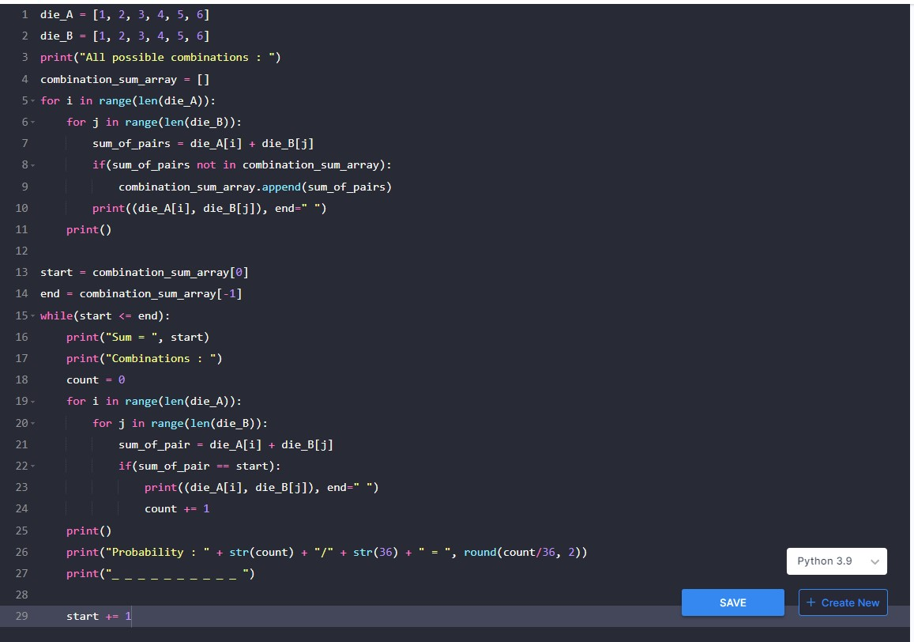

**Output Screenshot:**

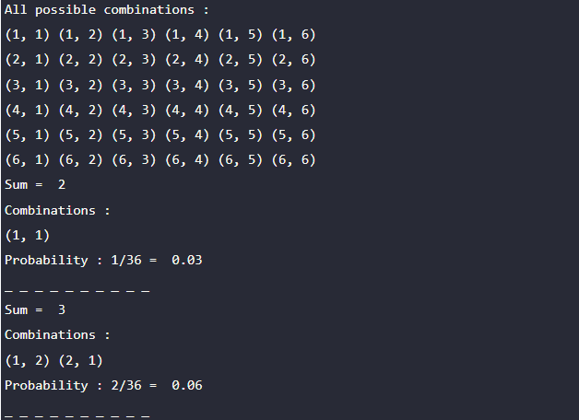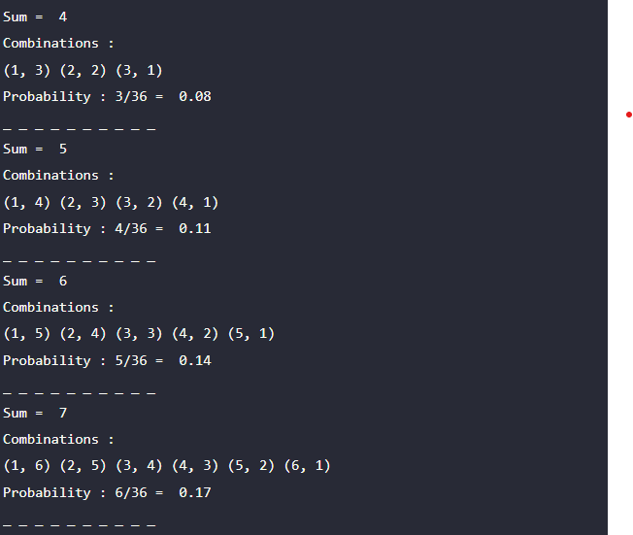

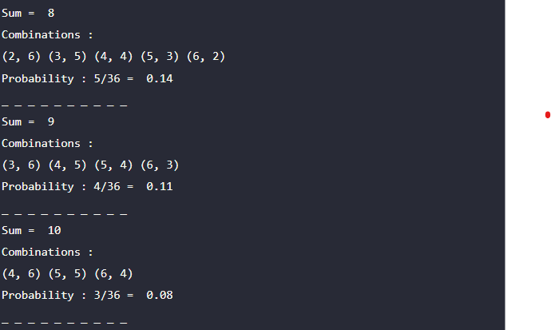

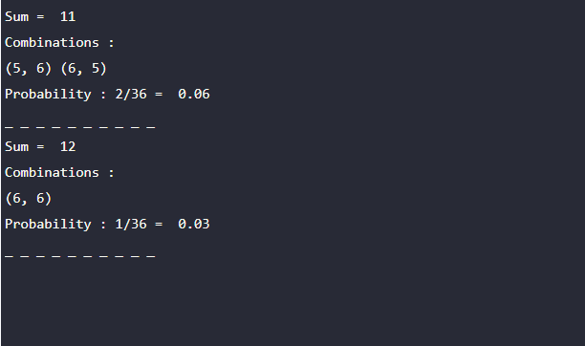

**Explanation:**

* Declare die_A and die_B as list and drop both the value [1, 2, 3, 4, 5, 6].
* Declare empty list to save sum of all combinations (combination_sum_array= []).
* Find all combinations, I took two for loop.

for i in range length of the die_A list and for j in range length of the die_B list.

and added a conditional statement to check whether sum_of_pair is not in **combination_sum_array** . If condition is True, allowed within the conditional statement.

* Print all combinations when throwing two dice.
* Now, Value of combination_sum_array = [] is [2, 3, 4, 5, 6, 7, 8, 9, 10, 11, 12].
* Assigned first index value to **Start**, last index value to **end**. i.e, (Start = 2, end = 12).
* I have Used while loop range from (2 to 12).
* Print Sum of Combinations, Possible combinations and Probability of all Possible Sums.

**Example** :

Start = 2, end = 12

count = 0

While loop **(2 <= 12)** is True. Print Sum = 2 inside

Enter into the for loop, here calculate the sum_of_pair (1, 1) is the only possible pair of Sum = 2.

Assuming sum_of_pair == start, i.e., (2 == 2) allowed in conditional statement, and print possible pairs and count value increases by 1, now count = 1.

Print the Probability count value divided by 36 and round it up to two decimal places. **(1 / 36 ) => 0.03.**

Start value increases by 1.

**Output**:

Sum = **2**

Combinations :

**(1, 1)**

Probability **: 1/36 = 0.03**

_ _ _ _ _ _ _ _ _ _

**Part – B:**

**Code :**

**def undoom_dice(Die_A, Die_B):**

**new_die_A = []**

**new_die_B = []**

**combination_sum_array = []**

**for i in range(len(Die_A)):**

**for j in range(len(Die_B)):**

**sum_of_pairs = Die_A[i] + Die_B[j]**

**if(sum_of_pairs not in combination_sum_array):**

**combination_sum_array.append(sum_of_pairs)**

**for i in Die_A:**

**for j in Die_B:**

**sum_of_value = i + j**

**if(sum_of_value in combination_sum_array):**

**if i > 4:**

**new_die_A.append(i - 4)**

**break**

**else:**

**if(i not in new_die_A):**

**new_die_A.append(i)**

**if(j not in new_die_B):**

**new_die_B.append(j)**

**return new_die_A, new_die_B**

**Die_A = [1, 2, 3, 4, 5, 6]**

**Die_B = [1, 2, 3, 4, 5, 6]**

**new_die_A, new_die_B = undoom_dice(Die_A, Die_B)**

**print("New_Die_A : ", new_die_A)**

**print("New_Die_B : ", new_die_B)**

**Code Screenshot :**

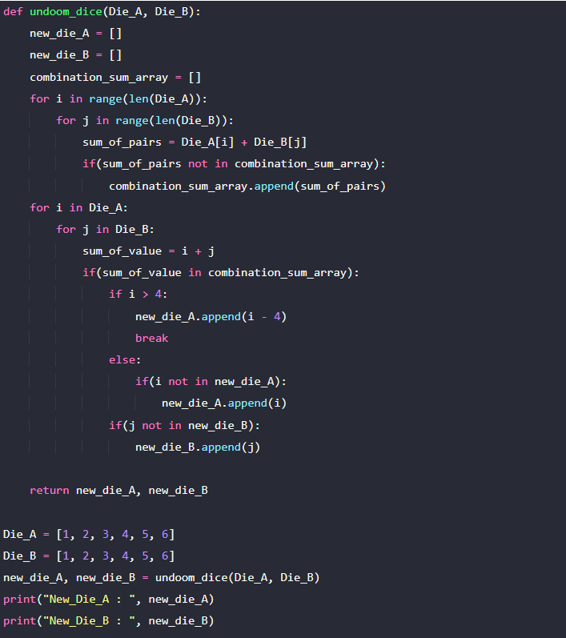

**Output:**

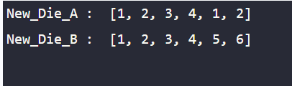

**Explanation:**

* Define a function undoom_dice and pass it as arguments Die_A, Die_B with an initial value.
* Declare new-die_A and new_Die_B with an empty list. Similarly, combination_sum_array.
* for i in range length of the Die_A list and for j in range length of the Die_B list.

and added a conditional statement to check whether sum_of_pair is not in combination_sum_array . If condition is True, allowed within the conditional statement.

* Two for loops were used, one for Die_A and one for Die_B.
* Once the sum_of_value is calculated, I added an If condition that the sum_of_value is present in the combination_sum_array allowed inside the statement, Die_A value > 4 is subtracted from 4 and added to the new_die_A.
* If not, block added a value to new_die_A that did not exist previously.
* The same process was followed for new_die_B.
* As a final step, return the new_die_A, new_die_B from the function. After that, print the new_die_A and new_die_B.