**Part – B:**

**Code :**

**from itertools import combinations_with_replacement**

**from itertools import combinations**

**def find_new_die_A_and_new_die_B(die_a, die_b):**

**probability = {2: 1, 12: 1, 3: 2, 11: 2, 4: 3, 10: 3, 5: 4, 9: 4, 6: 5, 8: 5, 7: 6}**

**unique_number = []**

**all_sums = []**

**for i in die_a:**

**for j in die_b:**

**sum_of_pairs = i + j**

**all_sums.append(sum_of_pairs)**

**if(sum_of_pairs not in unique_number):**

**unique_number.append(sum_of_pairs)**

**new_probability = {}**

**for each in unique_number:**

**count = all_sums.count(each)**

**# Add key and value to new_probability dictionary**

**new_probability[each] = count**

**if(new_probability == probability):**

**print("New_die_A : ", die_a)**

**print("New_die_B : ", die_b)**

**# all combinations of die_A (i.e, New_Die A[x] <= 4)**

**die_A = list(combinations_with_replacement([1, 2, 3, 4], 6))**

**# all combinations of die_B**

**die_B = list(combinations([1, 2, 3, 4, 5, 6, 7, 8], 6))**

**for pair_a in die_A:**

**for pair_b in die_B:**

**find_new_die_A_and_new_die_B(pair_a, pair_b)**

**Code Screenshot :**

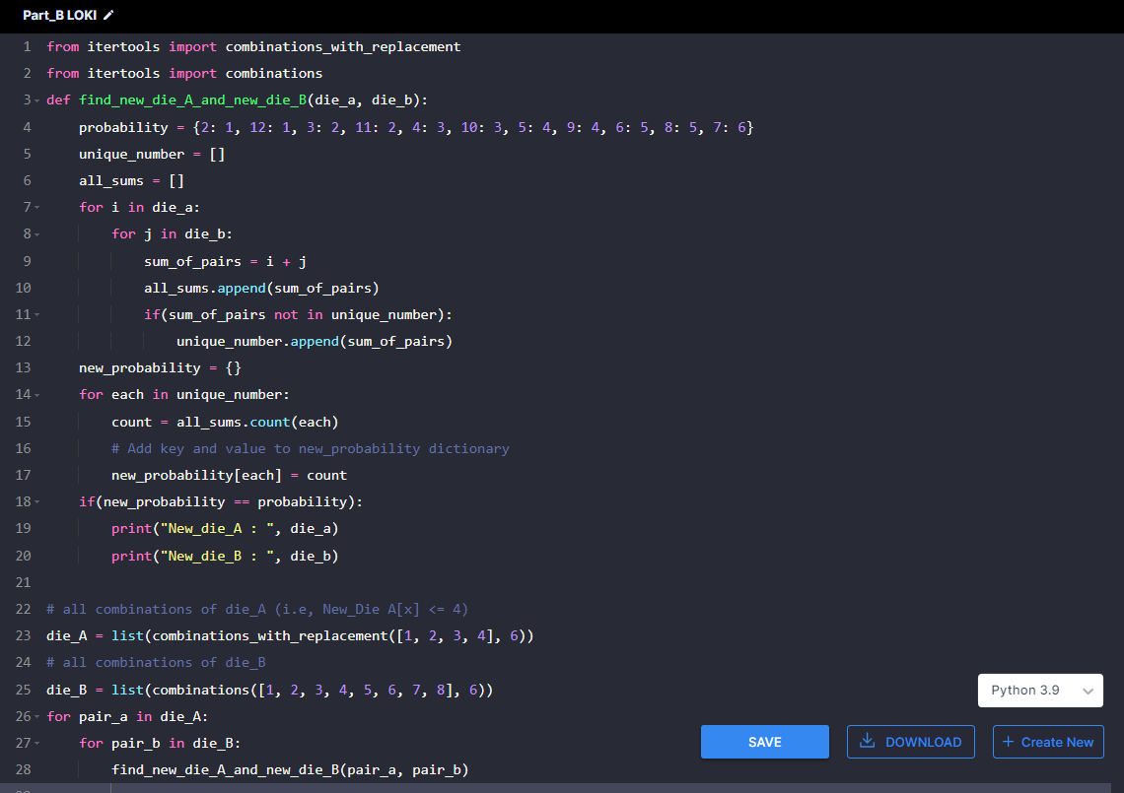

**Output :**

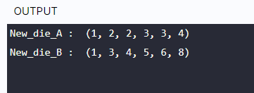

**Explanation :**

* Create a list die_A of all combinations based on the given condition. No value greater than 4 (New_Die A[x] <= 4).
* Similarly, die_B of all combinations based on the given condition. (i.e. even more than 6).
* Two for loop were used for die_A and die_B.
* Define a function find_new_die_A_and_new_die_B and pass each item of die_A and die_B as arguments.
* I define the probability of two dice values.

(i.e, probability = {2: 1, 12: 1, 3: 2, 11: 2, 4: 3, 10: 3, 5: 4, 9: 4, 6: 5, 8: 5, 7: 6})

* Two loop used for each pair, calculate the sum_of_pairs added to all_sums list.
* If condition used sum_of_pairs value not in unique_list, add the sum_of_pair value to unique_list.
* Declare an empty dictionary (new_probability = {})
* Using the count function, find the count of each sum_value and add it to the dictionary key, value pair.
* Return new_die_A, new_die_B if the initial probability value is equal to the new_probability value.