AMAZON SALES DATA ANALYSIS REPORT

Intern ID | IS/A1/N7349
Position | Data Analyst Intern
Organization | InnoByte Services

1. Executive Summary
This project analyzes an Amazon sales transaction dataset to identify sales trends, product preferences, fulfillment performance, customer-segment characteristics, geographical patterns, and operational issues.
The analysis was performed using Python-based exploratory data analysis with Pandas, NumPy, Matplotlib, and Seaborn.
The dataset contains 120,229 unique orders and 116,496 units sold. The recorded sales amount for records with an available Amount value is ₹78,496,786.39, with an Average Order Value of ₹695.36.
The overall cancellation rate is 14.28%, while the return rate is 1.65%.
The analysis shows that sales are concentrated in particular product categories, sizes, states, and cities. T-shirt is the leading product category by sales, M is the leading size by sales, Maharashtra is the leading state by sales, and Bengaluru is the leading city by sales.
Amazon fulfillment handles the larger share of orders and sales, while Merchant fulfillment has a higher cancellation rate in the analyzed dataset.

2. Problem Statement
Analyze and provide insights on the Amazon Sales Report.
The dataset contains Amazon sales transactions with information such as:
- Order ID
- Date
- Order Status
- Fulfillment Method
- Sales Channel
- Product Category
- Product Size
- Quantity
- Amount
- Shipping City
- Shipping State
- B2B Indicator
- Courier Status
The objective is to perform comprehensive exploratory data analysis and extract actionable business insights.

3. Objectives
The main objectives of this project are:
- Analyze overall sales trends and patterns over time.
- Identify popular product categories, sizes, and quantities.
- Evaluate the effectiveness of different fulfillment methods.
- Analyze B2B and B2C transaction behavior.
- Study sales distribution across geographical regions.
- Analyze operational order statuses such as cancellations, returns, pending orders, and deliveries.
- Provide actionable recommendations for sales, inventory, operations, and customer service.

4. Dataset Description
The project uses the Amazon Sales Report dataset provided for Project ID 78G0OL.
The dataset contains transactional and shipping-related information, including order details, product information, sales amount, fulfillment method, customer type indicator, and geographical information.
Important fields used in the analysis include:
Field | Description
Order ID | Unique identifier of an order
Date | Order date
Status | Current order status
Fulfilment | Fulfillment method
Category | Product category
Size | Product size
Qty | Quantity ordered
Amount | Transaction amount
B2B | Indicates business-to-business transaction
Courier Status | Courier / shipping status
ship-city | Shipping city
ship-state | Shipping state

5. Tools and Technologies
Tool / Library | Purpose
Python | Data analysis and programming
Pandas | Data loading, cleaning, grouping, and aggregation
NumPy | Numerical operations
Matplotlib | Data visualization
Seaborn | Statistical and categorical visualization
Jupyter Notebook | Interactive analysis and documentation

6. Data Cleaning and Preprocessing
The dataset was loaded into a Pandas DataFrame and examined for its structure, column names, data types, missing values, and duplicate records.
The following preprocessing activities were performed:
- Loaded the CSV dataset using Pandas.
- Examined the dataset structure.
- Checked column names and data types.
- Handled missing values where required.
- Converted the date field into an appropriate date format.
- Created time-based fields for monthly analysis.
- Used unique Order ID values for order-level calculations.
- Used records with available Amount values for monetary analysis.
- Created separate analytical DataFrames where necessary.
Since multiple rows can belong to the same order, unique Order ID counts were used for order-level KPIs instead of simply counting rows.

7. Sales Analysis

7.1 Sales KPIs
KPI | Value
Total Unique Orders | 120,229
Total Quantity Sold | 116,496
Orders with Amount | 112,887
Recorded Sales Amount | ₹78,496,786.39
Average Order Value | ₹695.36
Cancelled Orders | 17,166
Cancellation Rate | 14.28%
Returned Orders | 1,980
Return Rate | 1.65%
The analysis indicates that the dataset contains a large volume of transactions, with recorded sales of approximately ₹78.50 million.
The cancellation rate of 14.28% is an important operational metric and should be investigated further.

7.2 Monthly Sales
Month | Unique Orders | Sales
March 2022 | 158 | ₹101,683.85
April 2022 | 45,709 | ₹28,742,816.41
May 2022 | 39,221 | ₹26,226,476.75
June 2022 | 35,141 | ₹23,425,809.38
Finding: April 2022 recorded the highest sales among the months available in the dataset.
March contains only 158 unique orders, compared with substantially higher volumes in April, May, and June. Therefore, March should be interpreted cautiously when comparing monthly performance.
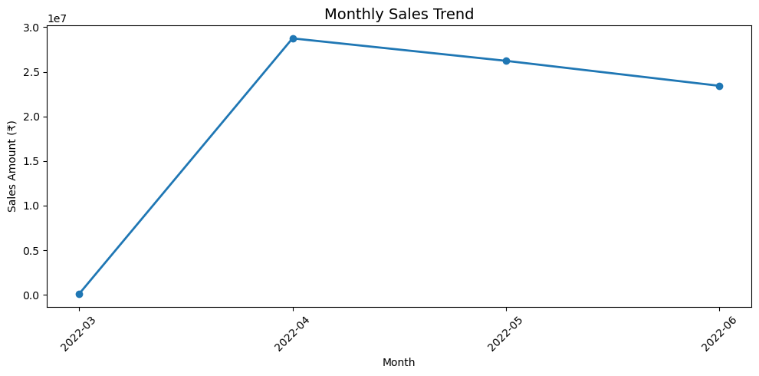
Figure 7.1 — Monthly Sales Trend
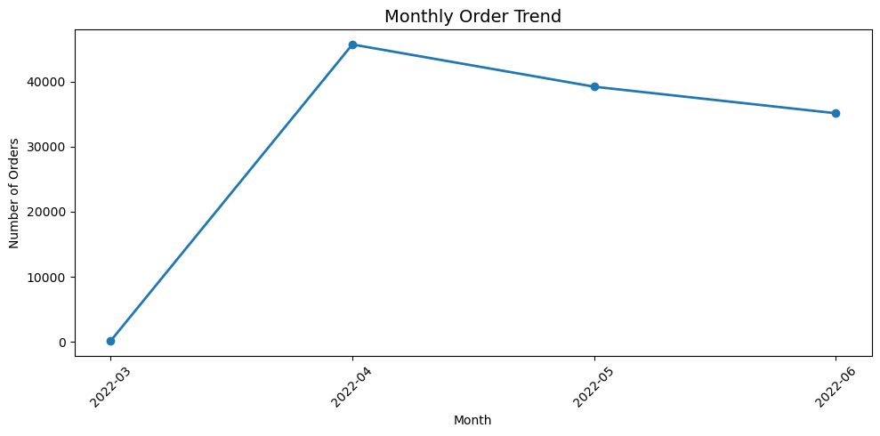
Figure 7.2 — Monthly Order Trend

8. Product Analysis

8.1 Category Performance
The product-category analysis identifies the categories contributing the highest recorded sales.
Category | Sales
T-shirt | ₹39,154,132.17
Shirt | ₹21,269,768.70
Finding: T-shirt is the highest-selling category by recorded sales.
This indicates that sales are significantly concentrated in the T-shirt category.
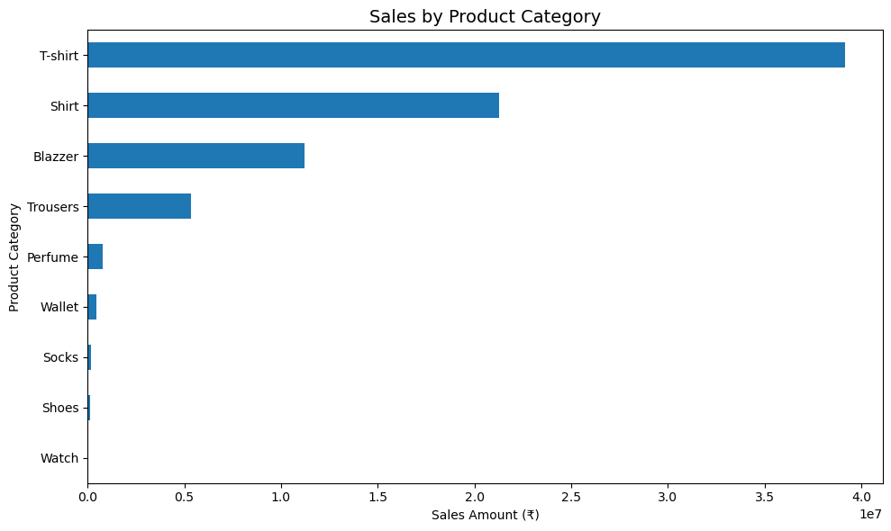
Figure 8.1 — Sales by Product Category

8.2 Size Performance
Size | Sales
M | ₹13,678,295.13
L | ₹13,023,938.84
XL | ₹12,240,095.38
XXL | ₹10,452,621.64
Finding: M is the highest-selling size by recorded sales, followed by L and XL.
This information can be used to support inventory planning and reduce the possibility of stock shortages in high-demand sizes.
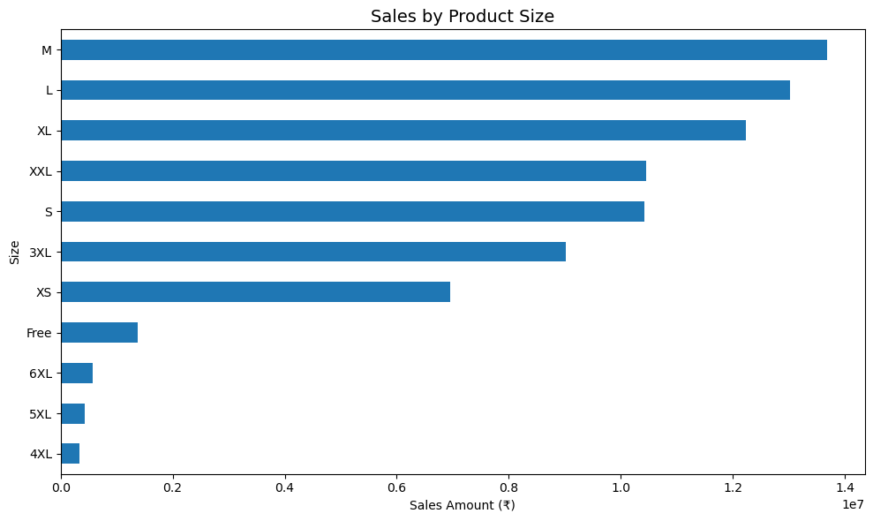
Figure 8.2 — Sales by Product Size

8.3 Category × Size Analysis
A category-by-size analysis was performed using pivot tables and heatmaps.
This analysis helps identify which sizes are most demanded within individual product categories.
For example, instead of analyzing only overall size demand, category-size combinations can be examined to determine where inventory should be prioritized.
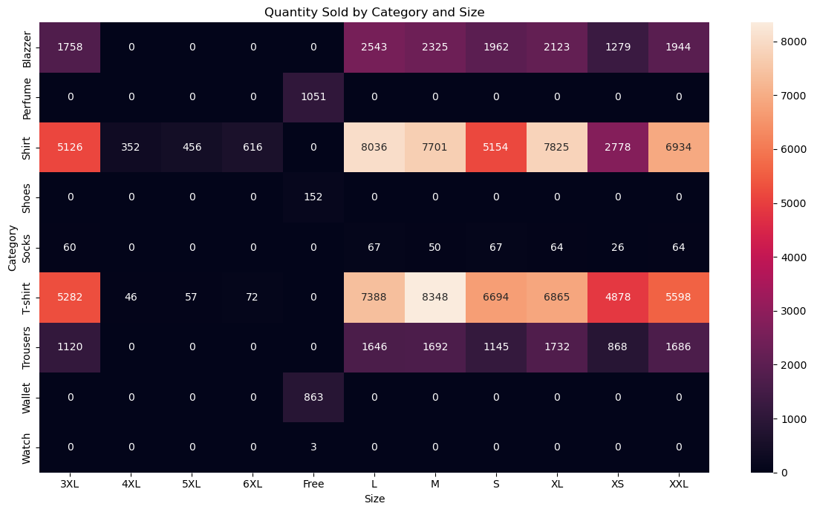
Figure 8.3 — Quantity Sold by Category and Size (Heatmap)

9. Fulfillment Analysis
The fulfillment analysis compares Amazon and Merchant fulfillment methods.
Fulfillment | Unique Orders | Recorded Sales | AOV | Cancellation Rate
Amazon | 83,906 | Approx. ₹54.26M | ₹693.79 | 12.86%
Merchant | 36,323 | Approx. ₹24.23M | ₹698.89 | 17.55%

Findings
- Amazon fulfillment handles the larger share of orders.
- Amazon fulfillment also contributes the larger share of recorded sales.
- Merchant fulfillment has a higher cancellation rate than Amazon fulfillment.
- Merchant fulfillment has a slightly higher AOV.
The difference in cancellation rate indicates that Merchant fulfillment deserves further operational investigation.
However, this analysis shows association rather than causation. The data alone does not prove that the fulfillment method causes cancellations.
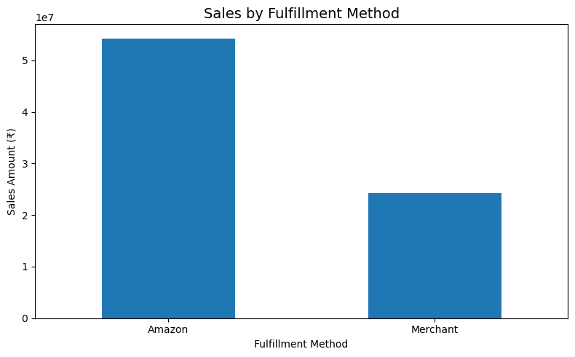
Figure 9.1 — Sales by Fulfillment Method
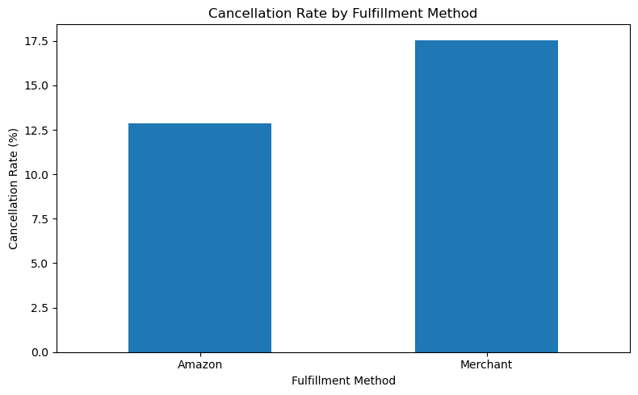
Figure 9.2 — Cancellation Rate by Fulfillment Method

10. Customer Segmentation (Behavior & Geography)
The dataset does not contain a unique customer ID, so individual-level behavioral segmentation was not possible. Segmentation was instead performed along the two customer-related dimensions the dataset does support: transaction behavior (B2B vs. B2C) and shipping geography (state and city). Read together, these two lenses form a behavior-plus-location segmentation view of the customer base, rather than two unrelated analyses.

10.1 Behavioral Segment: B2B vs. B2C
Metric | B2C | B2B
Unique Orders | 119,435 | 794
Order Share | 99.34% | 0.66%
Recorded Sales | Approx. ₹77.91M | Approx. ₹0.59M
Sales Share | 99.25% | 0.75%
AOV | ₹694.85 | ₹768.82
Cancellation Rate | 14.32% | 8.31%
Return Rate | 1.65% | 0.76%
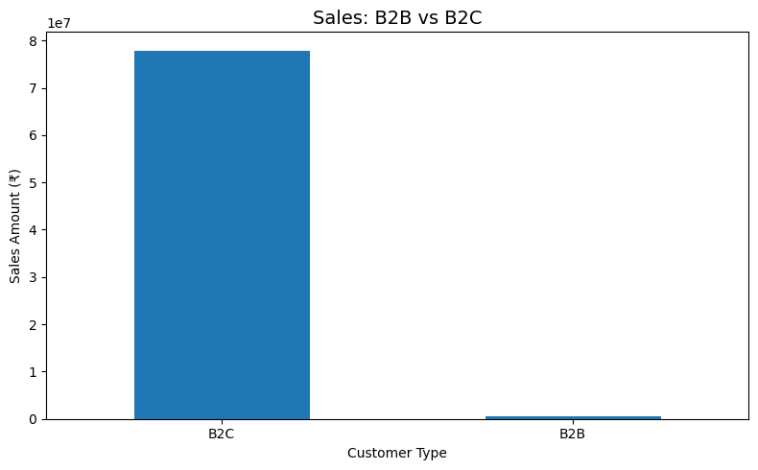
Figure 10.1 — Sales: B2B vs B2C

Findings
- B2C transactions dominate order volume.
- B2C transactions also account for the overwhelming majority of recorded sales.
- B2B transactions represent a very small proportion of total orders.
- B2B transactions have a higher AOV of ₹768.82 compared with B2C's ₹694.85.
- B2B transactions have lower cancellation and return rates in the analyzed dataset.
This suggests that B2B transactions may represent a potential higher-value segment despite their smaller volume.

10.2 Layering Geography onto the Behavioral Segments
Section 11 shows that recorded sales are concentrated in a small set of states and cities (Maharashtra, Karnataka, Telangana; Bengaluru, Hyderabad, Mumbai). Combined with the B2B/B2C split above, this points to a practical two-dimensional segment worth targeting operationally: the small, higher-AOV, lower-cancellation B2B segment concentrated within the same top-performing states and cities that already drive the bulk of B2C volume.
Note on scope: the source analysis did not compute a joint B2B-by-state/city cross-tabulation — the behavioral and geographic breakdowns were produced as separate group-by operations on the dataset, not a combined one. The statement above is therefore a reasoned combination of two existing findings, not a verified joint metric. A true joint segmentation (e.g. B2B order share and cancellation rate within each top state) would need to be computed directly from the raw CSV; this can be added if the dataset is made available.

11. Geographical Analysis

11.1 Top States
State | Recorded Sales
Maharashtra | ₹13,318,966.38
Karnataka | ₹10,465,387.03
Telangana | ₹6,909,670.08
Finding: Maharashtra is the leading state by recorded sales, followed by Karnataka and Telangana.
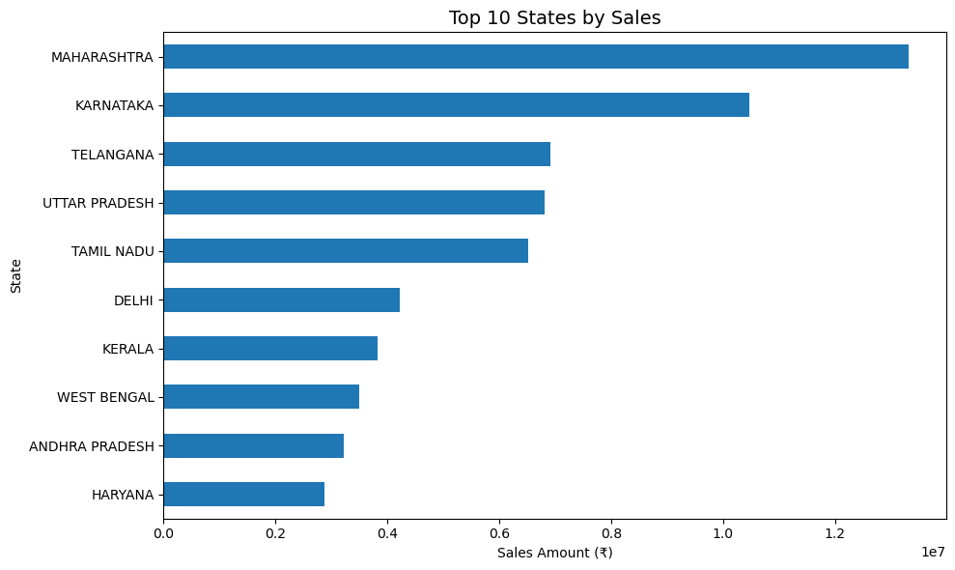
Figure 11.1 — Top 10 States by Sales

11.2 Top Cities
City | Recorded Sales
Bengaluru | ₹6,836,614.65
Hyderabad | Approx. ₹4.94M
Mumbai | Approx. ₹3.70M
New Delhi | Approx. ₹3.61M
Chennai | Approx. ₹3.10M
Finding: Bengaluru is the leading city by recorded sales in the analyzed dataset.
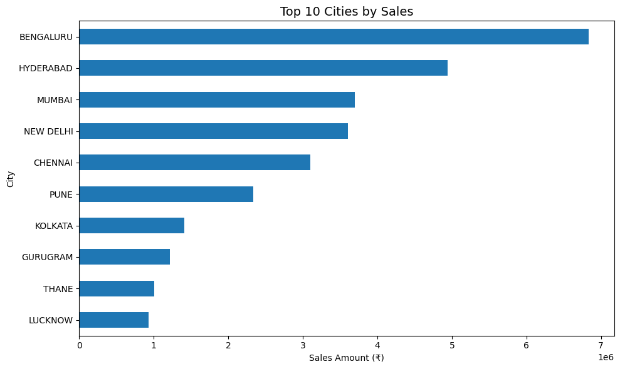
Figure 11.2 — Top 10 Cities by Sales
The concentration of sales in specific states and cities provides a basis for regional inventory planning and targeted marketing.
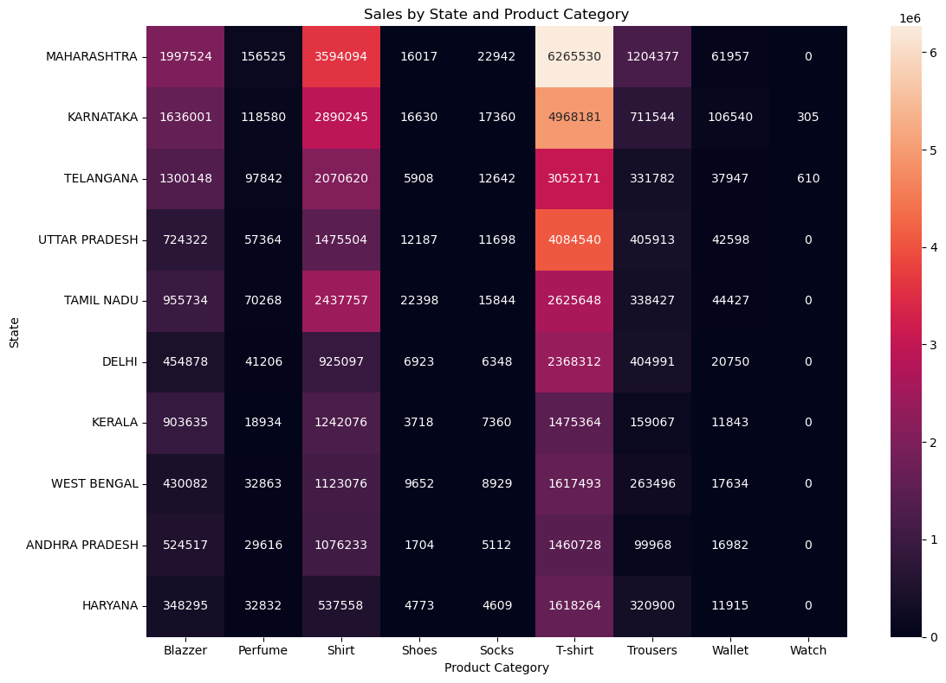
Figure 11.3 — Sales by State and Product Category (Heatmap)

12. Operational Analysis
The operational analysis examined:
- Courier Status
- Order Status
- Cancellation
- Returns
- Pending orders
- Delivery-related statuses
- Fulfillment performance
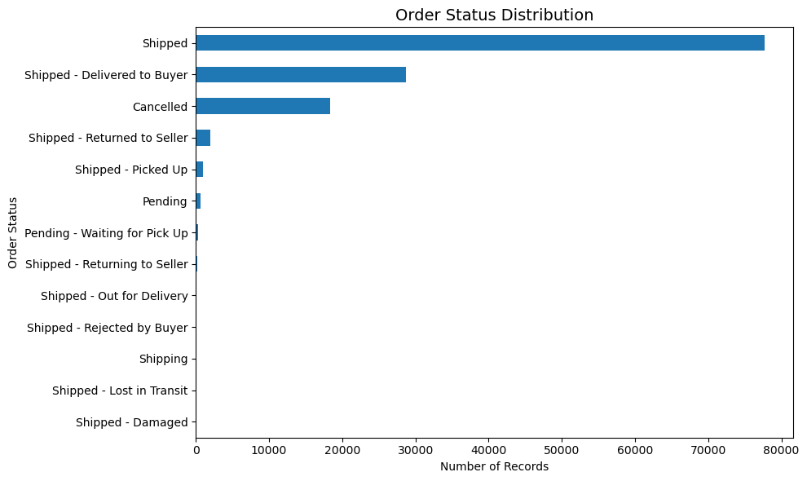
Figure 12.1 — Order Status Distribution
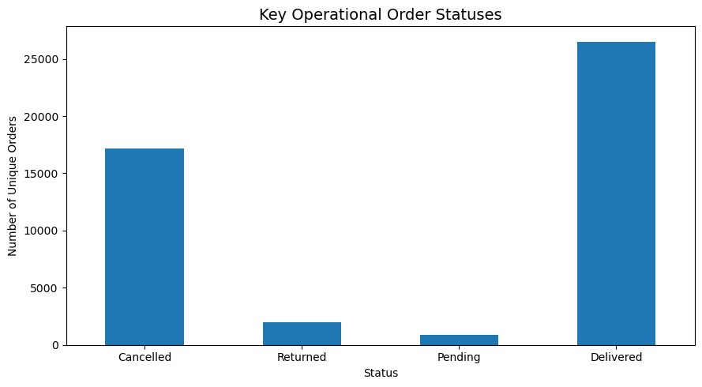

12.1 Cancellation
The analysis identified 17,166 cancelled unique orders, with an overall cancellation rate of 14.28%.
This is a significant operational metric and should be investigated.

12.2 Returns
The analysis identified 1,980 returned unique orders, with an overall return rate of 1.65%.
Returns should be monitored across product category, size, fulfillment method, and geography to identify recurring patterns.

12.3 Pending Orders
Pending and pending-waiting-for-pick-up statuses were analyzed to identify potential processing delays.
Monitoring pending orders can help identify operational bottlenecks.

12.4 Delivered Orders
The dataset contains the specific status "Shipped - Delivered to Buyer". The calculated delivered metric represents orders explicitly having this status.
It should not be interpreted as saying that all other Shipped orders were unsuccessful, because the dataset contains several other shipping statuses.

13. Key Findings
The major findings from the project are:
- The dataset contains 120,229 unique orders.
- Total recorded quantity is 116,496 units.
- Recorded sales amount is ₹78,496,786.39.
- Average Order Value is ₹695.36.
- The overall cancellation rate is 14.28%.
- The overall return rate is 1.65%.
- April 2022 recorded the highest sales among the available months.
- T-shirt is the leading product category by recorded sales.
- M is the leading size by recorded sales.
- Amazon fulfillment handles the larger share of orders and sales.
- Merchant fulfillment has a higher cancellation rate than Amazon fulfillment.
- B2C transactions dominate the dataset in terms of orders and sales.
- B2B transactions have a higher Average Order Value than B2C transactions.
- Maharashtra is the leading state by sales.
- Bengaluru is the leading city by sales.
- The cancellation rate is a significant operational issue that warrants further investigation.

14. Business Recommendations

14.1 Improve Cancellation Performance
Investigate the causes behind the 14.28% cancellation rate. The analysis should be extended by examining cancellations across:
- Fulfillment method
- Product category
- Product size
- Geography
- Order status
The highest-contributing areas should then be targeted for improvement.

14.2 Prioritize High-Performing Inventory
The T-shirt category contributes the highest recorded sales. Inventory planning should therefore prioritize high-performing categories and their most demanded sizes, particularly M, based on the observed sales pattern.

14.3 Optimize Regional Inventory
Sales are concentrated in specific states and cities. Inventory can be strategically positioned toward high-demand regions such as:
- Maharashtra
- Karnataka
- Telangana
- Bengaluru
- Hyderabad
- Mumbai
This can potentially improve product availability and operational efficiency.

14.4 Investigate Merchant Fulfillment
Merchant fulfillment has a 17.55% cancellation rate, compared with 12.86% for Amazon fulfillment. The reasons for this difference should be investigated, including:
- Processing delays
- Inventory availability
- Dispatch issues
- Order handling
- Shipping performance
The analysis does not establish that Merchant fulfillment causes cancellations; further investigation is required.

14.5 Monitor Returns
The overall return rate is 1.65%. Returned orders should be analyzed by:
- Product category
- Size
- Fulfillment method
- State
- City
This could identify recurring product or delivery issues.

14.6 Develop B2B Opportunities
B2B transactions represent only 0.66% of orders, but their AOV is ₹768.82, higher than the B2C AOV of ₹694.85. This suggests an opportunity to develop targeted B2B sales strategies.

14.7 Strengthen Operational Monitoring
A regular operational dashboard should monitor:
- Cancellation rate
- Return rate
- Pending orders
- Delivery status
- Fulfillment performance
- Regional performance
This would allow operational problems to be identified earlier.

15. Limitations
The following limitations apply to this analysis:
- The dataset does not contain a unique customer identifier, so individual customer-level segmentation cannot be performed.
- Monetary analysis is based on records where the Amount field is available.
- Multiple rows can belong to the same Order ID. Therefore, unique Order ID counts were used for order-level metrics.
- March 2022 contains substantially fewer orders than the following months and should therefore be interpreted cautiously.
- The analysis represents the supplied historical dataset and should not automatically be interpreted as current Amazon business performance.
- The analysis identifies associations between variables but does not establish causal relationships.
- The behavioral (B2B/B2C) and geographic (state/city) segmentations were computed independently; no joint B2B-by-region cross-tabulation was produced from the source data.

6. Conclusion
This project demonstrates how exploratory data analysis can transform transactional sales data into actionable business information. The analysis covered:
- Sales performance
- Monthly sales trends
- Product categories
- Product sizes
- Fulfillment methods
- B2B/B2C transactions
- Geographical distribution
- Courier and order statuses
- Cancellations
- Returns
- Pending orders
- Delivery-related performance
The results show that sales are concentrated among particular product categories, sizes, states, and cities. T-shirts and size M are important product segments, while Maharashtra and Bengaluru are leading geographical markets by recorded sales.
The analysis also identifies cancellations as an important operational issue, with a cancellation rate of 14.28%. Fulfillment-level comparison shows a higher cancellation rate for Merchant fulfillment than Amazon fulfillment in the analyzed data.
The findings provide a data-driven basis for improving:
- Inventory allocation
- Regional planning
- Fulfillment performance
- Sales strategy
- Customer service
- Operational monitoring
Overall, the project demonstrates the practical application of Python, Pandas, NumPy, Matplotlib, and Seaborn to transform raw Amazon transaction data into meaningful business insights and recommendations.

